Benz Aaron Medrano

Renold Pariñas

Janrix Joseph Sumait

veggie Slice

MAD2 midterm Requirement

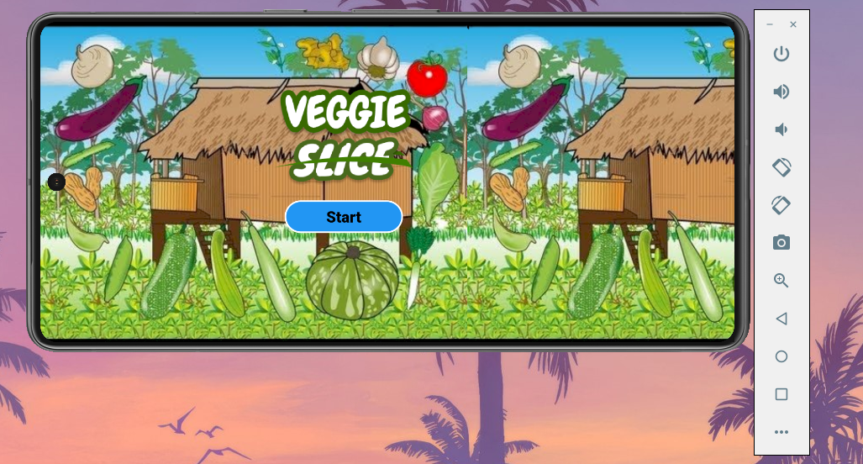

VEGGIE SLICE

Overview

Veggie Slice is an app inspired by the mobile game Fruit Ninja. Instead of fruits, vegetables are the targets and to elevate the gaming experience, we added the famous children song Bahay Kubo as the background music.

Table of Content

Screens

-Home Screen

-In Game Screen

-Highest Score

Database

-Hive

Features

- Easy to use game

- Records the Highest Score

- Inspired by Filipino Culture

Screens

Home Screen

The Home Screen display the image background and the button to enter the game.



In Game Screen

This Screen is the main screen for the game. The objective is to slice vegetables as many as you can using finger while avoiding bombs to gain a high score. Background Music is also played when the user starts the game to elevate the user gaming experience. User can also see the current score and the remaining life of the player. A button is also visible at the top left if user wants to pause the game and a back button to return to the Home Page.

Highest Score

After the game, it will display the highest recorded score.

