**Question One:**

1)

p1= (1.5, 0)

p2= (4, 5)

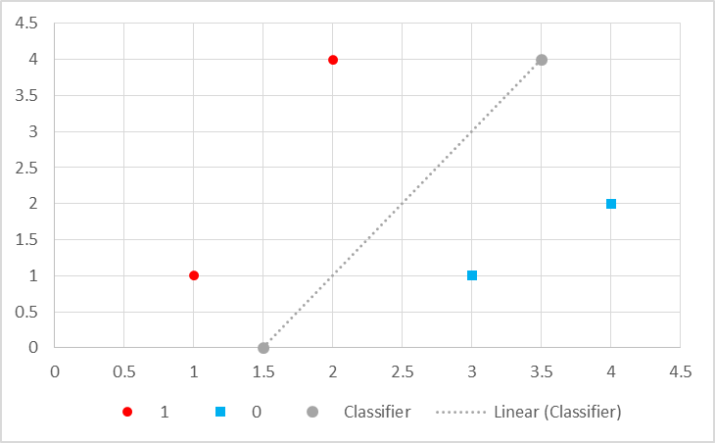m1 =

=

m1 =

b1 =

=

b1 =

2)

xi1 = x = 2

xi2 = y = 4

yi = class = 1

α = 0.1

$$m_{1} ←2-\left(0.1\right)\left(2\right)\left(1-1\right) \\ m_{1}←2-(0)$$

$$b_{1} ←-3-\left(0.1\right)\left(1-1\right) \\ b_{1}←-3-(0)$$

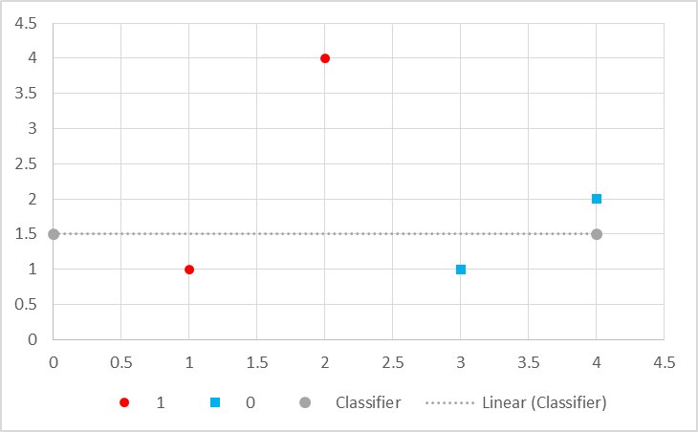3)

$$y = 1.5$$

4)

Point (1, 1.5 | 1)

$$m_{1} ←0-\left(0.1\right)\left(1\right)\left(1-0\right) \\ m_{1}←-(0.1)$$

$$b_{1} ←1.5-\left(0.1\right)\left(1-0\right) \\ b_{1}←1.5-\left(0.1\right)$$

$$b_{1}←1.4$$

**Question Two:**

1) $$h\left(x_{1},x_{2},m,b\right)=\frac{1}{1+e^{-(x_{2}-mx_{1}-b)}}$$

(2, 4 | 1) 🡪 🡪 0.9525741268224331

(1, 1 | 1) 🡪 🡪 0.8807970779778823

(3, 1 | 0) 🡪 🡪 0.11920292202211757

(4, 2 | 0) 🡪 🡪 0.04742587317756679

2) m = 2 b= -3

3)

(2, 4 | 1) 🡪 🡪 0.9526192830418644

(1, 1 | 1) 🡪 🡪 0.8808600597372731

(3, 1 | 0) 🡪 🡪 0.1193499914227

(4, 2 | 0) 🡪 🡪 0.04750725744145057

4)

(2, 4 | 1) 🡪 🡪 0.9241418199787566

(1, 1 | 1) 🡪 🡪 0.3775406687981454

(3, 1 | 0) 🡪 🡪 0.3775406687981454

(4, 2 | 0) 🡪 🡪 0.6224593312018546

5) m = 0 b= 1.5

6)

(2, 4 | 1) 🡪 🡪 0.9143814609235074

(1, 1 | 1) 🡪 🡪 0.3605121413023435

(3, 1 | 0) 🡪 🡪 0.3339961467390574

(4, 2 | 0) 🡪 🡪 0.5625018633518639

**Question 3**

(2, 4 | 1) 🡪 🡪 -3<0 🡪 1

(1, 1 | 1) 🡪 🡪 -2<0 🡪 1

(3, 1 | 0) 🡪 🡪 2>0 🡪 0

(4, 2 | 0) 🡪 🡪 3>0 🡪 0

**Question 4**

1)

(2, 4 | 1) 🡪 🡪 0.9525741268224331

(1, 1 | 1) 🡪 🡪 0.8807970779778823

(3, 1 | 0) 🡪 🡪 0.11920292202211757

(4, 2 | 0) 🡪 🡪 0.04742587317756679

(1, 3 | 0) 🡪 🡪 0.9820137900379085

2) m = 2 b= -3

3)

(2, 4 | 1) 🡪 🡪 0.9526192830418644

(1, 1 | 1) 🡪 🡪 0.8808600597372731

(3, 1 | 0) 🡪 🡪 0.1193499914227

(4, 2 | 0) 🡪 🡪 0.04750725744145057

(1, 3 | 0) 🡪 🡪 0.9820243845972844

**Question 5**

1)

$m_{1}=-0.3$

$$b_{1}=1.5$$

$$m_{2}=-0.3$$

$$b_{2}=3.5$$

|  |  |  |  |
| --- | --- | --- | --- |
|  | Class1 | Class2 | Output Classifier |
| Below both lines | 0 | 0 | 1 |
| Below C2, above C1 | 0 | 1 | n/a |
| Above C1, below C2 | 1 | 0 | 0 |
| Above both lines | 1 | 1 | 1 |

|  |  |  |  |  |  |  |  |  |  |  |
| --- | --- | --- | --- | --- | --- | --- | --- | --- | --- | --- |
| i | w | x | SUM | OUT |  |  |  |  |  |  |
| x | -0.3 | 1 | 0.2 | 0 | |  | | --- | |  | |  |  |  |  |  |
| y | -1 | 1 |  |  |  |  |  |  |  |  |
| b | 1.5 | 1 |  |  |  | i | w | x | SUM | OUT |
|  |  |  |  |  |  | x | 1 | 0 | -0.5 | 1 |
|  |  |  |  |  | |  | | --- | |  | | y | -1 | 0 |  |  |
| i | w | x | SUM | OUT |  | b | -0.5 | 1 |  |  |
| x | -0.3 | 1 | 2.2 | 0 |  |  |  |  |  |  |
| y | -1 | 1 |  |  |  |  |  |  |  |  |
| b | 3.5 | 1 |  |  |  |  |  |  |  |  |

$$f\left(o\right)=\left\{\begin{aligned}0, &o>0 \\ 1, &o≤0\end{aligned}\right.$$

$$f\left(\sum_{i}{f\left(\sum_{j}{w_{ij}*x_{ij}}\right)}\right)$$

(2, 4 | 1)🡪 🡪 🡪 🡪

(1, 1 | 1)🡪 🡪 🡪 🡪

(3, 1 | 0)🡪 🡪 🡪 🡪

(4, 2 | 0)🡪 🡪 🡪 🡪

(1, 3 | 0)🡪 🡪 🡪 🡪 0