BattleBots for New Players

Mackenzie Power
Haotian Ma
Ryan Tetland
William Revell
Mitchel Kovacs

Table of Contents

Game Description ………………………………………………….………………………………….03
Navigation…….. …………………………………………..…………………………………………….05
- Main Menu……………………………………………………………………………………….05
- Game Properties………………………………………………………………………………06
- Team Selection ……………….……………………………………………………………….07
- Game Panel………………………………………………………………………………………………08
- Victory Panel…………………………………………………………………………………………….09
- Stats Panel………………………………………………………………………………………………..10

BattleBots Introduction
BattleBots is a team based robot fighting game that takes place in an arena shaped like a giant hexagon made up of smaller hexagon spaces. Each player can be either human or AI and starts with three robots on their home hex. The home hex corresponds to the player’s colour and is located at one of the corners of the hexagonal arena. Red being at the far left and going clockwise is followed by orange, yellow, green, blue and purple. The game can be played in three different modes, 2-player with red and green used, 3-player with red, yellow and blue and 6-player mode with every home hex being used. Each team of robots consists of a scout, a sniper and a tank each with very different stats. The scout has 2 sight range, 3 movement, 1 health and does 1 damage, the sniper has 3 sight range, 2 movement, 2 health and does 2 damage and the tank has 1 sight range, 1 movement, 3 health and does 3 damage. The game is completed over several turns first each player must move their scout, then after each team has gone every sniper will get a turn and then finally every tank. This is repeated until the game ends, if a robot is destroyed then on its turn a player will move the next alive robot on the team. On a players turn they may move the robot up to it's movement stat using the WEDXZA keys on the keyboard to move one hex at a time, where W makes the robot go up and left, E makes it go up and right, D makes it go right, X makes it go down and right, Z makes it go down and left, and A makes it go left. The player may also shoot an opposing robot by clicking on it, if it is within range the robot will take damage. Once all the desired actions have been completed the user can click the end turn button to end their turn. Winner is decided when all opposing robots have been destroyed.

Game Navigation
For optimal performance it is suggested that BattleBots is run on a Linux computer, or through tuxworld. When the game is started, it will initially take the players to the main menu.

Main Menu
The main menu has three buttons on the screen labelled continue, help, and quit. The player can use the mouse and click on any of these buttons to navigate to the corresponding panels. The help button brings up a pop up screen which explains the basic rules of Battlebots. The quit button immediately exits the game, and the continue button takes the player to the game properties panel.
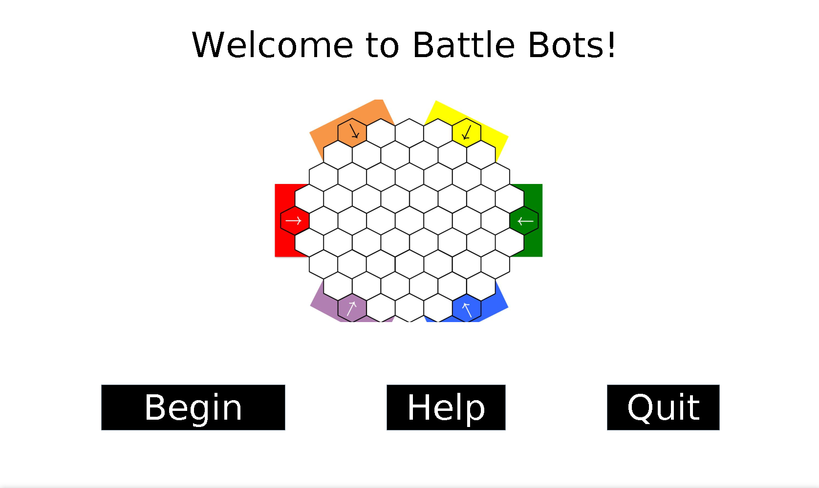

Help Panel
The help panel contains in depth rules on how the game works, and can be exited by clicking the x in the top right corner of the pop-up.
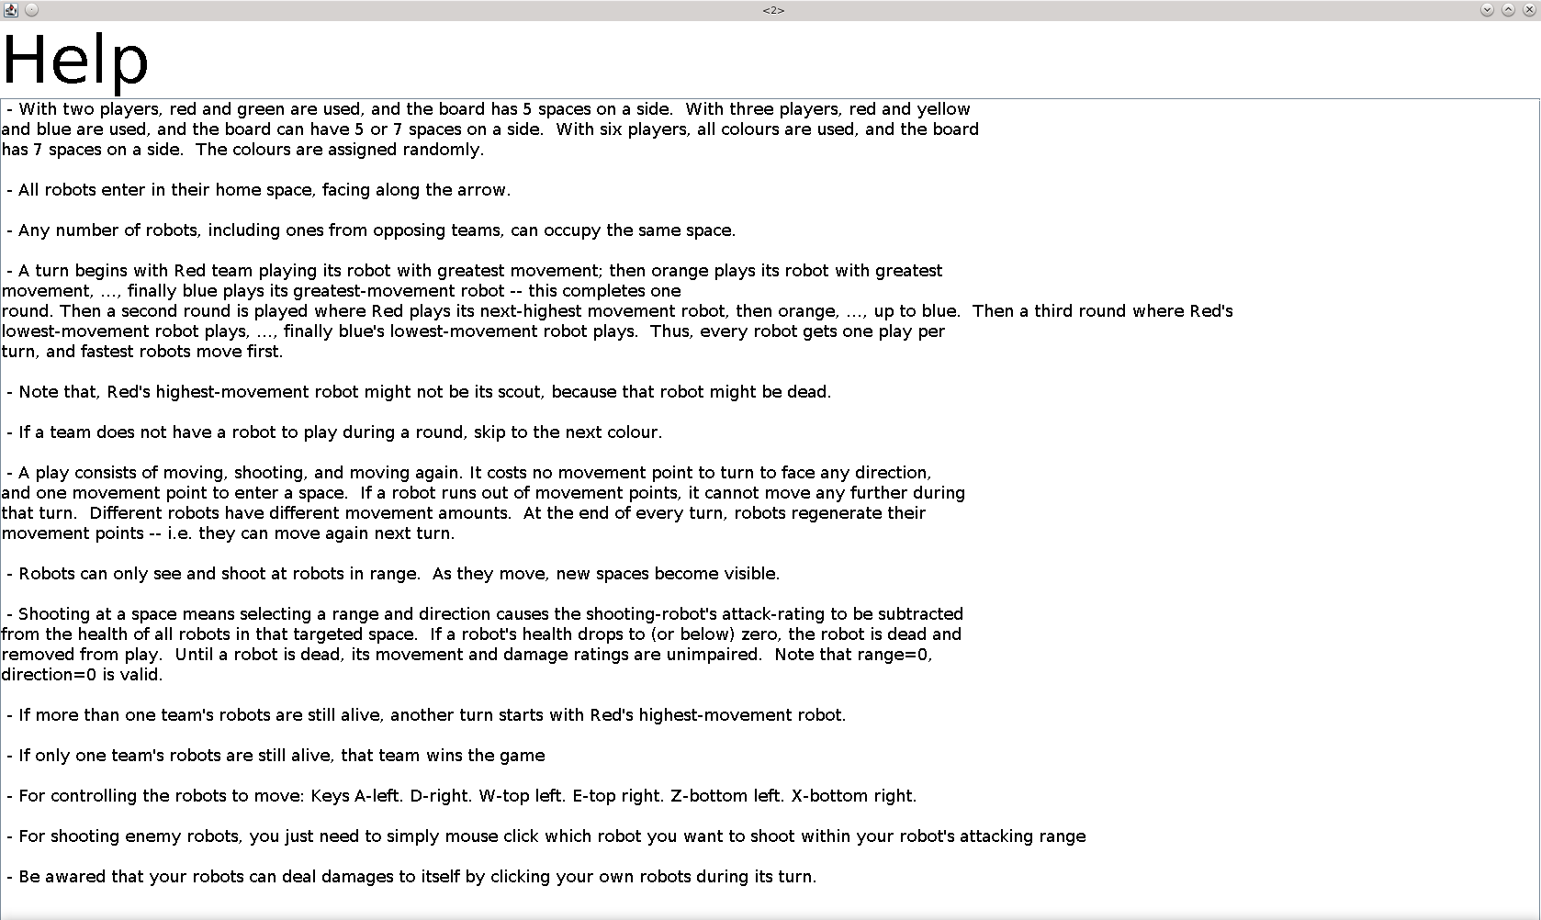

Game Properties Panel
The Game Properties panel contains three sections, the number of players, the number of humans and the board size, as well as three buttons: back, continue and quit. Under the number of players section there are three options 2, 3 and 6 with a corresponding radio button for each allowing the player to choose the number of teams in the game. The number of AI section has 6 options between 0 through 5 but can only select the options that correctly correspond with the number of players chosen. Finally the board size section will be automatically set to 5 if it is a 2 player game or 7 if it is a six-player game, otherwise if it’s a three player game the user is given the option of a 5 or 7 hex size board. The back button takes the user back to the main menu, whilst the quit button exits the game, and the continue button takes the user to the team selection panel.
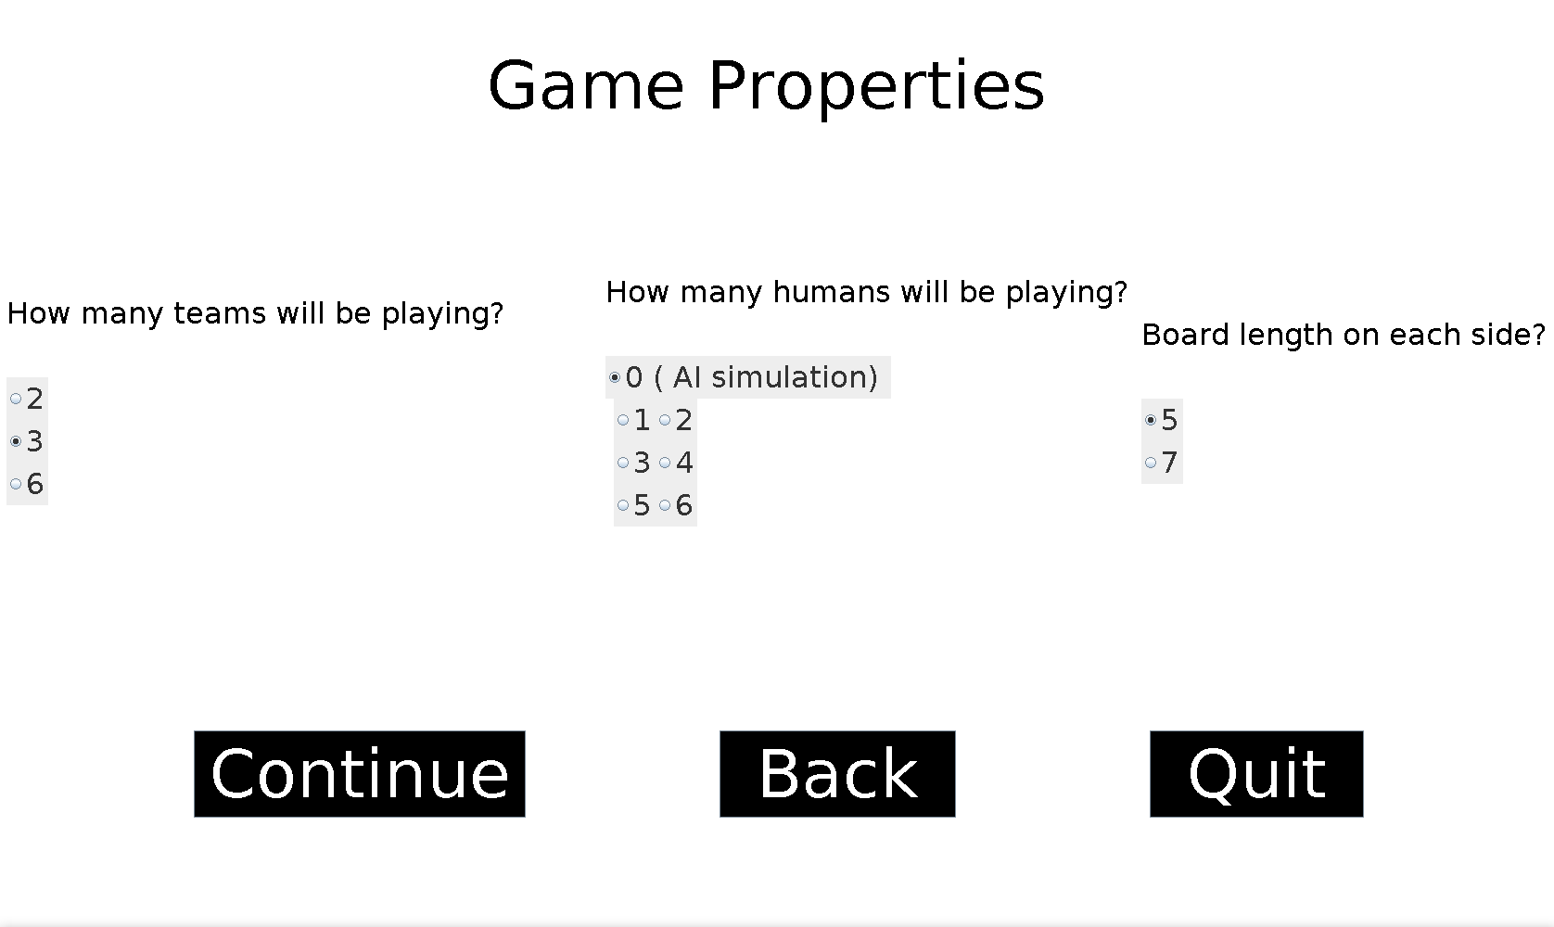

Team Selection Panel
The team selection panel itself contains three separate sections in the top right is the robot stats section which for every robot lists all its important statistics such as kills, wins and games played in its corresponding column. Underneath the robot stats section is the team selection section where the user can click a check box next to any teams they desire to play in the next game. On the right of the screen is the team creation section, here the user can edit any existing robot by selecting them on the left with their corresponding radio button or use the retire button to remove them from the library. The player can also create robots by selecting either an existing or new team name, a new robot name and type then clicking add-Robot to add the robot to the library. After all changes are completed the user can click the update button to update the library. There are three navigation buttons, quit exits the application, back takes the user to the game properties panel, and continue takes the user to the game panel.

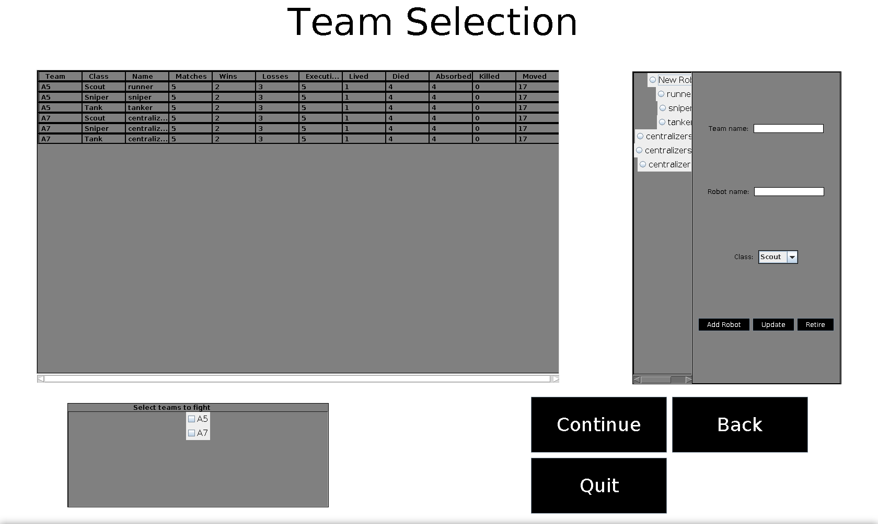

Game Panel
The game panel is the screen that the actual game is played on. In the middle of the screen is the hexagonal arena. On both the left and right sides of the screen the robot health for each robot on each specific team is displayed therefore the user can keep track of any damage dealt or taken. On the left bottom corner, there are 3 buttons the quit-game button, help button and the end turn button. The help button displays the rules pop-up, the quit-game button takes the user to the stats panel, and the end turn button ends the current robots turn. Above the buttons is the current robot turn tracker which displays the team and type of the current robots turn. When a winner is decided, the player is taken to the victory screen.
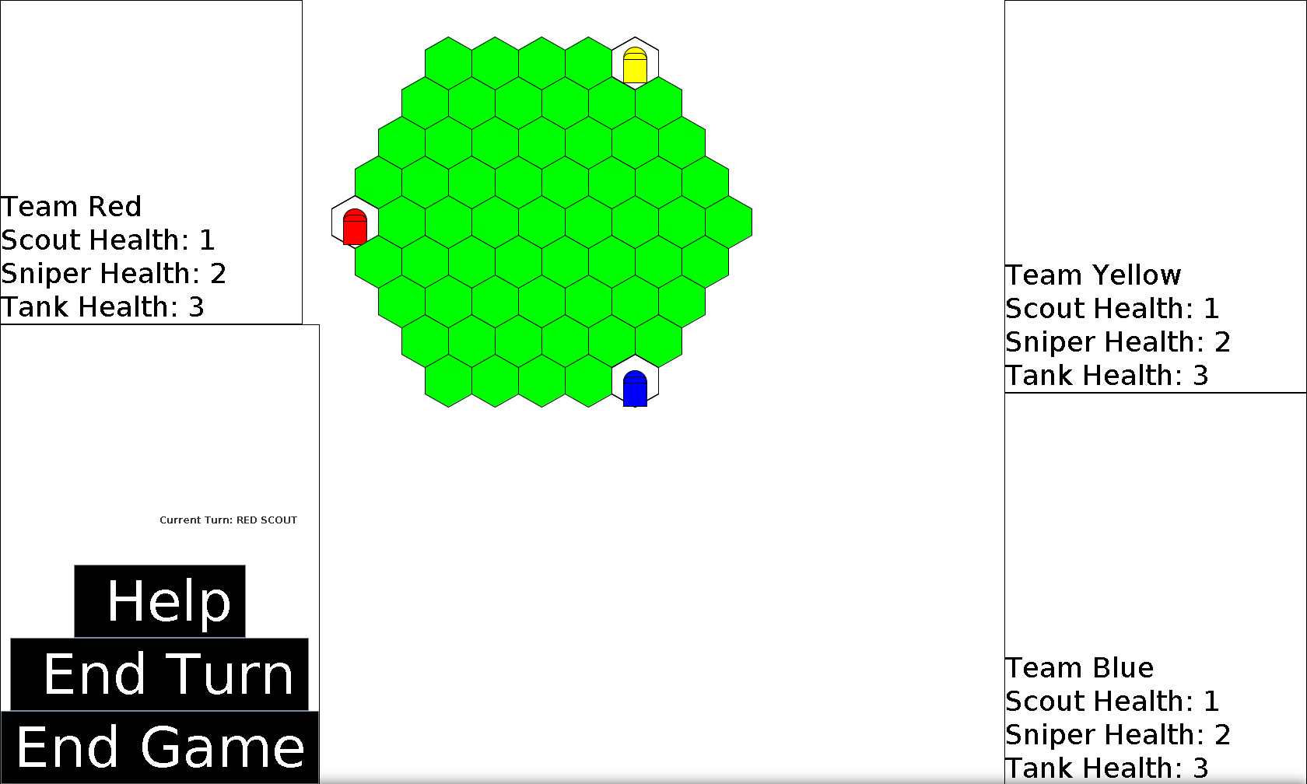

Victory Screen
The victory screen appears after the game is over displaying the winning team, here a player can click the play again button to be taken to the stats panel. The quit button exits the application.
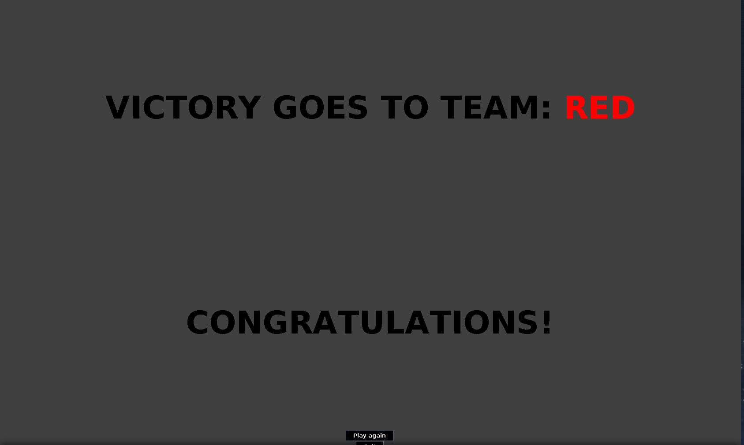

Stats Panel
This is the final panel of the game and displays a table containing each robot in the game with their updated statistics. The user can either click the quit button to exit the application, or the play again button which navigates the user to the games properties panel.

