Table of Contents

Premise…………………………………………..…………………………………1
Product……………………………………………………………………………...1
Platform and Software……………………………………………………………...1
Use Case Diagram 1………………………………………………………………..2
Actors……………………………………………………………………………….2
Actions…………..…..……………………………………………………………...3
Future Versions……………………………………………………………………..6
Product Functionality……………………………………………………………....7
Sequence Diagrams……………………………………………………………….10
GUI examples……………………………………………………………………..13
Executive Summary……………………………………………………………….16

Figure 1. The Game Run Through Display Sequence Diagram shows in detail the different paths a user can take through the games GUI interfaces. Beginning at the Start page and ending at the post-game stats page.

Figure 2. The game initiation sequence diagram describes a play through of a single match of Battlebots, from the various game options, through board initiation until a winner is decided and the end game stats shown. It does not include the numerous possible robot actions during a match.

Figure 3. The Robot Turn Sequence Diagram describes in detail the different action paths an AI controlled robot can take from the beginning of their turn until the end.

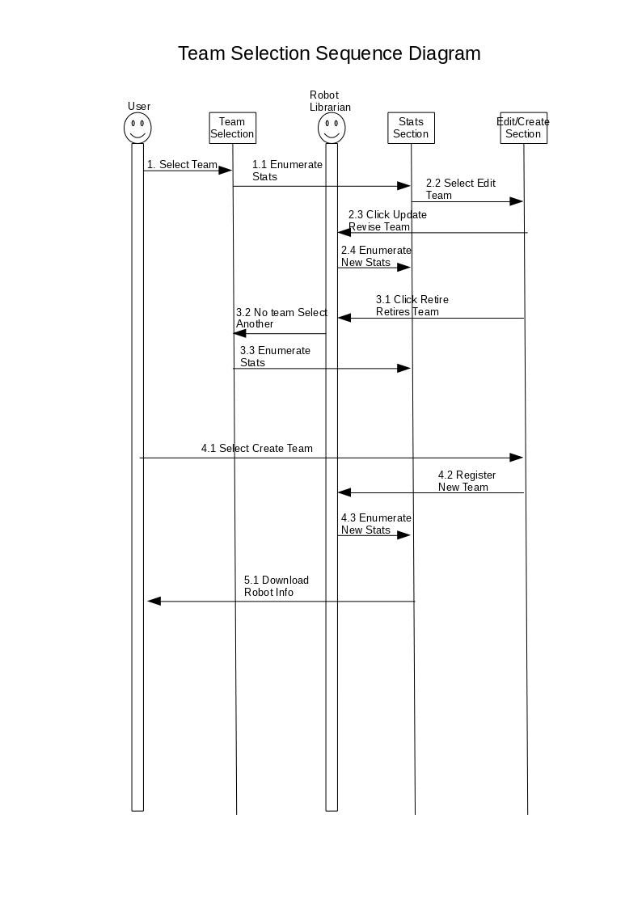

This is the main menu interface. The “Begin” button take the user to the Game Properties sceen, “Help” brings up the game rules screen, and “Quit” exits the game.

The Help Section screen displays the rules of the game and a link to a website for troubleshooting. The “Back” button returns to the main menu, and “Quit” exits the game.

In the Game properties interface, the user will be able to choose how many team will be participating. They will then choose how many of those teams will be played by humans. If the user chose three players, they will then get to choose if the board size will have five or 7 spaces on each side.

The user is able to choose which teams will play in the game. They will also be able to add a new team, and retire an existing team. The "Back" button takes the user back to the game properties, the "Quit" button exits the game, the "Continue" button takes the user to the game

This is the game screen. It displays each teams robots remaining and each robots health remaining. When it is a human teams turn, it shows the robot they can move, along with how many moves it has left. It also has a “Help” button to display the rules screen, and a “Quit” button to exit the game.

The winner of the game is displayed as well as 3 buttons. The "Play Again" button starts up a new game with the same amount of human teams, and AI teams. The "Stats" button takes the user to the stats screen and the "Quit" button exits the game

This is the end game stats screen. It displays each teams wins, losses, ties, scout kills, sniper kills, and tank kills The "Play Again" button starts up a new game with the same amount of human teams, and AI teams. The "Quit" button exits the game

