

**ESKİŞEHİR TECHNICAL UNIVERSITY**

**FACULTY OF ENGINEERING**

**DEPARTMENT OF COMPUTER ENGINEERING**

BIM209

PRINCIPLES OF SOFTWARE DESING AND DEVELOPMENT

**TERM PROJECT**

**REPORT**

Submitted to: Dr. Öğr. Üyesi Zeynep Batmaz

Due Date: 26.12.2023

Group No: G3

Project Description: Recipe Website (EasyRecipes)

|  |  |  |  |
| --- | --- | --- | --- |
|  | Student Id | Name Surname | Contribution |
| 1 | 12515187190 | Burak EVREN | Front-End, Report |
| 2 | 17164124848 | Buğra Eren BULGAY | Back-End, Test Cases |

**REQUIREMENTS**

1. We need a multifunctional search tool that provides users with the ability to search for recipes based on ingredients, dietary needs (vegan, gluten free, vegetarian), meal type and preparation time.
2. Recipes should be presented to the user on the main page.
3. Recipes should contain information about the meal.(such as nutritional information, calorie count)
4. Recipes should include an image which shows the final product.
5. There should be an interface for users to input their recipes step by step. It should allow text entry for each step, a list of ingredients, measurement units, and timing details.
6. Users should have the option to add visual content to their recipes.

**Following functions couldn’t make to the final product:**

1. Recipes should have a button for downloading the recipe.
2. If the user doesn’t know the nutritional details of their recipes. The system should automatically calculate the accurate value of given ingredients. The user can review and make changes to these values.
3. There should be a segment for selecting ingredients and the website should recommend some recipes according to the given ingredients.

**Following functions added additionally in the production phase:**

* 1. There should be three main cuisine options (Asian, European, American) and buttons to redirect users to the related cuisine searches. **(New Requirement 7)**
  2. There are a popular picks and vegetarian options presented to the user on the main page. **(New Requirement 8)**
  3. When the user clicks to site name, user should be redirected to the main page.

**(New Requirement 9)**

**USE CASES**

1. **User Wants to Search for a Recipe:**
   1. The user enters our website.
   2. The user uses the search tool to find a recipe based on desired criteria.
   3. The system lists suitable recipes and visually presents them to the user.
   4. The user selects and clicks on a recipe from the list.
   5. The system displays the details of the recipe, including information about the dish, calories and nutritional values, images, and step-by-step instructions.
   6. User exits the website.
2. **User Wants to Add Their Recipe:**
   1. The user enters our website.
   2. The user goes to the recipe adding interface.
   3. The user enters the recipe name, category, portion size, preparation, and cooking times.
   4. The user enters the ingredients and their measurements.
   5. The user inputs the step-by-step instructions for the recipe.
   6. The user enters the calorie and nutritional values of the recipe.
   7. If the user wants to add a picture to the recipe, they use the file upload option.
   8. The user clicks a button to save the recipe. The system saves the recipe in the database and directs the user to the main page.
   9. User exits the website.
3. **User Selects Recipe from the Popular Picks (New Case with Alternate)**
   1. The user enters our website.
   2. The user selects a recipe from the popular picks section.
   3. The system presents picked recipe in visually satisfying way.
   4. The user clicks the site name to redirected to the main page.

4.1 The user does not click the site name and instead clicks the one of the cuisine buttons.

4.2 The user redirected to the related cuisine searches page.

4.3 The user selects a recipe.

4.4 The user can click the site name to redirected to the main page.(Goes Step 5)

4.4.1 The user does not click the site name and instead clicks the one of the cuisine buttons.(Goes Step 4.1)

* 1. The user directed to home page for additional recipe search.
  2. User exits the website.

**USE CASE GENERAL ANALYSIS**

**Blue: Nouns Red: Verbs**

**CASE 1**

**Clear Value:** User enters the website with the intention of finding a suitable recipe.

**Start Condition:** The user enters the website. (Step 1)

**Stop Condition:** User exits the website. (Step 6)

**External Initiator:** User

* 1. The user enters our website.
  2. The user uses the search tool to find a recipe based on desired criteria.**(REQUIREMENT 1)**
  3. The system lists suitable recipes and visually presents them to the user.**(REQUIREMENT 2)**
  4. The user selects and clicks on a recipe from the list.
  5. The system displays the details of the recipe, including information about the dish, calories and nutritional values, images, and step-by-step instructions.**(REQUIREMENT 3)**
  6. User exits the website.

**CASE 2**

**Clear Value:** User enters the website with the intention of adding a new recipe.

**Start Condition:** The user enters the website. (Step 1)

**Stop Condition:** User exits the website. (Step 9)

**External Initiator:** User

* 1. The user enters our website.
  2. The user goes to the recipe adding interface. **(REQUIREMENT 5)**
  3. The user enters the recipe name, category, portion size, preparation, and cooking times.**(REQUIREMENT 5)**
  4. The user enters the ingredients and their measurements.**(REQUIREMENT 5)**
  5. The user inputs the step-by-step instructions for the recipe.**(REQUIREMENT 5)**
  6. The user enters the calorie and nutritional values of the recipe.**(REQUIREMENT 5)**
  7. If the user wants to add a picture to the recipe, they use the file upload option to upload. **(REQUIREMENT 6)**
  8. The user clicks a button to save the recipe. The system saves the recipe in the database and directs the user to the main page.
  9. User exits the website.

**CASE 3**

**Clear Value:** User enters the website with the intention of finding a popular recipe he/she can try.

**Start Condition:** The user enters the website. (Step 1)

**Stop Condition:** User exits the website. (Step 6)

**External Initiator:** User

* 1. The user enters our website.
  2. The user selects a recipe from the popular picks section. **(REQUIREMENT 8)**
  3. The system presents picked recipe in visually satisfying way. **(REQUIREMENT 2)**
  4. The user clicks the site name to redirected to the main page. **(REQUIREMENT 9)**

4.1 The user does not click the site name and instead clicks the one of the cuisine buttons.

4.2 The user redirected to the related cuisine searches page. **(REQUIREMENT 7)**

4.3 The user selects a recipe.

4.4 The user can click the site name to redirected to the main page.(Goes Step 5) **(REQUIREMENT 9)**

4.4.1 The user does not click the site name and instead clicks the one of the cuisine buttons.(Goes Step 4.2) **(REQUIREMENT 7)**

* 1. The user directed to home page for additional recipe search. **(REQUIREMENT 2)**
  2. User exits the website.

**TEXTUAL ANALYSIS**

**VERBS**

* Enter
* Uses
* Find
* Based
* Lists
* Present
* Select
* Click
* Display
* Include
* Exit
* Go
* Want
* Use
* Input
* Add
* Upload
* Save
* Redirect
* Direct
* Search

**NOUNS**

* User
* Website
* Search Tool
* Criteria
* System
* Recipe
* List
* Detail
* Information
* Dish
* Calorie
* Nutritional Value
* Image
* Step-by-step Instructions
* Recipe Adding Interface
* Recipe Name
* Category
* Portion Size
* Preparation Time
* Cooking Time
* Ingredient
* Measurement
* Picture
* File Upload Option
* Database
* Main Page
* Popular Picks Section
* Site Name
* Cuisine Buttons
* Cuisine Searches Page

**USE CASE DIAGRAM**

Use cases can be described as follows:

* When user enters the website, he/she can choose one of the first column functions such as search recipes. When the user chooses one of the functions the app should direct them to a related page with its function shown as second column functions.
* When user chooses functions, database should provide the app with related information or update its own information.

**(Primary Actor: User, Secondary Actor: Database)**

**(Dashed Lines where <<include>> written)**

**(Solid Lines between actors and use cases)**

**UML DIAGRAM**

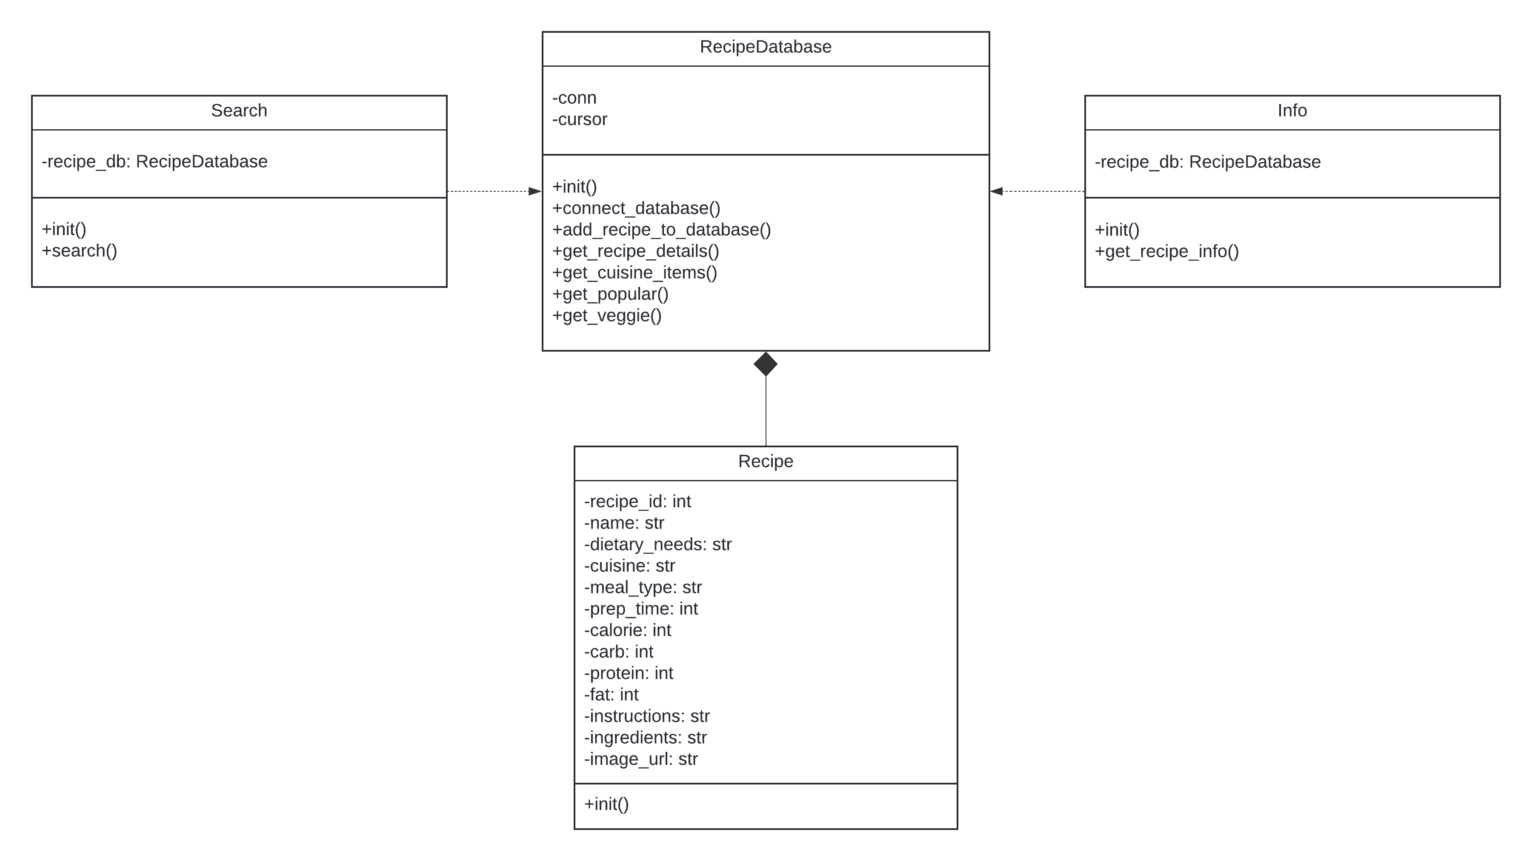

Relationship between our classes can be described as follows:

* RecipeDatabase and Recipe classes have composition relationship. RecipeDatabase fetches necessary information from the database and Recipe uses this information to store it inside of our application.
* Search and Info classes have dependency on RecipeDatabase class. Search and Info both utilize methods from the RecipeDatabase class to retrieve specific recipe information.

**(Between Search and RecipeDatabase There is Dashed Arrow)**

**(Between Info and RecipeDatabase there is Dashed Arrow)**

**(Between Recipe and RecipeDatabase there is Solid Arrow with Solid Diamond)**