Risk Management and Compliance Programme (RMCP)

DETAILS OF THE ORGANISATION:

Name of Accountable Institution: | {COMPANY_NAME}
Address (as registered): | {REG_ADDRESS}
goAML FIC registration number: | {GOAML_FIC_REG}
FIC Date of registration: | {FIC_REG_DATE}
Type(s) of Accountable Institution: | {ACCOUNTABLE_INST_TYPE}

POLICY ADOPTION:
Version: | v1.1
Publishing Date: | {SUBMIT_DATE}
Last Review Date: | 19 Jan 2026
Frequency on Review: | 12 months
Next Review Date: | 19 Jan 2027
Responsible Business Unit: | {BUSINESS_UNIT}
Responsible Persons Signature:

TABLE OF CONTENTS

Part I: Why we need to have a RISK MANAGEMENT approach in our business and HOW we go about setting up a COMPLIANCE PROGRAMME (RMCP)
- Purpose of the RMCP
- The Objective of the RMCP
- The reasons for implementing the RMCP
- How the RMCP is applied in the Business
- The role of a Risk Matrix in a RMCP
- Mechanisms to manage risk
- Where does customer due diligence fit into risk mitigation?
- Risk mitigation measures
- De-risking and avoiding risk

Part II: Who we are as a Business
Introduction to my RISK MANAGEMENT COMPLIANCE PROGRAMME (RMCP)

The RISK MANAGEMENT AND COMPLIANCE PROGRAMME (RMCP) consists of 10 Elements that every accountable institution must implement, in order to have an effective RMCP.

RMCP Element 1:
Description of the board of directors’ or senior management’s accountability and the appointment of a person with adequate seniority and experience to assist with ensuring compliance with the FIC Act:

- This is who we are, the Responsible Persons (Directors) of the Accountable Institution
- This is the Business, where it is located and where it operates
- Registration with FIC
- FIC Compliance Officer(s)

RMCP Element 2:
How the function to manage the establishment and maintenance of effective AML/CFT systems and controls will be discharged in the accountable institution:

- From a National Risk and Sectorial Risk perspective
- Sectorial Risk assessment includes, but is not limited to the following criteria as per FIC GN 7A
- These are the Accountable Institutions Policies in place as well as the Software packages used in the business operations to maintain control

RMCP Element 3:
Appropriate training on money laundering and terrorist financing to ensure that employees are aware of, and understand, their legal and regulatory responsibilities and their role in handling criminal property and money laundering/terrorist financing risk management

- This is WHO works for the Business and HOW the Staff are screened and trained
- Mechanisms used to screen the Accountable Institutions Staff
- When are our Staff screened
- Training intervals for board members, representatives and staff
- How the Accountable Institutions will train its board members, representatives and staff
- Evidence of training will be retained in the following manner
- DISCIPLINARY ACTION within the Accountable Institution
- Process of Escalation of non-compliance with RMCP or FIC Act within the Accountable Institution
- The following escalation of non-compliance process must be followed
- The following corrective measures must be adhered to

RMCP Element 4:
Appropriate provision of regular and timely information to the board of directors or senior management relevant to the management of the institution’s money laundering and terrorist financing risks.

- Impact of the Protection of Personal Information (POPI) Act, 2013 on the identification and verification requirements of the FIC Act
- As an Accountable Institution, we have appointed the following Compliance In-House Persons to be our POPI Information Officer

RMCP Element 5:
Appropriate documentation of the institution’s risk management policies and risk profile in relation to money laundering and terrorist financing, including documentation of the institution’s application of those policies.

- If the Accountable Institution belongs to Controlling Bodies and / or Regulatory Organizations, this is who they are
- In our Business, the RMCP forms part of our Governance and Risk Management Framework and therefore as an Accountable Institution, we have a duty in terms of the FIC Act
- The Accountable Institutions Inherent Risk to be associated with ML/TF activities is deemed to be
- The Accountable Institutions Residual Risk that remains, after the Inherent Risks mentioned above are considered, associated with ML/TF activities is deemed to be
- The AML/CFT policies, procedures and internal controls are designed to

RMCP Element 6:
Appropriate descriptions of decision-making processes in respect of the application of different categories of CDD and other risk management measures, including escalation of decision-making to higher levels of seniority in the accountable institution where necessary.

- The following decision-making processes are in place, with respect to the application of different categories of Customer Due Diligence (CDD) and other risk management measures
- Our commitment to the decision-making processes that are in place as well as the 'Living Document" called the RMCP, stems from the following objectives

RMCP Element 7:
"Appropriate measures to ensure that money laundering risks are taken into account in the day-to-day operation of the institution, including in relation to:
- The development of new products;
- The taking on of new clients; and
- Changes in the institution’s business profile"
- The organisation has adopted a risk-based approach with regards to performing CDD procedures
- In order for the Accountable Institution (the business) and its RMCP to be compliant with the Customer Due Diligence process, STEPS 1 to 5 need to be understood and actioned by the business.

STEPS 1 to 5 are as follows:
- As an Accountable Institution, we understand WHAT a Business Relationship is and a Single Transaction Threshold, Anonymous clients and Clients acting under a false or fictitious names
  - Business relationship
  - Single transaction threshold, Anonymous clients and Clients acting under a false or fictitious names
- As an Accountable Institution, we have the following understanding of Customer Due Diligence (CDD) and will implement the collection of our client’s information according to our risk rated scale of Simple Due Diligence (SDD) to Super Enhanced Due Diligence (SEDD), depending on the nature of the business relationship or single transaction
  - Our Customer due diligence (CDD) measures and controls
  - Types of Customer Due Diligence (CDD) information collected from potential client, existing client, persons acting on behalf of the client and or beneficial owners
  - The following processes will be followed when conducting CDD on the different types of potential clients, existing clients, persons acting on behalf of the client and beneficial owners
  - Risk Rating Scale
  - What is considered as Simplified Due Diligence (SDD)
  - Establishing and verifying the identities of natural persons
  - What is considered as Customer Due Diligence (CDD)
  - As an Accountable Institution, now that we have focused on HOW and WHAT our
  - Customer Due Diligence will include, we look at WHAT it means to establish verify Legal Person, Trusts and Partnerships:
  - Establishing the identity of Legal Persons (Companies and Close Corporations)
  - Establishing the identity of trusts
  - Establishing the identity of partnerships
  - What is considered as Super Enhanced Customer Due Diligence (EDD):
  - WHO or WHAT is a Domestic Politically Exposed Person (DPEP), Foreign
  - Politically Exposed Person (FPEP) & Prominent Influential Persons (PIP)
  - WHOM is considered a Family Member or Close Associate of a DPEP, FPEP or PIP
  - As an Accountable Institution, we accept and confirm
  - In the event that the Accountable Institution can NOT complete the Customer
  - Due Diligence process
- Avoiding Transactions and Business Relationships with Persons/Entities identified by the Targeted financial sanctions (TFS) List and United Nations Security Council
  - Targeted financial sanctions aimed at terrorist financing AND Targeted financial sanctions aimed at proliferation financing
  - Regarding the TFS lists and UN 1267 sanctions list, where a possible match is found, please follow the steps
  - This is how the accountable institution can screen clients on the FIC Website
  - Accessibility of sanctions list
- Timing of Customer Due Diligence (CDD) verification and concluding a business relationship or single transaction with a client
  - Reporting to FIC Centre (the how, when and what process explained)
- A suspicious and unusual transaction report can be divided into 4 types of reports
  - What is considered Suspicious or Unusual in order to file a Suspicious or Unusual Transaction Report to FIC?
  - What is considered Terrorist Property in order to file a Terrorist Property Report to FIC?
  - What does FIC mean by Freezing of Property?
  - The following process must be followed to identify reportable transactions
  - The Accountable Institution must keep written findings of decisions taken on whether to report or not to report.
  - Record-keeping for FIC
  - Do not share the FIC report information with anyone (tipping off) …
  - Do not be afraid to submit a report to FIC…

RMCP Element 8:
The nature and extent of an accountable institution’s internal systems and controls which form part of its RMCP depends on a variety of factors, including:
- The nature, scale and complexity of the accountable institution’s business;
- The diversity of its operations, including geographical diversity;
- Its client, product or services profile;
- Its distribution channels;
- The volume and size of its transactions; and
- The degree of risk associated with each area of its operation"
- Account monitoring
- Record-keeping for the Accountable Institution:
- Obligation to keep transaction records
- Manner in which records must be kept
- Commercial third-party services, or intra-group centralised data storage details and location

RMCP Element 9:
It is important that the content of an accountable institution’s RMCP is communicated widely throughout the institution, as may be applicable, to increase the effectiveness of its implementation
- Ongoing Due Diligence measures (ODD)

RMCP Element 10:
An accountable institution must review its RMCP at regular intervals to ensure that it remains relevant to the institution’s operation and the risks identified

Part III: Acceptance of the RMCP and Signing off an approved and implemented RMCP
DECLARATION

Acknowledgements

FIC REVISED GUIDANCE NOTE 7A - ON THE IMPLEMENTATION OF VARIOUS ASPECTS OF THE FINANCIAL INTELLIGENCE CENTRE ACT, 2001 (ACT 38 OF 2001)
Hereafter referred to in this RMCP document as FIC GN 7A

FIC PUBLIC COMPLIANCE COMMUNICATION No 53 - ON THE RISK MANAGEMENT AND COMPLIANCE PROGRAMME IN TERMS OF SECTION 42 OF THE FINANCIAL INTELLIGENCE CENTRE ACT, 2001 (ACT 38 OF 2001) FOR DESIGNATED NON-FINANCIAL BUSINESSES AND PROFESSIONS
Hereafter referred to in this RMCP document as FIC PCC No.53

DIRECTIVE 01/2013 - UPDATING OF REGISTRATION INFORMATION OF ACCOUNTABLE AND REPORTING INSTITUTIONS
DIRECTIVE 02/2014 – The use of login credentials following registration with the FIC
DIRECTIVE 3A – Notification of failure to report as required by the Financial Intelligence Centre in terms of the Financial Intelligence Centre Act
DIRECTIVE 04/2016 – UPDATING OF REGISTRATION RELATED INFORMATION TO ACCESS THE NEW REGISTRATION AND REPORTING PLATFORM OF THE FINANCIAL INTELLIGENCE CENTRE
DIRECTIVE 5/2019 - THE USAGE OF AN AUTOMATED TRANSACTION MONITORING SYSTEM FOR THE DETECTION AND SUBMISSION OF REGULATORY REPORTS TO THE FINANCIAL INTELLIGENCE CENTRE IN TERMS OF SECTION 29 OF THE FINANCIAL INTELLIGENCE CENTRE ACT, 2001 (ACT NO. 38 OF 2001)
DIRECTIVE 6 of 2023 - Submission of a risk and compliance return to the Financial Intelligence Centre by specified accountable institutions that are designated non-financial businesses and professions
DIRECTIVE 7 of 2023 - Submission of a risk and compliance return to the Financial Intelligence Centre by specified accountable institutions
DIRECTIVE 8 of 2023 - SCREENING OF EMPLOYEES FOR COMPETENCE AND INTEGRITY AND SCRUTINISING OF EMPLOYEE INFORMATION AGAINST APPLICABLE TARGETED FINANCIAL SANCTIONS LISTS AS A MONEY LAUNDERING, TERRORIST FINANCING AND PROLIFERATION FINANCING CONTROL MEASURE
DIRECTIVE 9 - concerning the implementation of the “Travel Rule” relating to crypto asset transfers in accordance with the Financial Action Task Force Recommendations

Part I: Why we need to have a RISK MANAGEMENT approach in our business and HOW we go about setting up a COMPLIANCE PROGRAMME, known as the RMCP:

The Purpose of the RMCP

"A country’s measures to combat money laundering and terrorist financing work effectively if the financial system in that country is transparent (based on robust customer due diligence measures) to ensure that adequate information is captured in the records of financial and other institutions and to make the sharing of information that may support further investigation of money laundering and terrorist financing possible. The purpose of the FIC Act, among others, is to introduce this transparency in the South African financial system. FIC GN 7A"

This is where we show FIC that our business, as an Accountable Institution, understands what Money Laundering (ML) and Terrorist Financing (TF) means and what it entails. We then go further and show FIC, how we the business and deemed accountable institution understand the risk of being exposed to Money Laundering (ML) and Terrorist Financing (TF) and what processes we have put in place to protect the business from being misused in the facilitation of Money Laundering (ML) and Terrorist Financing (TF), known as the “ML/TF risk”

“Accountable institutions” compliance with the regulatory requirements of the FIC Act contributes to making it more difficult for criminals to hide their illicit proceeds in the formal financial sector and thereby profiting from their criminal activities and cutting off the resources available to terrorists. FIC GN 7A"

The Objective of the RMCP

"The FIC Act incorporates a risk-based approach to compliance elements such as customer due diligence (CDD) into the regulatory framework. A risk-based approach requires accountable institutions to understand their exposure to money laundering and terrorist financing risks. By understanding and managing their money laundering and terrorist financing risks, accountable institutions not only protect and maintain the integrity of their businesses but also contribute to the integrity of the South African financial system. FIC GN 7A"

The reasons for implementing the RMCP

What is money laundering? | "Money laundering is the manipulation of money or property in order to disguise its true source. In order to benefit from the proceeds of unlawful activity, criminals must conceal the origins of these funds. This is the process of money laundering. The result of a successful money laundering scheme is that proceeds from an underlying unlawful activity are no longer associated with the activity. Unlawfully acquired proceeds therefore appear to be legitimate income. FIC GN 7A"
What is financing of terrorism? | "The financing of terrorism involves the solicitation, collection and the providing of funds and other assets with the intention that it may be used to support terrorist acts, terrorist organisations or individual terrorists. The funds and assets may stem from both legal and illicit sources. The primary goal of persons involved in the financing of terrorism is not to conceal the sources of the funds and assets, as with money laundering, but to conceal both the financing and the nature of the activity being financed. FIC GN 7A"
What is Risk? | "Risk refers to the likelihood and impact of uncertain events on set objectives. The impact can be either a positive or negative deviation from what is expected. This uncertainty is a function of three factors: threat, vulnerability and consequence. The context of this is important. For example, “threat" or “consequence” to whom or what. FIC GN 7A"  "A threat - is a person or group of people, object or activity with the potential to cause harm. On the other hand, vulnerability could arise from external and internal factors and may be either controllable or uncontrollable. The concept of vulnerabilities comprises those things that can be exploited by the threat or that may support or facilitate its activities. Identifying vulnerabilities, as distinct from threats, means focusing on, for example, the factors that represent weaknesses or features that may be exploited in a given system, institution, product, service etc. Consequences refer to the impact of a threat or the exploitation of a vulnerability if this impact is to materialise. FIC GN 7A"
What are Inherent and Residual Risks? | "Inherent risk is the risk of an event or circumstance that exists before controls or mitigation measures are applied by the accountable institution. FIC GN 7A"  "Residual risk is the level of risk that remains after controls and mitigation measures were implemented by the accountable institution. FIC GN 7A"

"The FIC Act requires an accountable institution to apply a risk-based approach when carrying out customer due diligence (CDD) measures. FIC GN 7A"

According to the Financial Intelligence Centre’s (FIC) webinar hosted on the 26 June 2025, regarding the elements of an effective RMCP:
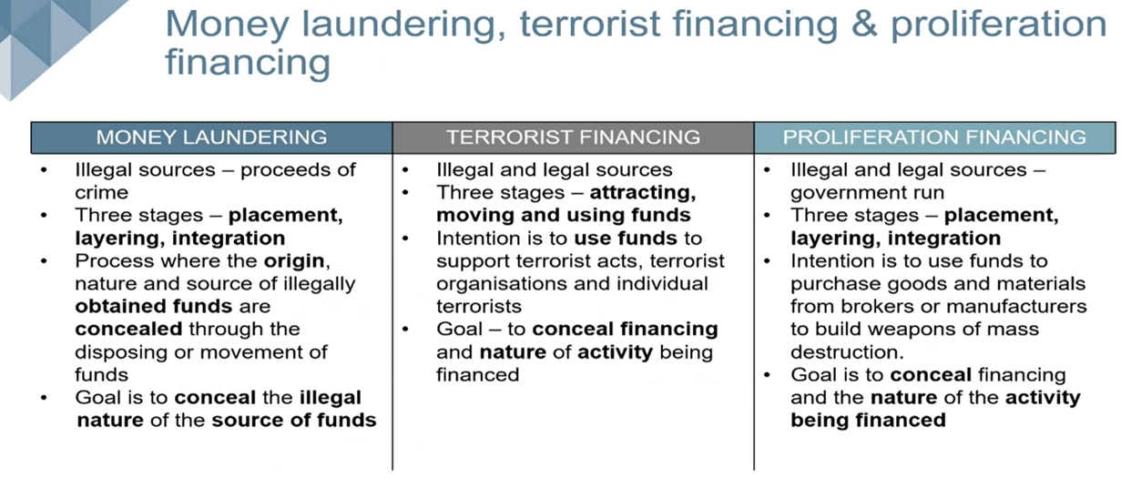

How the RMCP is applied in the Business

 | "In order to have a robust ML/TF risk management system, an accountable institution must be able to demonstrate how they contextualise the concepts of “ML/TF risk” within their particular businesses as having an impact on their operational, line management and strategic objectives. FIC GN 7A"
 | "ML/TF risk management is a process that includes the identification of ML/TF risks, the assessment of these risks, and the development of methods to manage and mitigate the risks that have been identified.  According to ISO 31000: 2009 (International Organization for Standardization), risk may be managed or dealt with, as follows:  - Avoiding the risk by deciding not to start or continue with the activity that gives rise to the risk;  - Accepting or increasing the risk in order to pursue an opportunity;  - Removing the risk source;  - Changing the likelihood;  - Changing the consequences;  - Sharing the risk with another party or parties (including contracts and risk financing);  - Retaining the risk by informed decision. FIC GN 7A"
 | "Accountable institutions must document the risk-rating methodology and procedures which they apply as well as the conclusions reached through the processes in the accountable institution’s RMCP. This includes the criteria and the intervals for the re-evaluation of risk-ratings. FIC GN 7A"
 | "An accountable institution’s risk appetite is a key determining factor in relation to its risk management decisions, in particular the extent to which it will apply resources to treat (mitigate) risks, the extent to which it may tolerate certain risks and the instances when it will avoid or terminate risks. An accountable institution’s risk appetite can also differ in relation to different types of risk (e.g. money laundering risk as opposed to terrorist financing risk) or risks arising in different contexts. FIC GN 7A"
 | "Treating ML/TF risk entails that the accountable institution develops systems and controls to manage the risks identified. These systems and controls should comprise of all the relevant risk mitigation measures at the accountable institution’s disposal. The mechanisms which an accountable institution may include in its risk management systems and controls should relate to the nature of particular risks. These mechanisms include the application of customer due diligence measures, the monitoring of business relationships with clients, managing delivery channels for particular products and services, structuring the features of particular products and services, etc. FIC GN 7A"  "The mechanisms used in a particular accountable institution to assess ML/TF risk must be proportionate to the size and complexity of the institution. The risk assessment process therefore might be quite simple or very sophisticated depending on the size and structure of the accountable institution and the nature and range of products and services it offers. FIC GN 7A"  "Accountable institutions may have access to and may use various databases to assess the ML/TF risks relating to their clients. FIC GN 7A"
 | "The process to manage ML/TF risk is a continuous cycle. Accountable institutions should satisfy themselves that their ML/FT risk management systems and controls remain adequate in view of changing circumstances relating to emerging threats and vulnerabilities, product innovations, new target markets, changes in circumstances of individual clients or classes of clients, etc. FIC GN 7A"
 | "Accountable institutions should also ensure that their ML/FT risk management systems and controls are adhered to within that institution. FIC GN 7A"
 | "The context within which accountable institutions assess ML/TF risks is also influenced by ML/TF risks that are identified at a national level in all the jurisdictions where they operate. Accountable institutions should therefore determine in their risk assessment processes what weight they give to risks identified at national level in the relevant jurisdictions where they operate. FIC GN 7A"  "The sources of information on risk indicators and the processes for their consideration should be described in an accountable institution’s Risk Management and Compliance Programme (RMCP). FIC GN 7A"
 | "Factors that may be indicative of ML/TF risks relate to a number of aspects such as product or service features, delivery channels, geographic areas, etc. and each of these may interact differently with the characteristics of different types of clients. FIC GN 7A"
 | ML/TF risk indicators:  - Indicators relating to products and services - examples on Page 16 and 17/76 FIC GN 7A  - * Indicators relating to delivery channels - examples on Page 17 and 18/76 FIC GN 7A
 | "The delivery channel refers to the means by which institutions and clients interact with each other in the offering of products and services, on-boarding of clients and the usage of products and services. FIC GN 7A"  - Indicators relating to geographic locations - examples on Page 18 and 119/76 FIC GN 7A
 | "...it is necessary that the institution have a holistic view of the information gathered about the client across all the points of engagement between the institution and the client. This implies that an accountable institution which offers a range of products and services should consider the different engagements with a particular client in relation to different products and services as component parts of one relationship with that client and assess the ML/TF risks relating to that relationship in a holistic manner. FIC GN 7A"
 | 'An assessment of ML/TF risks relating to clients could entail an assessment for each individual client or for groups of clients fitting the same profile. FIC GN 7A"  - Other factors - examples on Page 21/76 FIC GN 7A  "These are contextual factors which, on the one hand, may contribute to a more accurate assessment of ML/TF risks in relation to particular business relationships or categories of relationships, or assist in determining an institution’s risk appetite in relation to particular business relationships or categories of relationships, on the other. FIC GN 7A"  "Accountable institutions should reassess ML/TF risks, in particular residual risks after the application of ML/FT risk management systems and controls, at regular intervals. FIC GN 7A"

The role of a Risk Matrix in a RMCP

"The assessment of ML/TF risk should ultimately draw together all the factors that are relevant to an engagement with a client. A risk matrix could serve as a tool to provide an objective basis to the assessment of several risk indicators. A risk matrix may be made up of different components in order to evaluate a particular client, transaction, product or service in its entirety. FIC GN 7A"

"Risk mitigation in the context of ML/TF refers to the activities and methods used by an accountable institution to control and minimise the ML/TF risks it has identified. FIC GN 7A"

"Whether a particular risk is adequately addressed, will be determined by whether the level of residual risk is acceptable and within the risk appetite of the accountable institution. FIC GN 7A"

"Accountable institutions must establish and implement systems and controls in response to the assessed risks. These controls must be designed to detect money laundering and terrorist financing and respond appropriately when risks materialise. FIC GN 7A"

Risk Matrix  "The systems and controls by which an institution decides to manage ML/TF risks and the levels of due diligence it chooses to apply in relation to various risk levels must be documented in its RMCP. *Mechanisms to manage risk may include but are not limited to: Systems, policies and procedures - to be included in the RMCP; Awareness training of staff; Reporting channels; Client analytics; Process to exit from high risk relationships; Approval procedures for higher risk transactions and relationships; Adequate supervision for higher risk activities; and Screening tools. FIC GN 7A" | Low | "Where the ML/TF risks are assessed as lower, simplified measures may be applied. This means that controls must include certain CDD measures, but that the degree, frequency and/or the intensity of the controls conducted will be relatively lighter. FIC GN 7A" | "Accountable institution’s systems and controls may allow for less information to be obtained, less secure confirmation of information to be applied and less frequent scrutiny to be conducted where they assess the risk of  abuse to be lower. This is referred to as simplified due diligence. FIC GN 7A"
 | HIGH | "Where there are higher ML/TF risks, enhanced measures must be taken to mitigate those risks. This means that the range, degree, frequency or intensity of preventive measures and controls conducted will be stronger in higher risk scenarios. FIC GN 7A" | "An accountable institution’s systems and controls should provide for more information to be obtained about their clients, more secure confirmation of clients’ information to be applied and closer scrutiny to be conducted to their clients’ transaction activities where they assess the risk of abuse to be higher. This is referred to as enhanced due diligence. FIC GN 7A"



Risk Rating Scale
Identified ML/TF/PF Risk | # | Client Due Diligence Procedure
Low ML/TF/PF Risk | 1 | (SDD): Simplified CDD Procedure
Medium ML/TF/PF Risk | 2 | (CDD): CDD Procedure
Medium to High ML/TF/PF Risk | 3 | (EDD): Enhanced CDD Procedure
High ML/TF/PF Risk | 4 | (SEDD): Super Enhanced CDD Procedure
Annually / Account monitoring / A change in client transaction patterns was detected |  | (ODD): On-Going CDD Procedure

"A risk scale should be tailored according to the size of the accountable institution and consideration may be given to criteria set out in international best practice. The complexity of the risk scale should reflect the size and complexity of the accountable institution and the nature and the range of products and services it offers to its clients. FIC GN 7A"

"Risk-rating implies assigning different categories to different levels of risk according to a risk scale and classifying the ML/TF risks pertaining to different relationships or client engagements in terms of the assigned categories. FIC GN 7A"

"Accountable institutions offering a relatively homogenous range of products and services, using a limited range of delivery channels, operating in one or a few geographic location(s) or engaging with a homogenous range of clients require relatively simplistic risk scales distinguishing only between two or three risk categories. However, accountable institutions offering a more diverse range of products and services, using a wider range of delivery channels, operating in a larger number of geographic locations or engaging with a more diverse range of clients require more finely calibrated risk scales distinguishing between a larger number of risk categories. FIC GN 7A"

"The systems and controls by which an institution decides to manage ML/TF risks and the levels of due diligence it chooses to apply in relation to various risk levels must be documented in its RMCP. FIC GN 7A"

"An accountable institution should always have grounds on which it can base its justification for a decision that the appropriate CDD procedures chosen and the balance that was struck in a given client circumstance. FIC GN 7A"

"The ML/TF risk associated with a particular client engagement is not static. The factors underlying any given risk-rating will inevitably change over time. It is therefore essential that accountable institutions re-evaluate the relevance of particular risk factors and the appropriateness of previous risk-ratings from time to time and determine the intervals at which this will be done. FIC GN 7A"

Mechanisms to manage risk

"The risk-based approach is not a “zero failure” approach as there may be instances where an accountable institution has taken all reasonable measures to identify and mitigate ML/TF risks, but it is still exploited for money laundering or terrorist financing purposes. It is important that each institution has adequate detection and reporting measures in place to address ML/TF risks. FIC GN 7A"

"Systems, policies and procedures - to be included in the RMCP as per FIC GN 7A;
- Awareness training of staff;
- Reporting channels; Process to exit from high risk relationships;
- Approval procedures for higher risk transactions and relationships;
- Adequate supervision for higher risk activities; and
- Screening tools;
- Client analytics; Avoiding the risk by deciding not to start or continue with the activity that gives rise to the risk;
- Accepting or increasing the risk in order to pursue an opportunity;
- Removing the risk source;
- Sharing the risk with another party or parties (including contracts and risk financing."

Where does customer due diligence fit into risk mitigation
"Institutions should use the customer due diligence process as one of the measures to mitigate the ML/TF risk associated with a proposed business relationship or single transaction. The customer due diligence process provides an accountable institution with the information required to know who they are doing business with, to know who benefits from the business it does with its clients, to understand the nature of the business it does with its clients and to determine when the business with clients should be considered suspicious or unusual. This is one of the mechanisms at accountable institutions’ disposal to mitigate the risk of exploitation for money laundering or terrorist financing purposes. FIC GN 7A"

Risk mitigation measures
"Measures that may be applied in cases of higher ML/TF risk as per FIC GN 7A:
- Increased automated transaction monitoring;
- Increased intensity of CDD measures;
- Increased review periods of client information;
- Utilising more or higher quality sources for the vetting of information (impacts both quality and quantity);
- Senior management involvement in decisions to on-board clients;
- Dedicated specialist staff managing enhanced due diligence for specific clients;
- Limited reliance on another accountable institution’s controls (For example: have a contractual agreement in place with this other accountable institution, outlining these controls in place)"

De-risking and avoiding risk
"It should be noted that conducting high-risk activities or having high-risk business relationships is not prohibited anywhere in the FIC Act. Defining clients and products or services as high-risk does not cast a negative light on the accountable institutions nor on the clients and products and services. FIC GN 7A"

"Risk assessment does not imply that institutions should seek to avoid risk entirely (also referred to as de-risking), for example, through wholesale termination of client relationships for certain sectors. FIC GN 7A"

"The Centre views the wholesale termination or restriction of business relationships to avoid risk, rather than treat the risk, as an example of inadequate risk management. Instead, accountable institutions should take into account the level of ML/TF risk of each client and any applicable risk mitigation measures whether these are implemented by the financial institution or the client. Measures to mitigate risk should be applied accordingly. FIC GN 7A"

Part II: Who we are as a Business

Introduction to my RISK MANAGEMENT COMPLIANCE PROGRAMME (RMCP)
We recognize that our business is a Designated Non-Financial Businesses and Professions (the acronym is DNFBPs) and therefore, deemed an Accountable Institutions in South Africa. Since our business type is deemed a Designated Non-Financial Businesses and Professions (DNFBPs), this is where the RMCP comes into play.

"Accountable institutions must develop, document, maintain and implement a risk management and compliance programme (RMCP) for anti-money laundering (AML), counter-terrorist financing (CTF) and counter proliferation financing (CPF). The accountable institution’s RMCP documentation must record all the elements of the programme as set out in section 42 of the FIC Act. FIC GN 7A"

In our RMCP, we will explain to FIC that we understand what money laundering is, what terrorist financing and proliferation financing is and the associated risks that accompany these illegal activities, by demonstrating in our business RMCP and in practice what our customer due diligence process looks like as well as how we testing our new and existing clients names against the FIC Targeted financial sanctions (TFS) Lists published.

The RMCP outlines to FIC, HOW we will apply risk ratings to our clients and their business activities, by conducting risk appropriate customer due diligence on all our new and existing clients. The RMCP shows that you know who your client is (KYC) as well as the nature of the client’s business and what potential risk that client poses to your business. Further to that, by monitoring our clients activities or transactions between your organisation and your client, that appear suspicious in nature, must be quietly reported to FIC. Then FIC will tell you how to proceed with your client.

The RISK MANAGEMENT AND COMPLIANCE PROGRAMME (RMCP) consists out of 10 Elements that every accountable institution must implement, in order to have an effective RMCP

RMCP Element 1:
Description of the board of directors’ or senior management’s accountability and the appointment of a person with adequate seniority and experience to assist with ensuring compliance with the FIC Act:

This is who we are, the Responsible Persons (Directors / Members) of the Accountable Institution

Director 1
Capacity / Job Title | {DIR_TITLE}
Name & Surname {DIR2_NAME} | {DIR_NAME}
ID | {DIR_ID}
Income Tax Number | {DIR_TAX}
Start Date with Company | {DIR_START_DATE}
Married Y/N | {DIR_MARRIED}
Dependants | {DIR_DEPENDENTS}
Physical Address | {DIR_ADDRESS}
Cell phone Number | {DIR_CELL}
Email Address | {DIR_EMAIL}

Director 2
Capacity / Job Title {DIR2_TITLE}
Name & Surname
ID {DIR2_ID}
Income Tax Number {DIR2_TAX}
Start Date with Company {DIR2_START_DATE}
Married Y/N {DIR2_MARRIED}
Dependants {DIR2_DEPENDENTS}
Physical Address {DIR2_ADDRESS}
Cell phone Number {DIR2_CELL}
Email Address {DIR2_EMAIL}
Disclaimer
Where there are more than 2 Staff members (non-directors and non-key staff), their information needs to be created, maintained and kept on a separate annexure to this RMCP document, detailing all their information.

"The accountable institution’s board of directors, or senior management, or the person(s) with the highest authority must approve the RMCP and ensure compliance by the accountable institution and its employees with the provisions of the FIC Act and its RMCP. FIC GN 7A"

"The obligation to approve the RMCP and accountability of the board of directors, senior management, persons or group of persons with the highest authority of an accountable institution that is a legal person, cannot be delegated to other persons, groups of persons, employees, committees or structures within the accountable institution. The RMCP must be approved by the board of directors or senior management itself and cannot be delegated to any other persons. FIC GN 7A"

"An accountable institution that is a legal person must have a compliance function and assign a person with sufficient competence and seniority to assist the board of directors or senior management in complying with the FIC Act and their RMCP. An accountable institution that is not a legal person (except a sole proprietor) must appoint a person with sufficient competence as the compliance officer. FIC GN 7A"

"Where an accountable institution that is a legal person does not have a board of directors, the obligation for approval of the RMCP and accountability of the senior management or person or group of person(s) with the highest authority, cannot be delegated to other persons, employees, committees or structures within the accountable institution. FIC GN 7A"

"Where the accountable institution is a sole proprietor, the obligation for approval of the RMCP and accountability of the person(s) with the highest authority cannot be delegated to another person or group of persons. FIC GN 7A"

This is the Business, where it is located and where it operates

The business, named: {COMPANY_NAME} is an Accountable Institution as set out in Schedule 1 of the Financial Intelligence Centre Act, 2001 (Act No 38 of 2001) as (“FICA”).

Juristic Person Details
CIPC Registered Name | {COMPANY_NAME}
CIPC Company Registration | {REG_NUMBER}
Company Start Date | {START_DATE}
Registered Address | {REG_ADDRESS}
Postal Address | {POSTAL_ADDRESS}
Income Tax Number | {TAX_NUMBER}
VAT Number | {VAT_NUMBER}
PAYE Number
Business Telephone Number | {COMPANY_PHONE}
Business Email | {COMPANY_EMAIL}
Business Website | {COMPANY_WEBSITE}
Banking Institution | {BANK_NAME}
Primary Bank Account Number | {ACCOUNT_NUMBER}
The organisation has been operating since
FIC Accountable Institution Business Description | {BUSINESS_DESC}
What services does your business render or offer to clients? | {SERVICES}
In which location does your business operate? | {LOCATION}
In which geographical areas does your business render its services? | {GEO_AREAS}

Registration with FIC
Firstly, you need to register with FIC. Just because you are deemed an Accountable Institution doesn’t mean that you are automatically registered with FIC! You actually have to go to the FIC Website and register yourself and your business.

In terms of DIRECTIVE 04/2016 – UPDATING OF REGISTRATION RELATED INFORMATION TO ACCESS THE NEW REGISTRATION AND REPORTING PLATFORM OF THE FINANCIAL INTELLIGENCE CENTRE
This directive is effective from the date of its publication in the Government Gazette1.
- Accountable and reporting institutions that are successfully registered with the Centre as at 07 March 2016, must update their registration related information by accessing the portal provided by the Centre at www.fic.gov.za, in order to access the new registration platform.
- Accountable and reporting institutions must utilise the entity registration identity (also referred to as an “Org ID”) received from the Centre to commence updating their registration related information. The updating of registration related information must commence at 08H00, on Wednesday, 30 March 2016 and be completed by 17H00 on Friday, 22 April 2016.
Registration is free and must be completed via the Centre’s online registration and reporting system called goAML, which is accessible via the website www.fic.gov.za.

Secondly, once you are registered with FIC, you need to login into the goAML site and complete the FIC online RISK AND COMPLIANCE RETURN (RCR) QUESTIONNAIRE. This allows FIC to understand your business, your business geographical location and the types of goods and services that your business offers.

In terms of DIRECTIVE 7 of 2023 - Submission of a risk and compliance return to the Financial Intelligence Centre by specified accountable institutions
This Directive applies to accountable institutions that are listed in items 11, 14, 20, 21 and 22 of Schedule 1 to the FIC Act.
- The completion of the risk and compliance return is compulsory for all accountable institutions specified in this Directive.
- Accountable institutions must answer all questions in the risk and compliance return questionnaire as specified in Annexure “A”.
- Accountable institutions must answer all questions based on its understanding of ML, TF and PF risks and its implementation of current risk-based controls in compliance with the obligations set out in the FIC Act.
- https://www.gov.za/documents/notices/financial-intelligence-centre-act-schedule-1-list-accountable-institutions

In terms of DIRECTIVE 6 of 2023 - Submission of a risk and compliance return to the Financial Intelligence Centre by specified accountable institutions that are designated non-financial businesses and professions.
This Directive applies to accountable institutions that are designated financial businesses and professions and as listed in items 1, 2, 3 and 9 of Schedule 1 to the FIC Act.
- The completion of the risk and compliance return is compulsory for all accountable institutions specified in this Directive.
- Accountable institutions must answer all questions in the risk and compliance return questionnaire as specified in Annexure “A”.
- Accountable institutions must answer all questions based on its understanding of ML, TF and PF risks and its implementation of current risk-based controls in compliance with the obligations set out in the FIC Act.
- https://www.gov.za/documents/notices/financial-intelligence-centre-act-schedule-1-list-accountable-institutions

Thirdly, the reason that all deemed Accountable Institutions must register on the FIC’s goAML system, a secure platform, is to be able to:
• Submit reports to FIC
• Update your Accountable Institution details with FIC
• Appoint an internal FIC Compliance Officer

FIC Compliance Officer(s)
The FIC Compliance Officer(s) is the person(s) tasked to ensure that the organisation complies with FIC and this RMCP. If there are more than one FIC Compliance Officer in your organisation, they need to have their OWN PROFILE and secure login details registered with FIC.

As an Accountable Institution, we have appointed the following Compliance In-House Persons to be our FIC Compliance Officer:

FIC COMPLIANCE OFFICER
Appointment Date | Name | Position
{FIC_OFFICER_DATE} | {FIC_OFFICER_NAME} | FIC Compliance Officer
Additional Information
- Individual’s seniority in the organisation
- Details regarding the formal appointment by the Board of Directors / Senior management / person exercising the highest level of authority
- Appointment letter
- The individual’s background and knowledge/training on FICA and FICA related aspects

In terms of FIC DIRECTIVE 01/2013 - UPDATING OF REGISTRATION INFORMATION OF ACCOUNTABLE AND REPORTING INSTITUTIONS

All registered accountable and reporting institutions must update their registration details by submitting the relevant information to the Centre electronically by means of the internet-based reporting portal referred to in Regulation 27A (4) of the Money Laundering and Terrorist Financing Control Regulations. No other means of submitting the relevant information to update registration details will be an acceptable manner of updating registration details.

"Failure to register with FIC or provide information pertaining to changes to the FIC Compliance Officer or Money Laundering Reporting Officer(s) ("MLRO") is regarded as being non-compliant in terms of Section 61A of the FIC Act (as ) and is subject to an administrative sanction. FIC GN 7A"

"The FIC Compliance Officer or Money Laundering Reporting Officer(s) (""MLRO"") will monitor any changes to the organisation’s business particulars and/or contact details which must be communicated to the FIC.
Where any of the organisation’s particulars are updated subsequent to the registration process, or the FIC Compliance Officer or Money Laundering Reporting Officer(s) (""MLRO"") information changes, these updated changes must be communicated with the FIC Centre within 5 days after such change. FIC GN 7A"

"The FIC Compliance Officer and the Money Laundering Reporting Officer(s) ("MLRO") will keep a record of their instructions to the FIC as well as any confirmation notifications received from the FIC. FIC GN 7A"

In terms of FIC DIRECTIVE 02/2014 – The use of login credentials following registration with the FIC

These login credentials may only be used by the person who originally registered them on the FIC system. No one else may use these login credentials to submit reports to the FIC, that are required in terms of the Financial Intelligence Centre Act No. 38 of 2001 (the FIC Act). If the individual no longer holds the position he /she held at the time of registration with the FIC, the accountable or reporting institution must ensure that new login credentials are obtained.

RMCP Element 2:
How the function to manage the establishment and maintenance of effective AML/CFT systems and controls will be discharged in the accountable institution:

From a National Risk and Sectorial Risk perspective, we, the organisation, recognise that our institution is one that has been classified as a type of institution that is more readily targeted by criminals for money laundering, terrorist financing and proliferation financing purposes:
Select accordingly:
- recognise that our institution is one that has been classified as a type of institution that is more readily targeted by criminals for money laundering, terrorist financing and proliferation financing purposes.
or
- recognise that our institution is one that has been classified as a type of institution that is not readily targeted by criminals for money laundering, terrorist financing and proliferation financing purposes.

Given the above selection, the Board of Directors and Senior Management are fully committed to comply with FIC’s regulatory requirements, in order to hinder criminals in implicating the organisation in criminal activities.

The organisation further understands that we have both a moral and ethical responsibility to play our part in combating crime, locally and internationally.

{COMPANY_NAME}
Sectorial Risk assessment includes, but is not limited to the following criteria as per FIC GN 7A:
- nature, scale, and complexity of the business
- geographical operation
- products and services
- client profile (including Source of Funds and Wealth) and
- distribution channel.

According to the Financial Intelligence Centre’s (FIC) webinar hosted on the 26 June 2025, regarding the elements of an effective RMCP:
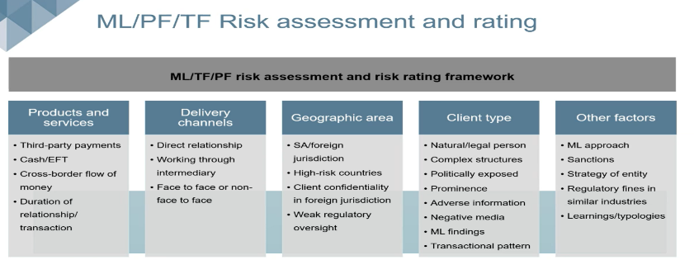

These are the Accountable Institutions Policies that are in place as well as the Software packages used in the business operations to maintain control:

Policies in Place: | Software Packages used in the business:
{POLICIES} | {SOFTWARE}
{OTHER_POLICIES} | {SOFTWARE_LIST}

RMCP Element 3:
Appropriate training on money laundering and terrorist financing to ensure that employees are aware of, and understand, their legal and regulatory responsibilities and their role in handling criminal property and money laundering/terrorist financing risk management.

This Risk Management and Compliance Programme (RMCP) forms part of the organisation’s internal business policies, processes and procedures. Therefore it is communicated and shared with all staff and personnel.
"The organisation’s Board of Directors, Senior Management and Employees are required to familiarise themselves with the RMCP and undertake to comply with the stated processes and procedures. Risk owners and control owners, namely Board of Directors, are responsible for overseeing and maintaining control procedures and activities of the business. FIC GN 7A"

"The RMCP shall be made available to every employee, and all employees shall receive appropriate ongoing FIC training as well as RMCP specific training on an annual basis.
All employees of the accountable institutions must comply with the procedures set out in the RMCP. Failure to do so may result in disciplinary action and the possibility of criminal sanctions. FIC GN 7A"

This is WHO works for the Business and HOW the Staff are screened and trained:
Staff Member 1:
Capacity / Job Title | {STAFF1_TITLE}
Name & Surname | {STAFF1_NAME}
ID | {STAFF1_ID}
Start Date with Company | {STAFF1_START_DATE}
Married Y/N | {STAFF1_MARRIED}
Dependants | {STAFF1_DEPENDENTS}
Physical Address | {STAFF1_ADDRESS}
Cell phone Number | {STAFF1_CELL}
Email Address | {STAFF1_EMAIL}

Staff Member 2:
Capacity / Job Title | {STAFF2_TITLE}
Name & Surname | {STAFF2_NAME}
ID | {STAFF2_ID}
Start Date with Company | {STAFF2_START_DATE}
Married Y/N | {STAFF2_MARRIED}
Dependants | {STAFF2_DEPENDENTS}
Physical Address | {STAFF2_ADDRESS}
Cell phone Number | {STAFF2_CELL}
Email Address | {STAFF2_EMAIL}
Disclaimer
Where there are more than 2 Staff members (non-directors and non-key staff), their information needs to be created, maintained and kept on a separate annexure to this RMCP document, detailing all their information.

In terms of DIRECTIVE 8 of 2023 - SCREENING OF EMPLOYEES FOR COMPETENCE AND INTEGRITY AND SCRUTINISING OF EMPLOYEE INFORMATION AGAINST APPLICABLE TARGETED FINANCIAL SANCTIONS LISTS AS A MONEY LAUNDERING, TERRORIST FINANCING AND PROLIFERATION FINANCING CONTROL MEASURE

This Directive is issued by the Financial Intelligence Centre (FIC) in terms of section 43A(1) of the Financial Intelligence Centre Act, 2001 (Act 38 of 2001) (the FIC Act.)

This Directive applies to all accountable institutions. - Accountable institutions must screen prospective employees and current employees for competence and integrity periodically, in a risk-based manner. - An accountable institution must scrutinise information concerning its prospective employees and current employees upon notice being given by the Director under section 26A(3) of the FIC Act, to determine whether any such prospective employee or current employee, is a person mentioned in the notice by the Director. - The accountable institution must provide for, and record, the manner in which screening for competence and integrity, as well as the manner in which scrutinising of employee information against targeted financial sanctions lists in terms of paragraph 2.3 and 2.4, will be conducted. - An accountable institution must keep a record of the outcome of the screening for competence and integrity as well as the scrutinising of employee information against targeted financial sanctions lists as required in terms of paragraph 2.3. and 2.4. - The records relating to both the manner and outcomes of the screening and scrutinising of employee information as required in terms of paragraph 2.5 and 2.6 must, on request, be made available to the FIC or a supervisory body which performs regulatory or supervisory functions in respect of that accountable institution.

Mechanisms used to screen the Accountable Institutions Staff:
{VETTING_MECHANISMS}

According to the Financial Intelligence Centre’s (FIC) webinar hosted on the 26 June 2025, regarding the elements of an effective RMCP:
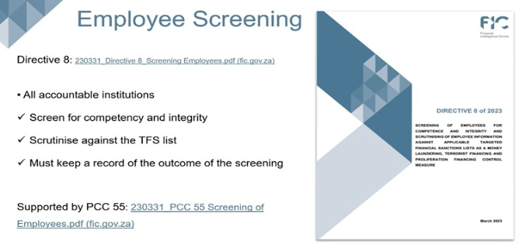

The organisation is dedicated in providing ongoing training to our employees to enable them to comply with the provisions of FIC and the RMCP.

Compulsory ongoing training on ML/TF/CF will be provided to ensure that employees are aware of and understand –
- their legal and regulatory responsibilities and their role in handling criminal property and ML/TF/PF risk management.
- the various stages of money laundering, how the financing of terrorism works and the impact of proliferation financing; and
- the contents of the RMCP.

The Accountable Institution: {COMPANY_NAME}

Training intervals for board members, representatives and staff are as follows:
Select accordingly
- On an ongoing basis.
- On induction of new employees: the training for new employees will be provided as part of the induction process, within 2 months of appointment.
- The organisation will ensure that adequate levels of training is provided to the board members, at least within 2 (two) months of taking up the role. Thereafter, training must be provided annually to ensure that the board members understand its responsibilities in terms of FIC, including the approval of the RMCP.
- Annually for all board members, representatives and staff

How the Accountable Institutions will train its board members, representatives and staff:
- Controlling Body CPD hours for good standing status
- In-house training on FICA
- FIC Webinars

Evidence of training will be retained in the following manner:
- Training registers or schedules will be kept ensuring that we can keep track of the training given and received, as well as presentations, and confirmation of attendance at FIC events.
- All board members, representatives and staff are required to sustain a minimum pass rate of 70%. The training will be as relevant changes in industry or procedure occur.
- An annual report will be issued to the organisation’s Board which includes details of any training conducted, any shortfalls or issues arising.

DISCIPLINARY ACTION within the Accountable Institution

Where a FIC related complaint or an investigation related to an infringement of FIC or the organisation’s RMCP has been finalised, the organisation may recommend any appropriate administrative, legal and/or disciplinary action to be taken against any employee reasonably suspected of being implicated in non-compliance.

Process of Escalation of non-compliance with RMCP or FIC Act within the Accountable Institution:

All instances of non-compliance with the Accountable Institutions’ RMCP or the FIC Act must be escalated to the directors, senior management/other persons exercising the highest level of authority, immediately upon becoming aware thereof.

The following escalation of non-compliance process must be followed:
Completion of an internal report of the transgression and submission thereof, to the FIC compliance officer via email.

The following corrective measures must be adhered to:
- In the case of ignorance or minor negligence by the employee, the organisation will undertake to provide further FIC Awareness training to the employee.
- In the case of gross negligence or the wilful non-compliance by the employee, this will be considered a serious form of misconduct for which the organisation may summarily dismiss the employee. Disciplinary procedures will commence where there is sufficient evidence to support an employee’s gross negligence.

Examples of immediate actions that may be taken subsequent to an investigation include:
- A recommendation to commence with disciplinary action.
- A referral to appropriate law enforcement agencies for criminal investigation.
- Recovery of funds and assets in order to limit any prejudice or damages caused.

RMCP Element 4:
Appropriate provision of regular and timely information to the board of directors or senior management relevant to the management of the institution’s money laundering and terrorist financing risks.

The RMCP document and processes will be reviewed at minimum on an annual basis, by the appointed FIC Compliance Officer and Board of Directors. If any changes are made to the RMCP, it will be signed off by the Board of Directors and communicated to all staff members.

A copy of this RMCP will be made available to the Financial Intelligence Centre (“FIC”) or any other regulatory body, upon request.

Impact of the Protection of Personal Information (POPI) Act, 2013 on the identification and verification requirements of the FIC Act.
The processing of personal information of clients for the purposes of the FIC Act compliance may only be done within the confines of the Protection of Personal Information Act, 2013 (the POPI Act). While the processing and further processing of personal information of a client for purposes of FIC Act requirements is allowed in terms of the (POPI Act), accountable institutions should be cautious of verifying clients’ identities using third party data sources which may have obtained personal information about a client without the client’s consent or knowledge.

The Duties and Responsibilities of the POPI Information Officer - In terms of section 55 of the POPI Act No. 4 of 2013:
(1) An information officer responsibility include:
(a) the encouragement of compliance, by the body, with the conditions for the lawful processing of personal information;
(b) dealing with requests made to the body pursuant to this Act;
(c) working with the Regulator in relation to investigations conducted pursuant to Chapter 6 in relation to this body;
(d) otherwise ensuring compliance by the body with the provisions of this Act; and
(e) as may be prescribed
(2) Officers must take up their duties in terms of this Act only after the responsibility party has registered them with the Regulator.

As an Accountable Institution, we have appointed the following Compliance In-House Person to be our POPI Information Officer:

POPI Information Officer
Appointment Date | Name | Position
{POPI_OFFICER_DATE} | {POPI_OFFICER} | POPI Information Officer
Additional Information
•Individual’s seniority in the organisation
•Details regarding the formal appointment by the Board of Directors / Senior management / person exercising the highest level of authority
•The individual’s background and knowledge / training on POPI and PAIA

- Please see link to register the POPI Information Officer: https://eservices.inforegulator.org.za/default.aspx

RMCP Element 5:
Appropriate documentation of the institution’s risk management policies and risk profile in relation to money laundering and terrorist financing, including documentation of the institution’s application of those policies.

If the Accountable Institution belongs to a Professional Body and / or Regulatory Organizations, please select where applicable:

Accounting Professional Body:
- Independent Regulatory Board of Auditors (IRBA)
- South African Institute of Chartered Accountants (SAICA)
- The Association of Chartered Certified Accountants (ACCA)
- South African Institute of Professional Accountants (SAIPA)
- Chartered Institute of Management Accountants (CIMA)
- Southern African Institute of Chartered Secretaries and Administrators (ICSA)
- South African Institute of Business Accountants (SAIBA)
- Institute of Certified Bookkeepers (ICB)
- Institute of Administration and Commerce (IACSA)
- Institute of Internal Auditors (IISA)
- South African Institute of Tax Professionals (SAITP)
Practice Number:
- Other:

Legal Professional Body:
- Law Society of South Africa (LSSA)
- Corporate Lawyers Association of South Africa (CLASA)
- General Council of the Bar (SABAR)
Practice Number:
- Other:

Property Professional Body:
- Property Practitioners Regulatory Authority (PPRA)
- Estate Agents Affairs Board (EAAB)
Practice Number:
- Other:

Financial Regulator:
- Financial Sector Conduct Authority (FSCA)
Practice Number
- Other:

Fraud Examiner Regulator:
- Associate of Certified Fraud Examiners (ACFE) Membership Number:

Government Regulators:
- South African Revenue Services (SARS)
PR Number: {SARS_PR_CODE}
- goAML FIC registration number: {GOAML_FIC_REG}
- Type of Accountable Institution: {ACCOUNTABLE_INST_TYPE}
- FIC Date of registration: {FIC_REG_DATE}
- Responsible Business Unit within your organisation: {BUSINESS_UNIT}

Additional Information:

In terms of DIRECTIVE 9 - concerning the implementation of the “Travel Rule” relating to crypto asset transfers in accordance with the Financial Action Task Force Recommendations. This Directive is issued by the Financial Intelligence Centre (Centre) in terms of section 43A (2) of the Financial Intelligence Centre Act, 2001 (Act 38 of 2001).
The purpose of this Directive is to ensure that accountable institutions that provide or engage in activities of crypto asset transfers, implement the requirements of Recommendation 16 of the Financial Action Task Force in the context of crypto asset transfers.
This Directive applies to accountable institutions listed in items 12 and 22 of Schedule 1 to the FIC Act that are ordering, intermediary or recipient crypto asset service providers, which facilitate or enable the origination or receipt of domestic and cross-border transfers of crypto assets or act as an intermediary in receiving or transmitting the crypto assets for or on behalf of a client.
* 4 - OBLIGATIONS OF ORDERING CRYPTO ASSET SERVICE PROVIDERS
* 5 - OBLIGATIONS OF INTERMEDIARY CRYPTO ASSET SERVICE PROVIDERS
* 6 - OBLIGATIONS OF RECIPIENT CRYPTO ASSET SERVICE PROVIDERS
* 7 - IMMEDIATE AND SECURE TRANSMISSION OF ORIGINATOR AND BENEFICIARY INFORMATION
* 8 - UNHOSTED WALLET TRANSFERS
* 9 - EFFECTIVE DATE AND NON-COMPLIANCE
This Directive comes into operation on 30 April 2025
A crypto asset service provider that fails to comply with a provision of this Directive is non-compliant and is subject to an administrative sanction in accordance with section 45C of the FIC Act.
Any additional Information that the Accountable Institution wishes to disclose in its RMCP:

According to the Financial Intelligence Centre’s (FIC) webinar hosted on the 29 September 2025, regarding the elements of an effective RMCP:

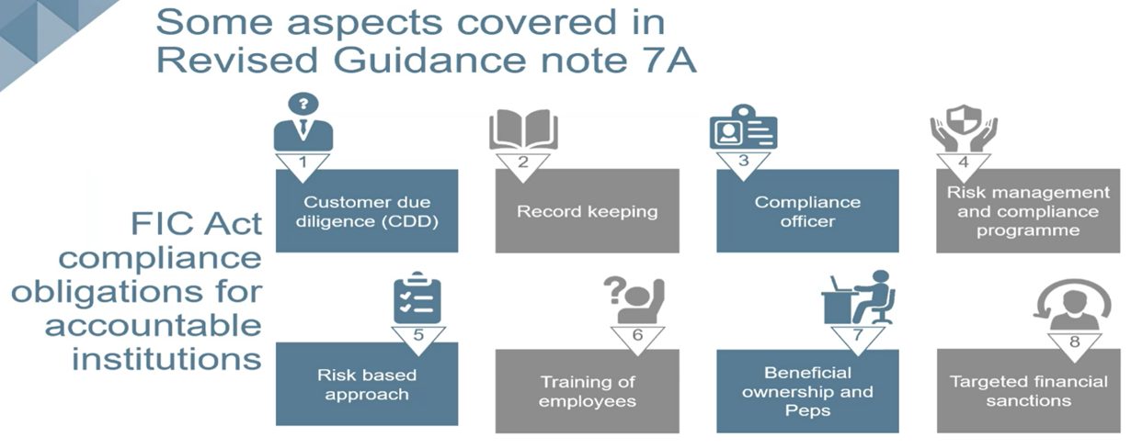
In our Business, the RMCP forms part of our Governance and Risk Management Framework and therefore as an Accountable Institution, we have a duty in terms of the FIC Act to:
- Register as an accountable institution with FIC (Obtain an ORG #)
- Ensure appropriate governance policy and measures are in place
- Develop, document, maintain and implement an anti-money laundering and counter-terrorist financing risk management and compliance programme (RMCP)
- Perform customer due diligence using a Risk-Based approach
- Run our clients against the Targeted Financial Sanctions List (TFS List)
- Determining whether our clients is a Politically exposed persons (PEP)
- Account Monitoring and Reporting where appropriate to FIC
- Record-keeping and maintaining these records
- Train all our staff regarding the RMCP and FIC
- If the Accountable Institution fails to comply with its duties in accordance with the FIC Act (as ) and Regulations, it will be regarded as being non-compliant and it will be subject to an administrative sanction. "

Y RISK IT (Pty) Ltd (prepopulates from INDEX page)
The business, as an Accountable Institution, is both Responsible and Accountable to its Board of Directors, its Representatives, its Staff, its Regulators and FIC. This commitment can be seen in our behaviour, actions and attitude towards the respective parties named, as well as the creation and implementation of our Risk Management and Compliance Program (RMCP).

Y RISK IT (Pty) LtdLevel of Identified ML/TF/PF Risk (prepopulates from INDEX page)

The Accountable Institutions Inherent Risk to be associated with ML/TF activities is deemed to be:
Select Risk Rating appropriate to your business
- Low ML/TF/PF Risk
- Medium ML/TF/PF Risk
- Medium to High ML/TF/PF Risk
- High ML/TF/PF Risk

Due to the following factors:
- It does not collect, hold, or receive money from clients in order to be paid over to third parties
- Its client base comprises primarily salaried employees, business owners and retirees (i.e., sources of funds are salary, business income and discretionary savings)
- Only has a local footprint and does not operate in foreign jurisdictions and
- Does not enter into single transactions and retains a professional business relationship with clients.
Other

Y RISK IT (Pty) Ltd Level of Identified ML/TF/PF Risk (prepopulates from INDEX page)

The Accountable Institutions Residual Risk that remains, after the Inherent Risks mentioned above are considered, associated with ML/TF activities is deemed to be:
Select Risk Rating appropriate to your business
- Low ML/TF/PF Risk
- Medium ML/TF/PF Risk
- Medium to High ML/TF/PF Risk
- High ML/TF/PF Risk

Due to the following factors:
- the implemented of our Risk Management and Compliance Program (RMCP) with the respective Controls Measure that are in place like;
- Client Due Diligence is done on all clients at inception and on client renewal;
- Customers Relations Management (CRM) System / Client Database System is used to onboard all our clients and these same clients are run against the FIC TFS List, PEP Lists;
- Inhouse monitoring of client’s monetary movements and record keeping;
- Due to our registration with FIC, our inhouse FIC Compliance Officer will notify FIC of any suspicious transactions and activities, immediately when it comes to his attention.
- Other

The AML/CFT policies, procedures and internal controls are designed to:
- ensure compliance with all applicable FIC legislation and
- will be reviewed and updated on a regular basis to ensure that appropriate policies, procedures and internal controls are in place to account for both changes in regulations and changes in our business.

RMCP Element 6:
Appropriate descriptions of decision-making processes in respect of the application of different categories of Customer Due Diligence (CDD) and other risk management measures, including escalation of decision-making to higher levels of seniority in the accountable institution where necessary.

The Control Owner can be any of the following persons in the business:
- Board of Directors / Members
- Business Owner
- Senior Management
- Appointed FIC Compliance Officer
- The Money Laundering Reporting Officer(s) ("MLRO")

The following Action / Activity / Process / Procedure for decision-making processes are in place, with respect to the application of different categories of Customer Due Diligence (CDD) and other risk management measures:
Action / Activity / Process / Procedure | Control Owner (Assign responsibility accordingly)
Review of the RMCP
Appointment of the FIC Compliance Officer(s)
Confirmation of FIC Registration
Monitoring changes to organisation’s registration particulars
Periodic Product and Service ML/TF/PF Risk Analysis
Review of the Client ML/TF/PF Risk Identification Criteria
Periodic screening of existing clients and employees against the Financial Intelligence Centre ("FIC") Targeted Financial Sanctions ("TFS") list
Submission and Record Keeping of Suspicious or Unusual Transaction Reports
Submission and Record Keeping of Terrorist Property Reports ("TPR")
Retention and Back-ups of Transaction Records
Retention and Back-ups of Client Due Diligence Records
Ensuring that employees undergo annual FIC Awareness Training
Periodic review of Senior Management Client Approval Procedure
Periodic review of Client Due Diligence Forms
Ongoing Due Diligence and Monitoring of Existing Business Relationships
Client random spot checks: FIC TFS List
Client random spot checks: False or Fictitious verification documents
Client random spot checks: DPEP or FPEP or PIP
Client random spot checks: Family or Associate of DPEP or FPEP or PIP
Internal Monitoring Compliance with Client Due Diligence procedure
Monitoring Compliance with Additional Information on a New Business Relationship

{COMPANY_NAME}
Our commitment to the decision-making processes that are mentioned above and are in place, together with our 'Living Document" called the RMCP, stems from the Accountable Institutions objectives, namely:
- To protect the integrity of the organisation through the continued management and monitoring of the organisation exposure to risk of being used by current or prospective clients to launder money, terrorist financing and proliferation financing risk (""ML/TF/CF risk"").
- To apply a risk-based approach to client transactions and to understand the purpose of all business relationships entered into with clients.
- To educate employees how to identify business relationships and transactions that pose a higher risk to money laundering, terrorist financing and proliferation financing.
- To implement robust Client Due Diligence procedures that will make it more difficult for criminals to hide the proceeds of unlawful activities.
- To submit to the FIC relevant reports concerning all transactions that are identified as being suspicious (STR), unusual (SAR) or above the prescribed cash threshold (CTR).
- To keep accurate records of all FIC related transactions and Client Due Diligence procedures.
- To prevent any reputational fallout or brand damage due to noncompliance with FIC and/or the organisation’s RMCP.
- To prevent any civil or criminal fines or penalties due to noncompliance with FIC and/or the organisation’s RMCP.
- To prevent loss of sales and client confidence due to noncompliance with FIC and/or the organisation’s RMCP.

RMCP Element 7:
Appropriate measures to ensure that money laundering risks are taken into account in the day-to-day operation of the institution, including in relation to:
- The development of new products or services;
- The taking on of new clients and monitoring existing clients;
- Changes in the institution’s business profile

"The organisation has adopted a risk-based approach with regards to performing CDD procedures. The risk-based approach allows the organisation’s employees to conduct proportionate levels of identification and verification activities depending on the ML/TF/PF risks that have been identified for each individual transaction. This procedure is a prerequisite prior to establishing a business relationship or single transaction and will provide us with the necessary confidence on the identification of clients. We will undertake CDD for each of our clients as specified in this RMCP and sufficient identification evidence must be obtained for both new and existing clients. The findings of the risk assessment will decide the appropriate level and type of CDD process to be followed. FIC GN 7A"

In order for the Accountable Institution, the business, and its RMCP to be compliant with the Customer Due Diligence process, STEPS 1 to 5 need to be understood and actioned by the business.

STEPS 1 to 5 are as follows:
- As an Accountable Institution, we understand WHAT a Business Relationship is and a Single Transaction Threshold, Anonymous clients and Clients acting under a false or fictitious names
- As an Accountable Institution, we have the following understanding of Customer Due Diligence (CDD) and will implement the collection of our client’s information according to our risk rated scale of Simple Due Diligence (SDD) to Super Enhanced Due Diligence (SEDD), depending on the nature of the business relationship or single transaction
- Avoiding Transactions and Business Relationships with Persons/Entities identified by the Targeted financial sanctions (TFS) List and United Nations Security Council
- Timing of Customer Due Diligence (CDD) verification and concluding a business relationship or single transaction with a client
- Reporting to FIC Centre (the how, when and what process explained)

To further understand and implement STEPS 1 to 5, the STEPS 1 to 5 are discussed in more detail below:

STEP 1:
As an Accountable Institution, we understand WHAT a Business Relationship is and a Single Transaction Threshold, Anonymous clients and Clients acting under false or fictitious names.

Business relationship
"A business relationship is defined in the FIC Act as an arrangement between a client and an accountable institution for the purpose of concluding transactions on a regular basis. A business relationship therefore entails an element of a time duration to the engagement with the client. FIC GN 7A"

"The manner and the point in time at which an accountable institution determines that a person is a prospective client or a client for the purposes of determining when the obligations of the FIC Act commences should be spelled out in an accountable institution’s RMCP, both in respect of a business relationship and a single transaction. The accountable institution should therefore determine, taking into account its particular business, who is to be regarded as a prospective client and client in order to apply the CDD and other requirements in terms of the FIC Act. FIC GN 7A"

"When establishing a business relationship, information on the source of funds, the nature of the client’s business, and the intended purposes of the business relationship must be obtained. This information is required regardless of the risk rating. FIC GN 7A"

"This information must be used by the Accountable Institution to determine whether future transactions that will be performed during the business relationship, are consistent with the institution’s knowledge of the client. FIC GN 7A"

Single transaction threshold, Anonymous clients and Clients acting under a false or fictitious names
"The FIC Act defines a single transaction as a transaction other than a transaction concluded in the course of a business relationship and where the value of the transaction is not less than R5 000.00 (the amount is determined by the Minister of Finance in the Regulations). This can be described as occasional or once-off business where there is no expectation on the part of the accountable institution or the client that the engagements would recur over a period of time. FIC GN 7A"

"Accountable institutions are not required to carry out the full scope of CDD measures in respect of clients conducting single transactions below the value to be set by the Minister of Finance in the MLTFC Regulations. However, the threshold for single transactions does not apply to the obligations set out in section 20A of the FIC Act. This means that, in spite of a single transaction being below the threshold, the accountable institution is still prohibited from dealing with an anonymous client or a client with an apparent false or fictitious name. As a result, in such cases, the accountable institution should obtain and record at least some information describing the identity of the client even if that information does not have to be verified. Examples of information to be obtained could include the full name and identity number of the client and other information such as a contact number. An added step of requesting to view an identification document of the client is advisable. The manner in which the accountable institutions comply with section 20A of the FIC Act in respect of business relationships and single transactions, both below and above the threshold, must be recorded in the institution’s RMCP. FIC GN 7A"
"The organisation will not conclude a single transaction or establish a business relationship with an anonymous client, or a client with an apparent false or fictitious name.
If at any stage during the employee’s interactions with a client or a client representative, the employee suspects that a false or fictitious name is being provided, the employee will:
- refrain from communicating their suspicion to the client or client representative.
- attempt to complete the Client Due Diligence Form.
- report their suspicion to the FIC Compliance Officer, who in turn will immediately report this suspicion to FIC in the form of:
- Submitting a Suspicious Transaction Report (STR) or Suspicious Activity Report (SAR) to FIC and then based on FIC’s instructions - either continue with the transaction or terminate the transaction. FIC GN 7A"

STEP 2
As an Accountable Institution, we have the following understanding of Customer Due Diligence (CDD) and will implement the collection of our client’s information according to our risk rated scale of Simple Due Diligence (SDD) to Super Enhanced Due Diligence (SEDD), depending on the nature of the business relationship or single transaction
"Customer due diligence (CDD) refers to the knowledge that an accountable institution has about its client and the institution’s understanding of the business that the client is conducting with it. CDD measures, if properly implemented, enable an accountable institution to better manage its relationships with clients and to better identify possible attempts by clients to exploit the institution’s products and services for illicit purposes. Requiring accountable institutions to apply CDD is a key component of a framework to combat money laundering and terrorism financing effectively. FIC GN 7A"

"This, combined with the obligation to apply a risk-based approach (as discussed in Chapter 1 above), gives accountable institutions greater discretion to determine the appropriate compliance steps to be taken in given instances. This means that accountable institutions now have the flexibility to choose the type of information by means of which it will establish clients’ identities and also the means of verification of clients’ identities, instead of following the rigid steps provided for in the MLTFC Regulations. FIC GN 7A"
The accountable institution: {COMPANY_NAME} , our Customer due diligence (CDD) measures and controls are:

The following individuals are deemed to be prospective clients or clients of the accountable institution:
Select accordingly
- the party to whom the invoice is addressed
- individuals that attend consultations
- contracting party in terms of a service agreement
- a letter of engagement that is addressed to
- natural persons or representatives of legal persons who signs an offer to purchase
- both sellers and buyers of an immovable property

The following process must be followed to ensure that no anonymous clients, or clients acting under an apparent false or fictitious name may be on-boarded.
- This is achieved by collecting Customer Due Diligence (CDD) on each and every client.
- When dealing with a client who is conducting a single transaction for an amount less than R5 000 the following information must be obtained and recorded at a minimum:
  - Simplified Due Diligence (SDD)
    - Client Identification,
    - proof of physical address and
    - contact details.
*Taken from FIC PCC No53, page 27

{COMPANY_NAME} the Accountable Institution establishes business relationships or conducts single transactions with the following types of clients:
Select accordingly
- South African natural person
- Non-resident foreign national natural person
- Foreign national residing temporarily in South Africa
- Public and private companies
- National government departments
- Partnerships
- Trusts
- Other

{COMPANY_NAME} the Accountable Institution will not perform a business relationship, or enter into a single transaction with the following types of persons:
Write a description

List the different client types you might encounter, or specify that there are no such exclusions, in the box below:

When we do establish a business relationship with a potential client, existing client, persons acting on behalf of the client and or beneficial owners:
- the Business will collect Customer Due Diligence information, which it obtains from that client, and
- based on the type of information collected, it will either be classified as
  - Simple Customer Due Diligence,
  - Customer Customer Due Diligence or
  - Enhanced Customer Due Diligence. The classification of Customer
- The Due Diligence will depend on the nature of the business relationship or single transaction... which in turn is risk rated.
All of the above is done to protect the business from being used, willingly or unwillingly for illegal activities like money laundering or terrorist financing. By conducting Customer Due Diligence, this protects you and your business from being implicated as a willing party to these illegal activities, as you will use this collected Customer Due Diligence to make an informed decision as to whether you will continue with the business relationship or single transaction or decide to quietly report this business relationship or single transaction to FIC as a suspicious activity. FIC in turn will guide you on the way forward.

These are the Types of Customer Due Diligence (CDD) information collected from potential client, existing client, persons acting on behalf of the client and or beneficial owners:
- Identification of Client
- Name
- Surname
- ID (Hard copy or Scan or Photo caption of ID)
- External Source verification: Use for example: https://checkid.co.za
- Proof of physical Address
- Not older than 3 months
- Contact details
- cell phone number
- email address
- Nature of business relationship
- Their business details
- Business location
- Intended purposes of the business relationship and
- The source of funds for which the prospective client expects to use in concluding transactions

The following processes will be followed when conducting CDD on the different types of potential clients, existing clients, persons acting on behalf of the client and beneficial owners:
- At the on-boarding of the Accountable Institution employee must request all relevant information and supporting documents/electronic records from the person
- Review the information and documents/electronic records
- where required obtain management approval for on-boarding
- recommended where high-risk business relationships are established, this business transaction must obtain senior management approval
- capture on the accountable institution’s systems
- conduct quality control checks
- allocate a risk rating to this client, see below RISK RATING SCALE, as this will determine the type of Client Due Diligence Procedure followed.
*Taken from FIC PCC No53, page 29

Risk Rating Scale
Identified ML/TF/PF Risk | # | Client Due Diligence Procedure
Low ML/TF/PF Risk | 1 | (SDD): Simplified CDD Procedure
Medium ML/TF/PF Risk | 2 | (CDD): CDD Procedure
Medium to High ML/TF/PF Risk | 3 | (EDD): Enhanced CDD Procedure
High ML/TF/PF Risk | 4 | (SEDD): Super Enhanced CDD Procedure
Annually / Account monitoring / A change in client transaction patterns was detected |  | (ODD): On-Going CDD Procedure

What is considered as Simplified Due Diligence (SDD)
Simplified due diligence (SDD) may be conducted for all low-risk single transactions or business relationships.

When conducting a low-risk single transaction or business relationship, the following LIST of SDD information must be obtained from the client.
1. Identification of Client
- Name
- Surname
- ID (Hard copy or Scan or Photo caption of ID)
- External Source verification: Use for example: https://checkid.co.za/

2. Proof of physical address
- Not older than 3 months

3. Contact details
- cell phone number
- email address

As an Accountable Institution, now that we have focused on HOW and WHAT our Customer Due Diligence will include, we look at WHAT it means to verify Natural Persons:

Establishing and verifying the identities of natural persons
"Establishing a client’s identity entails that an accountable institution obtains a range of information about the client. In most cases this information is provided by the client in response to questions being asked by the accountable institution as part of its on-boarding process (in the case of a business relationship) or its client engagement process (in the case of a single transaction). Verification of the client’s identity entails that the accountable institution corroborates the person’s identity information by comparing this information with information contained in documents or electronic data issued or created by reliable and independent third-party sources. FIC GN 7A"
"A natural person’s identity can be determined by reference to a number of attributes. At the very basic level these attributes are the person’s full names, date of birth and, in most cases, a unique identifying number issued by a government source (e.g. in the case of a South African citizen or resident, his/her identity number or, in the case of other natural persons, a passport number or numbers contained in asylum seeker or refugee permits, work permits, visitors’ visas etc.). It is expected that these basic attributes will always be used in accountable institutions’ processes to establish a natural person’s identity. FIC GN 7A"

"It is important that verification be done using information obtained from a reliable and independent third-party source and, as far as possible, the original source of the information. FIC GN 7A"

"Examples of sources of information that may corroborate a person’s identity attributes include records of the Department of Home Affairs, records of the Companies and Intellectual Property Commission, records of the South African Revenue Service, eNaTIS records and records of the Master of the High Court. FIC GN 7A"

This verification process is done by the business to ensure that no false identities are used by potential clients, existing clients, persons acting on behalf of the client and beneficial owners.
For example: This is where the accountable institution can verify the person's identification:
- https://checkid.co.za/ or
- https://www.gov.za/news/home-affairs-alive-status-verification-self-help-service-23-mar-2009

What is considered as Customer Due Diligence (CDD)
The following LIST of information and documents or electronic records that must be obtained from the client, based upon whether it is a business relationship or single transaction:
- Identification of Client
- Name
- Surname
- ID (Hard copy or Scan or Photo caption of ID)
- External Source verification: Use for example: https://checkid.co.za/

- Proof of physical Address
- Not older than 3 months

- Contact details
- cell phone number
- email address

- Nature of business relationship
- Their business details
- Business location

- Intended purposes of the business relationship and
- The source of funds for which the prospective client expects to use in concluding transactions

When conducting a single transaction or a business relationship, the Customer Due Diligence (CDD) information and documents must be obtained from the client.

"A factor that accountable institutions should bear in mind in this context, is the controls which are applied to ensure that information reflected in a particular source is accurate. Information sources created or generated by the client him/herself are not considered to be reliable and independent third-party sources. FIC GN 7A"

As an Accountable Institution, now that we have focused on HOW and WHAT our Customer Due Diligence will include we look at WHAT it means to establish verify Legal Person, Trusts and Partnerships:

"Section 21 of the FIC Act (the requirement to establish and verify a client’s identity) also applies to clients who are not natural persons acting in their personal capacity.
Clients of this nature are referred to as corporate vehicles and include legal persons, trusts and partnerships. In addition to the obligation to establish and verify the identities of corporate vehicles, section 21B of the FIC Act also require accountable institutions to apply additional due diligence measures namely to establish-
- the nature of the client’s business;
- the ownership and control structure of the client; and
- the beneficial ownership of clients, and to take reasonable steps to verify the identity of the beneficial owners.
The requirements to establish and verify the identities of corporate vehicles and to apply the additional due diligence measures are discussed separately in respect of legal persons, partnerships and trusts or similar arrangements in the sections that follow. FIC GN 7A"

"The requirements set out in sections 21 and 21B of the FIC Act apply whether the legal person, partnership or trust or similar arrangement between natural persons is incorporated or originated in South Africa or elsewhere. FIC GN 7A"

Establishing the identity of Legal Persons (Companies and Close Corporations):
"Accountable institutions should therefore give preference to using sources of information that are created or controlled by public sector institutions, such as the information held by the Companies and Intellectual Property Commission be used to corroborate attributes associated with the incorporation of companies. FIC GN 7A"

"A legal person is any person, other than a natural person and includes:
- A person incorporated as a company;
- Close corporation;
- Foreign company; or
- Any other form of corporate arrangement or association, but excludes a trust, partnership or sole proprietor. FIC GN 7A"

"When establishing a business relationship or conducting a single transaction for clients that are legal persons, Enhanced Due Diligence (EDD) must be conducted. FIC GN 7A"

"The Enhanced Due Diligence includes establishing the nature of the client’s business, establishing the ownership and control structure and identifying the beneficial owner of the client. FIC GN 7A"

"As per FIC GN 7A, the following examples of attributes which describe a legal person’s identity include:
- The name under which the legal person has been incorporated;
- Its form, e.g. whether it is a company or a close corporation;
- The registration number under which it is incorporated, if applicable;
  - The address of its registered office;
  - The powers that regulate and bind the legal person;
  - Its directors or members, as may be applicable;
  - Its senior management e.g. its chief executive officer;
  - Its trading name if it is different from the name under which it has been incorporated;
  - Its business address if it is different from the address of its registered office; and
  - Its income tax or value added tax numbers."

For Example: This is where the accountable institution can verify the Legal Persons identification:
- https://eservices.cipc.co.za/login.aspx
- https://www.bizportal.gov.za/

"In addition to establishing and verifying a legal person’s identity an accountable institution also must establish the nature of the legal person’s business and its ownership and control structure. Furthermore, an accountable institution must also establish who the beneficial owner of the legal person is and take reasonable steps to verify the beneficial owner’s identity. FIC GN 7A"

According to the Financial Intelligence Centre’s (FIC) webinar hosted on the 26 June 2025, regarding the elements of an effective RMCP:
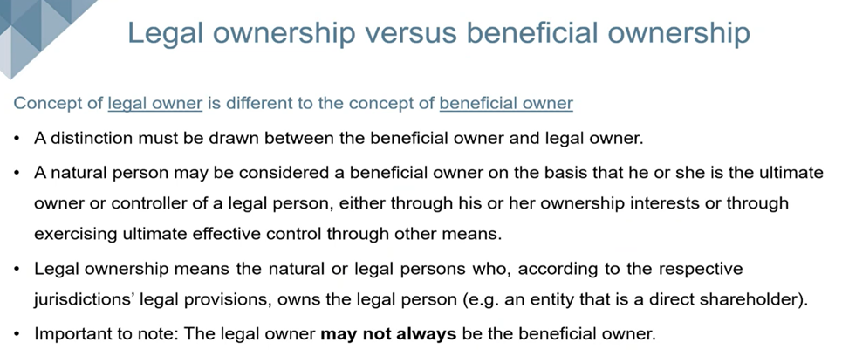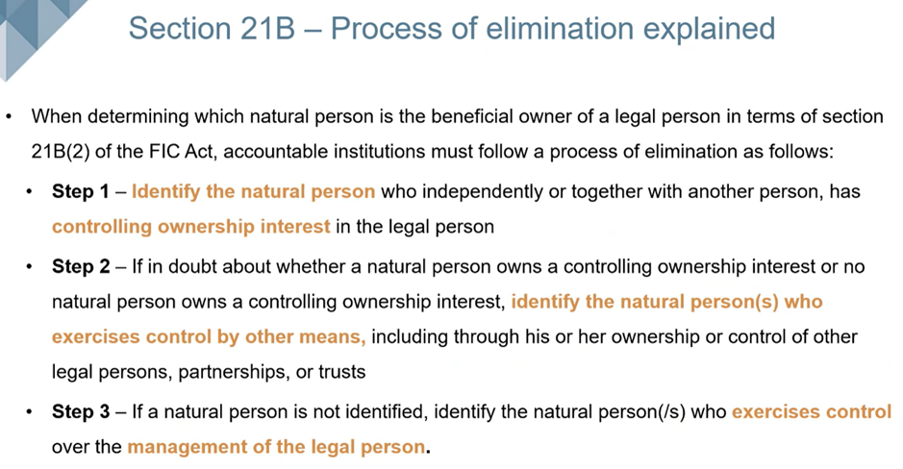

Financial Intelligence Centre’s (FIC) webinar: STEP 1 explained
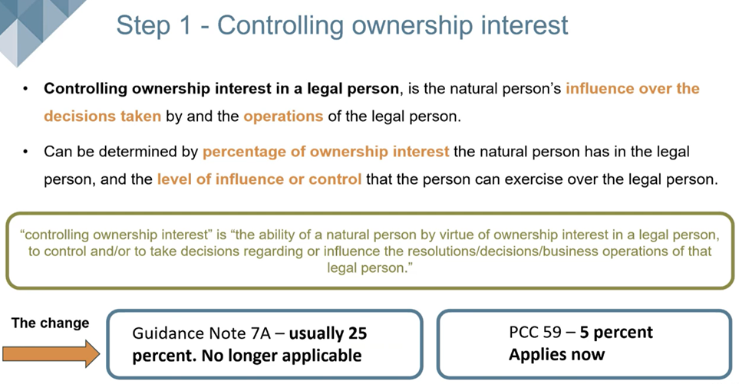

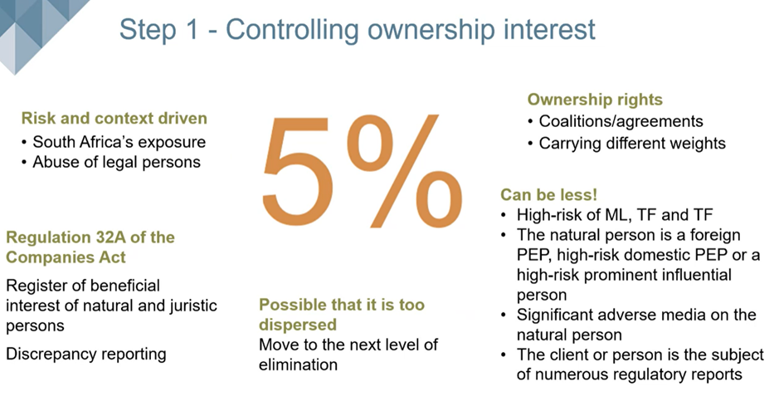

Financial Intelligence Centre’s (FIC) webinar: STEP 2 explained
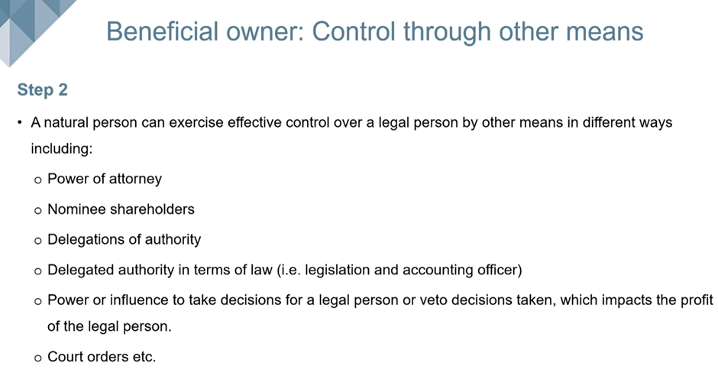

Financial Intelligence Centre’s (FIC) webinar: STEP 3 explained
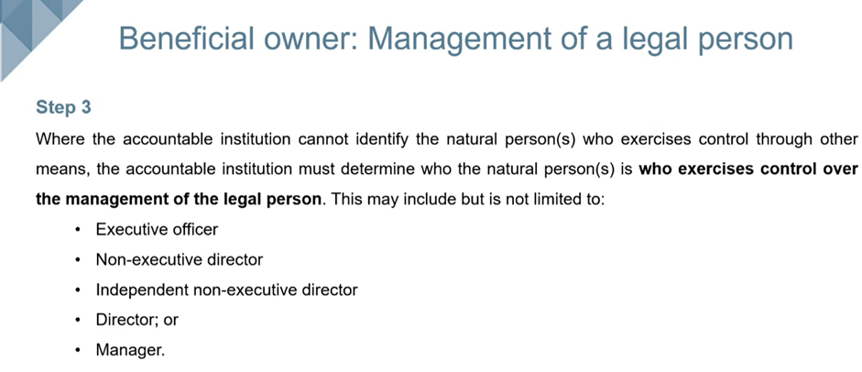

"The FIC Act defines a “beneficial owner” in respect of a legal person as the natural person who, independently or together with another person, owns the legal person or exercises effective control of the legal person. FIC GN 7A"

For additional reference please refer to:
- http://www.fatf-gafi.org/media/fatf/documents/reports/Guidance-transparencybeneficial-ownership.pdf
- https://www.youtube.com/@financialintelligencecentre

Establishing the identity of trusts
"Trusts are not incorporated entities and do not have legal personality. All trusts in South Africa are “express trusts” – either trusts intervivos (trusts created during the lifetime of a person) or mortis causa trusts (trusts created in terms of the will of a person and comes into effect after their death). The administration of trusts in South Africa is regulated by the Trust Property Control Act, 1988. FIC GN 7A"

"The FIC Act defines a ‘trust’ as any trust as contemplated in the Trust Property Control Act, 1988 but excludes trusts established-
- by virtue of a testamentary disposition;
- by virtue of a court order;
- in respect of persons under curatorship; or
- by the trustees of a retirement fund in respect of benefits payable to the beneficiaries of that retirement fund.
However, it is important to note that the definition of trusts includes a similar arrangement established outside the Republic. FIC GN 7A"
"The identification and verification requirements set out in section 21B(4) of the FIC Act apply in respect of a trust which is inter vivos. The existence of a trust must be registered at an office of the Master of the High Court before legal effect can be given to the trust and the trustee(s) can obtain authority from the Master of the High Court to perform their functions. Therefore, accountable institutions must establish the unique reference number identifying the trust in the Master’s Office and the address of the Master of the High Court where the trust is registered as part of the elements describing the identity of the trust. In respect of foreign trusts, accountable institutions should obtain a letter of authority or other official document from a competent trust registering authority in a foreign jurisdiction. FIC GN 7A"

"The concept of a beneficial owner in the context of a trust encompasses all the natural persons who may benefit from a trust arrangement or may control decisions in relation to the management of trust property or are otherwise associated with the trust. Hence, section 21B(4) of the FIC Act requires accountable institutions, over and above the requirements of sections 21 and 21A of the FIC Act, to establish:
- The identity of each founder;
- If a founder of the trust is a legal person or a person acting on behalf of a partnership or in pursuance of the provisions of a trust agreement, the beneficial owner of that legal person, partnership or trust
- The identities of each trustee and each natural person who purports to be authorised to enter into a single transaction or establish a business relationship with the accountable institution on behalf of the trust, and
- If a trustee is a legal person or a person acting on behalf of a partnership, the beneficial owner of the legal person or partnership
- Each natural person who purports to be authorised to enter into a single transaction or establish a business relationship with the accountable institution on behalf of the trust, whether such a person is appointed as a trustee for the trust or not
- The identities of each beneficiary referred to by name in the trust deed or other founding instrument in terms of which the trust is created; or
- If a beneficiary referred to by name in the trust instrument is a legal person or a person acting on behalf of a partnership or in pursuance of the provision of a trust agreement, the beneficial owner of the legal person, partnership or trust.
- If beneficiaries are not referred to by name in the trust deed or other founding instrument in terms of which the trust is created, the particulars of how the beneficiaries of the trust are determined.FIC GN 7A"

"Accountable institutions are required to take reasonable steps to verify the names of the natural persons covered by section 21B(4) of the FIC Act. The remarks made above about the verification of a natural person’s identity also apply in this instance. Again, here the reference to “reasonable steps” confirm that accountable institutions must apply measures to verify the relevant persons’ identities that are commensurate with the assessed ML/TF risk in a given case. The different measures which an accountable institution uses to verify the identities of natural persons associated with trusts must be described in the institution’s RMCP. The underlying element of this requirement is that the accountable institution must be satisfied that it knows the identities of the relevant natural persons. FIC GN 7A"

According to the Financial Intelligence Centre’s (FIC) webinar hosted on the 26 June 2025, regarding the elements of an effective RMCP:
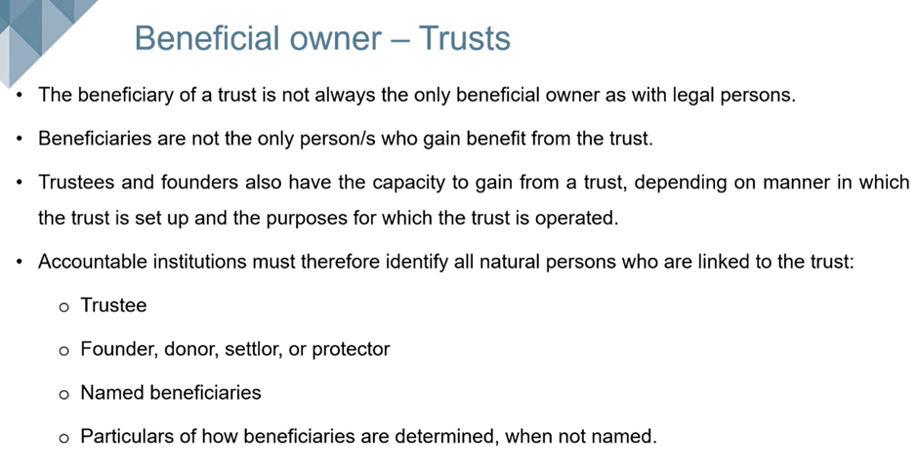
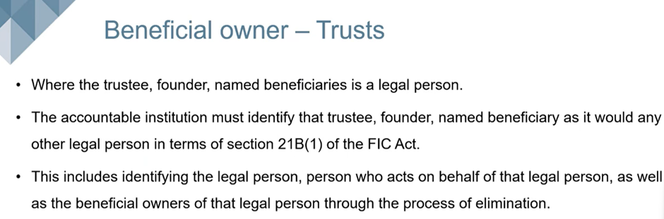
For Example: This is where the accountable institution can verify the Trusts identification:
- https://icmsweb.justice.gov.za/mastersinformation/MastersOfficeWebPortal/TrustSearch
- http://www.fatf-gafi.org/media/fatf/documents/reports/Guidance-transparencybeneficial-ownership.pdf
- https://www.youtube.com/@financialintelligencecentre

Establishing the identity of partnerships
"Partnerships are not incorporated entities and do not have legal personality. However, accountable institutions must establish the identities of partnerships who are their clients nonetheless. This means that the starting point to the identification of a partnership is to determine how the partnership is generally known. Accountable institutions must therefore establish whether a partnership is identified by a unique name or description. In addition to establishing this information, accountable institutions must take reasonable steps to verify it. This means that accountable institutions must apply measures that are commensurate with the assessed ML/TF risk relating to a partnership in a given case. Examples of information that can be used for this purpose include the partnership agreement which establishes the partnership and governs its membership and functioning, business correspondence of the partnership and promotional material advertising the partnership’s business. The measures which an accountable institution uses to verify the identities of partnerships must be described in the institution’s RMCP. FIC GN 7A"
"The concept of a beneficial owner in the context of a partnership encompasses all the partners in the partnership. Hence, section 21B(3) of the FIC Act requires accountable institutions, over and above the requirements of sections 21 and 21A of the FIC Act, to establish the identity of every partner in a partnership. This includes every member of a partnership en commandite (a partnership where the liability of certain partners who contribute a fixed amount and who remain undisclosed as partners, is limited according to the partnership agreement establishing and governing the partnership), an anonymous partnership (a partnership where the partners’ names are not disclosed to persons who are not partners in the partnership) or any similar partnership. FIC GN 7A"
"When establishing a business relationship or conducting a single transaction for clients that are Partnerships include all the due diligence steps, including obtaining name and number of partnership and establishing the identity of each partner. FIC GN 7A"

"Section 21B(3) of the FIC Act also requires accountable institutions to establish the identity of the person who exercises executive control over the partnership, if there is such a person, indicating that accountable institutions should determine the notion of control over (in addition to benefit from) a partnership. Moreover, the provision requires accountable institutions to establish the identity of each natural person who is authorised to enter into a single transaction or establish a business relationship with the accountable institution on behalf of a partnership. FIC GN 7A"
"Where it is established that the prospective client is a partnership between natural persons, whether incorporated or originated in South Africa or elsewhere, the organisation will establish and verify:
- The identifying name of the partnership, and
- The identity of:
  - every partner, including every member of a partnership en commandite, an anonymous partnership or any similar partnership;
  - if a partner in the partnership is a legal person or a natural person acting on behalf of a partnership or in pursuance of the provisions of a trust agreement, the beneficial owner of that legal person, partnership or trust;
- the natural person who exercises executive control over the partnership; and
  - each natural person who purports to be authorised to enter into a single transaction or establish a business relationship with the accountable institution on behalf of the partnership
  - The identity of each natural person who purports to be authorised to enter into a single transaction or to establish a business relationship with the organisation on behalf of the partnership. FIC GN 7A"

"The different measures which an accountable institution uses to verify the identities of the relevant natural persons must be described in the institution’s RMCP. The underlying element of this requirement is that the accountable institution must be satisfied that it knows the identities of the relevant natural persons. FIC GN 7A"
List the steps taken by your business, the accountable institution to verify partnerships:

What is considered as Super Enhanced Customer Due Diligence (SEDD):
"The Enhanced Due Diligence procedure will be followed and given effect to when a client is considered to be a Medium to High Risk or High ML/TF/PF Risk. High-Risk transactions are those transactions that have been identified by the organisation as more likely to be exploited for money laundering, terrorist financing and/or proliferation financing purposes. FIC GN 7A"

The following LIST of information and documents or electronic records that must be obtained from the client, whether it is a business relationship or a single transaction but with a person considered a Prominent Influential Person (PIP) or a Local or Foreign Politically Exposed Person (PEP):
- Identification of Client
- Name
- Surname
- ID (Hard copy or Scan or Photo caption of ID)
- External Source verification: Use for example: https://checkid.co.za/

- Proof of physical Address
- Not older than 3 months

- Contact details
- cell phone number
- email address

- Nature of business relationship
- Their business details
- Business location

- Intended purposes of the business relationship and
- The source of funds for which the prospective client expects to use in concluding transactions
- The source of wealth information of the prospective client

According to the Financial Intelligence Centre’s (FIC) webinar hosted on the 26 June 2025, regarding the elements of an effective RMCP:
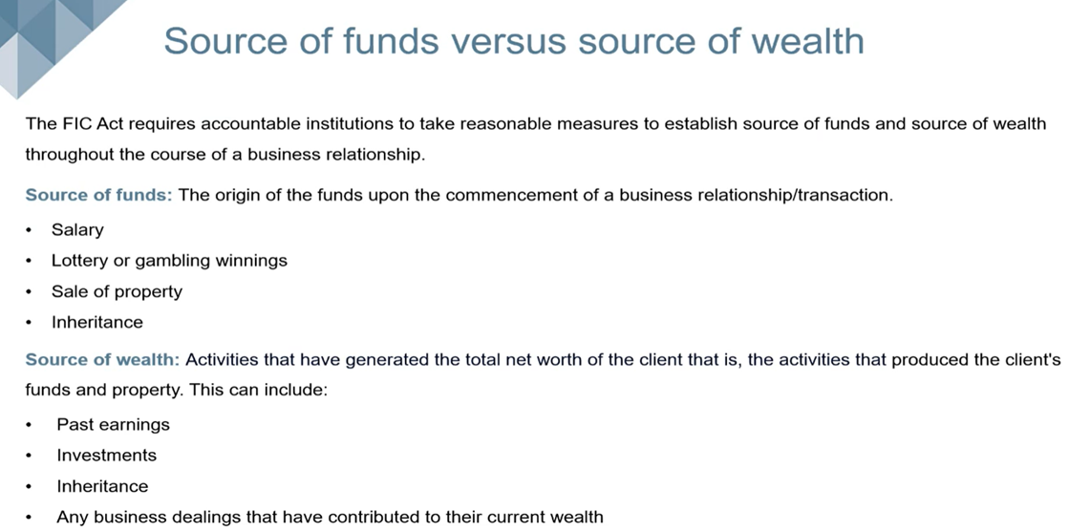

"As per the FIC GN 7A, the following clients are inherently considered high risk:
- Foreign politically exposed persons (FPEP’s)
- Domestic Politically Exposed Persons (DPEP’s)
- Prominent Influential Person (PIP's)
- Client who originates/does business from a high-risk country
- Complex business and ownership structure and
- Suspicious behaviour or activities."

"As per the FIC GN 7A, the following transactions are inherently considered to be high-risk ML/TF/PF transactions:
- A product or service that has been previously identified by the organisation as a ML/TF/PF high-risk product or service, forms part of that transaction, or
- A client or client representative who is party to that transaction, has been identified by the organisation as a ML/TF/PF high-risk person."

Super Enhanced Due Diligence (SEDD) must be conducted for all high-risk single transactions or business relationships. CASH amounts received in person or deposited into your bank account that are over R49 999,99 (collectively) are considered as high-risk single transactions.

WHO or WHAT is a Domestic Politically Exposed Person (DPEP), Foreign Politically Exposed Person (FPEP) & Prominent Influential Persons (PIP)

According to the Financial Intelligence Centre’s (FIC) webinar hosted on the 29 May 2025, regarding beneficial ownership, targeted financial sanctions and politically exposed persons:
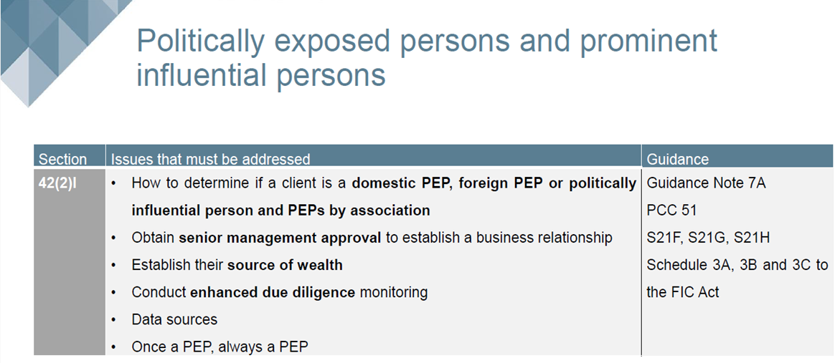

"The organisation will determine whether a prospective client with whom it engages to establish a new business relationship, or the beneficial owner of that prospective client, is a:
- domestic politically exposed person (""DPEP""),
- foreign politically exposed person (""FPEP"")
- prominent influential person (""PIP""). FIC GN 7A"

For additional reference please refer to:
- http://www.fatf-gafi.org/media/fatf/documents/recommendations/Guidance-PEPRec12-22.pdf
- https://www.youtube.com/@financialintelligencecentre

Prominent influential persons
The process of determining whether a person is a DPIP, FPPO, immediate family member or known close associate will be done in the following manner:
- Declaration sought from client. The accountable Institution must obtain a declaration from the client indicating whether the client, person acting on behalf of the client or beneficial owner, is a DPIP, FPPO, immediate family member or known close associate.
The Accountable Institution must keep on file:
  - list the various types of DPIPs and FPPOs and require the client to declare their position
  - Where the client does hold a position of either a DPIP, FPPO, immediate family member or known close associate then senior management approval must be obtained for on boarding
- Manually search for information online or automated where the client details are captured in a system of the relevant FPPOand DPIP source lists provided below, in schedule 3A to the FIC Act.
- Upon establishing a business relationship or an existing business relationship, the following client information must be scrutinised against the following FPPO and domestic prominent influential persons (DPIP) source lists in schedule 3A, in order to determine whether the individual is either a DPIP, FPPO, immediate family member or known close associate.
- At client on-boarding and thereafter at appropriate intervals, the client information must be scrutinised against the FPPO and DPIP source lists.
These intervals are proportionate to theML/TF risk:
  - On client interaction
  - On a monthly basis
  - Every six months
  - Annually
- The Accountable Institution must take reasonable measures to obtain the source of wealth information of an FPPO, high-risk DPIP, their immediate family member or known close associate in the following manner: request information through the application form and request verification documents for the information provided.
- The Accountable Institution must conduct enhanced ongoing monitoring of the business relationship with the FPPO, high-risk DPIP, their immediate family member or known close associate in the following manner: conduct client reviews of account activity on a quarterly basis or at the end of every month etc.
- Senior management approval must be obtained before establishing a business relationship with an FPPO, high-risk DPIP, immediate family member or known close associate in the following manner: escalation of all CDD, section 21F, 21G and 21H of the FIC Act information via e-mail to senior management with request to approve/decline the establishment of the business relationship, recording of the e-mail response from the senior management etc.
- The Accountable Institution must remember that once a person is classified as a PEP or PIP, they will always remain a PEP or PIP.
*Taken from FIC PCC No53, page 32
"Schedule 3A to the FIC Act contains a list of positions that will be considered domestic prominent influential persons (DPIP) which includes:
- The President or Deputy President; http://www.gov.za/aboutgovernment/leaders
- A government minister or deputy minister; (http://www.gov.za/aboutgovernment/leaders)
- The Premier of a province; (http://www.gov.za/links/provincial-government)
- A member of the Executive Council of a province; (http://www.gov.za/links/provincial-government)
- An executive mayor of a municipality elected in terms of the LocalGovernment Municipal Structures Act, 1998;(http://www.salga.org.za/Municipalities%20MCD.html)
- A leader of a political party registered in terms of the Electoral Commission Act, 1996; (http://www.elections.org.za/content/Parties/Political-party-list/).
- Note: The leader of a political party is the person identified by the party to occupy the position of the highest level of authority in the party.
- A member of the royal family or senior traditional leader as defined in the Traditional Leadership and Governance Framework Act, 2003; http://www.cogta.gov.za/?p=938 Note: The description of a “senior”traditional leader, therefore, applies to such traditional leaders who exercise authority over a number of headmen or headwomen in accordance with customary law, or within whose area of jurisdiction a number of headmen or headwomen exercise authority.
- The head, accounting officer or chief financial officer of a national or provincial department or government component as defined in section 1 of the Public Service Act, 1994; http://www.gcis.gov.za/gcis/pdf/government28.pdf
- The municipal manager of a municipality appointed in terms of section 54A of the Local Government: Municipal systems Act, 2000 or a chief financial officer designated in terms of section 80(2) of the Municipal Finance Management Act, 1999; (http://www.salga.org.za/Municipalities%20MCD.html).
- The chairperson of the controlling body, the chief executive officer, or a natural person who is the accounting authority, the chief financial officer or the chief investment officer of a public entity listed in Schedule 2 or 3 to the Public Finance Management Act, 1999; (http://www.gcis.gov.za/content/resourcecentre/contactdirectory/government-structures-and-parastatals);
- The chairperson of the controlling body, chief executive officer, chief financial officer or chief investment officer of a municipal entity as defined in section 1 of the Local Government: Municipal Systems Act, 2000 (Act No. 32 of 2000); (http://www.govpage.co.za/municipal-entities.html)
- A constitutional court judge or any other judge as defined in section 1 of the Judges’ Remuneration and Conditions of Employment Act, 2001; (http://www.judiciary.org.za/index.html);
- An ambassador or high commissioner or other senior representative of a foreign government based in the Republic of South Africa; (http://www.dirco.gov.za/foreign/forrep/index.htm);
- An officer of the South African National Defence Force above the rank of major-general;(http://www.dod.mil.za/leaders/leaders.htm)
- Note: This will include persons holding the position of General and Lieutenant General in the South African National Defence Force.
- The position of—
  - Chairperson of the board of directors;
  - Chairperson of the audit committee;
  - Executive officer; or
  - Chief financial officer of a company, as defined in the Companies Act, 2008 if the company provides goods or services to an organ of state and the annual transactional value of the goods or services or both exceeds an amount determined by the Minister of Finance by notice in the Gazette.
  - Note: It is envisaged that the Minister of Finance will delay the operational date of this paragraph in the legislation, given that information about persons who may fall in this category is not publically available currently. The National Treasury will explore ways to make such information readily available to enable easier compliance by accountable institutions.
  - The position of head, or other executive directly accountable to that head, of an international organisation based in the Republic of South Africa. http://www.dirco.gov.za/foreign/forrep/intorg.htm. FIC GN 7A"

"The definition of a foreign prominent public official includes a person who holds the relevant position or has held the position in a foreign country for a period of at least 12 months after the date on which that person ceased to hold that position.
It includes the following-
- Head of State or head of a country or government;
- Member of a foreign royal family;Government minister or equivalent senior politician or leader of a political party;
- Senior judicial official;
- Senior executive of a state owned corporation; or
- High-ranking member of the military. FIC GN 7A"

"Where it is established that the prospective client, or the beneficial owner of the prospective client, is a DPEP, FPEP or PIP, the organisation will:
- Regard the transaction as a ML/TF/PF High-Risk transaction, and
- Require the employee interacting with the client to obtain senior management approval before establishing the business relationship, and
- Take reasonable measures to establish the source of wealth and source of funds of the client, and
- Conduct enhanced ongoing monitoring of the business relationship.
The enquiry will form part of the Tier 1 ML/TF/PF Client Risk Rating criteria as provided for in the Enhanced Client Due Diligence (ECDD) Forms. FIC GN 7A"

WHOM is considered a Family Member or Close Associate of a DPEP, FPEP or PIP
"The organisation will determine whether a prospective client with whom it engages to establish a business relationship, or the beneficial owner of that prospective client, is an immediate family member or a known close associate of a DPEP, FPEP or PIP. FIC GN 7A"

"The following relationships between a natural person and a client will be regarded as an immediate family member relationship:
- A spouse, civil partner or life partner
- The previous spouse, civil partner or life partner
- Children and stepchildren and their spouse, civil partner or life partner
- Parents
- Siblings and stepsiblings and their spouse, civil partner or life partner. FIC GN 7A"

"Where it is established that the prospective client, or the beneficial owner of the prospective client, is an immediate family member or a known close associate of a DPEP, FPEP or PIP, the organisation will:
- Regard the transaction as a ML/TF/PF High-Risk transaction, and
- Require the employee interacting with the client to obtain senior management approval before establishing the business relationship, and
- Take reasonable measures to establish the source of wealth and source of funds of the client, and
- Conduct enhanced ongoing monitoring of the business relationship.
The enquiry will form part of the Tier 1 ML/TF/PF Client Risk Rating criteria as provided for in the Enhanced Client Due Diligence (ECDD) Forms. FIC GN 7A"

As an Accountable Institution, we accept and confirm:
"A client’s identity and, where applicable, the identities of beneficial owners and other persons associated with a client, must be verified in the course of conducting a single transaction or entering into a business relationship. This means that an accountable institution may initiate the processes related to the conclusion of a single transaction or entering into a business relationship while it is verifying the relevant persons’ identities, but the institution must complete the verification before the institution concludes a transaction in the course of the resultant business relationship or performs any act to give effect to the resultant single transaction. This implies that accountable institutions may, for example, accept a mandate from a prospective client to establish a business relationship or to conclude a single transaction or take any similar preparatory steps with a view of establishing a business relationship or concluding a single transaction before completing verification of the identities of the prospective client and other relevant persons. However, in doing so accountable institutions must take care not to incur unmitigated ML/TF risks by, for example, receiving funds from a client which may have to be returned to the client before completing the verification or making funds available to a client before completing the verification. FIC GN 7A"

"The information which an accountable institution obtains from a prospective client should be sufficient for the institution to form the intended understanding of the client and the business relationship. Accountable institutions may form this understanding by accepting the information obtained for this purpose at face value. Accountable institutions are not required to verify the veracity of the information obtained under section 21A of the FIC Act. FIC GN 7A"

In the event that the Accountable Institution can NOT complete the Customer Due Diligence process:
"Section 21E of the FIC Act prohibits accountable institutions from entering into or maintaining business relationships or concluding single transactions if they cannot perform the required CDD in accordance with the provisions of the Act. FIC GN 7A"
"Accountable institutions should take an objective approach when considering what constitutes an inability to conduct CDD in any particular situation. There may be circumstances where it is reasonable to delay discontinuing a business relationship while the institution facilitates the client’s efforts to rectify the failure. The reasonableness of such a delay will vary depending on the circumstances of each case. Where a client refuses to provide requested documentation or information the business relationship should be discontinued once the client has been informed of the potential implications and given time to respond accordingly. FIC GN 7A"
"The Accountable Institution must terminate a business relationship and must not conduct a single transaction where it is unable to conduct SDD, CDD, EDD or ODD. (FIC PCC No53, page 31)"

"The Accountable Institution must consider filing a section 29 report to FIC. The reporting of noncompliance with all supporting material to be sent to the compliance officer within 2 days in order to submit a report to FIC. (FIC PCC No53, page 31)"

"The sequence of attempts to obtain the required information or to apply other CDD measures needs to be spelled out in an accountable institution’s RMCP. In this context the accountable institution’s RMCP must also indicate at what point in the process of entering into a business relationship or concluding a single transaction the verification of a prospective client’s identity should be completed and at which point the conclusion will be reached that the institution is not able to conduct appropriate CDD of the required information is not forthcoming. Additionally, an accountable institution’s RMCP must provide for the manner in which it will terminate an existing business relationship when it is unable to complete the CDD requirements. FIC GN 7A"
"The process to terminate a business relationship is as follows: escalation of information to senior management, letter sent to client informing client the business relationship will be terminated if the client does not provide documents etc. The reason for terminating a business relationship must be recorded. (FIC PCC No53, page 31)"

"Where there are doubts regarding the veracity of previously obtained information, the process of SDD, CDD, EDD and ODD where relevant must be repeated. (FIC PCC No53, page 32)"

"Where something suspicious or unusual becomes apparent while conducting SDD, CDD, EDD and ODD, the employee must file a report to the compliance officer. (FIC PCC No53, page 32)"

"Where the Accountable Institution is unable to conduct CDD, it will not establish a business relationship with and or conduct a single transaction for a client. The following process will be followed in these instances: internal investigation process, then reporting to FIC and finally termination process. (FIC PCC No53, page 32)"

STEP 3:

Avoiding Transactions and Business Relationships with Persons/Entities identified by the Targeted financial sanctions (TFS) List and United Nations Security Council

"The FIC Act places the responsibility to administer the targeted financial sanctions (TFS) measures adopted by the United Nations Security Council (UNSC) in its Resolutions on the Centre.This inclusion of TFS measures is, inter alia, as a result of Recommendation 6 and 7 of the FATF recommendations, which requires member countries to implement the targeted financial sanctions proposed by the UNSC in the context of combating the financing of the proliferation of weapons of mass destruction. The use of TFS by the UNSC also extends beyond the instances relating to the financing of the proliferation of weapons of mass destruction and the relevant provisions of the FIC Act aim at enabling South Africa to meet these international obligations. FIC GN 7A"

"Sanctions impose restrictions on activities that relate to particular countries, goods and services, or persons and entities. TFS measures generally restrict sanctioned persons and entities from having access to funds and property under their control and from receiving financial services in relation to such funds and property. In order for these sanctions to be given effect the FIC Act requires accountable institutions to freeze property and transactions pursuant to financial sanctions imposed in the UNSC Resolutions. FIC GN 7A"

"The Notices by the Minister of Finance and the Director are public statements and are meant to advise both sanctioned persons and entities and accountable institutions who may have them as clients or prospective clients of the relevant sanctions. If an accountable institution has a sanctioned person or entity as a client, it is allowed to draw the attention of the person or entity to the relevant sanctions notices. FIC GN 7A par.195"
"The acquisition, collection or use of the property of persons or an entity whose names appear in the sanctions is prohibited. This includes the provision of financial services and products to those persons or entities. In short this means that accountable institutions are not allowed to transact with a sanctioned person or entity or to process transactions for such a person or entity. The status quo as at the time of the imposition of the sanction in relation to property or funds of the sanctioned person or entity must be maintained and no financial services may be provided to the person or entity. FIC GN 7A"

"Accountable institutions must report to the Centre, the property in the accountable institution’s possession or under its control which is owned or controlled by or on behalf of a person or an entity identified in the sanctions list. FIC GN 7A"

To stay informed of all amendments to these list, we recommend that the Accountable Institution subscribes to FIC mailing list:
- https://tfs.fic.gov.za/Pages/Subscriptions

Where a possible match is found on the TFS lists and UN 1267 sanctions list, please follow the steps below:

- The client information must be further analysed and compared to determine whether there is a true match (i.e. client is a sanctioned person) or a false positive (i.e. client has the same name as a sanctioned person but is not the same person).
- The process for analysing and comparing is: The Accountable Institution's employee will compare the client information against all the sanctioned persons information and determine whether it matches. Where required, the Accountable Institution will conduct further searches via search engines to source information to determine whether there is a match or not etc.
- In an instance where it is a false positive, the reason therefore must be documented, and the on-boarding may continue. This finding, and all information regarding the investigation and decision made that this is a false positive must be kept in the following manner: all material to be saved on the client file and signed off by compliance officer
- In an instance where a true positive is found, the reason therefore must be documented and the Accountable Institution may not establish a business relationship or conduct a single once-off transaction. This finding, and all information regarding the investigation and decision made that this is a positive match must be kept in the following manner: all material to be saved on the client file and signed off by compliance officer.

NOTE - The Accountable Institution must record evidence that client information has been scrutinised against both lists in the following manner: after screening a client's name against the TFS search tool on the Centre’s website, the employee will take a screen shot of the results and save the same on the client file etc.
*Taken from FIC PCC No53, page 35-36

How to screen clients on the FIC Website
"Accountable institutions must be able to determine whether they have a sanctioned person or entity as a client or whether a prospective client is a sanctioned person or entity in order to determine their exposure to TFS-related obligations. This implies that accountable institutions which are likely to come into contact with sanctioned persons or entities are able to screen clients and prospective clients against the relevant sanctions lists. This should be done during the client-take-on process as well as subsequently as and when the UNSC adopts new TFS measures or expands existing ones. FIC GN 7A"
"Accountable institutions should be mindful of the fact that failure to comply with TFS obligations is a criminal offence under section 49A of the FIC Act. The fact that an accountable institution had relied on a commercially available screening capability or that it had considered the risk of being exposed to TFS-related obligations to be low, would not be a defence against such a criminal charge. FIC GN 7A"

Accessibility of sanctions list
"The Centre will maintain an updated sanctions list which will be available on its website and which will reflect available identity particulars of persons and entities contained in notices published by the Director. FIC GN 7A"
"You can find possible matches on the TFS list via the FIC online search tool . The tool is designed to assist accountable institutions or any asset holder in finding possible matches between their clients’ names and/or entities names on the TFS list. FIC Website:
- www.fic.gov.za"
"It is important to note the TFS list is not a FIC or South African domestic sanctions list, but a replica of the original source, which is the UNSC consolidated list of targeted financial sanctions. FIC Website: www.fic.gov.za"
You can find possible matches on the TFS list via the FIC online search tool listed below.
- https://www.fic.gov.za/targeted-financial-sanctions/

"Accountable institutions should be mindful of the fact that failure to comply with TFS obligations is a criminal offence under section 49A of the FIC Act. The fact that an accountable institution had relied on a commercially available screening capability or that it had considered the risk of being exposed to TFS-related obligations to be low, would not be a defence against such a criminal charge. FIC GN 7A"

STEP 4:

Timing of Customer Due Diligence (CDD) verification and concluding a business relationship or single transaction with a client
"A client’s identity and, where applicable, the identities of beneficial owners and other persons associated with a client, must be verified in the course of conducting a single transaction or entering into a business relationship. This means that an accountable institution may initiate the processes related to the conclusion of a single transaction or entering into a business relationship while it is verifying the relevant persons’ identities, but the institution must complete the verification before the institution concludes a transaction in the course of the resultant business relationship or performs any act to give effect to the resultant single transaction. FIC GN 7A"
"This implies that accountable institutions may, for example, accept a mandate from a prospective client to establish a business relationship or to conclude a single transaction or take any similar preparatory steps with a view of establishing a business relationship or concluding a single transaction before completing verification of the identities of the prospective client and other relevant persons. However, in doing so accountable institutions must take care not to incur unmitigated ML/TF risks by, for example, receiving funds from a client which may have to be returned to the client before completing the verification or making funds available to a client before completing the verification. FIC GN 7A"

"The manner and processes for the identification of clients and verification of their identities described in an accountable institution’s RMCP must also provide for the timing of verification and the mitigation of ML/TF risks where verification is not completed before a single transaction is conducted or a business relationship entered into. FIC GN 7A"

STEP 5:

Reporting to FIC Centre (the how, when and what process explained)
A suspicious and unusual transaction report can be divided into 4 types of reports:
- Suspicious and unusual transaction report.
- Suspicious and unusual transaction activity report.
- Terrorist financing transaction report; and
- Terrorist financing activity reports.

According to the Financial Intelligence Centre’s (FIC) webinar hosted on the 26 June 2025, regarding the elements of an effective RMCP:
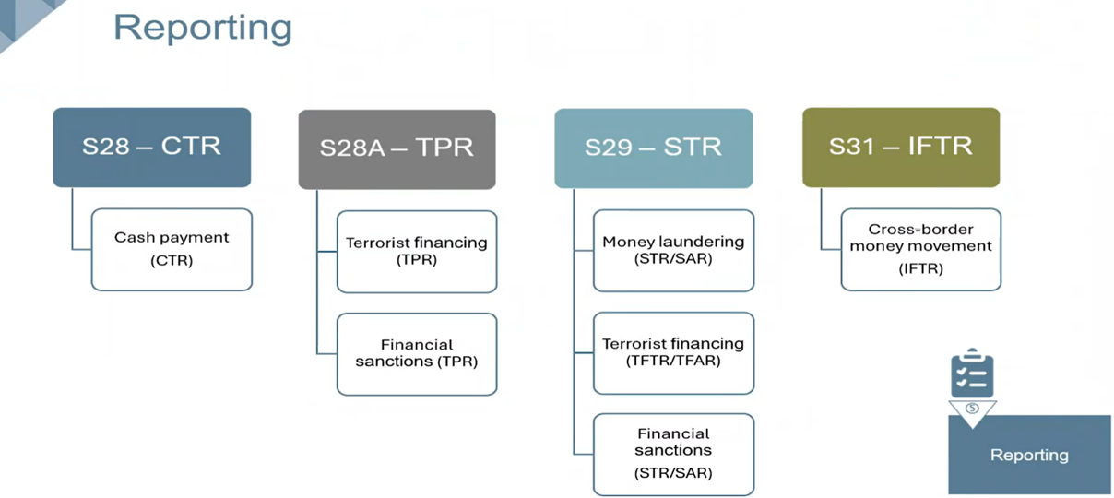

The differences are as follow:
- Transaction reports entail transactions that have already been successfully completed
- Transaction activity report is where the transactions or activities are in progress or have not yet been completed.
- Suspicious and unusual reports entail a money laundering activity or transaction, where the terrorist financing reports entails a terrorist financing activity or transaction.

What is considered Suspicious or Unusual in order to file a Suspicious or Unusual Transaction Report to FIC?
"Any person who knows or ought reasonably to have known or suspected that:
- the organisation has received, or is about to receive, or if a transaction was concluded, may have been received, and the proceeds of unlawful activities or property which is connected to an offence relating to the financing of terrorist and related activities, or
- a transaction or series of transaction to which the organisation is a party:
  - facilitated or is likely to facilitate, or if the transaction was concluded, may have facilitated, the transfer of the proceeds of unlawful activities or property which is connected to an offence relating to the financing of terrorist and related activities, or
  - has no apparent business or lawful purpose, or
  - is conducted for the purpose of avoiding giving rise to a reporting duty under FIC, or
  - may be relevant to the investigation of an evasion or attempted evasion of a duty to pay any tax, duty or levy imposed by legislations administered by the South African Revenue Services, or
  - relates to an offence relating to the financing of terrorist and related activities, or
  - will or may facilitate the acquisition, collection, use or provision of property or any other economic support, for the benefit of, or at the direction of, or under the control of a person or an entity identified pursuant to a resolution of the Security Council of the United Nations.
- the organisation has been used or is about to be used, or if the transaction was concluded, may have been used, in any way for money laundering purposes or to facilitate the commission of an offence relating to the financing of terrorist and related activities, must within the prescribed period after the knowledge was acquired or the suspicion arose, report to the FIC the grounds for the knowledge or suspicion."

What is considered Terrorist Property in order to file a Terrorist Property Report to FIC?
"In this context property refer to:
- money, or
- any movable, immovable, corporeal or incorporeal thing, or
- any rights, privileges, claims and securities and any interest therein and all proceeds thereof, which were acquired, collected, used, possessed, owned or provided for the benefit of, or on behalf of, or at the direction of, or under the control of an entity (or another entity that has provided financial or economic support to such an entity) which commits or attempts to commit, or facilitates the commission of a specified offence as defined in the Protection of Constitutional Democracy against Terrorist and Related Activities Act, 33 of 2004 (""POCDATARA"")."

Where an employee of the organisation obtains knowledge or becomes aware that the organisation has in its possession or under its control property associated with terrorist or related activities; property owned or controlled by or on behalf of, or at the direction of a specific person or entity identified, they will notify the FIC Compliance Officer or the MLRO within one business day after they has established this fact.

What does FIC mean by Freezing of Property?

Where a report is made to the FIC, it is an offence to continue dealing with that property in any way. No further transactions on behalf of the client may be undertaken. This is also referred to as "freezing".

The organisation will not conduct any further services with or deliver any products to any person or entity whose name appears on the sanction lists and will not deal with any of the relevant property in the organisation’s possession or under its control. The organisation will only be permitted to deal with property to the extent that FIC has permitted certain financial services or dealing with the property as to allow such a person or entity to certain basic living expenses.

The following process must be followed to identify reportable transactions:
Select accordingly
- check statement every day to determine, whether cash transactions above the threshold have been paid or received
- check statement at the end of the week to determine, whether cash transactions above the threshold have been paid or received
- check statement at the end of the month to determine, whether cash transactions above the threshold have been paid or received
- Scrutinize the client activity to determine whether any suspicious and unusual transactions are taking place, at on-boarding a client
- Scrutinize the client activity to determine whether any suspicious and unusual transactions are taking place, at renewal of clients services provided
- Scrutinize the client activities to determine whether any suspicious and unusual transactions have taken place, on an annual date to monitor client activities

"Where reportable transactions are identified, the following process must be applied: communicate all the relevant information immediately to the compliance officer and money laundering reporting officers in the prescribed manner, who will then analyse and determine whether it is reportable to FIC. (FIC PCC No53, page 37)"
According to the Financial Intelligence Centre’s (FIC) webinar hosted on the 26 June 2025, regarding the elements of an effective RMCP:
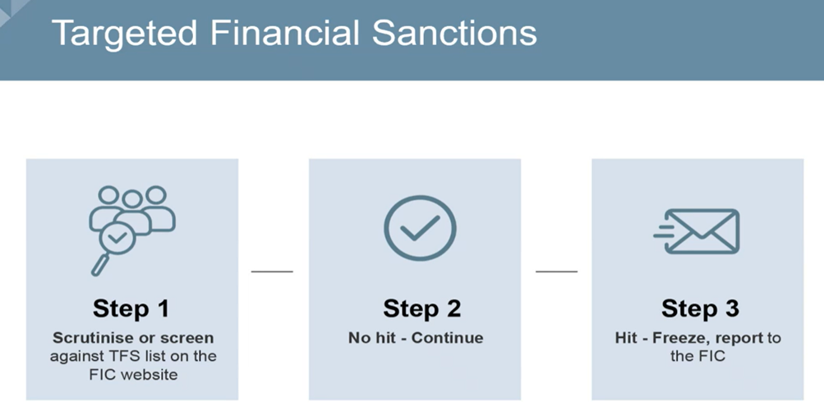

State in this box: the organization's end-to-end internal process that will be followed in order to analyse and report transactions to the FIC Centre:

"Reports made in terms of the FIC Act are confidential. (FIC PCC No53, page 37)"

"All reporting information is confidential! The Accountable Institution must under no circumstances disclose the contents of a report or the fact that a report has been considered or filed to any other persons. Disclosure of this information is regarded as tipping off, which is an offence. (FIC PCC No53, page 38)"

"The following client and transaction profile scenarios are examples of potential suspicious and unusual transactions in terms of section 29 of the FIC Act: Payment of large purchase price in cash, numerous round cash deposits which do not match the client’s stated source of income, numerous large electronic transfers made by a third party which does not match the clients stated source of income. Where these scenarios occur the Accountable Institution must conduct further analyses in order to determine whether the transactions/activity is suspicious or unusual or other reportable transactions/activity. (FIC PCC No53, page 37)"

The Accountable Institution will examine complex and unusually large transactions as well as unusual patterns of transactions which have no apparent business or lawful purpose, in the following manner (FIC PCC No53, page 38):
- review applications, statements, credit reports, annual financial statements etc.
- by the following persons: {FIC_OFFICER_NAME}
- before concluding a transaction as and when the transaction occurs, in order to identify as possible reportable transactions.

"A terrorist property report in terms of section 28A, must be filed where the Accountable Institution is in possession or control of property of (FIC PCC No53, page 37-38)":
- Any entity which has committed or attempted to commit an offence as defined in POCDATARA Act
- A specific entity identified in a UN 1267 sanctions list
- A person or entity identified in a TFS list as published on the Centre’s website

The Accountable Institution must keep written findings of decisions taken on whether to report or not to report.
- Section 27 requests for information in terms of the FIC Act, will be handled as follows:
- section 42A compliance officer should check the goAML inbox on a daily basis or on email communication received from FIC and respond to requests for information on time.
- Section 32 requests for additional information in terms of the FIC Act, will be handled as follows: In all instances the compliance officer must be made aware of section 32 requests for additional information immediately upon receipt thereof.
- Section 34 requests for intervention in terms of the FIC Act, will be handled as follows:
  - section 42A compliance officer should check the goAML inbox on a daily basis and where a section 34 written directive is received, the compliance officer must ensure all impacted transactions are identified and frozen for the period as stated in the direction.
*Taken from FIC PCC No53, page 38

Record-keeping for FIC:
The Accountable Institution will maintain a secure file of all reports made to the Centre, which will include the date on which the report was made, the person making the report and sufficient information and details regarding the transaction.

All reports issued on FIC Centre goAML must be downloaded in 48 hours of submitting the report and kept on record.

The Accountable Institution must keep records of all reports and related information, at a minimum period of five years from the date on which the transaction is concluded, or date of termination of a single transaction or a business relationship, or date of report being filed.
* Taken from FIC PCC No53, page 39

Do not share the FIC report information with anyone (tipping off) …

Commonly referred to as tipping off, is where the person involved in the making of a report to FIC may not inform anyone, including the customer or any other person associated with a reported transaction, of the contents of a suspicious transaction or activity report or even the fact that such a report has been made.

"All reporting information to FIC is confidential! The Accountable Institution must under no circumstances disclose the contents of a report or the fact that a report has been considered or filed to any other persons. Disclosure of this information is regarded as tipping off, which is an offence. (FIC PCC No53, page 38)"

Protection of confidential information, in terms of Section 41 of the FIC Act:
"No person may disclose confidential information held by or obtained from the Centre except—
- within the scope of that person’s powers and duties in terms of any legislation;
- for the purpose of carrying out the provisions of this Act;
- with the permission of the Centre;
- for the purpose of legal proceedings, including any proceedings before a judge in chambers; or
- in terms of an order of court."

Do not be afraid to submit a report to FIC…
In terms of Section 38 of the FICA Act: Protection of persons making reports
- "No action, whether criminal or civil, lies against an accountable institution, reporting institution, supervisory body, the South African Revenue Service or any other person complying in good faith with a provision of this Part, Part 4 and Chapter 4, including any director, employee or other person acting on behalf of such accountable institution, reporting institution, supervisory body, the South African Revenue Service or such other person.
- A person who has made, initiated or contributed to a report in terms of section 28, 29 or 31 or who has furnished additional information concerning such a report or the grounds for such a report in terms of a provision of this Part is competent, but not compellable, to give evidence in criminal proceedings arising from the report.
- No evidence concerning the identity of a person who has made, initiated or contributed to a report in terms of section 28, 29 or 31 or who has furnished additional information concerning such a report or the grounds for such a report in terms of a provision of this Part, or the contents or nature of such additional information or grounds, is admissible as evidence in criminal proceedings unless that person testifies at those proceedings."

RMCP Element 8:
"The nature and extent of an accountable institution’s internal systems and controls which form part of its RMCP depends on a variety of factors, including:
- The nature, scale and complexity of the accountable institution’s business;
- The diversity of its operations, including geographical diversity;
- Its client, product or services profile;
- Its distribution channels;
- The volume and size of its transactions; and
- The degree of risk associated with each area of its operation"

According to the Financial Intelligence Centre’s (FIC) webinar hosted on the 26 June 2025, regarding the elements of an effective RMCP:
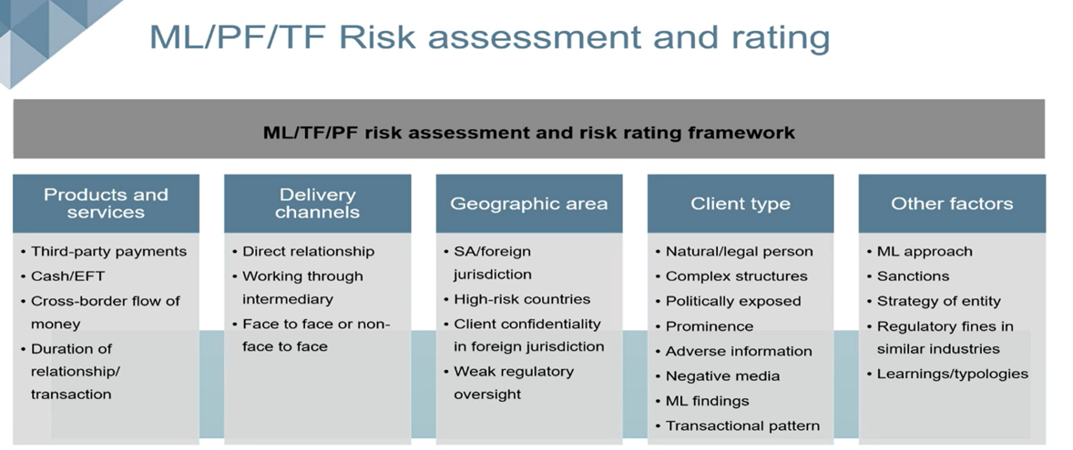

Regarding RMCP Element 8, please refer to your own client database to risk rate each of your clients. It is important to mention in the box below how you conduct your client risk rating, the process that you follow and why:

Account monitoring
All clients and prospective clients must be profiled according to the following factors below. Client profiling is required to determine/analyse whether future transactions are consistent with the Accountable Institutions knowledge of a client.
Client profiling aids in the identification of potentially suspicious and unusual transactions or activity.
- client type
- sector in which they operate
- occupation
- client income
- products or services sold to client
- payment methods including cash and EFTs
- transaction history where applicable
* Taken from FIC PCC No53, page 36

The Accountable Institution will monitor all account activity and transactions for all business relationships in order to identify possible reportable transactions mentioned in Directive 5 and PCC No45, in the following manner:
- Manually by reviewing statements daily/as and when transactions occur
- Automatically through an automated transaction monitoring system
*Taken from FIC PCC No53, page 36-37

Record-keeping for the Accountable Institution
All client information records and transaction records will be stored in the following places:
- In a strong room, which is subject to access controls
- In an office, which is subject to access controls
- Physical storage devices e.g. hard drives, CDs, DVDs, memory sticks, etc
- Internal networks storage facility
- Cloud storage
- Electronic document repositories
- Fintech capabilities
- Other

In the following format:
- Internal networks storage facility
- Cloud storage
- Electronic document repositories
- Fintech capabilities
- Other

At the business physical address specified:

"Section 22 of the FIC Act provides for an obligation on accountable institutions to keep customer due diligence records. This means that accountable institutions must keep record of all information pertaining to a client obtained in the course of its processes to comply with sections 21 to 21H of the FIC Act. Such records must include copies of, or references to, information provided to or obtained by the accountable institution to verify the person’s identity. FIC GN 7A"

Obligation to keep transaction records
"Accountable institutions must keep transaction records of single transactions and transactions concluded in the course of the business relationship with the client in terms of section 22A of the FIC Act. This means that the accountable institution must keep records of every transaction which that accountable institution has with a client. Transaction records must be sufficient to enable the transaction to be reconstructed and include the amount, currency, date of transaction, parties to the transaction, the nature of the transaction, pertinent or relevant business correspondence and also the identifying particulars of all accounts and account files related to the transaction if the accountable institution provides account facilities. FIC GN 7A"

Manner in which records must be kept
Records MUST be kept for a minimum period of five years (5 years) calculated from the date on which the transaction was concluded, or date of termination of a single transaction or a business relationship, or date of report being filed to FIC.

"The FIC Act is not prescriptive as to the manner in which records must be kept. This implies that records may be stored in accordance with an accountable institution’s standard procedures for the capture of information and the retention of records. Records can therefore be kept by way of storing original documents, photocopies of original documents, scanned versions of original documents or otherwise in computerised or electronic form. FIC GN 7A"

"Regardless of the manner in which records are kept, accountable institutions must ensure that the following principles are met:
- The accountable institution must have free and easy (in other words unencumbered) access to the relevant records;
- The records must be readily available to the Centre and the relevant supervisory body when required;
- The records must be capable of being reproduced in a legible format and
- If the records are stored off-site the Centre and the relevant supervisory body must be provided with the details of the third party storing the records. FIC GN 7A"

"It is advisable that records include details that will assist in the identification of the records such as:
- Reference numbers on documents or letters;
- Relevant dates, such as issue or expiry;
- Details of the issuer or writer. FIC GN 7A"

"Accountable institutions must ensure that records are tamper proof and that there are safeguards in place to prevent unauthorized access to information stored electronically. FIC GN 7A"

"It is advisable for accountable institutions which make use of commercial third party services, or intra-group centralised data storage to retain their records to conduct regular assessments of its service providers and to test the controls and business processes so as to provide assurance to the relevant supervisory body that the accountable institution can access and retrieve data and/or documents as envisaged under the FIC Act. FIC GN 7A"

Commercial third-party services, or intra-group centralised data storage details and location:

RMCP Element 9:
It is important that the content of an accountable institution’s RMCP is communicated widely throughout the institution, as may be applicable, to increase the effectiveness of its implementation.

Ongoing Due Diligence measures (ODD)
"Section 21C of the FIC Act provides for ongoing due diligence measures (ODD). These measures follow on from the obligation to understand the purpose and intended nature of a business relationship. They include the scrutiny of transactions undertaken throughout the course of a relationship, to ensure that the transactions being conducted in the course of a business relationship are consistent with an accountable institution’s knowledge of the client, and the client’s business and risk profile, including, where necessary, the source of funds. It also requires accountable institutions to ensure that the information that an accountable institution has about a client is still accurate and relevant. FIC GN 7A"

"The objective of the ongoing measures is to identify activities of clients during the course of the business relationship which are not consistent with the accountable institution’s knowledge of the client, or the purpose and intended nature of the business relationship, and which need to be assessed for the possibility that the institution may have grounds to report a suspicion of money laundering or terrorist financing. Accountable institutions should pay particular attention to complex or unusually large transactions and all unusual patterns of transactions which have no apparent business or lawful purpose. If the accountable institution suspects that a transaction or activity is suspicious or unusual and the institution believes that performing the ongoing due diligence requirements will disclose to the client that a report will be made in terms of section 29 of the FIC Act, the accountable institution may discontinue the ongoing due diligence process and consider making a report in terms of section 29 of the FIC Act. FIC GN 7A"

"The organisation will conduct ongoing due diligence in respect of all existing business relationships.
This process will ensure that all client information obtained during the Client Due Diligence procedure remains accurate and up to date.
The ongoing due diligence process will include the monitoring of transactions undertaken throughout the course of the business relationship, including among others:
- the source of funds, to ensure that the transactions are consistent with the organisation’s knowledge of the client and the client’s business and risk profile, and
- the background and purpose of all complex, unusually large transactions, and all unusual patterns of transactions, which have no apparent business or lawful purpose. FIC GN 7A"

"Ongoing due diligence (ODD) is conducted in respect of business relationships at the following intervals: annually for high-risk clients, every two years for medium risk clients and every three years on low-risk clients etc. The intervals at which ODD is conducted is dependent on the risk profile of the client. (FIC PCC No53, page 30)"
"In addition, ODD must be conducted when the following scenarios occur during the account monitoring, a change in client transaction pattern is detected, the accountable institution filed numerous section 29 reports in relation to the client etc. (FIC PCC No53, page 30 - 31)"
"The following process must be followed when conducting ODD: The Accountable Institutions staff must request the latest information and document via e-mail or a courier is sent to collect the required information and documentation etc. (FIC PCC No53, page 31)"

"Approval must be sought from the senior management before establishing high-risk business relationships in the following manner: e-mail all information and documents to the senior manager, who then must either approve/decline. Proof of decision to be maintained on client file. (FIC PCC No53, page 31)"
"The source of wealth information must be obtained from a client where it is determined the business relationship is high-risk from an ML/TF/PF perspective. (FIC PCC No53, page 31)"

RMCP Element 10:
An accountable institution must review its RMCP at regular intervals to ensure that it remains relevant to the institution’s operation and the risks identified

- The RMCP has been created, approved and implemented by the organisation’s Board of Directors.
- The RMCP will be reviewed on an annual basis to ensure that the RMCP remains relevant to the organisation’s operations and the achievement of the organisation’s FIC compliance objectives.
- An RMCP ad hoc review will take place, should there be a company restructure or on receipt of a complaint by a client.
- The RMCP will be printed and signed by all board members, representatives, staff and employees.
- The RMCP will be saved on the Company Internal Server as well as the company Cloud-Based secure storage.
- The updating and safe keeping of the RMCP and the Customer Due Diligence information gathered by the organisation, is the board of directors’ responsibility and liability to bear.

Acknowledgements

FIC REVISED GUIDANCE NOTE 7A - ON THE IMPLEMENTATION OF VARIOUS ASPECTS OF THE FINANCIAL INTELLIGENCE CENTRE ACT, 2001 (ACT 38 OF 2001)
Hereafter referred to in this RMCP document as FIC GN 7A

FIC PUBLIC COMPLIANCE COMMUNICATION No 53 - ON THE RISK MANAGEMENT AND COMPLIANCE PROGRAMME IN TERMS OF SECTION 42 OF THE FINANCIAL INTELLIGENCE CENTRE ACT, 2001 (ACT 38 OF 2001) FOR DESIGNATED NON-FINANCIAL BUSINESSES AND PROFESSIONS
Hereafter referred to in this RMCP document as FIC PCC No.53

DIRECTIVE 01/2013 - UPDATING OF REGISTRATION INFORMATION OF ACCOUNTABLE AND REPORTING INSTITUTIONS
DIRECTIVE 02/2014 – The use of login credentials following registration with the FIC
DIRECTIVE 3A – Notification of failure to report as required by the Financial Intelligence Centre in terms of the Financial Intelligence Centre Act
DIRECTIVE 04/2016 – UPDATING OF REGISTRATION RELATED INFORMATION TO ACCESS THE NEW REGISTRATION AND REPORTING PLATFORM OF THE FINANCIAL INTELLIGENCE CENTRE
DIRECTIVE 5/2019 - THE USAGE OF AN AUTOMATED TRANSACTION MONITORING SYSTEM FOR THE DETECTION AND SUBMISSION OF REGULATORY REPORTS TO THE FINANCIAL INTELLIGENCE CENTRE IN TERMS OF SECTION 29 OF THE FINANCIAL INTELLIGENCE CENTRE ACT, 2001 (ACT NO. 38 OF 2001)
DIRECTIVE 6 of 2023 - Submission of a risk and compliance return to the Financial Intelligence Centre by specified accountable institutions that are designated non-financial businesses and professions
DIRECTIVE 7 of 2023 - Submission of a risk and compliance return to the Financial Intelligence Centre by specified accountable institutions
DIRECTIVE 8 of 2023 - SCREENING OF EMPLOYEES FOR COMPETENCE AND INTEGRITY AND SCRUTINISING OF EMPLOYEE INFORMATION AGAINST APPLICABLE TARGETED FINANCIAL SANCTIONS LISTS AS A MONEY LAUNDERING, TERRORIST FINANCING AND PROLIFERATION FINANCING CONTROL MEASURE
DIRECTIVE 9 - concerning the implementation of the “Travel Rule” relating to crypto asset transfers in accordance with the Financial Action Task Force Recommendations

Part III: Acceptance of the RMCP and Signing off an approved and implemented RMCP

DECLARATION:
We, the accountable institution, acknowledge that this RMCP document is available for easy reference.

As signed below, we have read the RMCP, understand the RMCP and have applied the RMCP within our organization and we will also ensure that all processes as described in this RMCP will be followed accordingly.

Director Name: | {DIR_NAME}
Date Signed: | 24 Jan 2026
Signature:

Staff Name: | {STAFF1_NAME}
Date Signed: | 24 Jan 2026
Signature:

