

HIT

Introduction to Information Security

Lab 1

## class：1403201

## Student number：1130320118

## Name：Yang Yi

1. Purposes

1）learn how to set Kerberos network；

2）learn how to set Windows Server 2003 as DNS server；

3）learn Kerberos authentication protocol；

1. Procedure
2. step 1
   1. add active directory

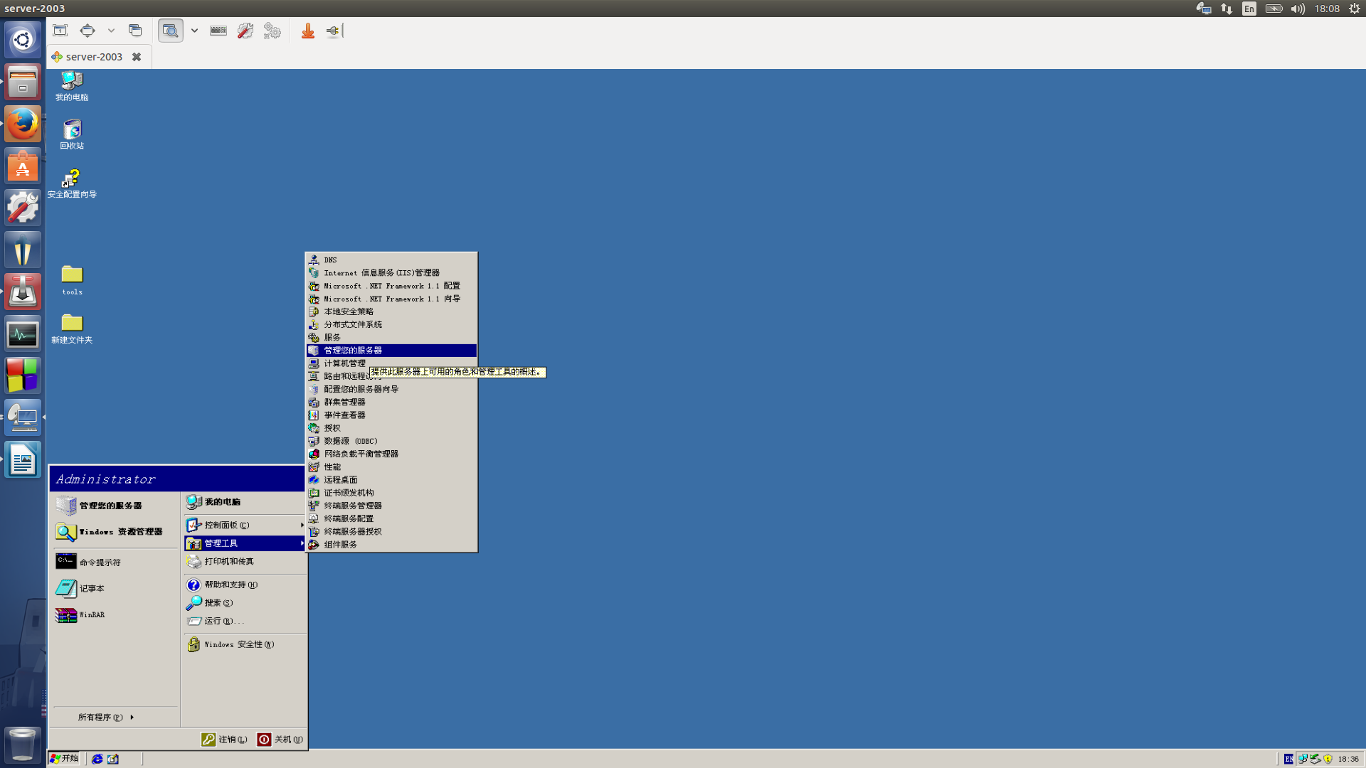

* 1. name the directory

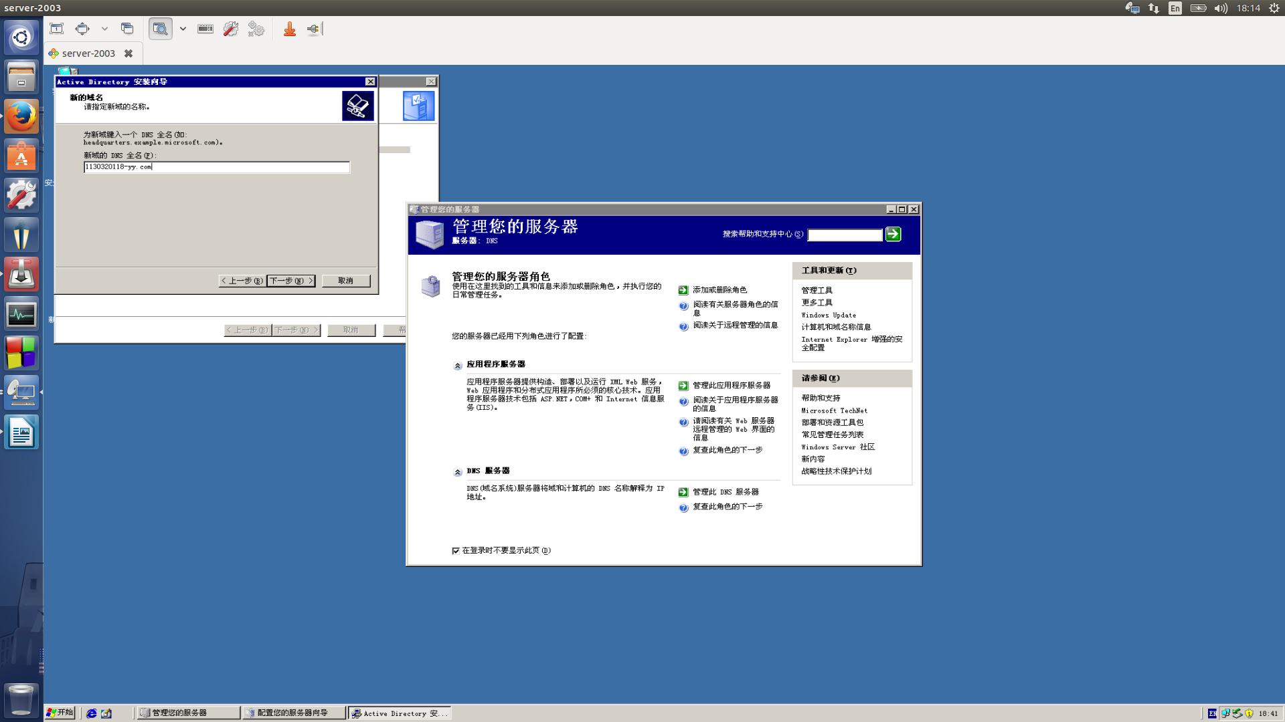

1. step 2
   1. check DNS server

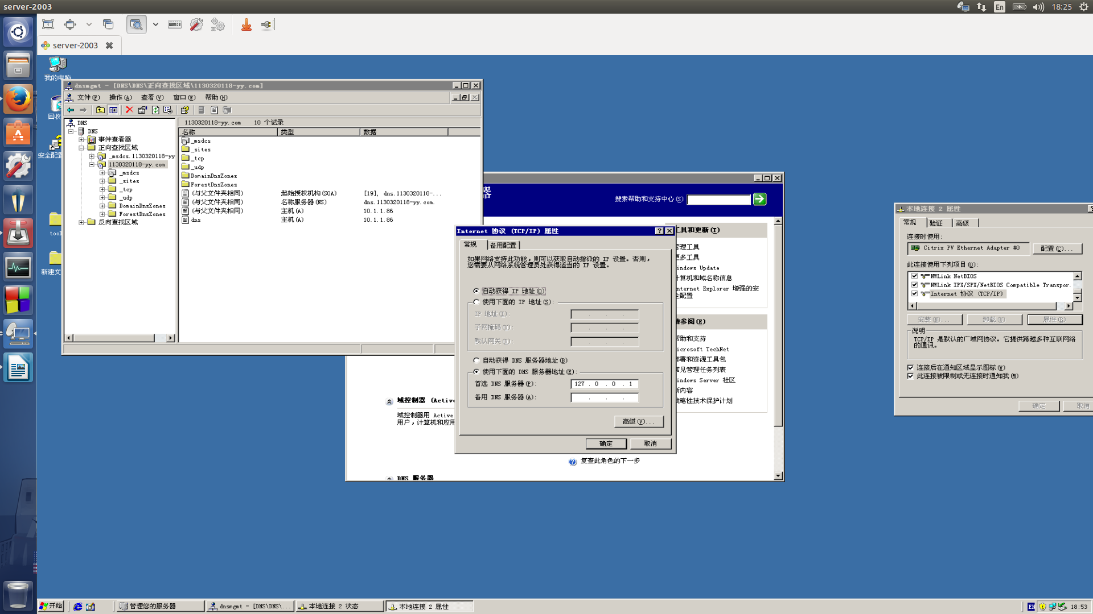

* 1. create a test account

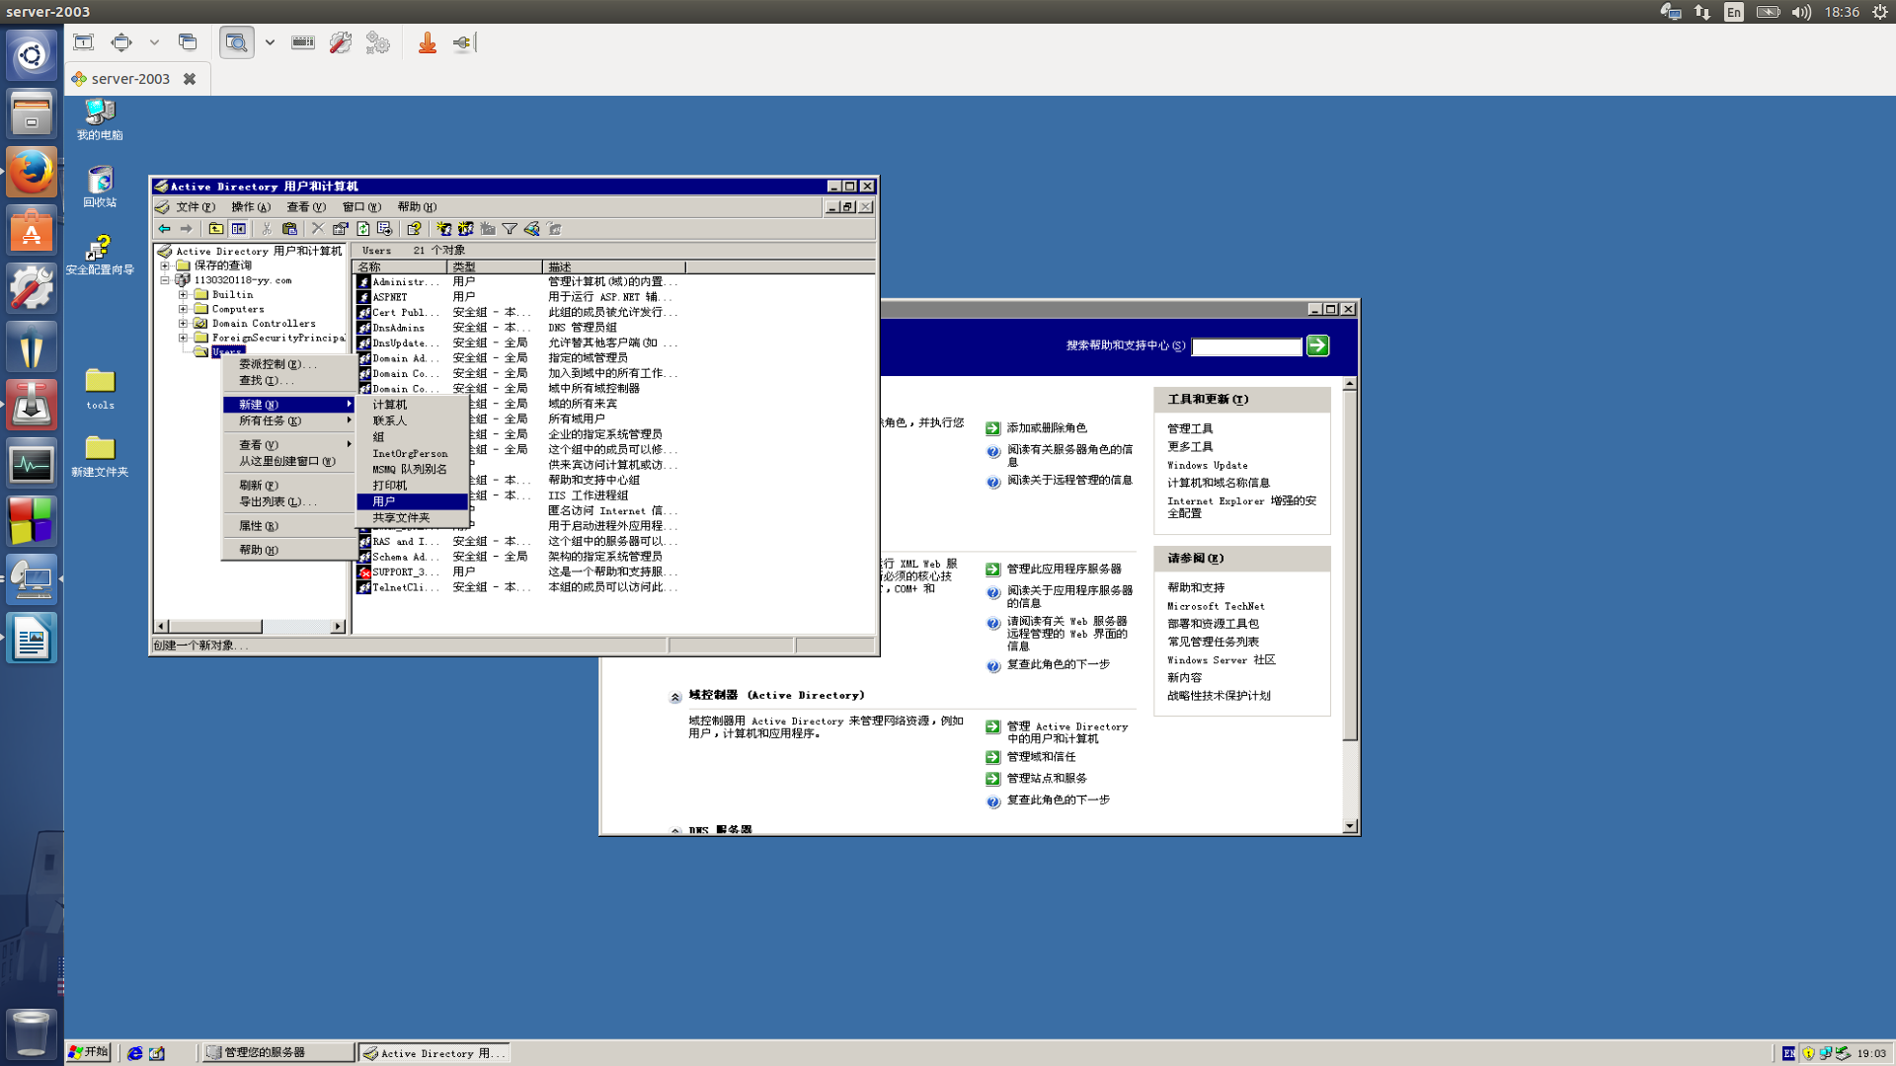

1. step 3
   1. add computer to the domain

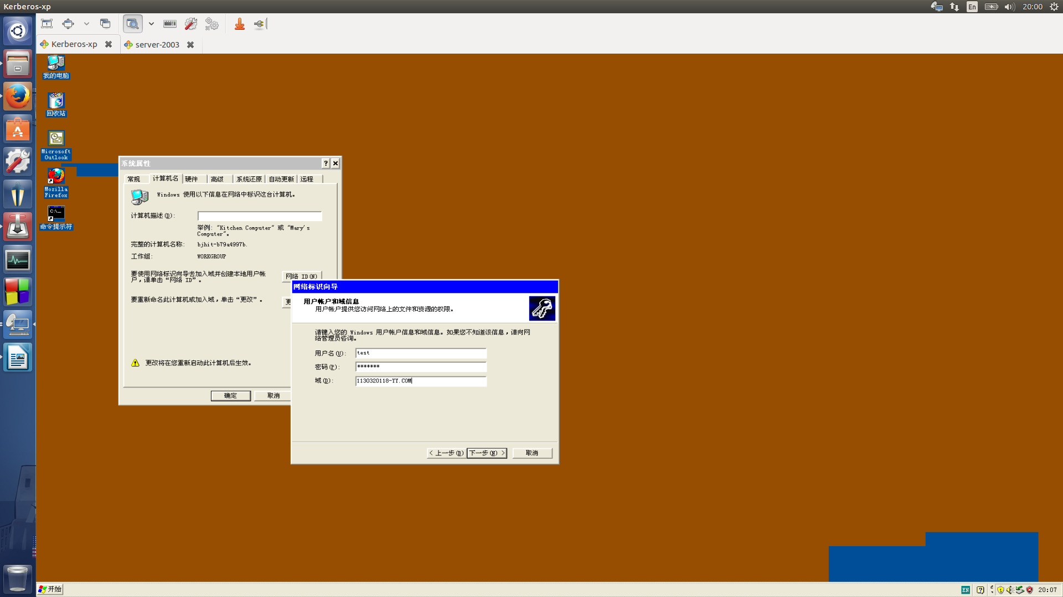

* 1. set DNS server

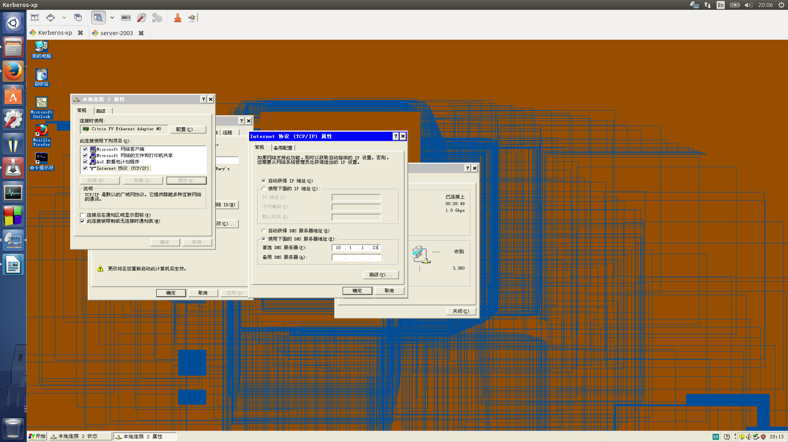

* 1. install Windows Resource Kit Tools

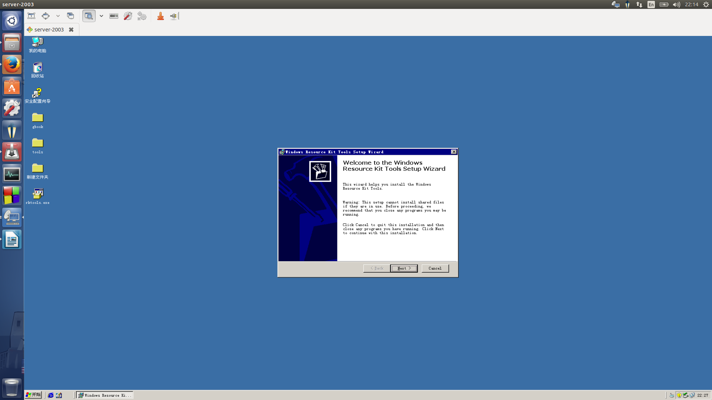

* 1. check the kerberos tickets

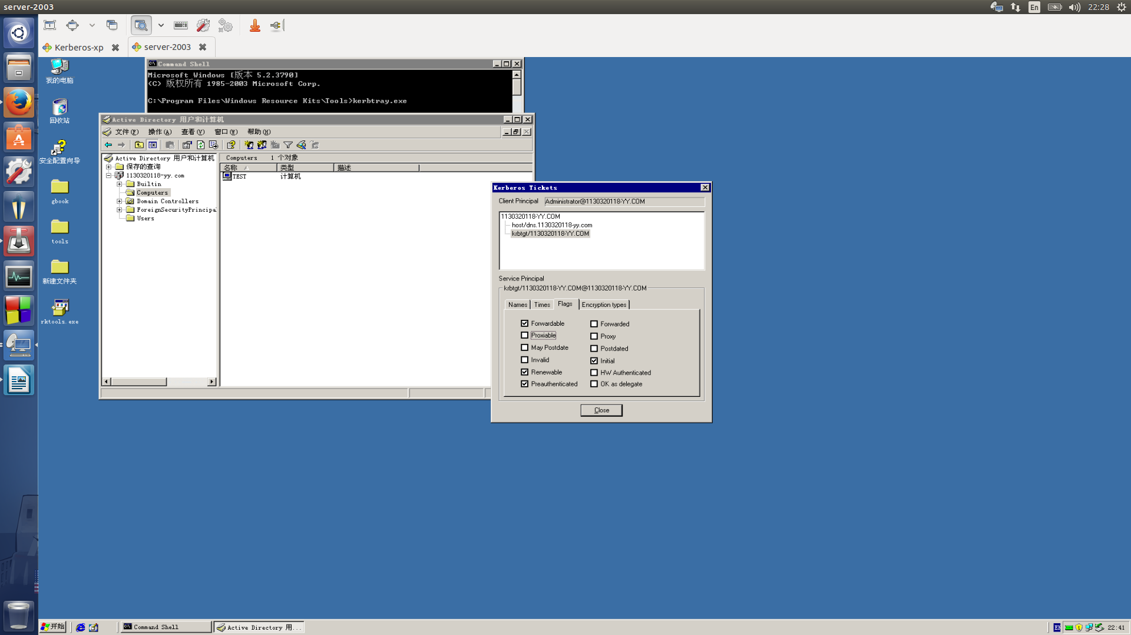

1. Conclusion

The Windows Server 2003 crash when I’m setting it.

So the Kerberos protocol has a vital problem:

if anyone make the KDC down , the hole network will stop working.