

HIT

Introduction to Information Security

Lab 3

## class：1403201

## Student number：1130320118

## Name：Yang Yi

1. Purposes
   1. Understand what is the firewall of router
   2. learn how to set the firewall , NAT and ACL
2. Procedure
   1. use Packet Tracer to build a network
      1. run Packet Tracer and add some device

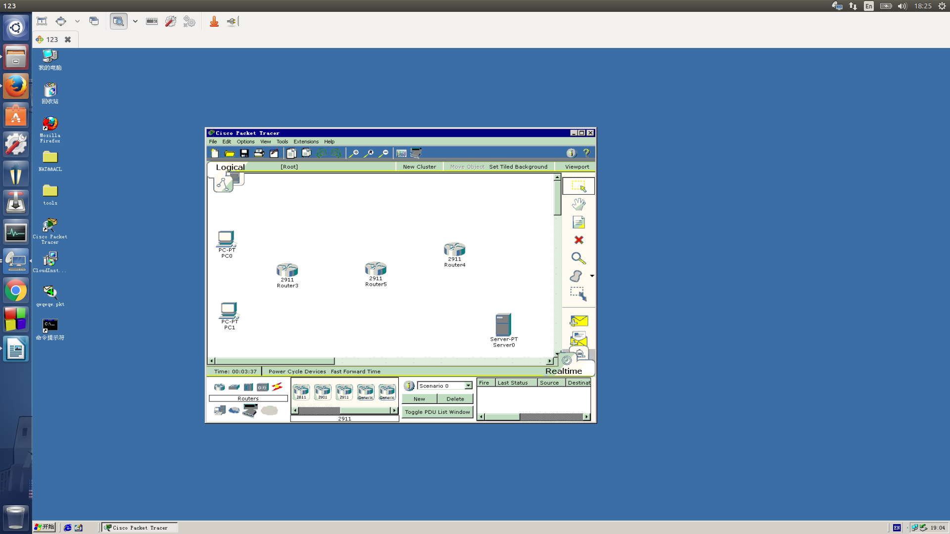

* + 1. Connect the devices

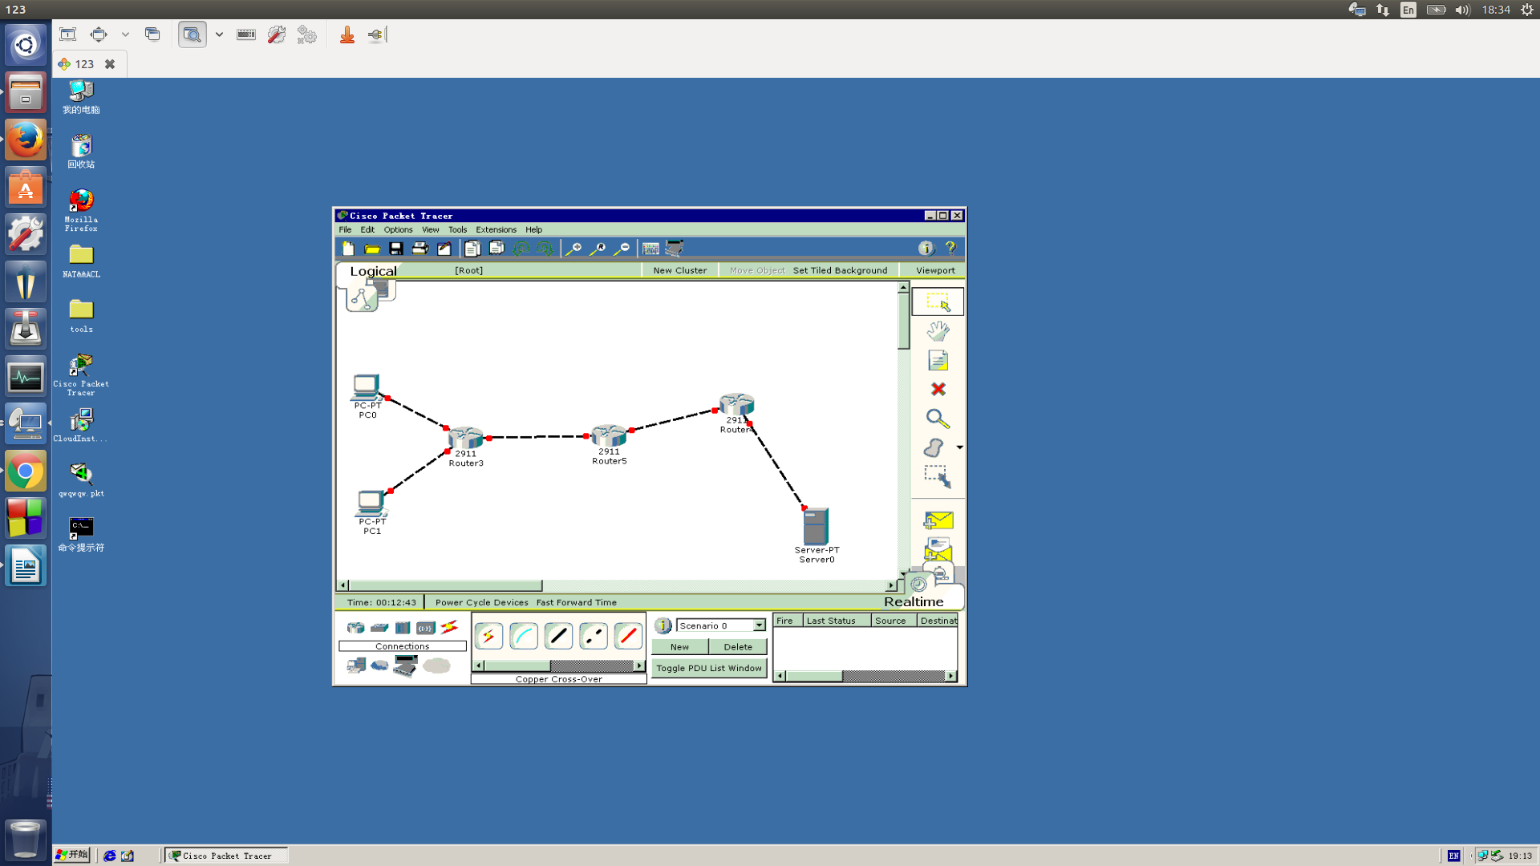

* + 1. Set IP for all devices

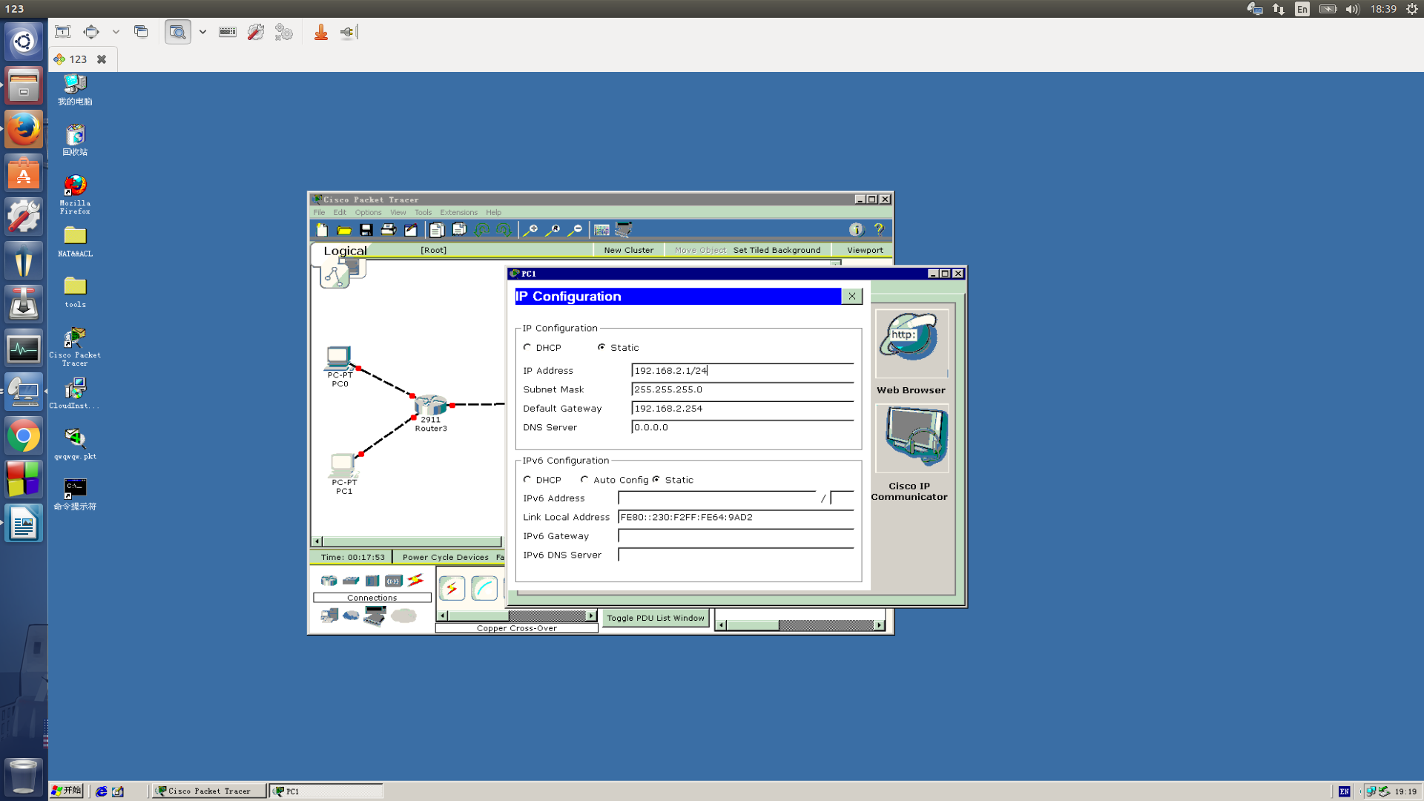

* + 1. check if the network is connected or not

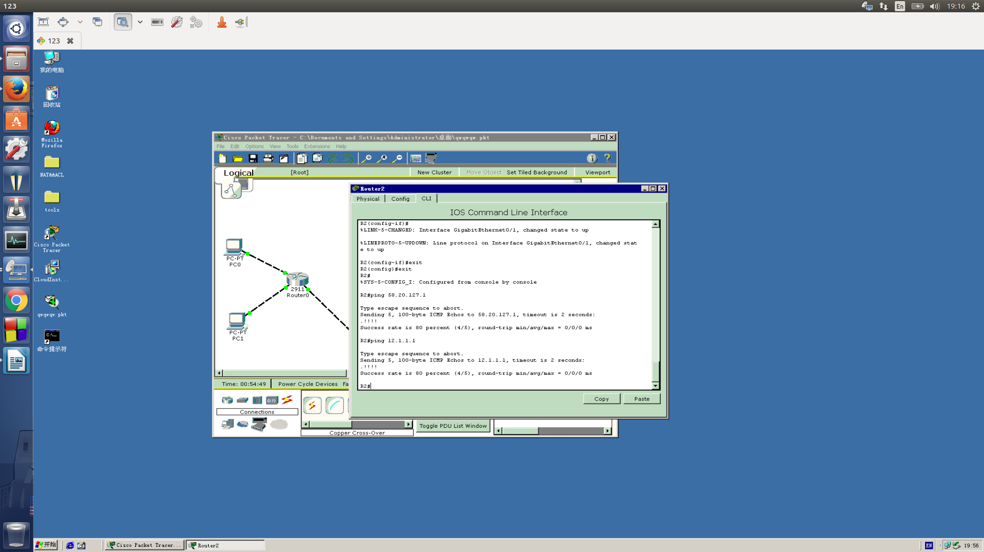

* 1. Setting NAT
     1. Static NAT
        1. Open the .pkt file

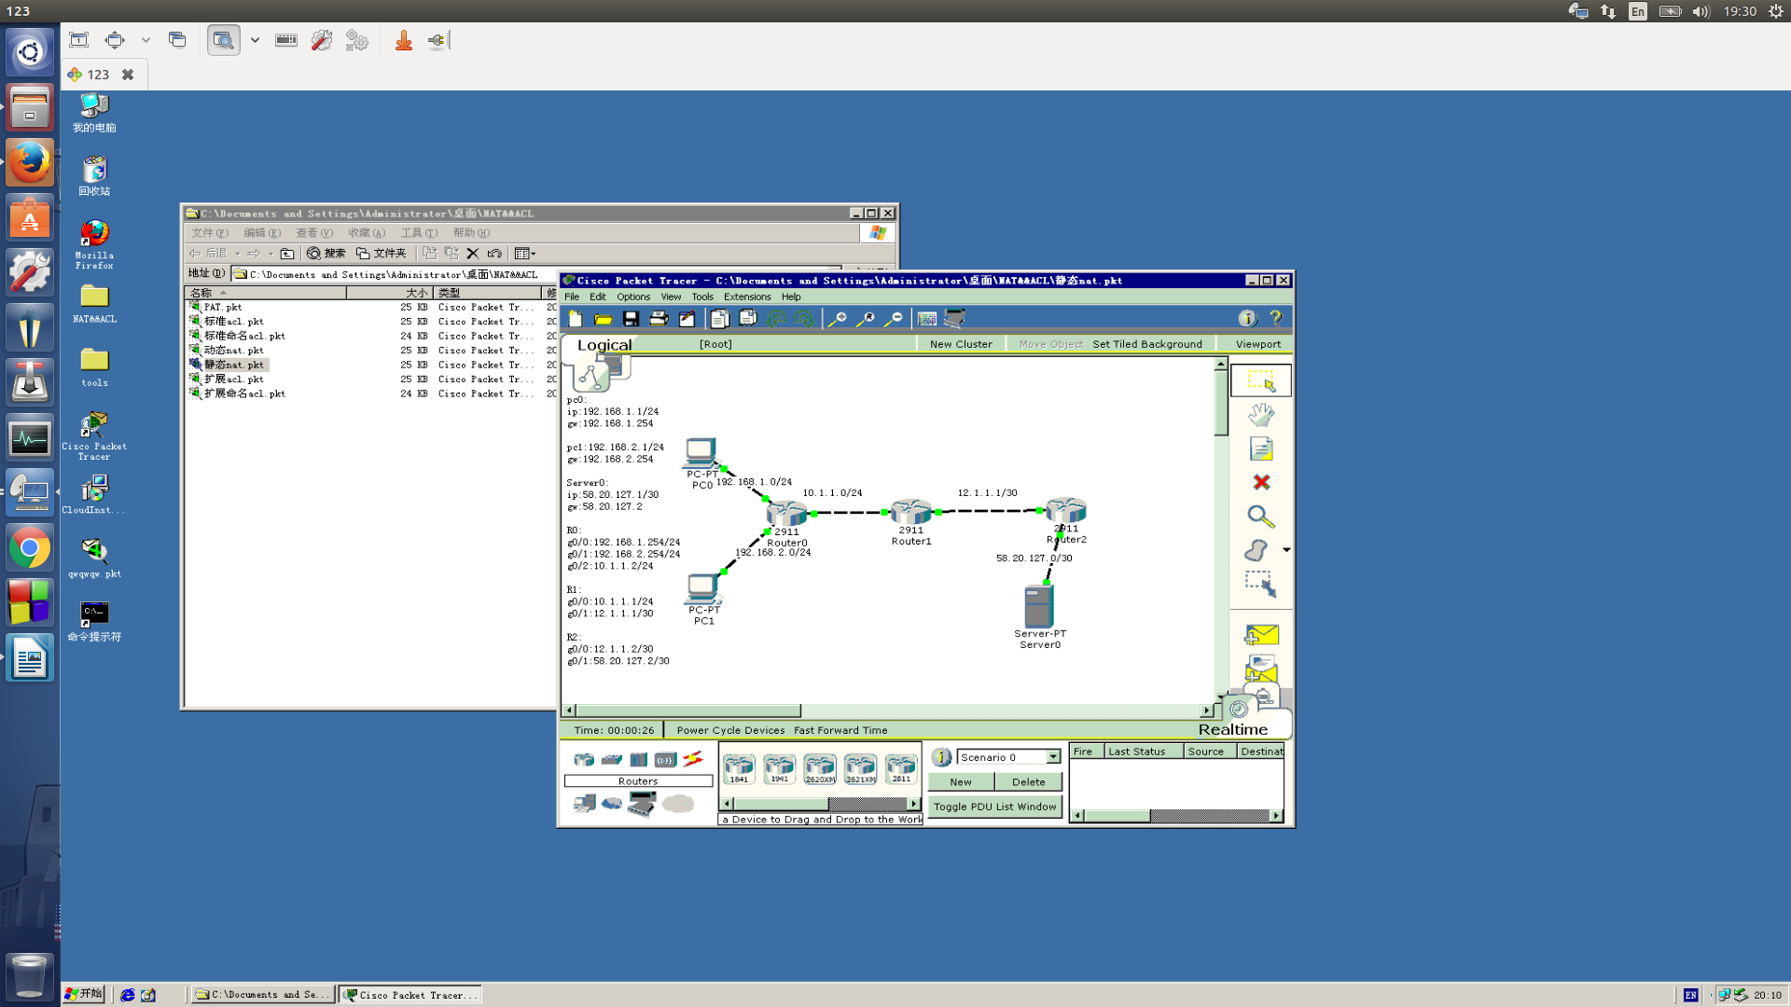

* + - 1. Set NAT and test

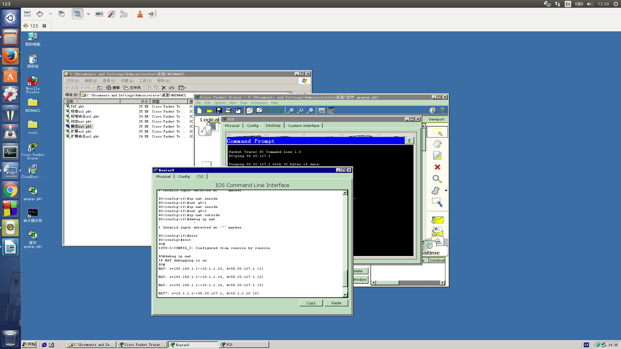

* + 1. Dynamic NAT
       1. Set NAT and test

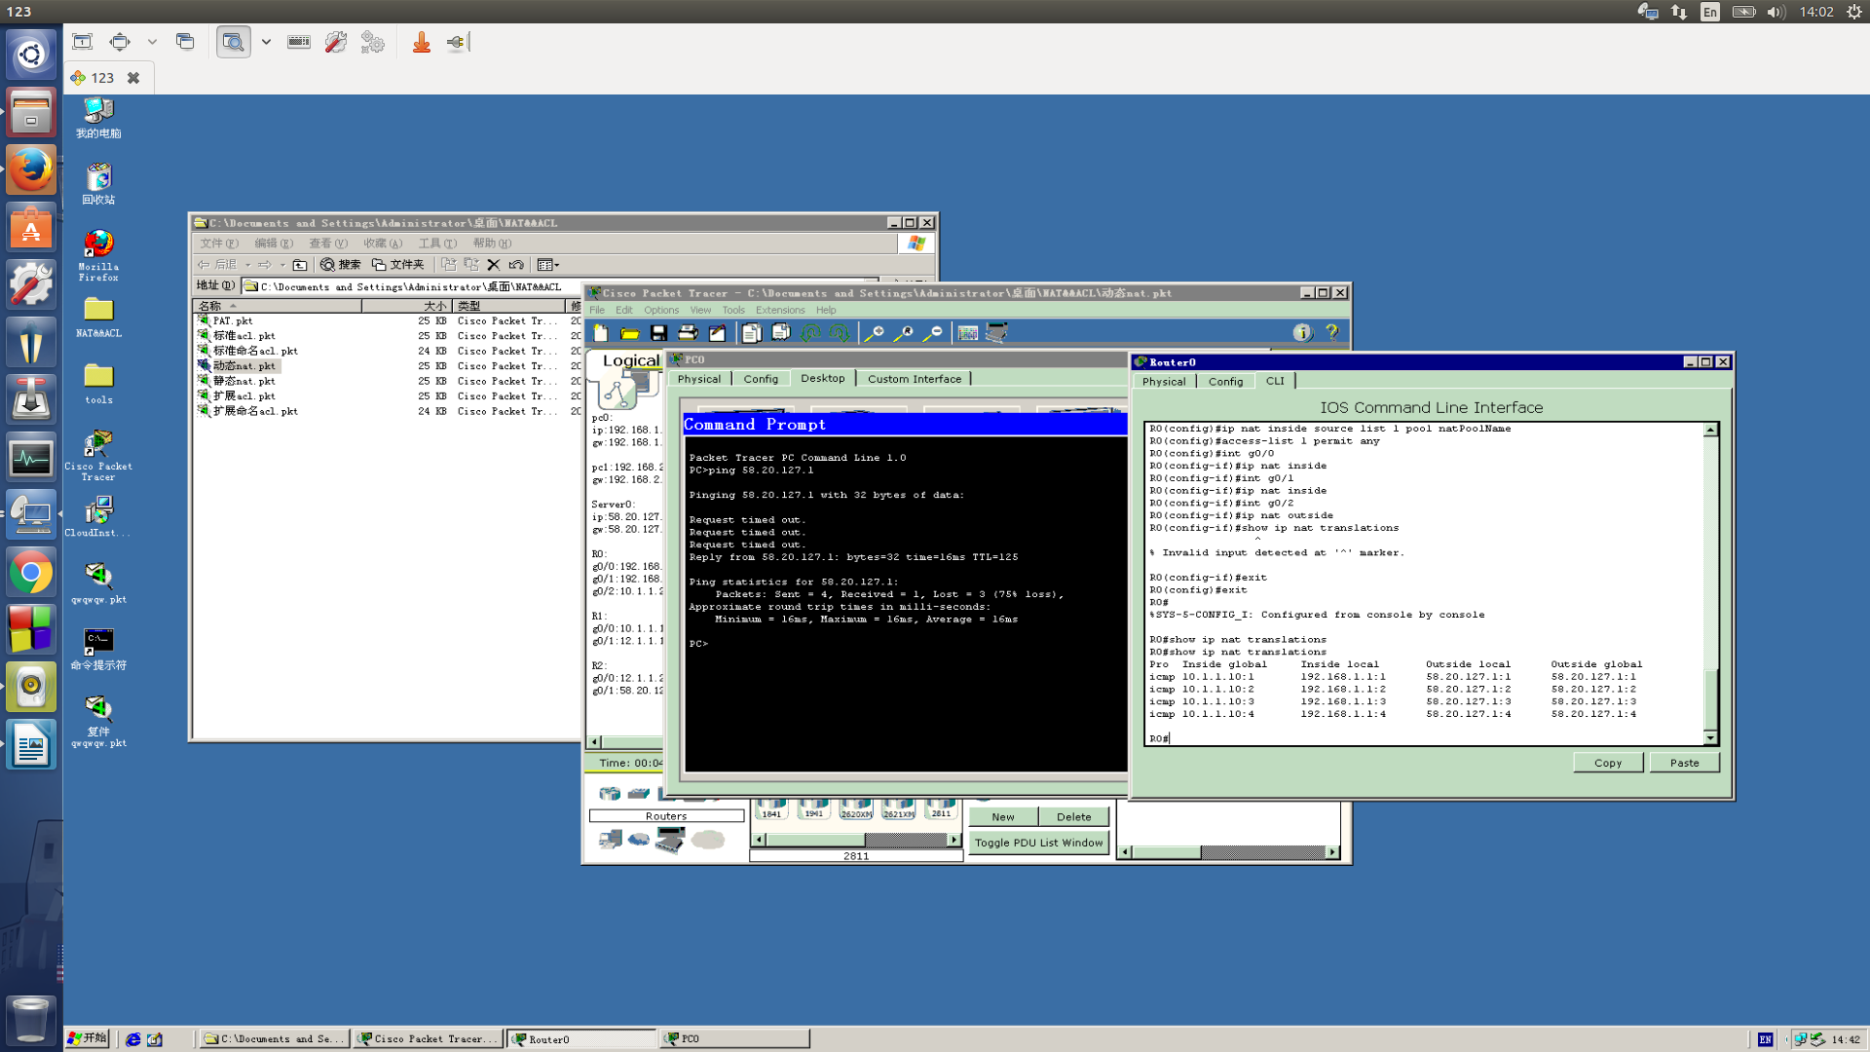

* + 1. PAT
       1. Set PAT and test

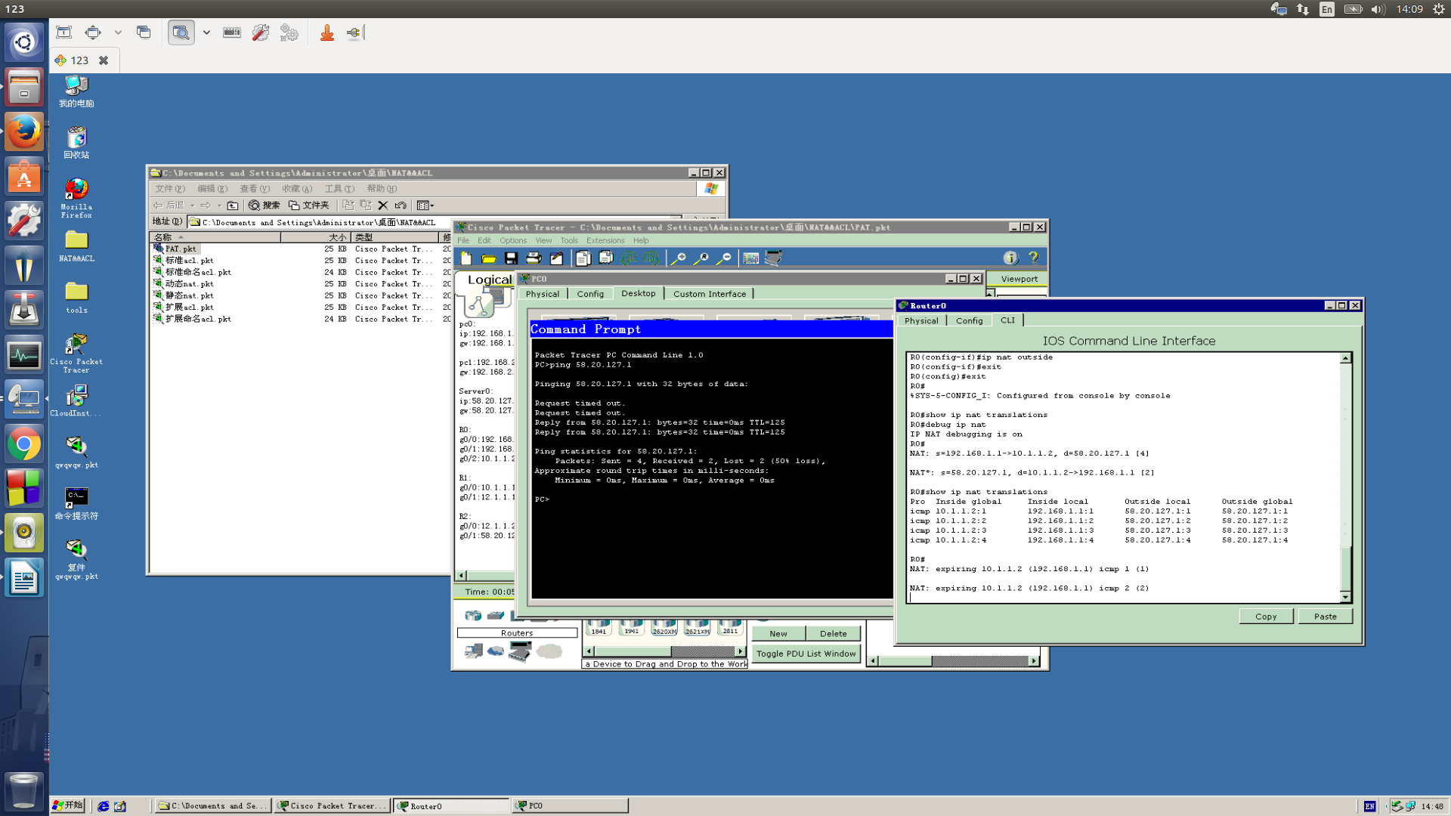

* 1. Use ACL to filter
     1. standard ACL
        1. set ACL and test

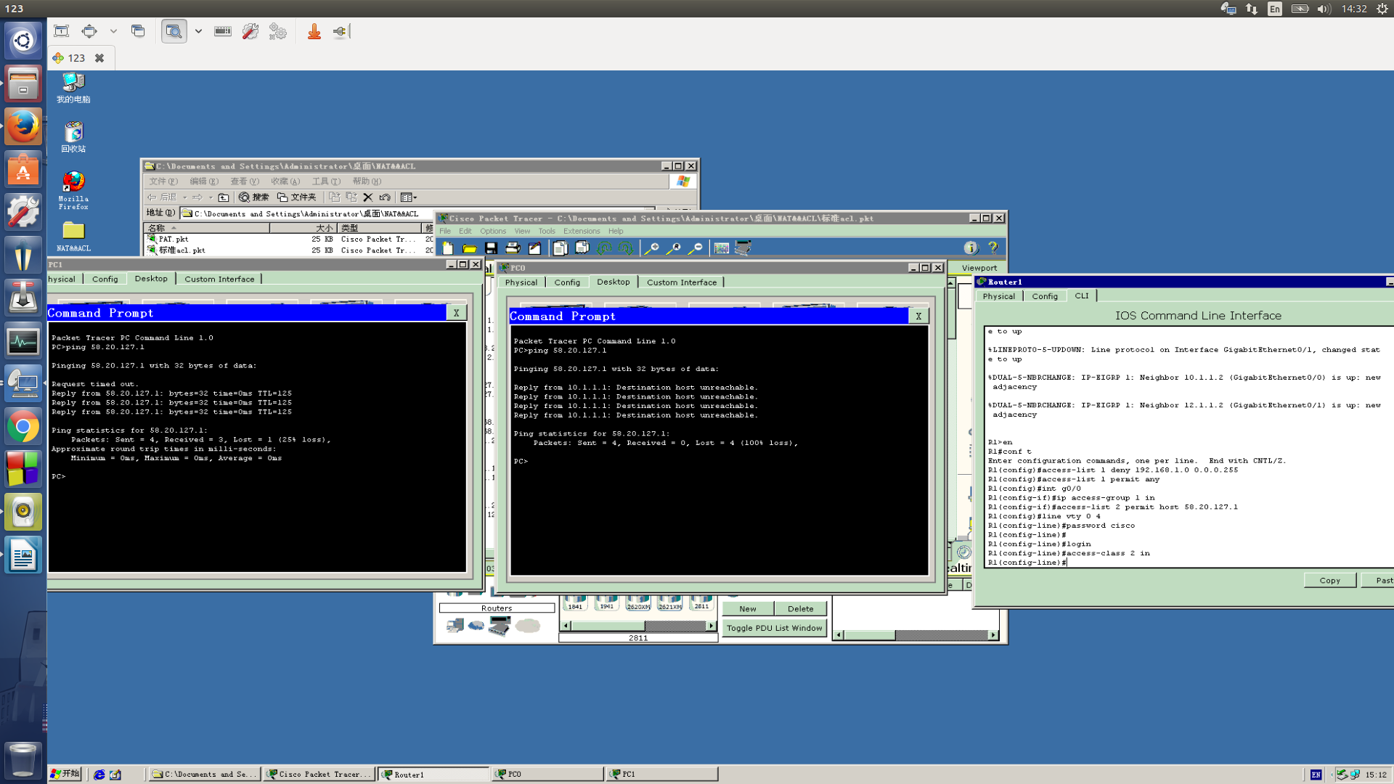

* + 1. extended ACL
       1. set ACL and test

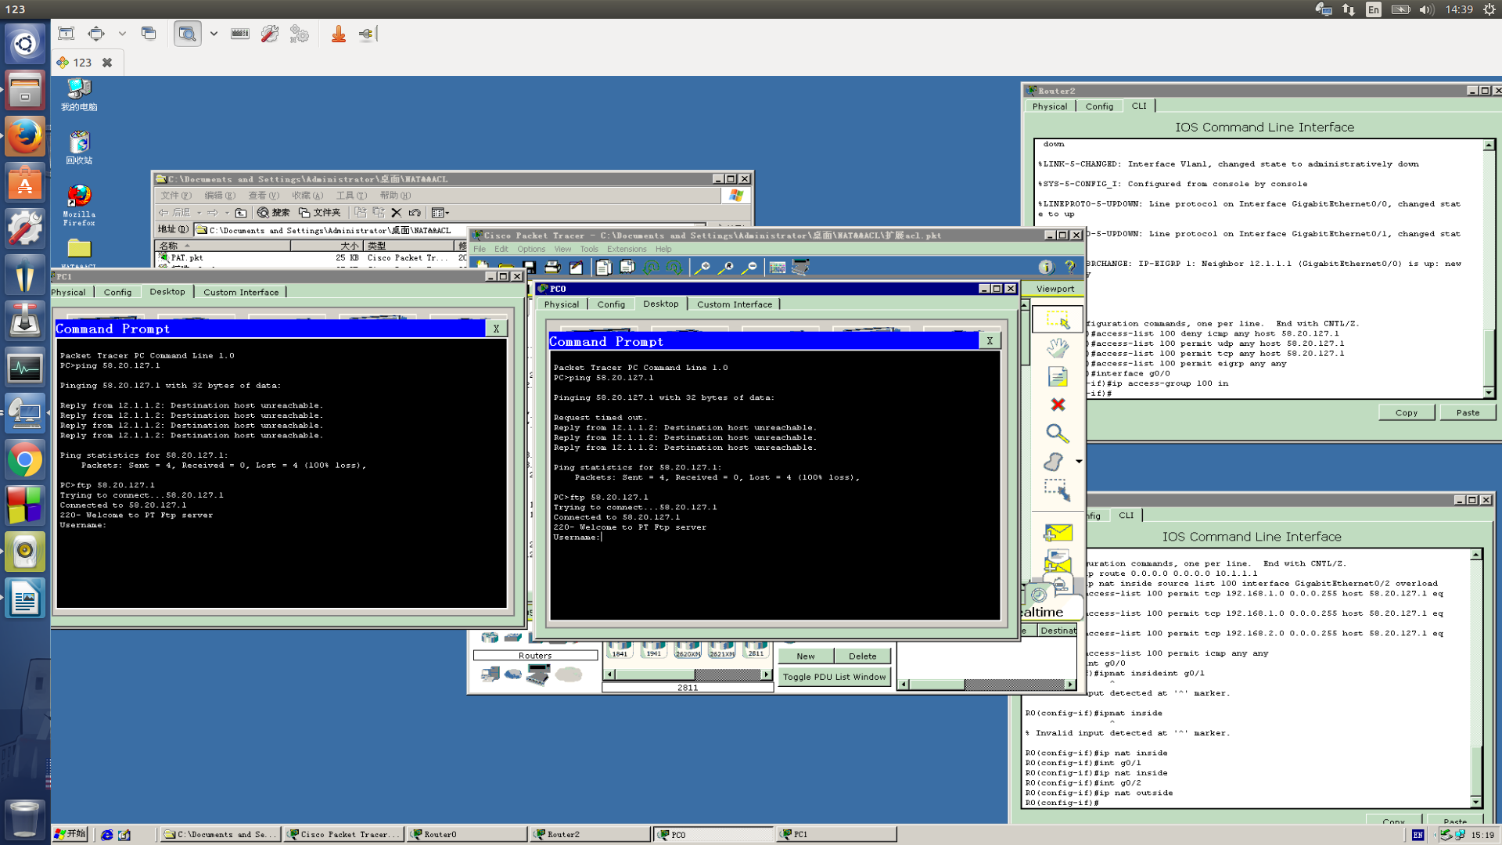

* + 1. Naming ACL
       1. set standard naming ACL and test

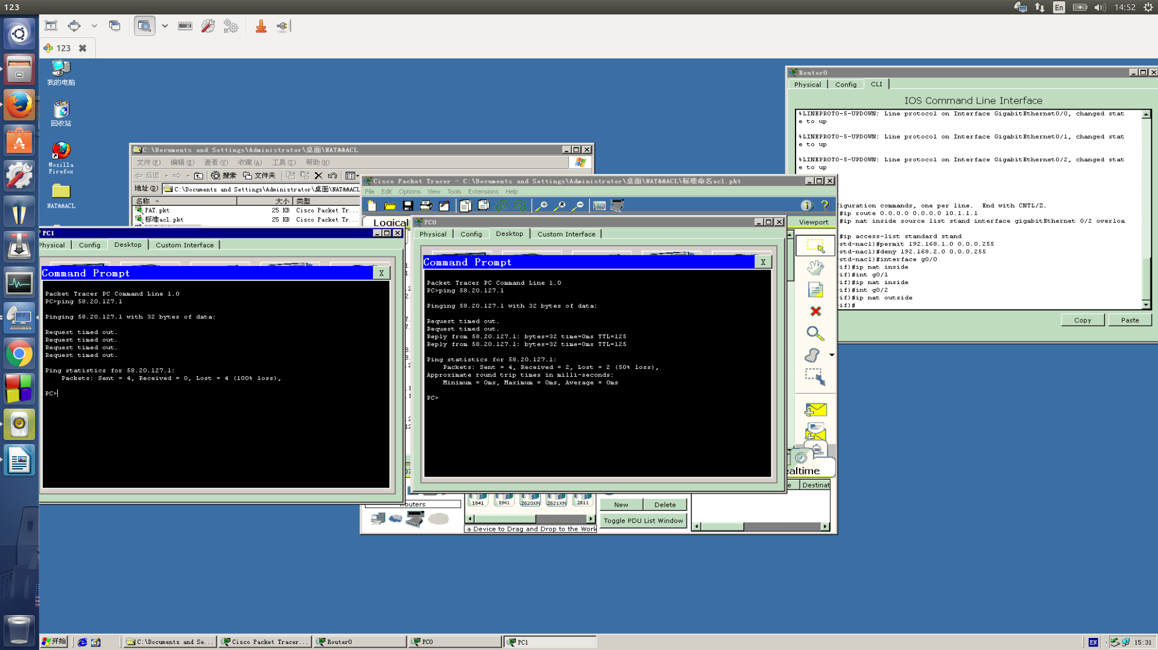

* + - 1. set extended naming ACL and test

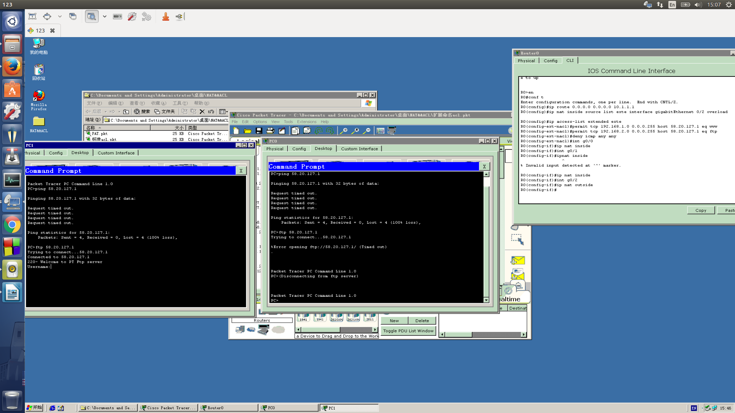

1. Conclusion

We can easily deny other’s access by setting the router , thats why China government can set a “GWF”.

I don’t understand why we’re not allow to visit google or youtube , etc.