Assignment 1

Wenyuan Wu

Ww6767w

Part 1:

1. Sometimes image noises are not as random as Gaussian noises. Additive Gaussian noises are generated based a probability distribution and therefore cannot fully represent the image noises.
2. The second derivative is f=[-0.25,0,-0.5,0,0.25]
3. f * I = [1,4,8,11,12,10,8,13,15]
4. One way is to change the threshold values. For example, when doing linking use a higher high threshold so many fine detail lines won’t be detected. Another method is to smooth the image first before running canny edge detection. That automatically remove the small fine edges.
5. Assumptions: The camera is taking images of upcoming fruits one at a time. Since the fruit is positioned randomly on the conveyor belt, taking only image’s shape into account is not enough to correctly identify the product. Therefore, in my method I am considering both the shape and texture of the product. Following are the steps.
   1. First we will have a bank of shapes and textures of all products stored in the system.
   2. Take an image of the product, using canny edge detector process to get the shape of the product.
   3. Use this shape as a template to match all the shapes stored in the image bank. This will generate a correlation score about each image. Call this score A
   4. Scan the image again to obtain its texture using filter banks. Obtain its texture and run template matching with each texture stored in the system. Obtain correlation similarity as score B.
   5. Sum up score A and B. The one with the highest score is assumed to be the product.
   6. Find its associated price and add up the total price.

Part 2:

1)

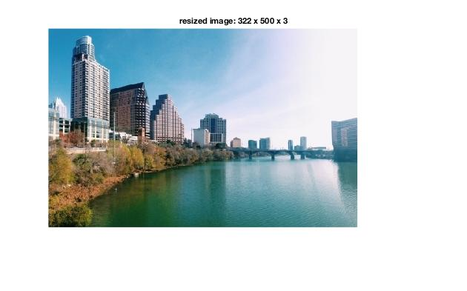

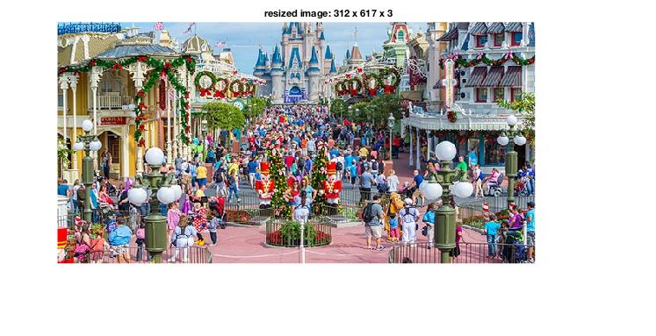

**Comments**: The Austin image has been shrink by width by 100 seams. The Disney image has been shrink by height by 100 seams.

2)

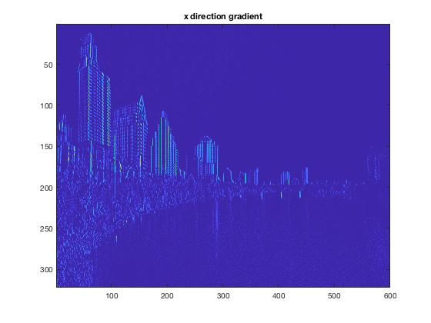

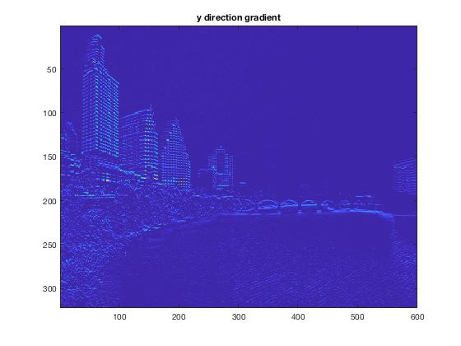

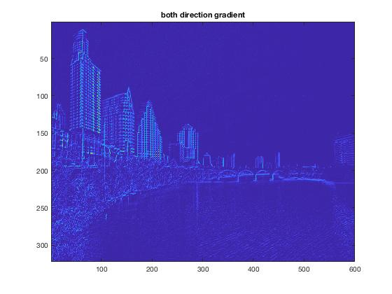

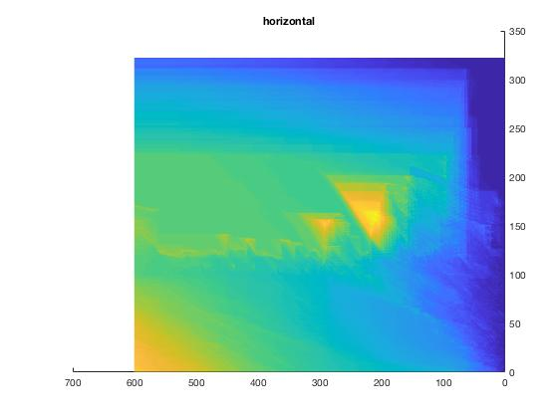

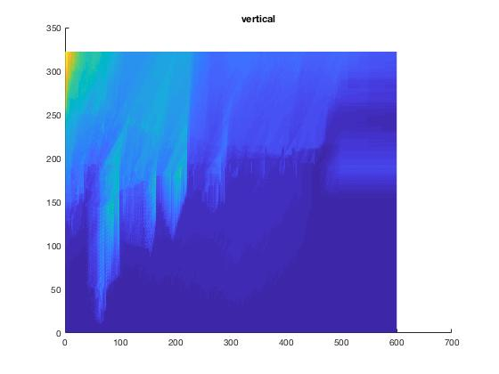

**Comments**: The first energy function filter takes the pixel value, minus the value of the left pixel, and replace that result as this pixel’s value. As a result, the first energy filter is better at displaying vertical energy gradients. On the contrary, the second energy filter produces more horizontal lines since it takes the difference of two vertical pixel values. The last energy filter is a combination of both so it shows both directions’ gradients. The last two images are the cumulative energy of the image.

3)

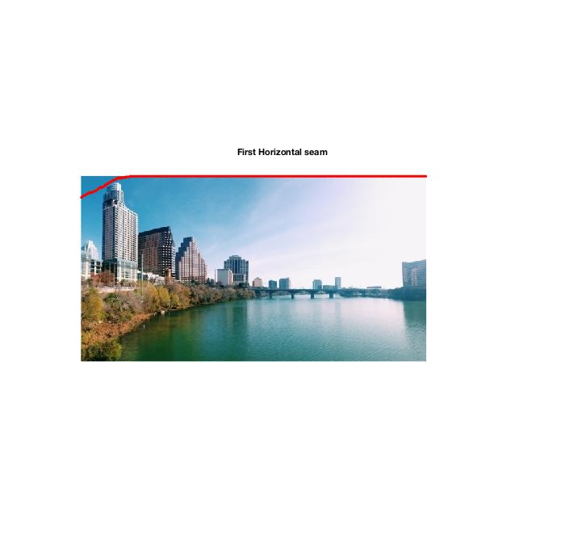

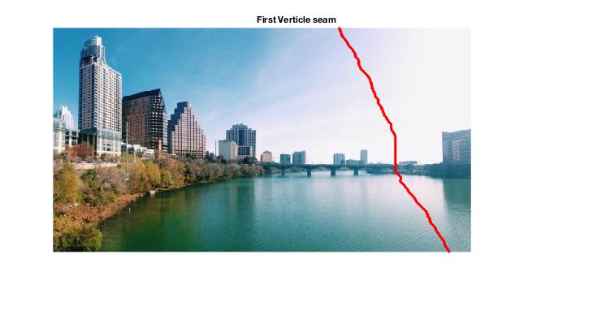

**Comments:** These two seams are optimal because they each consists of pixels with the least sum of the gradient energy. It is also visually convincing because they two lines barely touch any interesting objects like buildings or bridges. The seams tends to be consisted of as much cloud or sky as they can.

4)

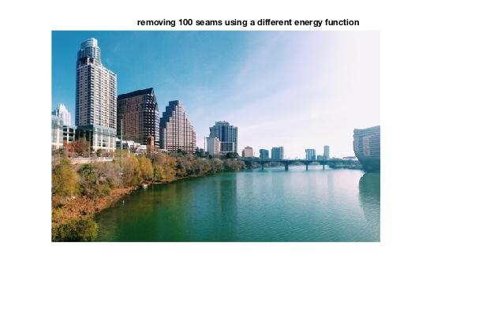

**Comment:** This is the result of using a different energy function filter. Now each pixel’s energy gradient is the absolute value of the difference of two neighbor pixel values (both x and y direction). The result is worst. For example the above result is austin.jpg after running reduceWidth 100 times. The building on the far right is much more distorted.

5)

Image 1

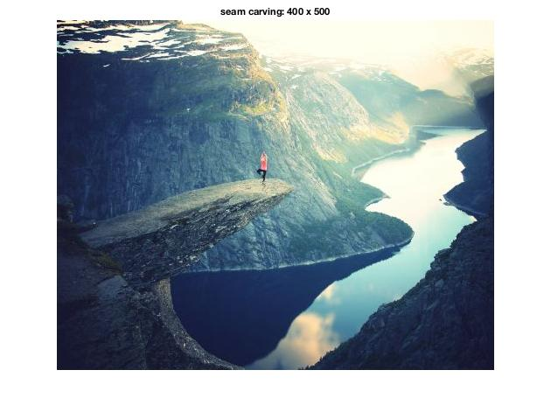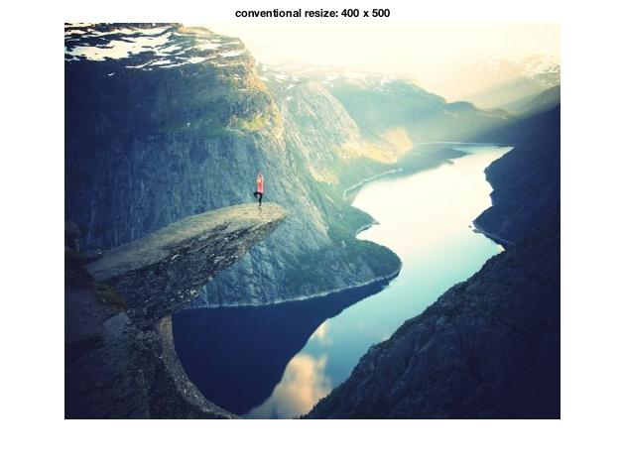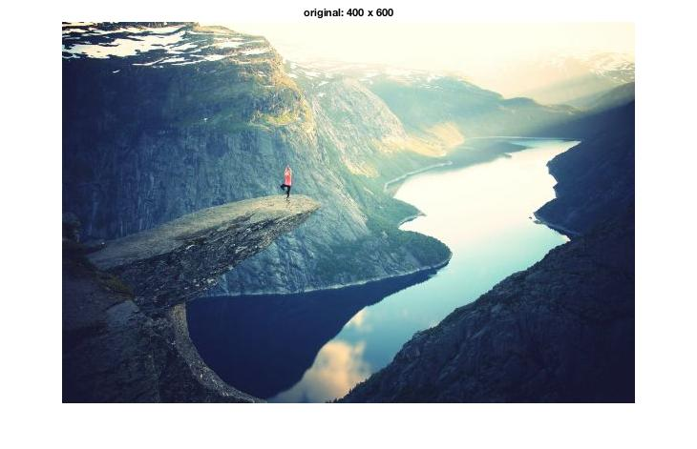

**Comments**: Above are the original image, the seam carving image (shrink the width by 100 pixels), and the conventional resizing image with same dimension as the seam carving. Here the seam carving image performs better than the traditional resizing because it preserves the shape of the river by taking out the mountain on the right side which is less interesting.

Image 2

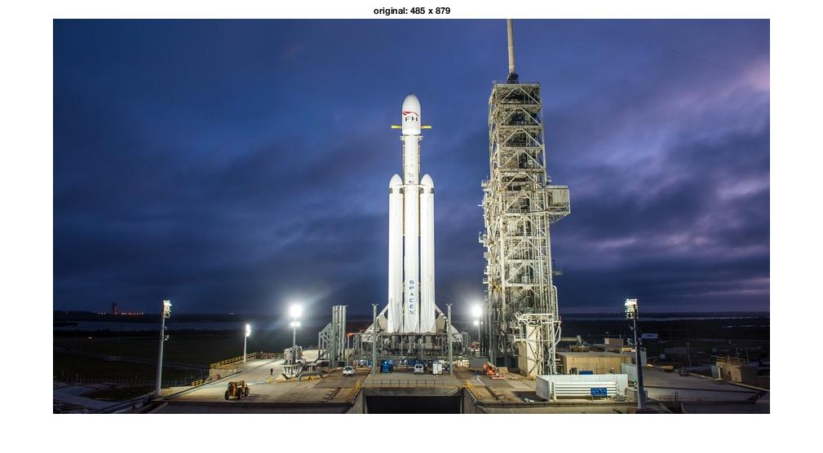

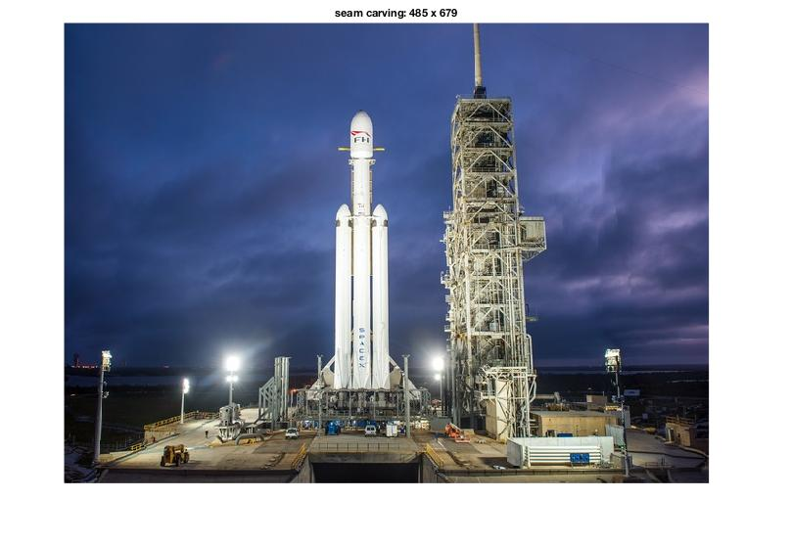

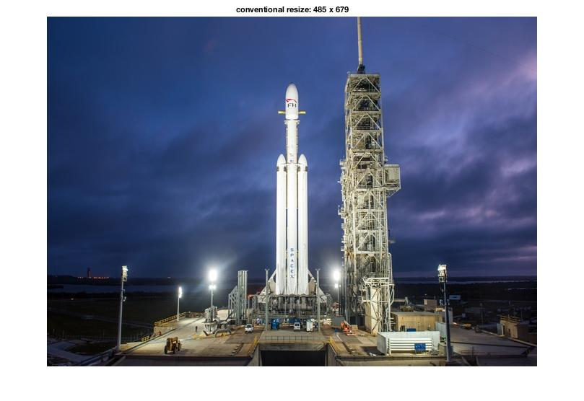

**Comments**: Seam carving removed 200 vertical seams while conventional resizing shrink the width by the same amount. Again the seaming carving image is better because the rocket is not distorted. What has been carved out was the background sky. Whereas in the conventional resizing image, the rocket is skinny and looks unreal.

Image 3

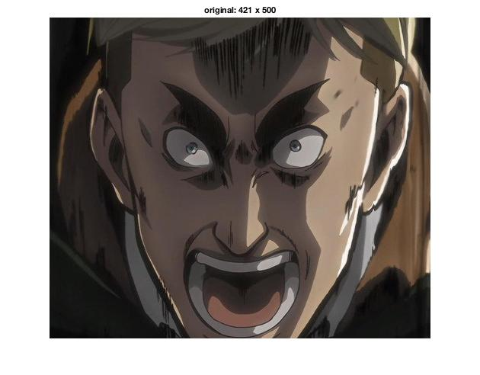

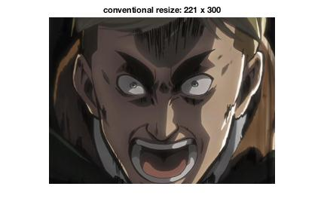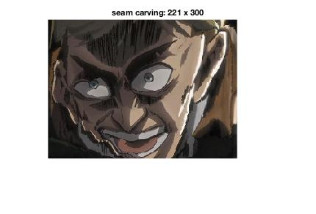

**Comments**: Here is an example where seam carving is in its disadvantage. The seam carving image first removed 200 pixels in width and then 200 pixels in height. The person looks very distorted with much of his face carved out. Whereas the conventional resizing image retains the same facial detail as the original one. In conclusion, seam carving works better with scenary images but not with images where most part of which is essential.

**Extra Credit**: (Question 3 & 4)

Q3: I used a modified method of reduceWidth where I inserted the least energy gradient seam into the image at the same location. For 100 seams, the same seam is inserted over and over again. Here are some results for austin image.

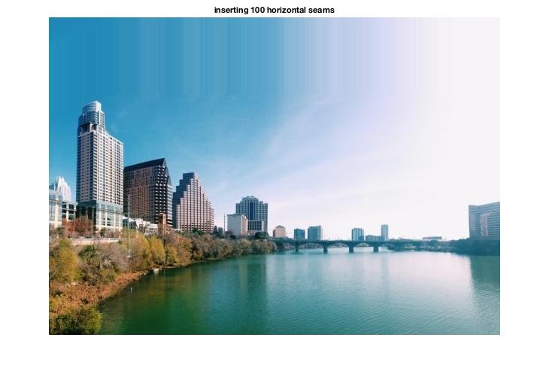

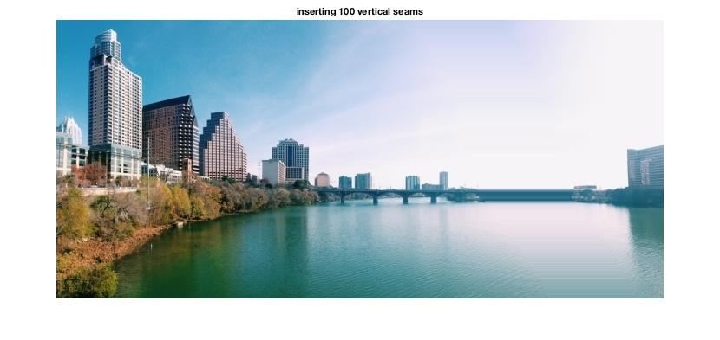

Q4:

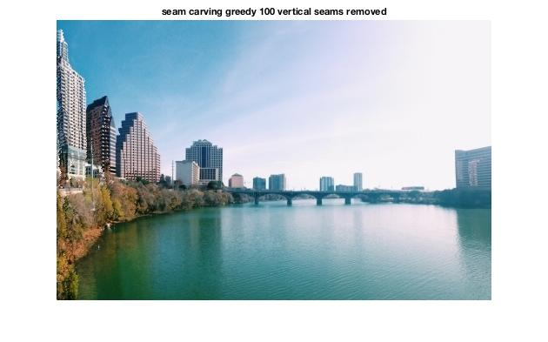

**Comments**: Assuming we are talking about vertical seam carving. The way I implement my greedy algorithm was to run through each pixel in the first row. Find the pixel with the lowest gradient energy. Pick that pixel as the starting seam. Run downward and pick the lowest energy seam of the 3-connect neighbor below. When the algorithm finishes, the chosen may not be the one that has the overall least gradient sum. The result is much worse than the one from doing DP. But it will be faster since it is greedy.