Cosc363 – Alien Theme Park
Luke Burling – 46662217
Brief Description:
The scene includes a large Ferris wheel directly infront of the camera that an alien climbs on and off periodically. Directly behind the camera is an Ice-skating rink with an alien sliding about on the ice.
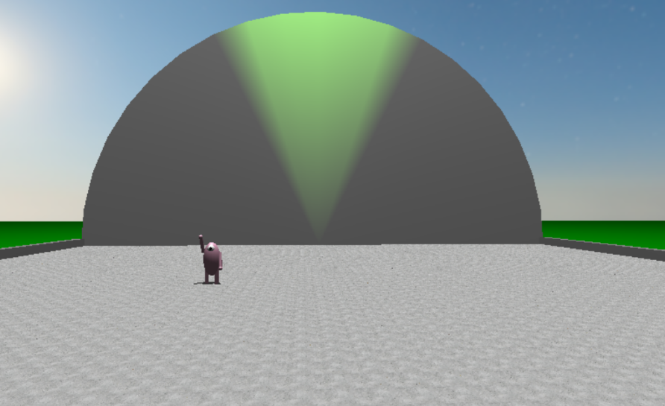
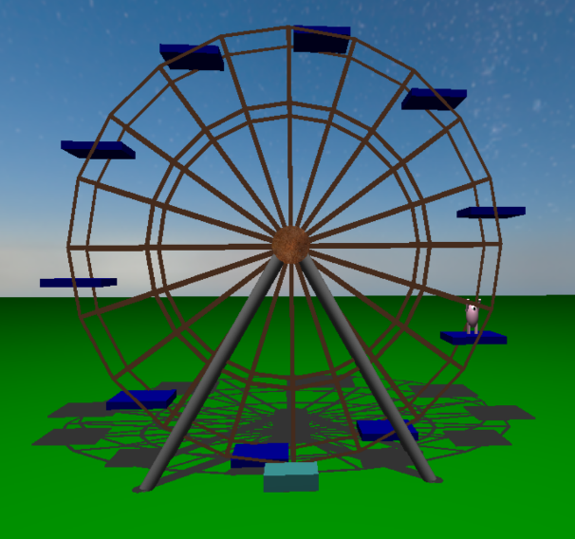
Extra Features:
- Planar shadows are cast by: Ferris wheel and seats, Ice Rink walls, skating Alien
- The Skating Alien moves around in a complex path (See below for equation)
- An Alien gets on and off the Ferris wheel without teleporting
- Dynamic spotlight on the back wall of Ice rink, changes colour and direction
- Smooth user movement in all directions
- The large semi circle at back of the rink is a sweep surface. The top is made of Quad strips, and two Triangle fan shapes for the front and back faces.

Equations:
The Semi circle sweep surface was simply made of using an Circle equation, but only half of it:
X = R * cos(Theta), Y = R * cos(Theta), Z = {0, 5}, Theta = i * pi / NUM_SEGMENTS

The complex motion of the Ice-skating alien is given by the Parametric equations:
X = 1 + (0.3*cos(4*t) + 0.2*sin(7*t)) * cos(t), Z= 1 + (0.3*cos(4*t) + 0.2*sin(7*t)) * sin(t),
Y = 0.8, {0 < t < 5}
2D Graphical representation of movement path:
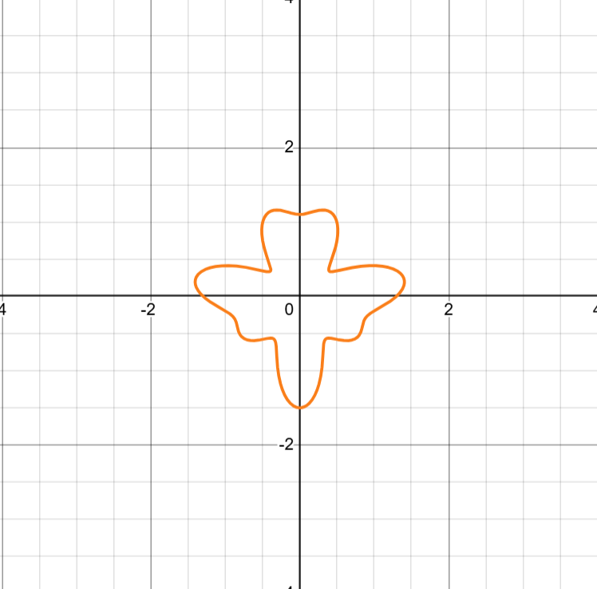
Control inputs:
- Q, q – Toggle wireframe
- Pgup, PgDn - Move up and Down
- Arrow keys – Move camera around
Build Commands:
Compile Command:
g++ Alien.cpp Animation.cpp Ferriswheel.cpp Iceskate.cpp Themepark.cpp -lglut -lGLU -lGL -lm
This Assignment was developed on Windows machines running Visual Studio Code and Cmake. When going into Uni to compile, the scene would be flashing in and out of rendering. The animation would also be running slow, like it was struggling to output 60FPS. This doesn’t not happen on my low spec Windows Laptop (Running through cmake, Or using WSL and compiling with above command), and gaming PC at home. So I can only assume this is a problem with the Lab computers, and out of my control.
References:
The Ferris wheel is loaded through an OBJ file created by me in Blender. All textures (Metal.tga, Skybox.tga, Ice.tga) were all obtained from Poly-haven, and are license free. The OBJ file loader was obtained from https://github.com/opengl-tutorials/ogl, Which states it is free to use.
AI Statement:
Ai was used in this assignment for purposes of debugging code, And helping to find functions without having to comb through the OpenGL Librarys.

I declare that this assignment submission represents my own work (except for allowed material provided in the course), and that ideas or extracts from other sources are properly acknowledged in the report. I have not allowed anyone to copy my work with the intention of passing it off as their own work.
Name: Luke Burling
Student ID: 46662217
Date: 27/03/2026

