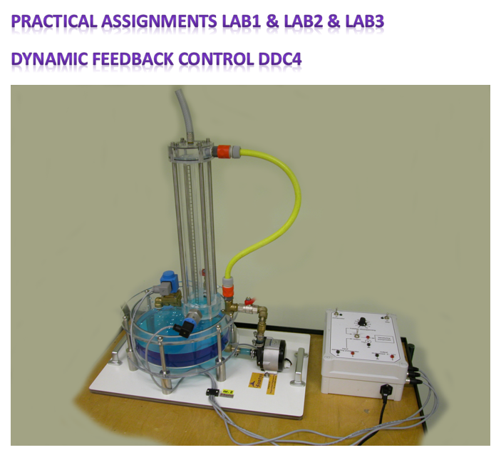

**Fontys University of Applied Sciences**

Mechatronics Engineering

Name: Luc Melis, Byron Greene

Student number: ( ), 3879518

Date: June 18, 2023

Version: 1

Class: MC2A

Practical Group: B

# Lab 1 Assignment

## Graph 1

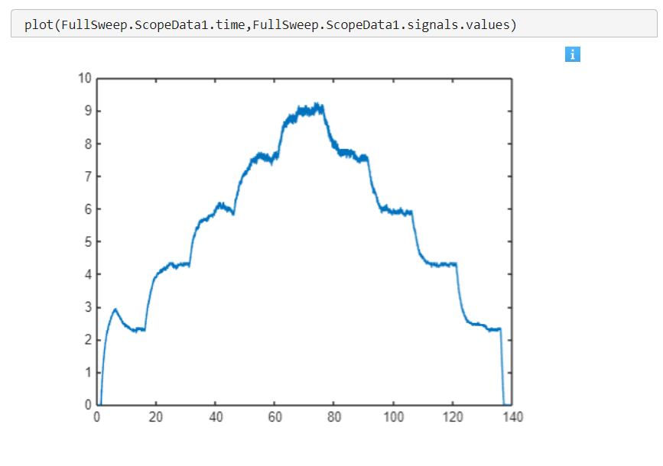

**Graph 1. Full Sweep Done Externally using MyDaq**

## Graph 2

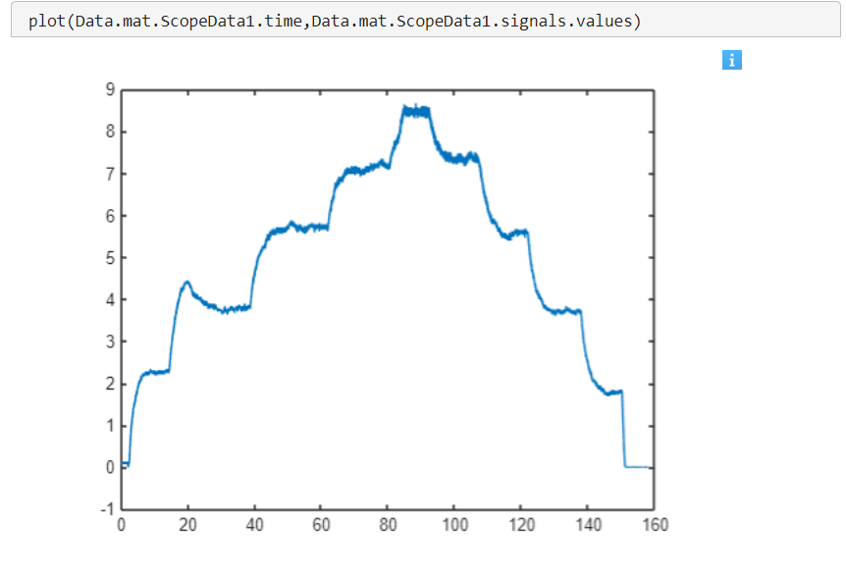

**Graph 2. Full Sweep Done Internally using Control Box.**

## Graph 3 (0-10 mat)

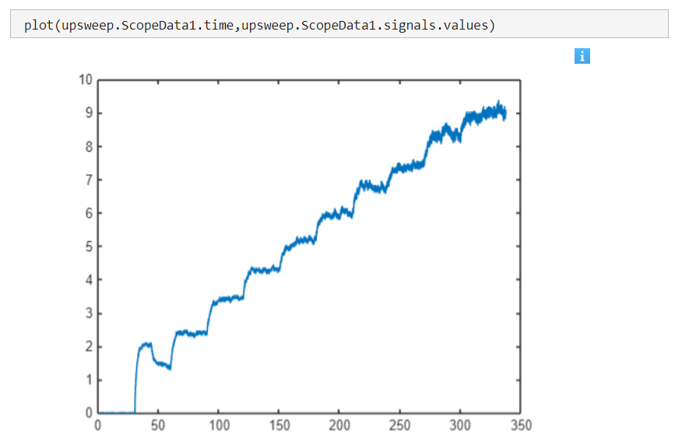

**Graph 3. Full Up Sweep**

## Graph 4

**Graph 4. Displaying a Full Rise from 0V to 10V.**

## Results from Lab 1.

Make sure to have correctly worked out your measurements *and* obtained the process parameters below:

* The process amplification **Kp**= 1.05
* The time constant **τ** = 2.804 seconds
* The offset on the process line (see the steady state input output graph) 0.115V
* The maximal and minimal values of the output (process limits): **MIN** = 1.206V, **MAX**=8.79V
* The linear work area of the process (not needed for Simulink interpretation): from …… V to ……V

For each of the 5 upwards and 5 downwards step responses you might get a different amplifications and time constants (thus in total 10 different amplifications and time constants). In fact, you only need 1 good representative amplification and time constant. A good method would be averaging up those amplifications and time constants but first make sure that the numbers that lie far away are not taken into the averaging. Because you find one transfer function that is valid for the response inside the operation region.

**Results for Time constant & Gain**

|  |  |  |  |  |
| --- | --- | --- | --- | --- |
| **Input** | **Output** |  | **Time Constants** | **Gain** |
| 0 | 0 |  |  |  |
| 1 | 1.4355 |  |  | 1.4355 |
| 2 | 2.414 | 1.4484 | 2.26 | 1.207 |
| 3 | 3.535 |  |  | 1.178333 |
| 4 | 4.262 | 3.5228 | 3.29 | 1.0655 |
| 5 | 5.15 |  |  | 1.03 |
| 6 | 5.92 | 5.2568 | 2.89 | 0.986667 |
| 7 | 6.53 |  |  | 0.932857 |
| 8 | 7.425 | 6.823 | 3.29 | 0.928125 |
| 9 | 8.129 |  |  | 0.903222 |
| 10 | 8.79 | 8.244 | 2.29 | 0.879 |
|  |  |  |  |  |
|  |  |  | 2.804 | 1.05462 |

**Avg Time constant =**  2.804 seconds

**Avg Gain =** 1.05462

## Graph Linear

## Simulink Block Diagram

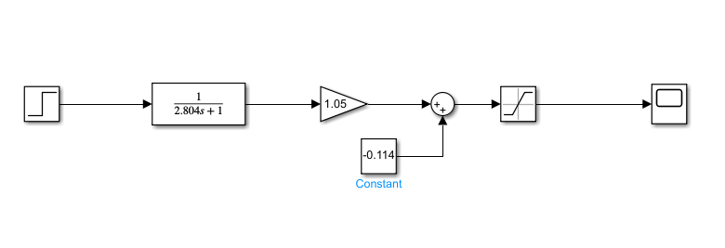

# LAB 2 Assignment

## Put experimental graphs on top of the simulated graphs to show the (mis)match. This might require some time to send all the data to MATLAB Workspace and manipulating the data in such a way that the curves are next to each other visually.

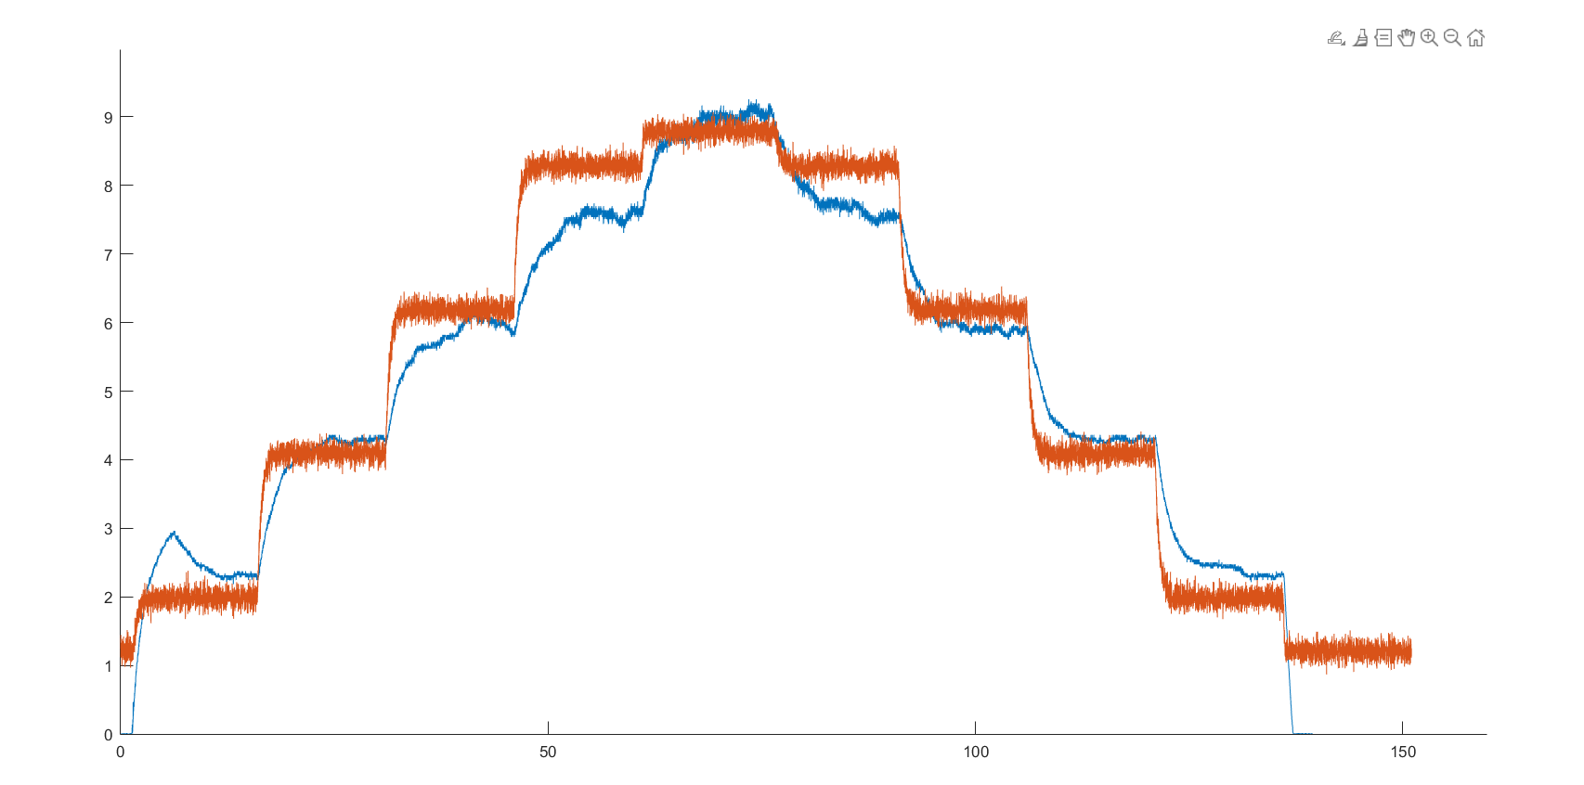

## To make your model represent the reality better, add some noise at the output and use saturation blocks where necessary because the actuation and measurement has limits.

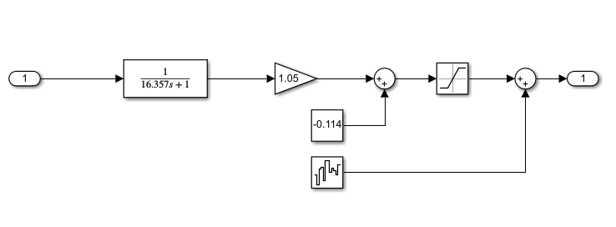

## Make a simulation of the P-controlled process. Comment on how realistic the simulation is with respect to the reality. Make sure your simulation graphs contain the reference, process output and the regulator output as shown below.

# LAB 3 Assignment

## PID- Controller Simulink Setup

## Simulated results of Constructed PID controller.

Build and experiment with PI, PD, and PID controllers. What are the roles of P, I and D controllers in this system? What are the best values you tuned for $K_{p}, K_{i},$ and $K_{d}$? How do the experiment results compare to simulated results?

1. **Roles of the P, I, D controllers.**

**P-controller**

The P-controller function in this system helped in reducing the steady- state error by adjusting the magnitude of the error from the input signal.

**I-controller**

The I-controller was responsible for eliminating the steady state error that could not be corrected by the P-controller alone. Once the error was detected the I- controller slowed the rate at which the voltage value approached the reference value. This trade of slowed the system down but resulted in non-oscillating reference value with no initial overshoot.

**D-controller**

The D- controller in this system focused on the rate of change of the error. It calculated the derivative of the error with respect to time and then generate a signal based on the rate of change. However, this was causing a significant over shoot and the D- controller was not turned off but instead limited to a very minuscule value of either zero(0) or **1x ${10}^{-10}$.**

1. **Best tune Values for $K_{p}, K_{i},$ and $K_{d}$.**

|  |  |  |  |
| --- | --- | --- | --- |
| **Tune Combination** | $$K_{p}$$ | $$K_{i}$$ | $$K_{d}$$ |
| **1** | **2** | **0.25** | **0** |
| **2** | **2.5** | **0.5** | **1x ${10}^{-10}$** |
| **3** | **2.5** | **2** | **1x ${10}^{-10}$** |
| **4** | **2.5** | **1.8** | **1x ${10}^{-10}$** |

**Combination 1 Tune Result**

-Reaches close to the selected 5V input. However, falls slight short below the 1% error.

**Combination 2 Tune Result**

-Reaches the 5V selected reference with no overshoot.

**Combination 3 Tune Result**

-Reaches the reference value with a slight overshoot below 10%

- Oscillates for a period of 1 Simulink second.

-However, Reaches the reference faster than previous tunes.

**Combination 4 Tune Result**

-Reaches the reference value the fastest.

-No overshooting above 10%.

-Consistent results for multiple reference Voltage values.

**C) How do the experiment results compare to simulated results?**

## Experimental performance summary.

Write down the experimental performance summary of the closed loop system. In other words, what are the achieved settling-time, rise-time, overshoot, steady state error, peak time?