**Study Report: Build A Blockchain**

Daniel van Flymen’s article is well written, it puts things of building a blockchain on such a clear way that it is easy and straightforward to understand. Following the teaching tutorial, I built a simple blockchain from scratch step by step as follows:

1. Open Visual Studio Code and create a python file *blockchain.py* (as attached), in this file I create a Blockchain class to manage the chain and to store transactions.
2. Create the *genesis* block and represent the blockchain; implement a similar algorithm of Hashcash for the blockchain; forge the new Block by adding it to the chain.
3. Interact with the Blockchain class over web using HTTP requests. Open my server and inspect the *genesis* block for this coin with random name as following:

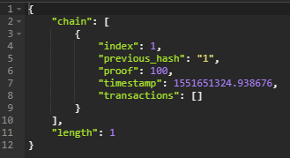

After mining a block by making a request, I inspect the block chain as following:

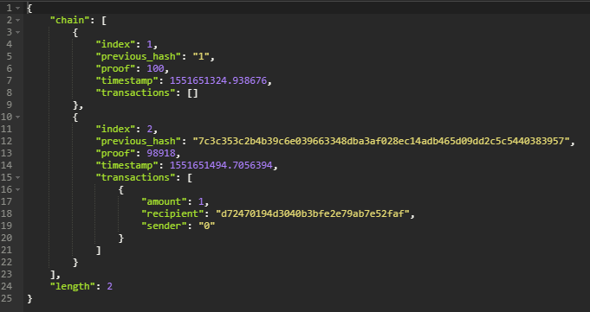

Again, I mine a new block and the block chain is as following:

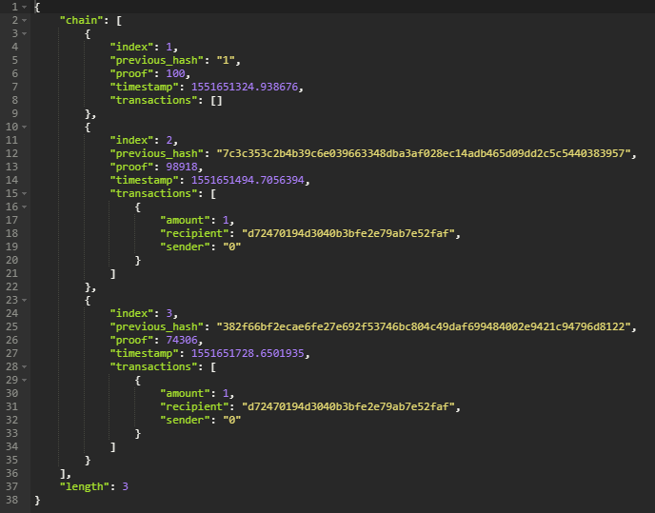

Then I create a new transaction to add to block 4 by making a request to server,

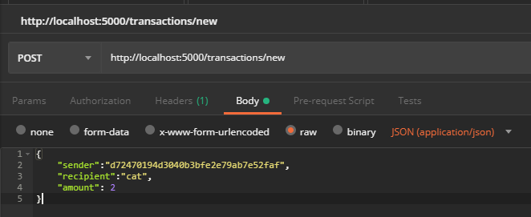

Send mine request again and then inspect the chain and we can see the change is reflected as following, as we can see, each new block contains a batch of transactions, a reference to the hash of the previous block (block number > 1).

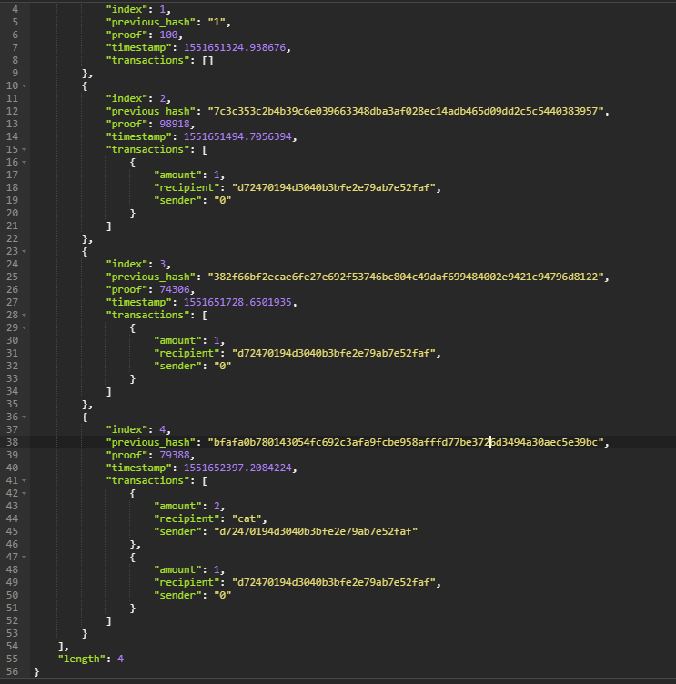

From learning this concrete example, in my opinion, focusing on the details will provide a deeper understanding of the strengths and limitations of blockchains. For example, I think one drawback of Daniel van Flymen’s code is when current_transactions list is empty miner still can mine, it generates a block that has only a reward transaction. The solution is to prohibit mining when transaction list is empty, except for the *genesis* block. I add line112-113 into *def new_block* as the solution (source code attached):

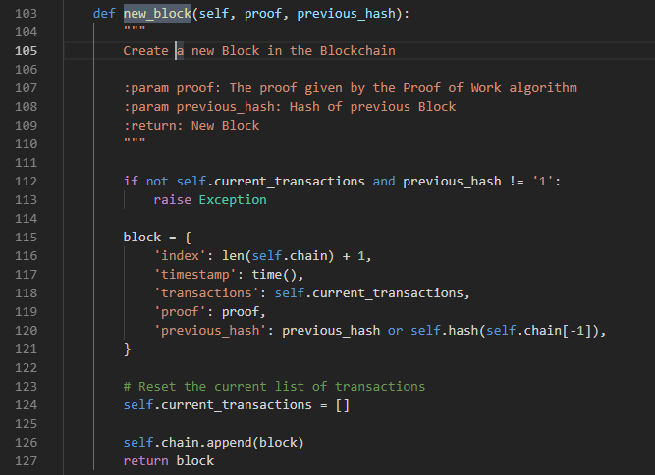

References:

1. Daniel van Flymen, *Learn Blockchains by Building One*, Sep 24, 2017, https://hackernoon.com/learn-blockchains-by-building-one-117428612f46
2. Build Your Own Blockchain - The Basics <https://github.com/emunsing/tutorials/blob/master/BuildYourOwnBlockchain.ipynb>
3. Deniel Bharath, *Understanding the basics of BlockChain*, https://medium.com/technology-nineleaps/how-to-create-blockchain-from-the-scratch-ce9e01436881