STAT 345 Midterm Project

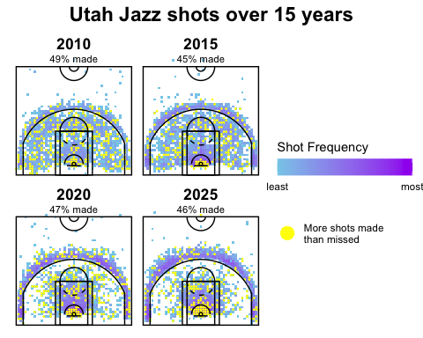

### Observations:

* Shots used to be spread more evenly across the court
* Shots are now concentrated in the three-second area and around the three-point line
* The percentage of made shots has slightly decreased

### A more thorough analysis:

* Shots used to be spread more evenly across the court
  + The 2010 chart has less white space, showing that shots were taken all over the court.
  + The 2025 chart has more white space, meaning there were many more locations on the court where no shots were taken.
  + The 2010 chart has less color variation, maintaining a mostly blue color throughout, showing the consistency in the frequency of shots being taken throughout the court.
  + The 2025 chart has more color variation, with purple clusters surrounded by blue, showing how specific locations on the court had much higher frequencies of shots than others.
* Shots are now concentrated in the three-second area and around the three-point line
  + From chart 2010 to 2015 and 2020, the intensity of the purple color, signifying high frequency, just beyond the three-point line increases, showing the progressive increase of shots near the line.
  + From chart 2010 to 2015 and 2020, the intensity of the purple color, signifying high frequency, in the three-second area increases, showing the progressive increase of shots in the zone.
  + The 2020 and 2025 charts look very similar, suggesting that the patterns have remained fairly constant over the past several years.
* The percentage of made shots has slightly decreased
  + 49% of shots were made in 2010.
  + This decreased to 45% in 2015 and stayed lower through 2025, where 46% were made.
  + This suggests that the changing of shot locations hasn’t necessarily led to a higher number of made shots.