4-Point Arc Proposal

Lucy Warren

2025-04-04

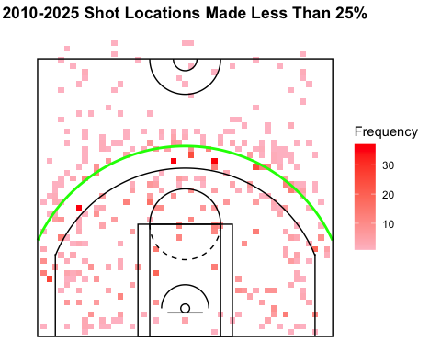

If the NBA were to incorporate a 4-point shot, I would suggest that the arc be a third of the distance from the 3-point arc to the center circle, similar to where the green arc is drawn on the plot. The plot shows locations on the court where, across 2010, 2015, 2020, and 2025, less than 20 percent of shots were made. All of the tiles beyond this line are pink, meaning they did not occur very frequently. I believe this line is therefore a good option for a 4-point line because it is proven to be difficult to make shots beyond it and players do not shoot from points beyond it all that often. A 4-point shot needs to be earned and shots made beyond this line would be appropriate to gift 4 points. A potential consequence of introducing a 4-point shot is that teams would quickly adjust to go for these shots more often. With enough training, players could improve their ability to make shots from this new line, making the frequency of made shots at this distance increase dramatically. This could lead to a 4-point shot becoming common and less exciting. A key feature of such a shot should be that they aren’t made all that often, so players mastering this shot would defeat the purpose of introducing it.