**Topology:**

**Client -------------X0 LAN -- FW--X1 WAN ---------------Server**

**第一种：** **Client : Ubuntu ,  Server : Ubuntu**

**Client: Ubuntu**

//root 是server user , 10.7.229.68是server ip

C:\Users\LuLi.SV\AppData\Local\Temp\enhtmlclip\Image(1).jpg

Issue 1 :"Unable to negotiate with 10.7.229.68 port22: no matching host key type found.Their offer:ssh-dss"

**Issue solved:**

 #vim /etc/ssh/ssh_config   //将X11 Forwarding 打开

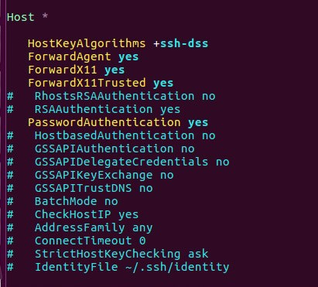

如果还提示错误

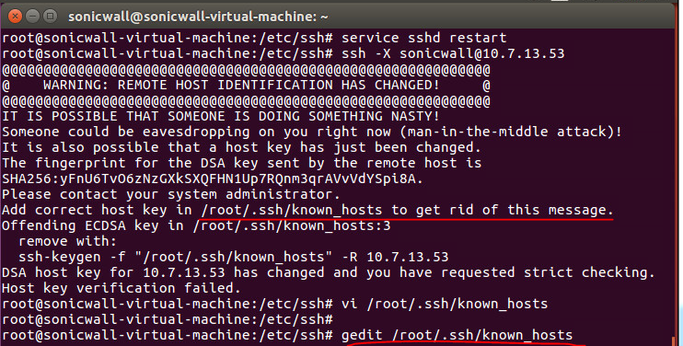

删掉known_hosts里面的信息。.ssh/known_hosts 裡面记录的目标主机 key 值不正确。这是最普遍的情况，只要删除对应的主机记录就能恢复正常。C:\Users\LuLi.SV\AppData\Local\Temp\enhtmlclip\Image(12).pngifconfig

打开server图形界面

#firefox

#gnome-system-monitor

Issue 2:＂firefox is already running, but is not responding.To open a new window, you must first close existing Firefox process ,or restart your system.＂

**Issue solved:**

#killall firefox

#apt-get install lost

#apt-get install xauth

#apt-get install xterm

**Server:Ubuntu**

#vi /etc/ssh/sshd_config    //把X11 forwarding 打开

#service sshd restart

