Complexity Analysis

Method 1
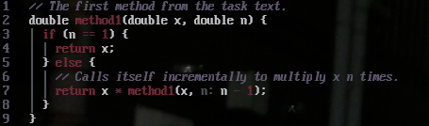

Figure 1: Code for the first method of calculating powers

The method contains no loops, and only creates 1 instance of itself, and can therefor be represented like this:
T(n) = T(n-1) + 1, because n decrements by one each recursion.
We can see that this is linear, and its upper and lower bounds are the same, so T(n) ∈ Θ(n).

Method 2
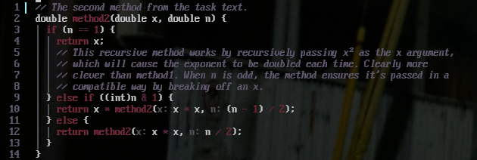

Figure 2: Code for the second method of calculating powers

The method also doesn't contain loops, creates only one instance of itself, and can be represented like this:
T(n) = T(n/2) + 1, because n is halved each recursion.
To find its time complexity we can use "mestermetoden", or "the master theorem" in english, because its recursion can be written in this form:
T(n) = aT(n/b) + cn^k.
a = 1,
b^k = 2^0 = 1,
so a = b^k, which means that:
T(n) ∈ Θ(n^k * log(n)) => T(n) ∈ Θ(log(n))

Measurements

First measurement
This measurement was done by incrementing n linearly and using averaging across a number of repetitions that decreases as n increases. This is done for stability in timing of smaller n.
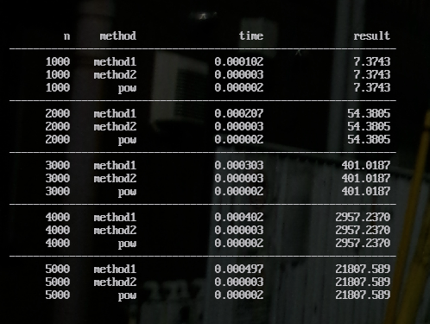

Figure 3: Normal measurement of the 3 methods
As can be seen above, the growth of time usage by method1 is very linear. So far method2 and pow can’t be effectively measured, but that will be improved upon bellow.

Second measurement
The second measurement was done by running a high number of repetitions to make the time significant enough to measure, and by measuring the n exponentially.
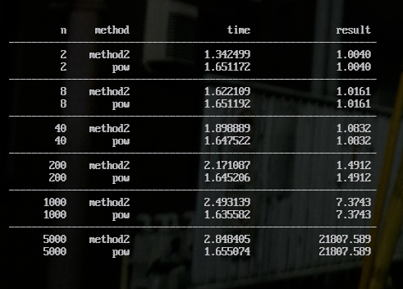

Figure 4: Measurements of method2’s logarithmic growth
For this measurement that looks more closely at method2’s growth, we can see that its growth falters over time. We can also see that pow’s growth is pretty consistent in comparison. We can also see that method2 actually seems to outperform pow for lower exponents.

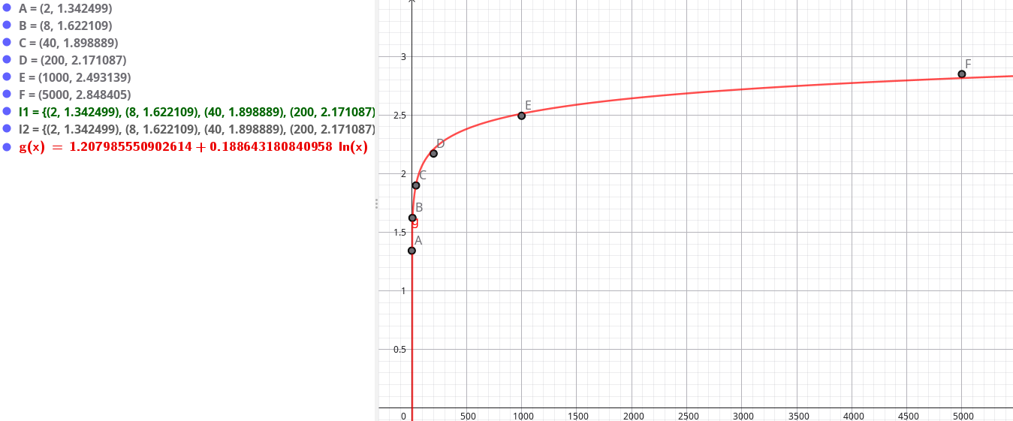

Figure 5: Measurements plottet and modelled as a logarithmic graph.
This graph shows more clearly the logarithmic growth of method2, which confirms the analysis.

