SSIS SQL Queries Of interest

Note: These queries are context specific. Each query creates a dataset that supports one or more frontend components with less overhead.

1. Accounting unit :

select trim(description) as description, trim(acct_unit) as acct_unit, obj_id, parent_obj_id

from **xxx**.GLNAMES

where trim(active_status) = 'A'

AND TRIM(posting_flag) = 'P'

and trim(chart_section) = 2

order by 1 asc

KC:

Filter on Accounts and include AU’s that are between

602000 - 699060

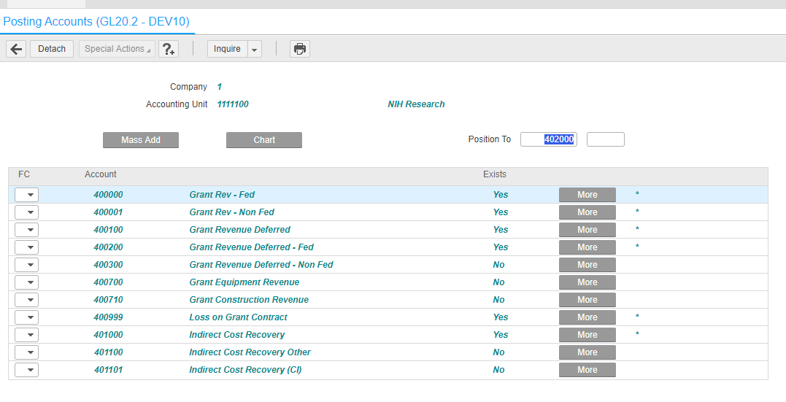

1. Accounting unit2Activity – Note: The left join is not needed in this context since In this query, I only need activities

select trim(ac.acct_unit) as acct_unit, trim(ac.activity) as activity,

trim(ac.description) as short_desc , trim(ac.ACTIVITY_GRP) as activity_grp,

trim(ac.usr_status) as usr_status, trim(ac.BEGIN_DATE) as begin_date,

trim(ac.END_DATE) as end_date,

trim(CONCAT(CONCAT(ac.LONG_DESC_01,'-'), TRIM(ac.LONG_DESC_02))) as long_desc

from xxx.ACACTIVITY ac, xxx.GLNAMES gl

where trim(ac.acct_unit) = trim(gl.acct_unit)

and ac.end_date >= current_date

and trim(gl.active_status) = 'A'

AND TRIM(gl.posting_flag) = 'P'

and trim(gl.chart_section) = 2

1. Accounting unit2requester

select trim(rq.requester) as requester, trim(rq.acct_unit) as acct_unit,

trim(r.R_NAME) as r_name, trim(r.req_location) as req_location,

trim(r.require_vendor) as require_vendor,trim(r.email_address) as email_address

from xxx.rqacctu rq, xxx.GLNAMES gl**, xxx**.REQUESTER r

where rq.company=1

and trim(rq.company)=trim(r.company)

and trim(rq.requester)=trim(r.requester)

AND TRIM(r.active_status) = 'A'

and trim(rq.acct_unit) = trim(gl.acct_unit)

and trim(gl.active_status) = 'A'

AND TRIM(gl.posting_flag) = 'P'

and trim(gl.chart_section) = 2;

1. Requester Location

SELECT trim(REQ_LOCATION) as req_location,

trim(R_NAME) as r_name, trim(CONCAT(CONCAT( TRIM(ADDR1),', '), ADDR2)) as address

FROM **xxx**.rqloc

where trim(active_status)='A'

and TRIM(COMPANY)='1'