Coin heist

Idea

Overview:
Two players face off in arena filled with obstacles. The goal is simple: collect coins scattered around the map. The first player to gather 10 coins (can be changed) wins

Power-Up Twist – The Zapper:
To shake things up, a power-up will occasionally spawn in the arena. The first player to grab it gains access to a special ability.
- Zapper Power-Up: Grants the player a 3-second window (can be changed) to shoot the opponent and loses coins (can be changed).
- If the Zapper mechanic doesn’t work as intended, we’ll replace it with another power-up (to be decided later).

Gameplay Details:
- Players: 2 competitors battle it out in the same arena.
- Arena: Filled with obstacles that block movement and line of sight.
- Objective: Collect coins that spawn throughout the arena.
- Winning Condition: The first player to collect 10 coins (or another set goal) wins the match.
- Power-up: Zapper (3-second shooting ability)

idea of the map
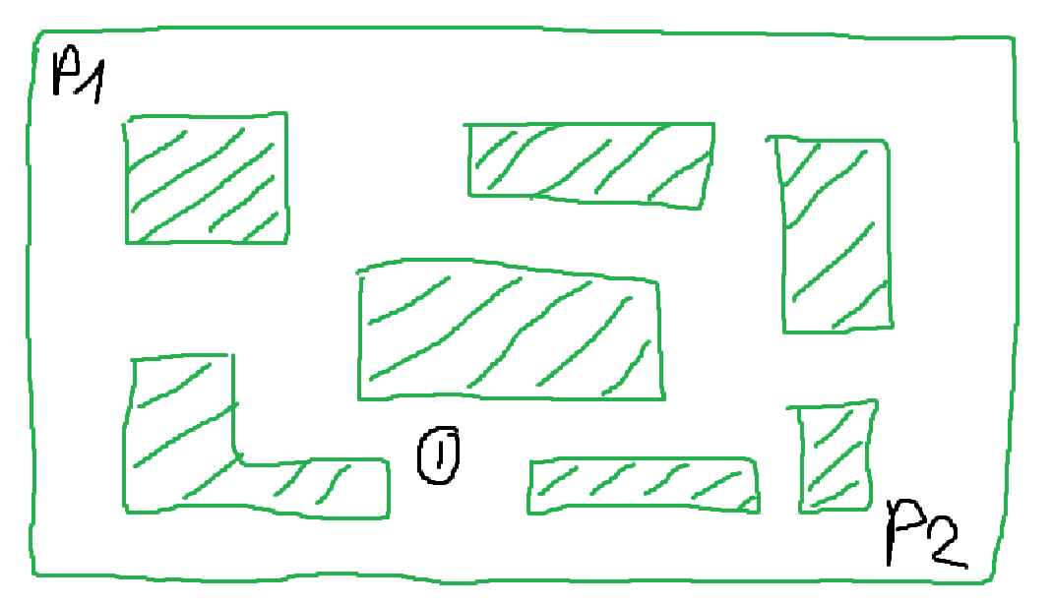

Planning

Programming
- Figuring out collision areas

Art
- Walls and obstacles baked in the background so just need to be a collision area (because 8 sprites limit)
- Players will be 1 sprite not metasprites
- Future like style

Sound

