**Author: Lucinda Frohlich**

**Module Name: Basic C# Programming**

**Module Code: MLBC1995-01**

**Date: 19/06/2019**

**Read me first**

Please ensure you have .Net Framework installed on your PC before attempting to run this Editor.

**Purpose**

The purpose of this project was to create a Rich Textbox Editor that would function in a similar way to Microsoft Word. It is simple and easy to use.

**Getting started**

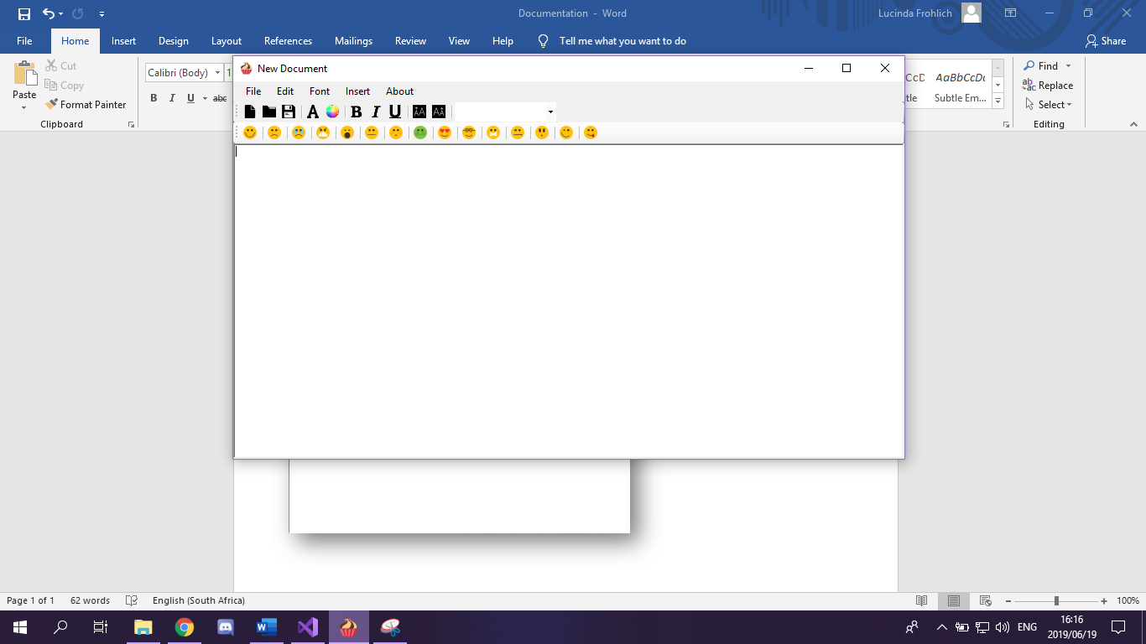As stated above the Editor is a simplified version of Microsoft’s word.

There are five menu tabs:

File, Edit, Font, Insert and About.

The (first) toolbar icons are as follows left to right:

New Document, Open, Save, Font, Font Colour, Bold, Italic, Underline, Uppercase, Lowercase and a word drop-down list.

The next toolbar houses a small selection of 15 emoticons and are as follows from left to right:

Smile, Sad, Crying, Angry, Bored, Confused, Embarrassed, Ill, In-love, Nerd, Quiet, Secret, Surprised, Wink and Tongue-out.

*Note: There are tool tips to assist you further.*

**Creating a new document**

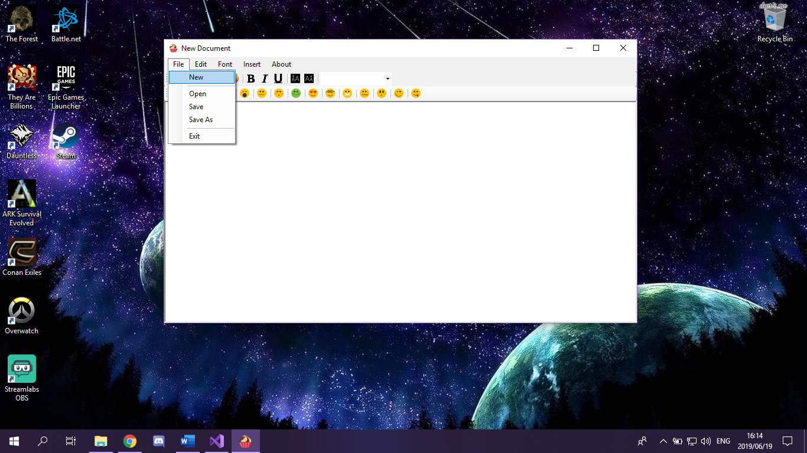

Click on the **File** tab and then select **New**. If the document is blank and has not been previously modified, it will open a new document.

It is also accessible by clicking on the **New Document** button on the first toolbar

**Icon:**

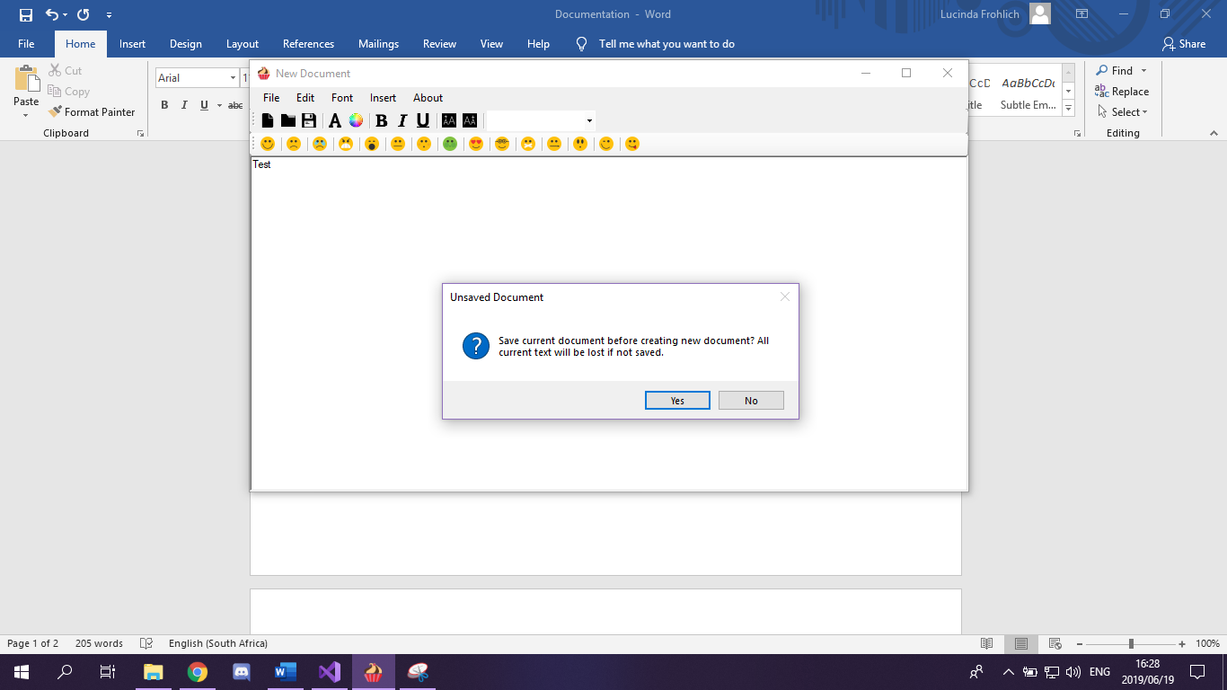

However, if the Editor has text or an image within it, it will first prompt the user with the following message before proceeding to open a new document:

“Save current document before creating new document? All current text will be lost if not saved. Yes/No”

If **No** is chosen, the message box will disappear and a new document will be opened.

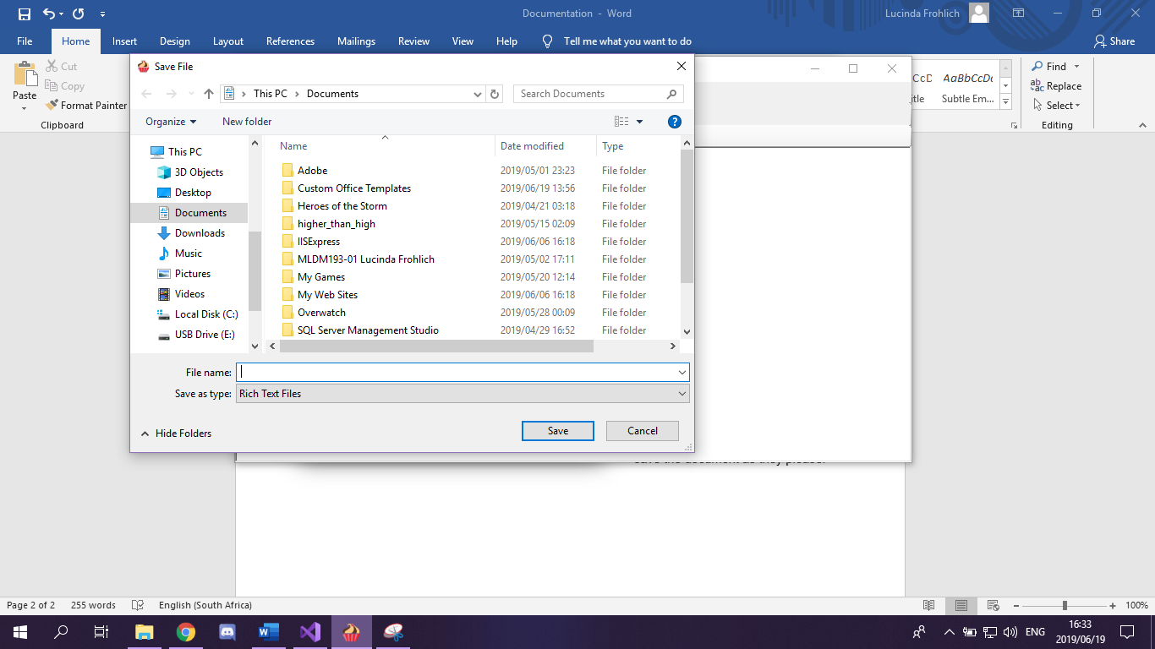

Should the user want to save their work before opening a new document, they will be diverted to a **Save File** screen and may save the document as they please.

_____________________________________________________________________________________

**Opening an existing document**

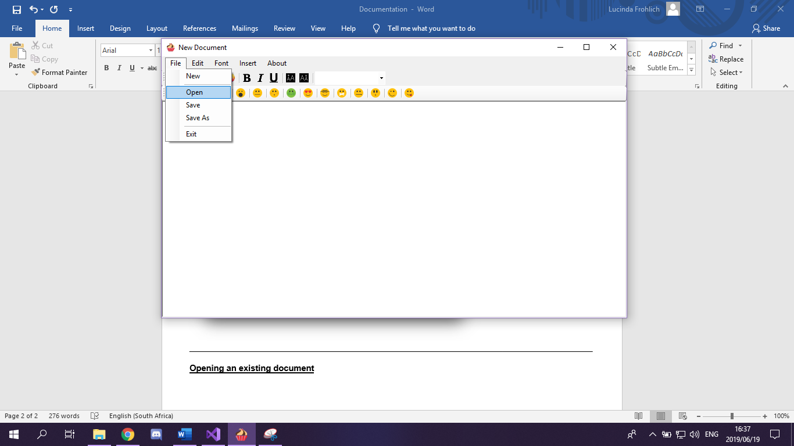

Click on the **File** tab and then select **Open**. If the document is blank and has not been previously modified, the user will be diverted to an **Open File** dialogue screen.

It is also accessible by clicking on the **Open** button on the first toolbar

**Icon:**

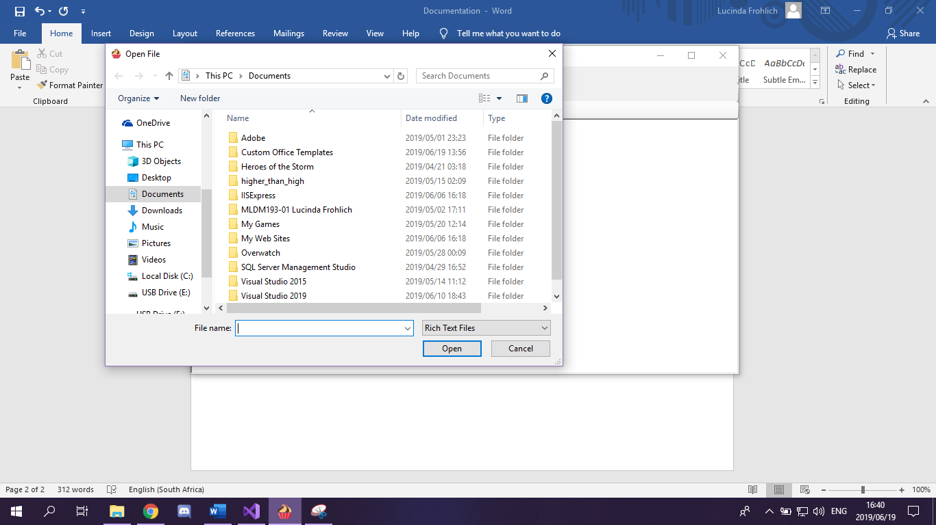

Here the user can navigate to their desired document, select it and click Open to open it in the Editor.

However, should they already have an open document that they have modified, they will receive a prompt to save as on page 2.

_____________________________________________________________________________________

**Save/ Save as**

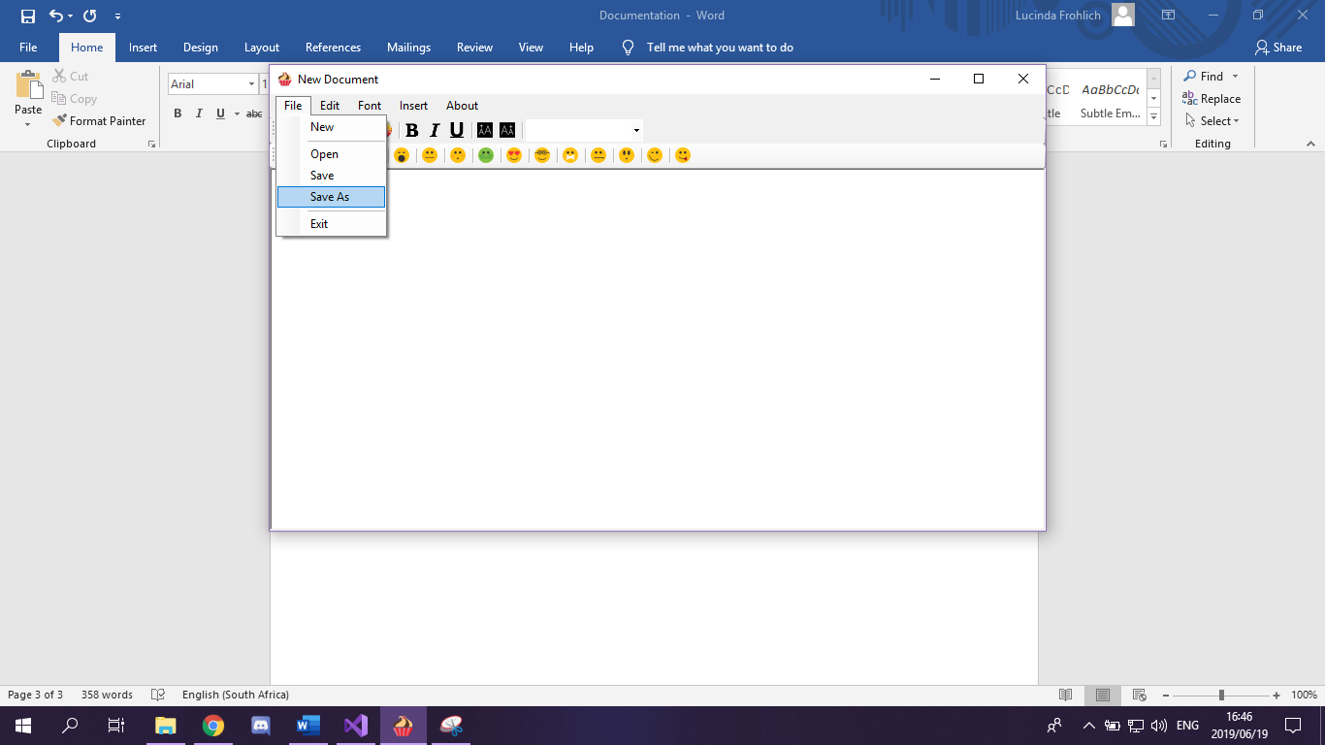

Click on the **File** tab and then click **Save** to save your document. If this is your first time saving this particular document, you'll be prompted to enter a name, save location, and preferred file format as well.

Click **Save as** to save your document "as"

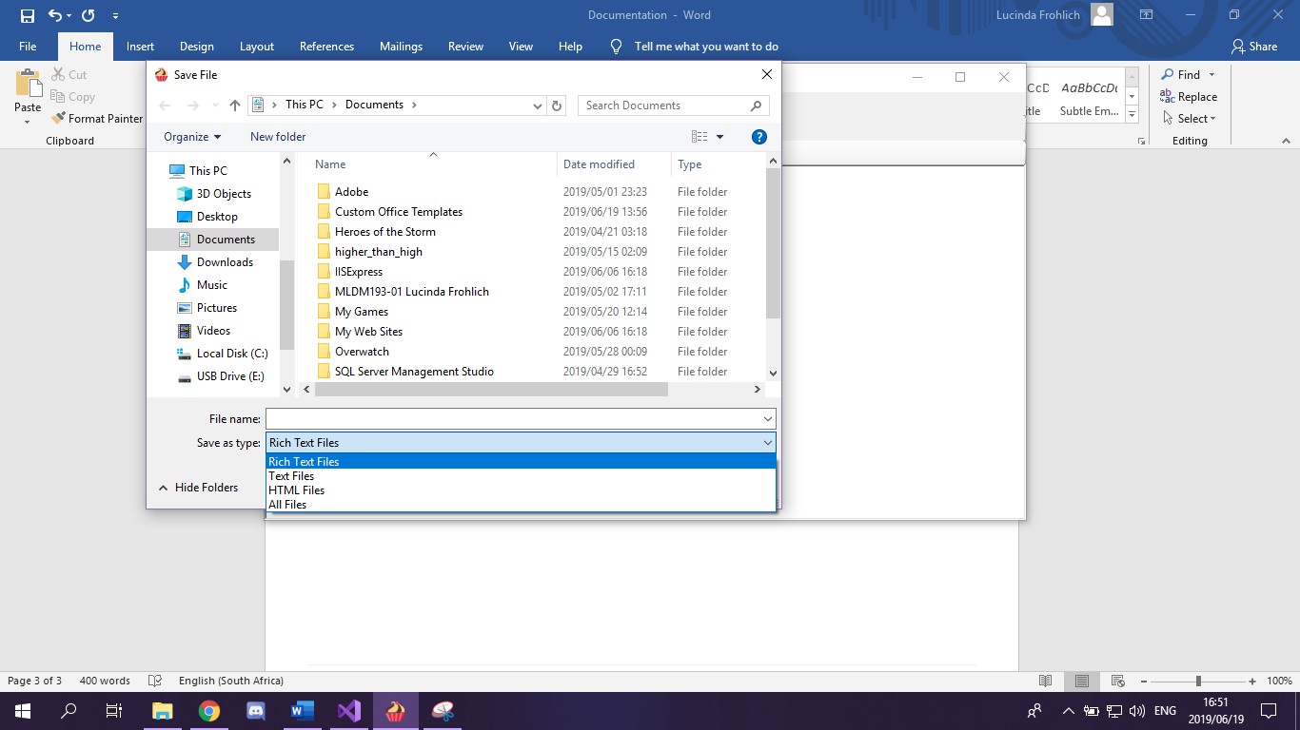

It is also accessible by clicking on the **Save** button on the first toolbar



**Icon:**

**Closing/ exiting the application**

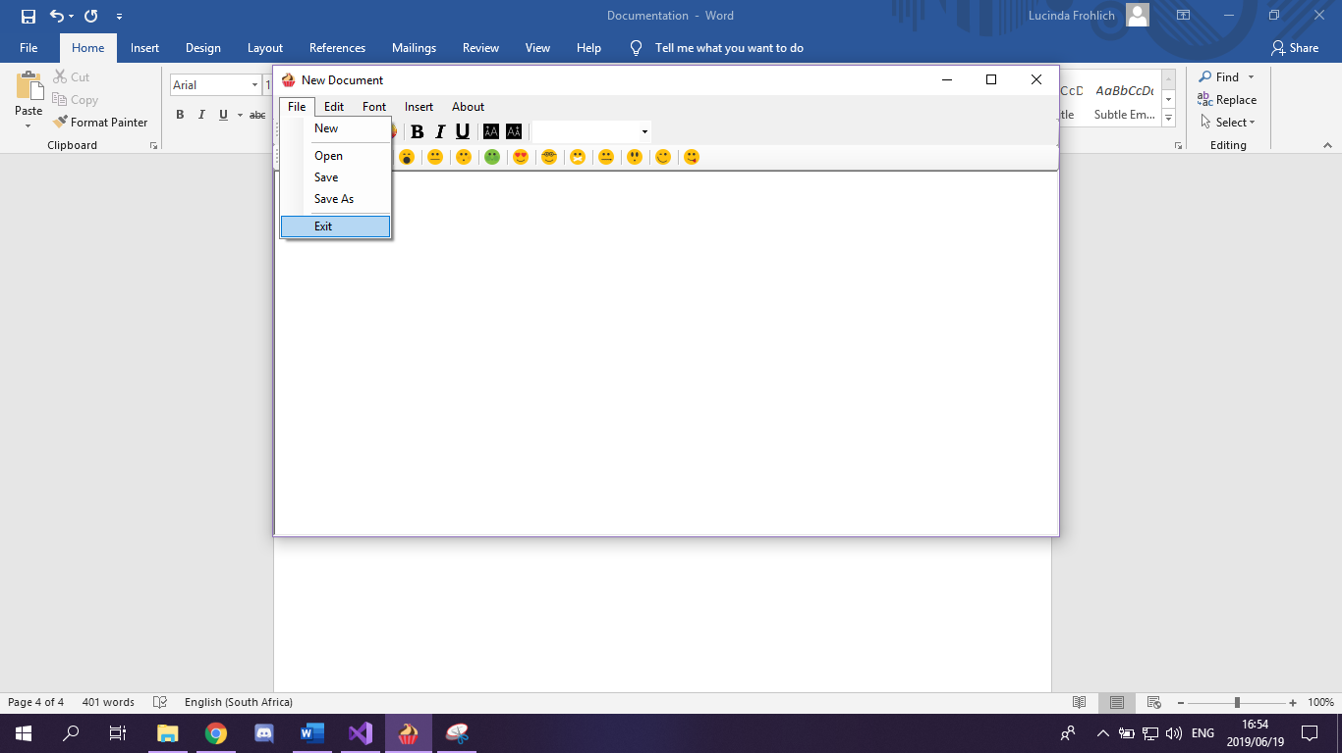

There are 2 methods to close the application:

1. Click on the **File** tab and then click on Exit to close the application

Or

1. Click on the X on the top righthand side of the screen.

Both methods function in the same way. If the document is blank and has not been previously modified, the application will close.

However, if the document was modified in anyway, they will receive a prompt to save as on page 2.

_____________________________________________________________________________________

**Edit**

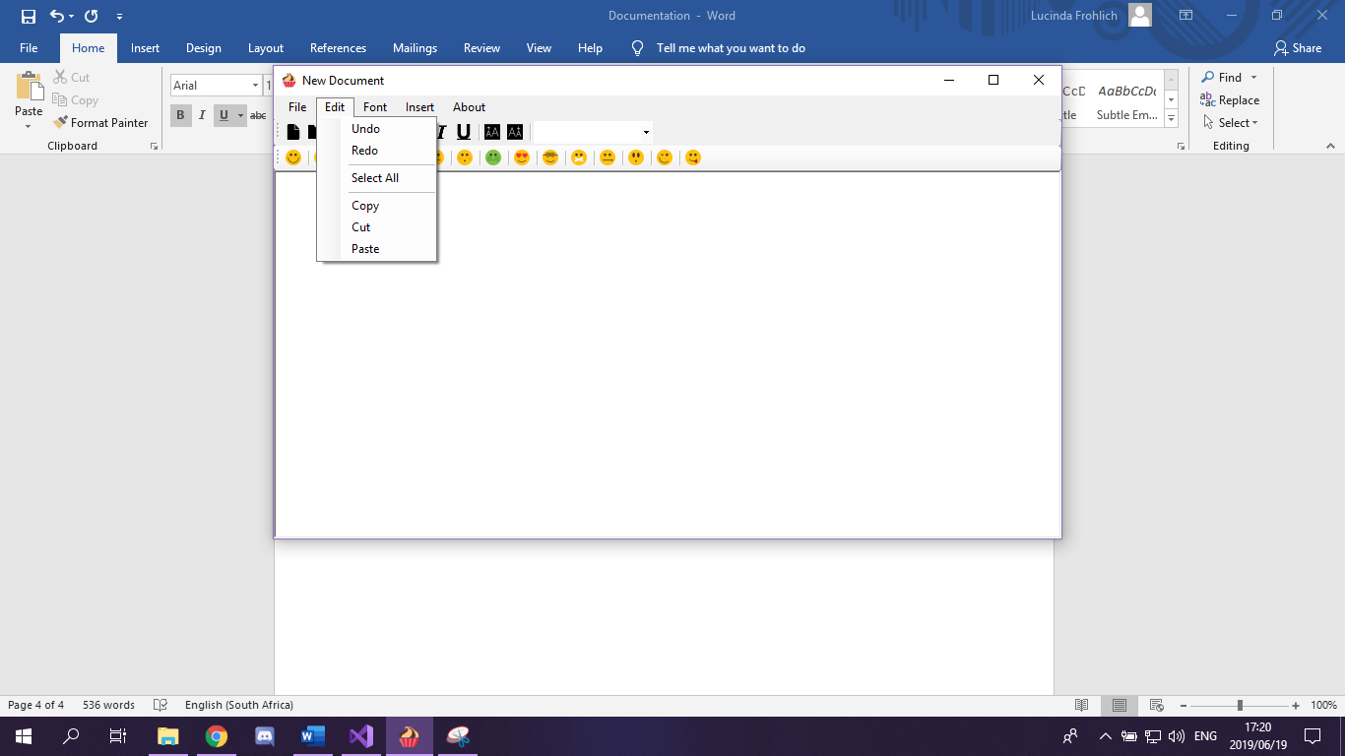

**Undo:** Click to undo a previous action.

**Redo**: Reverses the Undo action.

**Select All**: Selects all text and images in the document.

**Copy**: Makes a copy of the selected text and images.

**Cut**: Cuts the selected text and images.

**Paste**: Pastes the selected text and images that were previously copied or cut.

_____________________________________________________________________________________

**Font**

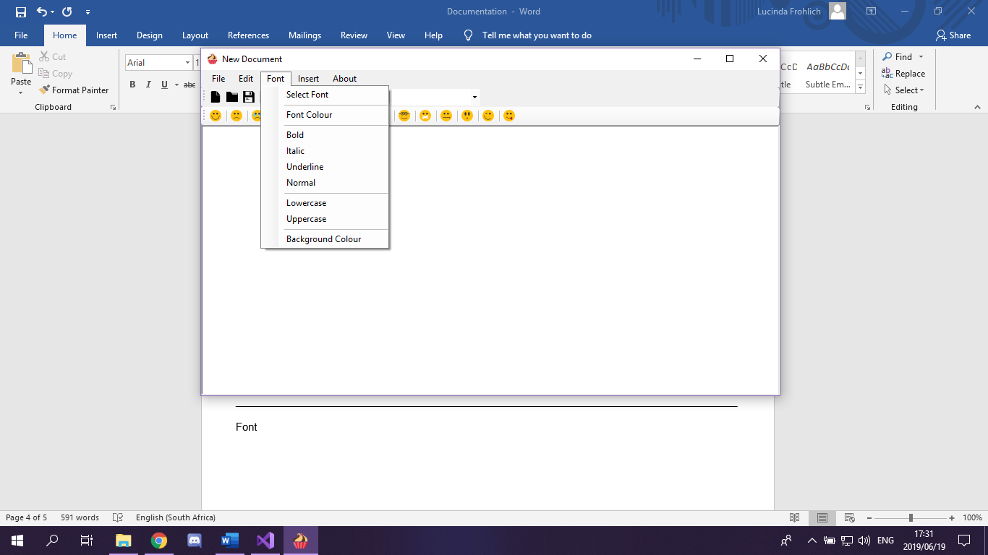

Click on the **Font** tab and then click **Select Font** to change the font of the text in your document. It will open a Font Dialogue as seen below where you will be able to select the Font, Font style and size best suited to your document.

**Bold**: Will change the selected text to bold style. (**Example**)

It is also accessible by clicking on the **B** button on the first toolbar

****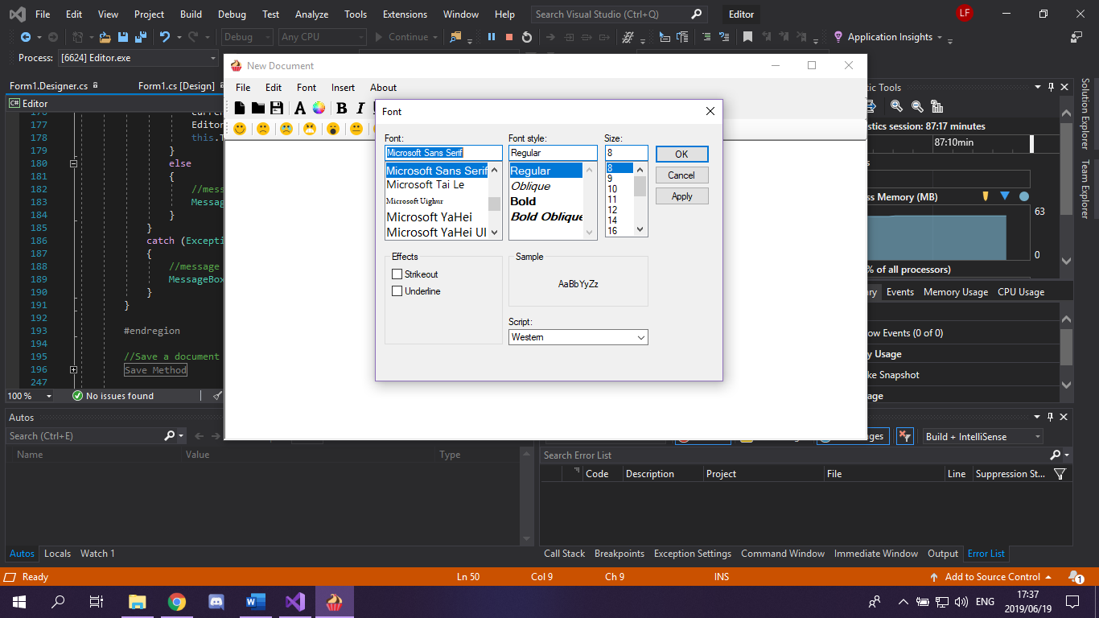  **Icon:**

**Italic**: Wil change the selected text to italic style. (*Example*)

It is also accessible by clicking on the **I** button on the first toolbar

**Icon:**

**Underline**: Will underline the

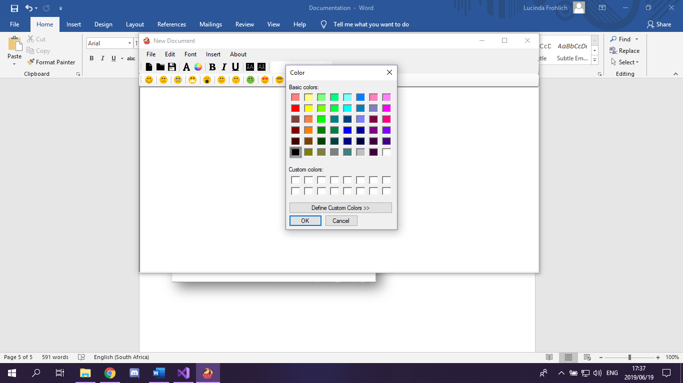selected text. (Example)

It is also accessible by clicking on the **U** button on the first toolbar

**Icon:**

**Normal:** Reverts all text settings back to default.

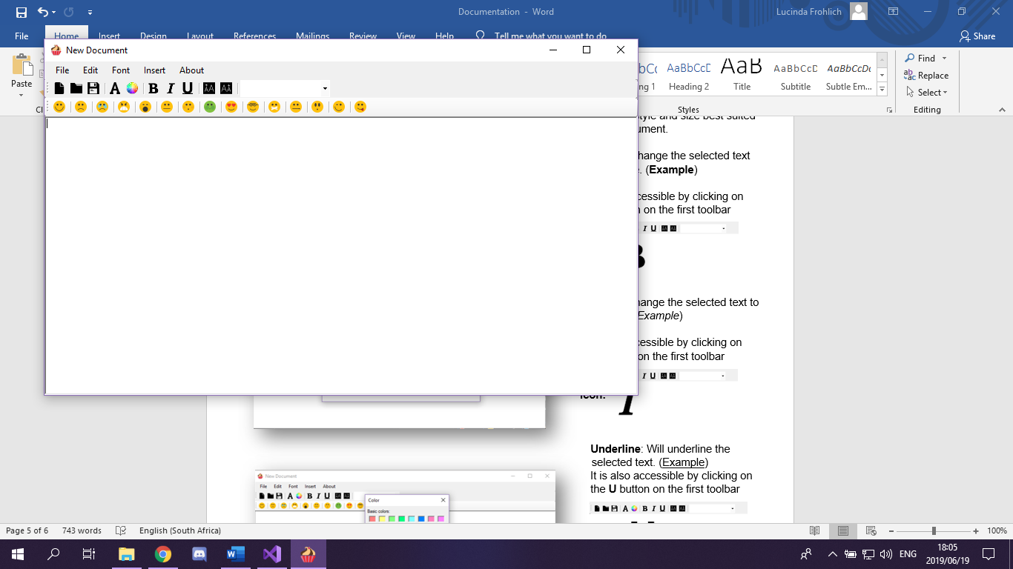

**Lowercase**: Will change all selected text to lowercase (example)

It is also accessible by clicking on the **I** button on the first toolbar

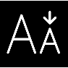

**Icon:**

**Uppercase**: Will change all selected text

to uppercase (EXAMPLE). It is also

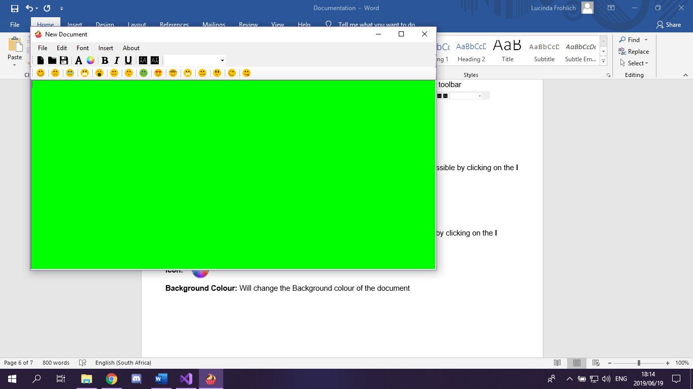 accessible by clicking on the **I** button on the first toolbar





**Icon:**

**Font Colour**: Will change all selected texts colour (Example). It is also accessible by clicking on the **I** button on the first toolbar



 **Icon:**

**Background Colour:** Will change the Background colour of the document

_____________________________________________________________________________________

**Inserting an image**

Click on the **Insert** tab and then click **Image** to insert an image from your 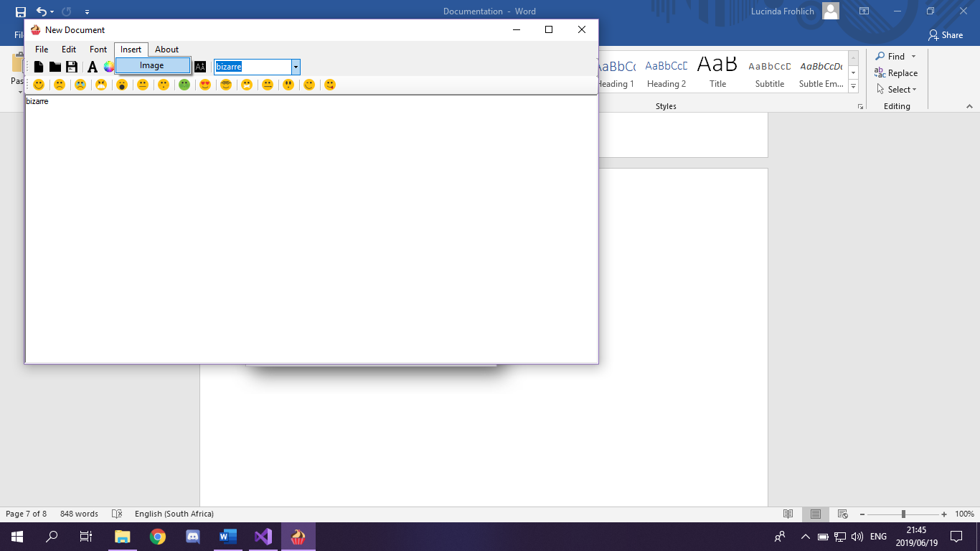personal library.

The application can insert any picture in the following formats:

BITMAP

GIF

JPG

**About**

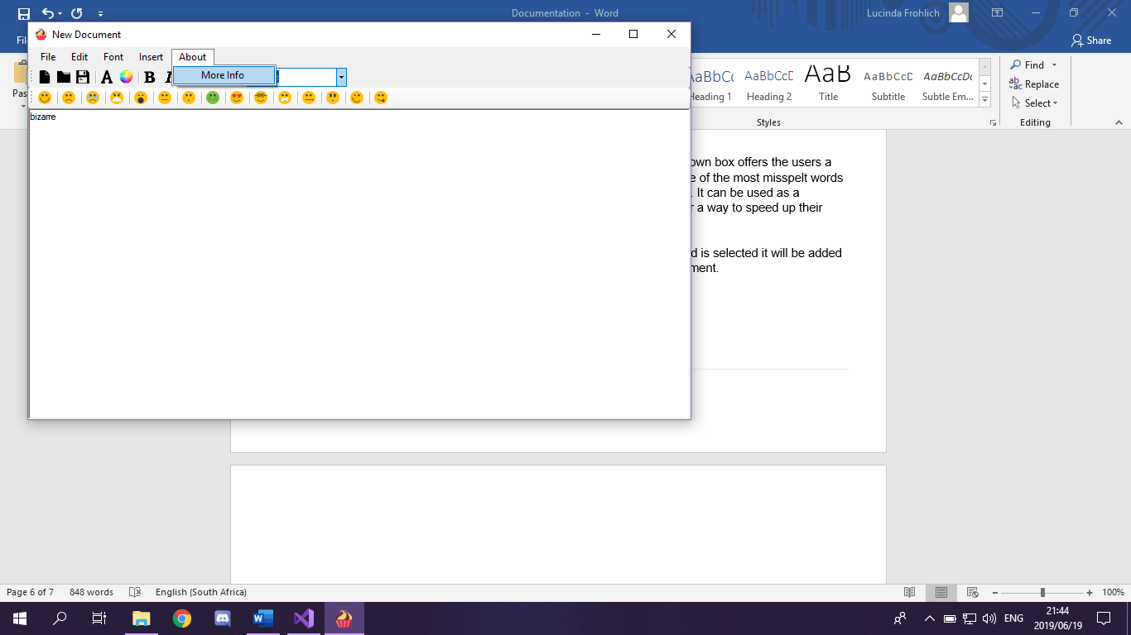If you are interested in knowing more about the application and its author, you can click on **About** and then **More Info**.

Updates will follow with more information and more features.

_____________________________________________________________________________________

**Word suggestions**

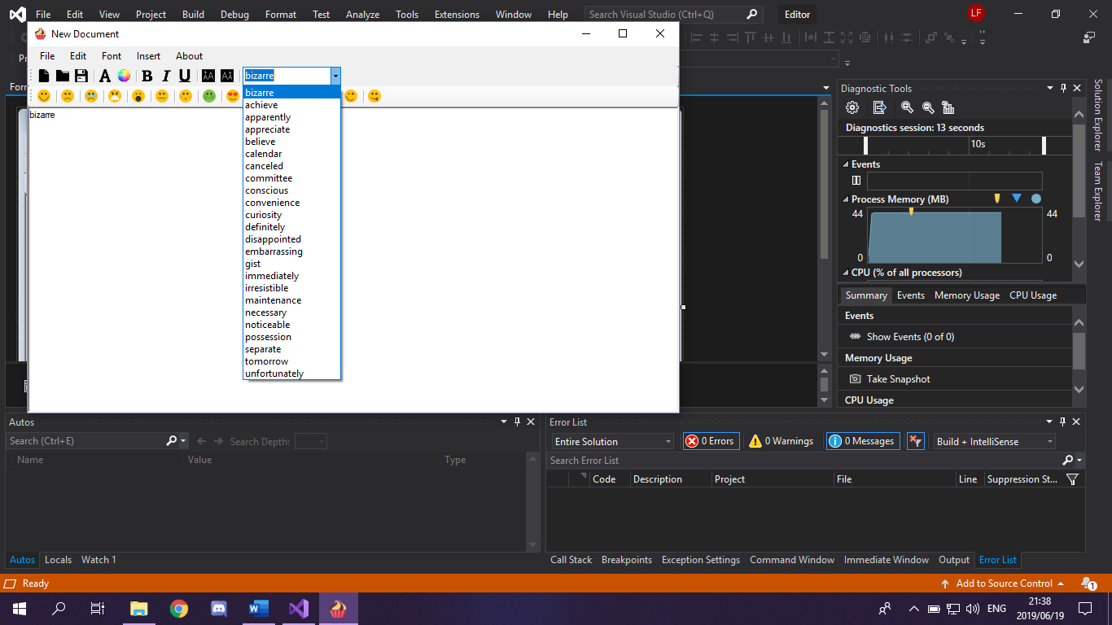

This drop-down box offers the users a pick of some of the most misspelt words in the world. It can be used as a reference or a way to speed up their typing.

Once a word is selected it will be added to the document.

_____________________________________________________________________________________

**Emoticons**



The Emoticon toolbar houses a small selection of 15 emoticons and are as follows from left to right:

Smile, Sad, Crying, Angry, Bored, Confused, Embarrassed, Ill, In-love, Nerd, Quiet, Secret, Surprised, Wink and Tongue-out.

By simply clicking on them they will be added to the document wherever the cursor is.