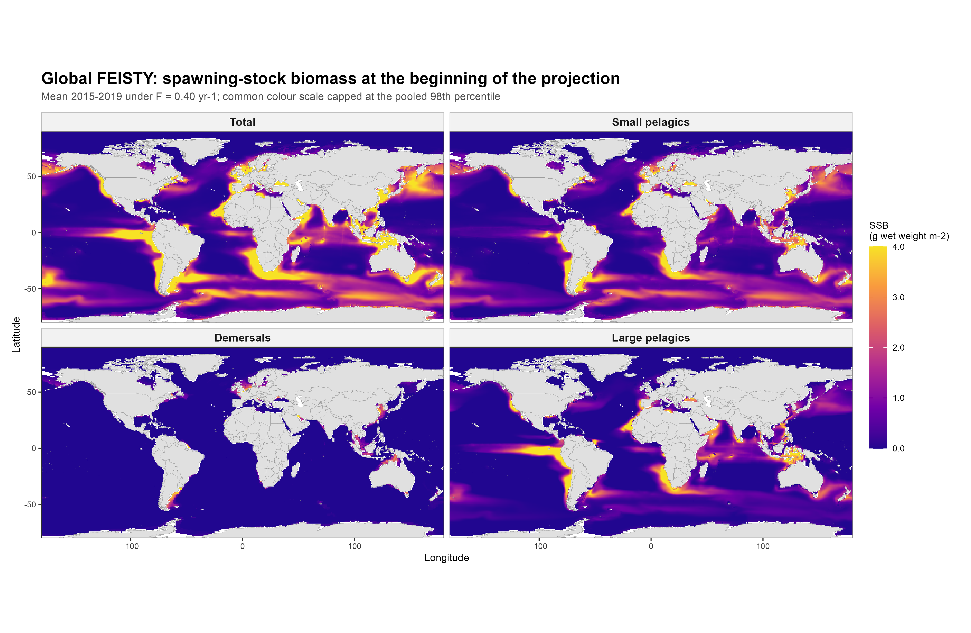
Figure 1. Mean spawning-stock biomass (SSB) in 2015-2019 under F = 0.40 yr-1. All four panels use the same colour scale, capped at the pooled 98th percentile.

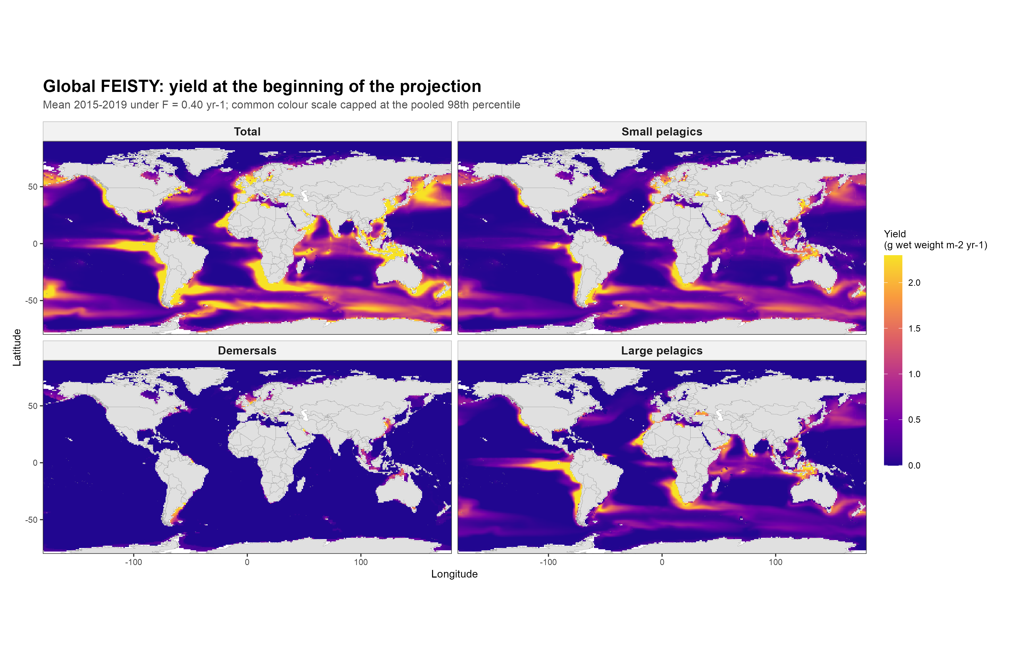
Figure 2. Mean yield in 2015-2019 under F = 0.40 yr-1. All four panels use the same colour scale, capped at the pooled 98th percentile.

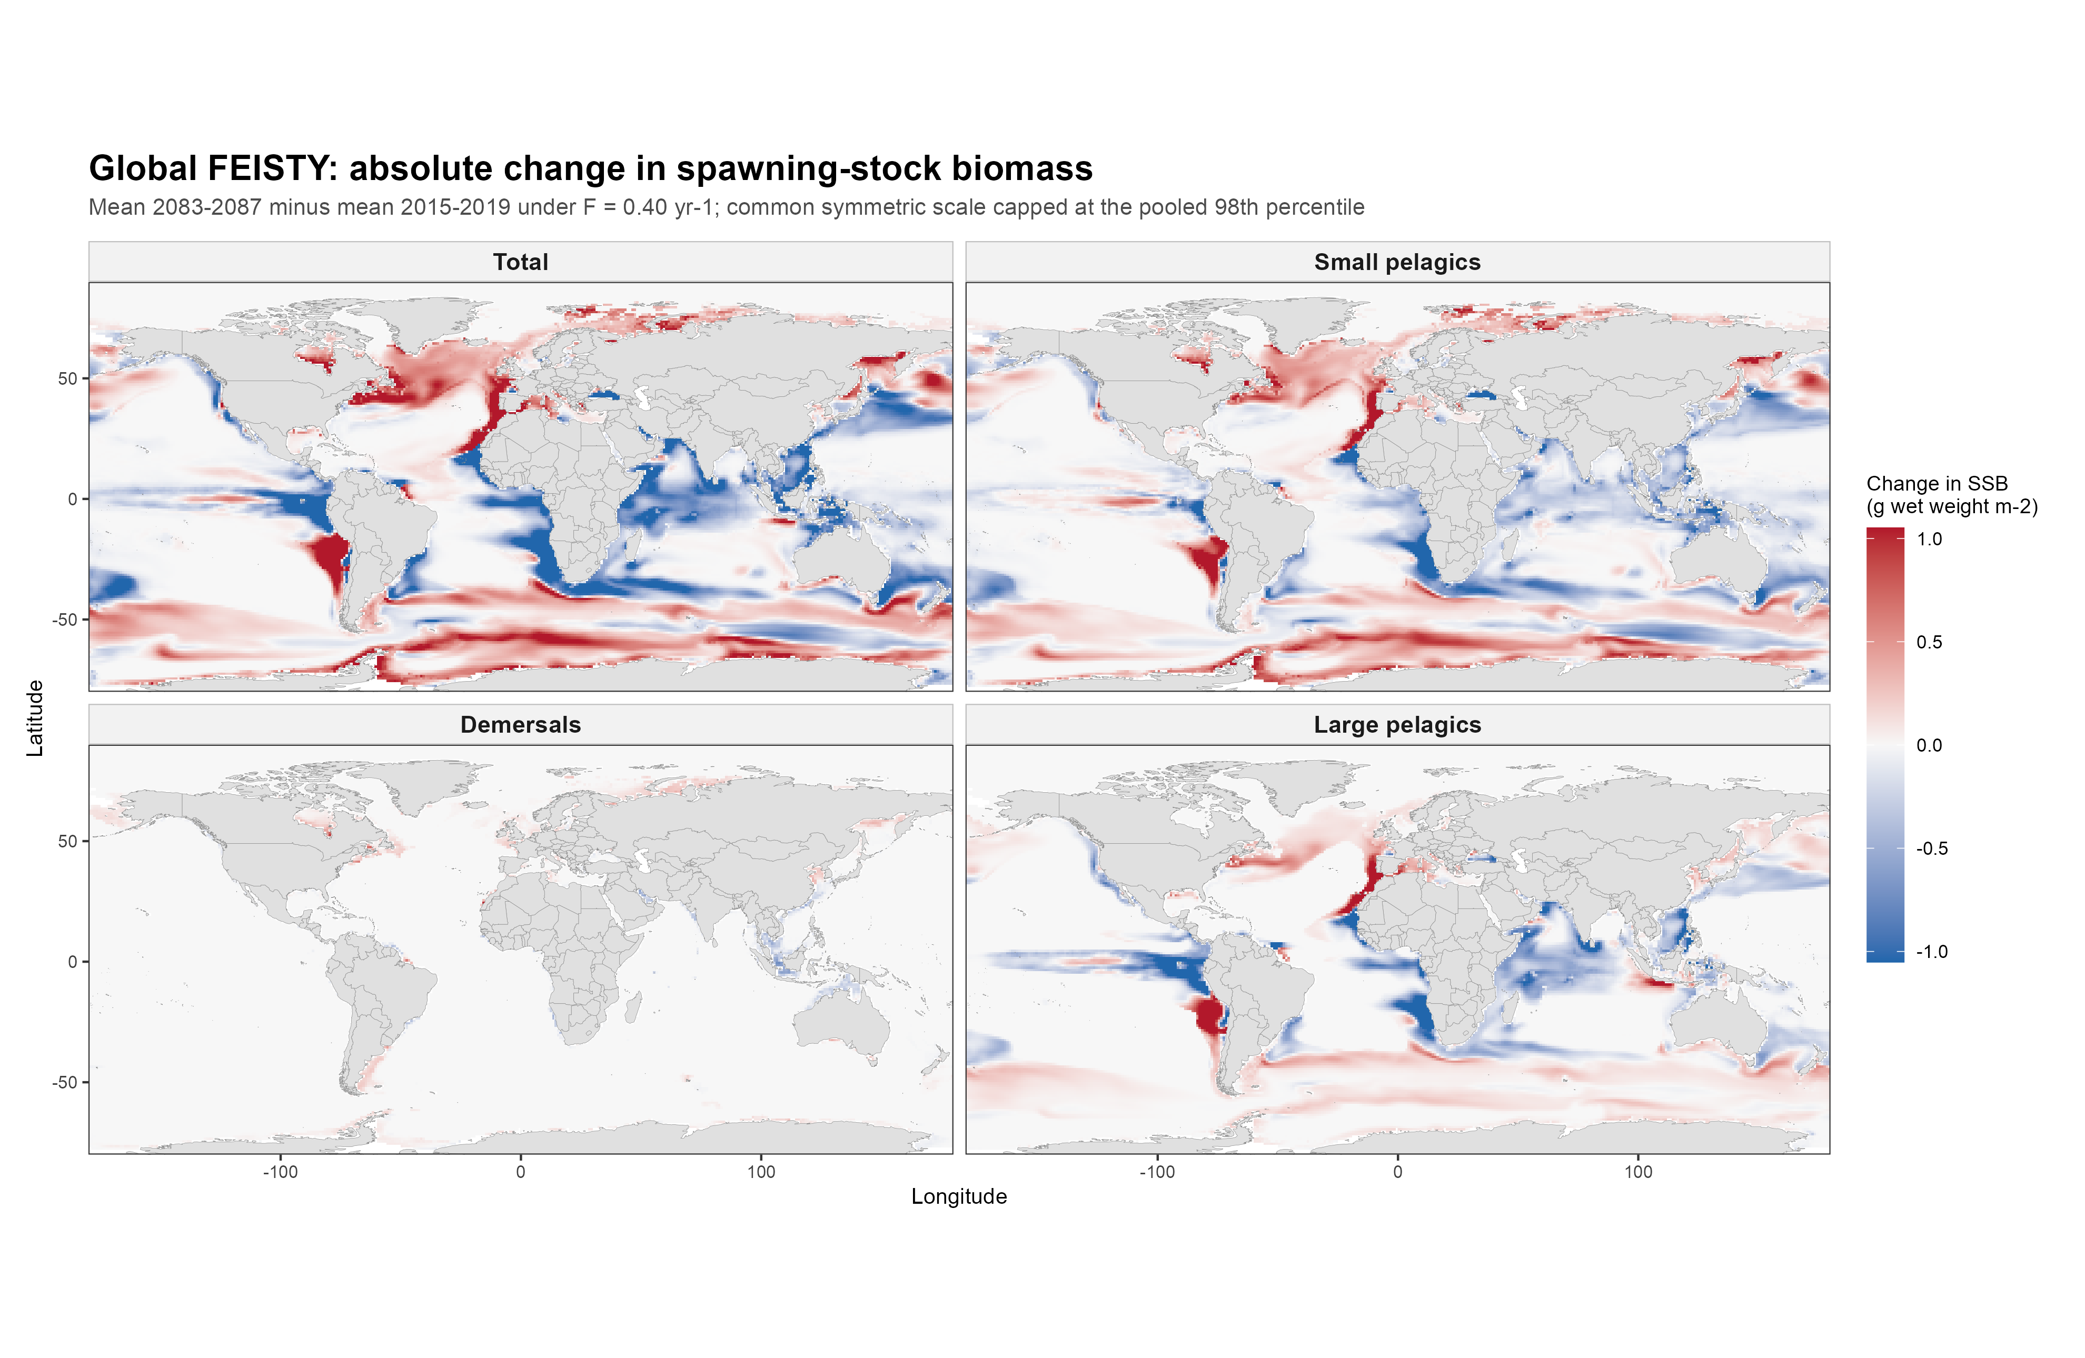
Figure 3. Absolute SSB change: mean 2083-2087 minus mean 2015-2019 under F = 0.40 yr-1. Blue indicates a decrease and red an increase; the same symmetric scale is used in all panels.

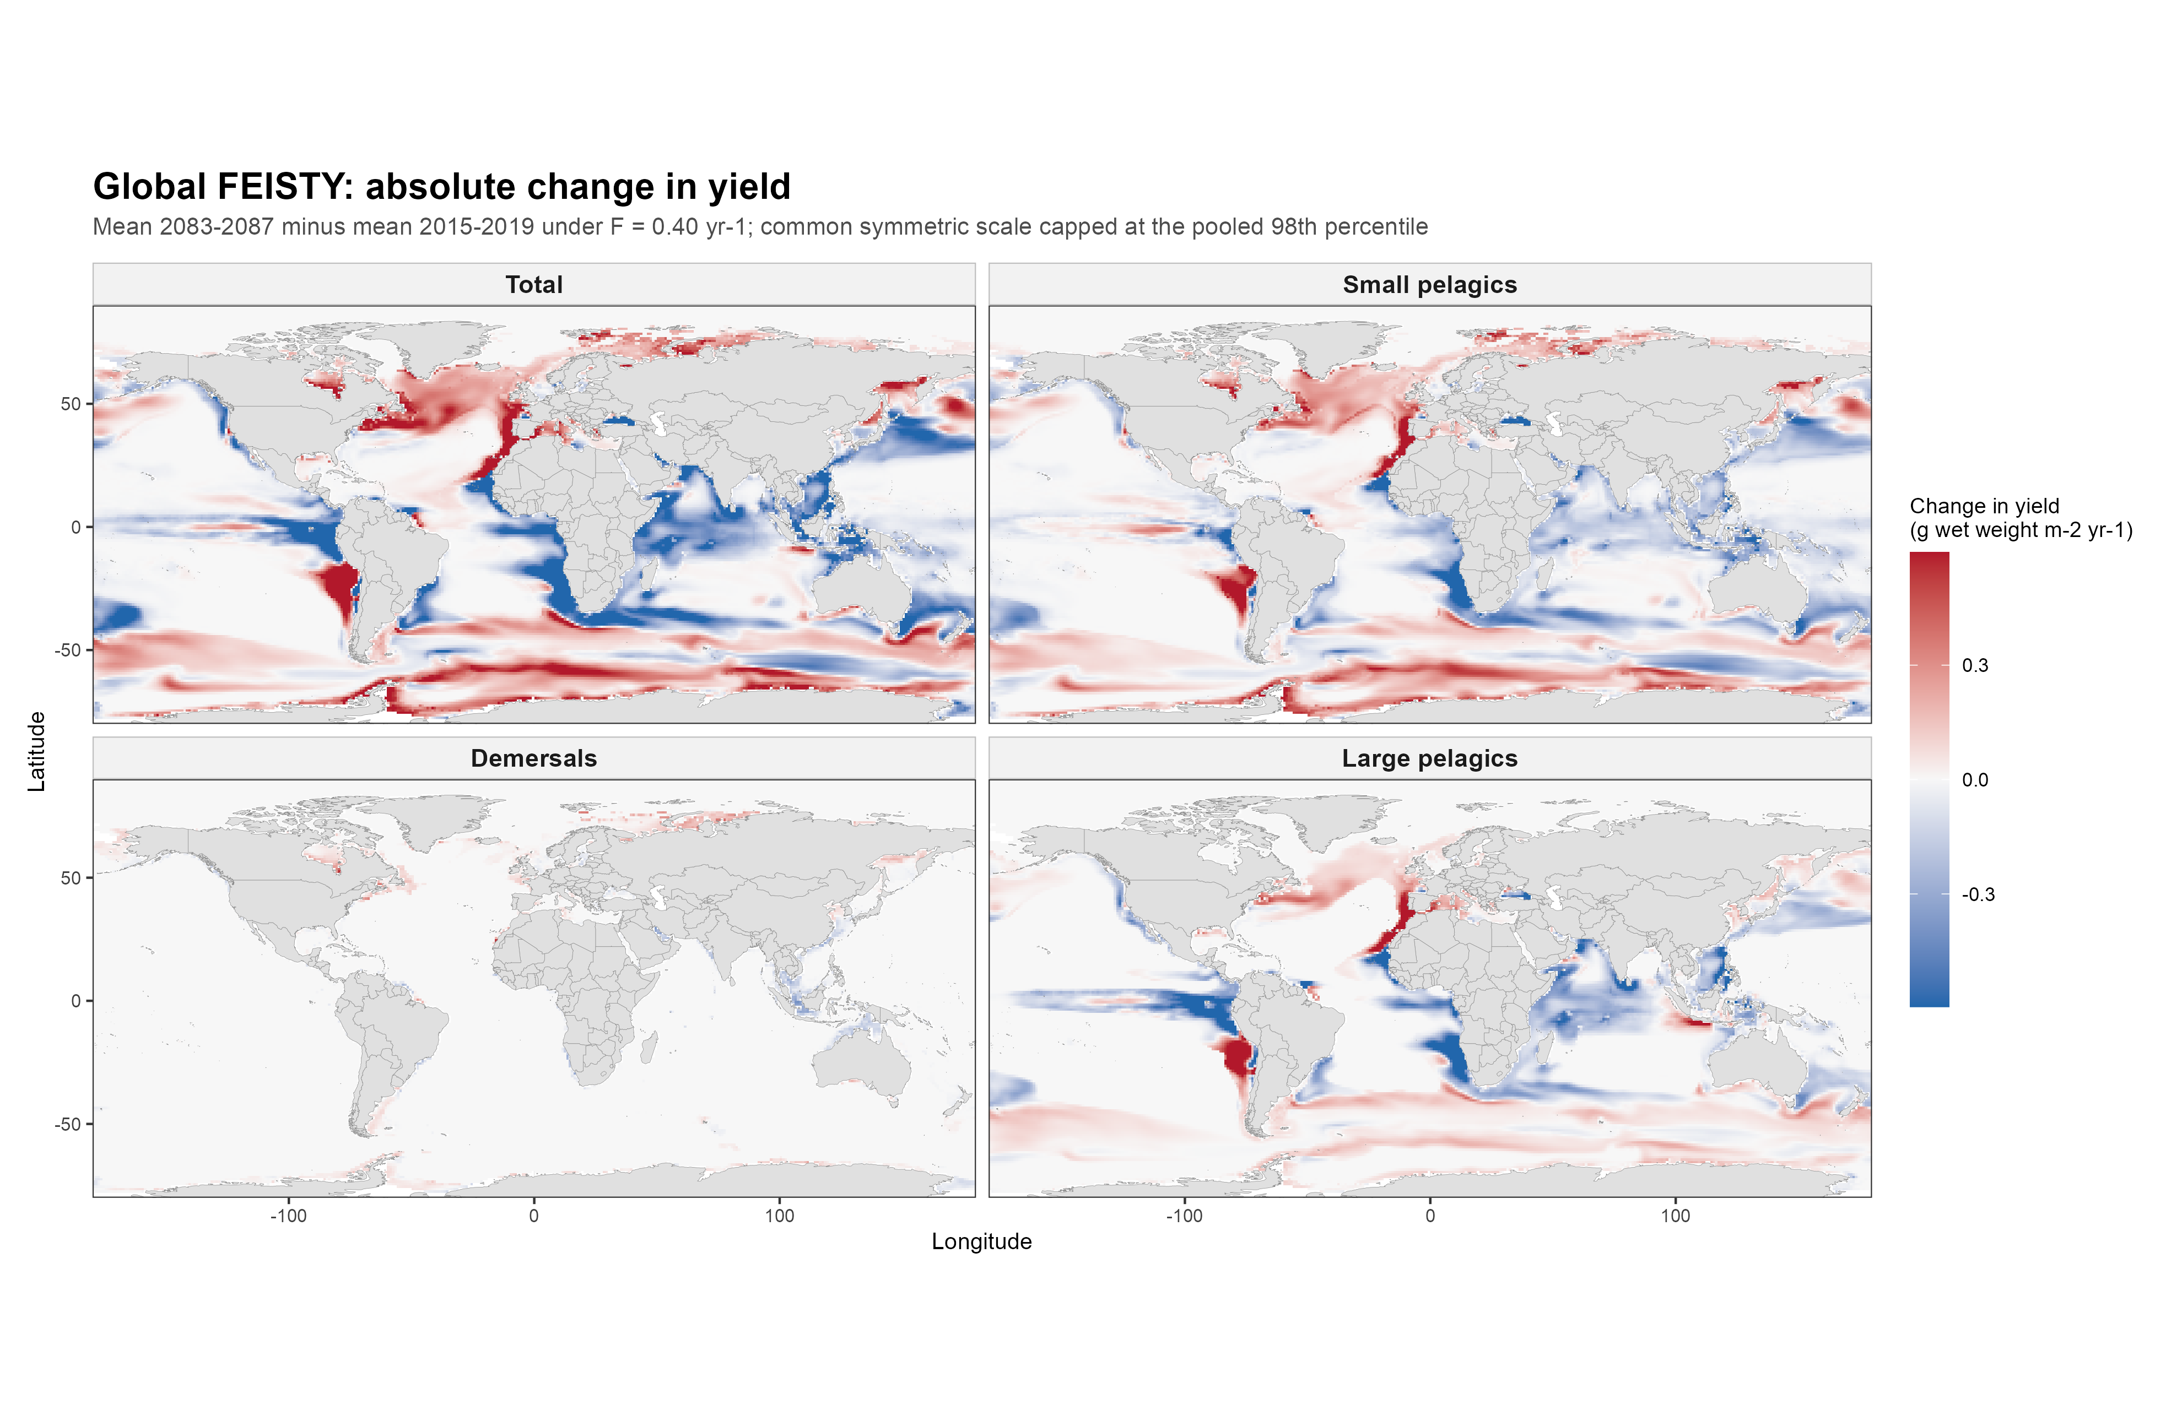
Figure 4. Absolute yield change: mean 2083-2087 minus mean 2015-2019 under F = 0.40 yr-1. Blue indicates a decrease and red an increase; the same symmetric scale is used in all panels.

