**Q8**

學號： B11209014 系級： 大氣二 姓名： 蔡知諺

**8.1 and 8.2**

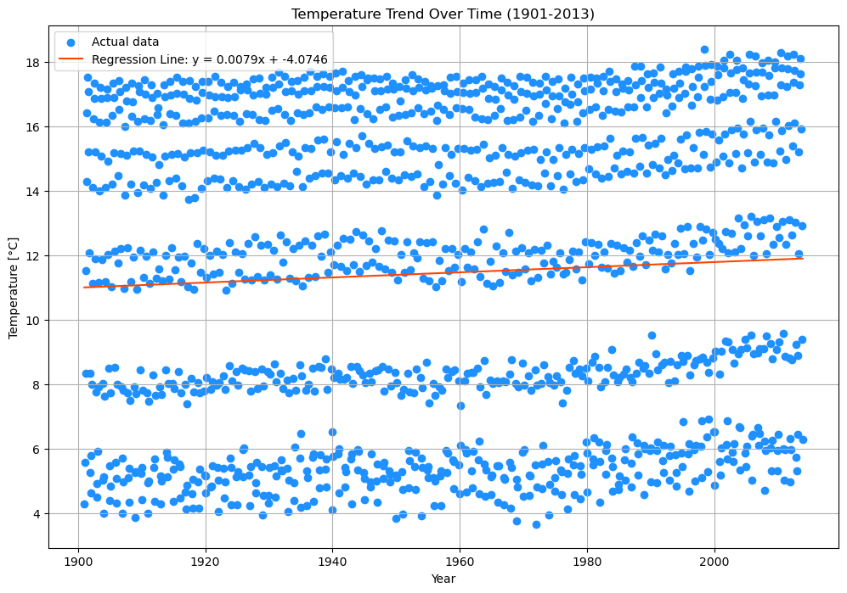

**Regression Line**: y = 0.0079x - 4.0746  
**R-squared**: 0.0031

**8.3**

**P-value**: 0.0392 < 0.05, which is significant.

**8.4 and 8.5**

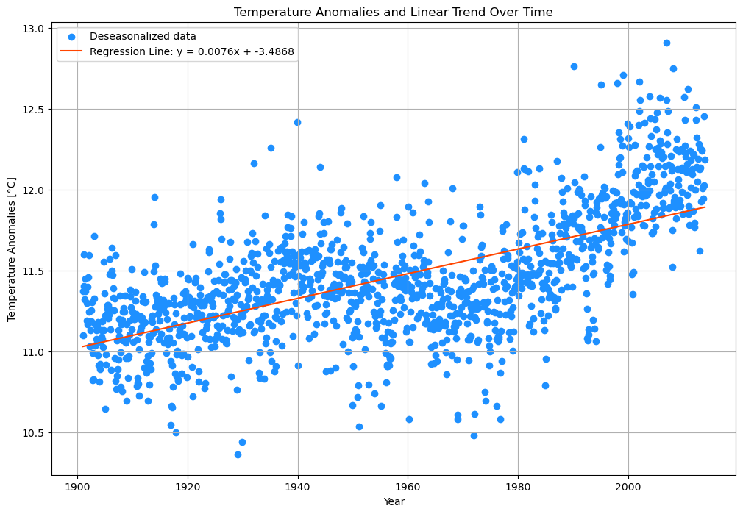

**Regression Line**: y = 0.0076x - 3.4868  
**R-squared**: 0.4085

**8.6**

**P-value**: 1.4478890748670055e-156 << 0.05 which is significant.

**8.7**

* Trend line **a1**: y = 0.0079x - 4.0746
* Trend line **a2**: y = 0.0076x - 3.4868
* Trend line **a1** is slightly bigger than **a2**. Both two line show the strong evidence of significant, but the trend line seems to be little difference. This is because deseasonalization only remove the seasonal pattern, did not change the ascending trend.

As to **P-value**, trend line **a1** is much bigger compared to **a2**, which is because the deseasonalization remove the “background noise” of seasonal difference, ampilfying the linear trend.