# Unit: ITSFT-406-1504

Programming for Computer Games

## Home Assignment 1 Designing and creating a basic 2D game

### Notes:

1. This is a guided Home Assignment
2. There will be review days, where your lecturer will guide you on your assignment completion. It is strongly suggested that you adhere to the review days to avoid assignment cramming and avoid losing marks.
3. You may refer to websites, forums, etc. for this assignment but you must include a reference (Harvard style) at the end of the assignment.
4. The final documentation should be uploaded on Turnitin by

**Monday 18 December 2017 12:00pm**

1. The program files must be uploaded (last commit) on Github, also by **Monday 18 December 2017 12:00pm** and the link shared with your lecturer.

### There will be no printed assignment submission, just soft copy.

***Scenario:***

### You have been asked to design and develop a 2-player ball game.

The game should have a Play Area, with borders and 2 goal scoring posts. 2 players should guard their own goal and try to score in the opposing player’s goal by reflecting a ball into the goal.

The player who reaches a set amount of score first wins and the game goes to another level, presenting the same play area, but increasing difficulty such as obstacles and increased ball movement. Scoring in Level 2 should be higher than Level 1 and include static obstacles.

Level 3 should be similar to Level 2 but having moving obstacles. There should be at least 3 levels in the game.

The players’ scores should be shown in UI Text and at the end of the last level, the player with the highest score wins.

The game should have 1 Menu Screen (Start or Quit), 3 Game Levels, 1 End Screen showing the scores and who won.

Player 1 should be controlled by the keyboard while player 2 should be controlled using the mouse.

For the game you can make use of any type of assets.

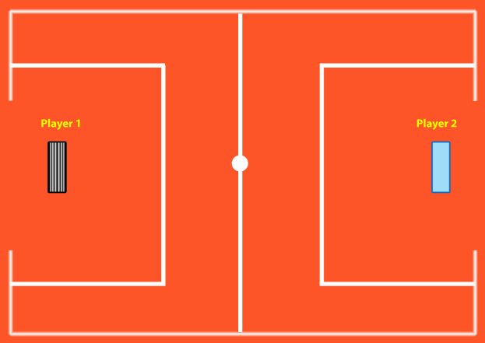

Above is a sample of how the Play Area should

Question 1 (AA1, AA2): *14 marks*

* 1. Select 2 game engines *(1 mark)* and list 4 reasons *(1.5 marks each)* why one particular game engine was selected (giving advantages of the game engine) and why the other was not selected.
* Unity and Unreal engine 4

Reasons:

* Both are free
* Unreal engine has more languages
* Unity has more mobile and computer platform targets
* Unreal engine 4 has more desktop targets

Advantages:

* Unity is better for those people who are trying to branch their gaming expiries for multiplatform games.
* Unity has better mobile branches they can run on Windows Phone; iOS; Android; BlackBerry 10; Tizen while Unreal engine has only iOS, Android.
* Unity has more console branches too like Xbox 360; Xbox One; Wii U; PlayStation 3; PlayStation 4; PlayStation Vita; Nintendo Switch; Nintendo 3DS while unreal engine has only PlayStation 4, Xbox One, Nintendo Switch
* Unity has tv targeted games while unreal engine doesn’t like Android TV; Apple TV; Samsung Smart TV.

Unity wins vs unreal engine 4

*7 marks*

* 1. Select 2 programming languages *(1 mark)* used in game development and choose one to support the game engine chosen and list 4 of its features *(1.5 marks each)*
* C# and C++
* C# is easier to learn and code.
* More rapid and potentially less errors when development than C++
* Easy to make multiple threads
* More advanced that C++

*7 marks*

Question 2 (SE1): *10 marks*

Prepare detailed design documents for the game:

1. One Game design document (State Diagram) should contain an overview of the whole game, from the Start Menu till the end showing correctly the interactions between the scenes

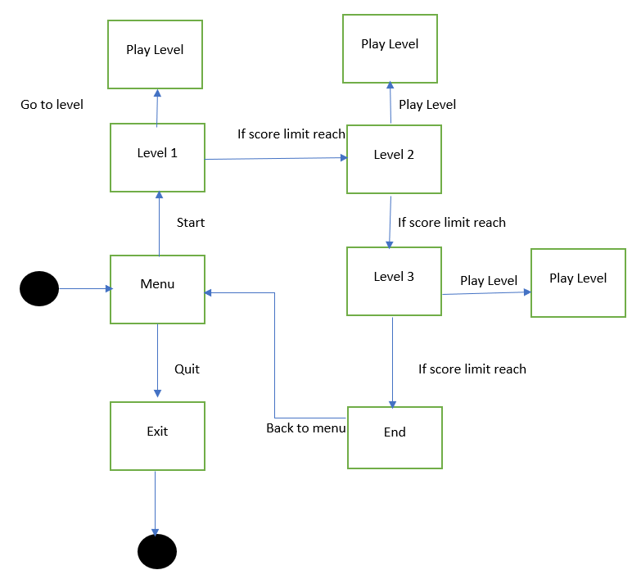

5 marks

1. The second design document should contain a detailed State Diagram of either Level 2 or Level 3 of the game showing correctly all events and interactions happening in the scene

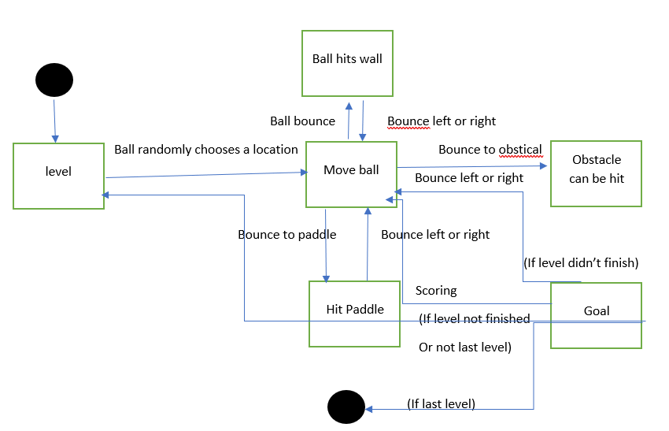 *5 marks*

Question 3 (KU 4) *5 marks*

In not less than 100 words, explain why compression is needed when using media assets such as images, videos and audio. Provide examples.

* Compression is used to reduce file size and save disc space. For images there are 3 types of file formats that are JPEG, GIF and PNG, A lossy compression averages nearby colours and removes colour variations that are not visible by the human eye. GIF compression reduces the colour palette of an image to 256 colours, which provides an efficient way to print each colour within the image. PNG compression uses a lossless compression algorithm that filters the image data and of pixel colours based on their pixels.
* For video there are 2 common types of file formats that are MP4 and MP3, Theas file formats remove inaudible frequencies and reduce the dynamics of the sound

Question 4 (KU1, KU 5, KU6, KU7, KU8) *25 marks*

Implement the game in Unity and C# as explained in the scenario and as described in the Game Design Documents above using the techniques you have learnt so far and researching others. Some programming techniques which you are expected to use include:

* Proper variables
* Scripts assigned to proper GameObjects
* Decision-making
* In-built methods and functions
* User-created Methods
* UI Text and Buttons
* Scene Management
* GameObjects and or prefabs
* FindObjectOfType
* Sprites (as players and background)
* Physics2D (Colliders, Triggers, Rigidbody, Materials, velocity)
* Input by mouse and keyboard

In your program you are expected to:

1. Make use of proper assets and arrange their settings to suit your needs. Images need to have their resolutions or pixels per unit properly set and not scaled.

Assets should be properly used and properly called programmatically when needed

*(5 marks)*

1. Program different input devices and methods for your game

*(5 marks)*

1. The game should be free from defects, as such you are expected to carry out proper programming and debugging using C# and Unity IDEs.

The whole program should work as expected according to the lecturer’s standards.

*(10 marks)*

1. Make use of GitHub for version control as one way to address resolution issues during development. You are expected to have at least 10 commits (with proper comments) over a span of 3 weeks (21 days), making sure to keep track of the review dates below

Also upload your part of the assignment by the review date given below on Turnitin, to be able to address issues during documentation and design

*(5 marks)*

Reviews:

Reviews will be held periodically to help you in your assignment. There will be a total of 3 reviews before the Assignment Final Submission as follows:

|  |  |  |
| --- | --- | --- |
| **Review Date Questions to review** | | |
| **1** | Week ending 1 December 2017 | 1, 2, 3 |
| **2** | Week ending 8 December 2017 | Part of Q 4 |
| **3** | Week ending 15 December 2017 | Part of Q 4 |

Adhering to the review dates will benefit you in the end as it is attached to Question 4d.

**Assignment Rubric**

|  |  |
| --- | --- |
| **Criteria and tasks** | **Marks** |
|  |  |
| **KU 1: Select a game engine and programming language** |  |
| Carry out proper programming and debugging using C# and Unity IDEs | **5** |
|  |  |
| **KU 4: State the relevance of compression settings in media assets** |  |
| Explain why compression is needed in media assets | **5** |
|  |  |
| **KU 5: Identify suitable resolutions for images of various types** |  |
| Make use of proper assets and arrange their settings to suit your needs. | **2** |
| Assets should be properly called programmatically when needed | **3** |
|  |  |
| **KU 6: Select asset types and settings for a range of media assets for a game design** |  |
|  |  |
| Make use of the techniques mentioned in Question 4 to implement the Game Design in Question 2 | **5** |
|  |  |
| **KU 7: Identify resolution issues for the development platforms** |  |
| Use Turnitin and GitHub for assignment submission by the assigned review dates | **5** |
|  |  |
| **KU 8: Identify appropriate input devices and methods for the**  **development platforms** |  |
| Use different input devices and methods | **5** |
|  |  |
| **AA 1: Compare game engines** |  |
| Select 2 game engines | **1** |
| Compare the differences between game engines | **6** |
|  |  |
| **AA 2: Compare programming languages** |  |
| Select 2 programming languages used for computer games | **1** |
| Compare the difference between the languages | **6** |
|  |  |
| **SE 1: Design and specify the details of the game to be developed including a state machine** |  |
|  |  |
| Create a State Diagram showing an overview of the whole game | **5** |
| Create a detailed State Diagram of Level 2 or Level 3 showing all interactions and events in the game | **5** |
|  |  |
| **TOTAL MARKS:** | **54** |
|  |  |