


BOILER HOUSE AUDIT REPORT
Rheinmetall Denel Munitions - Somerset West

Report No.: 2026-077

Distribution
Chordnum Naidoo (email) - 1
Test Engineer (email) - 1
Master File - 1

Prepared by:
Test Engineer
Service Engineer

Limit of Liability / Disclaimer

This report is limited to the matters stated herein and is not to be read as extending by implication to any other matters not specifically referred to herein. It is addressed to and is for the use and benefit of yourselves solely and may not be disclosed or communicated to, or relied upon by, any other person, firm, or corporation without our prior written consent.

The information appearing in this report is made available to you without any representation or warranty whatsoever, whether express or implied.

ACTOM (Pty) Ltd accepts no liability whatsoever for any loss, whether direct, indirect, or consequential, including without being limited to any loss of profit, or special damages arising from information made available to you in this report and actions or transactions resulting therefrom.

This “limit of liability/disclaimer” shall be governed by and construed according to the laws of the Republic of South Africa.

Confidentiality

This report is issued as per the distribution list only and may not be copied to any other parties without the expressed permission of the author.

EXECUTIVE SUMMARY
John Thompson was requested to perform a boiler house audit at Rheinmetall Denel Munitions - Somerset West on 27/07/2026. The audit consisted of a visual inspection of the boiler plant, testing of safety devices, testing of boiler controls and a general inspection of the boiler house and steam reticulation system.
The following actions are recommended to improve compliance of the boiler house with statutory regulations and to improve the operation and thermal efficiency of the boiler plant:
Boiler Water Level:
• Replace/repair sight glass. The gauge glass should be blown down once per shift to ensure it is working correctly and the standpipes do not become blocked with scale.
• Upgrade the water level control system by installing a Spirax LP21 probe, controller and a VSD for the feedwater pump for modulating control of the water level.
Fuel / HFO Handling — Burner:
• Restore the fuel supply pressure to specification. Install/set a separate pressure regulator for the burner and keep the ring main at constant pressure.
Fuel Handling & Feeding — Biomass:
• Control fuel moisture (typically below 30-35% for grate firing) and screen out contaminants. Record fuel moisture daily.
Economiser:
• Clean the economiser tubes and repair the soot blower.
Steam Traps:
• Carry out an in-house audit to determine whether the correct traps are selected and sized; replace damaged traps; set up and maintain a steam trap database; test traps at least once a year and record all maintenance.
Combustion — Stoker:
• Replace worn drive links; remove a link from the stoker chain and jack the motor to correct tension.

OBJECTIVE
John Thompson was assigned to perform a boiler house audit, carry out the necessary inspections, and provide recommendations to address any identified deficiencies.

SCOPE OF WORK
A boiler house audit was performed as detailed in the sections below.

DESCRIPTION OF BOILER PLANT
Boiler C6 is a John Thompson 18-080 coal-fired chain grate stoker boiler with a rated capacity of 8000 kg/h and a design pressure of 10.4 bar(g), manufactured in 1978 (serial no. 71940).
Boiler 2 is a Cochran TW HFO-fired burner boiler with a rated capacity of 6000 kg/h and a design pressure of 10 bar(g), manufactured in 2005 (serial no. 5555).
Boiler 3 is a John Thompson Bio 12 biomass-fired (Pine wood chips) boiler with a rated capacity of 12000 kg/h and a design pressure of 17 bar(g), manufactured in 2019 (serial no. 80001). The boiler is fitted with the following additional equipment: Economiser, Bag filter.

FUEL

Boiler C6 - Grade C Smalls
Fuel type | Grade C Smalls
Supplier / mine | Mine X
Calorific value (MJ/kg) | 25.1
Total moisture (%) | 8
Ash content (%) | 14
Fuel analysis report available | No
Notes | No analysis certificate on site.

Boiler 2 - HFO
Fuel type | HFO
Viscosity (cSt @ °C) | 380 cSt @ 50 °C
Supply temperature at burner (°C) | 115
Fuel analysis report available | Yes
Date of last fuel analysis | 03/2026

Boiler 3 - Pine wood chips
Fuel type | Pine wood chips
Calorific value (MJ/kg) | 10.5
Moisture content (%) | 42
Contaminants (sand, stones, metal) | Sand and stones visible

BOILER INSPECTION FINDINGS

BOILER WATER LEVEL

Boiler C6
• Water level control type: Mobrey
• Extra low water cut-out: Mobrey
Findings
• Sight glass not clearly visible / leaking and needs replacement.
• Gauge glass blown down at start of shift - working correctly.
• Water level Mobrey switches badly worn / water level control not ideal with slow response.
• Extra low water lock-out tested and working.
Recommendations
• Replace/repair sight glass. The gauge glass should be blown down once per shift to ensure it is working correctly and the standpipes do not become blocked with scale.
• Upgrade the water level control system by installing a Spirax LP21 probe, controller and a VSD for the feedwater pump for modulating control of the water level.
• Upgrade to Spirax LP40 at next shutdown for redundancy.

Boiler 2
No issues noted at time of inspection.

COMBUSTION — STOKER

Boiler C6
Findings
• The stoker mat could not be tensioned due to excessive wear on drive links.
Recommendations
• Replace worn drive links; remove a link from the stoker chain and jack the motor to correct tension.

FUEL / HFO HANDLING — BURNER

Boiler 2
• Actual fuel temperature at burner: 120
• Actual fuel pressure at burner: 95
Findings
• Actual fuel pressure measured at 95 bar, outside the required specification, negatively affecting combustion stability.
Recommendations
• Restore the fuel supply pressure to specification. Install/set a separate pressure regulator for the burner and keep the ring main at constant pressure.

FUEL HANDLING & FEEDING — BIOMASS

Boiler 3
Findings
• Fuel moisture content is high and the fuel contains contaminants (sand, stones, metal), reducing combustion efficiency and damaging the grate.
Recommendations
• Control fuel moisture (typically below 30-35% for grate firing) and screen out contaminants. Record fuel moisture daily.

COMBUSTION — BIOMASS

Boiler 3
Findings
• Reciprocating grate in good condition.

ECONOMISER

Boiler 3
Findings
• Economiser tubes heavily fouled with soot.
• Water outlet temperature measured at 142 °C.
Recommendations
• Clean the economiser tubes and repair the soot blower.

BAG FILTER

Boiler 3
No issues noted at time of inspection.

SITE-WIDE FINDINGS AND RECOMMENDATIONS

STEAM TRAPS
Findings
• Most steam traps are functional but some are passing steam, seen from the feedwater storage tank overfilling and steam flow from the tank vent.
Recommendations
• Carry out an in-house audit to determine whether the correct traps are selected and sized; replace damaged traps; set up and maintain a steam trap database; test traps at least once a year and record all maintenance.

WATER TREATMENT PLANT
Findings
• Softeners working; regeneration log up to date.

EFFICIENCY
Generally, the instrumentation required to complete an efficiency test is as follows: flue gas oxygen content, flue gas exit temperature, ambient air temperature and combustion (CO) readings. The table below indicates the flue gas oxygen content that should be achieved for optimal combustion efficiency. These values are provided as an indication to the customer of what should be achievable.
Firing | Target flue gas O2
Coal-fired chain grate stoker | 8 % O2
Oil / gas-fired burner | 3 - 6 % O2
Biomass-fired | 6 - 8 % O2

RECOMMENDATIONS

High Priority
Boiler C6
• Replace/repair sight glass. The gauge glass should be blown down once per shift to ensure it is working correctly and the standpipes do not become blocked with scale.
• Upgrade the water level control system by installing a Spirax LP21 probe, controller and a VSD for the feedwater pump for modulating control of the water level.
Boiler 2
• Restore the fuel supply pressure to specification. Install/set a separate pressure regulator for the burner and keep the ring main at constant pressure.
Boiler 3
• Control fuel moisture (typically below 30-35% for grate firing) and screen out contaminants. Record fuel moisture daily.
• Clean the economiser tubes and repair the soot blower.
Site
• Carry out an in-house audit to determine whether the correct traps are selected and sized; replace damaged traps; set up and maintain a steam trap database; test traps at least once a year and record all maintenance.

Medium Priority
Boiler C6
• Replace worn drive links; remove a link from the stoker chain and jack the motor to correct tension.

Low Priority
Boiler C6
• Upgrade to Spirax LP40 at next shutdown for redundancy.

WORK DONE ON SITE
No additional work was performed during the audit.

APPENDIX A - BOILER DETAILS
Boiler C6
Make | John Thompson
Model | 18-080
Serial number | 71940
Capacity (kg/h) | 8000
Design pressure (bar g) | 10.4
Year of manufacture | 1978
Firing | Coal fired (chain grate stoker)
Fuel | Grade C Smalls

Boiler 2
Make | Cochran
Model | TW
Serial number | 5555
Capacity (kg/h) | 6000
Design pressure (bar g) | 10
Year of manufacture | 2005
Firing | Oil / gas fired (burner)
Fuel | HFO

Boiler 3
Make | John Thompson
Model | Bio 12
Serial number | 80001
Capacity (kg/h) | 12000
Design pressure (bar g) | 17
Year of manufacture | 2019
Firing | Biomass fired
Fuel | Pine wood chips
Additional equipment | Economiser, Bag filter

PHOTOGRAPHS

Boiler C6
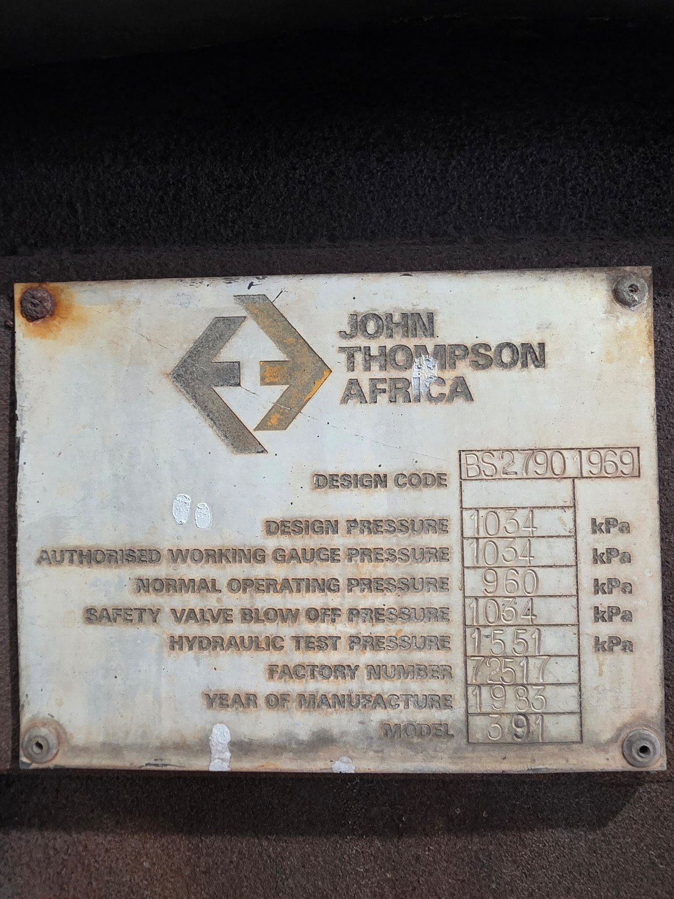  Figure 1: Boiler C6 - Nameplate |   Figure 2: Boiler C6 - Fuel sample
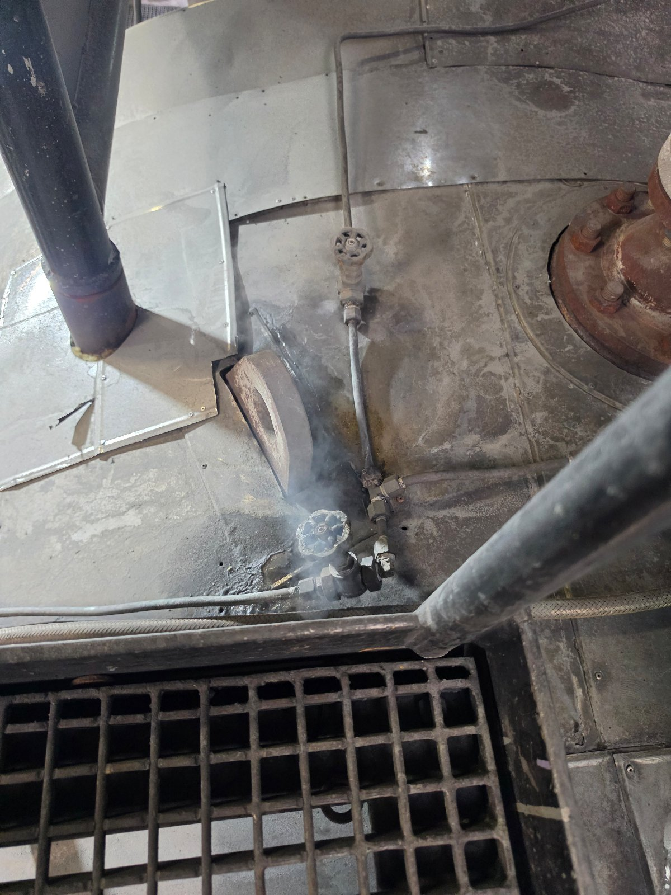  Figure 3: Boiler C6 - Gauge glass / sight glass condition | 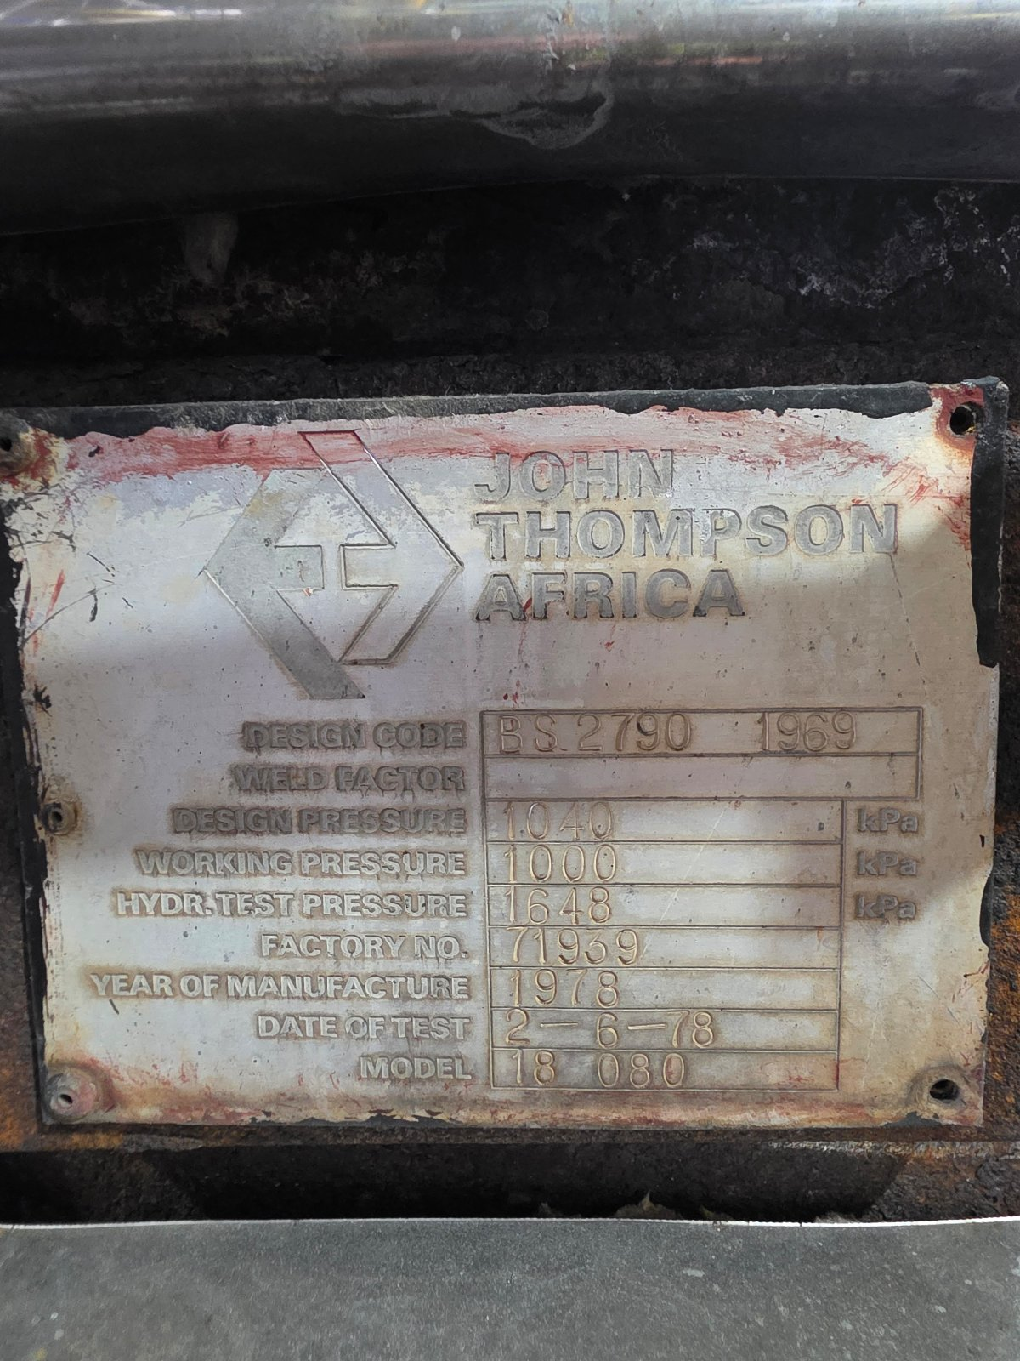  Figure 4: Boiler C6 - Water level control type & condition

Boiler C6 (continued)
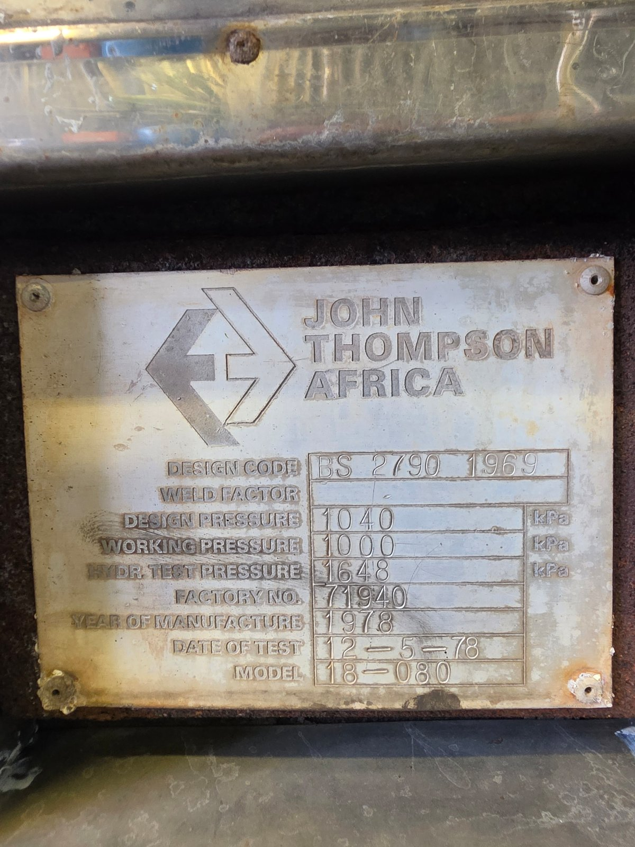
Figure 5: Boiler C6 - Level control blowdown pipework

Boiler 2
  Figure 6: Boiler 2 - Nameplate |   Figure 7: Boiler 2 - Fuel analysis report

Boiler 3
  Figure 8: Boiler 3 - Grate type & condition |   Figure 9: Boiler 3 - Grate type & condition
  Figure 10: Boiler 3 - Grate type & condition |   Figure 11: Boiler 3 - Grate type & condition

Boiler 3 (continued)
  Figure 12: Boiler 3 - Grate type & condition |   Figure 13: Boiler 3 - Grate type & condition

Figure 14: Boiler 3 - Economiser - Economiser tubes / fins condition

Site

Figure 15: Site - Traps passing steam?

