Future Development Document

Healthify



Contents

1. Introduction 1

2. Digital twin 1

2.1. Digital twin: Inputs 1

3. Scalability 1

3.1. Compatible diseases 1

3.2. Platform 1

4. Gamification 2

4.1. Improved real-life reward system 2

4.2. Ideas for further gamification 3

4.2.1. Experience/coins 3

4.2.2. Farmville light 3

4.2.3. Visualising progress 4

5. User experience 5

5.1. Customisation 5

5.1.1. Wardrobe 5

5.1.2. Switching background 5

5.2. Notifications 6

6. Additional UX-elements 7

# Introduction

The following document will specify which parts of the prototype will require further work and development in order to create a more complete product. The recommended steps that should be taken in this process will also be specified as well as potential future features that could add value to the product.

# Digital Twin

The mock digital twin implemented in the prototype is a proof of concept rather than a functional digital twin. The inputs are hard coded, and the prototype does not connect to the backend required to perform high quality simulations but rather to simple placeholder algorithms. In order to create a functioning digital twin, the frontend needs to be configured to handle actual inputs and then connected to the backend.

## Digital Twin: Inputs

The product is designed to handle manual inputs for two specific diseases. Healthify’s vision is automating the process of handling inputs by collaborating with other applications and using their data to continuously feed the digital twin. This will increase the accuracy of the simulations. Some applications that could be relevant are listed below.

Fitbit

Apple Health

Runkeeper

Freestyle Libre

Lifesum

The reasoning behind the chosen applications is that they have inputs and interfaces similar to Healthify’s goal. The above-listed applications are also somewhat large and well-known, which means that Healthify’s end-users are more likely to already be familiar with them, easing the usage.

## Digital Twin: Implementation

As previously stated, the current digital twin implemented is a proof of concept rather than a functioning digital twin. This project is mostly based off of the digital twin developed by Gunnar Cedersund at Linköping university, and the frontend is designed to be as compatible as possible with his digital twin. If the digital twin were to be implemented for real, the system would have to access the twin’s backend. In order to do that, further communication with Gunnar Cedersund would be required and any further implementation of the twin should be discussed with him.

# Scalability

The scalability of the product is more constrained by the backend than by the frontend. For the product to be able to run simulations on a specific disease, there must exist a mathematical model capable of simulating that disease given a set of input variables in the backend. If this is the case, the frontend needs to be configured to adjust for the new input and output variables. This would require some coding experience.

## Compatible Diseases

At the date of writing this document, the backend is capable of running simulations on both the diseases covered by the prototype. In addition to this, the backend is capable of simulating must cardiometabolic diseases but, as previously stated, this would require modifications to the frontend.

## Platform

A requested feature was for children to be able to communicate with other children in the same situation. By building a platform around the applications and implementing features such as chat-functions, Healthify could create a network where children are able to communicate with and support each other. The chat could either be connected to a specific illness or be scaled to work across the entire platform. This would give a social aspect to the platform and offer another incentive for children to use the application on a regular basis. An idea of how the chat could be built can be seen below, along with a view that allows the child to update their status and biography.

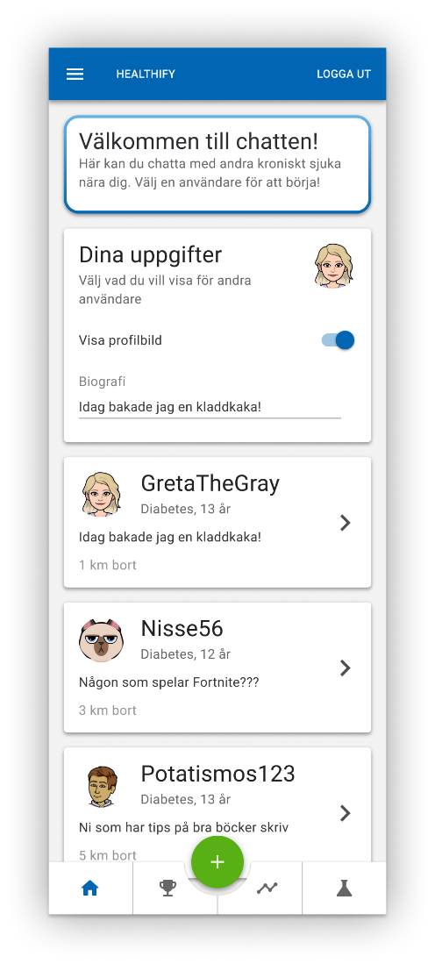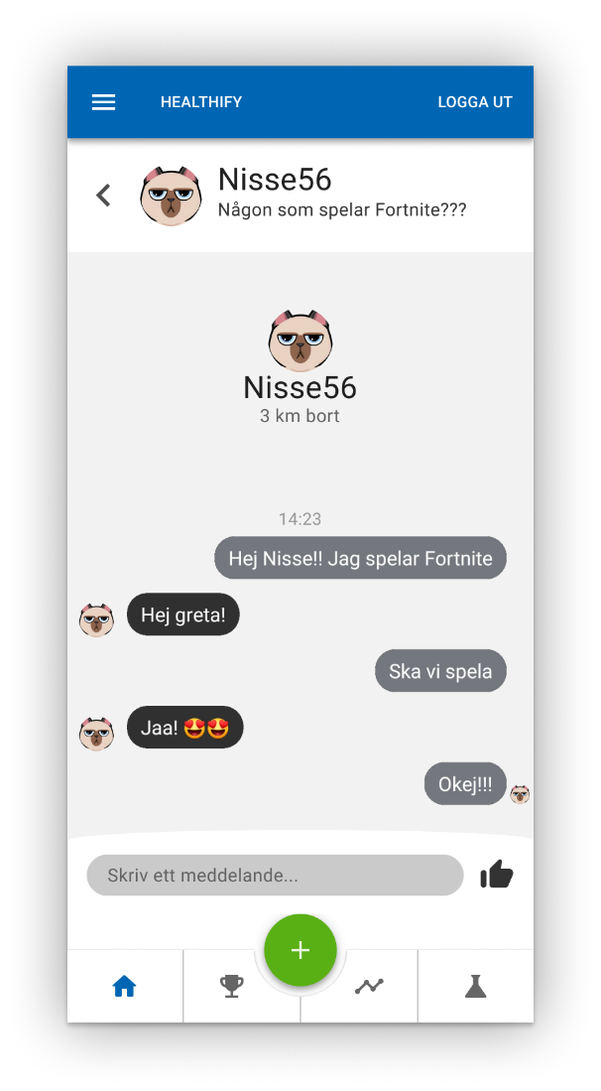

# Gamification

This section covers features and ideas that could improve the gamification element of the product. The gamification implemented in the product is a real-life reward system that allows parents to specify rewards and streaks (days in a row that the child must enter measurements) required to claim the entered reward.

## Improved Real-Life Reward System

As stated, the current application only allows streaks as a way of working towards the goal. This could be expanded upon in various ways. One example is to allow parents of obese children to specify, for example, amount of workout hours as another means of gaining rewards. Providing more flexibility for the parent would increase the usability of the reward-system. A prototype has been made for the improved reward system and can be seen below.

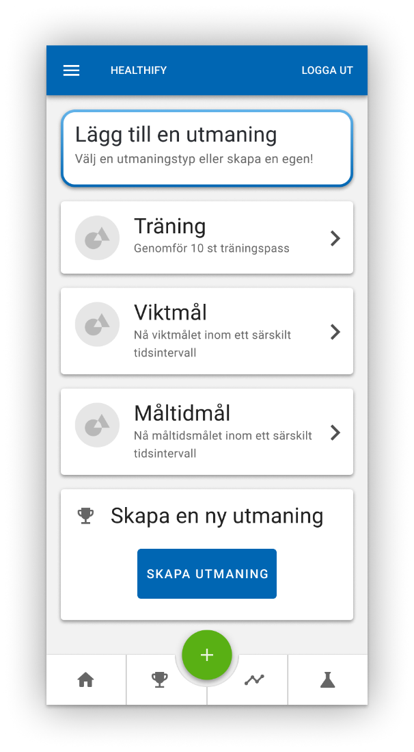

## Ideas for Further Gamification

During the development of the project, several different ideas of gamification were explored. The heavy focus on gamification was deprioritized due to the digital twin solution being deemed more important within the limited time frame. Nevertheless, this section presents some ideas explored during the project.

### Experience Points/Coins

To further increase the gamification of the product, a system revolving around experience points or coins could be implemented. The main idea would be to reward the child with an in-game currency by doing various activities such as maintaining streaks or completing challenges and/or quizzes.

This idea can then be implemented alongside multiple other solutions (see section 5.1, for example). To combine this element with other solutions would be the recommended path of action since this would provide little value as a stand-alone system.

### “Farmville Light”

One of the ways to incentivise continuous measuring was to create a virtual farm which would allow the end-user to plant and farm different crops by monitoring their disease. The main concept was a harvest function that would be tightly linked to the end-user entering their measurements. It was also planned to allow the end-user to unlock new crops, seeds, or farming patches by maintaining measurement-streaks. A sketch of the idea can be seen below.

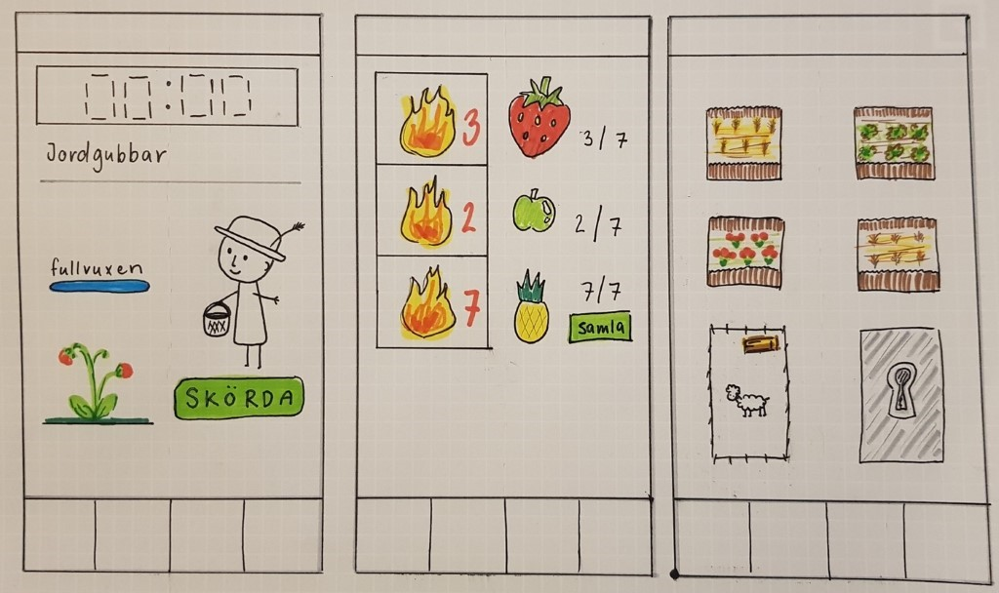

### Visualising Progress

Another gamification idea that was considered during the project was to allow visualisation of progress, meaning that monitoring and measuring the disease would somehow allow the user to see an object evolve on screen. Two ideas sprung from this, allowing the end-user to build a castle using coins or experience points collected by continuously entering measurements (see sketch below). 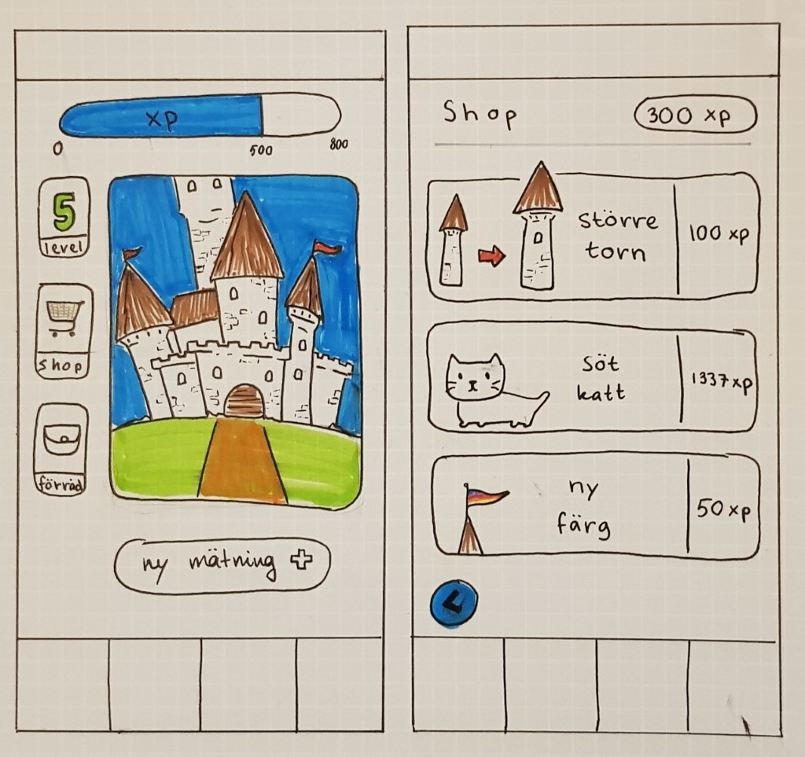

The other idea following the same theme was to have the user take care of a tree. Measuring and monitoring the disease would either add more leaves to the tree or allow it to grow. This could also be expanded to having the user plant their own forest by growing one tree at a time and allowing different types of trees. A very early development sketch can be seen below, outlining the basic principles. 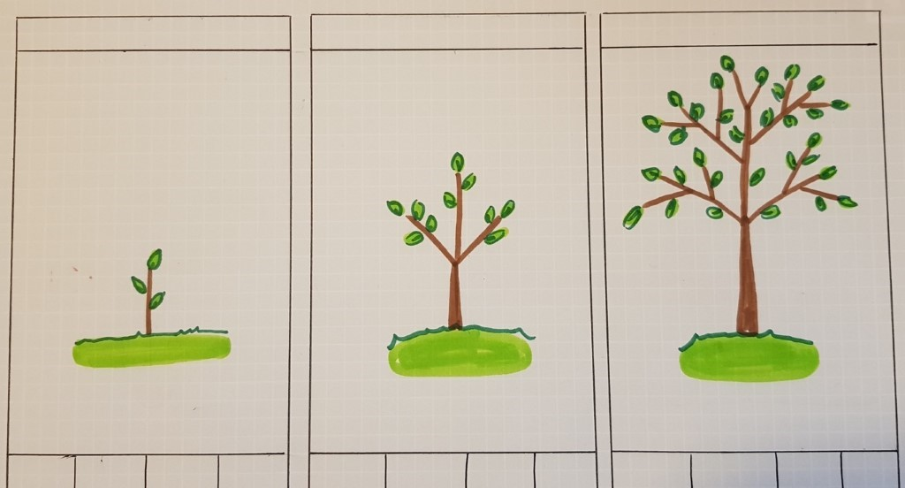

# User Experience

This section covers features and ideas, mainly gained through end-user testing, that would improve the end-users' overall experience while using the application.

## Customization

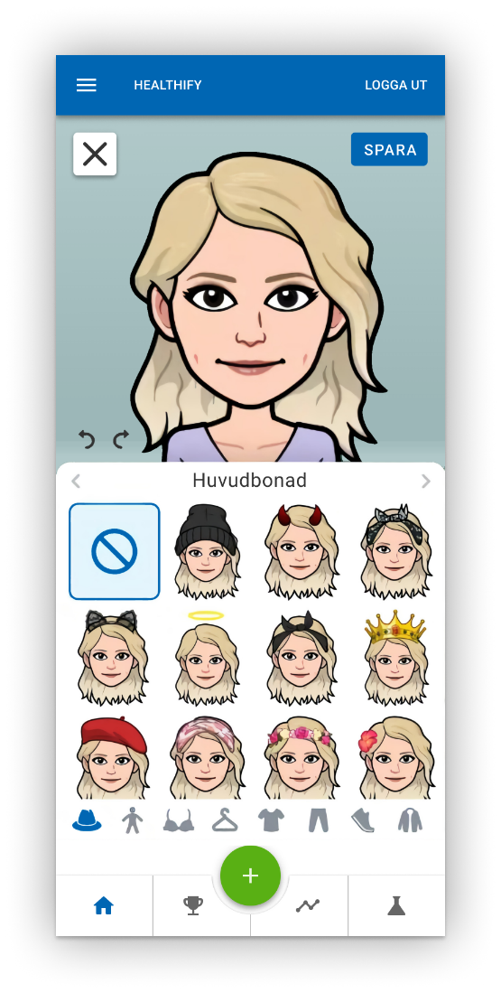During end-user testing, some end-users expressed the wish to be able to customise their avatar and make it feel more alive and stimulating. This section covers a few ways this could be incorporated into the application.

### Wardrobe

On the home page of the child view, a wardrobe feature could be implemented. This would allow the user to buy and/or unlock clothes either as a pure customization option or using experience points or coins. The latter option would utilize the previously discussed idea of gaining experience points or coins through various activities within the application. A desire to be able to switch clothing of the avatar was also identified during end-user testing. A prototype of the wardrobe can be seen above.

### Switching Background

The current application features a plain blue background. Another aspect that was pointed out during end-user testing was the desire to be able to switch the background of the home page in the child view. It was also suggested to make the background animated to make the application feel more alive. This could be combined with the previously mentioned wardrobe suggestion to allow the child to buy and/or unlock backgrounds as part of a game. It could also simply be implemented as a customization option to improve the user experience. The background changes could be more or less advanced, ranging from a simple change in colours to different designs for different seasons. Prototypes of the selections screen and a background that switches with the seasons have been made and can be seen below.

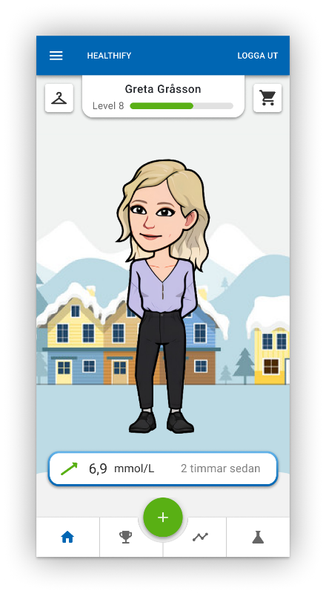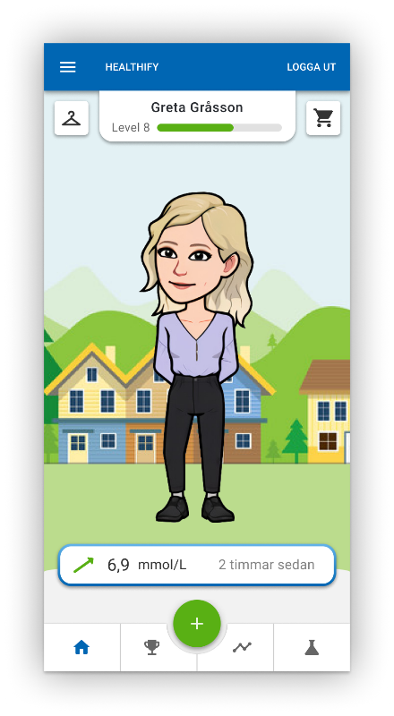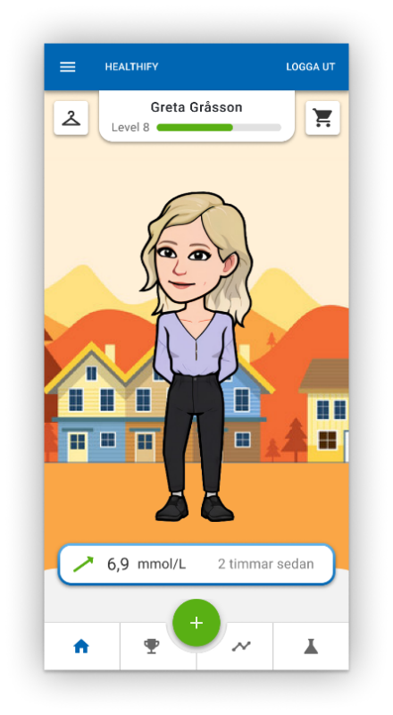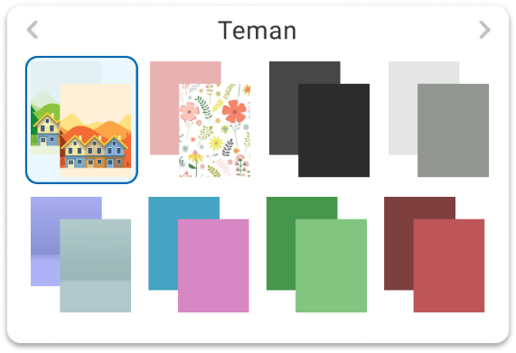

## Notifications

User testing also revealed that notifications was a requested feature. Specifically, having the application be able to send notifications to the child when it is time to log a meal or a training session. It was suggested that the number of times per day this notification would be sent was to be specified by the parent. The parents interviewed during the end-user testing also expressed a wish to be notified whenever their child had completed a measurement.

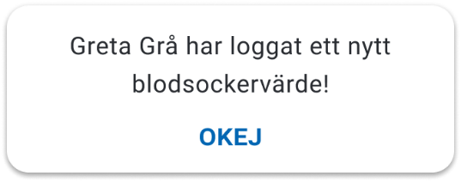

# Additional UX Elements

This section covers views that have not yet been implemented into the application and were not otherwise covered throughout this document.

