Personalized Clinic Management System

The All-In-One modernized clinic integrated with Scheduling, Inventory, real-time appointment overview management system.

Created by:

Introduction and Overview

TitaClinic is a web-based pediatric clinic management system designed to improve the coordination of clinic appointments, patient information, user accounts, and daily administrative activities. The system provides a centralized platform where parents or guardians can register their children, select a clinic branch, request appointment dates, and review their booking history. Doctors can monitor assigned appointments using a calendar-based dashboard, while administrators can approve accounts and oversee clinic activity through system-wide key performance indicators.

The primary purpose of TitaClinic is to provide a centralized and secure clinic portal that simplifies how parents, doctors, and administrators coordinate pediatric appointments and patient records.
The system is intended to:
- Reduce the amount of manual work involved in account registration and appointment scheduling.
- Allow parents to maintain organized child patient profiles.
- Give parents clear information regarding clinic branches, operating schedules, and available appointment dates.
- Allow doctors to view their scheduled patients using a calendar-based interface.
- Provide administrators with control over account approval, user roles, and account status.
- Maintain a reliable history of current, past, cancelled, completed, and missed appointments.
- Prevent unauthorized access to role-specific functions and records.
- Establish a technical foundation for future medical-record, immunization, and inventory features.

Entity-Relationship Diagram (ERD)

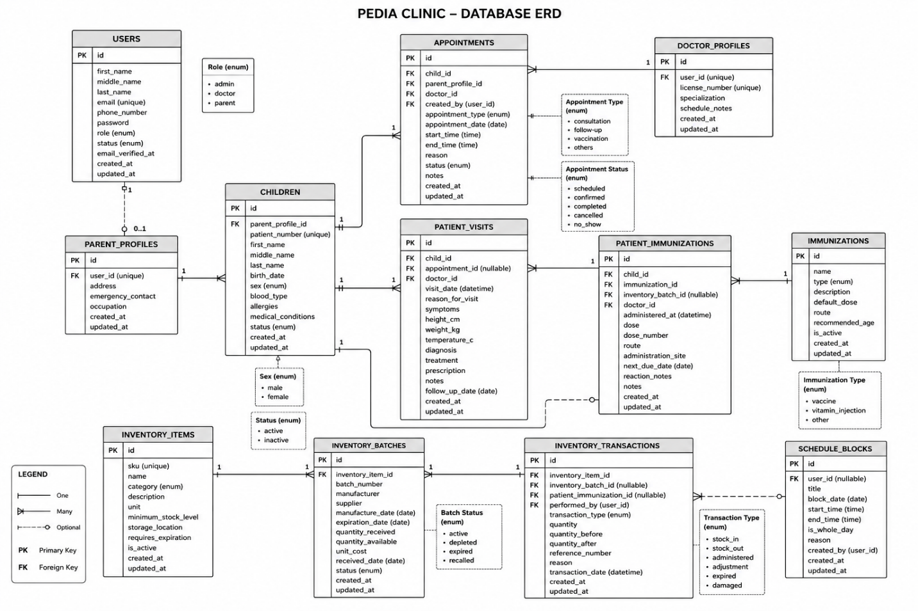

USER INTERFACE EXAMPLES

Landing page
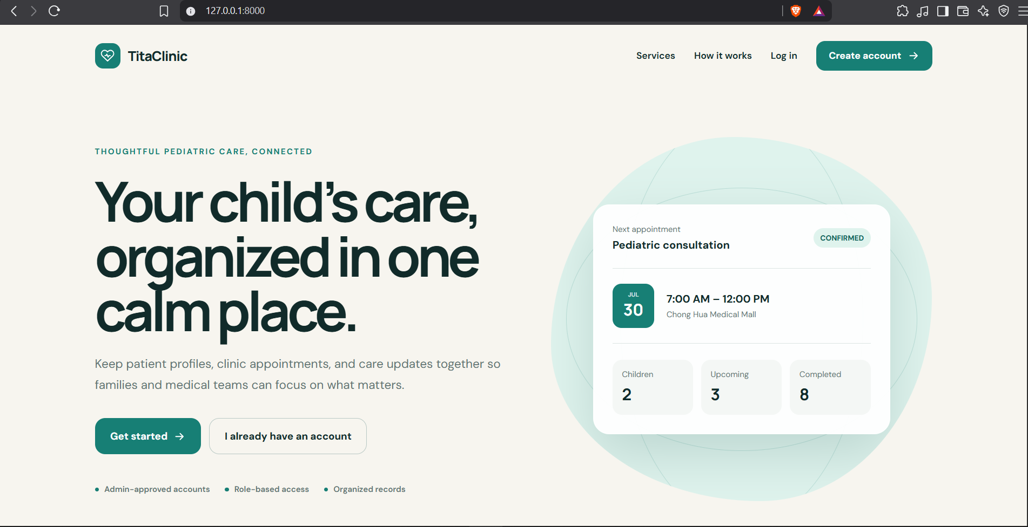
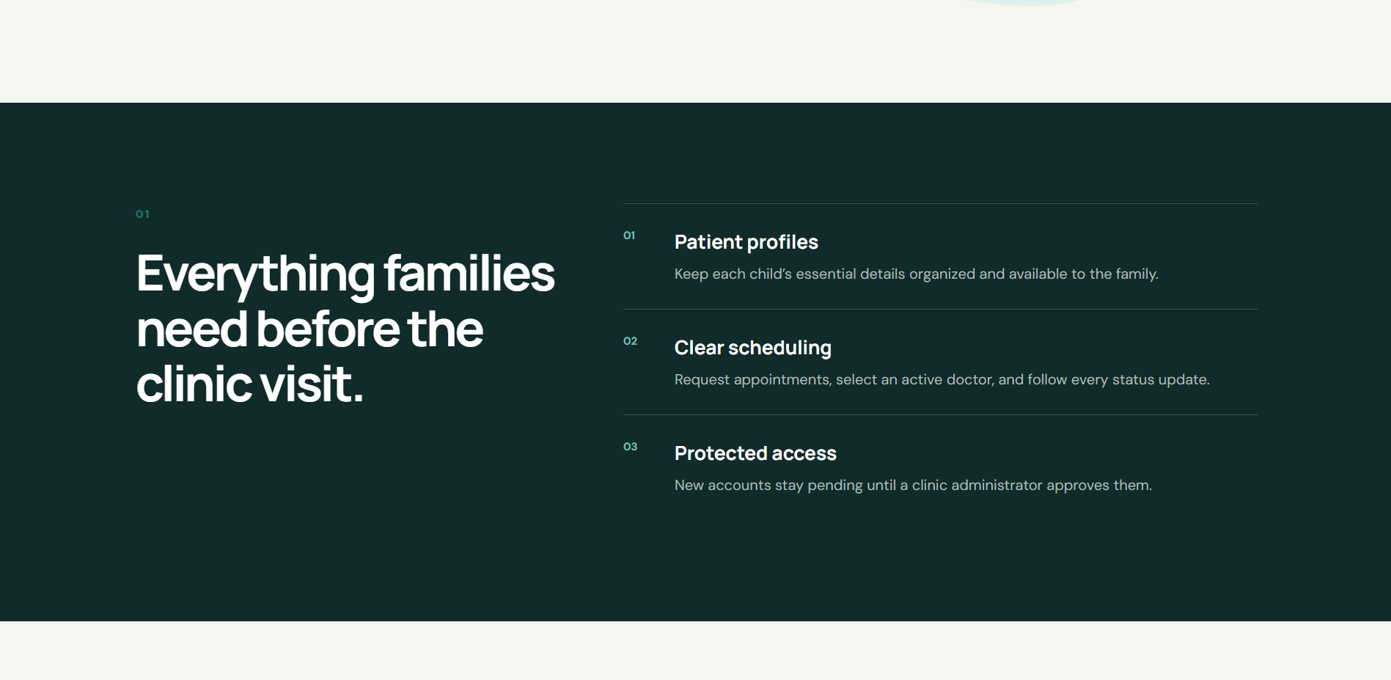

login & Create page(s)
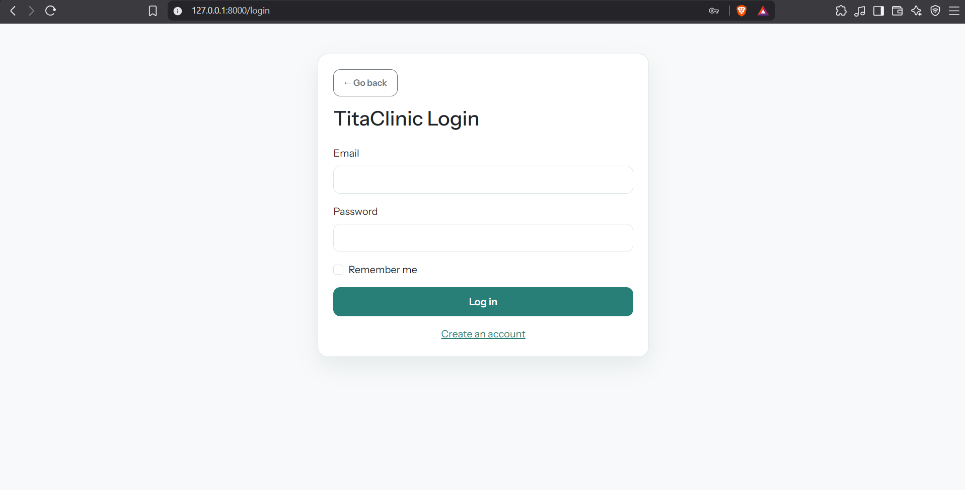

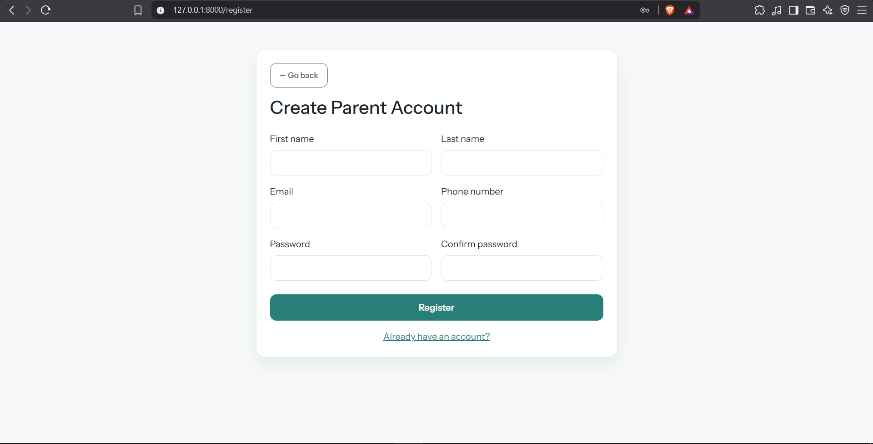

ADMIN DASHBOARD
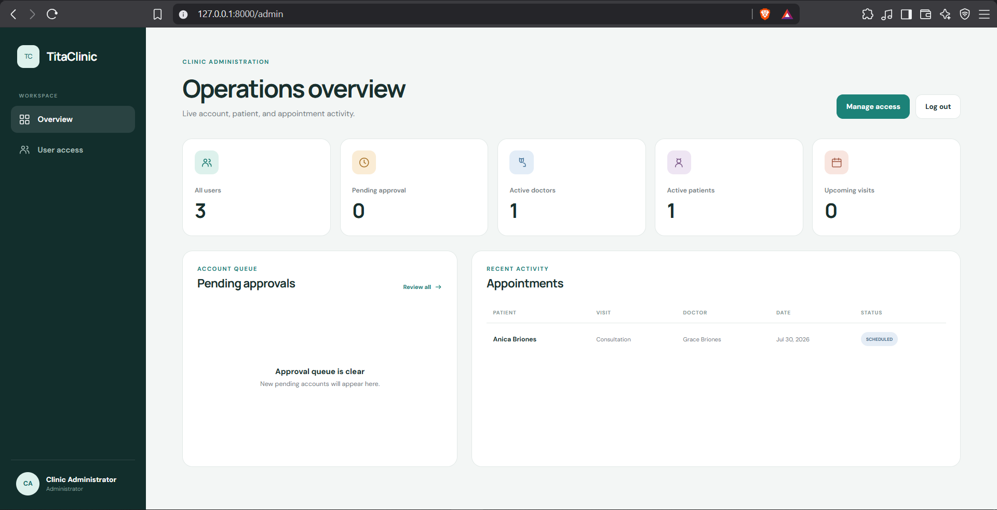
DOCTOR DASHBOARD
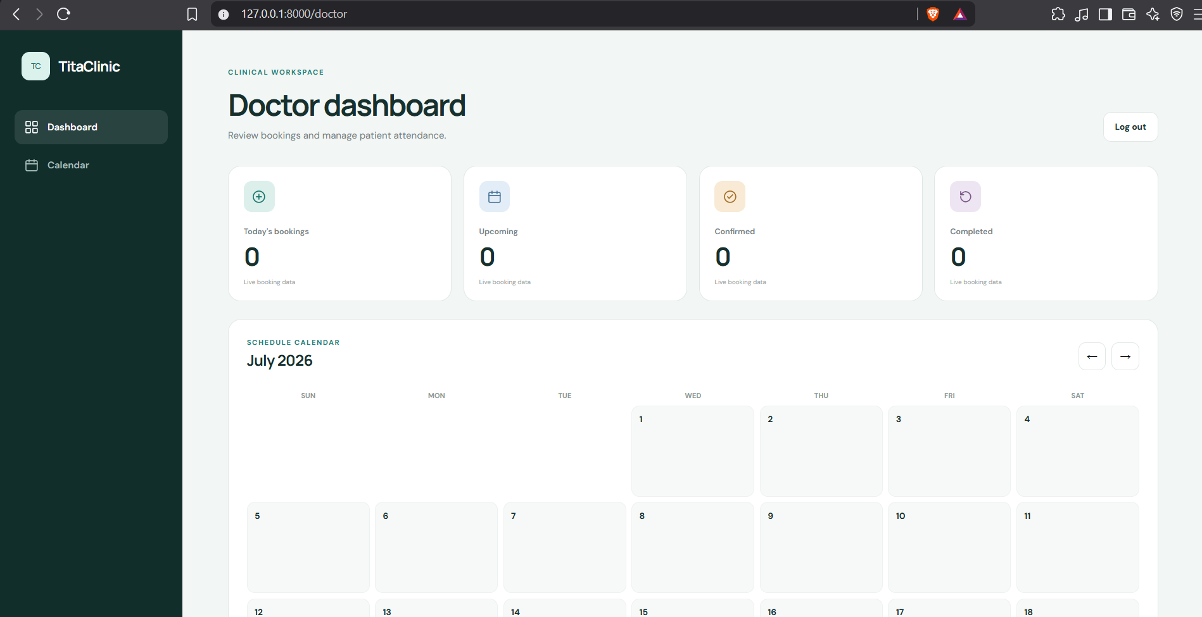

PATIENT/PARENT DASHBOARD
