-- DRAFT --

REPORT

**A 1.5 MW NuMAD Blade Model**

Brian R. Resor and Tyler Bushnell

Prepared by  
Sandia National Laboratories  
Albuquerque, New Mexico 87185 and Livermore, California 94550

Sandia National Laboratories is a multi-program laboratory managed and operated by Sandia Corporation,   
a wholly owned subsidiary of Lockheed Martin Corporation, for the U.S. Department of Energy's   
National Nuclear Security Administration under contract DE-AC04-94AL85000.







Issued by Sandia National Laboratories, operated for the United **S**tates Department of Energy by Sandia Corporation.

**NOTICE:** This report was prepared as an account of work sponsored by an agency of the United States Government. Neither the United States Government, nor any agency thereof, nor any of their employees, nor any of their contractors, subcontractors, or their employees, make any warranty, express or implied, or assume any legal liability or responsibility for the accuracy, completeness, or usefulness of any information, apparatus, product, or process disclosed, or represent that its use would not infringe privately owned rights. Reference herein to any specific commercial product, process, or service by trade name, trademark, manufacturer, or otherwise, does not necessarily constitute or imply its endorsement, recommendation, or favoring by the United States Government, any agency thereof, or any of their contractors or subcontractors. The views and opinions expressed herein do not necessarily state or reflect those of the United States Government, any agency thereof, or any of their contractors.

Printed in the United States of America. This report has been reproduced directly from the best available copy.

Available to DOE and DOE contractors from

U.S. Department of Energy

Office of Scientific and Technical Information

P.O. Box 62

Oak Ridge, TN 37831

Telephone: (865) 576-8401

Facsimile: (865) 576-5728

E-Mail: [reports@adonis.osti.gov](mailto:reports@adonis.osti.gov)

Online ordering: <http://www.osti.gov/bridge>

Available to the public from

U.S. Department of Commerce

National Technical Information Service

5285 Port Royal Rd.

Springfield, VA 22161

Telephone: (800) 553-6847

Facsimile: (703) 605-6900

E-Mail: [orders@ntis.fedworld.gov](mailto:orders@ntis.fedworld.gov)

Online order: <http://www.ntis.gov/help/ordermethods.asp?loc=7-4-0#online>



**A 1.5 MW NuMAD Blade Model**

Brian R. Resor and Tyler Bushnell  
Wind Energy Technologies Department  
Sandia National Laboratories  
P.O. Box 5800  
Albuquerque, New Mexico 87185-MS1124

**Abstract**

A public utility-scale FE wind turbine blade model is needed for public distribution by SNL as a generic example for use with NuMAD. The model here is reproduced entirely from publicly available reports. It is generically representative of a modern utility-scale blade. A 33 meter, 1.5 MW version of a blade coming out of the WindPACT series of projects meets these goals and is thoroughly documented in NREL contractor reports. The purpose of this report is to provide documentation of information gathered to create the blade model using NuMAD.

Contents

Disclaimer 8

Motivation 9

Methodology 9

The Baseline Model 10

Blade Geometry 10

Structural Modeling 11

Box Spar Termination 11

Trailing Edge Alteration 11

Trailing Edge Spline 11

Materials 12

Shear Webs 13

Blade Root 13

Additional Root Stations 13

The ANSYS FEA Model 14

Analysis Results 16

Blade Section Property Comparisons 17

Future Improvements to Baseline Model 19

Specification of X-Offset Distribution 19

Aerodynamic Center 19

Box Spar Termination Location 19

Root Design 19

Implemented Improvements to the Baseline Model 20

Shear Web Design Improvement 20

Methodology 20

Modeling Approach 20

Shear Web Material 20

Analyses Results 20

Summary 20

Modification from version 0.3 to 1.3 20

Changes 21

Analyses Results 21

Model Versions 22

References 23

Appendix A: Detailed Model Inputs 25

Distribution 27

Figures

Figure 1: Blade planform (*Griffin*, 2.2, Figure 2) 10

Figure 2: Baseline structural model cross-section (*Griffin*, 2.3, Figure 4) 11

Figure 3: WindPACT blade FE model. 14

Figure 4: FE model cross-section at Root, 25%, 50%, 75%, and tip 15

Figure 6: Buckling mode for flapwise point force application of 63,433 N at the blade tip. 16

Figure 7: Estimates of blade distributed properties. 18

Tables

Table 1: Short summary of blade parameters. 9

Table 2: Station definition information. 10

Table 3: Material properties summary (Griffin Table 5, p.8) 12

Table 4: Structural shell definition (*Griffin*, 2.3, Table 4) 12

Table 5: Shear web material definition 13

Table 6: Root section shell definition 13

Table 7 Mode Number and corresponding frequencies. 16

Table 1 Performance of each blade version. The first shear web extension shows that the model no longer buckles under normal loading. 20

Table 8: Blade information at each station 25

Table 9: Parameterized material thicknesses 26

Nomenclature

c chord length (m)

cmax maximum blade chord (% R)

FE finite element

LE leading edge

m meters

R rotor radius (m)

r/R spanwise blade station (% of rotor radius)

t maximum thickness of a blade section (m)

t/c airfoil thickness-to-chord ratio (%)

TE trailing edge

TSR tip-speed ratio

x/c distance along airfoil chord (normalized)

y/c distance perpendicular to airfoil chord (normalized)

# Disclaimer

The documentation and files contained in this package are an attempt to make available to the public a finite element model of a generic, utility scale wind turbine blade for use in wind turbine blade research efforts. This model does not represent a specific blade design found in production or operation. The detailed information required to create this finite element model was gathered from public reports related to the WindPact studies. Appropriate sources are referenced throughout the documentation included in this package.

The included model is based in NuMAD and can be used for generating ANSYS models and blade structural files for the FAST code. This model has not been created with an eye for Computational Fluid Dynamic (CFD) analysis, though it may be used for CFD with attention to the appropriate details.

# Motivation

A utility-scale FE wind turbine blade model is needed for public distribution by SNL for NuMAD software[1] training and for collaborative efforts. The model is reproduced entirely from publicly available reports. It is basically representative of a modern utility-scale blade found currently in operation. A 33 meter, 1.5 MW version of a blade coming out of the WindPACT series of projects meets these goals and is thoroughly documented in NREL contractor reports[2],[3].

The purpose of this report is to provide documentation of information gathered to create the blade FE model using NuMAD. Various blades are documented in the literature as scaling studies were performed. The blade recreated in this effort is a blade described by the following parameters:

Table : Short summary of blade parameters.

|  |  |
| --- | --- |
| Rotor Radius, R | 35m |
| Blade Length | 33.25m |
| TSR | 7 |
| Maximum chord, cmax | 8% of R |

The model created in this report is intended for use as a structural model. Use of this model for aerodynamic analyses is to be performed with caution.

# Methodology

Design information for the blade model is obtained from public reports. Some information is interpolated from provided information. Some information is reverse engineered from given properties of the 1.5MW WindPACT blade. These properties are listed in detail in the file 'Baseline_Blade.dat' which is distributed with the NREL FAST code[4].

With the basic blade model complete, the FE blade model is used to compute structural properties for comparison to given properties. An iterative process is employed to refine design assumptions that are shown to be inaccurate in the initial blade model.

# The Baseline Model

## Blade Geometry

The blade is defined with six crucial stations located at 5, 7, 25, 50, 75, and 100% r/R. The root is circular from 5% to 7% r/R before transitioning to maximum chord, a S818 airfoil at 25% r/R (*Malcolm & Hansen,* 3.2.1.2, pg. 16). The chord then tapers linearly to the tip (*Griffin*, 2.2, pg 5). Figure 1 shows the blade planform. Table 2 and Table 7 provide all of the information needed to build each station.



Figure : Blade planform (*Griffin*, 2.2, Figure 2)

Distance from root was determined by knowing the r/R% and the full rotor span of 35m. The airfoils are given in *Malcolm & Hansen,* (3.2.1.3, Table 3-2). The chord is determined by using the airfoil thickness, found in *Griffin* (2.2, Table 3), and %c/R, which can be extrapolated from Figure 1, and confirmed in *Malcolm & Hansen* (3.2.1.3, Table 3-2). Chord at 50% r/R and 75% r/R are determined using interpolation of the linear transition from cmax to tip. Twist is given in *Malcolm & Hansen* (3.2.1.3, Table 3-2). Table 2 provides all of the information needed to build each station.

The x-offset is assumed to be 50 %c at the root, and the leading edge was decided to be even, and perpendicular to the root based on the planform drawing, and initial analysis of the blade. To make this possible, each station is offset enough to match the root leading edge.

Table : Station definition information.

|  |  |  |  |  |  |  |  |
| --- | --- | --- | --- | --- | --- | --- | --- |
|  | %r/R | distance from root (m) | airfoil | airfoil thickness, %t/c | chord, c (m) | twist (deg) | x-offset, %c |
| Root | 5 | 0 | circular |  | 1.89 | 10.5 | 50 |
|  | 7 | 0.7 | circular |  | 1.89 | 10.5 | 50 |
| Max chord | 25 | 7 | S818 | 30 | 2.8 | 10.5 | 30 |
|  | 50 | 15.75 | S825 | 24 | 2.158333 | 2.5 | 30 |
|  | 75 | 24.5 | S825 | 21 | 1.516667 | 0 | 30 |
| Tip | 100 | 33.25 | S826 | 16 | 0.875 | -0.6 | 30 |

Airfoil coordinates are available in tabular format in reports by Somers[5],[6]. Airfoil thickness scaling is performed in a way that preserves the airfoil camber line.

## Structural Modeling

The baseline structural composition includes a leading edge panel from 0-15% chord, a box spar from 15%-50% chord, and trailing edge panel from 50%-100% chord. The box spar is made with two shear webs at 15% and 50% chord, (*Griffin,* 2.3, pg 7). The box spar begins at 25% r/R and tapered off to zero at the blade tip (*Malcolm & Hansen,* 3.2.1.2, pg. 16). The arrangement can be seen in Figure 2.



Figure : Baseline structural model cross-section (*Griffin*, 2.3, Figure 4)

### Box Spar Termination

The box spar is intended to taper off to zero at the blade tip. In reality, the spar should probably terminate at some point between the 75% span station and the blade tip. The current version of this model includes a spar that terminates at the blade tip, for simplicity. Future work can attempt to determine the location of spar termination.

### Trailing Edge Alteration

The trailing edge for the turbine is designated as having a finite thickness. (*Griffin,* 2.2, Table 3). This is a negligible effect to include for this structural model and has been omitted for simplicity. The trailing edge in this model is sharp.

### Trailing Edge Spline

For simplicity, the trailing edge spline referred to in Figure 2 is not represented in this model.

# Materials

Material properties for the model are explained and called out in *Griffin* Table 5, p.8. They are listed here in Table 3.

Table : Material properties summary (Griffin Table 5, p.8)

|  |  |  |  |  |  |  |  |
| --- | --- | --- | --- | --- | --- | --- | --- |
| Property | A260  Uniaxial fabric | CDB340  Triaxial fabric | Spar Cap Mixture  (70% uni &  30% triax) | Random Mat | Balsa | Gel Coat | Fill Epoxy |
| Ex (GPa) | 31 | 24.2 | 27.1 | 9.65 | 2.07 | 3.44 | 2.76 |
| Ey (GPa) | 7.59 | 8.97 | 8.35 | 9.65 | 2.07 | 3.44 | 2.76 |
| Gxy (GPa) | 3.52 | 4.97 | 4.7 | 3.86 | 0.14 | 1.38 | 1.1 |
| νxy | 0.31 | 0.39 | 0.37 | 0.3 | 0.22 | 0.3 | 0.3 |
| vf | 0.4 | 0.4 | 0.4 | - | N/A | N/A | N/A |
| wf | 0.61 | 0.61 | 0.61 | - | N/A | N/A | N/A |
| Density (g/cm3) | 1.70 | 1.70 | 1.70 | 1.67 | 0.144 | 1.23 | 1.15 |

Composite stacks in the structural model have a core thickness that is defined as a function of blade geometry, i.e. chord length or airfoil thickness. Table 4 shows the material stack information.

Table : Structural shell definition (*Griffin*, 2.3, Table 4)

|  |  |  |
| --- | --- | --- |
| Layer # | Material | Thickness |
| 1 | gel coat | 0.51 mm |
| 2 | random mat | 0.38 mm |
| 3 | triaxial fabric | 0.89 mm |
| 4  0%-15% c  15%-50% c  50%-85% c | balsa  spar cap mixture  balsa | 0.5% c  specified % t/c  1.0% c |
| 5 | triaxial fabric | 0.89 mm |

The core depends on the chord length at every point except the root, which means the core thickness tapers off moving outboard of 25% r/R. The thicknesses were defined at each station in NuMAD according to Table 4. It is important to note that the material definition at a given station in NuMAD applies to the entire blade section located outboard of that station, up to, and not including the next outboard station.

The spar cap has a core thickness that is defined based on several factors. This model used spar cap thickness ratios that aligned with an 1852 kg, 750 kW blade designed for a TSR of 7, which means the specified t/c % transitions from 8.3 at 25% span, to 6.5 at 75% span (*Griffin*, 3, Table 11).

## Shear Webs

The shear webs use a composite that leaves out the ‘gel coat’ and ‘random mat’ from the basic layer stack. (*Griffin,* Section 2.3, pg. 7) Table 5 gives the material information for the shear webs.

Table : Shear web material definition

|  |  |  |
| --- | --- | --- |
| Layer # | Material | Thickness |
| 1 | triaxial fabric | 0.89 mm |
| 2 | balsa | 1.0% c |
| 3 | triaxial fabric | 0.89 mm |

## Blade Root

The root is largely unspecified in the public reports, so the core thicknesses is reverse engineered based on the known 1.5MW WindPACT blade structural data, 'Baseline_Blade.dat'. An iterative approach determined that a ‘spar cap mixture’ thickness of 15 mm from the root to the 25% r/R station yields acceptable agreement with known structural parameters. Note that in reality, the WindPACT reports state that the thickness “is determined by bending-strength requirements, based on a direct calculation within the structural design spreadsheet.” (Griffin, 2.8.2, pg. 15)

The root composite used for this model are shown in Table 6.

Table : Root section shell definition

|  |  |  |
| --- | --- | --- |
| Layer # | Material | Thickness |
| 1 | gel coat | 0.51 mm |
| 2 | random mat | 0.38 mm |
| 3 | triaxial fabric | 0.89 mm |
| 4 | spar cap mixture | **15.0 mm** |
| 5 | triaxial fabric | 0.89 mm |

### Additional Root Stations

Note that the model has five stations that make up the root. In the current model version they all use the same material stacks, i.e. they all have the same wall thickness. Stations between the 7 %r/R and 25 %r/R stations consist of shapes which have been linearly interpolated between the S818 airfoil and the circular root. The additional stations are added in order to provide more material placement resolution in future design iterations.

# The ANSYS FEA Model

Following are images of the model. The mesh size used in this model is 0.2 m. The overall mass of the current FE model is 4784 kg. Note that this mass does not include hardware at the root of the blade.

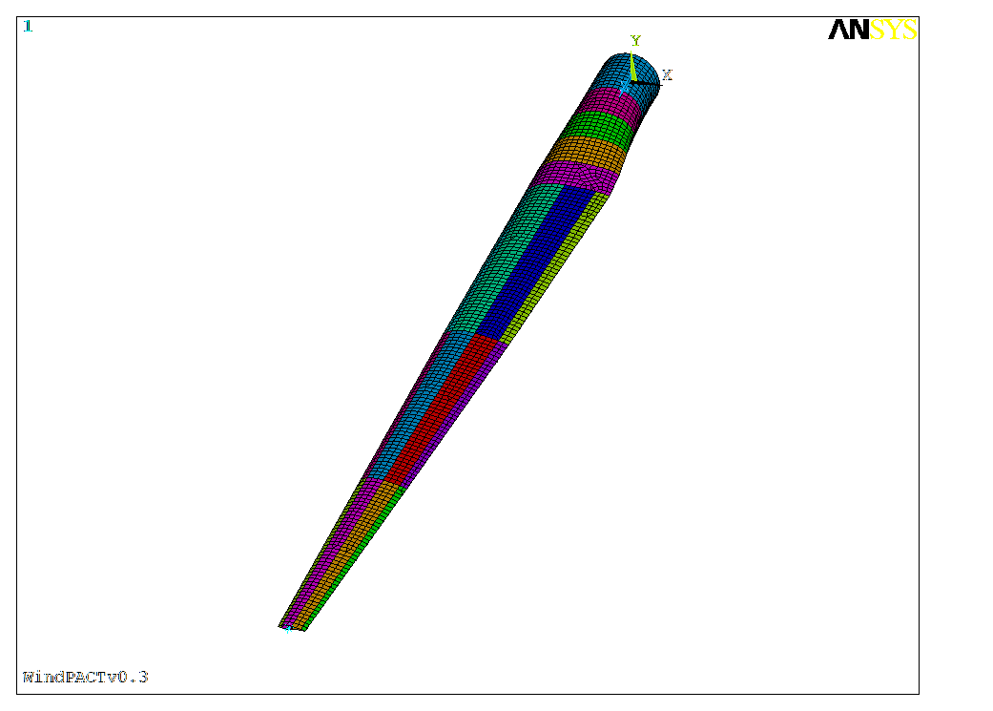

Figure : WindPACT blade FE model.

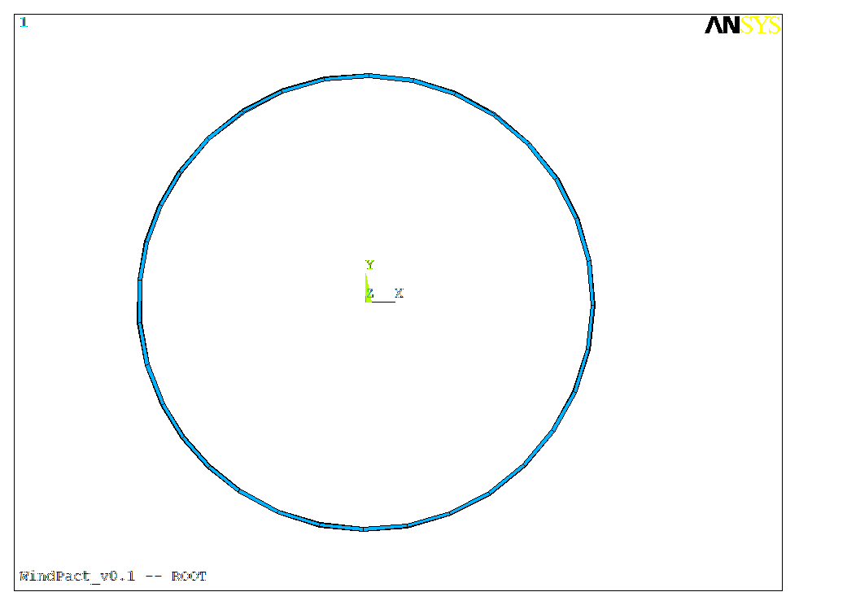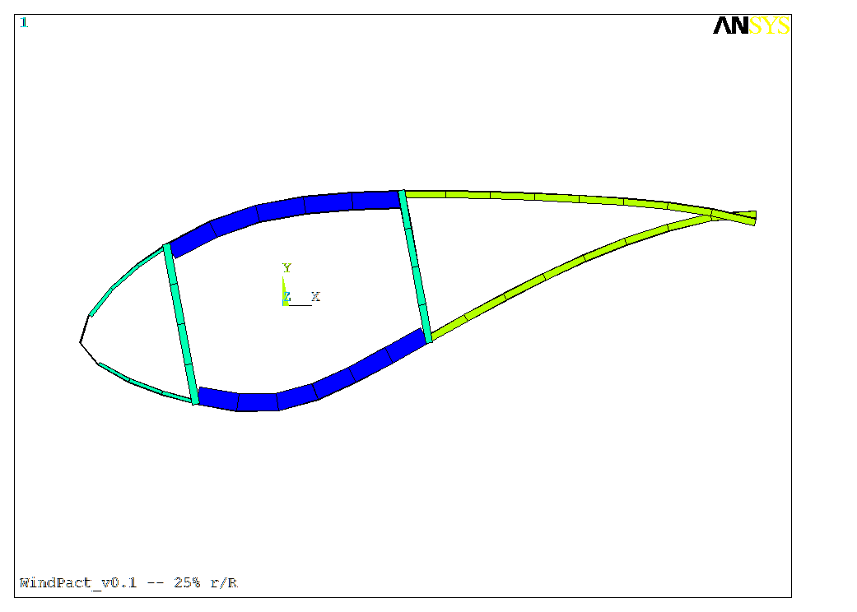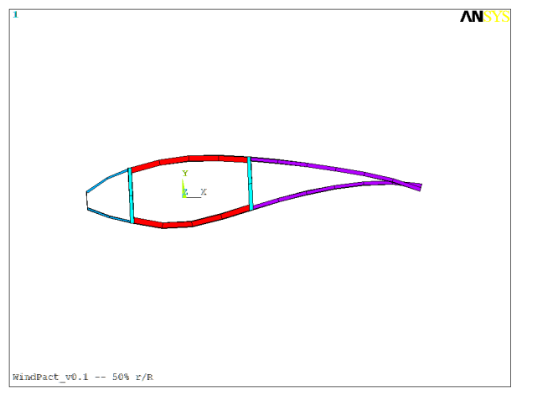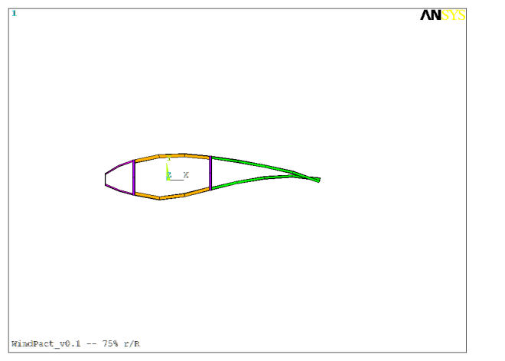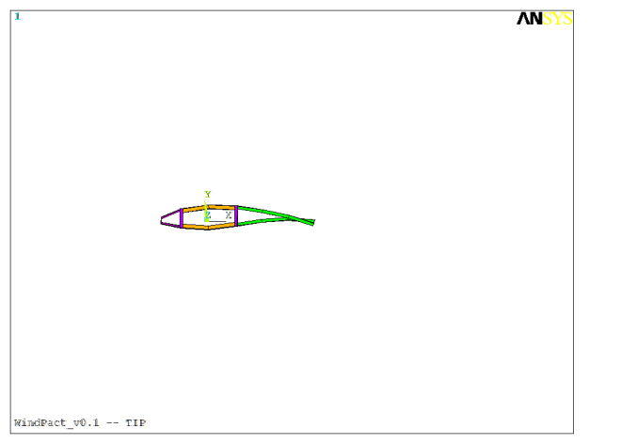

Figure : FE model cross-section at Root, 25%, 50%, 75%, and tip

## Analysis Results

(This section needs to be updated with latest model)

Following are a few example analyses of this blade. Settings: ANSYS V12.1 using Shell281 elements and offset-thickness nodes (improved element formulation), 0.2m mesh.

Figure 6 shows the panel buckling mode near the tip. This simple calculation is done with a single application of a flapwise force at the blade tip (Force in Y-direction). The force is equivalent to 2,109 kN-m of flapwise root moment. A more accurate estimate is achieved with application of a realistic distributed force.

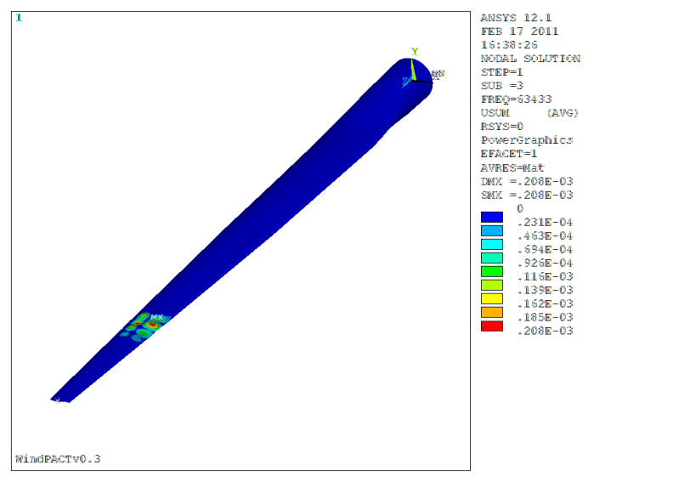

Figure : Buckling mode for flapwise point force application of 63,433 N at the blade tip.

ANSYS was used to calculate the first six mode shapes using the Block Lanczos method. The mode shapes and frequencies are included in Table 7.

Table Mode Number and corresponding frequencies.

|  |  |  |
| --- | --- | --- |
| **Mode Number** | **Frequency (Hz)** | **Shape** |
| 1 | 1.0783 | 1st Flapwise |
| 2 | 1.7001 | 1st Lag |
| 3 | 2.9804 | 2nd Flapwise |
| 4 | 5.0382 | 2nd Lag |
| 5 | 6.3093 | 3rd Flapwise |
| 6 | 10.305 | 4th Flapwise |

# Blade Section Property Comparisons

Both BPE and PreComp[7] were used to compute section properties along the span of the FE blade model. (PreComp v.JCB, including recent bug fixes) Plots in Figure 7 compare the computed section properties to the values in 'Baseline_Blade.dat', the blade structural file that is distributed with the WindPACT 1.5 MW turbine distributed with FAST4.

It is important to note again that the box spar in the current model terminates at the tip of the blade. Also, the tip of the blade uses the same material stacks as the next inboard station, i.e. the 75% r/R station. Therefore, in the following figures it is obvious that the tip section is a little too heavy and too stiff, compared to the values contained in 'Baseline_Blade.dat'.

The data in 'Baseline_Blade.dat' contains additional mass and stiffness at the root for hardware considerations. Root mounting hardware is not included in the current NuMAD model.

Regarding BPE results, a more accurate analysis would be done if the NuMAD model included more stations, which could be used as BPE analysis nodes. The root region of this model does have adequate station spacing. Of interest to note is that the BPE analysis indicates lower flapwise stiffness in the root region compared to the 2D section analysis of PreComp. This is due to the fact that the sections in this region are changing in shape dramatically, and there is no shear web to support the skins. Relatively dramatic three dimensional effects come to play in this scenario. Three dimensional effects are not captured by the 2D section analyses of PreComp. A more detailed description of nuances of BPE and PreComp can be found in the conference paper by Resor, et.al.[8]

The EA and GJ terms coming from BPE analysis are not included here because the current release of NuMAD with BPE does not include capability to output them.



Figure : Estimates of blade distributed properties.

# Future Improvements to Baseline Model

Following are topics from this report that are either incomplete or are obvious areas for improvement to the current baseline blade model.

## Specification of X-Offset Distribution

The station x-offsets in the baseline model are assumed to be 0.4 for airfoil sections. A more thorough investigation of optimal values could be useful. This parameter affects section parameters related to the bend-twist coupled behavior of the blade.

## Aerodynamic Center

NuMAD takes values for aerodynamic center of each station as input. The values of aerodynamic center for this blade have not been verified. Real values may differ only slightly from 0.25.

## Box Spar Termination Location

The spar in the current model terminates right at the blade tip. Addition of another station somewhere between 75 and 100 %r/R would allow termination of the spar at an inboard point and would be more representative of actual blade designs.

## Root Design

The root layup in the current model is a uniform thickness of fiberglass out to 25 %r/R. This layup should be better optimized for strength, weight and buckling resistance requirements. Additionally, extension of the shear webs inboard toward the root may be beneficial to these goals.

# Implemented Improvements to the Baseline Model

## Shear Web Design Improvement

After analysis of the original WindPACT model (v0.1 & v0.2) it was clear that the shear web should probably extend inboard for additional resistance to panel buckling near maximum chord. The model underwent a shear web redesign in order to increase its buckling resistance.

### Methodology

The original shear web started at max-chord according to published WindPACT reports. The NuMAD model was modified to have a shear web begin closer to the root, and analyzed in ANSYS for buckling and failure due to strain. The results are tabled in this report.

### Modeling Approach

Shapes of five stations between the blade root and max chord have been generated by interpolation between a cylindrical shape and the max-chord airfoil shape. The shear web was assumed to be placed at 15% and 50% chord, the same chord percentage as the rest of the blade.

### Shear Web Material

The additional shear web length is assumed to be the same stack as the original shear web.

### Analyses Results

The analysis results show that all models fail due to material strain criteria. After extending the shear web to 5.74 m, further extension causes greater failure due to the failure criteria. Only the original design fails due to buckling, but extending the shear web to before 4.48 m does not have much impact on the buckling load. The results from ANSYS analysis are summarized in Table 1.

Table Performance of each blade version. The first shear web extension shows that the model no longer buckles under normal loading.

|  |  |  |  |
| --- | --- | --- | --- |
| **Blade Version** | **Span Location of SW Inboard Edge (m)** | **Max Z-Direction Strain** | **Buckling Load Ratio** |
| **1.3.0** | 7 | .005212 | 0.636166 |
| **1.3.1** | 5.74 | .003481 | 1.424 |
| **1.3.2** | 4.48 | .002849 | 1.978 |
| **1.3.3** | 3.22 | .002929 | 1.76 |
| **1.3.4** | 1.96 | .002914 | 1.732 |
| **1.3.5** | 0 | .002675 | 1.731 |

### Summary

The analysis leads to the conclusion that the shear web should extend inboard of max chord. The WindPACT model contained in this release has a shear web that begins at 4.48m from root, based on the ANSYS strain and buckling results.

## Modification from version 0.3 to 1.3

Still in draft form as of 3/12/12.

### Changes

* Implementation in Excel format
* Addition of root stations
* X-offsets outboard of max chord were changed to 0.3375
* Mesh size changed from 0.2m to 0.14m
* Addition of intermediate stations outboard

### Analyses Results

Mass changed from 4784kg to xxxx kg

Modes changed:

|  |  |  |  |
| --- | --- | --- | --- |
| **Mode Number** | **Original Frequency (Hz)**  **V0.3** | **Current Frequency (Hz)**  **V1.3** | **Shape** |
| 1 | 1.0783 |  | 1st Flapwise |
| 2 | 1.7001 |  | 1st Lag |
| 3 | 2.9804 |  | 2nd Flapwise |
| 4 | 5.0382 |  | 2nd Lag |
| 5 | 6.3093 |  | 3rd Flapwise |
| 6 | 10.305 |  | 4th Flapwise |

# Model Versions

WP_Blade_v0.1 - Initial baseline

WP_Blade_v0.2 - Model update: core does not go all the way to TE, blade is a clockwise blade

WP_Blade_v0.3 - Model update: 50% chord station thickness corrected, LE x-offset% corrected

WindPact_v1.3.1 – Model update: “Shear web design improvement”

(latest model) WindPact_v1.3 – Implementation in Excel format, addition of root stations, x-offsets outboard of max chord were changed to 0.3375, mesh size changed from 0.2m to 0.14m, addition of intermediate stations outboard

# 

# References

# Appendix A: Detailed Model Inputs

Table : Blade information at each station

|  |  |  |  |  |  |  |  |  |  |  |
| --- | --- | --- | --- | --- | --- | --- | --- | --- | --- | --- |
| rotor span, %r/R | rotor span (m) | distance from root (m) | BlFract  (fraction of blade length) | airfoil | airfoil thickness, %t/c | chord, %c/R | chord, c (m) | airfoil thickness, t (m) | twist (deg) | x-offset, %c |
| 5 | 1.75 | 0 | 0.0000 | circular |  | 5.4 | 1.89 |  | 10.5 | 50 |
| 7 | 2.45 | 0.7 | 0.0211 | circular |  | 5.4 | 1.89 |  | 10.5 | 50 |
| 25 | 8.75 | 7 | 0.2105 | S818 | 30 | 8 | 2.8 | 0.84 | 10.5 | 33.75*2 |
| 50 | 17.5 | 15.75 | 0.4737 | S825 | 24 | 6.1667*1 | 2.158333 | 0.45325 | 2.5 | 43.784*2 |
| 75 | 26.25 | 24.5 | 0.7368 | S825 | 21 | 4.3333*1 | 1.516667 | 0.3185 | 0 | 62.308*2 |
| 100 | 35 | 33.25 | 1.0000 | S826 | 16 | 2.5 | 0.875 | 0.14 | -0.6 | 109*2 |
| Source: | Calculated  based on R=35 | Hub radius = 0.025*2*R  from Martin and Hansen,  Table 3-2, p.17 | Calculated | Martin and Hansen,  Table 3-2, p.17 | Martin and Hansen,  Table 3-2, p.17 | Martin and Hansen,  Table 3-2, p.17  (second specification) | Calculated | Calculated | Malcolm and Hansen,  Table 3-2, pg 17. | Assumed |

Notes:

*1 Indicate interpolated values

*2 Assumed values, not confirmed in literature

Table : Parameterized material thicknesses

|  |  |  |  |  |  |  |  |  |  |
| --- | --- | --- | --- | --- | --- | --- | --- | --- | --- |
| rotor span, %r/R | rotor span (m) | distance from root (m) | BlFract  (fraction of blade length) | root 'spar cap mix' thickness (mm) | LE panel balsa thickness, 0.5%c (mm) | spar cap thickness, %t | spar cap thickness (mm) | shear web balsa thickness, 1%c (mm) | TE panel balsa thickness, 1%c (mm) |
| 5 | 1.75 | 0 | 0.0000 | 15 |  |  |  |  |  |
| 7 | 2.45 | 0.7 | 0.0211 | 15 |  |  |  |  |  |
| 25 | 8.75 | 7 | 0.2105 |  | 14.00 | 8.30 | 69.72 | 28.00 | 28.00 |
| 50 | 17.5 | 15.75 | 0.4737 |  | 10.79 | 7.4 | 33.54*2 | 21.58 | 21.58 |
| 75 | 26.25 | 24.5 | 0.7368 |  | 7.58 | 6.50 | 20.70 | 15.17 | 15.17 |
| 100 | 35 | 33.25 | 1.0000 |  | 4.38*1 | 0.00*1 | 0.00*1 | 8.75*1 | 8.75*1 |
| Source: | Calculated  based on R=35 | Hub radius = 0.025*2*R  from Martin and Hansen,  Table 3-2, p.17 | Calculated | Reverse engineered | Griffin, Table 4 p.8 | Griffin, Table 11 p.20 (1852kg blade) | Calculated | Griffin, Text p.7 | Griffin, Table 4 p.8 |

Notes:

*1 Material definitions in NuMAD for the tip section must be the same as the next inboard section. Therefore, values in the final row of this table are not currently implemented in NuMAD. Instead, materials at 100% span are modeled as the materials at 75% span.

*2 Based on 21% thick airfoil (24% is actually intended)



1. NuMAD, Numerical Manufacturing Analysis and Design Tool, Sandia National Laboratories, v2.0, 2012.
2. Griffin, Dayton. WindPACT Turbine Design Scaling Studies Technical Area 1.Composite Blades for 80- to 120-Meter Rotor. April 2001, NREL/SR-500-29492. <http://www.nrel.gov/docs/fy01osti/29492.pdf>
3. Malcolm, D.J. and Hansen, A.C. WindPACT Turbine Rotor Design Study. April 2006, NREL/SR-500-32495. <http://www.nrel.gov/docs/fy06osti/32495.pdf>
4. NWTC Design Codes (FAST by Jason Jonkman, Ph.D.). <http://wind.nrel.gov/designcodes/> simulators/fast/. V7.00.00; Last modified 31-March-2010; accessed 31-March-2010.
5. Somers, D.M. The S816, S817, and S818 Airfoils. NREL Contractor Report NREL/SR-500-36333, December 2004. <http://www.nrel.gov/docs/fy05osti/36333.pdf>
6. Somers, D.M. The S825 and S826 Airfoils. NREL Contractor Report NREL/SR-500-36344, January 2005. <http://wind.nrel.gov/airfoils/Documents/S825,S826_Design.pdf>
7. *NWTC Design Codes (PreComp by Rick Damiani)*.  <http://wind.nrel.gov/designcodes/> preprocessors/precomp/.  Last modified 28-June-2012; accessed 28-June-2012.
8. Resor, Brian, Joshua Paquette, Daniel Laird and D. Todd Griffith. An Evaluation of Wind Turbine Blade Cross Section Analysis Techniques. AIAA SDM Conference Proceedings. Orlando, Florida. April 2010.