Smart Trolley System with Controlled Movement and QR-Based Billing

A Project report submitted in partial fulfillment of the
requirements for the award of the Degree of

BACHELOR OF TECHNOLOGY
IN
ELECTRONICS AND COMMUNICATION ENGINEERING
Submitted by
T.ANITHA SAIFULLA
(321136412097) (321136412081)

SK.GHOUSE MOHIDEEN T.DIVYA
(321136412085) (321136412098)
Under the Esteemed Guidance of
P.SAHITHYA KIRAN , M. Tech, Ph.D.
Assistant Professor, Department of ECE

DEPARTMENT OF ELECTRONICS AND COMMUNICATION ENGINEERING
DR. LANKAPALLI BULLAYYA COLLEGE OF ENGINEERING
(Affiliated to Andhra University)
VISAKHAPATNAM-530013
(2021-2025)

DR. LANKAPALLI BULLAYYA COLLEGE OF ENGINEERING
(Affiliated to Andhra University)
VISAKHAPATNAM-530013
(2021-2025)

DEPARTMENT OF
ELECTRONICS AND COMMUNICATION ENGINEERING

CERTIFICATE
This is to certify that the project report entitled “SMART TROLLEY SYSTEM WITH CONTROLLED MOVEMENT AND QR BASED BILLING” being submitted by T.ANITHA, SAIFULLA, SK.GHOUSE MOHIDEEN and T.DIVYA of 2021-2025 batch bearing Registration Number: 321136412097, 321136412081, 321136412085, 321136412098 in partial fulfilment for the award of the degree of Bachelor of Engineering in Electronics and Communication Engineering is a record of Bonafide work carried out by them under my guidance and supervision. The results embodied in this project have not been submitted to any other University of Institute for the award of any degree.

Head of the Department Project Guide
Dr. J. BABU P.SAHITHYA KIRAN
Professor Assistant Professor
Dept. of ECE Dept. of ECE

ACKNOWLEDGEMENT

We avail this opportunity to express our sincere heartfelt thanks to our esteemed guide, P.SAHITHYA KIRAN, Assistant Professor in Electronics and Communication Engineering, whose valuable guidance, supervision, and constant moral support throughout the duration of the entire course of this work

We would like to express our profound gratitude to Dr. J. BABU, Professor and Head of the Department of Electronics and Communication Engineering. Dr. Lankapalli Bullayya College of Engineering, for his unconditional support, timely arrangements, and unflinching encouragement while carrying out this project.

We wish to express our profound gratitude to Prof. D. DEEPAK CHOWDARY. Principal, Dr. Lankapalli Bullayya College of Engineering for creating facilities for carrying on this Project work.

We would like to express our sincere thanks to all teaching staff and non-teaching staff of the Department of Electronics and Communication Engineering for giving all the support and suggestions to complete our project.

We are very much thankful to the Management of Dr. Lankapalli Bullayya College of Engineering for their encouragement and cooperation in carrying out this work.

T.ANITHA (321136412097)
SAIFULLA (321136412081)
SK.GHOUSE MOHIDEEN (321136412085)
T.DIVYA (321136412098)

DECLARATION

We hereby declare that the project work entitled "SMART TROLLEY SYSTEM WITH CONTROLLED MOVEMENT AND QR BASED BILLING" is the work done by us in partial fulfilment of requirements for the award of the degree of Bachelor of Engineering in Electronics and Communication Engineering of Dr. Lankapalli Bullayya College of Engineering, affiliated to Andhra University, is authentic record of our work carried out during the Eight semester under the supervision of P.SAHITHYA KIRAN, Assistant Professor, Department of Electronics and Communication Engineering. The matter presented in this report has not been submitted to any other University/Institute for the award of a B.E. Degree.
Place: Visakhapatnam
Date:

T.ANITHA (321136412097)
SAIFULLA (321136412081)
SK.GHOUSE MOHIDEEN (321136412085)
T.DIVYA (321136412098)

ABSTRACT
The Smart Cart System leverages advanced Bluetooth-enabled human tracking to ensure seamless interaction and operational precision in dynamic environments. It utilizes a robust L298N driver that powers a line-following bot to navigate predetermined routes with exceptional accuracy. The system integrates sensor data and real-time communication protocols to adapt quickly to changing conditions and ensure safety. Innovative motor control techniques work in tandem with tracking technology, enhancing the overall responsiveness of the platform. This integration supports continuous monitoring and precise maneuvering, reducing the risk of errors during operation. The design emphasizes both functionality and efficiency, laying a solid foundation for advanced robotics applications. Overall, the first phase of the project focuses on combining state-of-the-art tracking and navigation to create a reliable automated solution.
The Smart Cart System further enhances its capabilities by incorporating RFID technology for effective smart grocery management. This integration enables accurate product identification and seamless inventory control throughout the shopping process. Dual-display modules, including LCD and OLED screens, facilitate real-time billing and transparent amount generation, improving user engagement and trust. The system's automated tracking minimizes human error, streamlining checkout procedures and elevating the overall retail experience. Each component is meticulously engineered to work harmoniously, ensuring efficient data flow and communication. By bridging robotics, digital interfacing, and retail automation, the project represents a significant leap forward in modern grocery management solutions. In essence, the second phase of the system revolutionizes the shopping experience through a blend of intelligent design and cutting-edge technology.
Keywords: Smart Cart, Human Tracking, Bluetooth, L298N Driver, Line-Following Bot, RFID, LCD, OLED, Automation, Smart Groceries.

CHAPTER 1
INTRODUCTION

INTRODUCTION
Introducing our revolutionary IoT-controlled LED sign board, a cutting-edge solution designed to redefine communication dynamics with unmatched flair and adaptability. Engineered for seamless integration into any environment, our sign board offers unparalleled versatility and convenience. With a user-friendly Bluetooth interface, effortlessly controls the display from your smartphone or tablet, enabling real-time updates and customization. Whether you're promoting specials, sharing announcements, or enhancing ambiance, our LED sign board provides a captivating visual platform. Vibrant colors, adjustable brightness, and customizable animations ensure you captivate your audience with eye-catching displays. Engineered for durability and energy efficiency, our sign board ensures longevity and sustainability. Revolutionize your communication strategy with our IoT-controlled LED sign board—empowering you to make a lasting impression, one pixel at a time.
In today's fast-paced world, the communication of important information in public spaces is essential for effective functioning. However, traditional notice board systems are often outdated, inefficient, and labor-intensive. To address this challenge, we present a smart noticeboard system utilizing state-of-the-art P10 LED display technology and IoT integration. Controlled by an Atmega32p microcontroller, interfacing with a Wi-Fi module and P10 LED display, our system offers a cost-effective and efficient solution for displaying critical information. Remote management is facilitated through an Android SSH client such as Juice Ssh, enabling seamless information updates from any location. Our goal is to provide an efficient means of displaying crucial information in various settings including schools, colleges, banks, and public places. With its cost-effectiveness, user-friendly interface, and scalability, our system is suitable for implementation across diverse institutions. Challenges encountered during development will be addressed, along with the innovative solutions implemented.
In this comprehensive project, we will delve into the design, implementation, and testing phases of our smart noticeboard system. Challenges encountered during development will be addressed, along with the innovative solutions implemented.

INTRODUCTION TO EMBEDDED SYSTEM
Brief History
A combination of computer hardware and software, and perhaps additional mechanical or other parts, designed to perform a dedicated function.
The first recognizably modern embedded system was the Apollo Guidance Computer, developed by Charles Stark Draper at the MIT Instrumentation Laboratory. The first mass-produced embedded system was the automatics D-17 guidance Computer for the Minuteman (missile), released in 1961. It was built from transistor logic and had a hard disk for main memory. Since these early applications in the 1960s, embedded systems have come down in price. There has also been an enormous rise in processing power and functionality.
In 1978 National Engineering Manufacturers Association released the standard for a programmable microcontroller. The definition was almost any Computer-based controller. They included single-board Computers, numerical controllers and sequential controllers in order to perform event-based instructions. By the mid-1980s, many of the previously external system components had been integrated into the same chip as the processor, resulting in integrated circuits called microcontrollers, and widespread use of embedded systems became feasible. Presently, a lot of varieties of embedded systems are available at very low costs.
Characteristics
Embedded systems are designed to do some specific task. Some also have real-time performance constraints that must be met for reasons such as safety and usability; others may have low or no performance requirements, allowing the system hardware to be simplified to reduce cost.
The embedded system consists of two parts:

- Hardware
- Software
Below is the diagram for Embedded system classification:

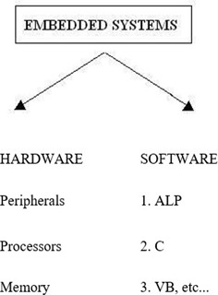

Fig1.1 Embedded System Classification
EMBEDDED SOFTWARE
Various software can be used for various purposes. ALP i.e. Assembly Language Program, can be used as the back end and other software like C, VB, etc. can be used in front end.
Embedded Software Architectures
There are several different types of software architecture in common use.
Simple Control Loop: In this design, the software has a loop. The loop calls the subroutines, each of which manages a part of the hardware or software.
Interrupt Controlled System: Some embedded systems are predominantly interrupt-controlled. This means that tasks performed by the system are triggered by different kinds of events. An interrupt could be generated, for example, by a timer in a pre-defined frequency, or by a serial port controller receiving a byte.
These kinds of systems run a simple task in a main loop also, but this task is not sensitive to expected delays. The tasks performed in the interrupt handlers should be kept short, the interrupt latency to a minimum. Sometimes longer tasks are added to a queue structure in the interrupt handlers to be processed in the main loop later.
Peripherals
Peripherals are the various devices that are connected to the CPU, for performing various functions. Embedded systems talk with the outside world via peripherals, such as:
Serial communication interfaces (SCI): RS-232, RS-422, RS-458etc.
Synchronous Serial communication interfaces (SSCI): I2C, JTAG, SPI, SSC and ESSI
Universal Serial Bus (USB)
1.3.3. Processors
Processors are the key element in any embedded system. The memory, where the various instructions of useful functions are integrated into a single IC package.
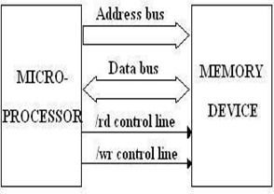

Fig1.2MicroprocessorAccessingMemory
MICROCONTROLLER
A microcontroller is a small computer on a single integrated circuit containing a processor core, memory, and programmable input/output peripherals. Program memory in the form of Ferroelectric RAM, NOR flash, or OTP ROM is also often included on chip, as well as a typically small amount of RAM. Microcontrollers are designed for embedded applications, in contrast to the microprocessors used in personal computers or other general-purpose applications. Microcontrollers are used in automatically controlled products and devices, such as automobile engine control systems, implantable medical devices, remote controls, office machines, appliances, power tools, toys, and other embedded systems. By reducing the size and cost compared to a design that uses a separate microprocessor, memory, and input/output devices, microcontrollers make it economical to digitally control even more devices and processes. Some microcontrollers may use four-bit words and operate at clock rate frequencies as slow as 4 kHz, for low power consumption. They will generally have the ability to retain functionality while waiting for an event such as a button press or other interrupt; power consumption while sleeping will be just nanowatts, making many of them well suited for long lasting battery applications. Other microcontrollers may serve performance-critical roles, where they may need to act more like a digital signal processor, with higher clock speeds and power consumption. Microcontrollers are “embedded” inside some other device so that they can control the features or actions of the product. Another name for a microcontroller, therefore, is “embedded controller”. Microcontrollers are dedicated to one task and run one specific program. The program is stored in ROM (read-only memory) and generally does not change. Microcontrollers are often low-power devices. A desktop computer is almost always plugged into a wall socket and might consume 50 watts of electricity. A battery-operated microcontroller might consume 50 milliwatts.
Classification of Microcontroller
The Microcontrollers are characterized by bus width, instruction set, and memory structure. Classification according to number of bits. The bits in a microcontroller are 8 bits, 16 bits, and 32 bits. In an 8-bit microcontroller, the point when the internal bus is 8-bit, then the ALU performs the arithmetic and logic operations. An example of an 8-bit microcontroller is Intel 8031/8051. PICIX and Motorola MC68HC11 families. The 16-bit microcontroller performs greater precision and performance as compared to an 8-bit. For example: 8-bit microcontrollers can only use 8 bits, resulting in a final range of 0x00OxFF (0255) for every cycle. In contrast, a 16-bit microcontroller with its 16-bit data width has a range of 0x00000xFFFF (065535) for every cycle. A longer timer most extreme worth can likely prove to be useful in certain applications and circuits. It can automatically operate on two 16bit numbers. Some examples of 16bit microcontrollers are 16bit MCUs are extended 8051XA, PIC2x, Intel 8096 and Motorola MC68HC12 families.
The 32-bit microcontroller uses the 32-bit instructions to perform the arithmetic and logic operations.
Classification according to memory devices
The memory devices are divided into two types, They are Embedded memory microcontroller
External memory microcontroller Embedded memory, microcontroller: When an embedded system has a microcontroller unit that has all the functional blocks available on a chip, it is called an embedded microcontroller. For example, 1051 has program& data memory, 10 ports, serial communication, counters.
External memory microcontroller: When an embedded system has a microcontroller unit that has not have all the functional blocks available on a chip is called an external memory microcontroller.
For example, 8031 has no program memory on the chip, an external memory microcontroller.
Classification according to instruction Set
CISC: CISC is a Complex Instruction Set Computer. It allows the programmer to use one instruction in place of many simpler instructions.
RISC: The RISC stands for Reduced Instruction Set Computer, this type of instruction set reduces the design of the microprocessor for industry standards. It allows each instruction to operate on any register or use any addressing mode and simultaneous access of the program and data.
Classification according to memory architecture
- Memory architecture of microcontrollers are two types, they are namely:
- Harvard memory architecture microcontroller
- Princeton memory architecture microcontroller
Harvard memory architecture microcontroller:
The point when a microcontroller unit has a dissimilar memory address space for program and data memory, the microcontroller has a Harvard memory architecture in the processor.
Princeton memory architecture microcontroller:
The point when a microcontroller has a common memory address for the program memory and data memory, the microcontroller has Princeton memory architecture in the processor.
Types of Microcontrollers
There are different types of microcontrollers. They are
- 8051Microcontroller
- Renesas Microcontroller
- PIC Microcontroller
- AVR Microcontroller
ADVANTAGES
Embedded systems find applications across various domains due to their ability to perform specific tasks efficiently with minimal human intervention. Here are some common application areas of embedded systems: Embedded systems are widely used in consumer electronics such as smartphones, tablets, smart TVs, digital cameras, and gaming consoles to provide functionality and user interaction.
- ·Embedded systems play a critical role in modern vehicles, controlling functions like engine management, safety systems (ABS, airbags), infotainment systems, navigation, and driver assistance systems (ADAS).
- ·In industries, embedded systems are used for process control, monitoring, and automation tasks. They manage machinery, robotics, sensors, and actuators to optimize production processes and ensure safety.
- ·Embedded systems are essential components of medical devices such as patient monitoring systems, infusion pumps, pacemakers, and diagnostic equipment, enabling precise control and data acquisition.
- ·Embedded systems are employed in smart home devices like thermostats, security cameras, smart locks, and lighting systems to provide remote control, automation, and energy efficiency.
- ·Embedded systems are used in telecommunications infrastructure for functions like network routers, switches, base stations, and VoIP systems to enable communication and data transfer.
- ·Embedded systems are critical in aerospace and defense applications for tasks like flight control systems, navigation, communication, and weapon systems control in aircraft, satellites, and missiles.
- ·Embedded systems form the backbone of IoT devices, connecting physical objects to the internet and enabling data collection and analysis.
- ·Embedded systems with image processing capabilities are used in applications like surveillance systems, object detection, facial recognition, and quality inspection in manufacturing.
- ·Embedded systems are utilized in energy management systems for monitoring and controlling power generation, distribution, and consumption in smart grids and renewable energy systems.

EMBEDDED DEVICES(SYSTEM) IN IoT
It is essential to know about the embedded device while learning the IoT or building projects on IoT. The embedded devices are the object that builds the unique computing system. These systems may or may not connect to the Internet.
An embedded device system generally runs a single application. However, these devices can connect to the Internet connection and able to communicate through other devices.
Embedded System Hardware
The embedded system can be of type microcontroller or type microprocessor. Both types contain an integrated circuit (IC). The essential component of the embedded system is a risk family microcontroller like Motorola 68HC11, PIC 16F84, Atmel 8051, and many more. The most important factor that differentiates these microcontrollers from the microprocessor like 8085 is their internal read and writable memory. The essential embedded device components and system architecture or below.
Embedded System Software
The embedded system that uses the devices for the operating system is based on the language platform, mainly where the real-time operation would be performed. Manufacturers build embedded software in electronics, e.g., cars, telephones, modems, appliances, etc. The embedded system software can be as simple as lighting controls running using an 8-bit microcontroller. It can be complicated software for missiles, process control systems, airplanes, etc.
IoT DECISION FRAMEWORK
The IoT decision framework provides a structured approach to create a powerful IoT product strategy. The IoT decision framework is all about the strategic decision making. The IoT decision framework helps us to understand the areas where we need to make decisions, ensures consistency across all our strategic business decisions, technical, and more.
The IoT decision framework is much more important as the product or services communicate over the network, which goes through 5 different layers of complexity of technology.

- Device Hardware
- Device Software
- Communications
- Cloud Application
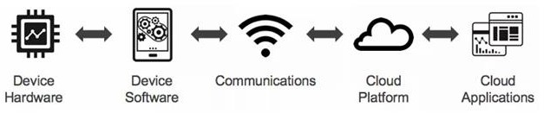

Fig 1.3 IoT Technology Stack
Decision Area
The IoT decision framework pays attention to six key decision areas in any IoT product.
These decisions are:
- User Experience
- Data
- Business
- Technology
- Security
- Standards & Regulation
Each of these decisions is evaluated at each of the IoT technology stacks. The user experience will be evaluated at Device Hardware, Device Software, and so to provide a better user experience.
IoT ARCHITECTURE
There is no such unique standard consensus on the Internet of Things (IoT) architecture, which is universally defined. The IoT architecture differs from their functional area and their solutions. However, the IoT architecture technology mainly consists of 4 major components.
Components of IoT architecture:
- Sensors/Devices
- Gateways and Networks
- Cloud or Management Service Layer
- Application Layer
There are several layers of IoT built up on the capability and performance of IoT elements that provide the optimal solution to the business enterprises and end-users. The IoT architecture is a fundamental way to design the various elements of IoT, so that it can deliver services over the networks and serve the needs for the future.
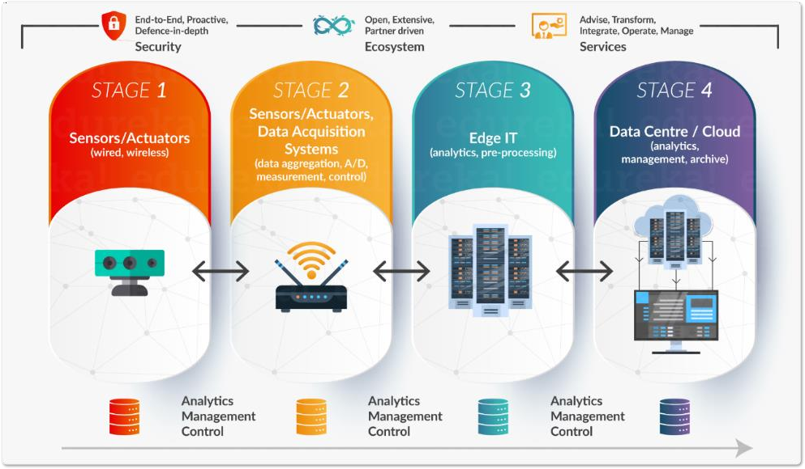

Fig 1.4 IoT Architecture
FEATURES OF IoT
The features of the Internet of Things (IoT) highlight its capabilities in connecting, collecting, and exchanging data among devices and systems. Here are key features of IoT:
- Connectivity
Wireless Communication: IoT devices often communicate wirelessly using protocols such as WiFi, Bluetooth, Zigbee, RFID, and cellular networks.
Network Integration: Devices can seamlessly integrate into existing networks, enabling communication between devices and systems.
- Sensors and Actuators
Sensor Integration: IoT devices are equipped with sensors to collect data from the physical world. Common sensors include temperature sensors, motion sensors, and environmental sensors.
Actuator Control: Actuators enable IoT devices to perform actions based on received instructions. Examples include turning on lights, controlling motors, or adjusting settings.
Big Data Processing: IoT generates vast amounts of data, and analytics tools process this data to extract meaningful insights.
- Realtime Monitoring: IoT enables realtime monitoring of processes, environments, and devices, facilitating quick decision-making.
- Remote Monitoring and Control
Remote Access: Users can monitor and control IoT devices remotely, providing flexibility and accessibility.
Automation: IoT allows for automation of tasks based on predefined rules and conditions.
- Interoperability
Standard Protocols: IoT systems use standard communication protocols to ensure interoperability between devices from different manufacturers.
Cross-Platform Integration: IoT platforms and devices can integrate with various systems and services, promoting interoperability.
- Security:
Authentication and Authorization: Security features such as user authentication and device authorization protect against unauthorized access.
Data Encryption: IoT systems use encryption to secure data during transmission and storage.
- Cost Effectiveness
Affordable Hardware: The cost of IoT hardware has decreased, making it more accessible for a wide range of applications.
Efficient Resource Utilization: IoT systems optimize resource utilization, reducing operational costs.
- User Friendly Interfaces
Intuitive Dashboards: IoT applications often feature user-friendly dashboards and interfaces for easy device management.
Mobile Applications: Many IoT platforms provide mobile apps for convenient monitoring and control on smartphones and tablets.

ADVANTAGES OF IoT
The Internet of Things (IoT) has numerous advantages across various domains. Here are some key advantages of IoT:
- Efficiency Improvement: IoT enables automation and optimization of processes, leading to increased efficiency in various industries and sectors.
- Cost Savings: With better resource management and process optimization, IoT helps organizations reduce costs by minimizing waste and improving overall operational efficiency.
- Data Collection and Analysis: IoT devices generate vast amounts of data, providing
- Improved Decision Making: The data collected by IoT devices allows for real-time monitoring and analysis, facilitating quicker and more accurate decision-making processes.
- Enhanced Customer Experience: IoT enables the development of smart products and services that can enhance the overall customer experience through personalized and responsive interactions.
- Remote Monitoring and Control: IoT allows for remote monitoring and control of devices and systems, enabling businesses to manage operations from anywhere in the world.
- Predictive Maintenance: IoT sensors can monitor the condition of equipment and predict when maintenance is needed, reducing downtime and extending the lifespan of assets.
- Energy Efficiency: IoT can be used to optimize energy consumption in buildings, factories, and other environments, leading to significant energy savings and a reduced environmental footprint.
- Healthcare Innovation: In healthcare, IoT devices can monitor patients in real-time, track vital signs, and provide timely information to healthcare professionals, improving patient care and outcomes.
- Supply Chain Optimization: IoT facilitates the tracking and monitoring of goods throughout the supply chain, enhancing transparency, reducing delays, and minimizing losses.

CHAPTER 2
LITERATURE SURVEY

LITERATURE SURVEY
The evolution of smart cart systems is rooted in decades of research in mobile robotics and automation. Early studies explored autonomous navigation using simple sensors and actuators, laying the groundwork for modern applications in retail and service industries. These investigations emphasized the integration of hardware and software to achieve reliable performance. The fusion of robotics with retail automation has since spurred numerous innovations, particularly in human interaction and real-time processing. This literature survey reviews key developments that have influenced the design of contemporary smart cart systems.
Research in human tracking has seen significant advancements with the advent of Bluetooth technology. Initial approaches focused on basic radio frequency communication for proximity sensing, which has evolved into sophisticated systems that enable precise human tracking. Contemporary studies highlight the low-power consumption, reliability, and responsiveness of Bluetooth-enabled devices. Such developments have been critical in establishing robust communication links between mobile units and tracking systems. The improved data transmission and reduced interference have directly contributed to the enhanced performance of automated retail solutions.
In parallel, the field of autonomous navigation has been enriched by studies on line-following robots. The L298N motor driver, a popular choice for controlling DC motors, has been extensively employed in these systems. Researchers have demonstrated that coupling the L298N driver with infrared or optical sensors yields high-precision navigation along predetermined paths. The literature underscores the driver’s versatility and robustness, which are essential for real-time adjustments in dynamic environments. This body of work provides valuable insights into the effective management of motor control for automated navigation tasks.
RFID technology has emerged as a pivotal element in smart retail management, with numerous studies documenting its benefits in inventory control and product identification. Research indicates that RFID systems streamline operations by automating the tracking process, reducing human error, and enhancing operational efficiency. In the context of smart cart systems, the integration of RFID technology facilitates instantaneous product recognition and seamless inventory updates. This approach not only improves accuracy but also accelerates checkout procedures. Such findings have been validated in various experimental setups, reinforcing RFID’s critical role in modern retail automation.
Digital display integration, particularly using LCD and OLED modules, has further enhanced the functionality and user experience of automated systems. Extensive research has explored how these display technologies can deliver real-time feedback on billing, inventory, and system status. The literature demonstrates that combining LCD and OLED displays offers clear, immediate communication of transaction details, thereby improving consumer interaction. Studies also point to the benefits of energy efficiency and visual clarity provided by these modules. Together, these advancements in digital interfacing contribute significantly to the overall effectiveness of smart cart systems in retail environments.
.

CHAPTER 3
HARDWARE COMPONENTS
HARDWARE COMPONENTS
BLOCK DIAGRAM
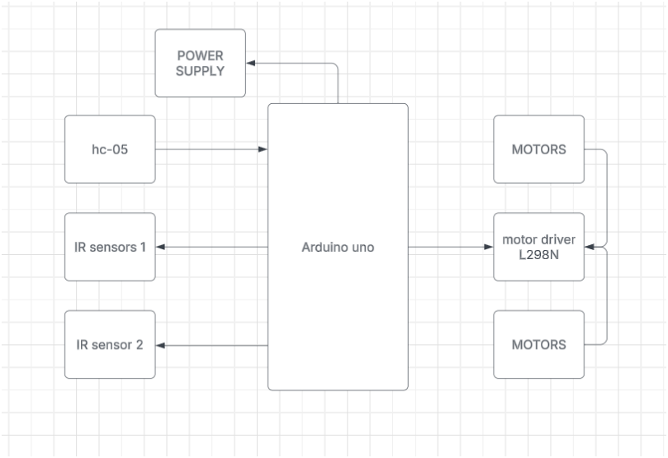
Fig3.1.1Block Diagram
The block diagram for the Smart Cart Trolley, Smart Cart Groceries, and Payment System illustrates a fully integrated approach where all modules work in tandem to ensure seamless operation. At the center is the Microcontroller Unit (MCU), which acts as the brain of the system. It processes incoming data from various sensors and modules, makes decisions, and directs the operation of other components.
On the navigation side, the Trolley Module includes a Bluetooth-enabled tracking unit and line-following sensors. The Bluetooth module gathers data on human presence and movement, while the line sensors provide positional feedback to keep the trolley aligned on its designated path. This data is processed by the MCU, which sends control signals to the L298N Motor Driver. The motor driver then powers the cart's motors, ensuring smooth and accurate movement.
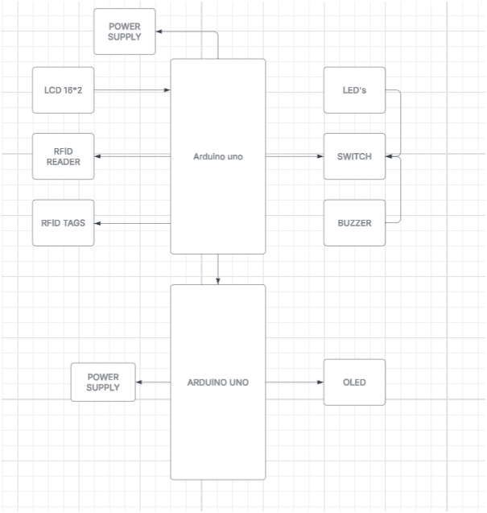
Fig3.1.2 Block Diagram
The Smart Groceries Module is designed to efficiently manage and track grocery items. An integrated RFID Reader scans products as they are added to the cart, capturing essential product information. The MCU receives this data, which it uses to calculate the running total of the purchase. This module is crucial for automating inventory tracking and ensuring that every item is accounted for accurately.
Complementing the grocery module is the Payment System. Once the total amount is computed by the MCU, the system enables seamless transaction processing. Payment-related data—potentially via NFC or other mobile payment integrations—is handled by the MCU and confirmed through visual feedback provided by LCD and OLED Displays. These displays ensure that users receive clear, real-time information regarding their billing details and payment confirmation.
Building on this idea, the Components Used
- Arduino Uno
- OLED
- L398N motor driver
- RFID
- 5v dc motor
- IR Sensors
- Hc-05
- 5v regulator
- LITHIUM-ION BATTERY
ARDUINO UNO
Introduction:
The Arduino UNO is a microcontroller board based on the ATmega328P chip. It is one of the most popular and versatile boards in the Arduino ecosystem due to its simplicity, ease of use, and a large supportive community. With 14 digital I/O pins, 6 analog inputs, and communication interfaces like UART, SPI, and I2C, the Arduino UNO is ideal for interfacing with various sensors and control systems. In this traffic light prioritization system, the Arduino serves as the central control unit, making real-time decisions based on inputs from RFID, GPS, and other sensors.
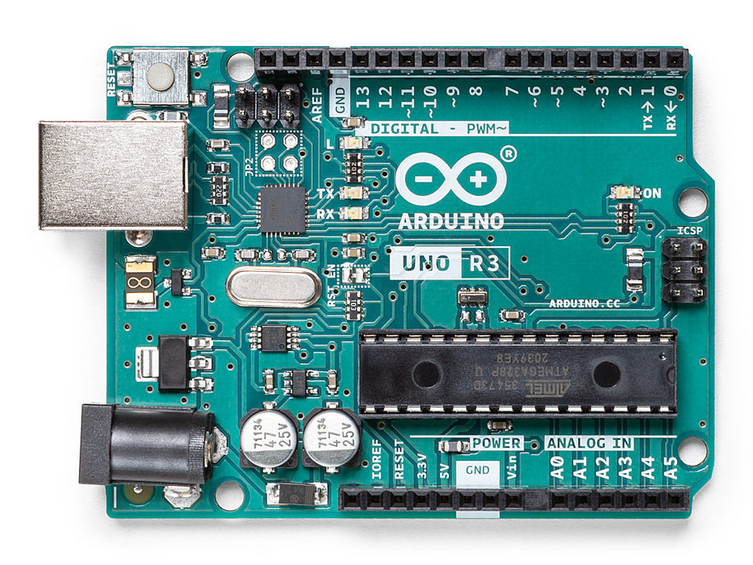
FIG: 3.2

Applications:
- Serves as the main controller to process inputs from the RFID, GPS, and other sensors.
- Controls the switching of traffic lights based on the priority of emergency vehicles.
- Sends SMS notifications via the GSM module to authorities regarding traffic light status.
- Manages communication between all system components to ensure smooth operation.
OLED DISPLAY
The OLED 0.9-inch display module is a compact, high-contrast screen used to display real-time attendance recognition results. It utilizes organic light-emitting diode (OLED) technology, which offers superior brightness and contrast compared to traditional LCD displays. The module is energy-efficient, requiring minimal power to operate, making it ideal for battery-powered IoT applications. It connects to the system via I2C or SPI communication protocols, allowing smooth data transmission and quick updates. The display ensures that recognized names and statuses are clearly visible, improving system transparency and user interaction. The small form factor makes it highly adaptable for embedded applications such as smart attendance systems, IoT devices, and compact control panels.

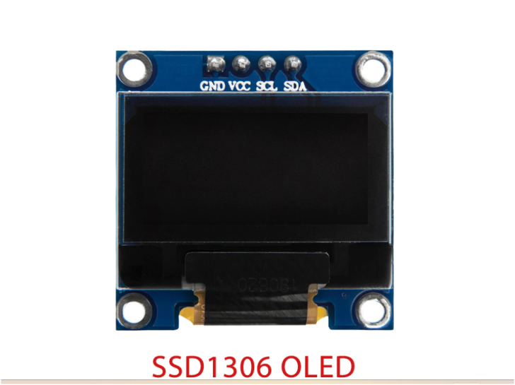

Fig 3.3 P10 LED Display
L298N motor
Introduction:
The L298N motor driver plays a pivotal role in our Restaurant Delivery Robot by enabling precise control over the DC motors responsible for movement. This dual full-bridge driver is specifically designed to manage bi-directional motor control and variable speed regulation, which are critical for smooth navigation in dynamic environments. By integrating the L298N, the system can efficiently execute commands received via Bluetooth, adjust motor speeds for obstacle avoidance, and ensure reliable operation even in fluctuating load conditions. Its robust design and compatibility with various microcontrollers, such as the Arduino Uno R3, make it an ideal choice for real-time applications in robotics and automation.
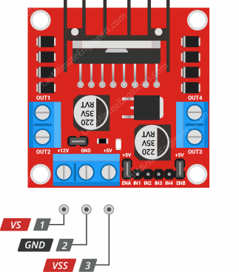
Fig 3.4 L298N motor
Applications:
- Bi-Directional Control: Facilitates forward and reverse motion, allowing the robot to navigate complex pathways and retreat safely when necessary.
- Speed Regulation: Enables precise modulation of motor speed to adjust to different surface conditions and obstacle proximity.
- Robust Performance: Supports continuous operation under varying electrical loads, ensuring reliable performance during extended use.
- Microcontroller Integration: Seamlessly interfaces with Arduino and other microcontrollers, simplifying system design and enhancing control capabilities.
- Compact Design: Its small footprint makes it suitable for integration into space-constrained robotic platforms, contributing to an overall efficient system design.

RFID RC522
The RC522 RFID Reader/Writer Module (Transceiver) is based on a highly integrated reader/writer IC MFRC522 from NXP Company. It is used for contactless Multi-communication at 13.56 MHz. The RFID stands for Radio Frequency Identification. This module uses electromagnetic waves in radio frequency to transfer data (read/write). It can read/write all types of Transponders (RFID card tags and key fob tags) which having 1KB memory and compatible with 13.56 MHz frequency. This is a low-voltage, low-cost, small-sized module and It comes with SPI protocol which enables it to easily interface with almost any microcontroller like AT Tiny, Arduino, ESP8266, Raspberry Pi, and other more advanced development boards.

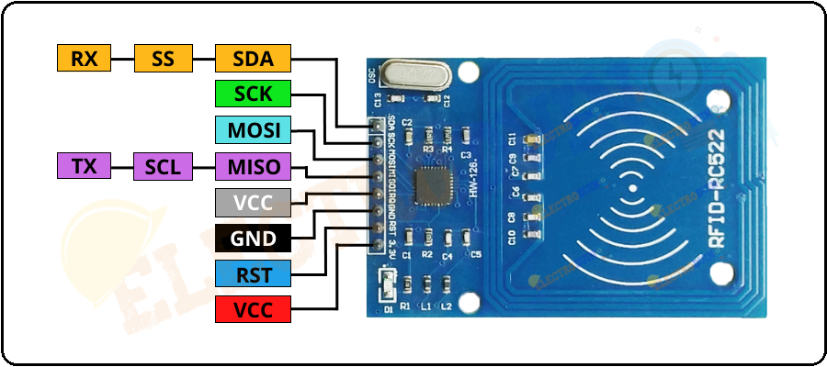
Fig : 3.5 RFID-RC522
Specification/Features
- Operating Voltage: 2.5V~3.3V.
- Working current: 13 – 26mA at 3.3V
- Standby current: 10 – 13mA at 3.3V
- Sleep current: <80uA
- Peak current: <30mA
- Operating Frequency: 13.56MHz
Applications
- Automatic billing systems
- Access control systems
- Verification/Identification system
- Attendance systems
5V DC motor
Introduction:
The 5V DC motor is a vital component in our Restaurant Delivery Robot, providing the necessary mechanical power to drive the robot’s movement. Operating at a low voltage of 5V, this motor offers a balance between power consumption and performance, making it ideal for battery-operated and compact robotic systems. Its smooth and consistent rotation ensures reliable movement control, which is critical for navigating through dynamic environments. Integrated with the control circuitry, the 5V DC motor works in harmony with other system components to facilitate precise and efficient motion, thereby enhancing the overall functionality of the robot.
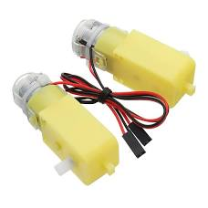
Fig 3.6 5V DC motor
Application:
- Movement Actuation: Powers the robot's wheels or drive system to enable forward and reverse motion.
- Precision Control: Provides smooth operation for controlled acceleration and deceleration, essential for navigating tight spaces.
- Low Power Consumption: Operates efficiently at 5V, making it well-suited for battery-powered applications and portable robotic systems.
- Integration Ease: Easily interfaces with motor drivers and microcontrollers, streamlining the design and implementation process.
- Versatile Usage: Applicable in various robotic and automation scenarios, including small mobile robots and educational platforms, due to its compact size and efficient performance.
IR Sensor
Introduction:
The IR sensor is an essential component in our Restaurant Delivery Robot, primarily used for real-time obstacle detection and navigation control. By emitting and detecting infrared light, the sensor can quickly determine the presence and proximity of obstacles in its path. Integrated with the Arduino Uno R3, the IR sensor enables the robot to maintain a collision-free route by providing continuous feedback on environmental conditions. Its fast response time and reliability make it a critical tool for ensuring safe and efficient movement, especially in dynamic and crowded restaurant environments.
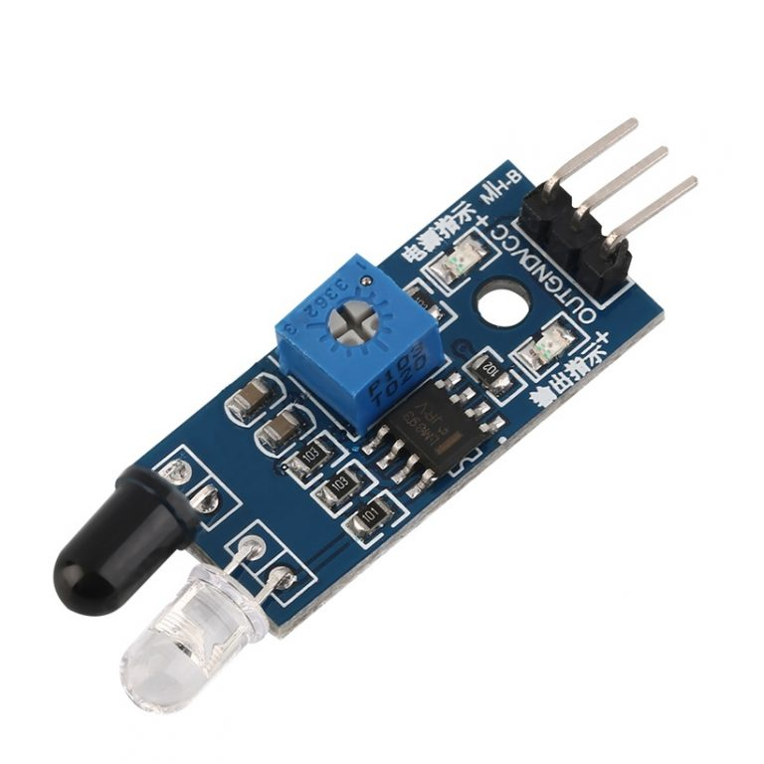
Fig 3.7 IR Sensor
Application:
- Obstacle Detection: Provides real-time data to identify and avoid obstacles, ensuring smooth navigation.
- Collision Prevention: Enhances the robot's safety by alerting the system to potential hazards in its immediate vicinity.
- Dynamic Navigation: Assists in adaptive path planning by continuously monitoring the robot's surroundings for any interference.
- Easy Integration: Seamlessly interfaces with microcontrollers like the Arduino Uno R3, simplifying system design and control logic.
- Versatile Implementation: Suitable for various robotic and automation applications, demonstrating robust performance in diverse operational conditions.
HC-05 Bluetooth Module
Introduction:
The HC-05 Bluetooth module is a widely adopted wireless communication device that enables serial data exchange over Bluetooth. In our Restaurant Delivery Robot, the HC-05 facilitates seamless command transmission between a smartphone or central control unit and the microcontroller (Arduino Uno R3). Designed for robust connectivity and easy integration, this module is instrumental in creating a wireless link that allows real-time control and monitoring of the robot. Its reliability and compatibility with various devices make it a preferred choice for applications requiring efficient, low-power wireless communication.
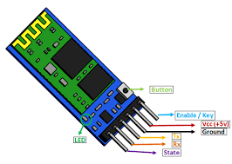
Fig 3.8 HC-05 Bluetooth Module
Application:
- Wireless Command Transmission: Enables the robot to receive commands such as “A” for Table 1 and “B” for Table 2 from a remote device.
- Real-Time Communication: Facilitates instantaneous data exchange between the robot and the controlling device, ensuring prompt responses.
- Seamless Integration: Easily interfaces with microcontrollers like the Arduino Uno R3, streamlining the development of wireless robotic systems.
- Low Power Operation: Operates on minimal power, making it ideal for battery-powered applications.
- Versatile Connectivity: Supports various Bluetooth-enabled devices, broadening its applications in robotics and automation.
5v regulator
Introduction:
The 5V regulator is a critical component in our Restaurant Delivery Robot, ensuring a steady and reliable voltage supply to all connected electronic modules. By converting varying input voltages to a constant 5V output, this regulator maintains stable operation of sensitive components such as the Arduino Uno R3, sensors, and communication modules. Its role is essential in preventing voltage fluctuations that could compromise the performance and longevity of the robot's circuitry, thereby contributing to a consistent and robust operation in dynamic environments.
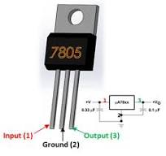
Fig 3.8 5v regulator
Application:
- Voltage Stabilization: Converts and regulates input voltage to a constant 5V, safeguarding sensitive electronic components from voltage spikes or drops.
- Power Efficiency: Optimizes power distribution within the robot, ensuring efficient operation of all electronic subsystems.
- Enhanced Reliability: Provides a stable power supply, which is crucial for maintaining the performance of microcontrollers and sensor modules during extended use.
- Integration Flexibility: Easily interfaces with various power sources, making it adaptable to different design requirements and battery-operated systems.
- Broad Utility: Widely applicable in numerous electronic projects, from robotics to portable devices, where consistent voltage is key to operational success.
LITHIUM-ION Batteries 3.7V
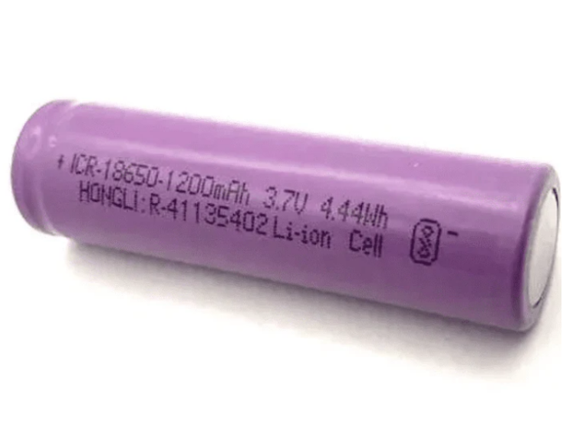
Lithium-ion batteries (3.7V) are a reliable and efficient power source for IoT applications, including the ESP32-CAM Smart Attendance System. These rechargeable batteries offer high energy density, ensuring prolonged operation without frequent recharging. They are lightweight and compact, making them ideal for portable and embedded systems. The 3.7V lithium-ion battery provides a stable voltage supply to the ESP32-CAM and other components, ensuring smooth performance and uninterrupted data processing. Integrated with a power management circuit, these batteries prevent overcharging and deep discharge, thereby enhancing the safety and longevity of the system. Their ability to deliver consistent power output makes them a preferred choice for smart devices, wearable’s, and remote monitoring applications.

Fig 3.9 LITHIUM-ION Batteries 3.7V

MICRO USB CABLE
The Micro USB cable is a type of USB (Universal Serial Bus) connector that was developed to replace the Mini USB connector, offering a smaller and more compact design.
The Micro USB standard was introduced to meet the growing demand for smaller and more portable devices.
- 2007: Introduction of Micro USB
The Micro USB standard was introduced in 2007 by the USB Implementers Forum (USB-IF), a non-profit organization that oversees the development and compliance of USB standards. The Micro USB connector was designed to be smaller and more durable than its predecessor, the Mini USB.
- 2008: USB 2.0 Micro USB Specification Released
The USB 2.0 Micro USB specification was released, defining the physical characteristics and electrical requirements for the Micro USB connector. This specification facilitated the widespread adoption of Micro USB in various devices.
- Adoption in Mobile Devices
Micro USB gained rapid adoption, especially in the mobile phone industry. Many mobile phone manufacturers began using Micro USB as the standard charging and data transfer port for their devices. Universal Charging Solution micro USB became a key component in the move toward a universal charging solution. The idea was to have a standard charging and data transfer cable for various devices, reducing the need for multiple cables and chargers.
- USB-IF and Compliance Certification
USB-IF played a crucial role in ensuring compliance with the Micro USB standard. The organization provided certification programs to ensure that devices and cables met the specifications, promoting interoperability among different manufacturers.
- Advancements and Revisions
Overtime, there were advancements and revisions to the Micro USB standard.
USB 3.0 and later USB 3.1 specifications included Micro USB connectors with improved data transfer speeds. These advancements expanded the use of Micro USB beyond charging and basic data transfer. It's important to note that while Micro USB has been prevalent, USB Type-C has become the more recent standard for many modern devices due to its improved features and capabilities.
Therefore, the Micro USB connector doesn't have a single inventor; instead, it resulted from the collective efforts and contributions of various engineers and companies within the USB-IF community.
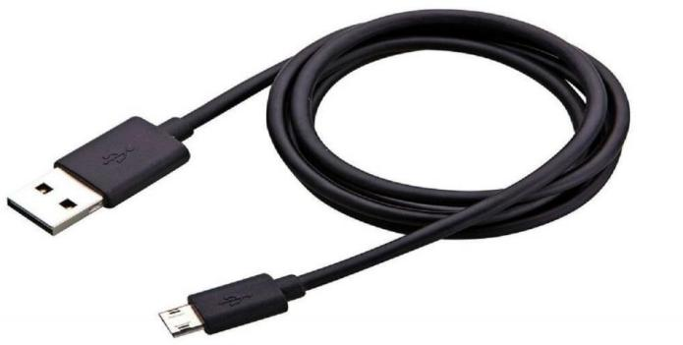

Fig3.10 Micro USB Cable for ESP8266
Transition to USB Type-C:
While Micro USB became widely adopted, especially in the mobile industry, the USB Type-C standard was introduced in 2014. USB Type-C offers further improvements in terms of reversible connectors, higher data transfer speeds, and increased power delivery capabilities.

CHAPTER-4
HARDWARE IMPLEMENTATION
HARDWARE IMPLEMENTATION
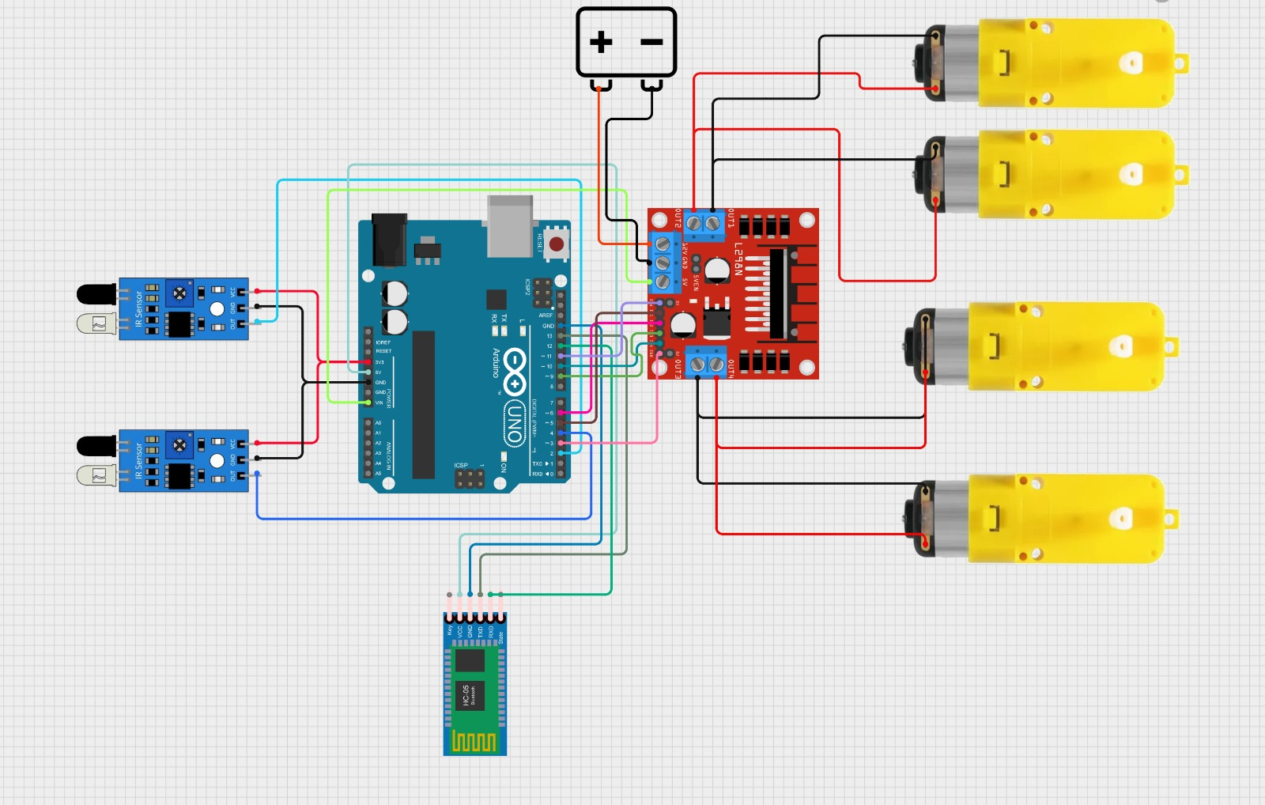

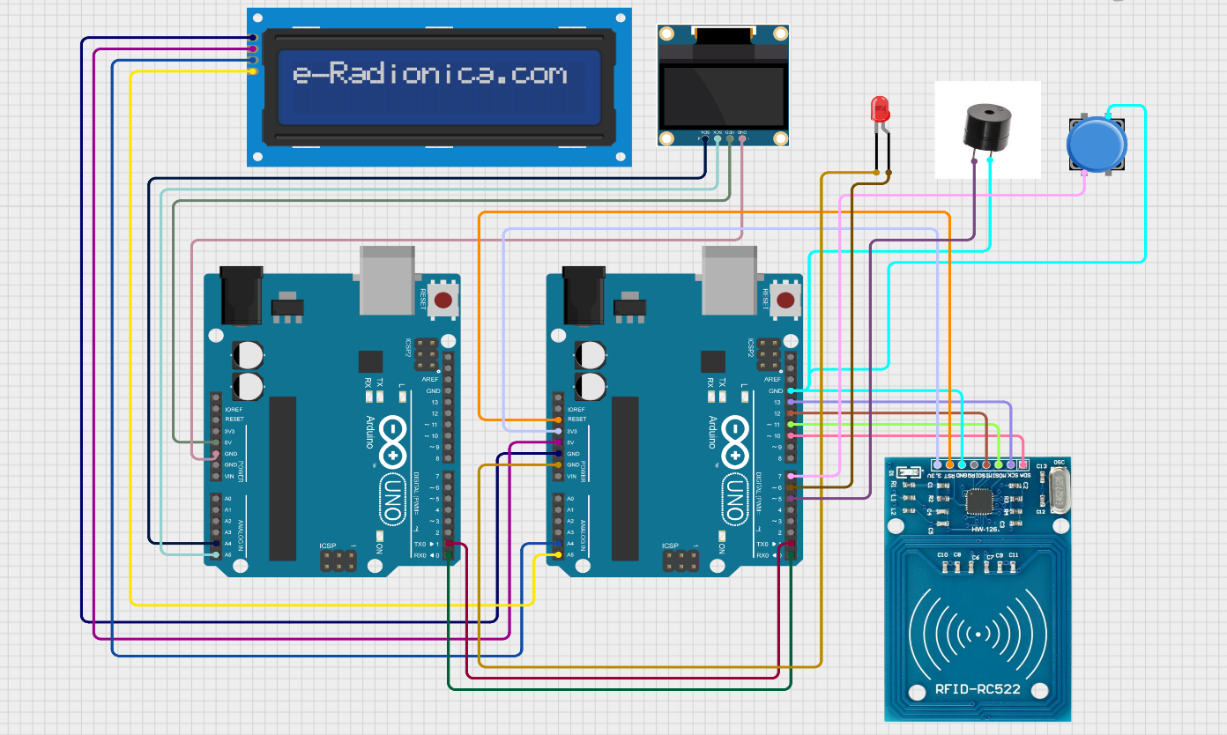

CHAPTER 5
Bluetooth-Controlled Line-Following Robot

Bluetooth-Controlled Line-Following Robot
1. Introduction
A Bluetooth-controlled line-following robot is an autonomous robotic system that follows a predefined path using IR sensors while also receiving manual control commands via Bluetooth. This project integrates Bluetooth communication with an automatic line-following mechanism, allowing the user to override the robot’s movement and control it manually using a smartphone or Bluetooth module.
2. Objectives of the Project
- Develop a line-following robot that can detect and follow a black line on a white surface using IR sensors.
- Implement Bluetooth-based manual control for forward, backward, stop, left, and right movements.
- Allow seamless switching between automatic (line-following) mode and manual (Bluetooth-controlled) mode.
- Provide real-time movement feedback via Serial Monitor.
3. System Architecture
The system consists of the following functional blocks:
- Power Supply: Provides power to the Arduino and motor driver.
- Switch: For ON and OFF purpose.
- Arduino Uno: The main microcontroller that processes sensor data and Bluetooth commands.
- IR Sensors: Detect the path and guide the robot in line-following mode.
- Motor Driver (L298N or similar): Controls the movement of DC motors.
- Bluetooth Module (HC-05/HC-06): Receives commands from the smartphone.
- DC Motors: Enable movement based on control signals.

4. Components & Technologies Used
4.1 Hardware Components
- Arduino Uno: Microcontroller for processing sensor and Bluetooth data
- IR Sensors (x2): Detect the line path (Left & Right sensors)
- Motor Driver (L298N): Controls the speed and direction of motors
- DC Motors (x2): Drive the robot forward, backward, left, and right
- Bluetooth Module (HC-05/HC-06): Enables wireless communication with a smartphone
- Battery Pack: Provides power to the Arduino and motors
- Chassis and Wheels: Physical structure of the robot
4.2 Software & Libraries
<SoftwareSerial.h>: Enables communication with the Bluetooth module
5. Working Principle
5.1 Line-Following Mode (Autonomous)
- The robot uses two IR sensors to detect the black line.
- Based on sensor readings:
  - Both sensors detect white (0,0) → Move forward.
  - Left sensor detects black (1,0) → Turn left.
  - Right sensor detects black (0,1) → Turn right.
  - Both sensors detect black (1,1) → Stop.
- The system continuously adjusts motor speeds for smooth line following.
5.2 Bluetooth Manual Control Mode
- The robot listens for commands via Bluetooth communication.
- Supported commands:
  - ‘f’ → Move Forward.
  - ‘b’ → Move Backward.
  - ‘s’ → Stop.
If no Bluetooth commands are received, the robot operates in line-following mode by default.

6. System Flow
- Start-Up:
  - Initializes Bluetooth communication.
  - Displays "Awaiting Bluetooth commands..." on the serial monitor.
- Line-Following Mode (Default):
  - Robot follows a black line autonomously.
  - Uses IR sensors to adjust direction.
- Manual Control via Bluetooth:
  - When a Bluetooth command is received:
    - ‘f’ → Switch to forward movement.
    - ‘b’ → Move backward.
    - ‘s’ → Stop the robot.
Overrides line-following mode until another command is sent.
- Completion:
  - If the robot stops, it waits for new commands or continues line-following.
7. Functions in the Code
setup(): Initializes the pins, serial communication, and stops the robot at startup
loop(): Checks for Bluetooth commands and executes movements.
lineFollowing(): Reads IR sensor data and adjusts movement accordingly.
forward(): Moves the robot forward.
backward(): Moves the robot backward.
turnRight(): Turns the robot to the right.
turnLeft(): Turns the robot to the left.
Stop(): Stops the motors.
8. Advantages of the System
- Dual Mode Functionality – Allows both automatic and manual Bluetooth control.
- Wireless Control – Bluetooth allows remote operation without physical intervention.
- Smooth Line Following – IR sensors ensure precise path tracking.
- Obstacle Handling – Can be improved by adding ultrasonic sensors for obstacle avoidance.
- Cost-Effective – Uses affordable components like Arduino, IR sensors, and Bluetooth modules.

9. Conclusion
- The Bluetooth-Controlled Line-Following Robot provides an intelligent, multi-functional navigation system that can operate autonomously while also allowing manual control via Bluetooth. The system demonstrates the integration of sensors, wireless communication, and motor control in robotics. With further enhancements like obstacle avoidance, GPS tracking, and voice control, this project can be extended for industrial automation, smart transportation, and warehouse robotics.

CHAPTER 6
RFID Scanning And QR-Based Billing
RFID Scanning And QR-Based Billing
Introduction
This project aims to enhance the shopping experience by integrating an RFID-based smart trolley system with automated billing and QR code-based payment. The system consists of two Arduino boards: one for RFID-based item scanning and another for displaying the total bill on an OLED screen while generating a dynamic UPI QR code for payment.
Components Used
- Arduino Uno (x2) – One for RFID scanning and another for OLED display.
- RFID Module (MFRC522) – To scan tagged items.
- I2C LCD Display (16x2) – To display item details and total bill.
- OLED Display (0.96-inch, 128x64 SSD1306) – To generate and display the QR code.
- IR Sensor – To detect item removal.
- Buzzer & LED – To provide audio-visual feedback.
- Push Button – To enable item removal.
- Wires and Connectors – To connect all components.
- Power Supply – Battery pack for Arduino.
Working Principle
1. Item Scanning and Billing
- Each product has an RFID tag with a unique ID.
- When an item is scanned, the Arduino reads the tag and compares it with a predefined list.
- If the tag matches an item in the database, its name and price are displayed on the LCD.
- The total bill is updated, and a buzzer/LED provides confirmation.
- If the payment RFID card is scanned, the final bill is transferred to the OLED display for QR code generation.
2. Item Removal Process
- Pressing the push button enables item removal mode.
- The user scans the RFID tag of an item to remove it.
- If the scanned tag matches an added item, it is removed from the bill.
- The total is updated, and feedback is provided through the LCD and buzzer.
3. QR Code-Based Payment
- The second Arduino receives the total bill amount serially from the first Arduino.
- It generates a dynamic UPI QR code using the format:
- upi://pay?pa=8074468294@ybl&pn=Payment&am=<amount>&cu=INR&tr=<txnRef>
- The QR code is displayed on the OLED screen.
- The customer scans the QR code using a UPI-enabled app (e.g., PhonePe, Google Pay) to complete the transaction.
System Flow
1.Start-Up
- Displays a welcome message on the LCD and OLED.
2.Item Scanning
- Reads RFID tag and updates the total.
- Displays the item name and price.
3.Item Removal (if needed)
- Activated by pressing the button.
- Removes the scanned item and updates the total.
4.Payment Process
- When the payment RFID tag is scanned, the total bill is displayed on the OLED.
- The QR code is generated and displayed.
- The user completes the payment via UPI scanning.
4.Completion
- Displays a thank-you message.
- Resets the total amount for the next transaction.

Objectives of the Project
- To develop an automated billing system for supermarkets using RFID technology.
- To minimize waiting time at checkout counters.
- To integrate a cashless payment system using dynamic QR codes.
- To provide real-time feedback through LCD and OLED displays.
- To enhance user experience with a smart, interactive trolley system.
Software Used
Software & Libraries
- Arduino IDE for coding and uploading sketches.
- Libraries Used:
  - <Wire.h> – Handles I2C communication.
  - <LiquidCrystal_I2C.h> – Controls the I2C LCD.
  - <SPI.h> – Enables SPI communication for the RFID module.
  - <MFRC522.h> – Reads RFID tags.
  - <Adafruit_GFX.h> & <Adafruit_SSD1306.h> – Controls the OLED display.
  - <qrcode.h> – Generates QR codes dynamically.
Implementation Details
- RFID Integration: Each product has an RFID tag. When scanned, its details are matched with stored data, and the price is updated on the LCD.
- Serial Communication: Two Arduino boards communicate via serial connection to send the total bill for QR code generation.
- Item Removal: If an item needs to be removed, pressing the push button enables removal mode, and the item is deducted from the total.
- Payment Processing: The OLED screen generates a dynamic UPI QR code, which users can scan using payment apps like Google Pay or PhonePe.

Advantages of the Smart Trolley
- Reduces human effort in scanning and billing.
- Avoids long queues at billing counters.
- Provides a seamless shopping experience with automated checkout.
- Encourages digital payments and reduces cash handling.
- Easy-to-use interface with instant feedback through LED and buzzer alerts.

Conclusion:
The Smart Trolley System revolutionizes the shopping experience by integrating RFID-based item scanning and QR code-based billing. By reducing manual efforts, streamlining checkout, and encouraging digital payments, this system significantly enhances efficiency in supermarkets and retail stores. Future enhancements, such as Wi-Fi integration and AI-powered analytics, can further improve the system, making it a valuable innovation in the retail industry.

CHAPTER 7
SOFTWARE IMPLEMENTATION

SOFTWARE IMPLEMENTATION
DESCRIPTION
The Arduino Integrated Development Environment is a cross-platform application written in Java, and is derived from the IDE for the Processing programming language and the Wiring projects. It includes a code editor with features such as syntax high-lighting, braces matching and automatic indentation, and is also capable of compiling and uploading programs to the board with a single click. A program or code written for Arduino is called a "sketch". Arduino programs are written in C or C++. Users only need define two functions to make a run able cyclic executive program:
Setup (): a function run once at the start of a program that can initialize settings.
Loop (): a function called repeatedly until the board powers off.
It is very simple to understand and has built-in functions for almost every simple or complex task. There are lots of libraries available which can be used to interface the Arduino board with any other devices. The Arduino runs a simplified version of the C programming language, with some extensions for accessing the hardware. In this guide, we will cover the subset of the programming language that is most useful to the novice Arduino designer. All Arduino instructions are one line. The board can hold a program hundreds of lines long and hasspaceforabout1,000two-byte variables. The Arduino executes programs at about 300,000 source code lines per sec.
USING ARDUINO DESKTOP IDE
If you want to program your Node MCU while offline you need to install the Arduino Desktop IDE the ESP32 WROOM-DA is programmed using the Arduino Software (IDE), our Integrated Development Environment common to all our boards. Before you can move on, you must have installed the Arduino Software (IDE)on your PC. Connect your Uno board with an B USB-cable; sometimes this cable is called a USB printer cable. The Arduino runs a simplified version of the C programming language, with some extensions for accessing the hardware. In this guide, we will cover the subset of the programming language that is most useful to the novice Arduino designer. All Arduino instructions are one line. The board can hold a program hundreds of lines long and has space for about 1,000 two-byte variables. The Arduino executes programs at about 300,000source code lines per sec.
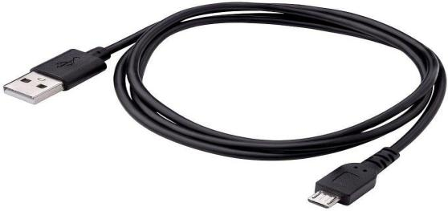

Fig 5.1 USB Cable
The USB connection with the PC is necessary to program the board and not just to power it up. The Uno automatically draw power from either the USB or an external power supply. Connect the board to your computer using the USB cable. The green power LED should go on.
INSTALL THE BOARD DRIVERS
If you use the Installer, Windows-from XP upto10-will install drivers automatically as soon as you connect your board.
If you downloaded and expanded the Zip package or, for some reason, the board wasn't properly recognized, please follow the procedure below.
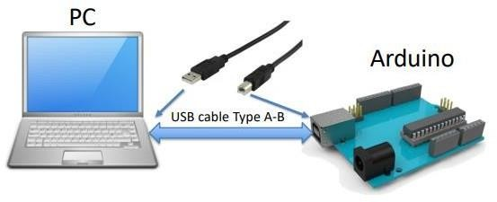

Fig5.2 Connection between the PC and Arduino Board
Step 1-Connect Arduino to Your Computer
First, you must have your Arduino board and a USB cable. In case you use Node MCU ESP32 WROOM-DA or ESP32, you will need a standard USB cable (A plug to B plug), the kind you would connect to a USB printer, as shown in the following image.
Step 2 – Download Arduino IDE Software
You can get different versions of Arduino IDE from the download page on the official Arduino website. You must select the software that is compatible with your operating system (Windows, macOS, or Linux). After your file download is complete, unzip the file.

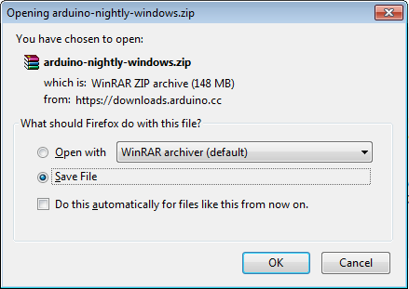
Fig5.3DownloadArduinoIDESoftware
Step 3 – Power up your board
The Arduino Uno, Mega, Duemilanove, and Arduino Nano automatically draw power from either the USB connection to the computer or an external power supply. If you are using an Arduino Diecimila, you must ensure that the board is configured to draw power from the USB connection. The power source is selected with a jumper—a small piece of plastic that fits onto two of the three pins between the USB and power jacks. Check that it is on the two pins closest to the USB port. Connect the Arduino board to your computer using the USB cable. The green power LED (labeled PWR) should glow.
Step 4 – Launch Arduino IDE
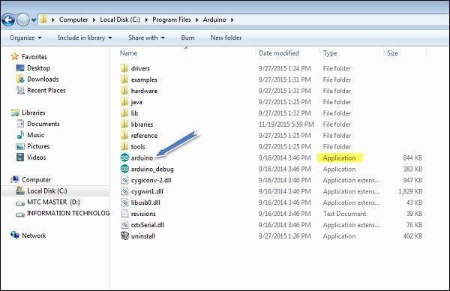
After your Arduino IDE software is downloaded, you need to unzip the folder. Inside the folder, you can find the application icon with an infinity label (application.exe). Double-click the icon to start the IDE.

Fig5.4LaunchArduinoIDESoftware
Step 5 – Open your first project
Once the software starts, you have two options:
- Create a new project
- Open an existing project example
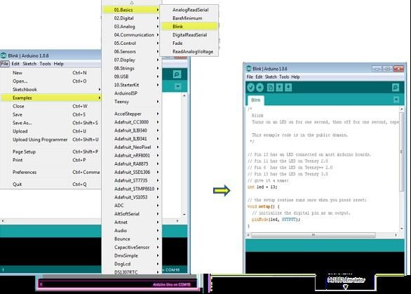
To create a new project, select File → New.

Fig5.5 Select of File→ Example→ Basics→ Blink.
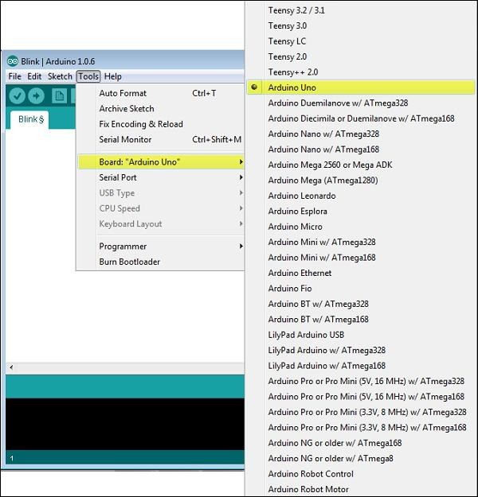
Here, we are selecting just one of the examples with the name blink. It turns the LED on and off with some time delay. You can select any other example from the list.
Step 6 − Select your Arduino board.

Fig5.6 Select the Arduino UNO Board
To avoid any error while uploading your program to the board, you must select the correct Arduino board name, which matches with the board connected to your computer.
Goto Tools→ Board and select your board.
Here, we have selected the Arduino Uno board according to our tutorial, but you must select the name matching the board that you are using.
Step 7 – Select your serial port
Select the serial device of the Arduino board. Go to Tools → Serial Port menu. This is likely to be COM3 or higher (COM1 and COM2 are usually reserved for hardware serial ports).To find out the correct port, you can disconnect your Arduino board and re-open the menu.
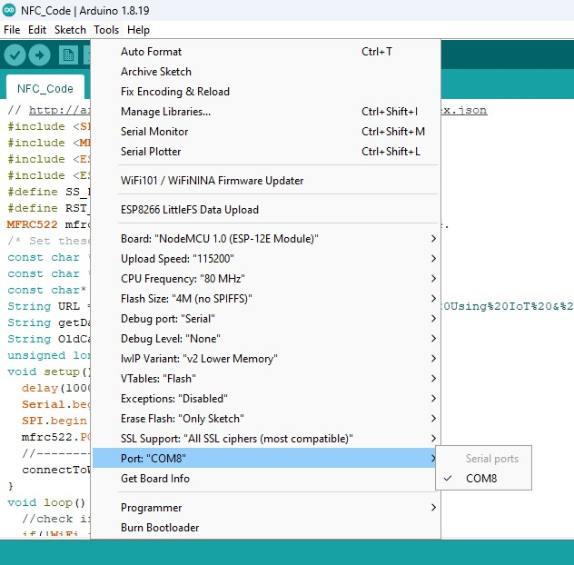
Fig5.7 Select your Serial Port
Step 8 – Uploading the Program to Your Board
Before explaining how to upload a program to the board, we must demonstrate the function of each symbol appearing in the Arduino IDE toolbar.
Arduino IDE Toolbar Functions:
- A – Used to check if there is any compilation error.
- B – Used to upload a program to the Arduino board.
- C – Shortcut used to create a new sketch.
- D – Used to directly open one of the example sketches.
- E – Used to save your sketch.
- F – Serial monitor used to receive serial data from the board and send commands.
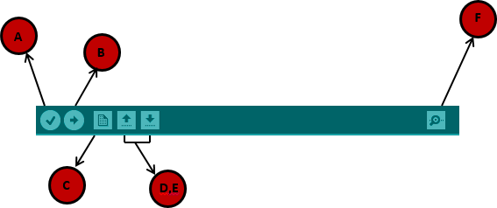
Fig5.8Uploading Programming to Board
F – Serial monitor used to receive serial data from the board and send serial data to the board.
Now, simply click the "Upload" button in the Arduino IDE. Wait a few seconds; you will see the RX and TX LEDs on the board flashing. If the upload is successful, the message "Done uploading" will appear in the status bar.
Note – If you have an Arduino Mini, NG, or another similar board, you need to press the reset button physically on the board immediately before clicking the upload button in the Arduino software.
Programs are created in the Arduino development environment and then downloaded to the Arduino board. Code must be entered with proper syntax, meaning valid command names and correct grammar for each line. The compiler will catch and flag syntax errors before downloading.
Sometimes, error messages may seem unclear, and the actual issue might have occurred before the flagged line. Even if your program passes the syntax check, it might not function as expected.
This is where debugging skills are essential. The Arduino executes what you told it to do, not necessarily what you intended. The best way to catch these errors is to read the code line by line as if you were the computer. Having another person review your code can also be helpful. Skilled debugging takes practice.
PROGRAM FORMATTING AND SYNTAX
Programs are entered line by line. Code is case-sensitive, meaning "myvariable" is different from "MyVariable".

Basic Syntax Rules
- Statements: Any command in the program. Statements must end with a semicolon (;).
A classic mistake is forgetting the semicolon, so if your program does not compile, check for missing semicolons.
- Comments:
  - Single-line comments start with //.
  - Multi-line block comments start with /* and end with */.
- Constants: Fixed numbers that can be entered as:
  - Decimal (e.g., 10)
  - Hexadecimal (e.g., 0xA)
  - Binary (e.g., 0b1010)
- Labels: Used to reference locations in your program.
  - Can contain letters, numbers, and underscores (_) but must start with a letter.
  - When marking a location, end the label with a colon (:).
  - When referring to the label in an instruction, do not use a colon.
Example: Using Labels in Arduino Code
Repeat:
digitalWrite(2, HIGH);
delay(1000);
digitalWrite(2, LOW);
delay(1000);
goto Repeat;
- Avoid using labels excessively, as they can make the program harder to follow and debug.
- Some C programmers even recommend never using labels.

Variables in Arduino
- Every variable must be declared before use.
- Scope of Variables:
  - If declared outside a function, it is global (accessible throughout the program).
  - If declared inside a function, it is local (accessible only within that function).

Common Variable Types
Type | Size | Range
byte | 8-bit | 0 to 255 (unsigned)
word | 16-bit | 0 to 65,536 (unsigned)
int | 16-bit | -32,768 to 32,767 (signed)
long | 32-bit | -2,147,483,648 to 2,147,483,647 (signed)
- Use byte variables unless you need negative numbers or numbers larger than 255.
- Using unnecessarily large data types consumes precious memory.

Variable Naming Rules
- Variable names must start with a letter.
- They can include letters and numbers but cannot be a reserved keyword.
- If you use a reserved keyword, the compiler will give an error.

Symbols in Arduino (#define)
- Symbols are used to define constants, making the code more readable.
- They are defined using the #define directive.
- Symbol definitions should go at the beginning of the program.

Example: Defining an LED Pin
#define LED_PIN 2

void setup() {
pinMode(LED_PIN, OUTPUT);
}

void loop() {

digitalWrite(LED_PIN, HIGH);
delay(1000);
digitalWrite(LED_PIN, LOW);
delay(1000);
}
In this example, LED_PIN is defined as 2, making the code more readable.
Voidsetup ()

{
pin mode(2,OUTPUT);

}
Void loop ()
{
digitalWrite(2,HIGH);delay (1000); digitalWrite(2.LOW);delay (1000);
}
PROGRAMMING STRUCTURE
All Arduino programs have two functions, setup () and loop (). The instructions you

place in the startup () function are executed once when the program begins and are used to initialize Use it to set directions of pins or to initialize variables. The instructions placed in loop are executed repeatedly and from the main tasks of the program.
Therefore, every program has this structure.
Void setup()
{
//commands to initialize go here
}
Void loop ()

//commands to run your machine go here
}
The absolute, bare minimum, do nothing program that can compile androids
Void setup ()
{}
void loop ()
{}
The program performs no function but is useful for clearing out any old program. Note that the compiler does not care about line returns, which is why this program works if typed all on one line.
COMMANDS
Pin Mode
This command, which goes in the setup() function, is used to set the direction of a digital I/O pin. Set the pin to OUTPUT if the pin is driving an LED, motor, or other device. Set the pin to INPUT if the pin is reading a switch or other sensor. On power-up or reset, all pins default to inputs. This example sets pin 2 to an output and pin 3 to an input.
Void setup ()
{
pin Mode (2,OUTPUT);pin Mode(3, INPUT);
}
Serial Print
The Serial.print command lets you see what’s going on inside the Arduino from your computer. For example, you can see the result of a math operation to determine if you are getting the right number. Or, you can see the state of a digital input pin to check if the Arduino is detecting a sensor or switch properly. When your interface circuits or program do not seem to be working, use the Serial.print command to shed a little light on the situation. For this command to show anything, the Arduino must be connected to the host computer with a USB cable. Additionally, the command Serial.begin(9600); must be placed in the setup() function for it to work. After the program is uploaded, you must open the Serial Monitor window to see the response. There are two forms of the print command: Serial.print() prints on the same line while Serial.println() starts the print on a new line.
Here is a brief program to check if your board is alive and connected to the PC. Void setup ()
{
Serial.begin(9600);Serial.println(“HelloWorld”);
}
Void loop ()
Here is a program that loops in place, displaying the value of an I/O pin. This is useful for checking the state of sensors or switches and to see if the Arduino is reading the sensor properly.
Void loop ()
{
Serial.print(digitalRead(2));
Delay(100);
}
If you wanted to see the states of pins 2 and 3 at the same time, you can chain a few print commands, noting that the last command is a println to start a new line.
Voidsetup ()
{
Serial.begin(9600);
}
Void loop ()
}
Serial.print(“pin2=“);
}
EMBEDDED C
C is a high-level programming language. Embedded C is just an extension variant of the C language. This programming language is hardware-independent. On the other hand, Embedded C language is truly hardware-dependent.

Introduction

Embedded C is a set of language extensions for the C programming language by the C Standards Committee to address commonality issues that exist between C extensions for different embedded systems. Embedded C programming typically requires non-standard extensions to the C language in order to support enhanced microprocessor features such as fixed-point arithmetic, multiple distinct memory banks, and basic I/O operations. The C Standards Committee produced a Technical Report, most recently revised in 2008 and reviewed in 2013, providing a common standard for all implementations to adhere to. It includes a number of features not available in normal C, such as fixed-point arithmetic, named address spaces, and basic I/O hardware addressing.
Embedded C uses most of the syntax and semantics of standard C, e.g., main() function, variable definition, data type declaration, conditional statements (if, switch-case), loops (while, for), functions, arrays and strings, structures and unions, bit operations, macros, etc.
The programming language used in this project is Embedded C. This Embedded C language is different from the generic C language in a few aspects like:
- Data Types
- Access over the architecture addresses
The Embedded C programming language forms a user-friendly language with access over port addresses, SFR register addresses, etc.

Table5.1Data Types

S.No | Datatypes | Size in Bits | Data Range
1 | Unsigned char | 8bit | 0255
2 | Signed char | 8bit | 128 to +127
3 | Unsigned int | 16bit | 0 to 65535
4 | Signed int | 16bit | 32,768 to +32,767
5 | S bit | 1bit | SFR bit addressable only
6 | Bit | 1bit | RAM bit addressable only
In embedded system programming, C code is preferred over other languages due to the following reasons:
- Easy to understand
- High reliability
- Portability
- Scalability

Embedded System Programming

a) Basic Declaration
Let's see the block diagram of Embedded C Programming development:
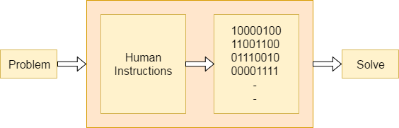
A function is a collection of statements used to perform a specific task, and a collection of one or more functions forms a programming language. Every language consists of basic elements and grammatical rules. The C language programming is designed with functions, variables, character sets, data types, keywords, expressions, and more, which are used for writing a C program.The extension in the C language is known as the Embedded C programming language.

Fig 5.9 Block Diagram of Embedded C Development

Basic Embedded C Programming Steps

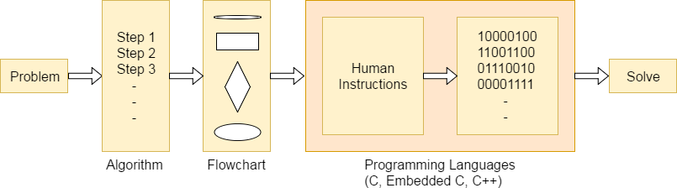
Let's see the block diagram representation of Embedded C Programming Steps:

Fig 5.10 Block Diagram of Embedded C Programming Steps
Embedded C programming involves a step-by-step process to develop software for microcontrollers and other embedded systems. The first step is to understand the hardware specifications and constraints of the target embedded system, including the microcontroller architecture, memory layout, and available peripherals. Once this understanding is established, the programmer moves on to designing the software architecture, defining the functionalities and tasks the embedded system will perform.
Next, the actual coding phase begins, where the C programming language is used to write the software based on the predefined architecture. This involves implementing algorithms, configuring hardware peripherals, and managing memory efficiently.
The microcontroller programming is different for each type of operating system. Even though many operating systems exist, such as Windows, Linux, and RTOS, RTOS has several advantages for embedded system development.
CODE
(SMART TROLLY VIA BLUETOOTH)
// Bluetooth-Controlled Line-Following Robot with Backward Command
#include <SoftwareSerial.h>

int bluetoothRx = 12, bluetoothTx = 13;
SoftwareSerial BluetoothSerial(bluetoothRx, bluetoothTx);
int enA = 11, enB = 3, in1 = 5, in2 = 6, in3 = 9, in4 = 10;
int R_S = 4, L_S = 2;
int normalSpeed = 120, customSpeed = 220;
char command = 's';

void setup() {
pinMode(R_S, INPUT); pinMode(L_S, INPUT);
pinMode(enA, OUTPUT); pinMode(enB, OUTPUT);
pinMode(in1, OUTPUT); pinMode(in2, OUTPUT);
pinMode(in3, OUTPUT); pinMode(in4, OUTPUT);
Serial.begin(9600);
BluetoothSerial.begin(9600);
Stop();
Serial.println("Awaiting Bluetooth commands...");
}

void loop() {
if (BluetoothSerial.available()) {
char newCommand = BluetoothSerial.read();
if (newCommand == 'f' || newCommand == 'b' || newCommand == 's') {
command = newCommand;
}
}

if (command == 'f') {
lineFollowing();
} else if (command == 'b') {
backward();
} else {
Stop();
}
}
void lineFollowing() {
int rightSensor = digitalRead(R_S);
int leftSensor = digitalRead(L_S);
if (rightSensor == 0 && leftSensor == 0) forward();
else if (rightSensor == 1 && leftSensor == 0) turnRight();
else if (rightSensor == 0 && leftSensor == 1) turnLeft();
else Stop();
}

void forward() {
analogWrite(enA, normalSpeed); analogWrite(enB, normalSpeed);
digitalWrite(in1, LOW); digitalWrite(in2, HIGH);
digitalWrite(in3, HIGH); digitalWrite(in4, LOW);
}

void backward() {
analogWrite(enA, normalSpeed); analogWrite(enB, normalSpeed);
digitalWrite(in1, HIGH); digitalWrite(in2, LOW);
digitalWrite(in3, LOW); digitalWrite(in4, HIGH);
Serial.println("Moving backward");
}
void turnRight() {
analogWrite(enA, customSpeed); analogWrite(enB, customSpeed);
digitalWrite(in1, HIGH); digitalWrite(in2, LOW);
digitalWrite(in3, HIGH); digitalWrite(in4, LOW);
}
void turnLeft() {
analogWrite(enA, customSpeed); analogWrite(enB, customSpeed);
digitalWrite(in1, LOW); digitalWrite(in2, HIGH);
digitalWrite(in3, LOW); digitalWrite(in4, HIGH);
}
void Stop() {
analogWrite(enA, 0); analogWrite(enB, 0);
digitalWrite(in1, LOW); digitalWrite(in2, LOW);
digitalWrite(in3, LOW); digitalWrite(in4, LOW);
Serial.println("Stopped");
}
(SMART CART SYSTEM)
#include <Wire.h>
#include <LiquidCrystal_I2C.h>
#include <SPI.h>
#include <MFRC522.h>

#define SS_PIN 10
#define RST_PIN 9
MFRC522 mfrc522(SS_PIN, RST_PIN); // Create MFRC522 instance.

LiquidCrystal_I2C lcd(0x27, 16, 2); // LCD address and size

// IR Sensor pin
int switchPin = 7;
int ledPin = 6;
int buzzerPin = 5;

// Predefined RFID Tags, Item Names, and Prices
String rfidTags[] = {"13da7230", "89f94916", "13d58cf5", "4ae9081"}; // The 4th tag is for payment
String itemNames[] = {"Sugar", "Rice", "Tea", "Milk"};
double itemPrices[] = {10.00, 20.00, 25.00, 25.00};
int itemPins[] = {4, 5, 6, 7}; // Pins for item activation

double total = 0;
int itemCount = 0;
int addedItems[10]; // Array to store added items
int addedItemCount = 0; // Number of items added

void setup() {
pinMode(4, OUTPUT);
pinMode(5, OUTPUT);
pinMode(6, OUTPUT);
pinMode(7, OUTPUT);
pinMode(switchPin, INPUT_PULLUP); // Switch setup
pinMode(ledPin, OUTPUT); // LED setup
pinMode(buzzerPin, OUTPUT);

lcd.init();
lcd.backlight();
lcd.clear();

Serial.begin(9600); // Start serial communication
SPI.begin(); // Start SPI bus
mfrc522.PCD_Init(); // Initialize MFRC522
// Create a custom smiley face symbol
byte heart[8] = {
B00000,
B01010,
B11111,
B11111,
B01110,
B00100,
B00000,
B00000
};

lcd.createChar(0, heart);
lcd.setCursor(0, 0);
lcd.print("WELCOME TO MART");
delay(2000);
lcd.clear();
lcd.setCursor(0, 0);
lcd.print("Plz Add Item");
}

void loop() {
// Check for switch press to enter removal mode (switch state LOW)
int switchState = digitalRead(switchPin);
if (switchState == LOW && addedItemCount > 0) {
lcd.clear();
lcd.setCursor(0, 0);
lcd.print("Scan RFID to");
lcd.setCursor(0, 1);
lcd.print("Remove Item");

// Wait for RFID input to identify which item to remove
removeItem();
}

// Check for new RFID card (for adding items)
if (mfrc522.PICC_IsNewCardPresent()) {
if (mfrc522.PICC_ReadCardSerial()) {
String rfidTag = "";
for (byte i = 0; i < mfrc522.uid.size; i++) {
rfidTag += String(mfrc522.uid.uidByte[i], HEX);
}

lcd.clear();

bool itemFound = false;
for (int i = 0; i < 4; i++) {
if (rfidTag == rfidTags[i]) {
if (i == 3) { // Check if it's the payment card
processPayment(); // Process the payment if it's the payment card
return; // Skip further processing since payment was processed
} else {
addItem(i); // Add the item if tag matches
itemFound = true;
break;
}
}
}

if (!itemFound) {
lcd.print("Item Not Found");
delay(2000);
lcd.clear();
}

mfrc522.PICC_HaltA(); // Halt RFID communication
}
}
}

void addItem(int itemIndex) {
// Add item to cart
lcd.setCursor(0, 0);
lcd.print(itemNames[itemIndex] + " Added");
lcd.setCursor(0, 1);
lcd.print("Price: " + String(itemPrices[itemIndex]));

// Update total and count
total += itemPrices[itemIndex];
itemCount++;

// Activate corresponding pin for item
digitalWrite(itemPins[itemIndex], HIGH);
delay(2000); // Delay to simulate activation
digitalWrite(itemPins[itemIndex], LOW); // Deactivate pin

// Show total and item count
lcd.clear();
lcd.setCursor(0, 0);
lcd.print("Total: " + String(total));
lcd.setCursor(0, 1);
lcd.print("Items: " + String(itemCount));
// Store the added item in the addedItems array
addedItems[addedItemCount++] = itemIndex;

// Activate LED and Buzzer immediately (same as for Sugar and Rice)
digitalWrite(ledPin, HIGH);
digitalWrite(buzzerPin, HIGH);
delay(200); // Short delay for buzzer
digitalWrite(ledPin, LOW);
digitalWrite(buzzerPin, LOW);
}

void removeItem() {
// Wait for an RFID card to be scanned to remove item
if (mfrc522.PICC_IsNewCardPresent()) {

if (mfrc522.PICC_ReadCardSerial()) {
String rfidTag = "";
for (byte i = 0; i < mfrc522.uid.size; i++) {
rfidTag += String(mfrc522.uid.uidByte[i], HEX);
}

bool itemFound = false;
for (int i = 0; i < addedItemCount; i++) {
if (rfidTag == rfidTags[addedItems[i]]) {
// If item is found in the cart, remove it
lcd.clear();
lcd.setCursor(0, 0);
lcd.print(itemNames[addedItems[i]] + " Removed");
lcd.setCursor(0, 1);
lcd.print("Price: " + String(itemPrices[addedItems[i]]));

// Update total and item count
total -= itemPrices[addedItems[i]];
itemCount--;
// Deactivate corresponding pin for item
digitalWrite(itemPins[addedItems[i]], HIGH);
delay(2000);
digitalWrite(itemPins[addedItems[i]], LOW);

// Remove the item from the addedItems array
for (int j = i; j < addedItemCount - 1; j++) {
addedItems[j] = addedItems[j + 1]; // Shift items left
}
addedItemCount--; // Decrease the count of added items

// Show total and item count
lcd.clear();
lcd.setCursor(0, 0);
lcd.print("Total: " + String(total));
lcd.setCursor(0, 1);
lcd.print("Items: " + String(itemCount));

// Activate LED and Buzzer when item is removed
digitalWrite(ledPin, HIGH);
digitalWrite(buzzerPin, HIGH);
delay(500);
digitalWrite(ledPin, LOW);
digitalWrite(buzzerPin, LOW);

itemFound = true;
break;
}
}

if (!itemFound) {
lcd.clear();
lcd.setCursor(0, 0);
lcd.print("Item Not Found");
lcd.setCursor(0, 1);
lcd.print("Try Again");

// Activate buzzer for failure
digitalWrite(buzzerPin, HIGH);
delay(500);
digitalWrite(buzzerPin, LOW);
delay(1000);
}

delay(2000); // Wait for a while before returning to the main loop
}
}
}

void processPayment() {
// Payment card detected, display total bill and process payment
lcd.clear();
lcd.setCursor(0, 0);
lcd.print("Total Bill: ");
lcd.setCursor(0, 1);
lcd.print("Amount: " + String(total));

// Activate LED and Buzzer for payment process
digitalWrite(ledPin, HIGH); // Turn on LED
digitalWrite(buzzerPin, HIGH); // Turn on Buzzer
delay(2000);
digitalWrite(buzzerPin, LOW);
// Simulate payment process
delay(2000); // Simulate processing time

lcd.clear();
lcd.setCursor(0, 0);
lcd.print("Payment Success");

delay(2000); // Wait for a while to show the payment success message
lcd.clear(); // Clear screen for next message

lcd.setCursor(0, 0); // Move cursor to the beginning of the first line
lcd.print("Thank you for");
lcd.setCursor(0, 1); // Move cursor to the beginning of the second line
lcd.print("your visit");

delay(2000); // Wait for a while to show the thank you message
lcd.clear(); // Clear screen for next message

lcd.setCursor(0, 0); // Move cursor to the beginning of the first line
lcd.print("We'd love to");
lcd.setCursor(0, 1); // Move cursor to the beginning of the second line
lcd.print("have you back");

delay(2000); // Wait for a while
lcd.clear();

lcd.setCursor(0, 0); // Move cursor to the beginning of the first line
lcd.print("anytime!");
lcd.write(byte(0));

delay(2000); // Wait before the program completes

// Reset total and item count after payment
total = 0;
itemCount = 0;

// Deactivate LED and Buzzer after payment
digitalWrite(ledPin, LOW); // Turn off LED
digitalWrite(buzzerPin, LOW); // Turn off Buzzer
}
(TOTAL AMOUNT PAYMENT CODE)
#include <Wire.h>
#include <Adafruit_GFX.h>
#include <Adafruit_SSD1306.h>
#include <qrcode.h>

#define SCREEN_WIDTH 128
#define SCREEN_HEIGHT 64
#define OLED_RESET -1
#define SCREEN_ADDRESS 0x3C

Adafruit_SSD1306 display(SCREEN_WIDTH, SCREEN_HEIGHT, &Wire, OLED_RESET);

// Function to generate and display a UPI QR code with dynamic amount and transaction reference
void showQRCode(float amount) {
// Create a unique transaction reference based on millis()
unsigned long txnRef = millis();
// Construct the UPI URI with the provided amount and the dynamic transaction reference.
// Including 'tr' makes the QR code dynamic, which should cause PhonePe to prefill the amount.
char upiData[200];
sprintf(upiData, "upi://pay?pa=8074468294@ybl&pn=Payment&am=%.2f&cu=INR&tr=%lu", amount, txnRef);

QRCode qrcode;
uint8_t qrcodeData[qrcode_getBufferSize(3)]; // Version 3 gives a good balance between size and clarity
qrcode_initText(&qrcode, qrcodeData, 3, 0, upiData);

// Calculate scaling and centering for the display
int scale = 2;
int xOffset = (SCREEN_WIDTH - (qrcode.size * scale)) / 2;
int yOffset = (SCREEN_HEIGHT - (qrcode.size * scale)) / 2;

display.clearDisplay();
// Draw each module of the QR code on the OLED
for (uint8_t y = 0; y < qrcode.size; y++) {
for (uint8_t x = 0; x < qrcode.size; x++) {
if (qrcode_getModule(&qrcode, x, y)) {
display.fillRect(xOffset + x * scale, yOffset + y * scale, scale, scale, WHITE);
}
}
}
display.display();
}

void setup() {
Serial.begin(115200);
if (!display.begin(SSD1306_SWITCHCAPVCC, SCREEN_ADDRESS)) {
Serial.println(F("SSD1306 allocation failed"));
for (;;);
}

display.clearDisplay();
// Optionally adjust the contrast if needed
display.ssd1306_command(SSD1306_SETCONTRAST);
display.ssd1306_command(0x7F);

// Display a welcome message
display.setTextSize(2);
display.setTextColor(WHITE);
display.setCursor(10, 20);
display.println("Welcome");
display.display();
}

void loop() {
// Wait for an amount input via Serial
if (Serial.available() > 0) {
// Parse the float value sent via Serial
float amount = Serial.parseFloat();

// Show the total amount on the screen
display.clearDisplay();
display.setTextSize(1);
display.setTextColor(WHITE);
display.setCursor(0, 0);
display.println("Scan with PhonePe");
display.print("Total: ");
display.print(amount, 2); // Print with two decimal places
display.display();

// Give the user 5 seconds to note the amount
delay(5000);

// Generate and display the QR code with dynamic UPI details.
showQRCode(amount);
}
}

CHAPTER 8
CONCLUSION AND FUTURE SCOPE

CONCLUSION AND FUTURE SCOPE

8.1 Conclusion
The Smart Trolley System with Controlled Movement and QR-Based Billing has been successfully developed to enhance the shopping experience by integrating automation, RFID-based item detection, and a seamless payment system. The proposed system enables smart grocery management by tracking items in real time, reducing checkout delays, and improving efficiency. The trolley moves autonomously using a line-following mechanism and can be controlled via Bluetooth. The RFID system detects items added to the cart, while the QR-based billing system simplifies the payment process, ensuring a hassle-free shopping experience. This project bridges retail automation, IoT, and embedded systems to offer an innovative solution for smart shopping.

8.2 Contribution
The proposed system contributes significantly to improving the efficiency of retail shopping by reducing checkout time, eliminating human errors in billing, and enhancing the overall shopping experience. By implementing RFID-based item tracking, it ensures real-time inventory updates, making it easier for store management to monitor stock levels. The automated trolley movement minimizes the need for physical effort, benefiting customers, especially the elderly and differently-abled individuals. The integration of QR-based payments further enhances security and convenience by eliminating the need for cash transactions. This system modernizes traditional shopping methods and aligns with the future of digital retail automation.

8.3 Future Scope
The Smart Trolley System has potential for further advancements, including:
- AI-based Object Detection – Enhancing the RFID system by integrating computer vision to recognize products without relying on RFID tags.
- Voice-Assisted Navigation – Implementing a voice-controlled shopping assistant for better accessibility.
- Integration with Online Shopping Apps – Allowing users to sync their shopping lists with the trolley, making in-store shopping more efficient.
- Advanced Payment Options – Supporting UPI Auto-Pay and contactless card transactions to improve checkout speed.
- Weight Sensors for Accuracy – Adding weight sensors to cross-verify item detection, ensuring that each item is correctly registered.
- Store Analytics & Inventory Tracking – Providing real-time insights into product demand, helping retailers optimize stock levels and improve customer experience.
With these enhancements, the Smart Trolley System can revolutionize retail shopping, making it more automated, efficient, and user-friendly.

REFERENCES
[1] S. S. Sarpate, A. V. Tirmali, A. P. Agrawal, "Smart Shopping Trolley using RFID and IoT for Automatic Billing System," International Research Journal of Engineering and Technology (IRJET), Vol. 6, Issue 3, March 2019.
[2] A. Sharma, M. Verma, A. K. Shukla, "Automated Shopping Trolley for Smart Billing using RFID and Zigbee," IEEE International Conference on Smart Systems and Technologies (SST), 2020.
[3] R. Pawar, P. R. Kulkarni, "Smart Trolley System using RFID, IoT and QR Code for Contactless Shopping," International Journal of Scientific & Technology Research (IJSTR), Vol. 8, Issue 12, 2019.
[4] S. P. Gupta, R. S. Kumar, "IoT-Based Intelligent Smart Trolley for Automated Billing and Navigation," International Journal of Engineering Research & Technology (IJERT), 2021.
[5] J. Patil, A. Waghmare, "RFID-Based Smart Shopping Cart with Bluetooth and Mobile Payment System," International Journal of Computer Applications (IJCA), 2018.
[6] T. B. Singh, K. R. Das, "Integration of RFID and QR Code for Smart Shopping System," IEEE International Conference on Consumer Electronics (ICCE), 2021.
[7] N. Choudhary, R. J. Tripathi, "AI-Powered Smart Trolley with Automatic Billing System and Gesture Recognition," International Journal of Recent Technology and Engineering (IJRTE), 2020.
[8] A. Roy, S. Ghosh, "An Efficient RFID-Based Shopping Cart with IoT-Powered Inventory Management," Springer Advances in Intelligent Systems and Computing (AISC), 2019.
[9] M. H. Khan, P. Sen, "Design and Implementation of an RFID-Enabled Smart Cart for Retail Shopping," IEEE Transactions on Consumer Electronics, 2017.
[10] P. K. Sinha, A. S. Gupta, "Smart Trolley with Automated Billing and Wireless Payment Integration," Elsevier Journal of Internet of Things and Smart Technologies (JIoTST), 2022.

