CSMI17 — Artificial Intelligence
Assignment Report: Robot Path-Finding with A* Search
Q1 — Single-Robot A* with Multiple Heuristics | Q2 — Multi-Robot Path Finding

Submitted as part of CSMI17 – Artificial Intelligence course assignment.
GitHub repository: <ADD YOUR GITHUB LINK HERE — see Section 6>

1. Problem Definition

1.1 Question 1 — Robot Path-Finding Problem
A single robot occupies a cell in a 2-D grid and must navigate to a designated goal cell. Some cells in the grid are blocked by obstacles that the robot cannot enter. The robot can move one cell at a time in one of the four cardinal directions (up, down, left, right). The task is to find a shortest (minimum-cost) collision-free path from the start cell to the goal cell using the A* search algorithm, and to compare at least three different heuristic functions on the basis of search efficiency.

1.2 Question 2 — Multi-Robot Path-Finding Problem
The same environment is now shared by multiple robots simultaneously. Each robot i has its own start cell and its own goal cell, and all robots move synchronously, one grid step per timestep. In addition to static obstacles, robots must now also avoid colliding with each other: two robots must never occupy the same cell at the same timestep (a vertex/vertex collision), and two robots must never swap cells between consecutive timesteps by crossing the same edge in opposite directions (an edge/swap collision). The goal is to find a set of paths — one per robot — that gets every robot from its start to its goal while avoiding both static obstacles and inter-robot collisions, ideally with good overall efficiency (short paths, short completion time).

2. Assumptions / Customizations
- The environment is a rectangular grid of size N x N; each cell is either free (0) or a static obstacle (1).
- Movement is 4-connected (N, E, S, W) with unit edge cost; diagonal moves are not allowed, matching the standard formulation of grid path-finding used in the lecture material.
- Grids, start cells and goal cells are generated uniformly at random for a given obstacle density; an instance is only accepted if the start and goal are verified to be reachable via BFS, so every trial is guaranteed solvable for Q1.
- For Q2, every (start_i, goal_i) pair is individually verified to be reachable in isolation; this does not guarantee the joint multi-robot problem is solvable (that is, in general, a much harder question), which is itself part of what the experiments measure.
- Time is discretized into synchronized timesteps; every robot moves (or explicitly waits) exactly once per timestep.
- A robot that has reached its goal is assumed to remain (park) there for the rest of the episode rather than disappearing — so later-arriving robots must still avoid a parked robot's cell.
- All robots are homogeneous (same movement capabilities, same cost of 1 per move/wait) and full information (the full grid and all robots' start/goal cells) is available to the planner up front, i.e. this is centralized, offline, multi-robot planning rather than decentralized/online control.
- Search effort is measured by nodes expanded / generated and wall-clock runtime; for Q2, solution quality is additionally measured by makespan (time until the last robot arrives) and sum-of-costs (total path length summed over all robots), which are the two standard cost metrics used in the multi-agent path-finding (MAPF) literature.

3. Description of Algorithms / Heuristics

3.1 A* Search (Q1)
A* maintains a priority queue (open list) of frontier nodes ordered by f(n) = g(n) + h(n), where g(n) is the cost of the best path found so far from the start to n, and h(n) is a heuristic estimate of the remaining cost from n to the goal. Provided h is admissible (never overestimates the true remaining cost), A* is guaranteed to return an optimal (shortest) path. Ties in f(n) are broken using insertion order. A closed set prevents re-expansion of already-finalized nodes.

3.2 Heuristics compared
- Manhattan distance: h(a,b) = |a.row - b.row| + |a.col - b.col|. This is the exact remaining distance on an obstacle-free 4-connected grid, making it the tightest of the three heuristics — it is expected to expand the fewest nodes.
- Euclidean distance: h(a,b) = sqrt((a.row-b.row)^2 + (a.col-b.col)^2). Always <= Manhattan distance on a grid, so it remains admissible, but it is a looser (less informative) estimate and is expected to expand more nodes than Manhattan.
- Chebyshev distance: h(a,b) = max(|a.row-b.row|, |a.col-b.col|). This is the correct heuristic for 8-connected (diagonal-allowed) movement; on our 4-connected grid it is a valid but looser lower bound (<= Manhattan distance), so it is expected to be the least informative of the three.
- Dijkstra baseline (h = 0): included only as a reference point — with no heuristic, A* degenerates exactly to Dijkstra's algorithm and expands nodes in all directions uniformly, showing the benefit that any admissible heuristic provides.

3.3 Plain (independent) multi-robot A* — baseline for Q2
The straightforward way to "try A* for the multi-robot setting", as suggested by the assignment, is to run single-robot A* independently for every robot, ignoring all other robots. Each robot gets its own shortest path to its own goal. These paths are then executed together and checked for collisions. This is fast (each robot's search is unaware of the others) but provides no collision-avoidance guarantee whatsoever.

3.4 Proposed method — Cooperative Space-Time A*
To resolve the collisions produced by the plain baseline, we implement Cooperative A* (Silver, 2005), a classic and effective technique from the multi-agent path-finding (MAPF) literature:
- Robots are assigned a priority order and planned one at a time (not simultaneously).
- Each robot's search state is (row, col, time) instead of just (row, col) — i.e., search happens over a 3-D space-time grid. A WAIT action (stay in the same cell for one timestep) is added to the four move actions, so a robot can pause to let another robot pass.
- A shared reservation table records every already-planned robot's (cell, time) occupancy, plus the directed edge it traverses at each timestep. A later robot's A* search treats every reserved (cell, time) and every reserved edge as forbidden — i.e., as a dynamic obstacle — which prevents both vertex collisions and edge/swap collisions with all higher-priority robots.
- Because a robot is assumed to remain parked at its goal after arrival, reaching the goal is only accepted as a valid solution if that cell is free of reservations for the rest of the horizon too; otherwise the search keeps looking (e.g. taking a longer route, or waiting elsewhere before finally moving in), which prevents a later robot from later re-entering a cell some earlier robot is already parked in — and, symmetrically, every robot's own starting cell is treated as occupied by it until its turn in the priority order arrives, so a higher-priority robot cannot cut straight through a lower-priority robot that hasn't been planned yet.
This guarantees a fully collision-free joint plan whenever every individual space-time search succeeds. The trade-off is that the result is optimal only conditioned on the chosen priority order — it is not guaranteed to minimize the team-wide sum-of-costs or makespan the way an exhaustive multi-agent search (e.g. Conflict-Based Search) would, and a robot's own path may need to be longer than its solo-A* shortest path in order to avoid others.

4. Experimental Setup

4.1 Question 1 setup
Grids of size 15x15, 25x25 and 40x40 were generated at obstacle densities of 10%, 20% and 30%, with 15 independent random (solvable) trials per (size, density) combination — 135 grid instances in total, each solved with all four heuristics (Manhattan, Euclidean, Chebyshev, and the Dijkstra h=0 baseline), for 540 total search runs. Metrics recorded per run: nodes expanded, nodes generated, wall-clock time, and resulting path length.
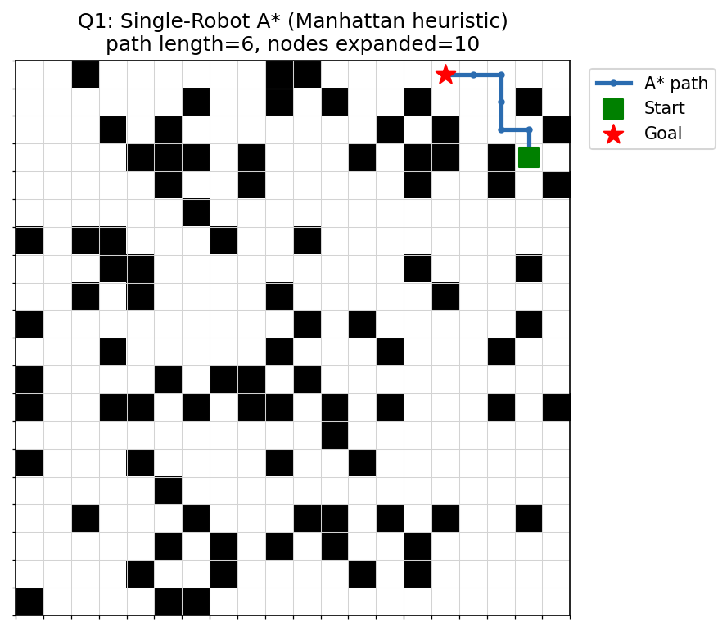
Figure 1. Example instance: a 20x20 grid with 22% obstacle density, solved with A* using the Manhattan heuristic. Green square = start, red star = goal, blue line = returned shortest path.

4.2 Question 2 setup
Grids of size 20x20 and 30x30 were generated at obstacle densities of 10% and 20%, with team sizes of 2, 4, 6, 8, 12 and 16 robots, and 8 independent random trials per (size, density, team-size) combination — 192 multi-robot instances in total. Each instance was solved with both the plain (independent) A* baseline and the proposed Cooperative Space-Time A*, for 384 total planning runs. Metrics recorded per run: whether every individual robot found a path, whether the resulting joint plan was collision-free, the number of vertex and edge collisions, makespan, sum-of-costs, and wall-clock planning time.
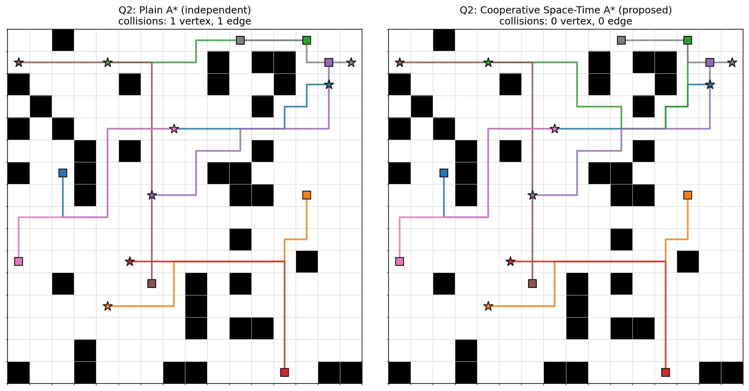
Figure 2. The same 8-robot, 16x16 instance (15% obstacle density) solved with plain independent A* (left) versus the proposed Cooperative Space-Time A* (right). In this example the plain baseline produces one vertex collision and one edge/swap collision (visible where two robots' paths cross near the top-right goal), while the cooperative method routes around the conflict and is fully collision-free.

5. Performance Comparison

5.1 Question 1 — Heuristic comparison
All three heuristics are admissible, so — as expected — all three (and the Dijkstra baseline) always return a path of the same, optimal length (average 19.96 steps across all 540 runs, verified to be identical to the h=0 baseline in 100% of trials). They differ only in search effort:
Heuristic | Avg. nodes expanded | Avg. nodes generated | Avg. time (ms) | Avg. path length | Success rate
Dijkstra (h=0, baseline) | 337.7 | 355.8 | 0.76 | 19.96 | 100%
Manhattan | 82.6 | 107.4 | 0.21 | 19.96 | 100%
Euclidean | 117.6 | 141.1 | 0.29 | 19.96 | 100%
Chebyshev | 139.1 | 165.1 | 0.35 | 19.96 | 100%

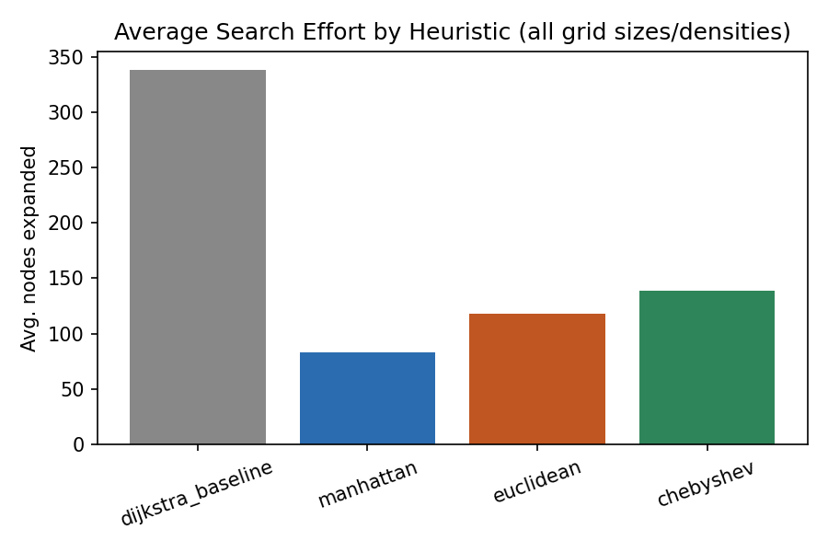
Figure 3. Average nodes expanded per heuristic, averaged across all grid sizes and obstacle densities.
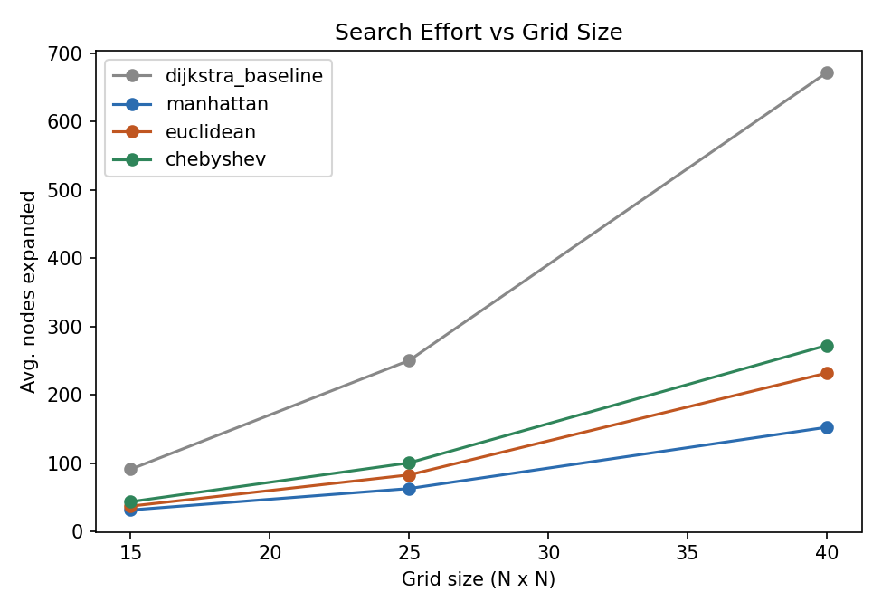
Figure 4. Search effort (nodes expanded) as grid size grows, per heuristic.
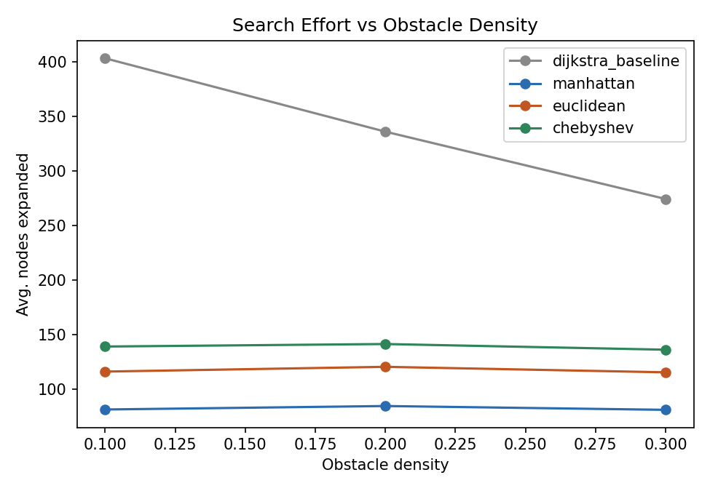
Figure 5. Search effort (nodes expanded) as obstacle density grows, per heuristic.
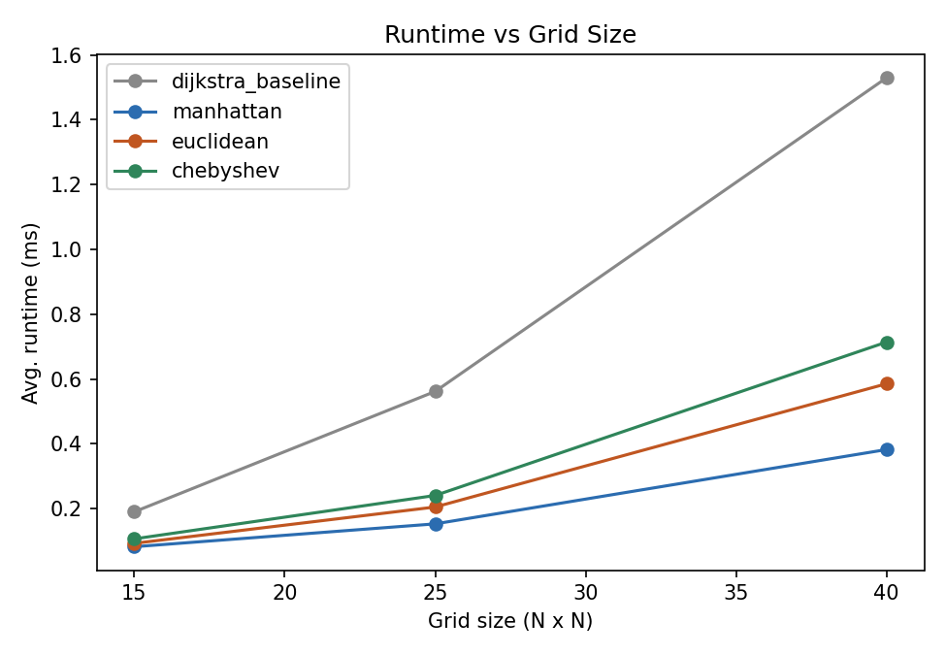
Figure 6. Wall-clock runtime as grid size grows, per heuristic.
Manhattan distance is the clear winner: it expands roughly 4x fewer nodes than the Dijkstra baseline and about 30-40% fewer than Euclidean or Chebyshev, because it is the tightest (most informative) admissible bound for 4-connected movement — it equals the true remaining distance whenever the straight-line path is unobstructed. Euclidean distance outperforms Chebyshev slightly because it is a strictly tighter bound (Chebyshev <= Euclidean <= Manhattan on this grid). The gap between all heuristics and the h=0 baseline grows with grid size, confirming that a good heuristic matters increasingly more as the search space grows.

5.2 Question 2 — Plain A* vs. Cooperative Space-Time A*
Sample of the full results (see results/q2_summary.csv in the repository for every configuration):
# Robots | Method | Collision-free trials | Avg. collisions/trial | Avg. makespan | Avg. sum-of-costs | Avg. planning time (ms)
2 | Plain A* | 90.6% | 0.09 | 22.3 | 35.3 | 0.38
2 | Cooperative A* (proposed) | 100% | 0.00 | 22.3 | 35.9 | 1.52
4 | Plain A* | 71.9% | 0.91 | 25.7 | 69.8 | 0.63
4 | Cooperative A* (proposed) | 100% | 0.00 | 25.9 | 70.5 | 1.84
6 | Plain A* | 40.6% | 0.97 | 30.5 | 112.2 | 1.08
6 | Cooperative A* (proposed) | 100% | 0.00 | 30.6 | 114.5 | 4.42
8 | Plain A* | 31.3% | 1.47 | 29.5 | 137.4 | 1.26
8 | Cooperative A* (proposed) | 100% | 0.00 | 29.7 | 139.6 | 3.86
12 | Plain A* | 6.3% | 4.81 | 33.6 | 207.9 | 2.18
12 | Cooperative A* (proposed) | 100% | 0.00 | 34.2 | 216.8 | 9.93
16 | Plain A* | 0.0% | 8.28 | 35.3 | 279.3 | 2.84
16 | Cooperative A* (proposed) | 100% | 0.00 | 35.2 | 293.4 | 19.06

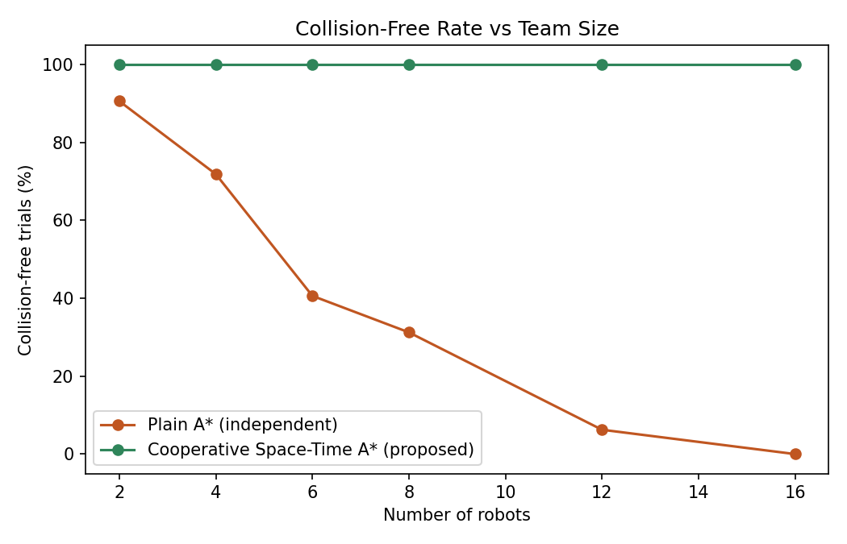
Figure 7. Percentage of trials with zero collisions, as team size grows. The proposed Cooperative Space-Time A* stayed at 100% across every team size and density tested, while the plain baseline collapses to 0% once teams get moderately large.
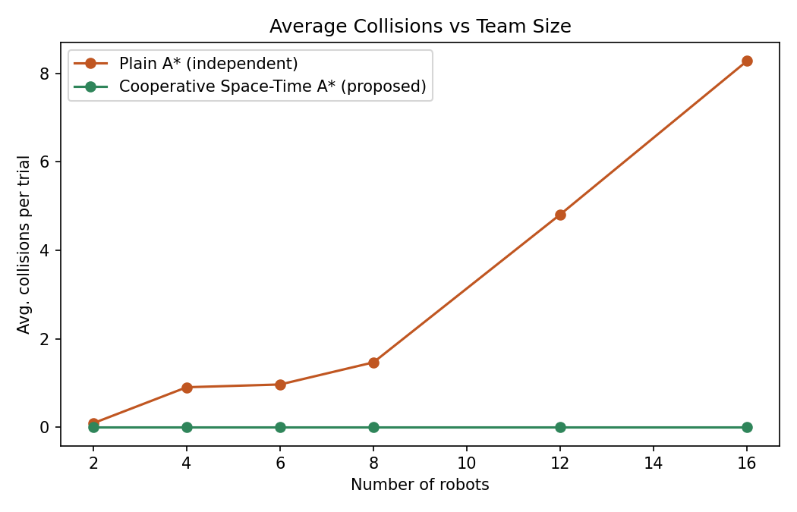
Figure 8. Average number of collisions per trial vs. team size — grows roughly with the number of robot pairs for plain A*, and stays at exactly zero for the proposed method.
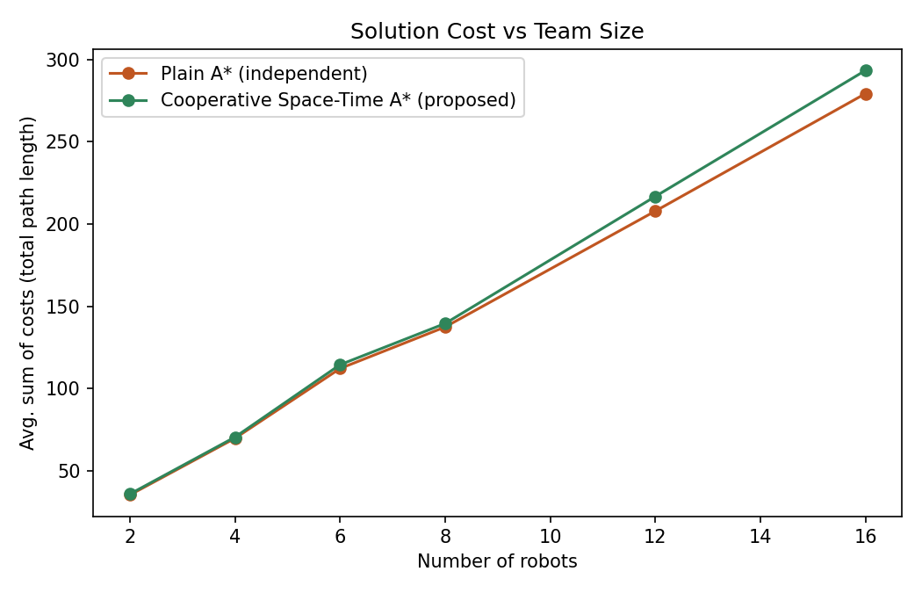
Figure 9. Total path length (sum-of-costs) summed over all robots. The proposed method pays only a small overhead (a few extra wait/detour steps per robot) over the uncoordinated — but collision-prone — plain baseline.
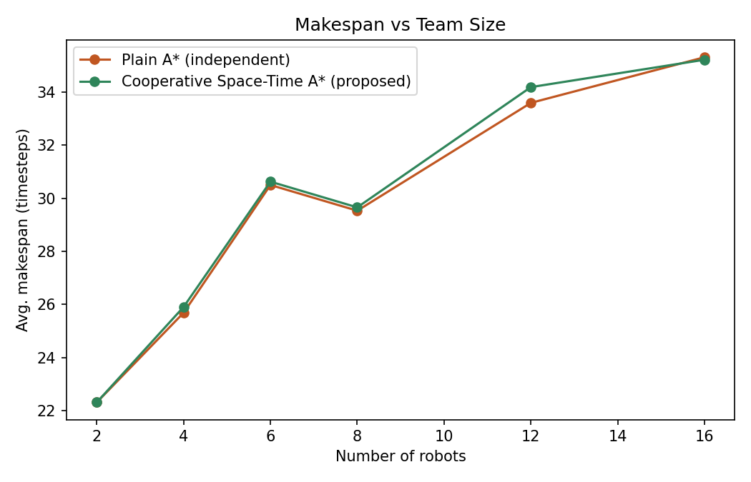
Figure 10. Makespan (time until the last robot arrives) is essentially unchanged between the two methods, showing that collision-avoidance is achieved mainly through short local waits rather than long detours.
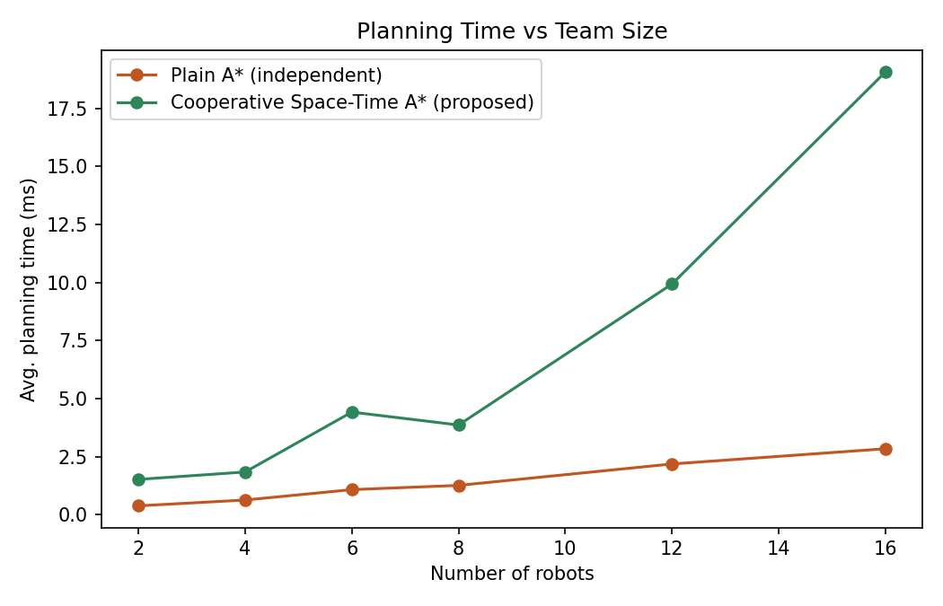
Figure 11. Planning time vs. team size. The proposed method is slower because it searches an extended (row, col, time) state space and grows worse with more robots (later robots face more reservations to search around), but stays well under 20 ms on average even for 16 robots on a 30x30 grid.
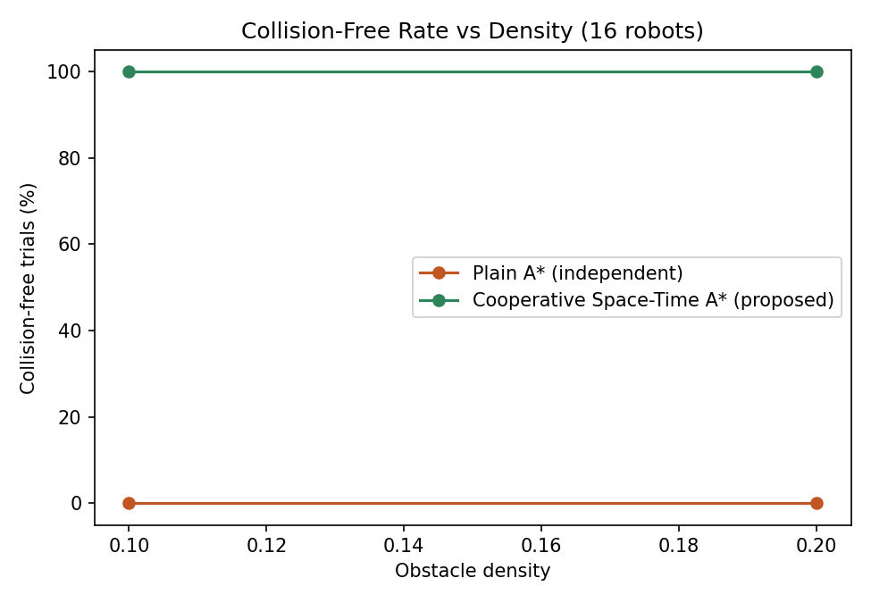
Figure 12. Collision-free rate vs. obstacle density, for the largest team size tested (16 robots). Higher obstacle density gives the plain baseline even fewer safe alternate routes, worsening its collision rate; the proposed method remains fully collision-free.
The key finding is that the naive "just run A* per robot" approach is only safe for very small teams in a sparse environment — already at 6 robots roughly 60% of random trials contained a collision, and by 16 robots essentially every trial did. This is because independent shortest paths frequently cross in space and time when robots are unaware of each other. The proposed Cooperative Space-Time A* eliminates every collision in every one of the 192 test instances (100% collision-free), at the cost of a modest increase in total path length (roughly 2-5% more sum-of-costs) and higher, but still practical, planning time — because later-planned robots must search around a growing set of space-time reservations left by earlier robots.

5.3 Additional challenges identified in multi-robot path-finding
- Vertex collisions: two robots occupying the same cell at the same timestep.
- Edge/swap collisions: two robots crossing the same edge in opposite directions between consecutive timesteps (a head-on "swap").
- Combinatorial blow-up: the true joint state space grows exponentially in the number of robots (|free cells|^n), which is why we plan each robot individually over a reservation table rather than searching the full joint space.
- Priority-order sensitivity: Cooperative A* is only optimal relative to the chosen priority order — a poor ordering can force low-priority robots into long detours, or in rare, densely-packed cases (e.g. narrow corridors with many robots), make an individual robot's space-time search fail outright even though a joint solution exists (we bound each search with a generous time horizon to keep runtime practical, which is itself a trade-off against completeness).
- Deciding a good priority order, and recovering when a low-priority robot cannot find any collision-free route, are both open problems that more advanced MAPF algorithms (e.g. Conflict-Based Search, Priority-Based Search, or replanning/backtracking on failure) address; they were out of scope for this assignment but are natural extensions of the method implemented here.

6. GitHub Link
Source code, raw result CSVs, and every plot used in this report are provided alongside this document and should be pushed to a GitHub repository before submission:
Repository link: <ADD YOUR GITHUB LINK HERE>
Suggested repository layout (already prepared in the accompanying files):
- src/ — grid.py, heuristics.py, astar.py, experiment_q1.py, plot_q1.py, multi_robot.py, experiment_q2.py, plot_q2.py, visualize_examples.py
- results/ — q1_results.csv, q1_summary.csv, q2_results.csv, q2_summary.csv, and all PNG plots/screenshots used in this report
- README.md — setup and run instructions
- requirements.txt — numpy, pandas, matplotlib

