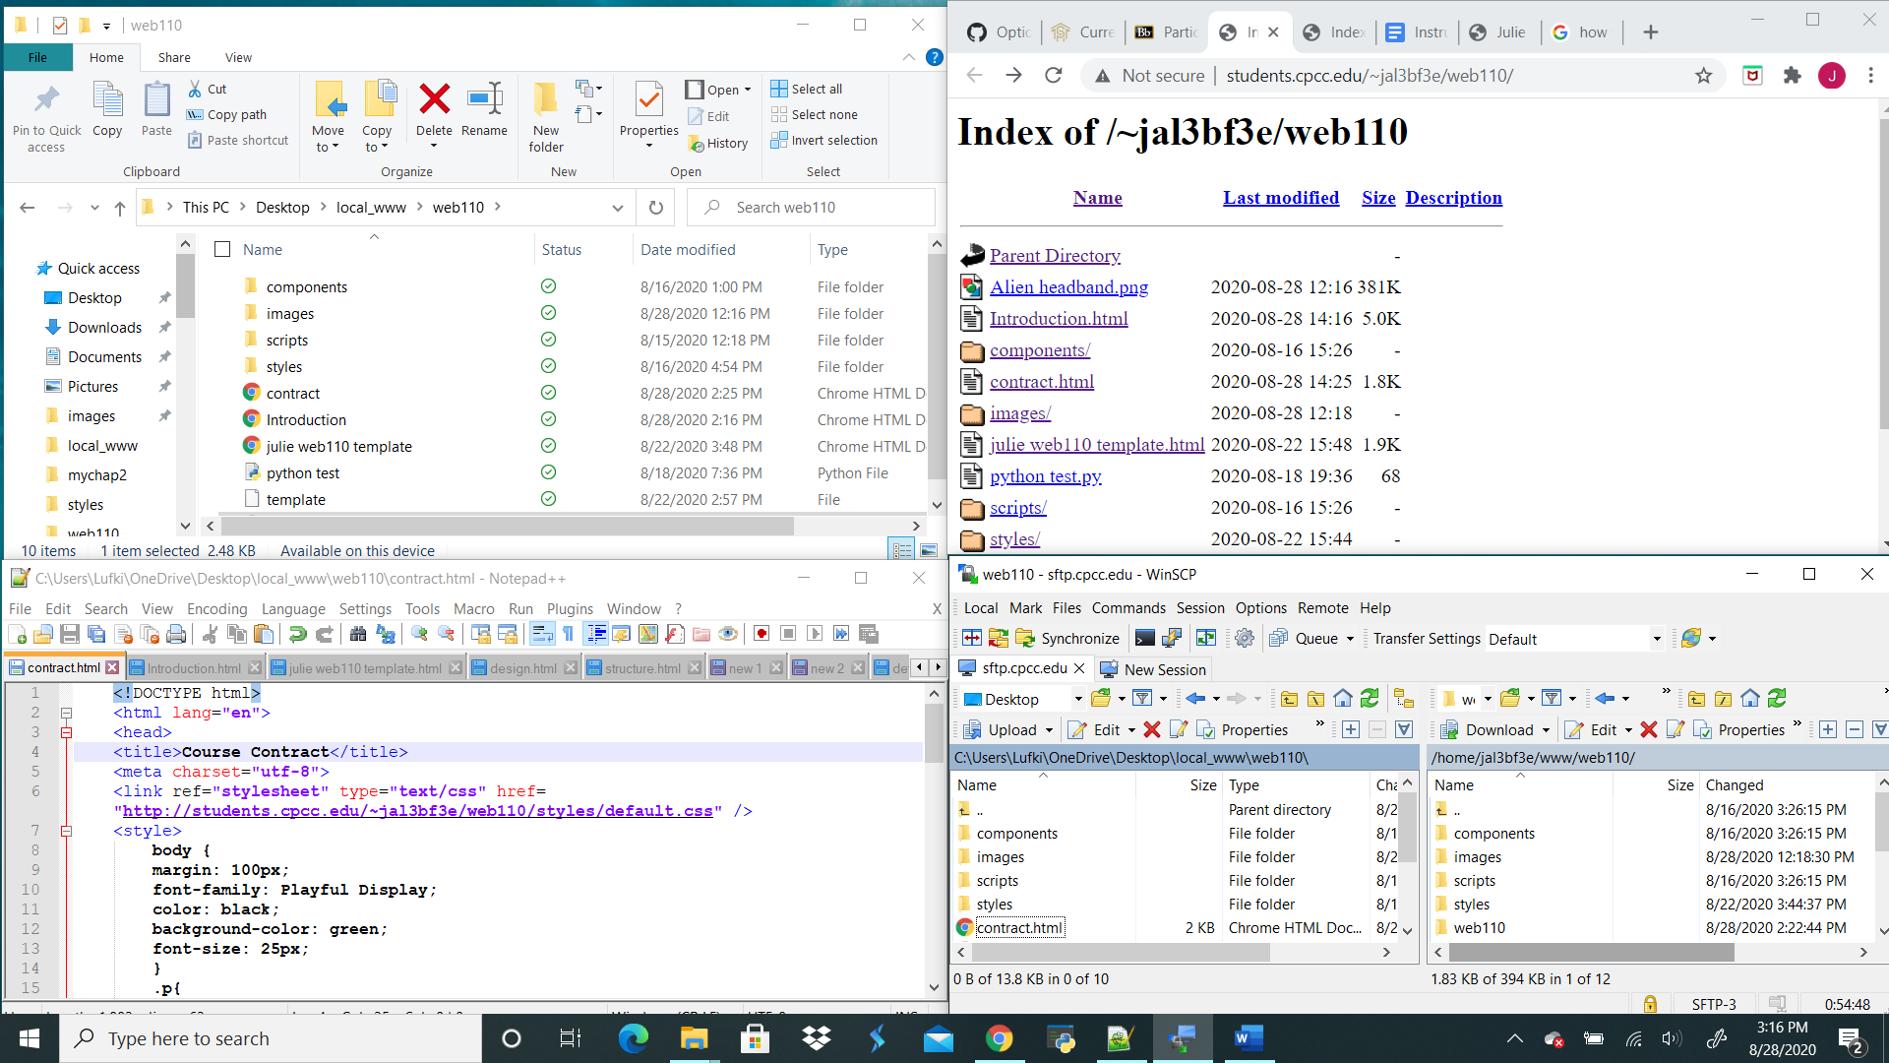

WinSCP

Notepad ++

Elocker Page

File Explorer