Лабораторная работа №1

Выполнил: Снитко Д.А. 250501

Схема

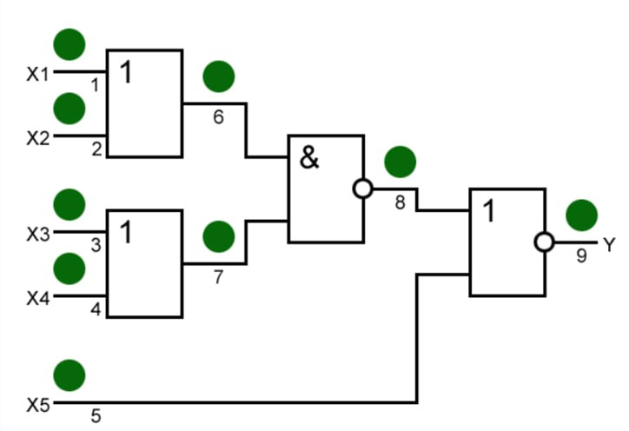

|  |  |  |  |  |  |  |  |  |  |  |  |  |  |  |  |  |  |  |  |  |  |  |  |  |  |  |
| --- | --- | --- | --- | --- | --- | --- | --- | --- | --- | --- | --- | --- | --- | --- | --- | --- | --- | --- | --- | --- | --- | --- | --- | --- | --- | --- |
|  | **X1** | **X2** | **X3** | **X4** | **X5** |  | **Y** |  | **1/0** | **1/1** | **2/0** | **2/1** | **3/0** | **3/1** | **4/0** | **4/1** | **5/0** | **5/1** | **6/0** | **6/1** | **7/0** | **7/1** | **8/0** | **8/1** | **9/0** | **9/1** |
| **0** | 0 | 0 | 0 | 0 | 0 |  | 0 |  | 0 | 0 | 0 | 0 | 0 | 0 | 0 | 0 | 0 | 0 | 0 | 0 | 0 | 0 | 1 | 0 | 0 | 1 |
| **1** | 1 | 0 | 0 | 0 | 0 |  | 0 |  | 0 | 0 | 0 | 0 | 0 | 1 | 0 | 1 | 0 | 0 | 0 | 0 | 0 | 1 | 1 | 0 | 0 | 1 |
| **2** | 0 | 1 | 0 | 0 | 0 |  | 0 |  | 0 | 0 | 0 | 0 | 0 | 1 | 0 | 1 | 0 | 0 | 0 | 0 | 0 | 1 | 1 | 0 | 0 | 1 |
| **3** | 1 | 1 | 0 | 0 | 0 |  | 0 |  | 0 | 0 | 0 | 0 | 0 | 1 | 0 | 1 | 0 | 0 | 0 | 0 | 0 | 1 | 1 | 0 | 0 | 1 |
| **4** | 0 | 0 | 1 | 0 | 0 |  | 0 |  | 0 | 1 | 0 | 1 | 0 | 0 | 0 | 0 | 0 | 0 | 0 | 1 | 0 | 0 | 1 | 0 | 0 | 1 |
| **5** | 1 | 0 | 1 | 0 | 0 |  | 1 |  | 0 | 1 | 1 | 1 | 0 | 1 | 1 | 1 | 1 | 0 | 0 | 1 | 0 | 1 | 1 | 0 | 0 | 1 |
| **6** | 0 | 1 | 1 | 0 | 0 |  | 1 |  | 1 | 1 | 0 | 1 | 0 | 1 | 1 | 1 | 1 | 0 | 0 | 1 | 0 | 1 | 1 | 0 | 0 | 1 |
| **7** | 1 | 1 | 1 | 0 | 0 |  | 1 |  | 1 | 1 | 1 | 1 | 0 | 1 | 1 | 1 | 1 | 0 | 0 | 1 | 0 | 1 | 1 | 0 | 0 | 1 |
|  |  |  |  |  |  |  |  |  |  |  |  |  |  |  |  |  |  |  |  |  |  |  |  |  |  |  |
| **8** | 0 | 0 | 0 | 1 | 0 |  | 0 |  | 0 | 1 | 0 | 1 | 0 | 0 | 0 | 0 | 0 | 0 | 0 | 1 | 0 | 0 | 1 | 0 | 0 | 1 |
| **9** | 1 | 0 | 0 | 1 | 0 |  | 1 |  | 0 | 1 | 1 | 1 | 1 | 1 | 0 | 1 | 1 | 0 | 0 | 1 | 0 | 1 | 1 | 0 | 0 | 1 |
| **10** | 0 | 1 | 0 | 1 | 0 |  | 1 |  | 1 | 1 | 0 | 1 | 1 | 1 | 0 | 1 | 1 | 0 | 0 | 1 | 0 | 1 | 1 | 0 | 0 | 1 |
| **11** | 1 | 1 | 0 | 1 | 0 |  | 1 |  | 1 | 1 | 1 | 1 | 1 | 1 | 0 | 1 | 1 | 0 | 0 | 1 | 0 | 1 | 1 | 0 | 0 | 1 |
| **12** | 0 | 0 | 1 | 1 | 0 |  | 0 |  | 0 | 1 | 0 | 1 | 0 | 0 | 0 | 0 | 0 | 0 | 0 | 1 | 0 | 0 | 1 | 0 | 0 | 1 |
| **13** | 1 | 0 | 1 | 1 | 0 |  | 1 |  | 0 | 1 | 1 | 1 | 1 | 1 | 1 | 1 | 1 | 0 | 0 | 1 | 0 | 1 | 1 | 0 | 0 | 1 |
| **14** | 0 | 1 | 1 | 1 | 0 |  | 1 |  | 1 | 1 | 0 | 1 | 1 | 1 | 1 | 1 | 1 | 0 | 0 | 1 | 0 | 1 | 1 | 0 | 0 | 1 |
| **15** | 1 | 1 | 1 | 1 | 0 |  | 1 |  | 1 | 1 | 1 | 1 | 1 | 1 | 1 | 1 | 1 | 0 | 0 | 1 | 0 | 1 | 1 | 0 | 0 | 1 |
|  |  |  |  |  |  |  |  |  |  |  |  |  |  |  |  |  |  |  |  |  |  |  |  |  |  |  |
| **16** | 0 | 0 | 0 | 0 | 1 |  | 0 |  | 0 | 0 | 0 | 0 | 0 | 0 | 0 | 0 | 0 | 0 | 0 | 0 | 0 | 0 | 0 | 0 | 0 | 1 |
| **17** | 1 | 0 | 0 | 0 | 1 |  | 0 |  | 0 | 0 | 0 | 0 | 0 | 0 | 0 | 0 | 0 | 0 | 0 | 0 | 0 | 0 | 0 | 0 | 0 | 1 |
| **18** | 0 | 1 | 0 | 0 | 1 |  | 0 |  | 0 | 0 | 0 | 0 | 0 | 0 | 0 | 0 | 0 | 0 | 0 | 0 | 0 | 0 | 0 | 0 | 0 | 1 |
| **19** | 1 | 1 | 0 | 0 | 1 |  | 0 |  | 0 | 0 | 0 | 0 | 0 | 0 | 0 | 0 | 0 | 0 | 0 | 0 | 0 | 0 | 0 | 0 | 0 | 1 |
| **20** | 0 | 0 | 1 | 0 | 1 |  | 0 |  | 0 | 0 | 0 | 0 | 0 | 0 | 0 | 0 | 0 | 0 | 0 | 0 | 0 | 0 | 0 | 0 | 0 | 1 |
| **21** | 1 | 0 | 1 | 0 | 1 |  | 0 |  | 0 | 0 | 0 | 0 | 0 | 0 | 0 | 0 | 1 | 0 | 0 | 0 | 0 | 0 | 0 | 0 | 0 | 1 |
| **22** | 0 | 1 | 1 | 0 | 1 |  | 0 |  | 0 | 0 | 0 | 0 | 0 | 0 | 0 | 0 | 1 | 0 | 0 | 0 | 0 | 0 | 0 | 0 | 0 | 1 |
| **23** | 1 | 1 | 1 | 0 | 1 |  | 0 |  | 0 | 0 | 0 | 0 | 0 | 0 | 0 | 0 | 1 | 0 | 0 | 0 | 0 | 0 | 0 | 0 | 0 | 1 |
|  |  |  |  |  |  |  |  |  |  |  |  |  |  |  |  |  |  |  |  |  |  |  |  |  |  |  |
| **24** | 0 | 0 | 0 | 1 | 1 |  | 0 |  | 0 | 0 | 0 | 0 | 0 | 0 | 0 | 0 | 0 | 0 | 0 | 0 | 0 | 0 | 0 | 0 | 0 | 1 |
| **25** | 1 | 0 | 0 | 1 | 1 |  | 0 |  | 0 | 0 | 0 | 0 | 0 | 0 | 0 | 0 | 1 | 0 | 0 | 0 | 0 | 0 | 0 | 0 | 0 | 1 |
| **26** | 0 | 1 | 0 | 1 | 1 |  | 0 |  | 0 | 0 | 0 | 0 | 0 | 0 | 0 | 0 | 1 | 0 | 0 | 0 | 0 | 0 | 0 | 0 | 0 | 1 |
| **27** | 1 | 1 | 0 | 1 | 1 |  | 0 |  | 0 | 0 | 0 | 0 | 0 | 0 | 0 | 0 | 1 | 0 | 0 | 0 | 0 | 0 | 0 | 0 | 0 | 1 |
| **28** | 0 | 0 | 1 | 1 | 1 |  | 0 |  | 0 | 0 | 0 | 0 | 0 | 0 | 0 | 0 | 0 | 0 | 0 | 0 | 0 | 0 | 0 | 0 | 0 | 1 |
| **29** | 1 | 0 | 1 | 1 | 1 |  | 0 |  | 0 | 0 | 0 | 0 | 0 | 0 | 0 | 0 | 1 | 0 | 0 | 0 | 0 | 0 | 0 | 0 | 0 | 1 |
| **30** | 0 | 1 | 1 | 1 | 1 |  | 0 |  | 0 | 0 | 0 | 0 | 0 | 0 | 0 | 0 | 1 | 0 | 0 | 0 | 0 | 0 | 0 | 0 | 0 | 1 |
| **31** | 1 | 1 | 1 | 1 | 1 |  | 0 |  | 0 | 0 | 0 | 0 | 0 | 0 | 0 | 0 | 1 | 0 | 0 | 0 | 0 | 0 | 0 | 0 | 0 | 1 |

Анализируя схему, можно увидеть, что все неисправности покрывают следующие наборы:

1) 10000

4) 00100

6) 01100

9) 10010

21) 10101

График покрытия:

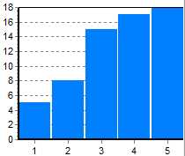

Метод активизации путей:

|  |  |  |  |  |  |
| --- | --- | --- | --- | --- | --- |
|  | X1 | X2 | X3 | X4 | X5 |
| 1/0 | 1 | 0 | 1 | 0 | 0 |
| 1/1 | 0 | 0 | 1 | 0 | 0 |
| 2/0 | 0 | 1 | 0 | 1 | 0 |
| 2/1 | 0 | 0 | 1 | 0 | 0 |
| 3/0 | 1 | 0 | 1 | 0 | 0 |
| 3/1 | 1 | 0 | 0 | 0 | 0 |
| 4/0 | 0 | 1 | 0 | 1 | 0 |
| 4/1 | 1 | 0 | 0 | 0 | 0 |
| 5/0 | 1 | 0 | 1 | 0 | 1 |
| 5/1 | 1 | 0 | 1 | 0 | 0 |

Исходя из таблицы берем наборы: 10100, 00100, 01010, 10000, 10101.

График покрытия:

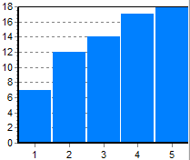

Реконвергентная схема:

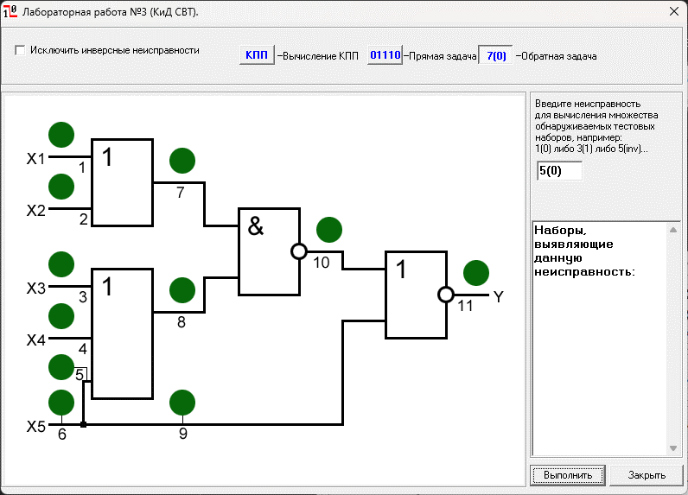

Неисправность 5/0 ни одним набором не выявлена.