250501 Снитко Д.А.

Поиск примитивных полиномов

|  |  |  |  |  |  |
| --- | --- | --- | --- | --- | --- |
| D1 | D2 | D3 | D4 | D5 | Примитивный полином |
| 1 | 0 | 1 | 1 | 1 | x5 ⊕ x4 ⊕ x3 ⊕ x2 ⊕ 1 |
| 1 | 1 | 0 | 1 | 1 | x5 ⊕ x4 ⊕ x3 ⊕ x1 ⊕ 1 |
| 1 | 1 | 1 | 0 | 1 | x5 ⊕ x4 ⊕ x2 ⊕ x1 ⊕ 1 |
| 1 | 1 | 1 | 1 | 0 | **x5 ⊕ x3 ⊕ x2 ⊕ x1 ⊕ 1** |
| 1 | 0 | 0 | 1 | 0 | x5 ⊕ x3 ⊕ 1 |
| 1 | 0 | 1 | 0 | 0 | x5 ⊕ x2 ⊕ 1 |

Аналитическое деление полинома:

Анализируемая последовательность: 1101 1001 1110 0010.

Выбранный примитивный полином полином:

$$g\left(x\right)=x^{5}⊕x^{3}⊕x^{2}⊕x^{1}⊕1$$

Деление полинома:

|  |  |  |  |  |  |  |  |  |  |  |  |  |  |  |  |  |  |  |  |  |  |  |  |  |  |  |
| --- | --- | --- | --- | --- | --- | --- | --- | --- | --- | --- | --- | --- | --- | --- | --- | --- | --- | --- | --- | --- | --- | --- | --- | --- | --- | --- |
| 1 | 1 | 0 | 1 | 1 | 0 | 0 | 1 | 1 | 1 | 1 | 0 | 0 | 0 | 1 | 0 | 1 | 0 | 1 | 1 | 1 | 1 |  |  |  |  |  |
| 1 | 0 | 1 | 1 | 1 | 1 |  |  |  |  |  |  |  |  |  |  | 1 | 1 | 1 | 1 | 0 | 0 | 1 | 1 | 1 | 1 |  |
| 0 | 1 | 1 | 0 | 0 | 1 | 0 |  |  |  |  |  |  |  |  |  |  |  |  |  |  |  |  |  |  |  |  |
|  | 1 | 0 | 1 | 1 | 1 | 1 |  |  |  |  |  |  |  |  |  |  |  |  |  |  |  |  |  |  |  |  |
|  | 0 | 1 | 1 | 1 | 0 | 1 | 1 |  |  |  |  |  |  |  |  |  |  |  |  |  |  |  |  |  |  |  |
|  |  | 1 | 0 | 1 | 1 | 1 | 1 |  |  |  |  |  |  |  |  |  |  |  |  |  |  |  |  |  |  |  |
|  |  | 0 | 1 | 0 | 1 | 0 | 0 | 1 |  |  |  |  |  |  |  |  |  |  |  |  |  |  |  |  |  |  |
|  |  |  | 1 | 0 | 1 | 1 | 1 | 1 |  |  |  |  |  |  |  |  |  |  |  |  |  |  |  |  |  |  |
|  |  |  | 0 | 0 | 0 | 1 | 1 | 0 | 1 | 1 | 0 |  |  |  |  |  |  |  |  |  |  |  |  |  |  |  |
|  |  |  |  |  |  | 1 | 0 | 1 | 1 | 1 | 1 |  |  |  |  |  |  |  |  |  |  |  |  |  |  |  |
|  |  |  |  |  |  | 0 | 1 | 1 | 0 | 0 | 1 | 0 |  |  |  |  |  |  |  |  |  |  |  |  |  |  |
|  |  |  |  |  |  |  | 1 | 0 | 1 | 1 | 1 | 1 |  |  |  |  |  |  |  |  |  |  |  |  |  |  |
|  |  |  |  |  |  |  | 0 | 1 | 1 | 1 | 0 | 1 | 0 |  |  |  |  |  |  |  |  |  |  |  |  |  |
|  |  |  |  |  |  |  |  | 1 | 0 | 1 | 1 | 1 | 1 |  |  |  |  |  |  |  |  |  |  |  |  |  |
|  |  |  |  |  |  |  |  | 0 | 1 | 0 | 1 | 0 | 1 | 1 |  |  |  |  |  |  |  |  |  |  |  |  |
|  |  |  |  |  |  |  |  |  | 1 | 0 | 1 | 1 | 1 | 1 |  |  |  |  |  |  |  |  |  |  |  |  |
|  |  |  |  |  |  |  |  |  |  |  | 0 | 1 | 0 | 0 | 0 |  |  |  |  |  |  |  |  |  |  |  |
|  |  |  |  |  |  |  |  |  |  |  |  |  |  |  |  |  |  |  |  |  |  |  |  |  |  |  |

Остаток от деления: 01000.

Проверка результата деления с помощью учебной системы моделирования.

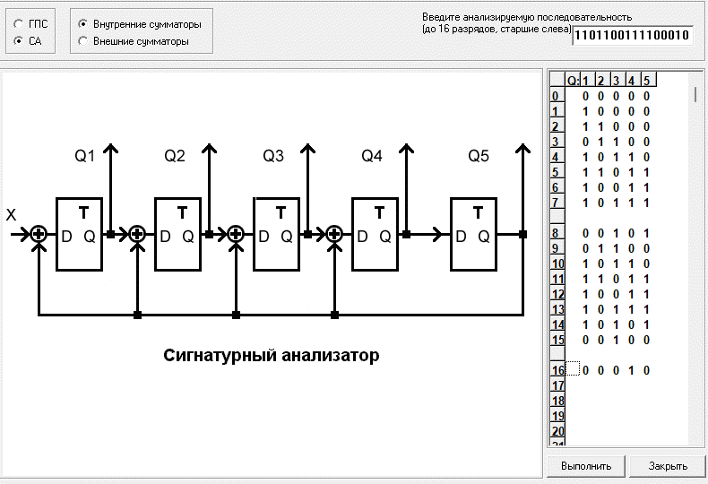

Видно, что 16-ая итерация имеет зеркальное остатку значение, что подтверждает правильность проведенных вычислений.

Делимое 1101 1001 1110 0010 не изменяет остаток-сигнатуру.

Анализ сигнатур

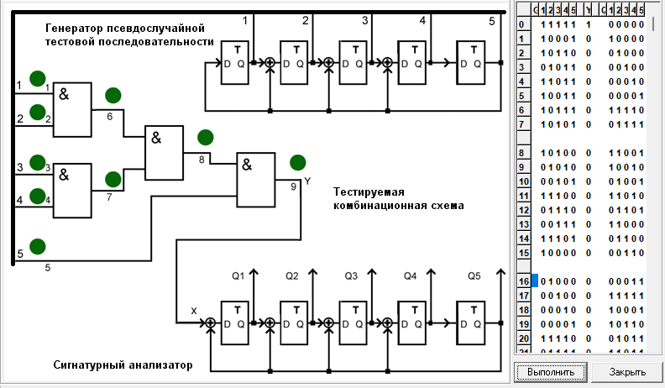

График зависимости полноты обнаружения одиночных константных неисправностей в полюсах 1,2,3,4,5 в зависимости от длины теста.