Лабораторная работа №1
Выполнил: Снитко Д.А. 250501
Схема

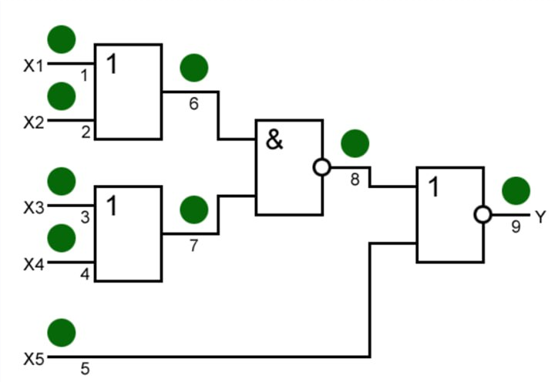

 | X1 | X2 | X3 | X4 | X5 |  | Y |  | 1/0 | 1/1 | 2/0 | 2/1 | 3/0 | 3/1 | 4/0 | 4/1 | 5/0 | 5/1 | 6/0 | 6/1 | 7/0 | 7/1 | 8/0 | 8/1 | 9/0 | 9/1
0 | 0 | 0 | 0 | 0 | 0 |  | 0 |  | 0 | 0 | 0 | 0 | 0 | 0 | 0 | 0 | 0 | 0 | 0 | 0 | 0 | 0 | 1 | 0 | 0 | 1
1 | 1 | 0 | 0 | 0 | 0 |  | 0 |  | 0 | 0 | 0 | 0 | 0 | 1 | 0 | 1 | 0 | 0 | 0 | 0 | 0 | 1 | 1 | 0 | 0 | 1
2 | 0 | 1 | 0 | 0 | 0 |  | 0 |  | 0 | 0 | 0 | 0 | 0 | 1 | 0 | 1 | 0 | 0 | 0 | 0 | 0 | 1 | 1 | 0 | 0 | 1
3 | 1 | 1 | 0 | 0 | 0 |  | 0 |  | 0 | 0 | 0 | 0 | 0 | 1 | 0 | 1 | 0 | 0 | 0 | 0 | 0 | 1 | 1 | 0 | 0 | 1
4 | 0 | 0 | 1 | 0 | 0 |  | 0 |  | 0 | 1 | 0 | 1 | 0 | 0 | 0 | 0 | 0 | 0 | 0 | 1 | 0 | 0 | 1 | 0 | 0 | 1
5 | 1 | 0 | 1 | 0 | 0 |  | 1 |  | 0 | 1 | 1 | 1 | 0 | 1 | 1 | 1 | 1 | 0 | 0 | 1 | 0 | 1 | 1 | 0 | 0 | 1
6 | 0 | 1 | 1 | 0 | 0 |  | 1 |  | 1 | 1 | 0 | 1 | 0 | 1 | 1 | 1 | 1 | 0 | 0 | 1 | 0 | 1 | 1 | 0 | 0 | 1
7 | 1 | 1 | 1 | 0 | 0 |  | 1 |  | 1 | 1 | 1 | 1 | 0 | 1 | 1 | 1 | 1 | 0 | 0 | 1 | 0 | 1 | 1 | 0 | 0 | 1
8 | 0 | 0 | 0 | 1 | 0 |  | 0 |  | 0 | 1 | 0 | 1 | 0 | 0 | 0 | 0 | 0 | 0 | 0 | 1 | 0 | 0 | 1 | 0 | 0 | 1
9 | 1 | 0 | 0 | 1 | 0 |  | 1 |  | 0 | 1 | 1 | 1 | 1 | 1 | 0 | 1 | 1 | 0 | 0 | 1 | 0 | 1 | 1 | 0 | 0 | 1
10 | 0 | 1 | 0 | 1 | 0 |  | 1 |  | 1 | 1 | 0 | 1 | 1 | 1 | 0 | 1 | 1 | 0 | 0 | 1 | 0 | 1 | 1 | 0 | 0 | 1
11 | 1 | 1 | 0 | 1 | 0 |  | 1 |  | 1 | 1 | 1 | 1 | 1 | 1 | 0 | 1 | 1 | 0 | 0 | 1 | 0 | 1 | 1 | 0 | 0 | 1
12 | 0 | 0 | 1 | 1 | 0 |  | 0 |  | 0 | 1 | 0 | 1 | 0 | 0 | 0 | 0 | 0 | 0 | 0 | 1 | 0 | 0 | 1 | 0 | 0 | 1
13 | 1 | 0 | 1 | 1 | 0 |  | 1 |  | 0 | 1 | 1 | 1 | 1 | 1 | 1 | 1 | 1 | 0 | 0 | 1 | 0 | 1 | 1 | 0 | 0 | 1
14 | 0 | 1 | 1 | 1 | 0 |  | 1 |  | 1 | 1 | 0 | 1 | 1 | 1 | 1 | 1 | 1 | 0 | 0 | 1 | 0 | 1 | 1 | 0 | 0 | 1
15 | 1 | 1 | 1 | 1 | 0 |  | 1 |  | 1 | 1 | 1 | 1 | 1 | 1 | 1 | 1 | 1 | 0 | 0 | 1 | 0 | 1 | 1 | 0 | 0 | 1
16 | 0 | 0 | 0 | 0 | 1 |  | 0 |  | 0 | 0 | 0 | 0 | 0 | 0 | 0 | 0 | 0 | 0 | 0 | 0 | 0 | 0 | 0 | 0 | 0 | 1
17 | 1 | 0 | 0 | 0 | 1 |  | 0 |  | 0 | 0 | 0 | 0 | 0 | 0 | 0 | 0 | 0 | 0 | 0 | 0 | 0 | 0 | 0 | 0 | 0 | 1
18 | 0 | 1 | 0 | 0 | 1 |  | 0 |  | 0 | 0 | 0 | 0 | 0 | 0 | 0 | 0 | 0 | 0 | 0 | 0 | 0 | 0 | 0 | 0 | 0 | 1
19 | 1 | 1 | 0 | 0 | 1 |  | 0 |  | 0 | 0 | 0 | 0 | 0 | 0 | 0 | 0 | 0 | 0 | 0 | 0 | 0 | 0 | 0 | 0 | 0 | 1
20 | 0 | 0 | 1 | 0 | 1 |  | 0 |  | 0 | 0 | 0 | 0 | 0 | 0 | 0 | 0 | 0 | 0 | 0 | 0 | 0 | 0 | 0 | 0 | 0 | 1
21 | 1 | 0 | 1 | 0 | 1 |  | 0 |  | 0 | 0 | 0 | 0 | 0 | 0 | 0 | 0 | 1 | 0 | 0 | 0 | 0 | 0 | 0 | 0 | 0 | 1
22 | 0 | 1 | 1 | 0 | 1 |  | 0 |  | 0 | 0 | 0 | 0 | 0 | 0 | 0 | 0 | 1 | 0 | 0 | 0 | 0 | 0 | 0 | 0 | 0 | 1
23 | 1 | 1 | 1 | 0 | 1 |  | 0 |  | 0 | 0 | 0 | 0 | 0 | 0 | 0 | 0 | 1 | 0 | 0 | 0 | 0 | 0 | 0 | 0 | 0 | 1
24 | 0 | 0 | 0 | 1 | 1 |  | 0 |  | 0 | 0 | 0 | 0 | 0 | 0 | 0 | 0 | 0 | 0 | 0 | 0 | 0 | 0 | 0 | 0 | 0 | 1
25 | 1 | 0 | 0 | 1 | 1 |  | 0 |  | 0 | 0 | 0 | 0 | 0 | 0 | 0 | 0 | 1 | 0 | 0 | 0 | 0 | 0 | 0 | 0 | 0 | 1
26 | 0 | 1 | 0 | 1 | 1 |  | 0 |  | 0 | 0 | 0 | 0 | 0 | 0 | 0 | 0 | 1 | 0 | 0 | 0 | 0 | 0 | 0 | 0 | 0 | 1
27 | 1 | 1 | 0 | 1 | 1 |  | 0 |  | 0 | 0 | 0 | 0 | 0 | 0 | 0 | 0 | 1 | 0 | 0 | 0 | 0 | 0 | 0 | 0 | 0 | 1
28 | 0 | 0 | 1 | 1 | 1 |  | 0 |  | 0 | 0 | 0 | 0 | 0 | 0 | 0 | 0 | 0 | 0 | 0 | 0 | 0 | 0 | 0 | 0 | 0 | 1
29 | 1 | 0 | 1 | 1 | 1 |  | 0 |  | 0 | 0 | 0 | 0 | 0 | 0 | 0 | 0 | 1 | 0 | 0 | 0 | 0 | 0 | 0 | 0 | 0 | 1
30 | 0 | 1 | 1 | 1 | 1 |  | 0 |  | 0 | 0 | 0 | 0 | 0 | 0 | 0 | 0 | 1 | 0 | 0 | 0 | 0 | 0 | 0 | 0 | 0 | 1
31 | 1 | 1 | 1 | 1 | 1 |  | 0 |  | 0 | 0 | 0 | 0 | 0 | 0 | 0 | 0 | 1 | 0 | 0 | 0 | 0 | 0 | 0 | 0 | 0 | 1

Анализируя схему, можно увидеть, что все неисправности покрывают следующие наборы:
1) 10000
4) 00100
6) 01100
9) 10010
21) 10101
График покрытия:

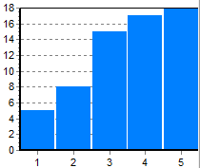

Метод активизации путей:

 | X1 | X2 | X3 | X4 | X5
1/0 | 1 | 0 | 1 | 0 | 0
1/1 | 0 | 0 | 1 | 0 | 0
2/0 | 0 | 1 | 0 | 1 | 0
2/1 | 0 | 0 | 1 | 0 | 0
3/0 | 1 | 0 | 1 | 0 | 0
3/1 | 1 | 0 | 0 | 0 | 0
4/0 | 0 | 1 | 0 | 1 | 0
4/1 | 1 | 0 | 0 | 0 | 0
5/0 | 1 | 0 | 1 | 0 | 1
5/1 | 1 | 0 | 1 | 0 | 0

Исходя из таблицы берем наборы: 10100, 00100, 01010, 10000, 10101.
График покрытия:

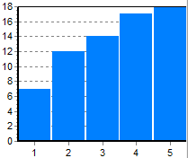

Реконвергентная схема:

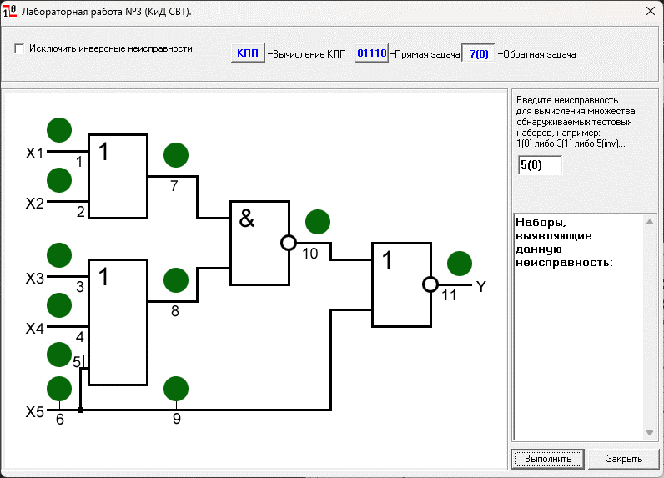
Неисправность 5/0 ни одним набором не выявлена.

