Поиск примитивных полиномов

Таблица 2.1 – Примитивные полиномы

D₁ | D₂ | D₃ | D₄ | D₅ | Итерации | Примитивный полином
1 | 1 | 1 | 1 | 1 | 6
1 | 0 | 1 | 1 | 1 | 31 | x⁵ ⊕ x⁴ ⊕ x³ ⊕ x² ⊕ 1
1 | 1 | 0 | 1 | 1 | 31 | x⁵ ⊕ x⁴ ⊕ x³ ⊕ x¹ ⊕ 1
1 | 0 | 0 | 1 | 1 | 14
1 | 1 | 1 | 0 | 1 | 31 | x⁵ ⊕ x⁴ ⊕ x² ⊕ x¹ ⊕ 1
1 | 0 | 1 | 0 | 1 | 15
1 | 1 | 0 | 0 | 1 | 8
1 | 0 | 0 | 0 | 1 | 21
1 | 1 | 1 | 1 | 0 | 31 | x⁵ ⊕ x³ ⊕ x² ⊕ x¹ ⊕ 1
1 | 0 | 1 | 1 | 0 | 12
1 | 1 | 0 | 1 | 0 | 15
1 | 0 | 0 | 1 | 0 | 31 | x⁵ ⊕ x³ ⊕ 1
1 | 1 | 1 | 0 | 0 | 14
1 | 0 | 1 | 0 | 0 | 31 | x⁵ ⊕ x² ⊕ 1
1 | 1 | 0 | 0 | 0 | 21
1 | 0 | 0 | 0 | 0 | 1

Аналитическое деление полинома:

Анализируемая последовательность: 1111 1011 1011 1100.
Выбранный примитивный полином полином:

$$g\left(x\right)=x^{5}⊕x^{4}⊕x^{3}⊕x^{2}⊕1$$

Деление полинома:

1 | 1 | 1 | 1 | 1 | 0 | 1 | 1 | 1 | 0 | 1 | 1 | 1 | 1 | 0 | 0 | 1 | 1 | 1 | 1 | 0 | 1
1 | 1 | 1 | 1 | 0 | 1 |  |  |  |  |  |  |  |  |  |  | 1 | 0 | 0 | 0 | 1 | 0 | 0 | 0 | 0 | 0
0 | 0 | 0 | 0 | 1 | 1 | 1 | 1 | 1 | 0
 |  |  |  | 1 | 1 | 1 | 1 | 0 | 1
 |  |  |  |  |  |  |  | 1 | 1 | 1 | 1 | 1 | 1
 |  |  |  |  |  |  |  | 1 | 1 | 1 | 1 | 0 | 1
 |  |  |  |  |  |  |  |  |  |  |  | 1 | 0 | 0 | 0

Остаток от деления: 01000.

Проверка результата деления с помощью учебной системы моделирования.

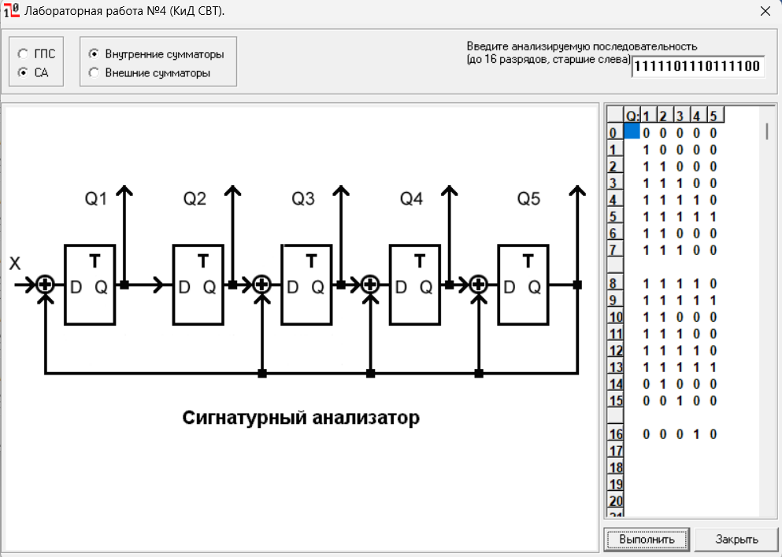

Видно, что 16-ая итерация имеет зеркальное остатку значение, что подтверждает правильность проведенных выше вычислений.

Для полинома
$$g\left(x\right)=x^{5}⊕x^{4}⊕x^{3}⊕x^{2}⊕1$$
составим обратный полином
$$g^{-1}\left(x\right)={x^{5}(x}^{-5}⊕x^{-4}⊕x^{-3}⊕x^{-2}⊕1)$$
$$g^{-1}(x)=1 ⊕x^{1}⊕x^{2}⊕x^{3}⊕x^{5}$$
S’(x) = 01100
S’(x):
0
0
1
1
0

Матрица:

1 | 0 | 0 | 0 | 0
1 | 1 | 0 | 0 | 0
1 | 1 | 1 | 0 | 0
1 | 1 | 1 | 1 | 0
0 | 1 | 1 | 1 | 1

Найдем S(x) =
1*0 | + | 0*0 | + | 0*1 | + | 0*1 | + | 0*0
1*0 | + | 1*0 | + | 0*1 | + | 0*1 | + | 0*0
1*0 | + | 1*0 | + | 1*1 | + | 0*1 | + | 0*0
1*0 | + | 1*0 | + | 1*1 | + | 1*1 | + | 0*0
0*0 | + | 1*0 | + | 1*1 | + | 1*1 | + | 1*0

S(x) =
0
1
0
0
0

S(x) = 01000

Проанализировав полученные результаты видно, что обе полученные сигнатуры совпадают, значит вычисления были проведены правильно.

Анализ сигнатур

Схема в собранном виде:

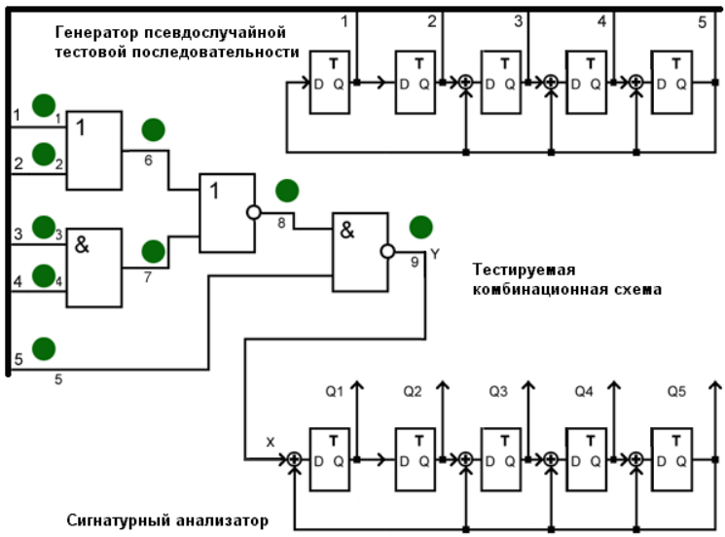

Карта эталонных сигнатур в полюсах 6, 7, 8 и 9
№ | ПСП |  |  |  |  | ЭС |  |  |  |  |  | 6_{/0} |  |  |  |  |  | 6_{/1} |  |  |  |  |  | 7_{/0} |  |  |  |  |  | 7_{/1} |  |  |  |  |  | 8_{/0} |  |  |  |  |  | 8_{/1} |  |  |  |  |  | 9_{/0} |  |  |  |  |  | 9_{/1}
 | Q₁ | Q₂ | Q₃ | Q₄ | Q₅ | Y | Q₁ | Q₂ | Q₃ | Q₄ | Q₅ | Y | Q₁ | Q₂ | Q₃ | Q₄ | Q₅ | Y | Q₁ | Q₂ | Q₃ | Q₄ | Q₅ | Y | Q₁ | Q₂ | Q₃ | Q₄ | Q₅ | Y | Q₁ | Q₂ | Q₃ | Q₄ | Q₅ | Y | Q₁ | Q₂ | Q₃ | Q₄ | Q₅ | Y | Q₁ | Q₂ | Q₃ | Q₄ | Q₅ | Y | Q₁ | Q₂ | Q₃ | Q₄ | Q₅ | Y | Q₁ | Q₂ | Q₃ | Q₄ | Q₅
0 | 1 | 1 | 1 | 1 | 1 | 1 | 0 | 0 | 0 | 0 | 0 | 1 | 0 | 0 | 0 | 0 | 0 | 1 | 0 | 0 | 0 | 0 | 0 | 1 | 0 | 0 | 0 | 0 | 0 | 1 | 0 | 0 | 0 | 0 | 0 | 1 | 0 | 0 | 0 | 0 | 0 | 0 | 0 | 0 | 0 | 0 | 0 | 0 | 0 | 0 | 0 | 0 | 0 | 1 | 0 | 0 | 0 | 0 | 0
1 | 1 | 1 | 0 | 0 | 0 | 1 | 1 | 0 | 0 | 0 | 0 | 1 | 1 | 0 | 0 | 0 | 0 | 1 | 1 | 0 | 0 | 0 | 0 | 1 | 1 | 0 | 0 | 0 | 0 | 1 | 1 | 0 | 0 | 0 | 0 | 1 | 1 | 0 | 0 | 0 | 0 | 1 | 0 | 0 | 0 | 0 | 0 | 0 | 0 | 0 | 0 | 0 | 0 | 1 | 1 | 0 | 0 | 0 | 0
2 | 0 | 1 | 1 | 0 | 0 | 1 | 1 | 1 | 0 | 0 | 0 | 1 | 1 | 1 | 0 | 0 | 0 | 1 | 1 | 1 | 0 | 0 | 0 | 1 | 1 | 1 | 0 | 0 | 0 | 1 | 1 | 1 | 0 | 0 | 0 | 1 | 1 | 1 | 0 | 0 | 0 | 1 | 1 | 0 | 0 | 0 | 0 | 0 | 0 | 0 | 0 | 0 | 0 | 1 | 1 | 1 | 0 | 0 | 0
3 | 0 | 0 | 1 | 1 | 0 | 1 | 1 | 1 | 1 | 0 | 0 | 1 | 1 | 1 | 1 | 0 | 0 | 1 | 1 | 1 | 1 | 0 | 0 | 1 | 1 | 1 | 1 | 0 | 0 | 1 | 1 | 1 | 1 | 0 | 0 | 1 | 1 | 1 | 1 | 0 | 0 | 1 | 1 | 1 | 0 | 0 | 0 | 0 | 0 | 0 | 0 | 0 | 0 | 1 | 1 | 1 | 1 | 0 | 0
4 | 0 | 0 | 0 | 1 | 1 | 0 | 1 | 1 | 1 | 1 | 0 | 0 | 1 | 1 | 1 | 1 | 0 | 1 | 1 | 1 | 1 | 1 | 0 | 0 | 1 | 1 | 1 | 1 | 0 | 1 | 1 | 1 | 1 | 1 | 0 | 1 | 1 | 1 | 1 | 1 | 0 | 0 | 1 | 1 | 1 | 0 | 0 | 0 | 0 | 0 | 0 | 0 | 0 | 1 | 1 | 1 | 1 | 1 | 0
5 | 1 | 0 | 1 | 1 | 0 | 1 | 0 | 1 | 1 | 1 | 1 | 1 | 0 | 1 | 1 | 1 | 1 | 1 | 1 | 1 | 1 | 1 | 1 | 1 | 0 | 1 | 1 | 1 | 1 | 1 | 1 | 1 | 1 | 1 | 1 | 1 | 1 | 1 | 1 | 1 | 1 | 1 | 0 | 1 | 1 | 1 | 0 | 0 | 0 | 0 | 0 | 0 | 0 | 1 | 1 | 1 | 1 | 1 | 1
6 | 0 | 1 | 0 | 1 | 1 | 1 | 0 | 0 | 0 | 0 | 0 | 0 | 0 | 0 | 0 | 0 | 0 | 1 | 0 | 1 | 0 | 0 | 0 | 1 | 0 | 0 | 0 | 0 | 0 | 1 | 0 | 1 | 0 | 0 | 0 | 1 | 0 | 1 | 0 | 0 | 0 | 0 | 1 | 0 | 1 | 1 | 1 | 0 | 0 | 0 | 0 | 0 | 0 | 1 | 0 | 1 | 0 | 0 | 0
7 | 1 | 0 | 0 | 1 | 0 | 1 | 1 | 0 | 0 | 0 | 0 | 1 | 0 | 0 | 0 | 0 | 0 | 1 | 1 | 0 | 1 | 0 | 0 | 1 | 1 | 0 | 0 | 0 | 0 | 1 | 1 | 0 | 1 | 0 | 0 | 1 | 1 | 0 | 1 | 0 | 0 | 1 | 1 | 1 | 1 | 0 | 0 | 0 | 0 | 0 | 0 | 0 | 0 | 1 | 1 | 0 | 1 | 0 | 0
8 | 0 | 1 | 0 | 0 | 1 | 1 | 1 | 1 | 0 | 0 | 0 | 0 | 1 | 0 | 0 | 0 | 0 | 1 | 1 | 1 | 0 | 1 | 0 | 1 | 1 | 1 | 0 | 0 | 0 | 1 | 1 | 1 | 0 | 1 | 0 | 1 | 1 | 1 | 0 | 1 | 0 | 0 | 1 | 1 | 1 | 1 | 0 | 0 | 0 | 0 | 0 | 0 | 0 | 1 | 1 | 1 | 0 | 1 | 0
9 | 1 | 0 | 0 | 1 | 1 | 1 | 1 | 1 | 1 | 0 | 0 | 0 | 0 | 1 | 0 | 0 | 0 | 1 | 1 | 1 | 1 | 0 | 1 | 1 | 1 | 1 | 1 | 0 | 0 | 1 | 1 | 1 | 1 | 0 | 1 | 1 | 1 | 1 | 1 | 0 | 1 | 0 | 0 | 1 | 1 | 1 | 1 | 0 | 0 | 0 | 0 | 0 | 0 | 1 | 1 | 1 | 1 | 0 | 1
10 | 1 | 1 | 1 | 1 | 0 | 1 | 1 | 1 | 1 | 1 | 0 | 1 | 0 | 0 | 1 | 0 | 0 | 1 | 0 | 1 | 0 | 0 | 1 | 1 | 1 | 1 | 1 | 1 | 0 | 1 | 0 | 1 | 0 | 0 | 1 | 1 | 0 | 1 | 0 | 0 | 1 | 1 | 1 | 0 | 0 | 0 | 0 | 0 | 0 | 0 | 0 | 0 | 0 | 1 | 0 | 1 | 0 | 0 | 1
11 | 0 | 1 | 1 | 1 | 1 | 1 | 1 | 1 | 1 | 1 | 1 | 1 | 1 | 0 | 0 | 1 | 0 | 1 | 0 | 0 | 0 | 1 | 1 | 1 | 1 | 1 | 1 | 1 | 1 | 1 | 0 | 0 | 0 | 1 | 1 | 1 | 0 | 0 | 0 | 1 | 1 | 0 | 1 | 1 | 0 | 0 | 0 | 0 | 0 | 0 | 0 | 0 | 0 | 1 | 0 | 0 | 0 | 1 | 1
12 | 1 | 0 | 0 | 0 | 0 | 1 | 0 | 1 | 0 | 0 | 0 | 1 | 1 | 1 | 0 | 0 | 1 | 1 | 0 | 0 | 1 | 1 | 0 | 1 | 0 | 1 | 0 | 0 | 0 | 1 | 0 | 0 | 1 | 1 | 0 | 1 | 0 | 0 | 1 | 1 | 0 | 1 | 0 | 1 | 1 | 0 | 0 | 0 | 0 | 0 | 0 | 0 | 0 | 1 | 0 | 0 | 1 | 1 | 0
13 | 0 | 1 | 0 | 0 | 0 | 1 | 1 | 0 | 1 | 0 | 0 | 1 | 0 | 1 | 0 | 1 | 1 | 1 | 1 | 0 | 0 | 1 | 1 | 1 | 1 | 0 | 1 | 0 | 0 | 1 | 1 | 0 | 0 | 1 | 1 | 1 | 1 | 0 | 0 | 1 | 1 | 1 | 1 | 0 | 1 | 1 | 0 | 0 | 0 | 0 | 0 | 0 | 0 | 1 | 1 | 0 | 0 | 1 | 1
14 | 0 | 0 | 1 | 0 | 0 | 1 | 1 | 1 | 0 | 1 | 0 | 1 | 0 | 0 | 0 | 1 | 0 | 1 | 0 | 1 | 1 | 1 | 0 | 1 | 1 | 1 | 0 | 1 | 0 | 1 | 0 | 1 | 1 | 1 | 0 | 1 | 0 | 1 | 1 | 1 | 0 | 1 | 1 | 1 | 0 | 1 | 1 | 0 | 0 | 0 | 0 | 0 | 0 | 1 | 0 | 1 | 1 | 1 | 0
15 | 0 | 0 | 0 | 1 | 0 | 1 | 1 | 1 | 1 | 0 | 1 | 1 | 1 | 0 | 0 | 0 | 1 | 1 | 1 | 0 | 1 | 1 | 1 | 1 | 1 | 1 | 1 | 0 | 1 | 1 | 1 | 0 | 1 | 1 | 1 | 1 | 1 | 0 | 1 | 1 | 1 | 1 | 0 | 1 | 0 | 1 | 0 | 0 | 0 | 0 | 0 | 0 | 0 | 1 | 1 | 0 | 1 | 1 | 1
16 | 0 | 0 | 0 | 0 | 1 | 0 | 0 | 1 | 0 | 0 | 1 | 0 | 0 | 1 | 1 | 1 | 1 | 1 | 0 | 1 | 1 | 0 | 0 | 0 | 0 | 1 | 0 | 0 | 1 | 1 | 0 | 1 | 1 | 0 | 0 | 1 | 0 | 1 | 1 | 0 | 0 | 0 | 1 | 0 | 1 | 0 | 1 | 0 | 0 | 0 | 0 | 0 | 0 | 1 | 0 | 1 | 1 | 0 | 0
17 | 1 | 0 | 1 | 1 | 1 | 1 | 1 | 0 | 0 | 1 | 1 | 1 | 1 | 0 | 0 | 0 | 0 | 1 | 1 | 0 | 1 | 1 | 0 | 1 | 1 | 0 | 0 | 1 | 1 | 1 | 1 | 0 | 1 | 1 | 0 | 1 | 1 | 0 | 1 | 1 | 0 | 0 | 1 | 1 | 1 | 0 | 1 | 0 | 0 | 0 | 0 | 0 | 0 | 1 | 1 | 0 | 1 | 1 | 0
18 | 1 | 1 | 1 | 0 | 0 | 1 | 0 | 1 | 1 | 1 | 0 | 1 | 1 | 1 | 0 | 0 | 0 | 1 | 1 | 1 | 0 | 1 | 1 | 1 | 0 | 1 | 1 | 1 | 0 | 1 | 1 | 1 | 0 | 1 | 1 | 1 | 1 | 1 | 0 | 1 | 1 | 1 | 1 | 1 | 0 | 0 | 1 | 0 | 0 | 0 | 0 | 0 | 0 | 1 | 1 | 1 | 0 | 1 | 1
19 | 0 | 1 | 1 | 1 | 0 | 1 | 1 | 0 | 1 | 1 | 1 | 1 | 1 | 1 | 1 | 0 | 0 | 1 | 0 | 1 | 0 | 1 | 0 | 1 | 1 | 0 | 1 | 1 | 1 | 1 | 0 | 1 | 0 | 1 | 0 | 1 | 0 | 1 | 0 | 1 | 0 | 1 | 0 | 1 | 0 | 1 | 1 | 0 | 0 | 0 | 0 | 0 | 0 | 1 | 0 | 1 | 0 | 1 | 0
20 | 0 | 0 | 1 | 1 | 1 | 1 | 0 | 1 | 1 | 0 | 0 | 1 | 1 | 1 | 1 | 1 | 0 | 1 | 1 | 0 | 1 | 0 | 1 | 0 | 0 | 1 | 1 | 0 | 0 | 1 | 1 | 0 | 1 | 0 | 1 | 1 | 1 | 0 | 1 | 0 | 1 | 0 | 0 | 0 | 0 | 1 | 0 | 0 | 0 | 0 | 0 | 0 | 0 | 1 | 1 | 0 | 1 | 0 | 1
21 | 1 | 0 | 1 | 0 | 0 | 1 | 1 | 0 | 1 | 1 | 0 | 1 | 1 | 1 | 1 | 1 | 1 | 1 | 0 | 1 | 1 | 0 | 1 | 1 | 0 | 0 | 1 | 1 | 0 | 1 | 0 | 1 | 1 | 0 | 1 | 1 | 0 | 1 | 1 | 0 | 1 | 1 | 0 | 0 | 0 | 0 | 1 | 0 | 0 | 0 | 0 | 0 | 0 | 1 | 0 | 1 | 1 | 0 | 1
22 | 0 | 1 | 0 | 1 | 0 | 1 | 1 | 1 | 0 | 1 | 1 | 1 | 0 | 1 | 0 | 0 | 0 | 1 | 0 | 0 | 0 | 0 | 1 | 1 | 1 | 0 | 0 | 1 | 1 | 1 | 0 | 0 | 0 | 0 | 1 | 1 | 0 | 0 | 0 | 0 | 1 | 1 | 0 | 0 | 1 | 1 | 1 | 0 | 0 | 0 | 0 | 0 | 0 | 1 | 0 | 0 | 0 | 0 | 1
23 | 0 | 0 | 1 | 0 | 1 | 0 | 0 | 1 | 0 | 1 | 0 | 0 | 1 | 0 | 1 | 0 | 0 | 1 | 0 | 0 | 1 | 1 | 1 | 0 | 0 | 1 | 1 | 1 | 0 | 1 | 0 | 0 | 1 | 1 | 1 | 1 | 0 | 0 | 1 | 1 | 1 | 0 | 0 | 0 | 1 | 0 | 0 | 0 | 0 | 0 | 0 | 0 | 0 | 1 | 0 | 0 | 1 | 1 | 1
24 | 1 | 0 | 1 | 0 | 1 | 1 | 0 | 0 | 1 | 0 | 1 | 0 | 0 | 1 | 0 | 1 | 0 | 1 | 0 | 0 | 1 | 0 | 0 | 1 | 0 | 0 | 1 | 1 | 1 | 1 | 0 | 0 | 1 | 0 | 0 | 1 | 0 | 0 | 1 | 0 | 0 | 0 | 0 | 0 | 0 | 1 | 0 | 0 | 0 | 0 | 0 | 0 | 0 | 1 | 0 | 0 | 1 | 0 | 0
25 | 1 | 1 | 1 | 0 | 1 | 1 | 0 | 0 | 1 | 0 | 1 | 0 | 0 | 0 | 1 | 0 | 1 | 1 | 1 | 0 | 0 | 1 | 0 | 1 | 0 | 0 | 1 | 0 | 0 | 1 | 1 | 0 | 0 | 1 | 0 | 1 | 1 | 0 | 0 | 1 | 0 | 0 | 0 | 0 | 0 | 0 | 1 | 0 | 0 | 0 | 0 | 0 | 0 | 1 | 1 | 0 | 0 | 1 | 0
26 | 1 | 1 | 0 | 0 | 1 | 1 | 0 | 0 | 1 | 0 | 1 | 0 | 1 | 0 | 1 | 0 | 1 | 1 | 1 | 1 | 0 | 0 | 1 | 1 | 1 | 0 | 0 | 1 | 0 | 1 | 1 | 1 | 0 | 0 | 1 | 1 | 1 | 1 | 0 | 0 | 1 | 0 | 1 | 0 | 1 | 1 | 1 | 0 | 0 | 0 | 0 | 0 | 0 | 1 | 1 | 1 | 0 | 0 | 1
27 | 1 | 1 | 0 | 1 | 1 | 1 | 0 | 0 | 1 | 0 | 1 | 0 | 1 | 1 | 1 | 0 | 1 | 1 | 0 | 1 | 0 | 1 | 1 | 1 | 1 | 1 | 0 | 0 | 1 | 1 | 0 | 1 | 0 | 1 | 1 | 1 | 0 | 1 | 0 | 1 | 1 | 0 | 1 | 1 | 1 | 0 | 0 | 0 | 0 | 0 | 0 | 0 | 0 | 1 | 0 | 1 | 0 | 1 | 1
28 | 1 | 1 | 0 | 1 | 0 | 1 | 0 | 0 | 1 | 0 | 1 | 1 | 1 | 1 | 0 | 0 | 1 | 1 | 0 | 0 | 0 | 1 | 0 | 1 | 0 | 1 | 0 | 1 | 1 | 1 | 0 | 0 | 0 | 1 | 0 | 1 | 0 | 0 | 0 | 1 | 0 | 1 | 0 | 1 | 1 | 1 | 0 | 0 | 0 | 0 | 0 | 0 | 0 | 1 | 0 | 0 | 0 | 1 | 0
29 | 0 | 1 | 1 | 0 | 1 | 1 | 0 | 0 | 1 | 0 | 1 | 0 | 0 | 1 | 0 | 1 | 1 | 1 | 1 | 0 | 0 | 0 | 1 | 1 | 0 | 0 | 0 | 1 | 0 | 1 | 1 | 0 | 0 | 0 | 1 | 1 | 1 | 0 | 0 | 0 | 1 | 0 | 1 | 0 | 1 | 1 | 1 | 0 | 0 | 0 | 0 | 0 | 0 | 1 | 1 | 0 | 0 | 0 | 1
30 | 1 | 0 | 0 | 0 | 1 | 1 | 0 | 0 | 1 | 0 | 1 | 0 | 1 | 0 | 0 | 1 | 0 | 1 | 0 | 1 | 1 | 1 | 1 | 1 | 1 | 0 | 0 | 0 | 1 | 1 | 0 | 1 | 1 | 1 | 1 | 1 | 0 | 1 | 1 | 1 | 1 | 0 | 1 | 1 | 1 | 0 | 0 | 0 | 0 | 0 | 0 | 0 | 0 | 1 | 0 | 1 | 1 | 1 | 1
31 | 1 | 1 | 1 | 1 | 1 | 1 | 0 | 0 | 1 | 0 | 1 | 1 | 0 | 1 | 0 | 0 | 1 | 1 | 0 | 0 | 0 | 0 | 0 | 1 | 0 | 1 | 1 | 1 | 1 | 1 | 0 | 0 | 0 | 0 | 0 | 1 | 0 | 0 | 0 | 0 | 0 | 0 | 0 | 1 | 1 | 1 | 0 | 0 | 0 | 0 | 0 | 0 | 0 | 1 | 0 | 0 | 0 | 0 | 0

Первым набором, для которого сигнатуры при всех неисправностях начинают отличатся от эталонных, является набор № 21.

Неисправность | Q₁ | Q₂ | Q₃ | Q₄ | Q₅
6/0 | 0 | 0 | 0 | 0 | 0
6/1 | 1 | 1 | 1 | 1 | 1
7/0 | 0 | 0 | 1 | 1 | 0
7/1 | 1 | 1 | 1 | 1 | 1
8/0 | 1 | 1 | 1 | 1 | 1
8/1 | 0 | 0 | 0 | 0 | 0
9/0 | 0 | 0 | 0 | 0 | 0
9/1 | 1 | 1 | 1 | 1 | 1

Неисправности 6_{/0}, 8_{/1}, 9_{/0} и 6_{/1}, 7_{/1}, 8_{/0}, 9_{/1} соответственно имеют одинаковые сигнатуры, следовательно определить, какая именно из этих неисправностей имеется, невозможно.

