Object-oriented Designed
- Desigining system using self-contained and object classes
+ self-contained: each object will have its own data to manage (attributes) and behaviour itself (methods).
- Advantages:
- Easier maintainance
- Reusable components
Message passing: = gọi method của Object khác. Ex: user.placeOrder(order)
The Unified Modeling Language (UML)
Structural diagrams: class diagram, object diagram, package diagram, component diagram, deployment diagram
Behavior diagrams: Sequence diagram, activity diagram, state machine diagram, use case diagram
Classes:
- Description of a set of objects
- Having same attributes, operations, relationships, and semantics
- Classname: required tag of graphical representation
- Attribute: it is a named property of a class that describe the object being modeled.
- Derived attribute: it can be computed from other attributes. Ex: age can be derived from birthday
/ age: Date (with “ / ”)
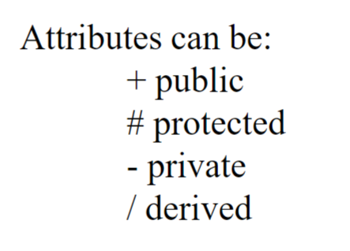
- Operations: describe class behaviour
operation signature: includes Name, parameter types, default values, and return type
Relationships:
- How each classes connect each oher
- 3 kinds of relationships
+ dependencies
+ generalizations
+ associations

Dependency:
- Indicates semantic relationship (liên quan đến nhau về quan hệ)
- 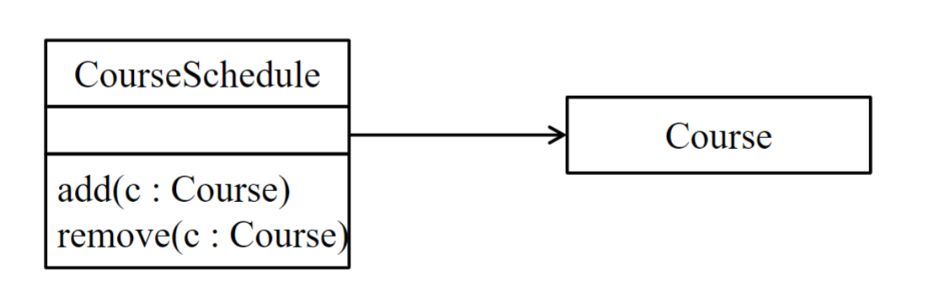
- If you modify on CourseSchedule class, Course class will be affected.

Generalization:
- It connects subclass to its superclass.
- It inherits of attributes and behaviour from superclass

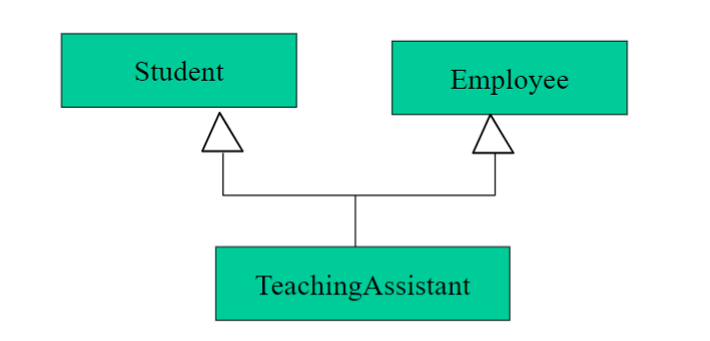

Association:
- When 2 classes need to communicate with each other, there must be an association.
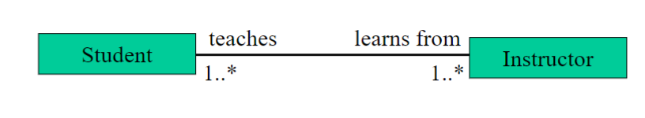

In association relationship, an object that contain other objects by these 2 mehtods.
+ Aggregation: (white diamond)
- Specify whole-part relationship
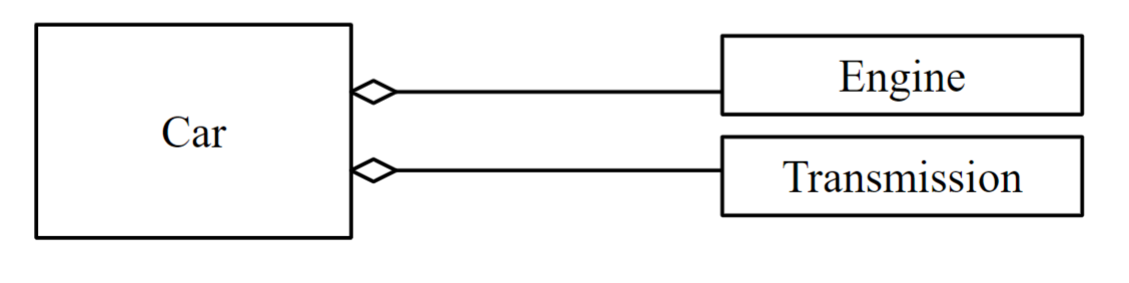
- A car (a whole) can have engine and transmission (parts), but those part can exist independently

+ Composition: (black diamond)
- Part and Whole must be together
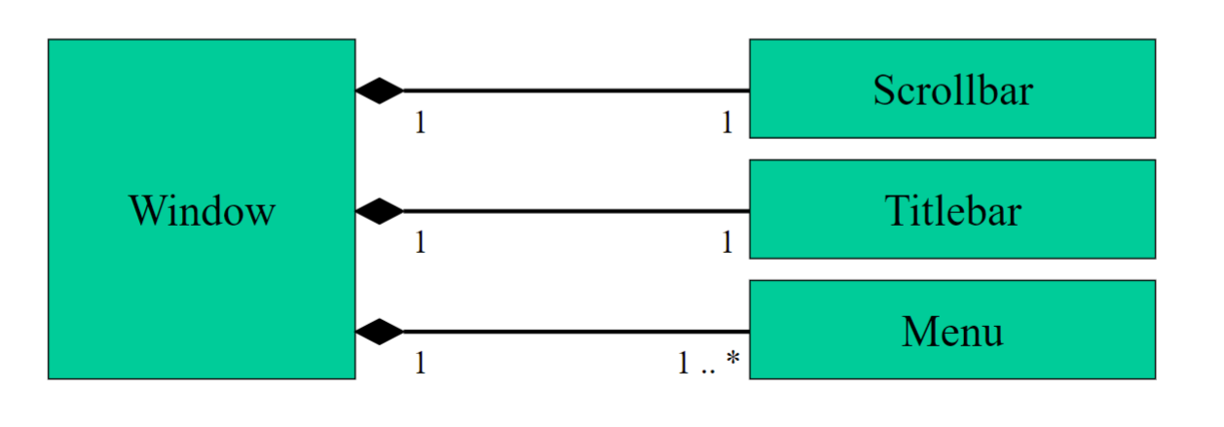

Interfaces:
- An abstract class
- A named set of operations that specifies the behaviour of objetc without showing the inner structure.
- Having only method name but not implement them
realization: là implement của class
Sequence diagram:
- Emphasize on the time order of the messages and the communication between Objects
- Depict a logic flow of usecase
- Ex: User → ATM → Bank → ATM → User (tương tác theo thứ tự giữa các Objects)
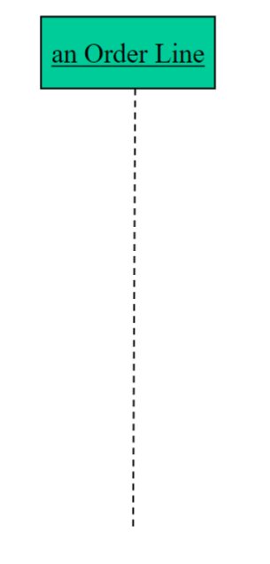
- The line is called object lifeline, representing the existence of an object over the period of time
- The Green box is Object (a.k.a usecase participant)

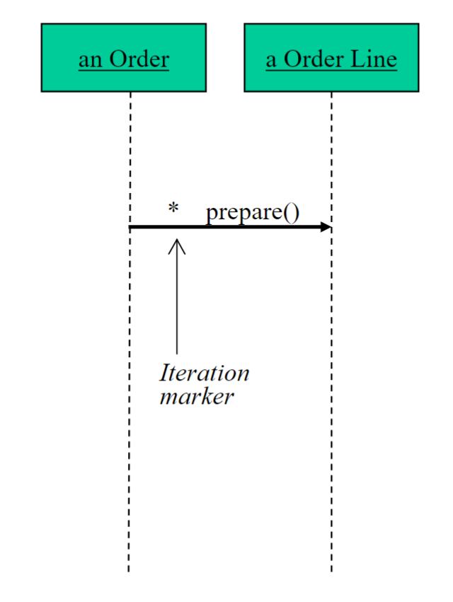The * is iteration marker, indicate that message will repeat until it meets the conditions.
prepare(): is the message

ex) 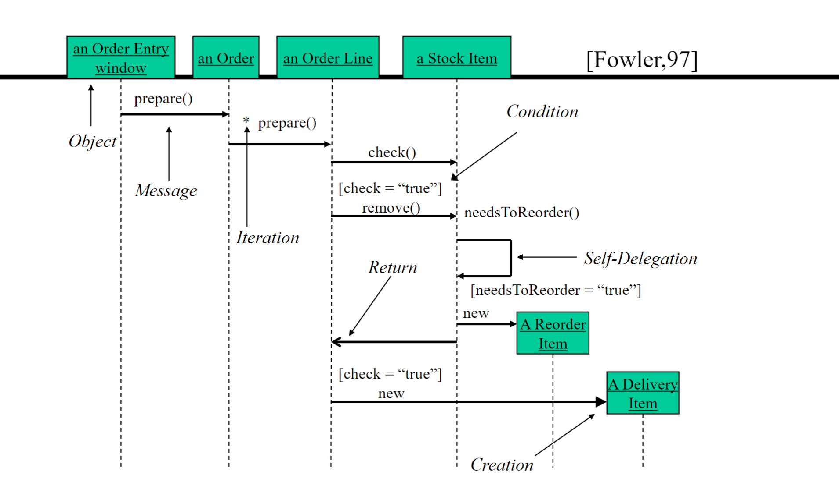
Packages Diagram:
- The classes are grouped together to form a package
- Those classes in both Front-end and Back-end packages can’t access each other
- 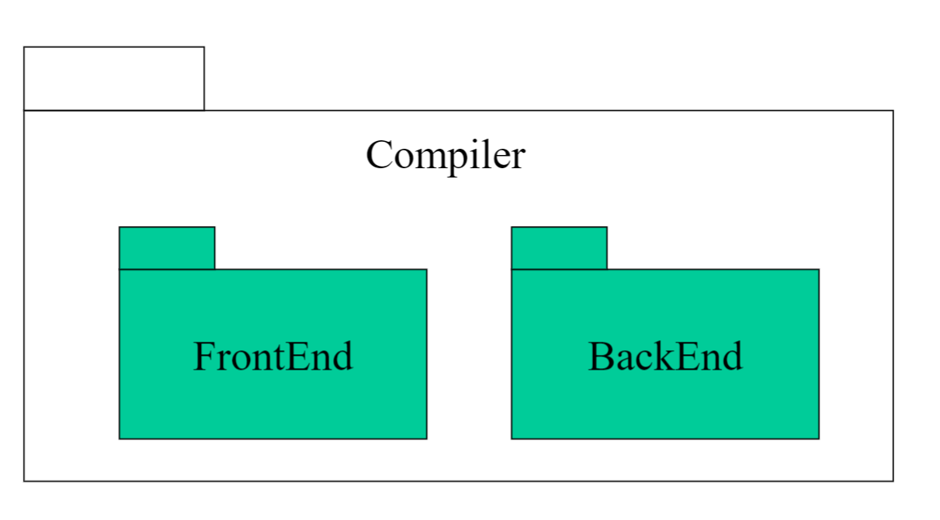
Component Diagram
- Showing dependecies and
Deployment Diagram
State Machine Diagram:
- The state of the object is in some specific state at any given time during its lifecycle.
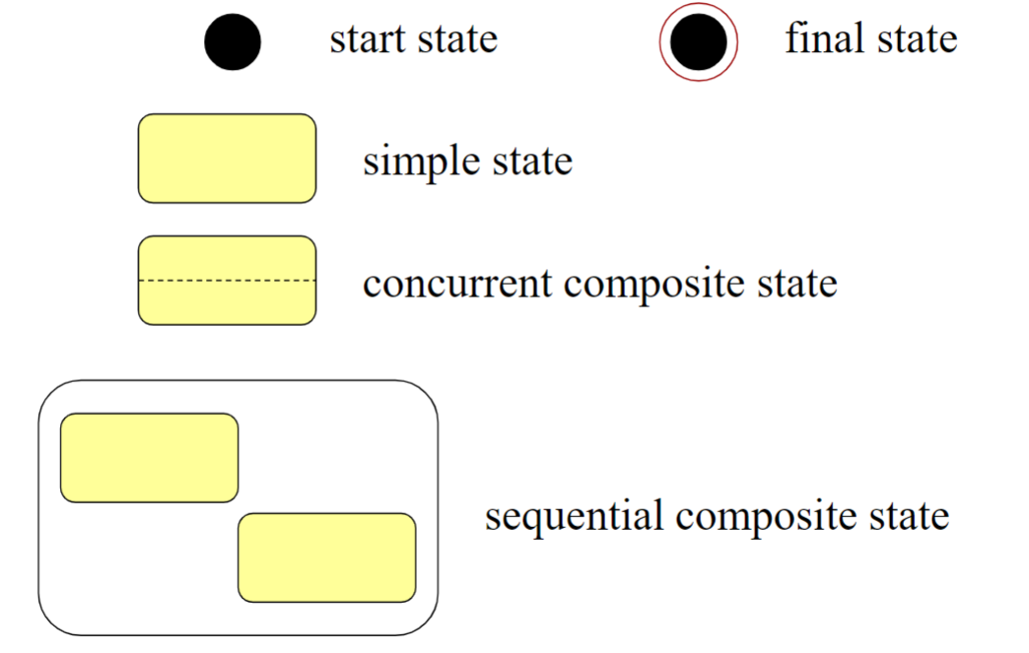
Simple state:
Ex: Logged in, Idle
Sequential state: contain serveral states inside processing sequentially.
Ex: Order Processing
- Validating Order
- Payment
- Shipping
Concurrent Composite State: serveral states happens parallel
Ex: User Session
- Listening music
- Downloading music
3 states: start state, intermediate states, final states
Activity Diagram
- flow of control from activity to activity
- ex: Insert Card → Enter PIN → Choose Action → Withdraw
