Use Case:
- A step by step description of how user will use the system to be accomplished business goals.
3 key elements:
- Actor: experimental agent or actor will cooperate with the system
ex: customer, email server, admin, …
- Use case diagram: show relations of actor and use cases.
- Use case scenario: plan for realization of user goals or handling contingencies (surprise situations).
Types of Actors:
- Initiating actor:
  - also called primary actor or “simply user”
  - who hit the button first will be Initiating actor / first user.
Ex: Use case: Place Order
Initiating actor: Customer placing the order.

- Participating actor:
  - Also called secondary actor
  - Supporting actor: help the system to complete the use case
- third party system like email server, sms server
Ex: Use case: Place order
Supporting actor: Payment gateway to checkout

  - Offstage actor: passively participate in use case
+ neither initiate or complete the use case but keeping record
Ex: Use case: Place Order
Offstage actor: the system confirm the order information.

Subrountine use case:
- Use case được tách ra khỏi base use case để bổ trợ cho base use case

<<extend>> Relationship
- Represents exceptional or seldom invoked cases.
- Means those functions that is not in the main flow, factored out from the main flow

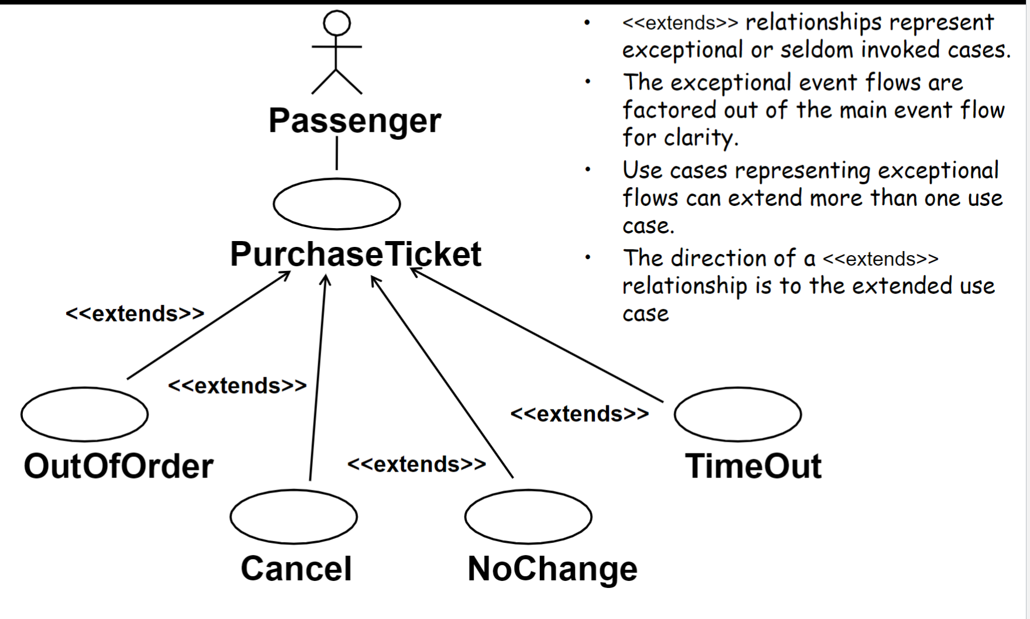

<<include>> Relationship
- Representing that behavior is factored out of the use case.
- Factored out for reuse, NOT because of exception
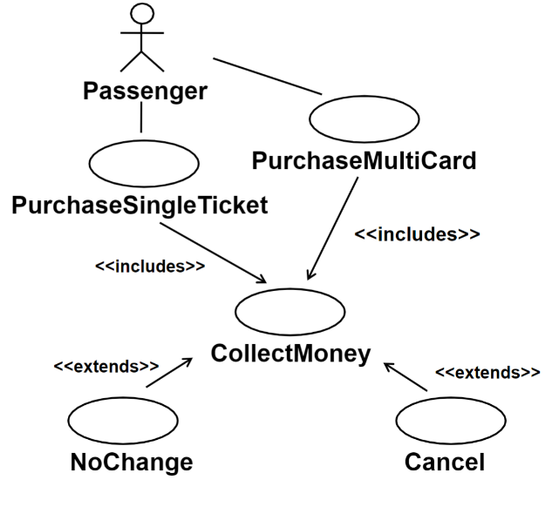

DRY Use Case (Don’t Repeat Yourself)
- Remove redundant parts of use cases (multiple common use cases) by parameterizing them as subroutine use cases.
- Tách những phần use case thừa đó thành use case chung để có thể reuse.

Ex:
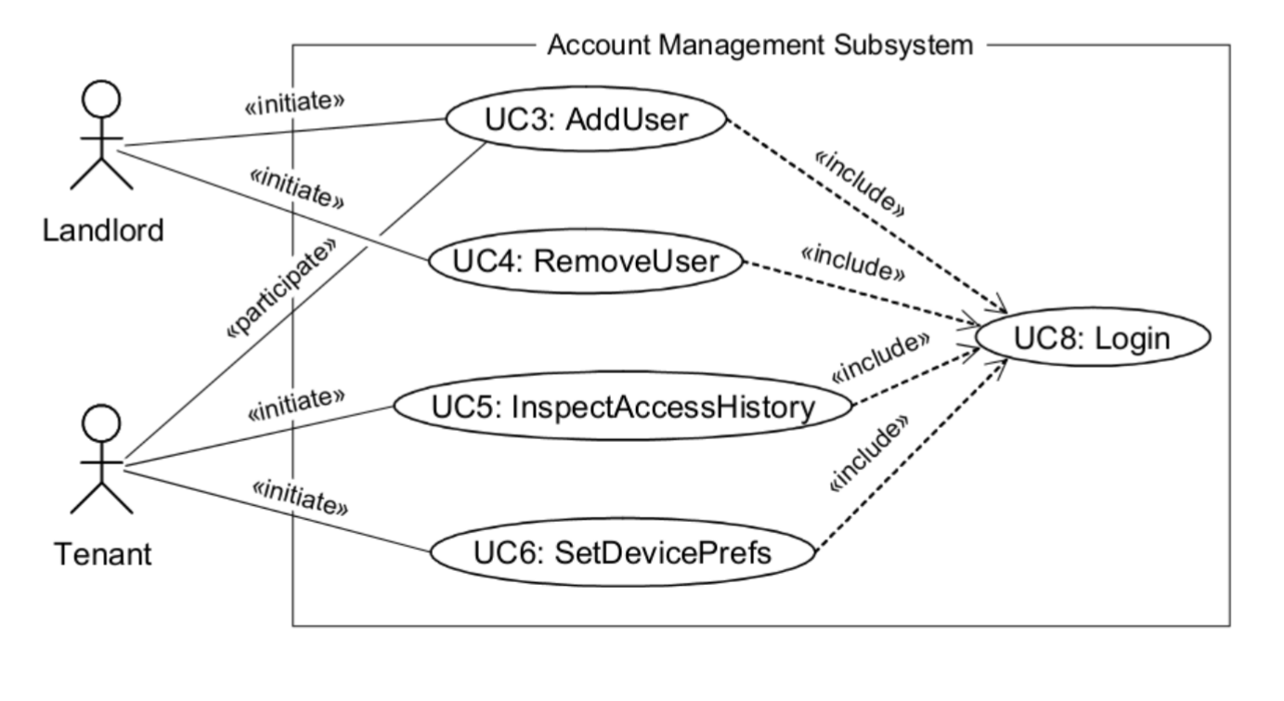

Use Case Generalization:
- Quan hệ kế thừa

UseCase template:
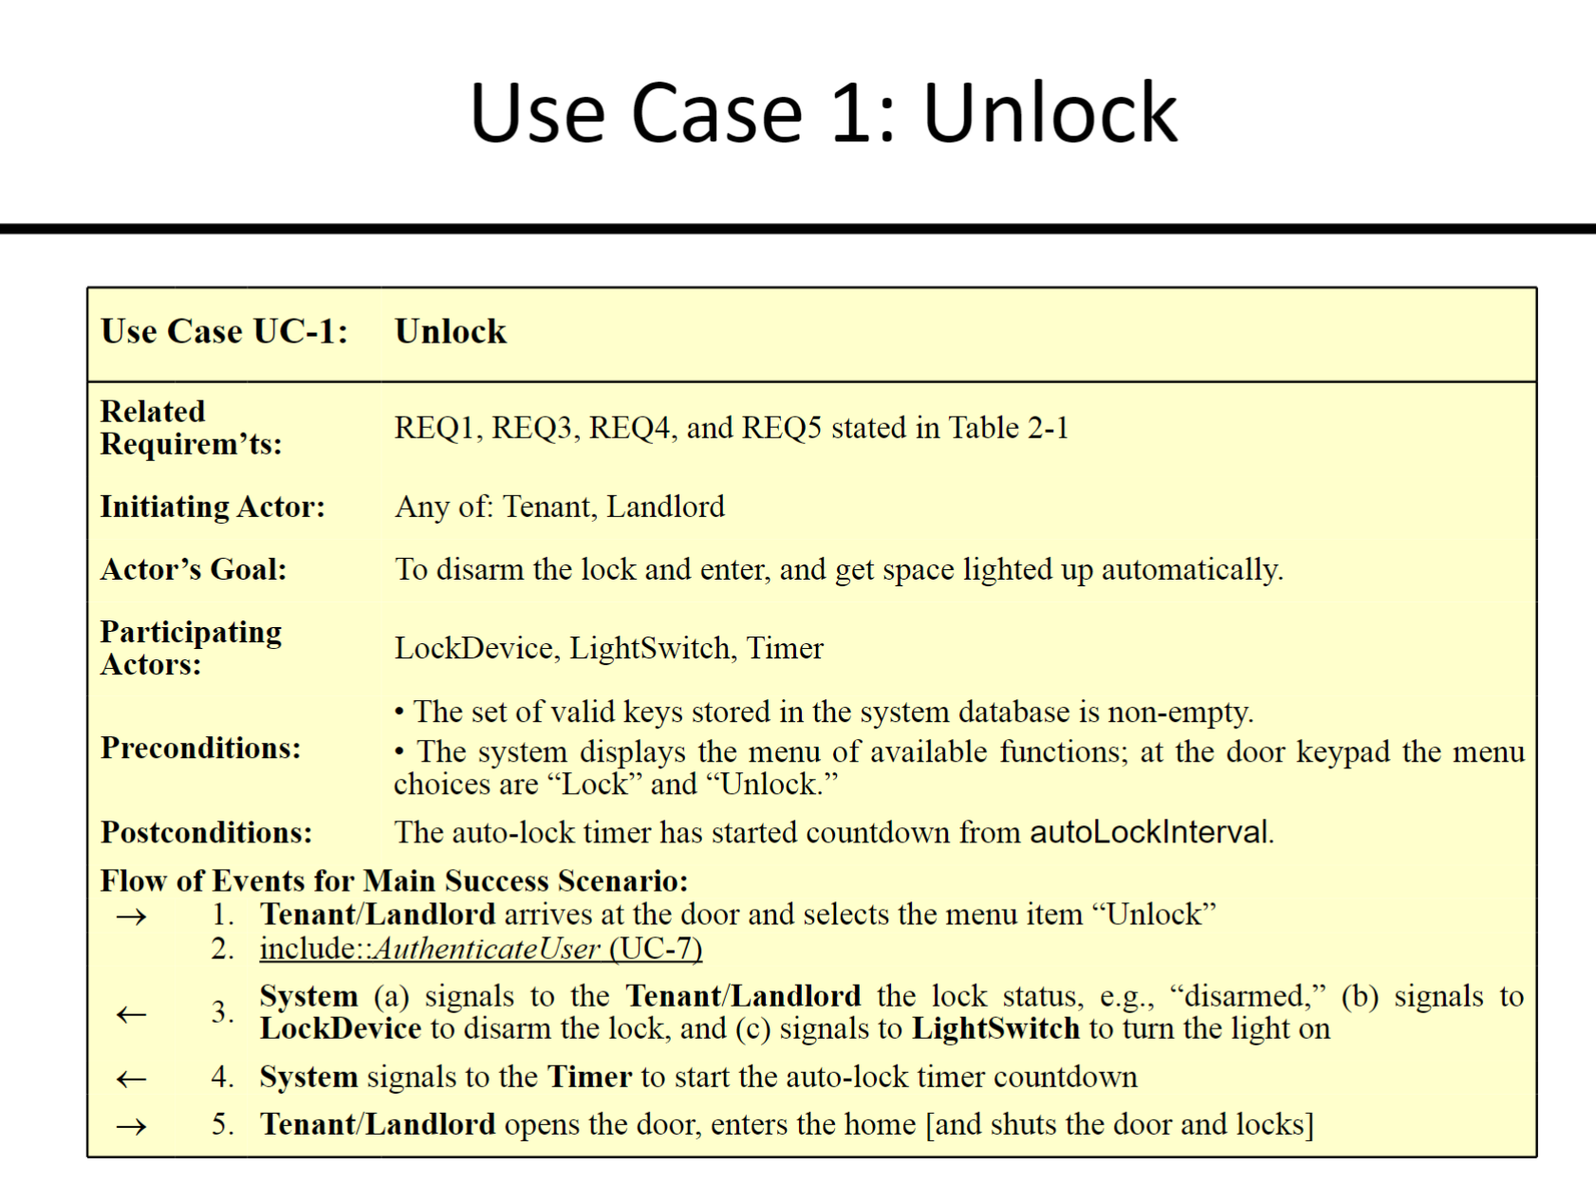

- : the input to the system
<- : the outcome of system

Sequence diagram:
- Emphasis on the order of the message between actor and object
Activity diagram:
- Emphasis on business logic, business flow

