Nama: Robbi Hably Minassholihyn

NIM: J3C119105

Kelas: INF 1A-Prk1

Mata Kuliah : Bahasa Pemrograman

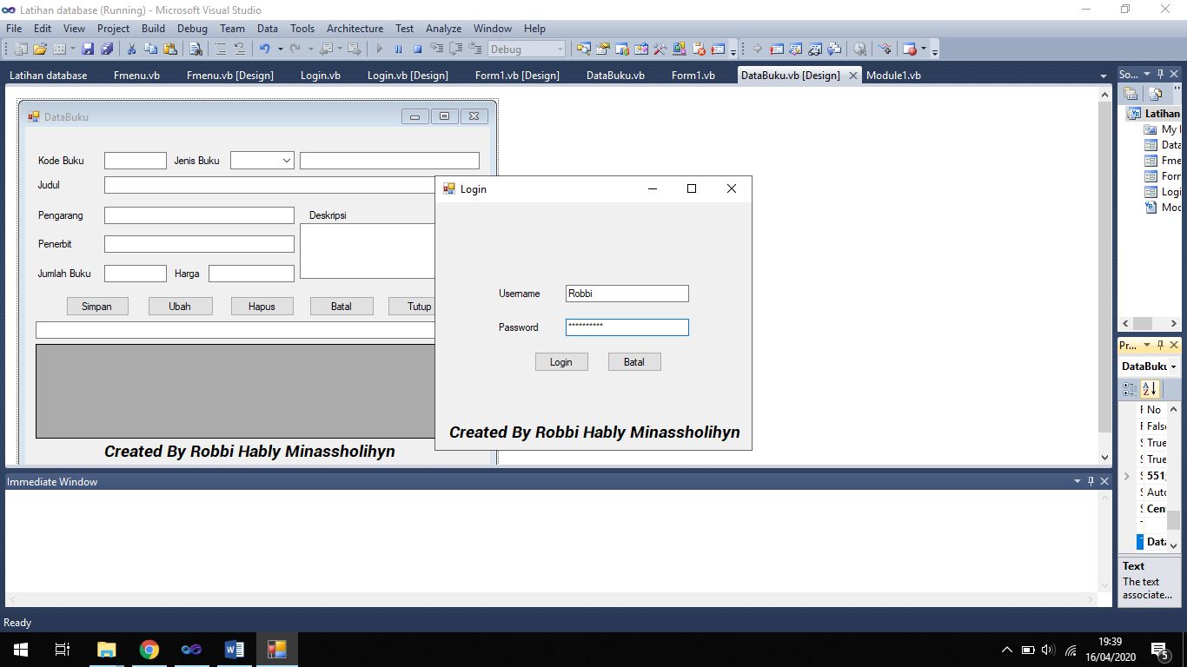-Login menggunakan data yang telah ditambahkan pada database

-Maka akan muncul tampilan Form menu utama

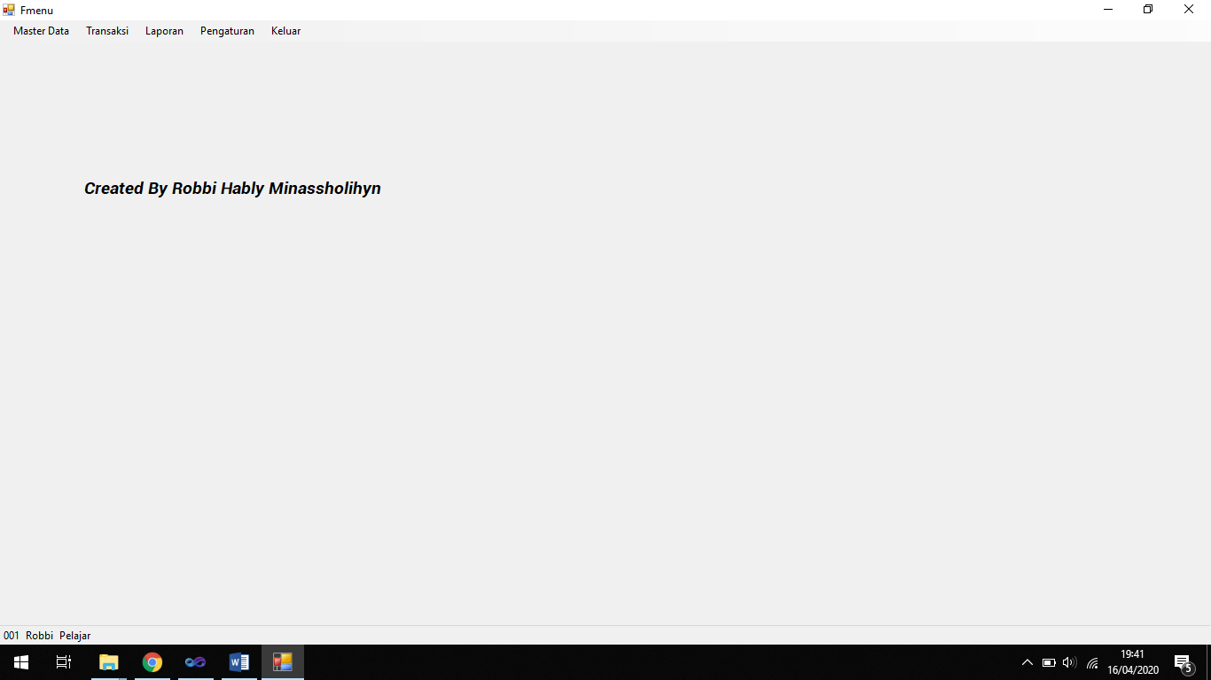

-Masuk menu data jenis baru untuk membuka form jenis buku

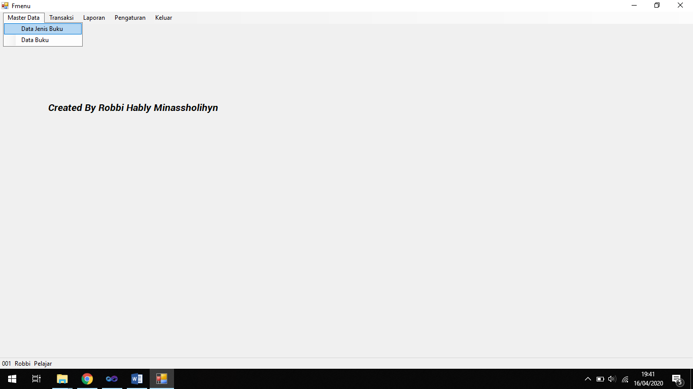

-Maka akan tampil form data jenis kemudian isikan data dan tekan button simpan.

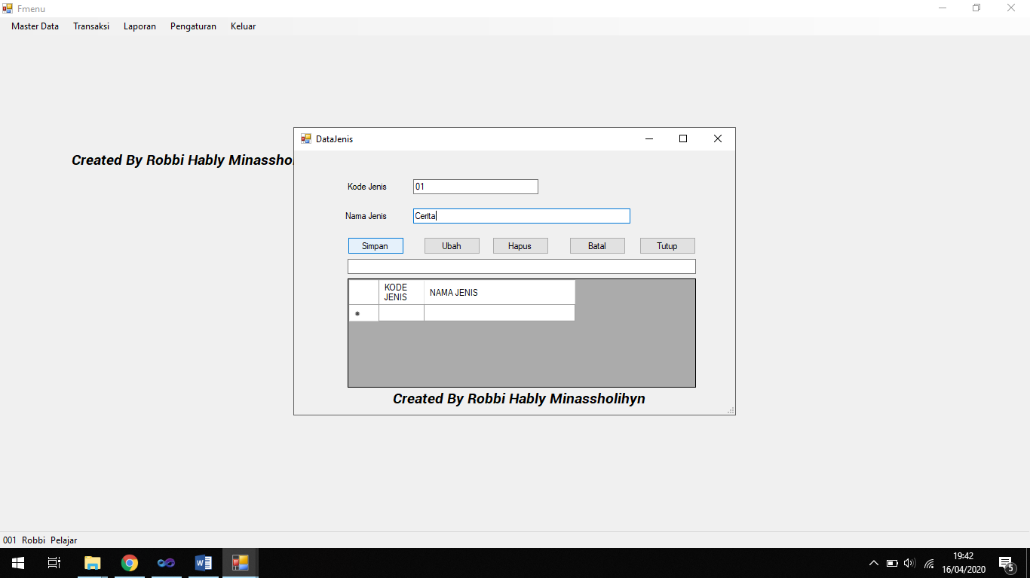

-Maka data akan tersimpan ke database dan ditampilkan pada tabel grid.

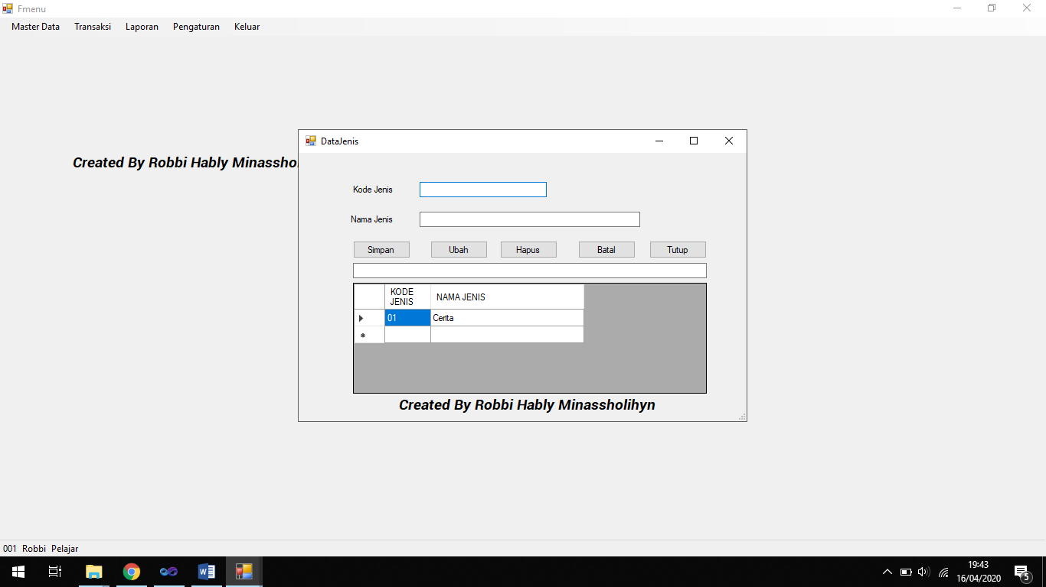

-Pada bagian ini untuk mengubah data pada database dengan mengisi textbox dengan kode jenis yang sudah ada pada database kemudian data akan otomatis terupdate di tabel grid dan database

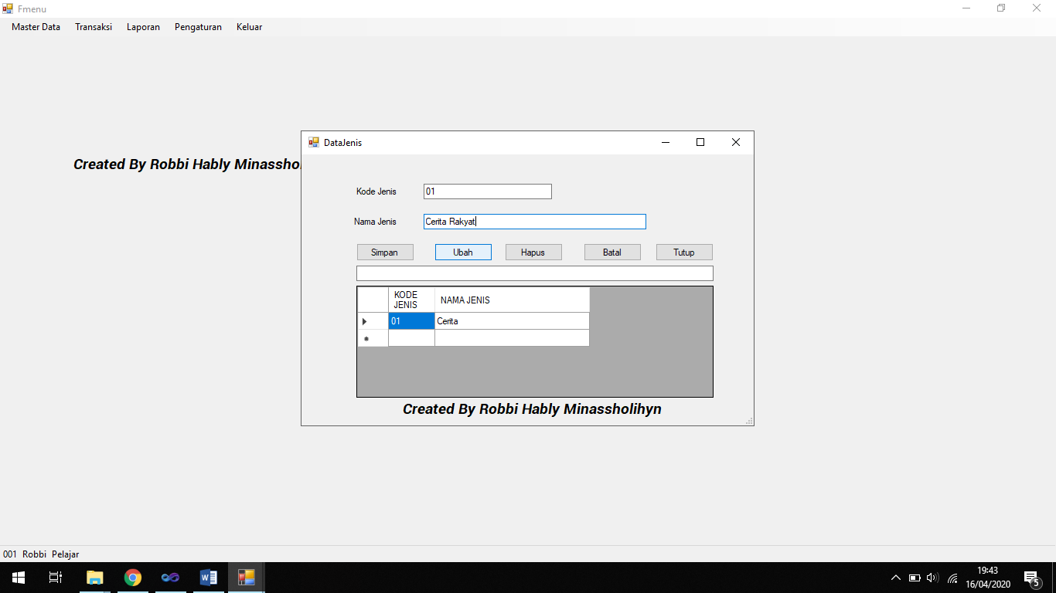

-Tabel grid telah terupdate

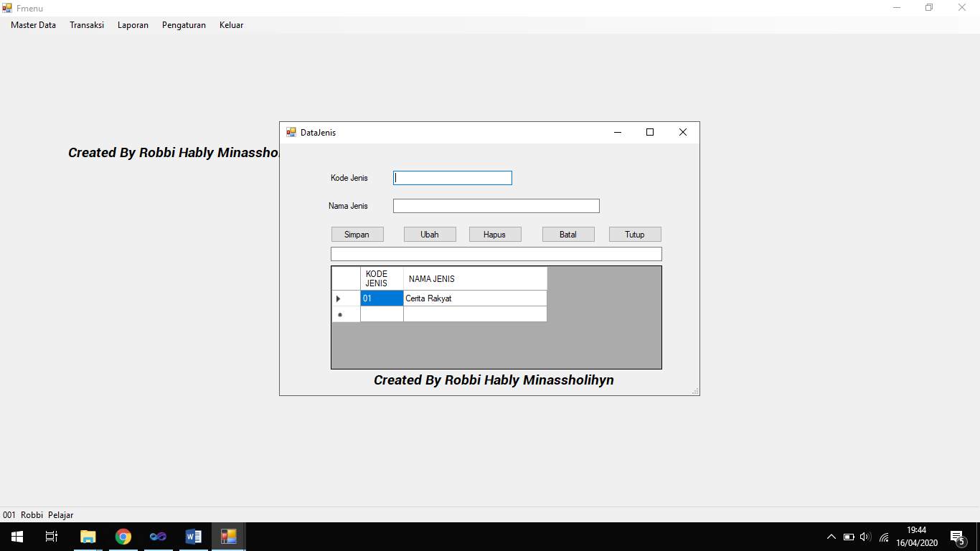

-Pada tahap ini yaitu menghapus data pada tabel grid atau pada database dengan memasukkan kode jenis pada textbox1 kemudian tekan button hapus, maka data pada tabel dan database akan terhapus.

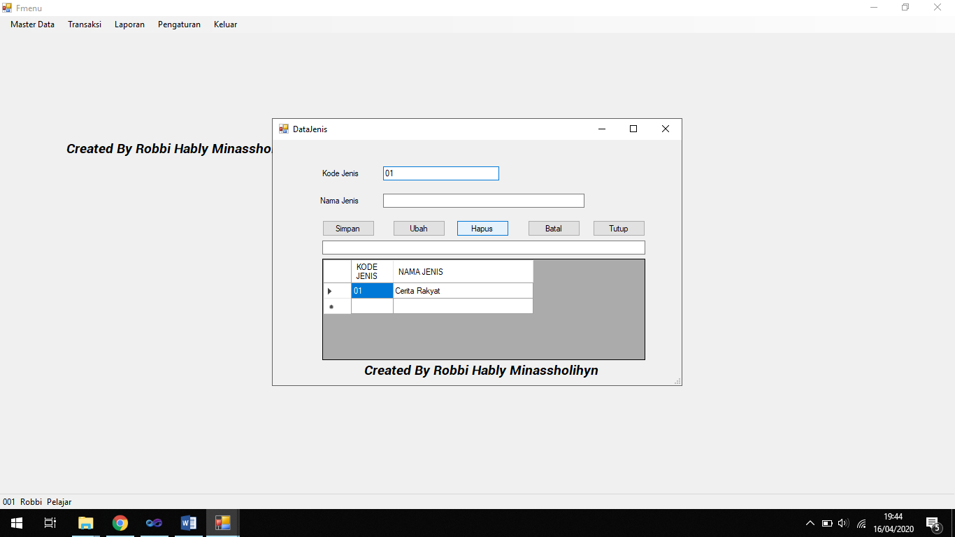

-Tabel atau database terbaru setelah penghapusan.

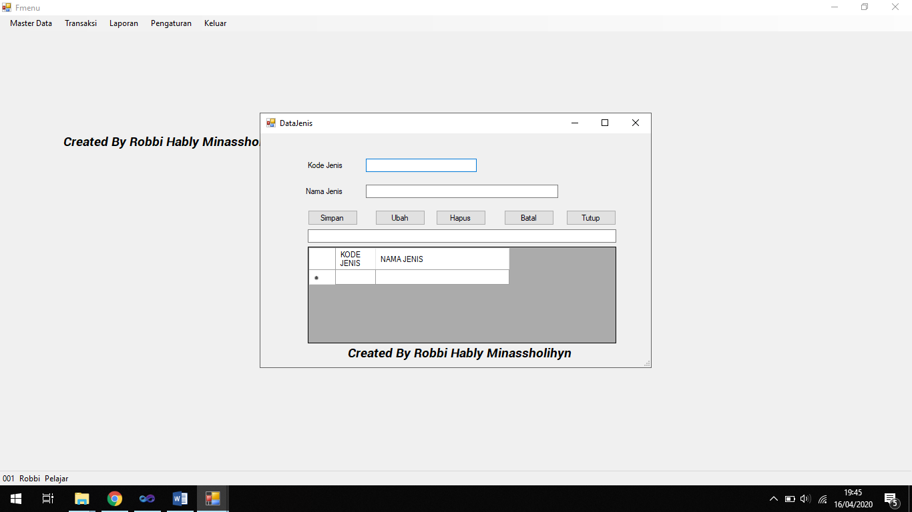

-Pada tahap ini yaitu membatalkan apa yang sudah kita isi pada textbox.

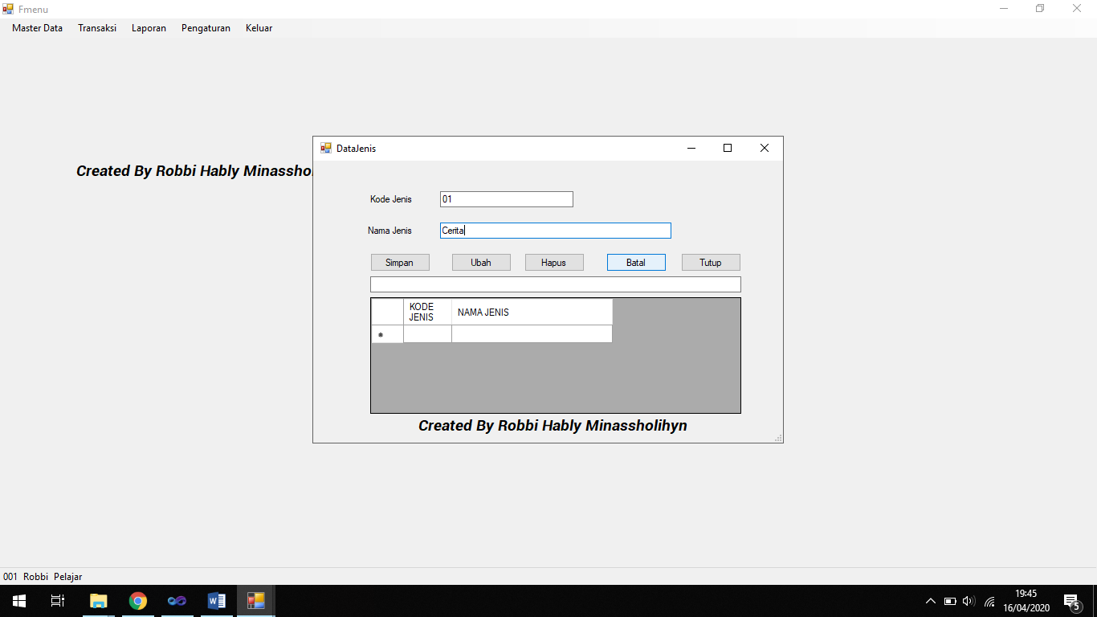

-Seperti ini, tulisan pada textbox kembali kosong.

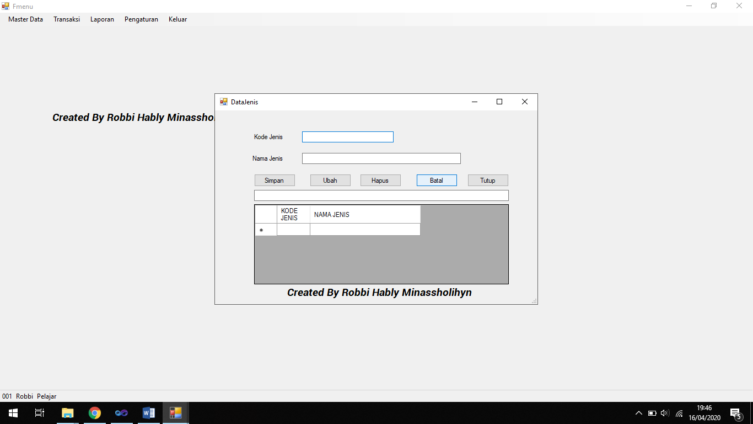

-Pada tahap ini yaitu mencari data pada database menggunakan textbox.

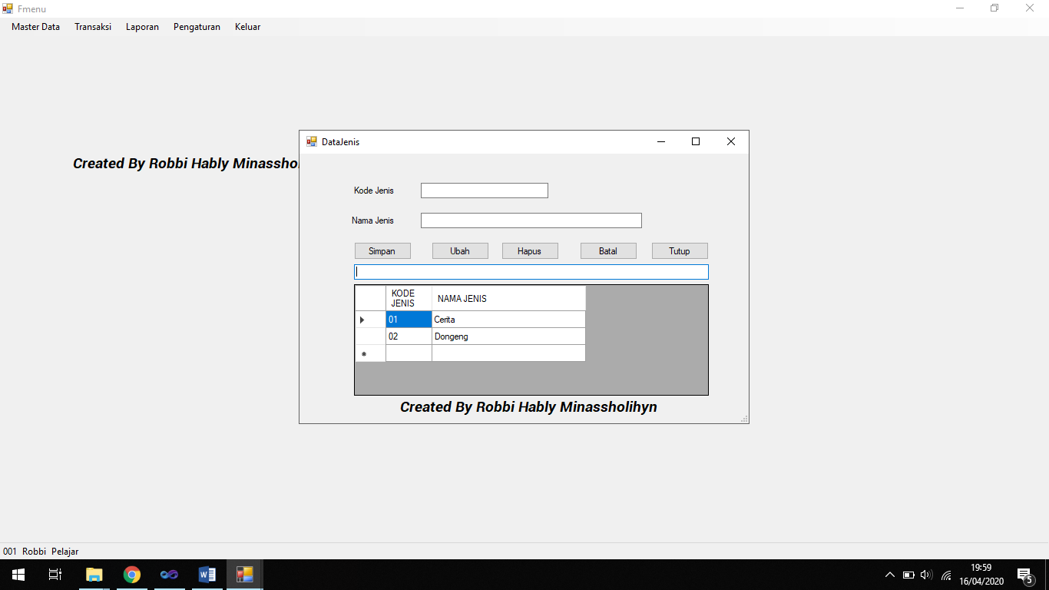

-Karena data ditemukan maka data tersebut dimunculkan seperti berikut ini.

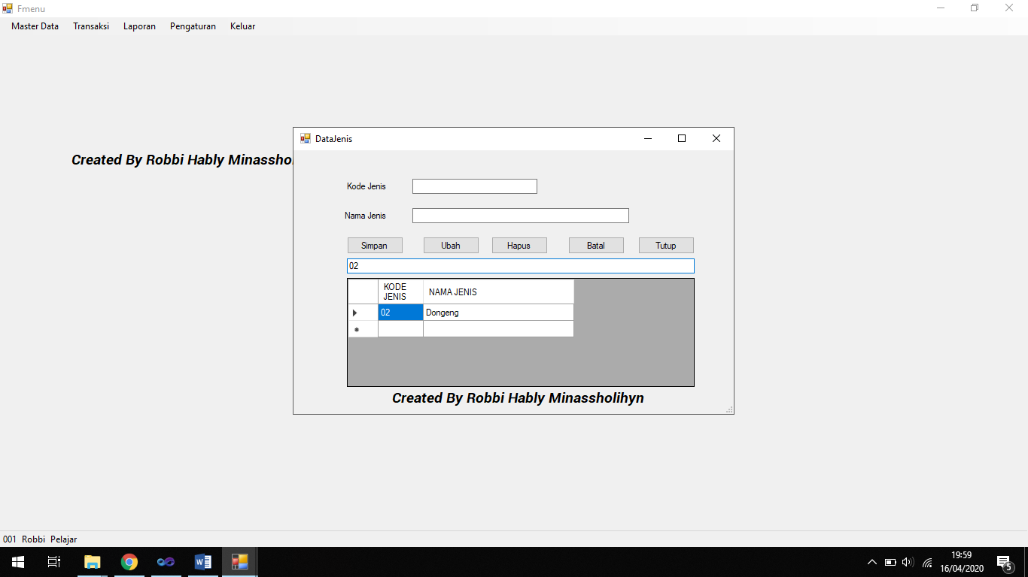

-Pada tahap ini yaitu kita menutup form kodejenis dan kembali ke form menu utama.

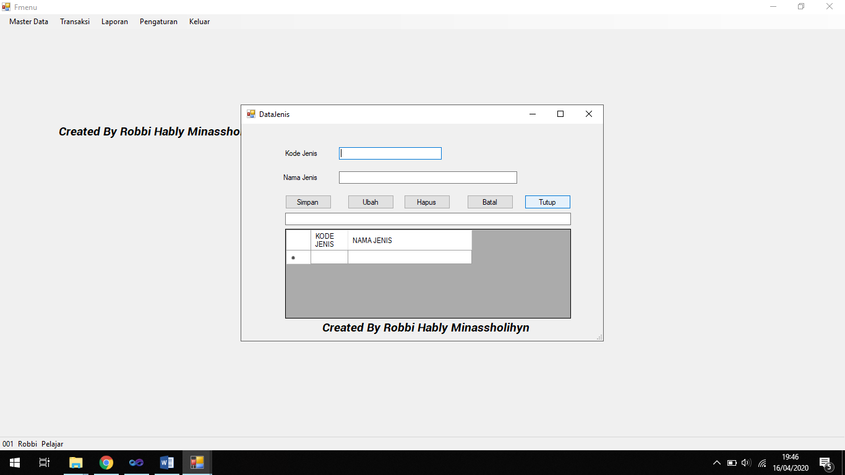

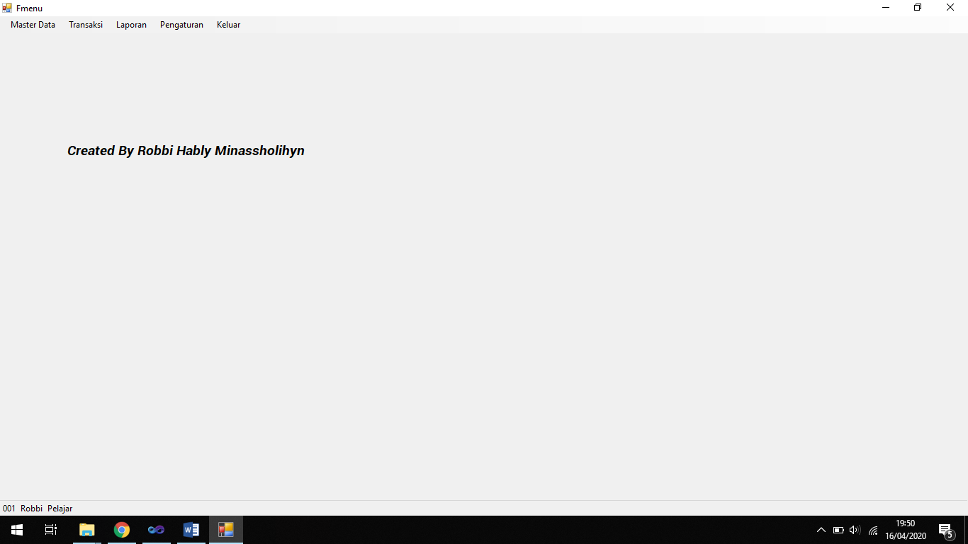

-Untuk proses pada form databuku sama seperti pada form data jenis hanya ditambah beberapa textbox dan satu listbox.

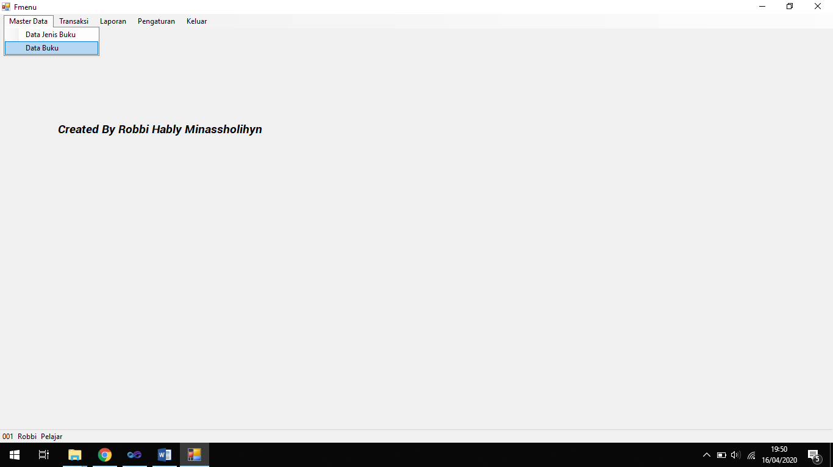

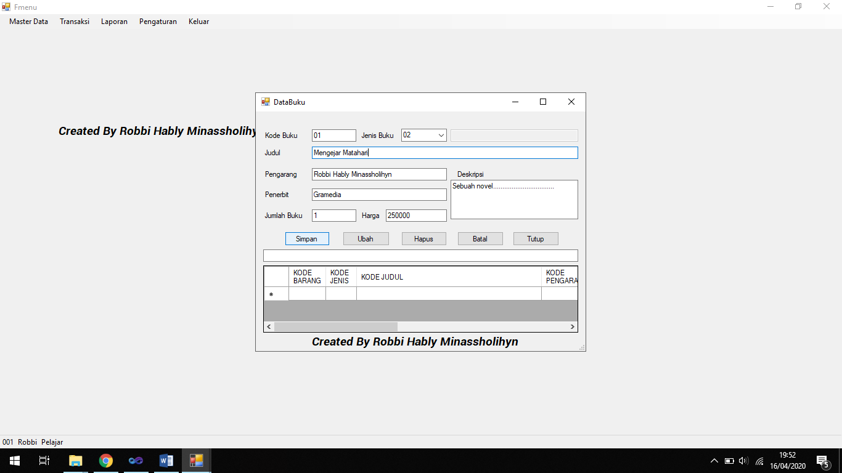

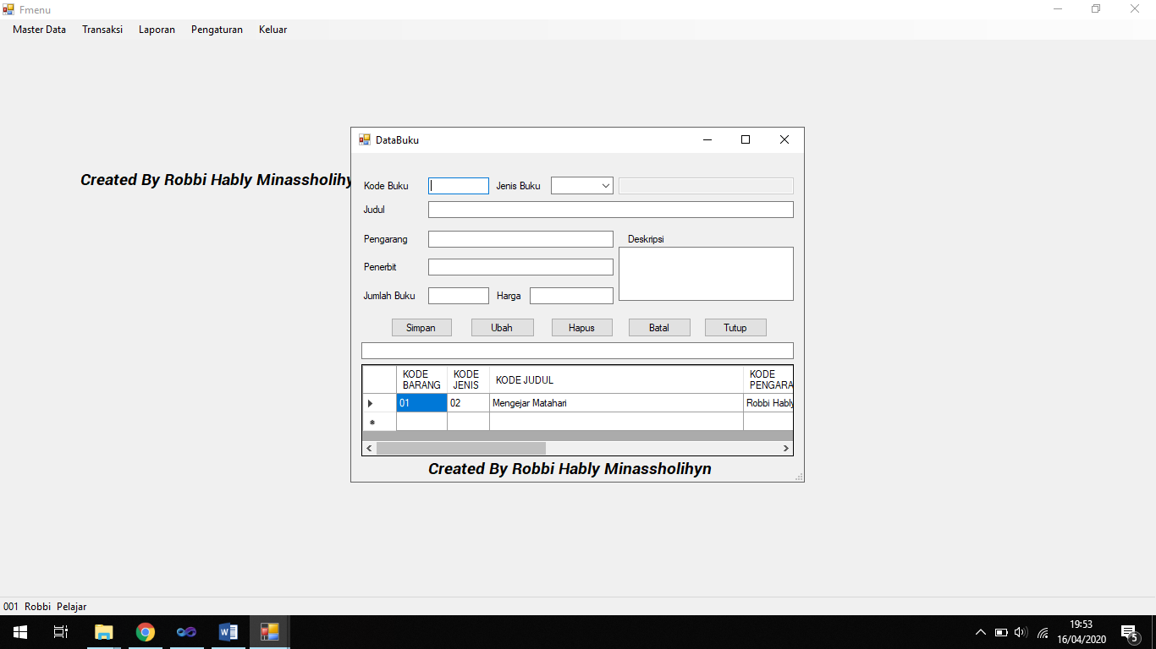

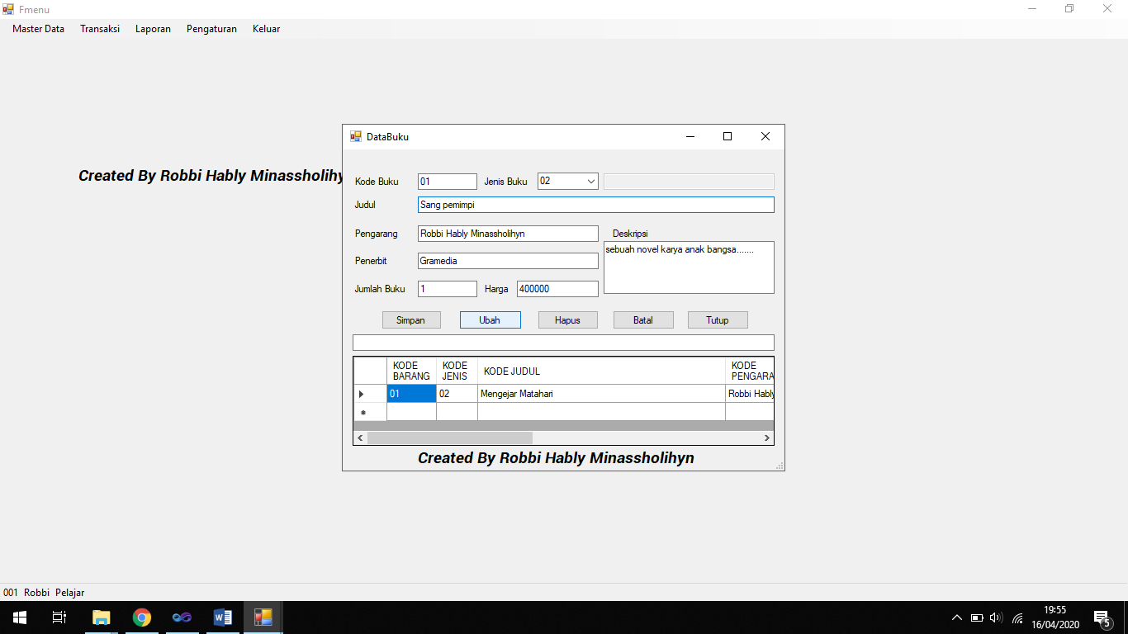

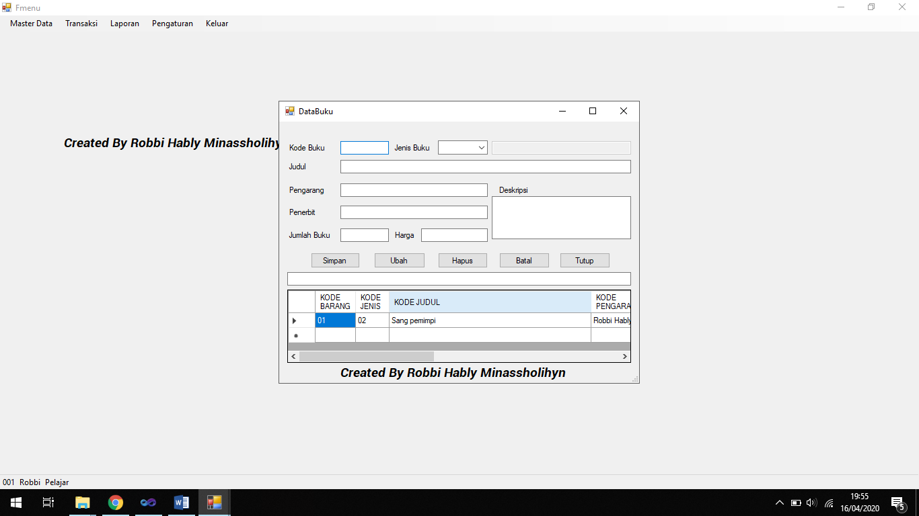

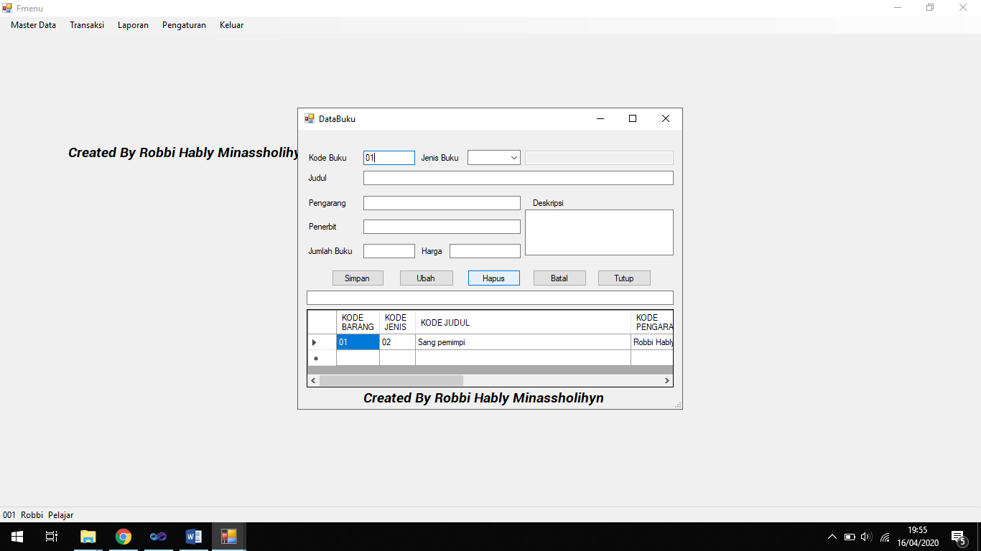

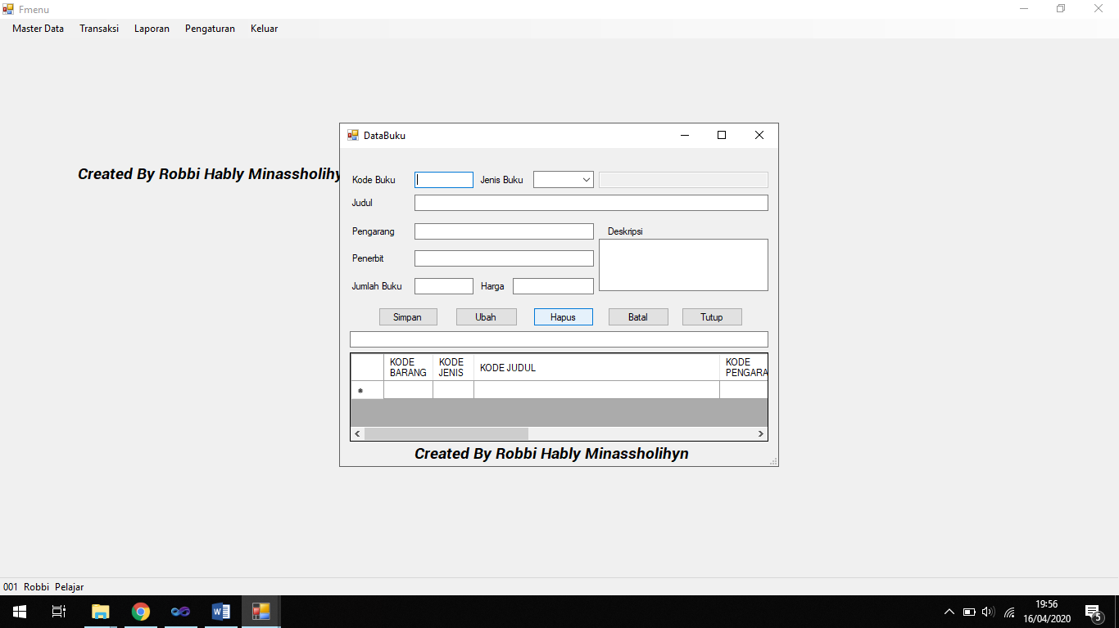

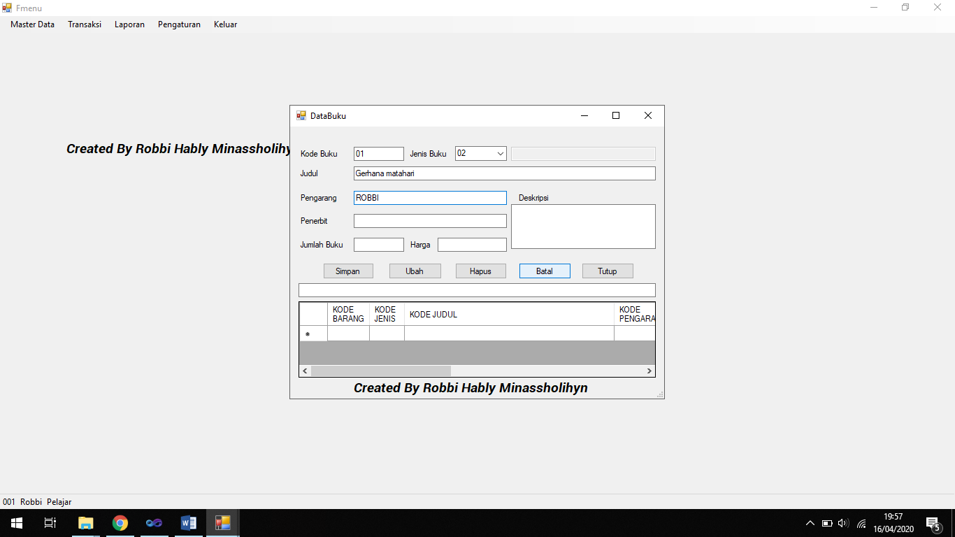

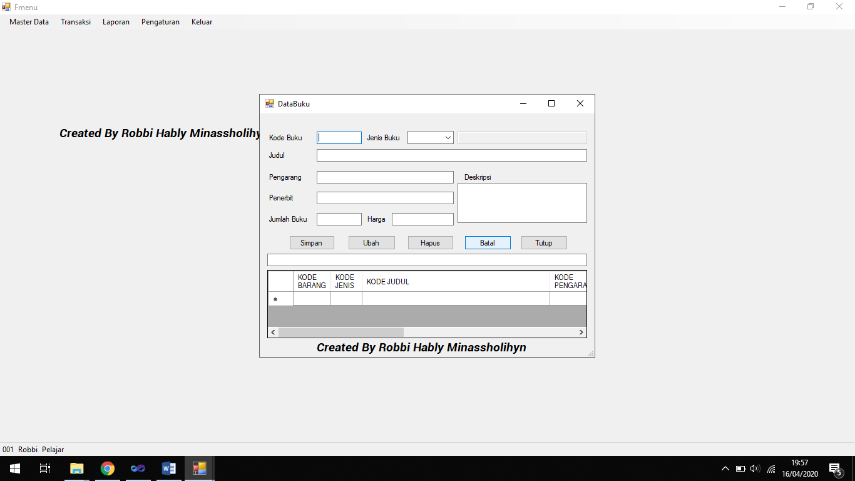

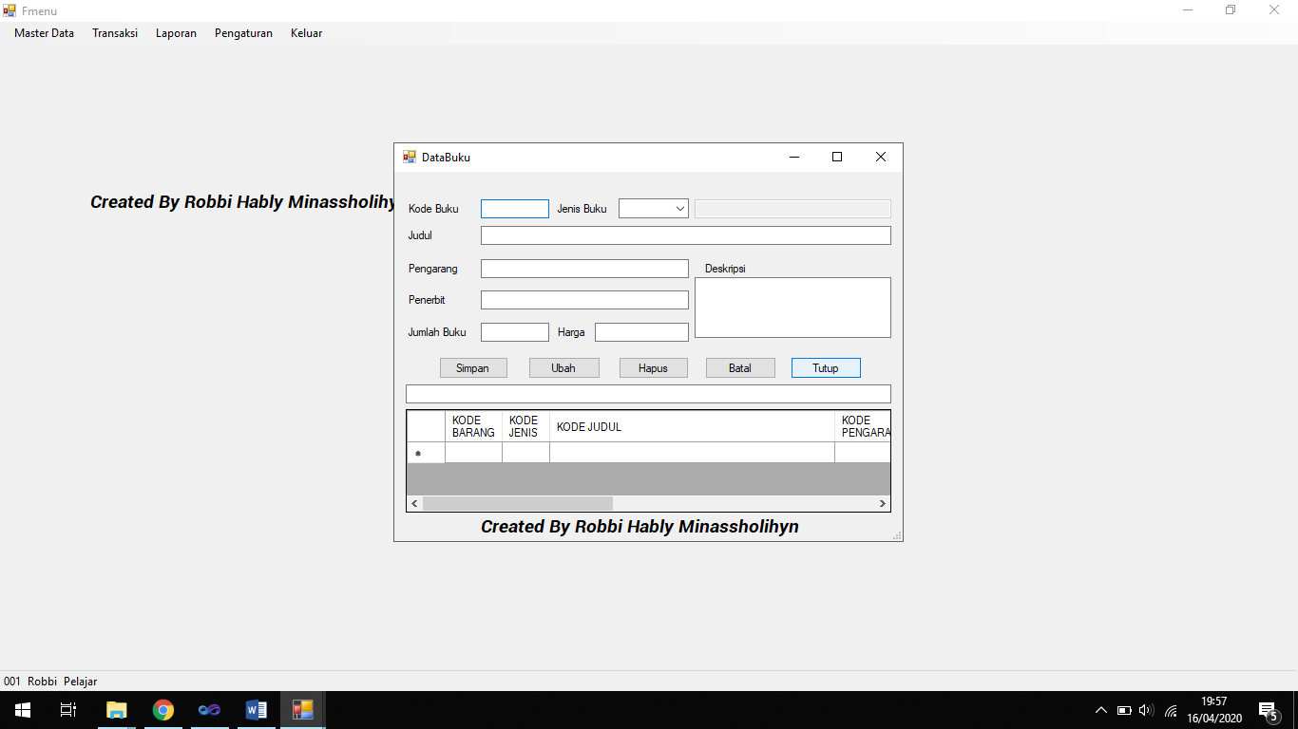

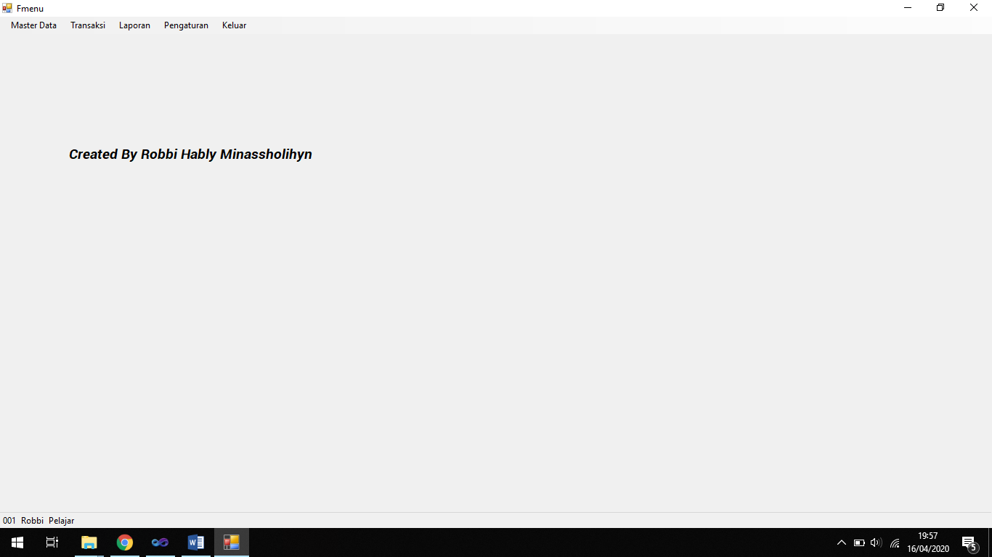

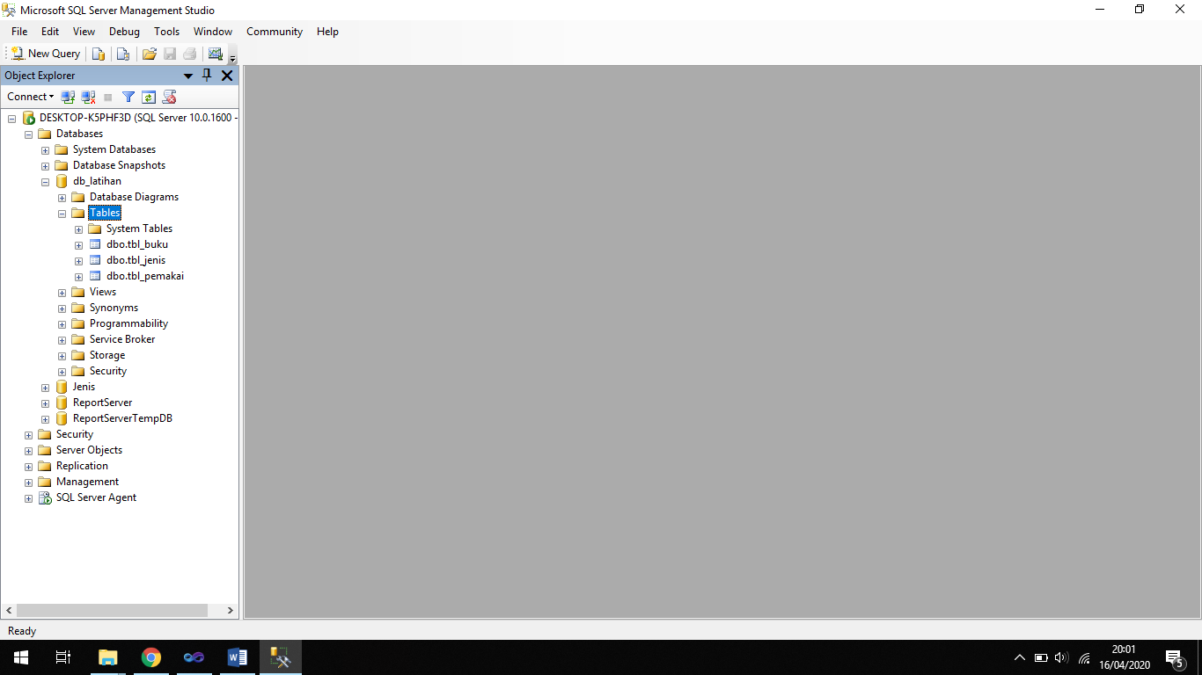

**Kodingan Module1:**

Imports System.Data.SqlClient

Module Module1

Public conn As SqlConnection

Public da As SqlDataAdapter

Public cmd As SqlCommand

Public rd As SqlDataReader

Public ds As DataSet

Public mydb As String

Sub koneksi()

mydb = "data source=DESKTOP-K5PHF3D;initial catalog=db_latihan;integrated security=true"

conn = New SqlConnection(mydb)

If conn.State = ConnectionState.Closed Then conn.Open()

End Sub

End Module

**Kodingan form data jenis:**

Imports System.Data.SqlClient

Public Class Datajenis

Sub kosong()

tb1.Clear()

tb2.Clear()

tb1.Focus()

End Sub

Sub isi()

tb2.Clear()

tb2.Focus()

End Sub

Sub tampiljenis()

da = New SqlDataAdapter("Select * from tbl_jenis", conn)

ds = New DataSet

ds.Clear()

da.Fill(ds, "tbl_jenis")

DataGridView1.DataSource = (ds.Tables("tbl_jenis"))

DataGridView1.Refresh()

End Sub

Sub aturgrid()

DataGridView1.Columns(0).Width = 60

DataGridView1.Columns(1).Width = 200

DataGridView1.Columns(0).HeaderText = "KODE JENIS"

DataGridView1.Columns(1).HeaderText = "NAMA JENIS"

End Sub

Private Sub Datajenis_Load(ByVal sender As System.Object, ByVal e As System.EventArgs) Handles MyBase.Load

Call koneksi()

Call tampiljenis()

Call kosong()

Call aturgrid()

End Sub

Private Sub Button1_Click(ByVal sender As System.Object, ByVal e As System.EventArgs) Handles Button1.Click

If tb1.Text = "" Or tb2.Text = "" Then

MsgBox("Data belum lengkap")

tb1.Focus()

Exit Sub

Else

cmd = New SqlCommand("select * from tbl_jenis where KodeJenis='" & tb1.Text & "'", conn)

rd = cmd.ExecuteReader

rd.Read()

Call koneksi()

If Not rd.HasRows Then

Dim inputdata As String = "insert into tbl_jenis values ('" & tb1.Text & "','" & tb2.Text & "') "

cmd = New SqlCommand(inputdata, conn)

cmd.ExecuteNonQuery()

MsgBox("Simpan data sukses..!!", MsgBoxStyle.Information, "Perhatian")

End If

Call tampiljenis()

Call kosong()

tb1.Focus()

End If

End Sub

Private Sub tb2_KeyPress(ByVal sender As Object, ByVal e As System.Windows.Forms.KeyPressEventArgs) Handles tb2.KeyPress

tb2.MaxLength = 50

If e.KeyChar = Chr(13) Then

tb2.Text = UCase(tb2.Text)

End If

End Sub

Private Sub DataGridView1_CellContentClick(ByVal sender As Object, ByVal e As System.Windows.Forms.DataGridViewCellEventArgs) Handles DataGridView1.CellContentClick

Dim i As Integer

i = Me.DataGridView1.CurrentRow.Index

With DataGridView1.Rows.Item(i)

Me.tb1.Text = .Cells(0).Value

Me.tb2.Text = .Cells(1).Value

End With

End Sub

Private Sub Button2_Click(ByVal sender As System.Object, ByVal e As System.EventArgs) Handles Button2.Click

If tb1.Text = "" Then

MsgBox("Data jenis belum diisi!")

tb1.Focus()

Exit Sub

Else

Call koneksi()

Dim ubahdata As String = "update tbl_jenis set Jenis='" & tb2.Text & "'where KodeJenis='" & tb1.Text & "'"

cmd = New SqlCommand(ubahdata, conn)

cmd.ExecuteNonQuery()

MsgBox("Ubah data sukses!!", MsgBoxStyle.Information, "Perhatian")

Call tampiljenis()

Call kosong()

tb1.Focus()

End If

End Sub

Private Sub Button3_Click(ByVal sender As System.Object, ByVal e As System.EventArgs) Handles Button3.Click

If tb1.Text = "" Then

MsgBox("Kode buku belum diisi")

tb1.Focus()

Exit Sub

Else

If MessageBox.Show("Yakin akan menghapus data jenis " & tb1.Text & " ?", "", MessageBoxButtons.YesNo) = Windows.Forms.DialogResult.Yes Then

Call koneksi()

Dim hapusdata As String = "delete tbl_jenis where KodeJenis='" & tb1.Text & "'"

cmd = New SqlCommand(hapusdata, conn)

cmd.ExecuteNonQuery()

Call tampiljenis()

Call kosong()

Else

Call kosong()

End If

End If

End Sub

Private Sub Button4_Click(ByVal sender As System.Object, ByVal e As System.EventArgs) Handles Button4.Click

Call kosong()

End Sub

Private Sub tb1_KeyPress(ByVal sender As Object, ByVal e As System.Windows.Forms.KeyPressEventArgs) Handles tb1.KeyPress

tb1.MaxLength = 2

If e.KeyChar = Chr(13) Then

cmd = New SqlCommand("select * from tbl_jenis where KodeJenis='" & tb1.Text & "'", conn)

rd = cmd.ExecuteReader

rd.Read()

Call koneksi()

If rd.HasRows = True Then

tb2.Text = rd.Item(1)

tb2.Focus()

Else

Call isi()

tb2.Focus()

End If

End If

End Sub

Private Sub tb3_Click(ByVal sender As Object, ByVal e As System.EventArgs) Handles tb3.Click

End Sub

Private Sub tb3_TextChanged(ByVal sender As System.Object, ByVal e As System.EventArgs) Handles tb3.TextChanged

Call koneksi()

cmd = New SqlCommand("select * from tbl_jenis where KodeJenis like '%" & tb3.Text & "%'", conn)

rd = cmd.ExecuteReader

rd.Read()

If rd.HasRows Then

Call koneksi()

da = New SqlDataAdapter("select * from tbl_jenis where KodeJenis like '%" & tb3.Text & "%'", conn)

ds = New DataSet

da.Fill(ds, "Dapat")

DataGridView1.DataSource = ds.Tables("Dapat")

DataGridView1.ReadOnly = True

Else

MsgBox("Data tidak ditemukan!!", MsgBoxStyle.Information, "Perhatian")

tb3.Clear()

tb3.Focus()

End If

End Sub

Private Sub Button5_Click(ByVal sender As System.Object, ByVal e As System.EventArgs) Handles Button5.Click

Me.Close()

End Sub

End Class

**Kodingan form data buku:**

Imports System.Data.SqlClient

Public Class DataBuku

Sub kosong()

tb1.Clear()

cb1.Text = ""

tb2.Clear()

tb3.Clear()

tb4.Clear()

tb5.Clear()

tb6.Clear()

tb7.Clear()

tb8.Clear()

tb1.Focus()

End Sub

Sub isi()

cb1.Text = ""

tb2.Clear()

tb3.Clear()

tb4.Clear()

tb5.Clear()

tb6.Clear()

tb7.Clear()

cb1.Focus()

End Sub

Sub tampilbuku()

da = New SqlDataAdapter("Select * from tbl_buku", conn)

ds = New DataSet

ds.Clear()

da.Fill(ds, "tbl_buku")

DataGridView1.DataSource = ds.Tables("tbl_buku")

DataGridView1.Refresh()

End Sub

Sub tampiljenis()

cmd = New SqlCommand("Select KodeJenis from tbl_jenis", conn)

rd = cmd.ExecuteReader

Do While rd.Read

cb1.Items.Add(rd.Item(0))

Loop

Call koneksi()

End Sub

Sub aturgrid()

DataGridView1.Columns(0).Width = 60

DataGridView1.Columns(1).Width = 50

DataGridView1.Columns(2).Width = 300

DataGridView1.Columns(3).Width = 100

DataGridView1.Columns(4).Width = 100

DataGridView1.Columns(5).Width = 100

DataGridView1.Columns(6).Width = 100

DataGridView1.Columns(7).Width = 300

DataGridView1.Columns(0).HeaderText = "KODE BARANG"

DataGridView1.Columns(1).HeaderText = "KODE JENIS"

DataGridView1.Columns(2).HeaderText = "KODE JUDUL"

DataGridView1.Columns(3).HeaderText = "KODE PENGARANG"

DataGridView1.Columns(4).HeaderText = "KODE PENERBIT"

DataGridView1.Columns(5).HeaderText = "KODE JUMLAH"

DataGridView1.Columns(6).HeaderText = "KODE HARGA"

DataGridView1.Columns(7).HeaderText = "KODE DESKRIPSI"

End Sub

Private Sub DataBuku_Load(ByVal sender As System.Object, ByVal e As System.EventArgs) Handles MyBase.Load

Call koneksi()

Call tampiljenis()

Call tampilbuku()

Call kosong()

Call aturgrid()

End Sub

Private Sub Button1_Click(ByVal sender As System.Object, ByVal e As System.EventArgs) Handles Button1.Click

If tb1.Text = "" Or tb2.Text = "" Or tb3.Text = "" Or tb4.Text = "" Or tb5.Text = "" Or tb6.Text = "" Or cb1.Text = "" Then

MsgBox("Data belum lengkap!")

tb1.Focus()

Exit Sub

Else

cmd = New SqlCommand("select * from tbl_buku where KodeBuku='" & tb1.Text & "'", conn)

rd = cmd.ExecuteReader

rd.Read()

Call koneksi()

If Not rd.HasRows Then

Dim inputdata As String = "insert into tbl_buku values ('" & tb1.Text & "','" & cb1.Text & "','" & tb2.Text &

"','" & tb3.Text & "','" & tb4.Text & "','" & tb5.Text & "','" & tb6.Text & "','" & tb7.Text & "')"

cmd = New SqlCommand(inputdata, conn)

cmd.ExecuteNonQuery()

MsgBox("Simpan data sukses..!!", MsgBoxStyle.Information, "Perhatian")

End If

Call tampilbuku()

Call kosong()

tb1.Focus()

End If

End Sub

Private Sub DataGridView1_CellContentClick(ByVal sender As System.Object, ByVal e As System.Windows.Forms.DataGridViewCellEventArgs) Handles DataGridView1.CellContentClick

Dim i As Integer

i = Me.DataGridView1.CurrentRow.Index

With DataGridView1.Rows.Item(i)

Me.tb1.Text = .Cells(0).Value

Me.tb2.Text = .Cells(1).Value

Me.tb3.Text = .Cells(2).Value

Me.tb4.Text = .Cells(3).Value

Me.tb5.Text = .Cells(4).Value

Me.tb6.Text = .Cells(5).Value

Me.tb7.Text = .Cells(6).Value

Me.cb1.Text = .Cells(7).Value

End With

End Sub

Private Sub Button2_Click(ByVal sender As System.Object, ByVal e As System.EventArgs) Handles Button2.Click

If tb1.Text = "" Then

MsgBox("Data jenis belum diisi!")

tb1.Focus()

Exit Sub

Else

Call koneksi()

Dim ubahdata As String = "update tbl_buku set KodeJenis='" & cb1.Text & "', Judul='" & tb2.Text & "', Pengarang='" & tb3.Text &

"', Penerbit='" & tb4.Text & "', JumlahBuku='" & tb5.Text & "', Harga='" & tb6.Text & "', Deskripsi='" & tb7.Text &

"' where KodeBuku='" & tb1.Text & "'"

cmd = New SqlCommand(ubahdata, conn)

cmd.ExecuteNonQuery()

MsgBox("Ubah data sukses!!", MsgBoxStyle.Information, "Perhatian")

Call tampilbuku()

Call tampiljenis()

Call kosong()

tb1.Focus()

End If

End Sub

Private Sub Button3_Click(ByVal sender As System.Object, ByVal e As System.EventArgs) Handles Button3.Click

If tb1.Text = "" Then

MsgBox("Kode buku belum diisi")

tb1.Focus()

Exit Sub

Else

If MessageBox.Show("Yakin akan menghapus data buku " & tb1.Text & " ?", "", MessageBoxButtons.YesNo) = Windows.Forms.DialogResult.Yes Then

Call koneksi()

Dim hapusdata As String = "delete tbl_buku where KodeBuku='" & tb1.Text & "'"

cmd = New SqlCommand(hapusdata, conn)

cmd.ExecuteNonQuery()

Call tampilbuku()

Call tampiljenis()

Call kosong()

Else

Call kosong()

End If

End If

End Sub

Private Sub Button5_Click(ByVal sender As System.Object, ByVal e As System.EventArgs) Handles Button5.Click

Me.Close()

End Sub

Private Sub Button4_Click(ByVal sender As System.Object, ByVal e As System.EventArgs) Handles Button4.Click

Call kosong()

End Sub

End Class

**Kodingan form login:**

Imports System.Data.SqlClient

Public Class Login

Private Sub Button1_Click(ByVal sender As System.Object, ByVal e As System.EventArgs) Handles Button1.Click

Call koneksi()

cmd = New SqlCommand("Select * from tbl_pemakai where Nama_Pmk='" & tb1.Text & "' and Password_Pmk='" & tb2.Text & "'", conn)

rd = cmd.ExecuteReader

rd.Read()

If rd.HasRows Then

Me.Visible = False

Fmenu.Show()

Fmenu.ToolStripStatusLabel1.Text = rd.GetString(0)

Fmenu.ToolStripStatusLabel2.Text = rd.GetString(1)

Fmenu.ToolStripStatusLabel3.Text = rd.GetString(2)

If Fmenu.ToolStripStatusLabel3.Text <> "Administrator" Then

Fmenu.PemakaiToolStripMenuItem.Enabled = False

Else

Fmenu.PemakaiToolStripMenuItem.Enabled = True

End If

Else

MsgBox("Login salah, pastikan kembali nama dan password anda")

tb1.Focus()

End If

End Sub

Private Sub tb1_KeyPress(ByVal sender As Object, ByVal e As System.Windows.Forms.KeyPressEventArgs) Handles tb1.KeyPress

If e.KeyChar = Chr(13) Then

tb2.Focus()

End If

End Sub

Private Sub tb2_KeyPress(ByVal sender As Object, ByVal e As System.Windows.Forms.KeyPressEventArgs) Handles tb2.KeyPress

If e.KeyChar = Chr(13) Then

Button1.Focus()

End If

End Sub

Private Sub Button2_Click(ByVal sender As System.Object, ByVal e As System.EventArgs) Handles Button2.Click

tb1.Clear()

tb2.Clear()

End Sub

End Class

**Kodingan form Fmenu:**

Public Class Fmenu

Private Sub KeluarToolStripMenuItem_Click(ByVal sender As System.Object, ByVal e As System.EventArgs) Handles KeluarToolStripMenuItem.Click

End

End Sub

Private Sub DataJenisBukuToolStripMenuItem_Click(ByVal sender As System.Object, ByVal e As System.EventArgs) Handles DataJenisBukuToolStripMenuItem.Click

Datajenis.ShowDialog()

End Sub

Private Sub DataBukuToolStripMenuItem_Click(ByVal sender As System.Object, ByVal e As System.EventArgs) Handles DataBukuToolStripMenuItem.Click

DataBuku.ShowDialog()

End Sub

End Class