

Joseph Eppinger

Jake Farrar

Remy Brandriff

Jacob Lemon

Justin Shaner

CS 386 Final Project

https://github.com/LugwellDR/CS386_TeamAvatar

**D.2 Requirements**

CS36 Software Engineering

Spring 2018

Dr. Marco Gerosa

**1. Positioning:**

**1.1. Problem Statement:**

The problem of disperse and unorganized campaign materials affects roleplaying game players; the impact of which is difficulty and frustration in creating and playing campaigns.

**1.2. Product Position Statement:**

For players of roleplaying games, Dungeons and Companions App is a planning and resource app that consolidates information related to Dungeons and Dragons and other roleplaying games to provide a centralized resource for players; unlike [competition app], our product provides a wide variety of resources and tools in a multi-platform manner.

**1.3. Value Proposition:**

Dungeons and Companions App is a multi-platform planning and resource app that allows players of roleplaying games to access reference information and use interactive tools to aid in character and campaign creation, as well as gameplay.

Consumer segment: D&D players who struggle to find organized information

**2. Stakeholders:**

* Players of D&D and other similar roleplaying games
* Dungeon/Game Masters creating campaigns and managing players
* Team Avatar (development team)
* Publishers of roleplaying games

**3. Function Requirements:**

1. The app must store books and other D&D materials
2. The app must be able to roll dice
3. The app must be able to create random characters
4. The app must be able to link players in a game
5. The app needs to have a way for players to edit their characters

**4. Non-Function Requirements:**

1. The app will have a simple database to view the materials
2. The app will have an easy-to-use automatic dice roller
3. The app will have a reliable character developer
4. The app needs to have a secure and effective server to provide connections.
5. The app needs to have a visually appeasing design to create a character

**5. Minimum Viable Product (MVP):**

The strategy that our group is going to work in very small steps. We have decided to start with the database and first creating an app that holds all the material and can be used. We will then take on the editing of the characters next, then the randomizer and if we can develop a server for players then we will create the player lobbies. Extensive testing will be done with users on the app between each creation of the newest function and we will fix most of our problems before going onto the next step.

**6. Use Cases:**

**6.1. Use Case Diagram:**

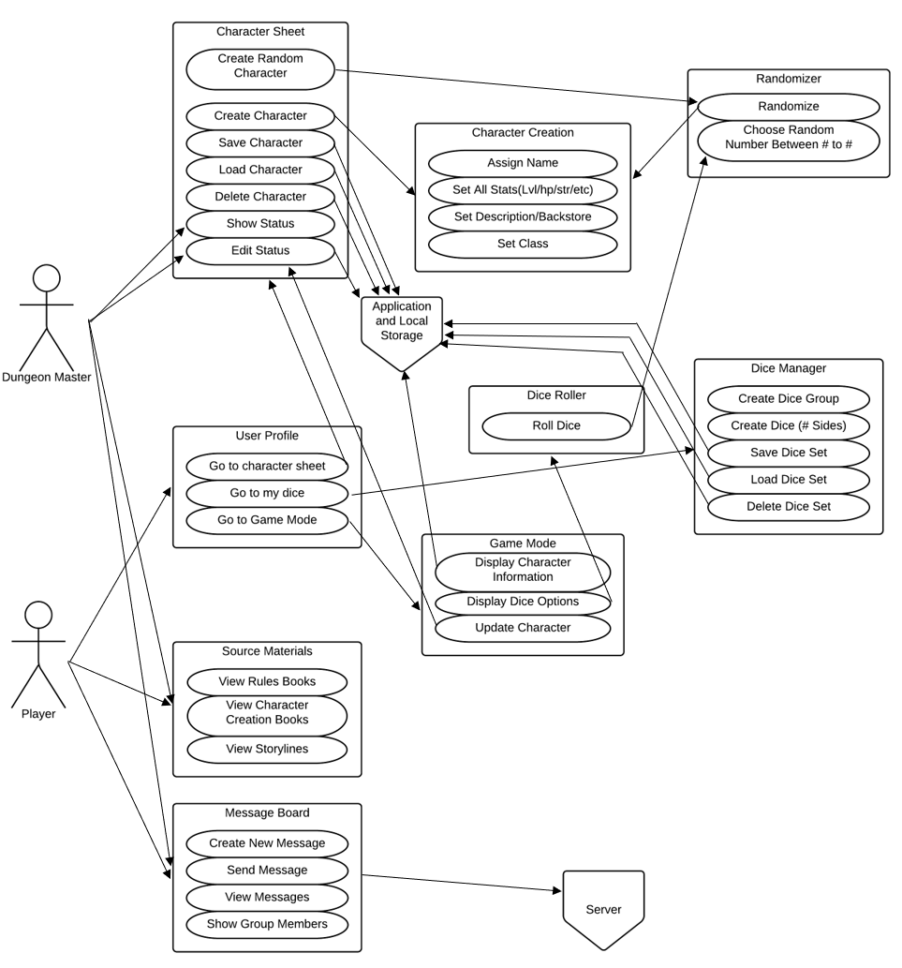

**6.2. Use Case Descriptions:**

*<One use case description per group member>*

1. Use Case: Roll Dice

Actor: Player

Description: The player hits a button and rolls a certain type of dice.

Pre-Conditions: The app is open to dice tab.

Post-Conditions: The player gets a result from the roll.

Main Flow: The player opens the dice roller section of the app. The user selects a type of dice and how many. Then the app calculates the total and returns it to the user.

2. Use Case: User Interface

Actor: Player

Description: The player interacts with the app and the different functionalities.

Pre-Conditions: The app is open.

Post-Conditions: The player interacts with the app.

Main Flow: The player interacts with the different sections of the app. The app’s user interface design is organized and responsive while being used.

3.

4.

5.

**7. User Stories:**

*<Two user stories per group member: Adopt the following format: "As a <ROLE>, I want <SOMETHING> for that <GOAL>." Priority, Hours to complete demand.>*

Remy:

* As a Dungeon Master, I want to be able to track my players’ progress for the campaign. *Priority: Medium, Hours to Complete: 10 hours.*
* As a player, I want to be able to easily see and manage my spells for that particular character. *Priority: Low, Hours to Complete: 5 hours.*

Jake:

* As a player, I want to be able to roll dice quickly and truly random. *Priority: High, Hours to Complete: 5 hours.*
* As a player, I want to be able to communicate with my Game master. *Priority: Low, Hours to Complete: 10 hours.*

Jacob:

* As a player, I want a clear, concise, and organized user interface to make the app easy to use. *Priority: High, Hours to Complete: 15 hours.*
* As a player, I want to be able to be able to receive notifications when other players message me. *Priority: Low, Hours to Complete: 5 hours.*

Justin:

* As a new player, I want to be able to choose a pre-created character, so I can get into playing the game quickly. *Priority: Low, Hours to Complete: 5 hours.*
* As a new player, I would like to be able to search for help when I have little idea what to do during the game. *Priority low, Hours to complete: 5 hours.*

**8. Trello:**

https://trello.com/b/kGudYPUZ

**Group Participation:**

*< Example: Justin Shaner: In one sentence, describe stuff done for this deliverable. (20%) >*

Joseph Eppinger:

Jake Farrar: Worked on sections regarding the case diagram, requirements, and user stories. (20%).

Remy Brandriff:

Jacob Lemon:

Justin Shaner: