

Joseph Eppinger

Jake Farrar

Remy Brandriff

Jacob Lemon

Justin Shaner

CS 386 Final Project

https://github.com/LugwellDR/CS386_TeamAvatar

**D.3 Analysis**

CS36 Software Engineering

Spring 2018

Dr. Marco Gerosa

**1. Description:**

*The following paragraphs should describe the features of our system. (Descriptions should be consistent with D.2 Stakeholders, requirements, use case, and user stories. Refine as needed.)*

*Use -***Bold-** *for a noun that is a class in our model.*

*Use -Italic- for a noun that is an attribute in our model.*

*Use -Underlined- for noun/verb that is an association in our model.*

The Dungeons and Companion app will solve the problem of not being organized when it comes to campaign materials for both players and game masters. The product will provide a centralized resource that contains a variety of tools and functions to ease of playing D&D. This app in particular will allow players of role playing games to access reference information as well as a way to aid in the creation of characters, gameplay and campaign creation.

The D&C app will contain many features. The main **interface** will act as a hub for the players and have tabs for the other functions within the program. The first tab will be called **Source Material**. This section will include *Dungeon and Dragons’ books and blank character sheets.* They can come from any version but the app will focus on material from 5e. The user will be able to view the material on the app. The next tab on the main interface will be **Personal Sheet.**  It will extend the character sheets material from the source tab. The user will be able to create character, view a character, and delete a character. Real edits to a personal character sheet will be able to be edited in real time. The next tab will be **Game.** Game will just be a way for a user to connect to a certain game with their friends. This allows for the user to connect to the message board as well. The next tab will be **Dice.** The tool will have the option to randomly roll dice and save the result to the user.

A hidden class needs to be included that is called **Random**. This will handle all the random variables throughout the app.

**2. Model:**

*Provide conceptual model of our systems as a UML class diagram.*

*Represent proper cardinalities for all associations.*

*Include association names and filled arrows to indicate the direction of the relationships.*

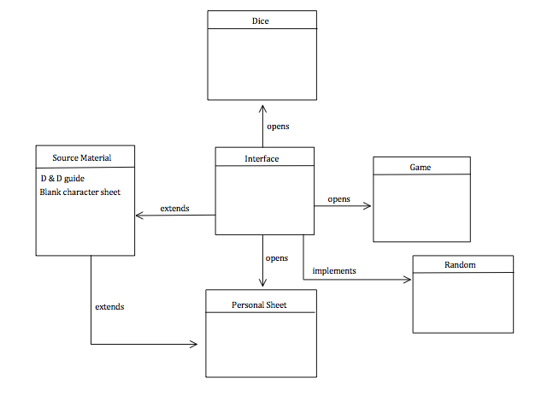

**Group Participation:**

Joseph Eppinger:

Jake Farrar: 20%, Jake did the in words writing for section one of D3

Remy Brandriff: 20%, UML class diagram

Jacob Lemon:

Justin Shaner: