**2022-2023 学年第一学期**

**《基础英语 I/ ABC》课程期末书面考查伯苓班《英语综合技能》课程期末书面考查**

Writing Test

# Read the following passage carefully and then write a thank-you letter of about 150 words in “my” name to “my” mother on Thanksgiving Day based on the given story. (25 points)

When I was young, I read a lot, but I read only comic books. My mother, who was an avid reader, tried to get me to read regular books, but they seemed boring to me. Why would anyone want to read a book without pictures, I wondered. It would be like watching a movie with your eyes closed. And novels seemed like they’d be so long and boring! In my mind, a comic book was a rollercoaster ride while a novel was five hours in rush hour traffic.

Whenever she saw me with a comic book, my mother would complain, which totally ruined my comic book reading experience. One summer, she even threatened me. “If you don’t read at least one book this summer, we’re not going to go on our camping trip,” she said. What could I do? I had been looking forward to that camping trip for months! My mother had become my own personal comic book villain!

“Fine,” I agreed, “I’ll read one book.” Gleefully, my mother took me down to her evil dungeon, the local library, where the librarian recommended *The Lion, the Witch and the Wardrobe*, the first book of *The Chronicles of Narnia* by C. S. Lewis. I reluctantly accepted the book while my mother and the librarian exchanged a conspiratorial glance.

When we got home, I cracked the book open and started reading. I figured I’d read the first few pages then skip to the end because I knew my mother would quiz me about it. Imagine my surprise when my mother called me to dinner and I was halfway through the book! If a comic book was a rollercoaster ride, this novel was all the rides at Disney World rolled into one!

I ended up reading the entire *The Chronicles of Narnia* series that summer, which I consider the start of my great friendship with books. Now I read an average of one book a week, and sometimes my wife complains that I read too much!

1. **Lu Zhi, an official in the Tang Dynasty once proposed: “What we take from nature should be well-measured, and how we use these things should be restrained**

**（取之有道，用之有节）.” What do you think of the proposal? Please write an essay of about 150 words on the topic. (25 points)**

1. **Write an essay of about 300 words based on the following drawing. In your**

**interpret its meaning,**

**describe the drawing,**

**point out its**

**essay, you should**

# (50 points)

**implications in our life.**

**and**

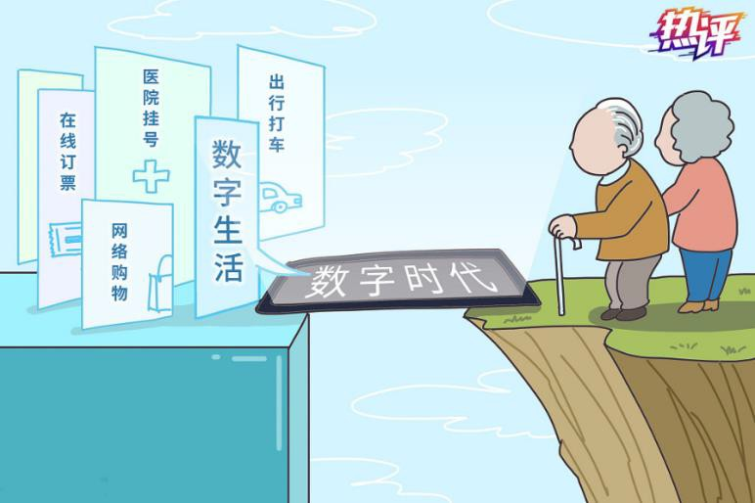

注意事项：

* 1. 答卷以 Microsoft Word 文档形式提交，文件命名方式为“班号-学号-姓名”，如“0111-

20212345-张三”。

* 1. 电子文档格式要求：A4；两端对齐；段落首行缩进 2 个字符；单倍行距；Times New Roman 字体；字号 12。