《数据库系统》2023-2024第二学期SQL考试

**样题（供练习）**

学号： 姓名： 专业：

机房号： 座位号： 分数：

注意事项：

1. 答案以Word文件的方式提交，文件名为“学号_姓名.docx”，文件放在D盘根目录下，未按照规定方式命名会影响考试成绩。
2. 每个题目的SQL语句都必须在查询分析器中调试，运行无误后提交查询的SQL语句（文字）和查询结果截图（需将SQL语句和运行结果保存在同一张截图中提交）。
3. 查询结果集中的列名必须采用查询需求中给出的列名。

**数据库模式**

**学院**（学院编号*，学院名，负责人）

**学生**（学号*，姓名，性别，年龄，身份证，学院编号+，入学日期）

**课程**（课号*，课程名，学院编号+，学分，星期，开始时间，结束时间）

**选课**（学号*+，课号*+，平时成绩，期末成绩）

注：*为主键，+为外键

**部分示例数据如下（含表名、属性名）：**

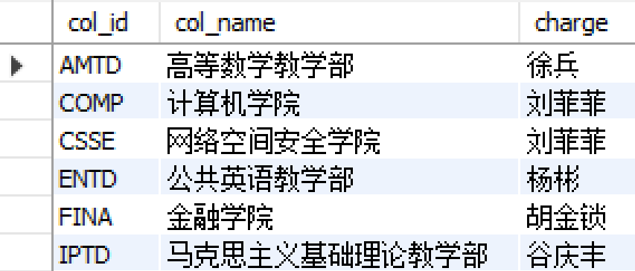 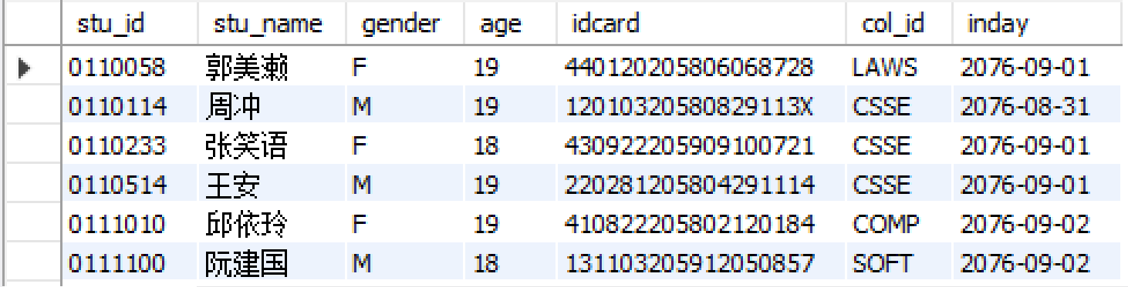

**学院（college） 学生（student）**

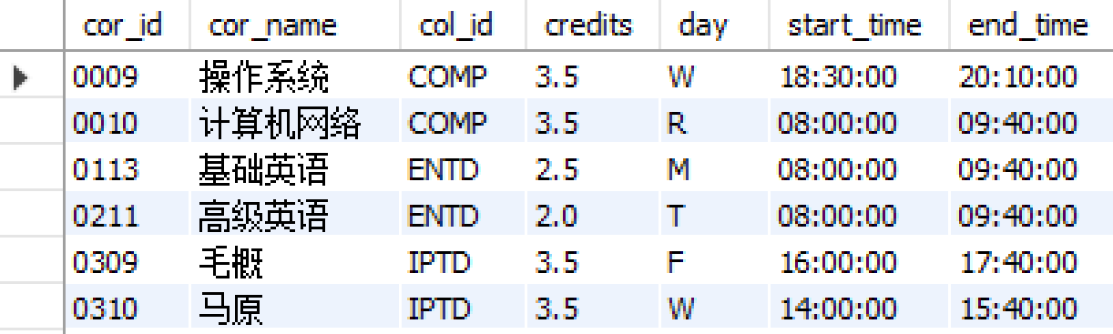 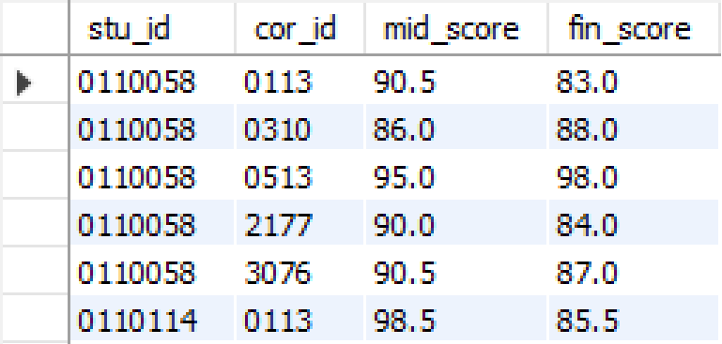

**课程（course）** **选课（takes）**

**注：以上部分示例数据仅供参考，具体的SQL语句不应该和具体的数据有关，请在答题过程中合理考虑*空值、重复值*等。题目中给出了结果模式的属性**

**1. 查询 ‘选课’ 表中所有不同的课号、平时成绩、期末成绩；要求只包括期末成绩高于平时成绩且课号大于3000的记录。（cor_id, mid_score, fin_score）（10分）**

**参考sql语句：**

|  |
| --- |
| SELECT DISTINCT cor_id, mid_score, fin_score  FROM takes  WHERE fin_score > mid_score and cor_id>3000; |

**预期结果：**

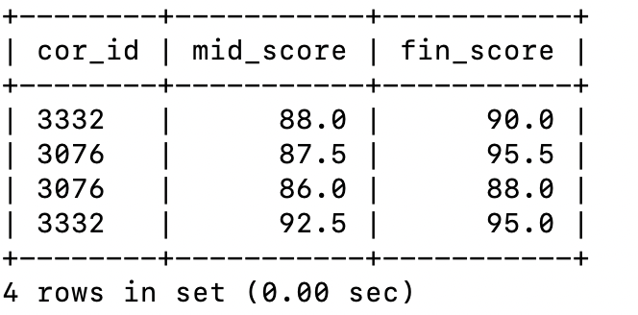

**2. 查询每个学院的学生平均年龄 (注：过滤学院编号为空的数据)。(col_id, avg_age)（10分）**

**参考sql语句：**

|  |
| --- |
| SELECT col_id, AVG(age) AS avg_age  FROM student where col_id is not null  GROUP BY col_id; |

**预期结果：**

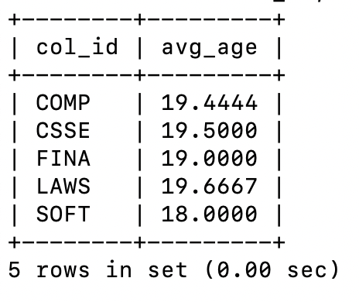

**3. 查询开设课程数量大于1门的学院编号、开设课程数量，并按课程数量从多到少排序。(col_id, cor_num)（10分）**

**参考sql语句：**

|  |
| --- |
| SELECT col_id, COUNT(*) AS cor_num  FROM course  GROUP BY col_id  HAVING cor_num>1  ORDER BY cor_num DESC; |

**预期结果：**

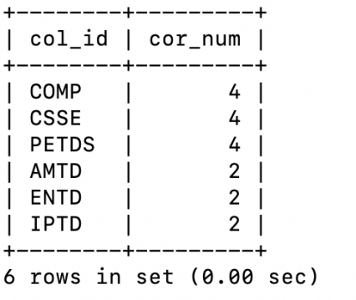

**4. 查询身份证号码中包含‘X’的学生的学号、姓名、性别、身份证号。(stu_id, stu_name, gender, idcard)（10分）**

**参考sql语句：**

|  |
| --- |
| SELECT stu_id, stu_name, gender,idcard  FROM student  WHERE idcard LIKE '%X%'; |

**预期结果：**

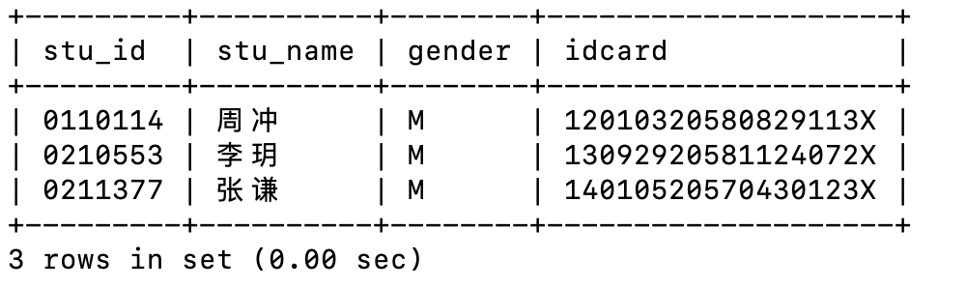

**5. 查询每门课程的平均成绩和选课人数，其中课程最终成绩=0.3*平时成绩+0.7*期末成绩，按选课人数降序。（cor_id，cor_name，avg_score，student_count）（10分）**

**参考sql语句：**

|  |
| --- |
| SELECT  c.cor_id,  c.cor_name,  AVG(0.3*t.mid_score + 0.7*t.fin_score) AS avg_score,  COUNT(t.stu_id) AS student_count  FROM  course c  LEFT JOIN  takes t ON c.cor_id = t.cor_id  GROUP BY  c.cor_id, c.cor_name  ORDER BY student_count DESC; |

**预期结果：**

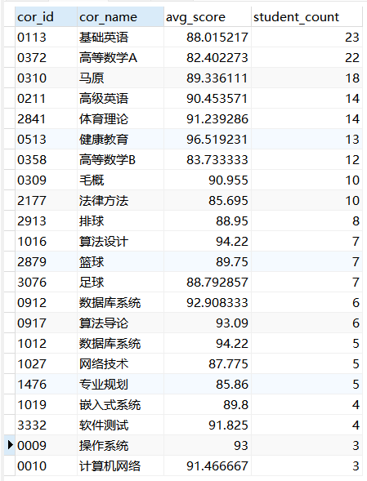

**6. 查询属于同一学院开设且在同一天上课的课程信息对儿。（cor_id, cor_name, dup_id, dup_name）（10分）**

**参考sql语句：**

select c1.cor_id,c1.cor_name,c2.cor_id,c2.cor_name

from course c1, course c2

where c1.col_id=c2.col_id and c1.day=c2.day and c1.cor_id<c2.cor_id

|  |
| --- |
| Select c1.cor_id, c1.cor_name, c2.cor_id as dup_id, c2.cor_name as dup_name  From course c1  Join course c2 on c1.cor_id <>c2.cor_id  Where c1.day=c2.day and c1.col_id=c2.col_id and c1.cor_id <c2.cor_id; |

**预期结果：**

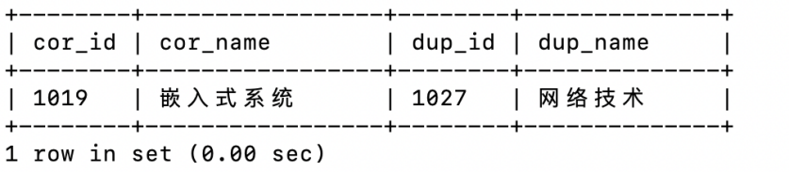

**7. 找出“高等数学A”课程成绩排名第十的学生信息，其中课程最终成绩=0.3*平时成绩+0.7*期末成绩。（stu_id，stu_name，mid_score，fin_score）（10分）**

**参考sql语句：**

|  |
| --- |
| SELECT t1.stu_id, s.stu_name, t1.mid_score, t1.fin_score  FROM takes t1  INNER JOIN student s ON t1.stu_id = s.stu_id  INNER JOIN course c ON t1.cor_id = c.cor_id  WHERE c.cor_name = '高等数学A'  AND (  SELECT COUNT(*)  FROM takes t2  INNER JOIN course c2 ON t2.cor_id = c2.cor_id  WHERE c2.cor_name = '高等数学A' AND ((t2.mid_score * 0.3) + (t2.fin_score * 0.7)) > ((t1.mid_score * 0.3) + (t1.fin_score * 0.7))  ) = 9; |

**预期结果：**

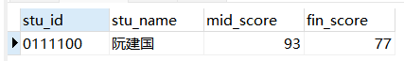

**8. 查询所有没在周末（周末对应星期属性值为S）开设课程的学院的学院编号、学院名。（col_id, col_name）(10分)**

**参考sql语句：**

|  |
| --- |
| SELECT c.col_id,col_name  FROM college c  WHERE NOT EXISTS (  SELECT *  FROM course cou  WHERE cou.col_id = c.col_id and day= 'S');  或者  Select col_id,col_name  From college  Where not exists (  Select 1  From course  Where college.col_id=course.col_id  And day= 'S'); |

**预期结果：**

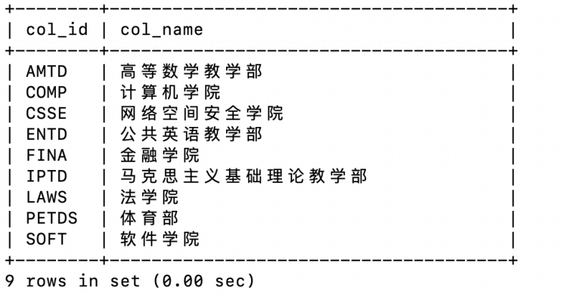

**9. 查询至少选修了6门课程的学生的学号、姓名。（stu_id, stu_name）(10分)**

**参考sql语句：**

|  |
| --- |
| SELECT  s.stu_id,  s.stu_name  FROM  student s  JOIN (  SELECT  sc.stu_id  FROM  takes sc  GROUP BY  sc.stu_id  HAVING  COUNT(sc.cor_id) >= 6  ) AS subquery ON s.stu_id = subquery.stu_id; |

**预期结果：**

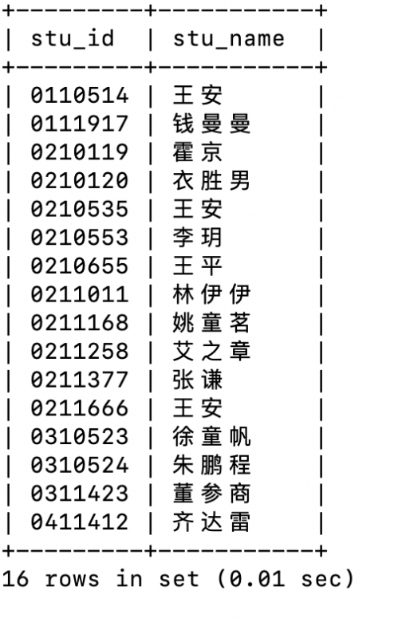

**10. 查询至少选修了一门课程的学生的学号、姓名、学院编号以及他们的加权平均分，并且按照加权平均分从高到低排序。其中，加权平均分计算方式：[(课程A期末成绩*课程A学分)+ (课程B期末成绩*课程B学分)] / 总课程学分。（stu_id, stu_name, col_id, w_score）（10分）**

**参考sql语句：**

|  |
| --- |
| SELECT  s.stu_id,  s.stu_name,  s.col_id,  SUM(sc.fin_score * c.credits) / SUM(c.credits) AS w_score  FROM  student s  JOIN  takes sc ON s.stu_id = sc.stu_id  JOIN  course c ON sc.cor_id = c.cor_id  GROUP BY  s.stu_id, s.stu_name, s.col_id  HAVING  SUM(c.credits) > 0  ORDER BY  w_score DESC; |

**预期结果：**

