1. 找出名字中包含“刘”的所有员工号和员工名称**(empno, empname)**

select empno,empname

from employee

where empname like '刘%'

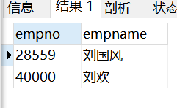

1. 找出1999-01-01前参与过项目“网络布线”的员工**(empno, empname)**

select empno,empname

from employee natural join workson natural join project

where enterdate<'1999-01-01' and projectname='网络布线'

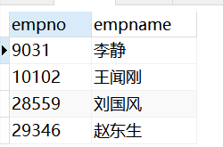

1. 统计每个部门中参与项目最少的员工

**(deptno, deptname,empno, empname, projectcount)**

select *

from (select deptno, deptname,empno, empname, count(projectname)as projectcount from employee natural join workson natural join department natural join project group by empno) as t1

where projectcount<=all

(

select projectcount

from (select deptno, deptname,empno, empname, count(projectname)as projectcount from employee natural join workson natural join department natural join project group by empno) as t2

where deptno=t1.deptno

)

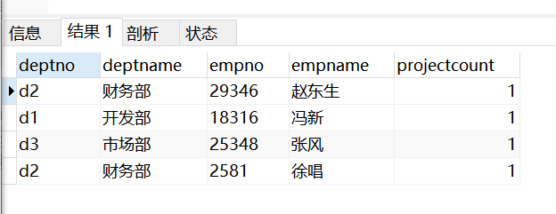

1. 找出有未安排职务(job)的员工的项目**(projectno, projectname)**

select projectno, projectname

from workson left outer join employee on workson.empno=employee.empno

natural join project

where job is null

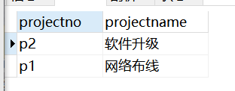

1. 找出所在地不在“广东”且员工数不是最多的部门**(deptno,deptname,location)**

select deptno,deptname,location

from

(select deptno,deptname,location,count(empno)as num

from department natural join employee

group by deptno) as t

where location<>'广东' and num<any

(

select count(empno)

from department natural join employee

group by deptno

)

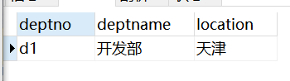

1. 找出所有参与过两个或两个以上项目的员工**(empno, empname)**

select empno,empname

from employee natural join workson

group by empno

having count(projectno)>=2

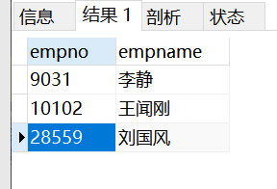

1. 列出每个项目的员工数**(projectno, projectname, empcount)，**按照员工数由大到小排序，没有员工参与的项目，员工数显示为0，显示为NULL或不显示的不给分

本题使用一种方法且正确即可得满分，使用两种方法可加分

提示：方法一使用outer join；方法二使用inner join 和union

select project.projectno,projectname,count(empno) as empcount

from project left outer join workson on workson.projectno=project.projectno

group by project.projectno

order by empcount desc

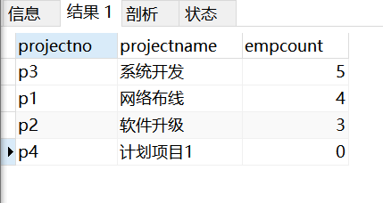

1. 找出每个项目中入职时间最早的员工**(projectno, empno)**

select projectno,empname

from workson w1 natural join employee

where w1.enterdate<=all

(

select enterdate

from workson

where projectno=w1.projectno

)

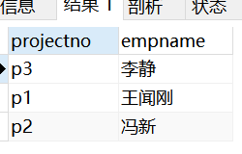

1. 找出预算超过所有项目平均预算数的项目**(projectno，budget)**

select projectno,budget

from project

where budget>all

(select avg(budget) from project)

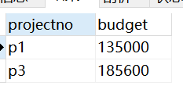

1. 找出除了”信息技术部”外，所有部门都参与了的项目**(projectno,projectname)**

select projectno,projectname

from

(

select project.projectno,projectname,count(employee.deptno) as deptcount

from

department left outer join employee on department.deptno=employee.deptno

and department.deptname<>'信息技术部'

left outer join workson on employee.empno=workson.empno

left outer join project on project.projectno=workson.projectno

group by project.projectno

) as t1

where deptcount=

(

select count(*)

from project

)

