1. 找出所有参与项目“网络布线”的员工**(empno, empname)**

select empno,empname

from employee natural join workson natural join project

where projectname='网络布线'

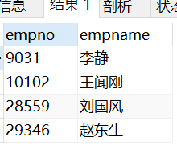

1. 找出只参加过一个项目的员工**(empno,empname)**

select empno,empname

from (select empno,empname,count(distinct projectno) as pnum

from employee natural join workson

group by empno) as t

where pnum=1

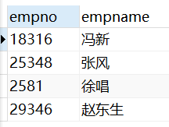

1. 统计每个部门中参与项目最多的员工

**(deptno, deptname, empno, empname, projectcount)**

select deptno, deptname, empno, empname,projectcount

from

(select deptno, deptname, empno, empname, count(projectno)as projectcount

from workson natural join employee natural join department

group by empno)as t1

where projectcount>=all

(

select count(projectno)

from workson natural join employee natural join department

where deptno=t1.deptno

group by empno

)

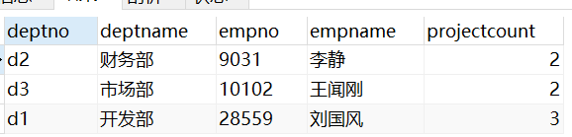

1. 找出拥有最多工作为“职员”的员工的项目**(projectno, projectname,职员人数)**

select projectno,projectname,max(empcount) as 职员人数

from

(select projectno,projectname,count(empno) as empcount

from workson natural join project

group by workson.projectno) as t

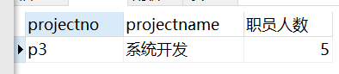

⬆⬆⬆这么写不对！！！！！！

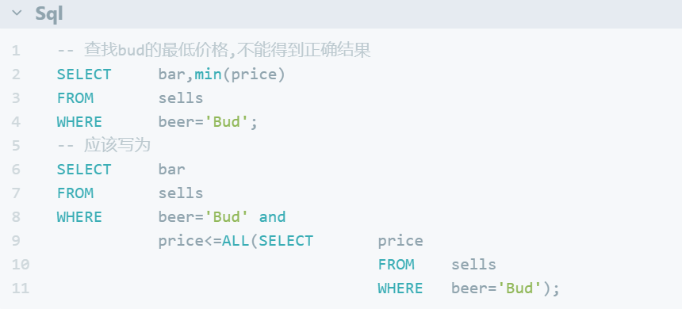

应该写为

select projectno,projectname,empcount as 职员人数

from

(select projectno,projectname,count(empno) as empcount

from workson natural join project

where job='职员'

group by workson.projectno

) as t

where empcount>=all

(

select count(empno) as empcount

from workson natural join project

where job='职员'

group by workson.projectnoa

)

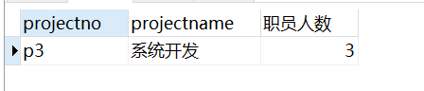

1. 统计每个地区的员工数**(location, empcount)**

select location,count(empno) as empcount

from department left outer join employee

on department.deptno=employee.deptno

group by location

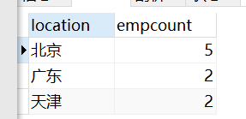

1. 列出每个部门的员工数**(deptno, deptname, empcount)，**按照员工数由大到小排序，没有员工参与的部门，员工数显示为0，显示为NULL或不显示的不给分

本题使用一种方法且正确即可得满分，使用两种方法可加分

提示：方法一使用outer join；方法二使用inner join 和union

select department.deptno,deptname,count(empno) as empcount

from department left outer join employee

on employee.deptno=department.deptno

group by department.deptno

order by empcount desc

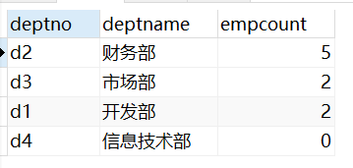

(select department.deptno,deptname,count(empno) as empcount

from department inner join employee

on employee.deptno=department.deptno

group by department.deptno

order by empcount desc)

union

(

select department.deptno,deptname,0 as 'empcount'

from department

where deptno not in

(

select deptno

from

(select deptno,count(empno)

from department natural join employee

group by deptno

having count(empno)<>0

) as t

)

)

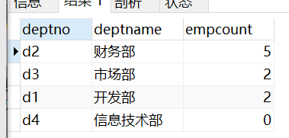

1. 假设每个项目预算的10%用来发奖金，请计算每个项目的人均奖金数**(projectno,人均奖金)**，没有员工的项目不用显示

select projectno, budget/count(empno)*0.1 as 人均奖金

from project natural join workson

group by projectno

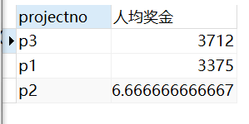

1. 找出1998-01-01之后参与过项目“系统开发”的员工**(empno, empname)**

select empno,empname

from employee natural join workson natural join project

where enterdate>='1998-01-02' and projectname='系统开发'

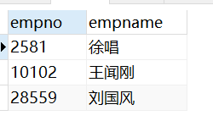

1. 找出每个项目中入职时间最晚的员工**(projectno, empno)**

select projectno,empno

from workson w

where enterdate>=all

(

select enterdate

from workson

where projectno=w.projectno

)

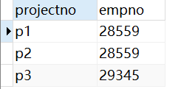

1. 列出每个部门参与的项目数**(deptno, deptname, projectcount)，**没有参与项目的部门其项目数显示为0，显示为NULL或不显示的不给分

select department.deptno,deptname,count(distinct projectno) as projectcount

from department left outer join employee on department.deptno=employee.deptno

left outer join workson on employee.empno=workson.empno

group by department.deptno

