1. 给出职工中所有男性的所有信息（empid,empname,age,sex,depid）

select empid,empname,age,sex,depid

from employee

where sex='男';

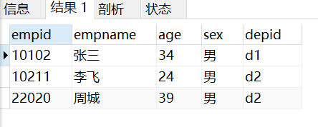

1. 统计来自天津的“李”性职工信息，按年龄降序排序。（empid,empname,age,location）

select empid,empname,age,location

from employee natural join department

where empname like '李%' and location='天津'

ORDER BY age desc;

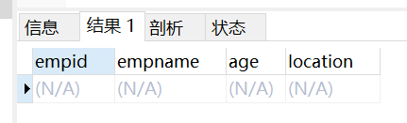

1. 给出每位职员参与项目的最高预算和最低预算（empname，highestbudget，lowestbudget）

select empname,max(budget) as highestbudget,

min(budget) as lowestbudget

from employee natural join workson natural join project

group by empname

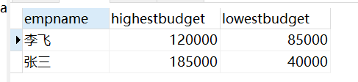

1. 给出所有项目超过一个的员工的id和参加的项目个数

select empid,count(\*)

from employee natural join workson natural join project

group by empid

having count(\*)>1;

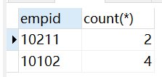

1. 给出项目编号为“c2”且预算最多的项目。（proid，projectname，budget）

select proid,projectname,max(budget) as budget

from project

where catid='c2';

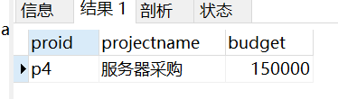

1. 给出参加“产品推广”项目，但不担任职位的员工的员工信息，（empid,empname，age,sex.depid）

select empid,empname,age,sex,depid

from employee

where empid in(

select empid

from project natural join workson

where projectname='产品推广' and job is null

);

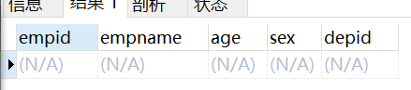

1. 给出工号为“10102”的员工每类项目的参加总数，若没有参加过某类项目，则参加项目总数显示为0（catid，proNum）注意，即使是相同的列明，不同的表count出来结果也不相同

select category.catid, count(workson.proid) as proNum

from category left outer join project on category.catid=project.catid

left outer join workson on workson.proid=project.proid and workson.empid='10102'

group by category.catid;

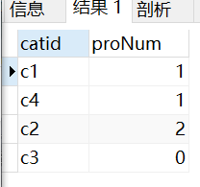

1. 给出没有参与“软件类”项目女性职工的信息（empid,empname, age,sex,depid)

select empid,empname,age,sex,depid

from employee

where sex='女' and empid not in(

select empid

from workson natural join project natural join category

where catname='软件类'

);

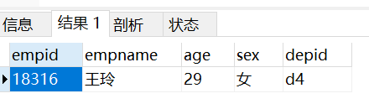

1. 给出有30岁以上男性员工的省份名称和该省男员工最大年龄，结果按最大年龄升序排序（location，maxAge）

select location,max(age) as maxAge

from employee natural join department

where location in(

select location

from employee natural join department

where age>30 and sex='男'

)

group by location

order by maxAge desc

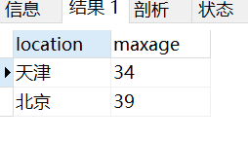

;

1. 给出在广州工作的、参加“'产品推广'”项目的职员id、姓名及他们参加的项目个数

select empid,empname,count(distinct proid)

from employee natural join department natural join workson natural join project

where empid in

(

select empid

from workson natural join project natural join category natural join employee natural join department

where location='广州' and projectname='产品推广'

)

group by empid

