

SELECT empno,empname

FROM employee

WHERE empname like '%刘%'

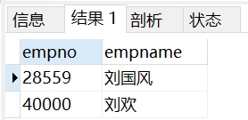



SELECT empno,empname

FROM workson natural join project natural join department natural join employee

WHERE enterdate<'1999-01-01 00:00:00' AND projectname='网络布线'

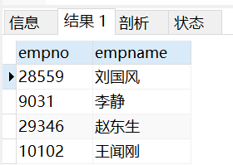

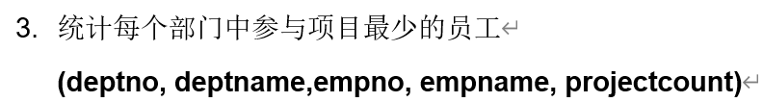

SELECT d1.deptno,d1.deptname,empno,empname,count(projectno) as projectcount

FROM workson natural join employee natural join department d1

GROUP BY empno

HAVING count(projectno)<=ALL(

SELECT count(projectno)

FROM workson natural join department d2 natural join employee

WHERE d1.deptno=d2.deptno

GROUP BY empno

)

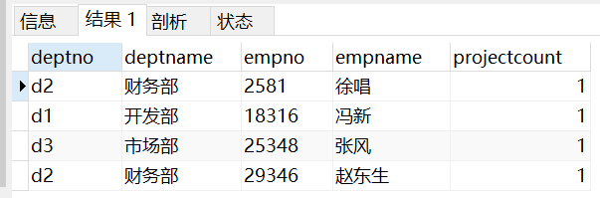



SELECT projectno,projectname

FROM(

SELECT distinct projectno

FROM workson

WHERE job IS NULL

) as son1 NATURAL JOIN project

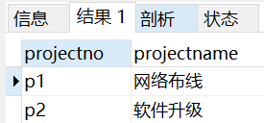



SELECT deptno,deptname,location

FROM department natural join(

SELECT deptno

FROM employee

GROUP BY deptno

HAVING count(\*)< ANY (

SELECT count(\*)

FROM employee

GROUP BY deptno

)

) as son1

WHERE location<>'广东'

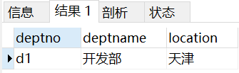



SELECT empno,empname

FROM employee natural join workson

GROUP by empno

HAVING count(projectno)>=2

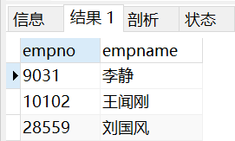

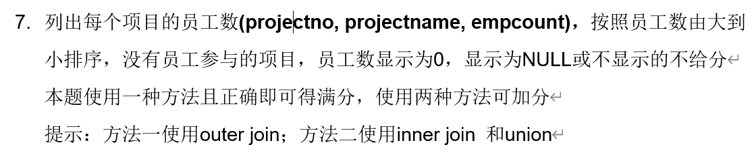

SELECT project.projectno,projectname,count(empno)as empcount

FROM workson RIGHT OUTER JOIN project on workson.projectno=project.projectno

GROUP BY project.projectno

ORDER BY empcount desc

(

SELECT projectno,projectname,count(empno) as 'empcount'

FROM workson natural join project

GROUP BY projectno

ORDER BY empcount DESC)

union

(

SELECT projectno,projectname,0 as 'empcount'

FROM project

WHERE projectno not in(

SELECT projectno

FROM workson natural join project

GROUP BY projectno

HAVING count(empno)>0

)

)

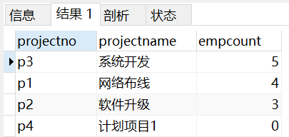



SELECT projectno,empno

FROM workson w1 natural join employee

WHERE w1.enterdate<=ALL(

SELECT enterdate

FROM workson w2

WHERE w1.projectno=w2.projectno

)

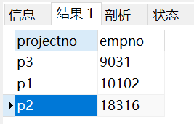



SELECT projectno,budget

FROM project

WHERE budget>(

SELECT AVG(budget)

FROM project)

