

SELECT empno,empname

FROM employee

WHERE empno in(

SELECT empno

FROM workson natural join project

WHERE projectname='网络布线'

)

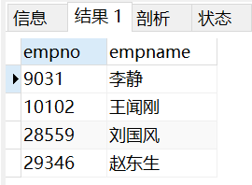



SELECT empno,empname

FROM workson NATURAL JOIN employee

GROUP BY empno

HAVING count(projectno)=1

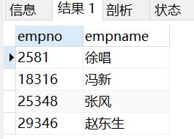



SELECT projectno,projectname,count(\*) as '职员人数'

FROM(

SELECT \*

FROM workson NATURAL JOIN project

WHERE job='职员'

) as son1

GROUP BY projectno

HAVING count(\*)>= ALL(

SELECT count(\*)

FROM(

SELECT \*

FROM workson NATURAL JOIN project

WHERE job='职员'

) as son2

GROUP BY projectno

)

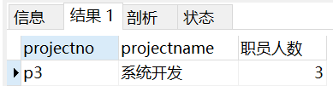



SELECT location,count(\*) AS empcount

FROM employee NATURAL JOIN department

GROUP BY location

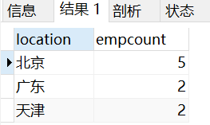



SELECT projectno, budget/count(\*) as '人均奖金'

FROM project NATURAL JOIN workson

GROUP BY projectno

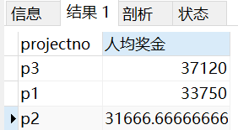



SELECT empno,empname

FROM workson NATURAL JOIN employee NATURAL JOIN project

WHERE enterdate>'1998-01-01 23:59:59' AND projectname='系统开发'

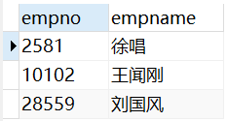



SELECT projectno,empno

FROM workson w1

WHERE w1.enterdate>= ALL(

SELECT enterdate

FROM workson w2

WHERE w1.projectno=w2.projectno

)

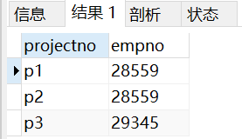



SELECT department.deptno,deptname,count(projectno) as projectcount

FROM department

LEFT OUTER JOIN employee ON department.deptno=employee.deptno

LEFT OUTER JOIN workson ON workson.empno=employee.empno

GROUP BY deptno

