Advanced Digital System Development Using MATLAB, C and VHDL

Thiago Alves Mendes do Amaral
Luiz Henrique Antoniassi Santos
Felipe Fazio da Costa
Vanderlei Cunha Parro

2026/02/06
Summary

1 Introduction 3
2 HDL and VHDL Languages 4
2.1 Verilog and SystemVerilog Languages 4
2.2 VHDL Language 5
3 C Language and RTOS 31
3.1 C Language 31
3.2 RTOS e o FreeRTOS Systems 46
4 Neural Networks and PINNs 66
4.1 The Neural Networks and MLPs 66
5 Conclusion 81
6 Referências 82

Introduction
This handbook’s main objective is to introduce the reader to the key development tools and coding practices for embedded electronic systems in the current context (as of the year 2026).
Embedded electronic systems are deeply integrated into the daily life of modern individuals and into several other advanced applications, including the industrial, academic, and even aerospace sectors. All of these applications bring together hardware and software components, whose main characteristics and key points will be addressed in this document.
From this perspective, each chapter of this handbook will cover—at a sufficient level—the technologies necessary for understanding, building, and developing modern embedded systems, bringing together:
- What hardware description languages (HDLs) are, and their importance and impact on the development of advanced embedded systems.
- How the C language integrates into embedded systems development, what a Real-Time Operating System (RTOS) is, and its respective importance.
- How neural networks — and, more specifically, Physics-Informed Neural Networks (PINNs) — can be implemented on embedded electronic systems.

All topics discussed are accompanied by short demonstrations and tutorials, intended to illustrate each problem and theoretical aspect presented. All demonstrations are available in a public GitHub repository, at the following link.
By the end of reading this handbook—together with executing and understanding its examples—it is expected that a reader who initially had little prior knowledge will develop a solid ability to understand and build embedded systems using the techniques and tools presented in this manuscript. However, if the reader intends to delve deeper into the subject, it is recommended to consult other, more extensive and specialized references—both theoretical and practical.

HDL and VHDL Languages
In this chapter, we will discuss what HDL (Hardware Description Language) languages are and, more specifically, VHDL (VHSIC Hardware Description Language).
HDL languages are used to describe advanced digital electronic circuits in text/code form. In the context of digital signal processing (DSP) or high-performance computing (HPC), they are essential for specifying complex systems that perform specific tasks, such as real-time processing of sensor data, parallel and intensive processing of large data loads from the internet, among others.
Currently, the HDL languages most widely used for designing integrated circuits (ICs), ASICs, and even processor or microcontroller chips are VHDL, Verilog, and SystemVerilog.

Verilog and SystemVerilog Languages
Verilog is a hardware description language invented between 1983 and 1984. Its inventors are Prabhu Goel, Phil Moorby, and Chi-Lai Huang. It is a language that resembles the C programming language. Verilog is also widely used for the development of ASICs and digital circuits on FPGAs. Verilog is primarily used within Cadence development tools for ASIC (Application-Specific Integrated Circuit) design. Its variant, Verilog-A, is used to model analog circuits through Laplace-domain functions, and it is also possible to simulate digital circuits.
On the other hand, SystemVerilog is a hardware description language with a higher level of abstraction compared to Verilog. Created around the year 2000, it is mainly used for verification and for building testbenches for circuit descriptions implemented in other HDL languages.
Although they are widely used in many fields for the development and creation of embedded systems, they will not be covered in this manuscript, leaving room for VHDL, which is discussed in the next subsection.

VHDL Language
VHDL is one of the most important HDL languages for describing advanced digital circuits and, subsequently, synthesizing them. Therefore, it is not a programming language!
The VHDL language was developed by the United States Department of Defense—DARPA—out of the need to document and design ASIC (Application-Specific Integrated Circuit) circuits in a fast, secure, and efficient way. This language was also conceived with simulation in mind, enabling validation of the described digital circuits during the conceptual design stages.
Initially, its intellectual property was granted to a few companies, such as IBM, Texas Instruments, and Intermetrics. This initiative aimed to develop the language and supporting tools that used it for the design of advanced digital circuits.
Later, the IEEE took over the development and standardization of VHDL, with the first standard being IEEE 1076-1987, released in 1987. Currently, the latest standard released by the institute is IEEE 1076-2019.
Due to its robustness combined with strong typing and efficiency, VHDL will be the HDL language covered in this manuscript, alongside the other technologies addressed. This text does not aim to present all the features and syntax of the language in an extensive way; rather, it introduces VHDL at an introductory level, sufficient to understand its application in the development of advanced embedded electronic systems.
Next, a few examples of code and circuits described in VHDL will be presented, using them as a basis to introduce the reader to the language and its principles.
THEORETICAL EXAMPLE 1 – COMBINATIONAL CIRCUIT IN VHDL

The code below creates a VHDL module responsible for performing two fundamental operations in the digital domain: an OR and an AND.
library IEEE;
use IEEE.STD_LOGIC_1164.ALL;

-- Entity declaration
entity Example_1 is
Port (
inputA : in STD_LOGIC;
inputB : in STD_LOGIC;
outputA : out STD_LOGIC;
outputB : out STD_LOGIC;
);
end Example_1;

-- Architecture definition
architecture Behavioral of Example_1 is
begin
outputA <= inputA AND inputB;
outputB <= inputA OR inputB;
end Behavioral;

In summary, any VHDL code is composed of one or a set of modules. Each module represents a logical unit of a described digital circuit. Analogously, it can be illustrated as a simple integrated circuit, bringing together its interface pins and configuration (called the entity) and its internal logic (called the architecture).

The module’s entity is responsible for defining its main characteristics with respect to the other modules in the described digital circuit, bringing together its interface pins (called ports) and its configuration parameters (called generics).
In the example code, the entity Example_1 is declared with no associated generics, with input ports inputA and inputB, and output ports outputA and outputB. It is also important to note that all described ports have an associated type. In this example, all of them are of type STD_LOGIC—a type from the IEEE library that, in digital logic, represents a single bit. Additional care must be taken when working with STD_LOGIC variables, but under normal conditions it assumes the values '0' or '1'.
Next, an architecture named Behavioral is defined and then associated with the entity Example_1 of the module. In this architecture, outputA is defined to always present the result of an AND between inputA and inputB, while outputB always receives the result of an OR between inputA and inputB.
The operator <= is used to assign a value to a port or to a signal within the architecture. When used on its own—i.e., outside any other block—it represents a direct connection between the signal or port on the left-hand side and the logic on the right-hand side of the operator. Therefore, the module represented by the code figuratively describes the logic circuit shown in Figure 1.
Figure 1 — Graphical representation of the logic circuit described in Example 1.
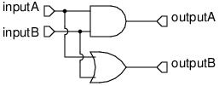
Source: The Authors.

Since it does not explicitly depend on a synchronization source (clock) or on timing, the described circuit is said to be purely combinational. Therefore, the circuit has no “memory”, relying only on its current inputs to determine its outputs.

Empirically, the code that describes the circuit in Theoretical Example 1 above provides, by itself, sufficient information to isolate the circuit’s expected behavior. Thus, regardless of which input signals are applied, the module’s output will always conform to the logic circuit illustrated in Figure 1.
Therefore, this module could be simulated with the aid of a specialized tool, such as Modelsim or Vivado. This simulation, by arbitrarily setting the module’s input signals, would be able to validate its expected behavior, representing the module’s input and output ports and its associated signals through timing diagrams. In the practical examples of this section, this capability will be explored in greater depth.

THEORETICAL EXAMPLE 2 – SEQUENTIAL CIRCUIT IN VHDL

The example VHDL code shown below represents a simple 8-bit register.
library IEEE;
use IEEE.STD_LOGIC_1164.ALL;
use IEEE.NUMERIC_STD.ALL;

entity register_top_level is
Port (
clk : in STD_LOGIC;
reset : in STD_LOGIC;
enable : in STD_LOGIC;
input : in STD_LOGIC_VECTOR(0 to 7); -- 8 bits LITTLE ENDIAN
output : out STD_LOGIC_VECTOR(0 to 7) -- 8 bits LITTLE ENDIAN
);
end register_top_level;

architecture Behavioral of register_top_level is

signal s_output: std_logic_vector(0 to 7);

begin
process_register: process(clk, reset)
begin
if reset = '1' then
s_output <= (others => '0');
elsif rising_edge(clk) then -- or event'clk and clk='1' then
if enable = ‘1’ then
s_output<= input;
end if;
end if;
end process;
output <= s_output;
end Behavioral;

The module, through its register_top_level entity, implements all the ports typical of a simple 8-bit register: its clock, an enable signal, a reset signal, and its input and output ports for the stored data.
Its architecture, in turn, presents important characteristics of a sequential circuit. First, it implements an auxiliary signal called s_output. This signal is responsible for storing the information written into the register throughout its operation and, therefore, it is an 8-bit STD_LOGIC_VECTOR.
It also implements a new functional block: a process. In general terms, a process allows the sequential execution of a set of assignments, enabling even repetition loops and conditional structures (such as if and else). All assignments inside the process are “executed” whenever any signal in its sensitivity list changes. In this case, the sensitivity list of the process_register process includes only the module’s clock and reset ports.
Finally, it is easy to see that the implemented process mimics the behavior of a classic register: if the reset signal is active, it clears the stored value. If reset is not active and enable is asserted on a rising edge of the clock, the value of s_output momentarily takes on the input value.
Even though we define the logic for s_output, its value must still be associated with the module’s output port, which happens outside the process—since it does not depend on sequential behavior and always assumes that value.

The two theoretical examples presented are sufficient to explain VHDL’s capabilities and to illustrate part of its syntax and main characteristics. Virtually any possible digital circuit, including CPUs and even GPUs, can be coded in VHDL, often bringing together multiple grouped modules.
It is expected that the reader, by following the sections ahead, will already have a significant level of knowledge and familiarity with VHDL. Studying and understanding the examples shown above is, in many cases, sufficient—provided that all the concepts addressed have been fully understood. Although the main focus is not the language itself, but rather what is developed through its use, it is important to know its structures and their respective roles in a specific piece of code. To learn a bit more about the language, the following physical and digital resources are recommended:

2.3 Practical Examples with VHDL and MATLAB

After introducing HDL languages—and, more specifically, VHDL—to the reader, this section will address some practical examples of using this language for the design of embedded systems and more complex modules, covering important engineering topics. The aim of this section is to provide the reader with the necessary tools for building, simulating, and validating these systems.
The first example will cover the design of a moving-average filter using only the VHDL language and the Modelsim simulation tool. This example will show how such a filter can be coded in the language and simulated using the adopted auxiliary tools.
The second example will cover the design and validation of an FIR (Finite Impulse Response) filter with the help of MATLAB tools. Initially, the goal of this example is to introduce the reader to using MATLAB to create and tune more complex digital filters, which can eventually be transferred to embedded-system languages such as VHDL and C.

PRACTICAL EXAMPLE 1 – MOVING AVERAGE FILTER IN VHDL

Basically, a moving-average filter is applied to digital signals with the goal of “smoothing” them. The filter’s output, at any given moment in time, takes the value of the average of the last n samples of the filtered signal, as shown in Equation 1 below.

 | $$y\left[k\right]=\frac{1}{n}⋅\sum_{i=0}^{n}{x\left[k-n\right]}$$ | (1)

Let y[k] be the value of the moving-average filter at sample k, and x[k] the value of the filtered signal at an arbitrary sample k. By carrying out a more refined analysis of the difference equation in question—particularly by using the Z-transform—it is possible to verify that this filter behaves as a low-pass filter. This explains its characteristic “smoothing” behavior on a signal—in other words, it filters out the higher-frequency components of the time series.
In VHDL, the filter can be represented as a combination of a combinational circuit and a sequential one: the sequential circuit is responsible for storing the last n samples of the digital signal, while the combinational circuit is responsible for the actual computation of the average of the stored samples. With this in mind, the code below can be developed.
library IEEE;
use IEEE.STD_LOGIC_1164.ALL;
use IEEE.NUMERIC_STD.ALL;

entity moving_average is
Port (
clk : in STD_LOGIC;
rst : in STD_LOGIC;
inputA : in STD_LOGIC_VECTOR(7 downto 0); -- 8 bits
average : out STD_LOGIC_VECTOR(7 downto 0) -- 8 bits
);
end entity moving_average;

architecture Behavioral of moving_average is

type bufferA is array(0 to 3) of unsigned(7 downto 0); --memory sram for 4 samples
signal m_bufferA :bufferA;
signal sum : unsigned(9 downto 0); -- 4 * 255 = 1020

begin
process(clk, rst)
begin
if rst = '1' then
m_bufferA(0) <= (others => '0');
m_bufferA(1) <= (others => '0');
m_bufferA(2) <= (others => '0');
m_bufferA(3) <= (others => '0');
sum <= (others => '0');
avarage <= (others => '0');
elsif rising_edge(clk) then

In essence, in the VHDL module shown, the input signal is digitally represented by 8 bits and is named inputA, and the filter’s output signal is called average, also 8 bits wide. The value of n adopted for the filter is arbitrarily chosen as 4 in order to make its implementation easier.
-- shift the buffer
m_bufferA(3) <= m_bufferA(2);
m_bufferA(2) <= m_bufferA(1);
m_bufferA(1) <= m_bufferA(0);
m_bufferA(0) <= unsigned(inputA);

-- sum the values in the buffer
sum <= ("00" & m_bufferA(0)) + ("00" & m_bufferA(1)) + ("00" & m_bufferA(2)) + ("00" & m_bufferA(3));

-- avarage calculation
average <= std_logic_vector(sum(9 downto 2)); -- sum >> 2, divide by 4
end if;
end process;

end architecture Behavioral;
In summary, the last n values of inputA are stored in the signal m_bufferA. Then, the sum of these n values is stored in a variable of type unsigned—which allows simple integer arithmetic operations such as addition and subtraction—named sum. Finally, an integer division is applied to the variable sum, and the resulting value is assigned to the filter output at the average port.
In order to test and validate the operation of the created HDL module, it is necessary to design a testbench. A testbench is generally implemented as another HDL module, but without any ports. In short, the testbench aims to establish the boundary conditions of the module by simulating its nominal operation. For this reason, it has no input or output ports. The HDL code named tb_moving_average.vhd can be viewed in the folder 1_LINGUAGENS_HDL_E_VHDL in the GitHub repository.
Essentially, the testbench stimulates the created module with a clock of an arbitrary period and with some arbitrary input values, enabling the validation of its output signal against known values. To allow them to be tested together, both the module and its respective testbench must be loaded into an HDL simulation tool—in this case, Modelsim.
To download and install Modelsim, simply follow the instructions provided by Altera on that web page. The only additional note regarding the installation process is that the reader should choose to install the “Modelsim – Intel FPGA Starter Edition” version, which does not require any additional license to use.
After installing Modelsim, in order to enable the files to be simulated, a few steps must be followed:
- First, the user should launch the installed Modelsim software and enter its main menu.
- Next, they should click File >> New >> Project, then select the default options for creating a project and choose any name, such as “proj_moving_average”.
- After that, the reader should import the files tb_moving_average.vhd and moving_average.vhd from the manuscript’s GitHub repository, located in the 1_LINGUAGENS_HDL_E_VHDL folder. To do so, they should use the Add Existing File option that appears in the project creation environment in Modelsim.
- After adding the files, they must be compiled. This ensures that no errors are present in the created HDL module code. To do so, click the Compile All button, as shown in Figure 2 below, at least twice.
Figure 2 — Button Compile All.
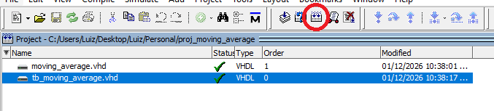
Source: the authors.

- After that, the reader should click the Simulate button, immediately to the right of the previously clicked button. In the pop-up window that opens, the user should expand the work tab and look for the tb_moving_average.vhd module, select it, and click OK.
- The Modelsim simulation window will then open. To view the simulated timing diagram for the module and its testbench, the reader should right-click on the tb_moving_average module and then choose Add Wave, as shown in Figure 3 below.
Figure 3 — Add Wave Option.
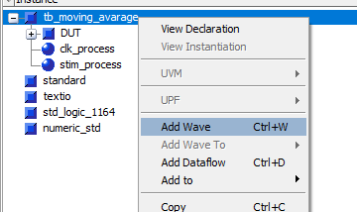
Source: The authors.

- Finally, a timing-diagram window will open in the software. This window requires that a simulation time setting be defined. To do so, set a simulation time window of 135 ns, as shown in Figure 4 below.

Figure 4 — Simulation time configuration
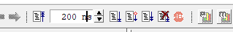
Source: the authors.

- Now, for the simulation to run, simply click the Run button, located immediately next to the simulation time setting. After that, the timing diagram for the signals configured with the Add Wave option is generated. It is recommended to zoom out on the generated view using Modelsim’s magnifying-glass tools or the shortcut Ctrl + Mouse Scroll.
- After viewing the full timing diagram, configure the display of the signals /(...)/inputA and /(...)/average to be of type unsigned: select them and, with a right-click, use the option Radix >> Unsigned. This allows the direct visualization of the natural (integer) values represented by both binary signals.

After completing all the steps, it is possible to view the timing diagram that shows the module’s operation, as in Figure 5 below.

Figure 5 — Timing diagram of the moving-average module.
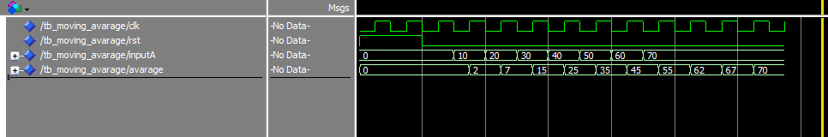
Source: the authors.

From a straightforward analysis of the testbench signals, it is easy to see that the module is performing the function of a moving-average filter with n = 4 samples. After inputA takes the value 10 on the rising edge of the clock, the value of average becomes 2—according to the moving-average calculation, with the other three values being zero. Then, as the other inputA values are captured, average is updated according to the correct filter computation, confirming that it operates as expected.

In the previous step, a simple digital filter was designed using purely VHDL and a simple simulator—Modelsim. In the second practical example, the steps shown earlier will be complemented using MATLAB HDL Coder, a MATLAB toolbox that allows the generation of HDL code for multiple applications. Initially, however, we will briefly discuss how to create and simulate a simple FIR filter in MATLAB using the Simulink environment.

PRACTICAL EXAMPLE 2 – CREATING AN FIR FILTER IN MATLAB
In essence, FIR-type digital filters are very similar to the moving-average case discussed earlier. Their general difference equation can be illustrated by Equation 2 below:
 | $$y\left[k\right]=\sum_{i=0}^{n}{b_{n}⋅x\left[k-n\right]}$$ | (2)
The bₙ are real values characteristic of the filter’s specific tuning. In this way, it is possible to adjust bₙ so as to achieve any desired transfer function, enabling different behaviors: a low-pass filter, a high-pass filter, and so on. The most important characteristic of FIR filters is that they allow the creation of virtually any equivalent desired transfer function, at the expense of a high number of parameters (and therefore higher delay). The practical example discussed here clearly involves sequential behavior and will therefore be presented in steps:
- First, open MATLAB (preferably version R2025b, used in this example).
- In the Home tab, look for the Simulink icon and select it.
- Once it opens, click Create Blank Model to create a new Simulink project.
- Under Simulation >> Library Browser, search for the Chirp Signal component. This component provides a sine signal with variable frequency, which is important for testing the filter to be created. Drag it into the Simulink workspace.
Then do the same with the Zero-Order Hold, Digital Filter Design, and a Scope components, configuring them as shown in Figure 6 below.

Figure 6 — Setup for configuring the Simulink environment.
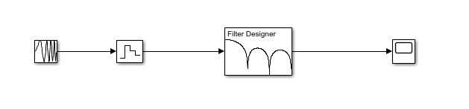
Source: The Authors

- Next, double-click the Zero-Order Hold block and set its Sample time to 1/48000. This ensures that the system is operating at a sampling frequency of 48,000 Hz.
- Now, double-click the Digital Filter Design block and configure it as described below. The goal of this configuration is to create a simple 5th-order FIR low-pass filter with a cutoff frequency of 2,000 Hz. To tune the filter, click Design Filter.
Figure 7 — Digital Filter Design configuration.

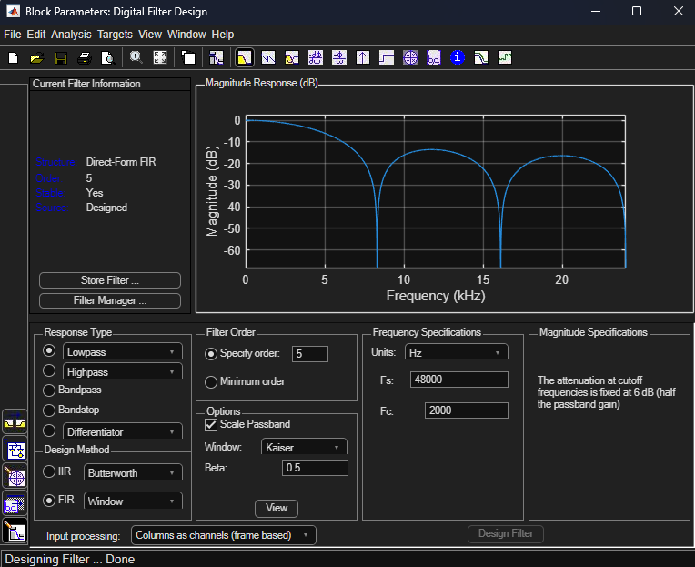
Source: the authors.

- Now, double-click the Chirp Signal block and configure it as shown below. This generates a sinusoidal signal whose frequency starts at 1,000 Hz and increases to 10,000 Hz over 100 s of simulation.

Figure 8 — Chirp signal Configuration.
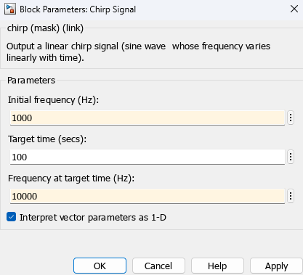
Source: the authors.

- Finally, set the Stop Time field in the Simulation tab to 100, matching it to the filter input produced by the Chirp Signal.
- After all configurations, you can run the simulation by pressing the Run button.
MATLAB will then run the simulation of the blocks configured in the Simulink environment, which represent the FIR filter in operation. After the simulation process finishes, you can double-click the Scope, revealing an image similar to Figure 8 below.

Figure 8 — Expected output of the FIR filter.

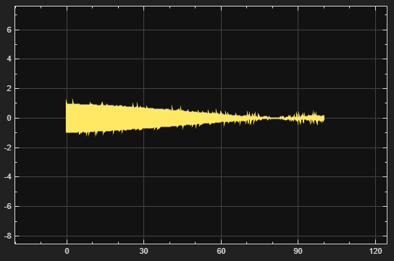
Source: the authors.

This output shows the low-pass characteristic of the generated filter, consistent with its magnitude Bode diagram previously shown in Figure 8. In this way, it is demonstrated that designing digital filters using MATLAB’s native tools is very straightforward, including their testing and validation. It is worth noting that the setup shown already takes critical digital variables into account, such as sampling time, acquisition, and related factors.

The practical examples presented earlier demonstrate the creation of digital filters widely used in embedded systems—sometimes in VHDL, sometimes in MATLAB. The next section will therefore discuss how MATLAB’s native toolboxes can be used to transfer the streamlined design and testing of a digital filter in its environment into functional VHDL code.

2.3 Generating HDL Code with MATLAB HDL Coder

Previously, we saw how it is possible to create complex systems—such as digital filters—either directly in VHDL or using MATLAB as a design and development tool. Here, we will discuss how to use MATLAB HDL Coder, a MATLAB toolbox that enables the generation of HDL code (and, more specifically, VHDL) from designs created in MATLAB.
In essence, MATLAB HDL Coder includes an advisor (or assistant) that translates designs made purely in MATLAB—with the help of Simulink—into HDL models. The advisor guides the user through the necessary steps for translating the design, making the tool easier to use for newcomers.
It is important to note that MATLAB HDL Coder does not have unlimited capability to translate any Simulink design into an HDL language: some blocks and components are not supported for this transformation. In general, blocks associated with the MATLAB HDL Coder and DSP System Toolbox HDL Support add-ons can be translated without additional difficulty.
The following practical example will demonstrate the generation and simulation of VHDL code for the FIR filter designed in the last example of the previous section. All the development carried out earlier will be used as a reference for performing this practical part, prioritizing the translation of the system created in Simulink into HDL code.

PRACTICAL EXAMPLE 3 – TRANSLATING AN FIR FILTER IN MATLAB TO VHDL
Using the practical example from the previous subsection as a reference, the MATLAB HDL Coder tool—integrated into the Digital Filter Design block—will be used to translate the created FIR filter into an equivalent HDL code. The goal is to obtain this code and generate a testbench, enabling its validation using HDL simulation tools such as Modelsim.
In light of the stated objectives, a sequential step-by-step guide will be provided to carry out this practical example, as was done in previous cases:
- First, open the Simulink model corresponding to the FIR filter from the previous practical example. In that same workspace, you can open the configuration window of the Digital Filter Design block, as was done earlier.
- Next, in the block’s configuration window, the reader should go to Target >> Generate HDL. This will take you to a page called DSP HDL IP Designer, which allows the translation of the created FIR filter into HDL code. After that, the tab shown below can be viewed.
Figure 10 — HDL code generation tab for the FIR filter.
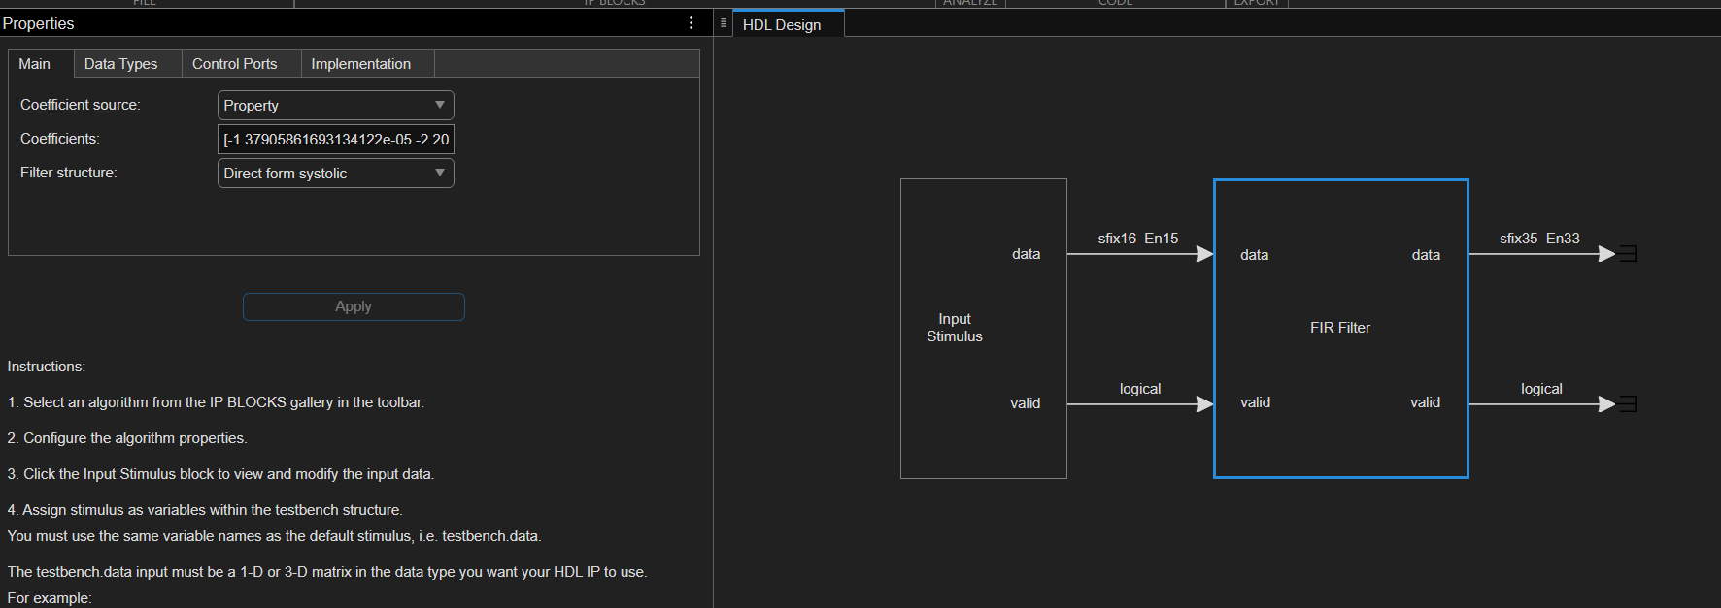Source: The authors.

- Next, you need to configure the filter stimulus for its validation in the testbench. To do so, click the block named Input Stimulus and, in the Properties >> Input Settings tab that appears on the right, enter the stimulus code below. This will allow us to test the filter by injecting two superimposed sine waves: one at 1,000 Hz and another at 5,000 Hz.
4. Now, simply click Apply in the same Input Settings section and then, on the top tab, click Generate HDL. This will create, in the project folder, a directory containing the equivalent HDL code for the FIR filter and its testbench.
%% Parâmetros
numSamples = 2000; % number of samples

fs = 48000; % sample rate (Hz)
t = (0:numSamples-1)'/fs;

f1 = 1000; % frequency of the first sine wave (Hz)
f2 = 5000; % frequency of the second sine wave (Hz)

A1 = 0.8; % amplitude 1
A2 = 0.5; % amplitude 2

%% Sine-wave signal generation
x1 = A1 * sin(2*pi*f1*t);
x2 = A2 * sin(2*pi*f2*t);
% combined signal
x = x1 + x2;

%% Fixed-point conversion
% Here we use a signed, wordlength=16, fraclength=15
testbench.data = fi(x, true, 16, 15);

Now that the filter’s VHDL code has been generated along with its testbench, you can create a Modelsim project to simulate and test it. Following the same steps as in Practical Example 1, create a project in Modelsim and add all the .vhd files from the folder:
<project_source>/codegen/hdl_IP/hdlsrcs
To make it easier to include the files, it is suggested that the source folder for the Modelsim project be that same directory mentioned above.
After that, the user should follow the same steps as in Practical Example 1 to compile the added .vhd files—clicking the Compile All button at least three times to ensure that all files were compiled successfully. Similarly to that example, the reader should click Simulate and, in the pop-up window, select the hdl_ip_tb entity within the work library. After completing these steps successfully, the reader will see an image similar to the one shown below.

Figure 11 — FIR filter simulation environment in Modelsim.
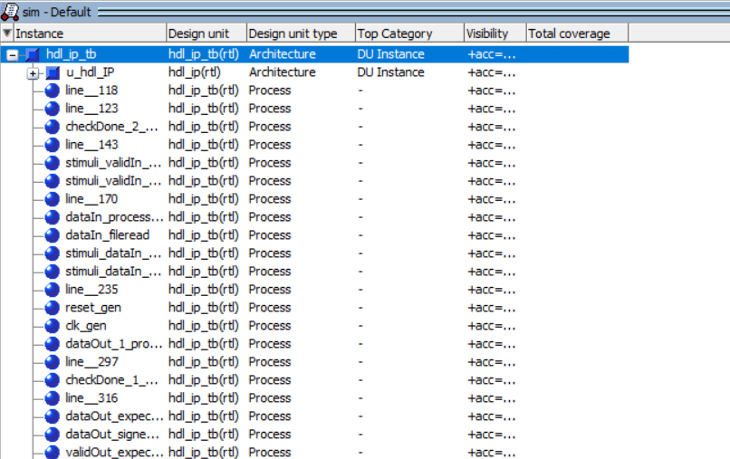
Source: the authors.

Here, the reader should right-click on the u_hdl_OP item and choose Add Wave. This will allow the visualization of the signals from the HDL entity corresponding to the designed FIR filter. After that, the reader will be able to view the timing-diagram window for the filter signals, as shown below.

Figure 12 — FIR filter simulation environment in Modelsim.
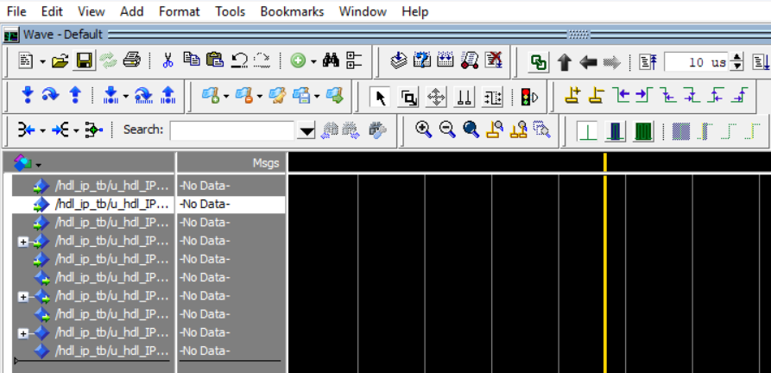
Source: The authors.

Just as in Practical Example 1, the reader should set the simulation time to 10 μs and click Run, simulating the filter’s behavior. After that, it is recommended that the reader select the signals hdl_ip_tb/u_hdl_IP/dataIn and hdl_ip_tb/u_hdl_IP/dataOut, right-click them, and choose Radix >> 1 float32 and Format >> Analog (automatic). This will allow you to view the module’s input and output signals (the ones mentioned earlier) similarly to an oscilloscope.
After completing the steps and zooming out the window, it will be possible to see an image similar to the one below.
Figure 13 — Time map resulting from the FIR filter simulation in Modelsim.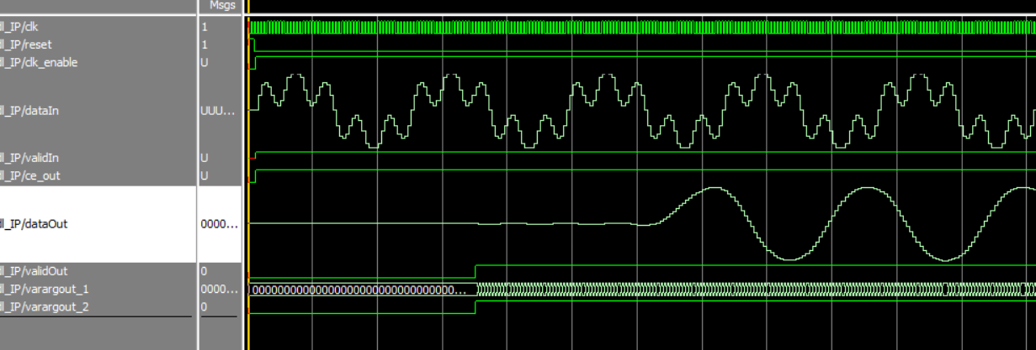
Source: the authors.

Here, the low-pass nature of the generated filter is clear: it preserves the 1,000 Hz sine wave at its input while practically eliminating the 5,000 Hz sine wave. This highlights how MATLAB can actively contribute to the creation of complex HDL code using its native tools.
It is also worth noting that the module representing the created FIR filter already includes signals consistent with practical use, such as clk, clk_enable (allowing selection/control of the filter’s behavior), reset, validIn, and validOut. In particular, the last two signals mentioned are important to indicate when the filter should process an input signal on dataIn, and when it produces a valid output on dataOut.
Finally, it is also possible to see—at least from a theoretical perspective—that this FIR filter has a prolonged transient response before reaching steady state, which confirms that it has a high order.
In addition to being able to generate HDL code for virtually any digital filter designed with the Digital Filter Design tool, it is also possible to manually build synthesizable digital subsystems using blocks from MATLAB HDL Coder and/or DSP System Toolbox HDL Support. Furthermore, it is also possible to create functions in MATLAB and later translate them into HDL, as shown in Practical Example 4 below.

PRACTICAL EXAMPLE 4 – BUILDING AN INTEGRATOR WITH HDL CODER
To demonstrate how the process of creating and translating a Simulink subsystem into its HDL counterpart is done, we will focus on creating a simple digital integrator.
First, you need to create a new project in MATLAB. Open Simulink and choose Create Model with the Blank Model option. In the Simulink workspace, you must first create the subsystem corresponding to the integrator. To do this, click Simulation >> Library Browser and search for the Discrete-Time Integrator component, inserting it into the model. Considering that the HDL code will operate under a 100 MHz clock, double-click the inserted component and, in Sample Time, enter the value 100/100000000. This will provide a 100× oversample, giving the integrator the necessary processing time.
Finally, select the component and, with a right-click, choose Create Subsystem from Selection. The created subsystem will be the element translated to VHDL, and to characterize it, rename the subsystem to “Integrador”, as shown below.
Figure 14 — Integrator subsystem created in MATLAB.

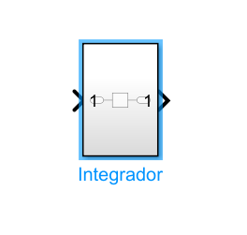
Source: the authors.

Now that the subsystem has been created correctly, you can add functional blocks that allow it to be verified using known stimuli. As shown below, set up the test environment for the subsystem by adding the Repeating Sequence Stair and Scope blocks.
Figure 15 — Test setup for the integrator.
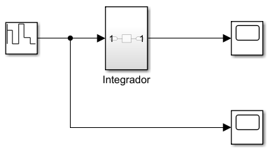
Source: the authors.

To simulate the subsystem’s behavior within MATLAB itself, in the Simulation tab set the simulation Stop Time to 1000/100000000, allowing the simulation of 10 samples. Then click Run and, after the simulation finishes, right-click on the two Scope blocks. After that, you will be able to view the integrator’s input and output, as shown below. It is recommended that the reader choose the Dock All Scopes option, located in the upper-left corner of the Scope viewing window. This will allow the Scope windows to be repositioned side by side, as shown in the image below.
Figure 16 — Input scope (left) and output scope (right) of the integrator.
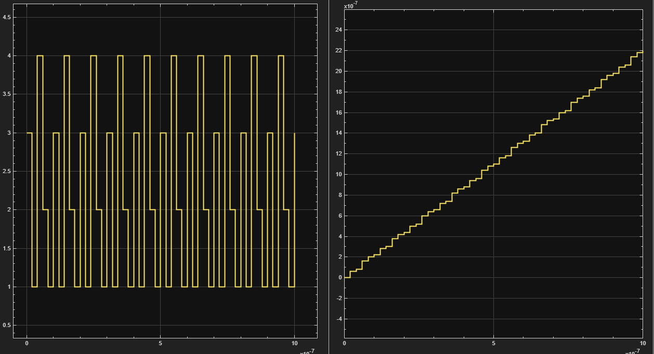
Source: the authors.

It is clearly possible to observe the integrator behavior in response to the subsystem’s input signal, confirming its correct operation.
Now that the subsystem and its auxiliary validation blocks are configured, the translation to VHDL can begin. First, in the Apps tab, look for the HDL Coder component, located in the Code Generation group. Then, click the component, which will open a new tab: HDL Code. Initially, a few settings are required under Settings:
- In the search field, look for Use Floating Point and enable it.
- In the search field, look for Solver selection, choosing Fixed-step for Type and discrete (no continuous states) for Solver.
- Finally, in the search field, look for Treat Simulink rates as actual hardware rates and enable it. This will allow HDL Coder to interpret the Sample Times configured for the system blocks as real hardware rates.
After implementing the mentioned settings, right-click on the integrator subsystem and go to HDL Code >> Workflow Advisor. This will open a pop-up window for the reader, acting as a guided assistant for translating the code into HDL languages.
In the new pop-up window, go to the 1. Set Target tab and, in 1.2 Set Target Frequency, set the Target Frequency (MHz) to 100. Then return to the 1. Set Target tab and click Run All.
Next, go to 2. Prepare Model for HDL Code Generation and click Run All. Some warnings will be shown, but they can be ignored for now.

Finally, go to the 3. HDL Code Generation tab and then to 3.2 Generate RTL Code and Testbench. In this tab, select the Generate test bench option. Returning to the 3. HDL Code Generation tab, click Run All. If everything runs correctly, you should see the message “Passed Generated HDL code, testbench. Click on the file name link(s) to open the generated code in the editor” in the HDL Workflow Advisor log. This indicates that the HDL code for the module and its respective testbench were generated correctly.
Finally, following the steps previously shown in Practical Example 2, you can create a Modelsim project in the folder <MATLAB_project_root_folder>/hdl_prj/hdlsrc/untitled/ and add all files with the .vhd extension to the project. Remember to compile the files at least three times using the Compile All button. Then go to Simulate and, under the work library, select the integrador_tb entity and click OK.
In the simulation tab, select the u_Integrador entity and, with a right-click, choose Add Wave, adding the integrator module signals to the simulator’s timing diagram. Finally, set the simulation time to 11 μs and click Run.
In the generated timing diagram, to allow better visualization of the signals, zoom in on the displayed signals using the magnifying-glass tool and apply the following settings to the signals:

- For the signal /integrador_tb/u_Integrador/In1, select Radix >> float64 and then Format >> Analog (automatic). This will allow you to visualize the analog waveform generated by the Repeating Sequence Stair block.
- For the signal /integrador_tb/u_Integrador/Out1, select Radix >> float64. Although it is an analog signal, the automatic formatting option should not be applied, as it makes the signal harder to visualize.

Finally, it will be possible to view the timing diagram illustrated below. By placing the cursor (with the left mouse button) at different points on the signal /integrador_tb/u_Integrador/Out1, you can verify that its value increases gradually, according to the rectangular integration of the signal /integrador_tb/u_Integrador/In1 over time.

Figure 17 — Timing diagram for the integrator module testbench.

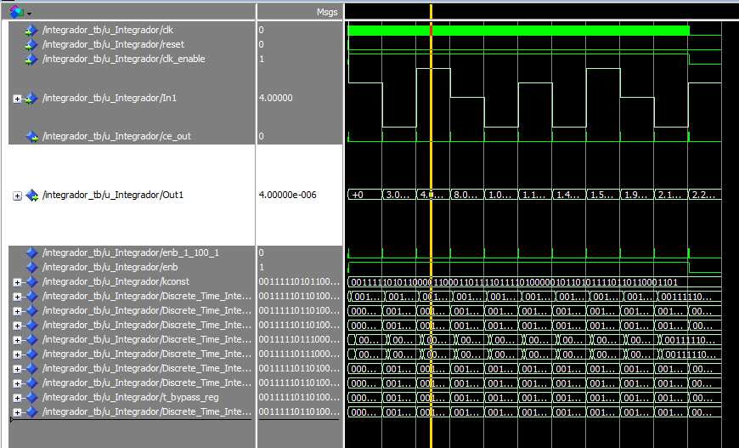
Source: the authors.

Thus, it is possible to verify that the HDL code representing the integrator component is working correctly, in the sense that its output signal is accumulating terms of the form Δt · in(t), where Δt is the adopted sampling period and in(t) is the input signal value at an arbitrary time t. It is important to note that the oversampling chosen for the module is fundamental to its operation, since it allows the integration calculations to be carried out over multiple clock cycles, avoiding latency and concurrency issues in the created design.
According to the step-by-step procedure illustrated in Practical Example 4, it is possible to develop virtually any HDL component using the support tools provided by MATLAB. Some issues may eventually be encountered during the HDL code generation process, but the HDL Workflow Advisor offers several ways to guide the user toward the final goal, making the automatic code generation tool easier to use.

C Language and RTOS
In this chapter, the role of the C language in the development of embedded electronic systems will be discussed, as well as an introduction to Real-Time Operating Systems (RTOS) and their importance in modern applications. The goal is to show the reader how the C language serves as a fundamental link between the previously described digital hardware—often implemented in VHDL—and the higher layers of control, communication, and task management.
In addition, it will be discussed how MATLAB automatic code generation tools can be used to produce functional C code, integrable both in bare-metal systems and in RTOS-based systems, while maintaining temporal coherence, determinism, and reliability.

C Language
The C programming language was created around the 1970s by Dennis Ritchie at AT&T Bell Labs, initially as a tool for developing the Unix operating system. Since then, the language has become established as one of the most important in the history of computing.
One of the main reasons for C’s widespread adoption is its high portability. C can be used on most existing processor architectures, from simple microcontrollers to high-performance processors. This characteristic made the language a de facto standard for low-level software development and embedded systems.
Historically, C has directly or indirectly influenced several other widely used programming languages today, such as C++, Java, C#, Python, JavaScript, and PHP. For this reason, C is often referred to as the “father of modern languages,” since many of its fundamental concepts—such as explicit typing, control structures, and direct memory manipulation—were inherited or adapted by these later languages.
In addition to its historical importance, C remains highly relevant in practice. It is widely used in the development of operating systems, device drivers, and fundamental software libraries. In the context of embedded systems, C plays a central role and is often combined with assembly code when extreme performance optimization, precise timing control, or direct access to specific hardware resources is required.
Unlike higher-level languages, C offers the developer explicit control over memory usage, data types, and execution flow. In embedded systems, this closeness to the hardware is essential, since the software often interacts directly with memory-mapped registers, peripherals, and digital modules implemented in HDL, such as those described in previous chapters.
These characteristics allow the language to be used in different application fields, especially embedded electronics. However, it is important to note that its syntax and basic capabilities do not provide broad, built-in functionality—requiring significant software architecture planning and careful integration with the target hardware.
It is also worth noting that, unlike hardware description languages (HDLs) such as VHDL or Verilog, the C language depends directly on a processor or microcontroller to be executed, since the developed code is compiled to the instruction set architecture (ISA) implemented by that component. In this way, these two types of language complement each other: HDLs can be used to describe a hardware architecture in an FPGA, potentially including a processor, which in turn can be programmed using code written in C. This type of integrated development is a fundamental approach in the design of modern embedded systems, known as hardware/software co-design, in which architectural decisions are made while simultaneously considering the functional, timing, and performance requirements of the system as a whole.
Due to its broad adoption in electrical engineering and computer engineering, the intrinsic characteristics and syntax of the C language will not be covered in depth in this manuscript. Practical Example 5 below aims to present a simple C-based program that, although executed on Windows, represents a common filtering application for embedded systems.

PRACTICAL EXAMPLE 5 – CREATING A MOVING-AVERAGE FILTER IN C

The purpose of this practical example, based on the resources provided by the C programming language, is to develop a simple moving-average filter with n parameters. The main goal of this example is to demonstrate the basic workflow of programming, compiling, and executing C code on a Windows operating system, using the GCC (GNU C Compiler) compiler. It is worth noting that the compilation workflow for another architecture follows a very similar sequence, differing only in how the compiled code is deployed and in the use of the compilation binaries.
First, the reader must have (or install) the GCC binaries on their system. One of the simplest ways to do this is by using the Cygwin binary manager, which makes it easy to install common compilation and build tools—such as gcc and make—in a Windows environment. To install Cygwin and gcc, follow the tutorial in that video.
After installing the tool and the gcc binaries, open a Cygwin64 Terminal and type the command below:
$ gcc --version

If it was installed correctly, the following message will be returned:
gcc (GCC) 13.4.0
Copyright (C) 2023 Free Software Foundation, Inc.
This is free software; see the source for copying conditions. There is NO
warranty; not even for MERCHANTABILITY or FITNESS FOR A PARTICULAR PURPOSE.

In this case, the gcc version used in this example is 13.4.0, but it may be any more recent version, if needed.
Now it is possible to create code that represents a simple moving-average filter. Ideally, the filter’s inputs and outputs will be handled using the scanf() and printf() functions from C’s standard stdio.h library. This simplification does not reduce the generality of the filter code, which can eventually be ported to any embedded system and used with different input and output interfaces. In addition, the filter parameters and its input and output values are treated as variables of type float, i.e., floating-point variables. The code for this filter is shown below:
#define NUM_TERMS 4

float moving_avg_function(float current_input){

// Creates an empty array for holding the last terms - It must be static to hold the last items
static float last_terms[NUM_TERMS] = {0};
float acc_value = 0;

// For loop to right shift last terms
for(int i = NUM_TERMS - 1; i > 0; i--) last_terms[i] = last_terms[i - 1];

// Stores the current term
last_terms[0] = current_input;

// Accumulates the last terms values and returns the function
for(int i = 0; i < NUM_TERMS; i++) acc_value += last_terms[i];

return acc_value / NUM_TERMS;

}

int main(){

// Creates float variables for the input and output values
float input_value, output_value;

// Enters a continuous loop
while(1){

// Asks the user for a input value and stores it
printf("Please, enter an input value: ");
scanf("%f", &input_value);

// Executes the moving avg function
output_value = moving_avg_function(input_value);

// Prints the current value
printf("\nThe current moving avg value is: %.4f\n", output_value);

}

return 0;
}

Basically, this code implements the moving_avg_function(), which, each time it is called, recalculates the current moving-average filter output based on the filter’s current input value current_input and its previous memory. The filter stores its previous input values using the static array last_terms.
To compile the code in question, located in the folder, simply open the Cygwin64 Terminal and navigate to the repository folder, following the command below:
$ cd <REPOSITORY_FOLDER_PATH >
Then, you can run the following command to compile the filter code, generating an executable:
$ gcc ./main.c -o ./main

After that, you can run the program using the command:
$ ./main
This will allow the user to type input data for the filter and obtain its current output values. As shown in the execution example below, the moving-average behavior applied to the code’s input values is evident.
$ ./main
Please, enter an input value: 10

The current moving avg value is: 2.5000
Please, enter an input value: 0

The current moving avg value is: 2.5000
Please, enter an input value: 10

The current moving avg value is: 5.0000
Please, enter an input value: 0

The current moving avg value is: 5.0000
Please, enter an input value: -7

The current moving avg value is: 0.7500
Please, enter an input value: -8

To stop the program, the user can simply use the shortcut Ctrl + C in the open Cygwin64 Terminal.
After investigating how this filter operates, it is possible to modify this base code to allow the user to visualize the filter’s input and output signals. To do this, an array called square_wave[] is created to simulate a symmetric square wave with unit amplitude, which is then subjected to the filter’s action. In order to store its input and output values, the C code is configured to write the filter’s iterative data to a file named data.txt, using a .csv (Comma Separated Values) format, as shown below.
iterator,input_value, output_value
1, 1.0000, 0.2500
2, 1.0000, 0.5000
3, 1.0000, 0.7500
4, 1.0000, 1.0000
5, 1.0000, 1.0000
6, 1.0000, 1.0000
7, 1.0000, 1.0000
8, 1.0000, 1.0000
9, 1.0000, 1.0000
10, 1.0000, 1.0000
11, -1.0000, 0.5000
12, -1.0000, 0.0000
13, -1.0000, -0.5000
14, -1.0000, -1.0000
15, -1.0000, -1.0000
16, -1.0000, -1.0000
17, -1.0000, -1.0000
18, -1.0000, -1.0000
19, -1.0000, -1.0000
20, -1.0000, -1.0000

Organizing the filter’s input and output data in .csv format makes it possible to import it into a Microsoft Excel spreadsheet, enabling the creation of charts to analyze the module’s behavior. In order to output this data to a file in the format shown, the following changes are made to the main() function of the original C code:
float square_wave[40] = {1, 1, 1, 1, 1, 1, 1, 1, 1, 1, -1, -1, -1, -1, -1, -1, -1, -1, -1, -1, 1, 1, 1, 1, 1, 1, 1, 1, 1, 1, -1, -1, -1, -1, -1, -1, -1, -1, -1, -1};

int main(){

// Creates float variables for the input and output values
float input_value, output_value;

// Initializes an itrt for the square_wave
int square_wave_itrt = 0;

// Initializes a file and writes the firts line
FILE* file_pointer = fopen("data.txt", "w");
fputs("iterator,input_value, output_value\n", file_pointer);

// Creates a str to write into the file
char file_string[100];

// Enters a continuous loop
while(1){

// Asks the user for a input value and stores it
printf("Entering the %ith value from the square_wave...", square_wave_itrt);
input_value = square_wave[square_wave_itrt];
square_wave_itrt++;

// Executes the moving avg function
output_value = moving_avg_function(input_value);

// Prints the current value
printf("\nThe current moving avg value is: %.4f\n\n", output_value);

// Puts the values into the file string and puts the file string into the file
sprintf(file_string, "%d, %.4f, %.4f\n",square_wave_itrt, input_value, output_value);

fputs(file_string, file_pointer);

// If the square_wave_itrt is equal or greater than 40, stops the code
if (square_wave_itrt >= 40) break;

}

return 0;
}

After compiling and running this main_modified.c code, in the same way as done previously, the file data.txt will be generated and can be imported into Microsoft Excel.
Open Microsoft Excel and go to Data >> Get Data >> From File >> From Text/CSV. Then select the data.txt file generated by the filter code; a preview window will open and show the filter data already tabulated. Click Load to insert the data into the spreadsheet.
Now, simply select all the generated data and then go to Insert >> Insert Scatter (X, Y) Chart >> Scatter with Straight Lines and Markers, as shown below.

Figure 18 — Creating a scatter plot in Microsoft Excel.
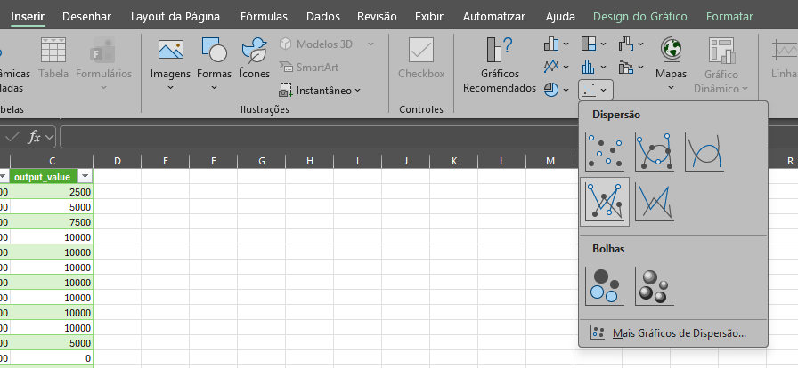
Source: the authors.

Finally, it is possible to view the chart below, where Series 1 (blue) represents the filter input and Series 2 (orange) represents its output. You can see that the filter smooths the input signal, even though it still has 4 parameters. If the number of parameters were larger—set through #define NUM_TERMS—the square wave would be smoothed even further at the output.
This process exemplifies the creation of a filtering code based on the C language, which could easily be ported to any embedded system.
Practical Example 5 shows how the C language can be used for filtering digital and analog signals. A simplification was adopted in the example, mainly regarding the code execution environment (Windows) and its inputs and outputs (through the terminal), but it thoroughly demonstrated the code design procedure and its application.
Next, a C-based filter will be created with the help of MATLAB’s digital filter design tools and MATLAB C Coder. Considering the use of these auxiliary MATLAB capabilities, the filter to be generated will be a high-pass IIR filter, with a significantly larger number of coefficients compared to the previous practical example.

PRACTICAL EXAMPLE 6 – DESIGN AND C IMPLEMENTATION OF AN IIR FILTER USING MATLAB
IIR (Infinite Impulse Response) filters are widely used in complex embedded electronic systems, especially in critical and time-constrained applications—such as telecommunications or control systems. Unlike FIR filters, their counterpart, IIR filters allow the use of previous outputs in forming their current outputs, as shown in Equation 3 below.
Here, bₙ and aₙ are real values that characterize and tune the filter. It is important to note that the negative sign preceding the aₙ parameters is merely a convention.
The main benefit of IIR filters is the ability to achieve the desired Bode magnitude response with relatively few components compared to FIR filters. For this reason, they are widely used in applications with tight timing requirements, since they do not exhibit long transients. Despite their advantages, they have an important drawback: they can have nonlinear phase, which can distort non-sinusoidal signals.
In this example, the filterDesigner tool will be used to create a high-pass IIR filter. In the MATLAB command window, type the command highlighted below:
>> filterDesigner

After typing this command, it is expected that the same Digital Filter Design window seen in the previous examples will open. This window allows you to model virtually any digital filter. In this case, the filter to be created should follow the settings shown below.
Figure 19 — High-pass IIR filter configuration.
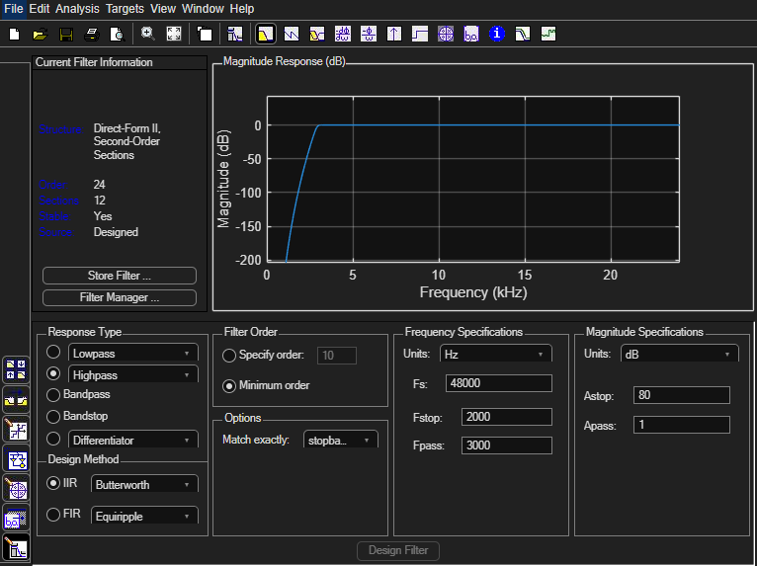
Source: the authors.

The filter settings in question allow the modeling of a high-pass IIR filter with a 48,000 Hz sampling rate, a 2,000 Hz stopband frequency, and a 3,000 Hz passband frequency. After configuring these parameters and checking Highpass, as shown in the image, click the Design Filter button.
Once the filter has been designed, go to File >> Generate MATLAB Code >> Data Filtering Function (with System Objects). This will create code containing a function named doFilter(), which applies the previously designed filter to any input array of values.
Save the generated code using the function’s own name: doFilter.m. In order to avoid additional issues when using it, modify the last two generated lines to match the code below, allowing the filter to accept arrays as input.
s = double(x(:)); % force column to N×1
y = step(Hd, s);
This step will allow the function to be reused in any MATLAB test script. To verify that the filter is working, create a script via Home >> New Script and, using the shortcut Ctrl + S, save it as test_script.m. Fill this script with the code below, which creates a sinusoidal signal with two components at 5,000 Hz and 15,000 Hz, applies it to the designed filter, and plots the resulting input and output.
%% Signal parameters
fs = 48000; % sample rate (48 kHz)
t = 0:1/fs:0.01; % 10 ms

f1 = 1000; % 5 kHz
f2 = 5000; % 15 kHz

%% Input signal: superimposed sine waves
x = sin(2*pi*f1*t) + sin(2*pi*f2*t);

%% Filtering
y = doFilter(x);

%% Signal Plot
figure;

subplot(2,1,1);
plot(t, x, 'r');
grid on;
xlabel('Time (s)');
ylabel('Amplitude');
title('Input Signal: sine waves of 5 kHz and 15 kHz');

subplot(2,1,2);
plot(t, y, 'b', 'LineWidth', 1.2);
grid on;
xlabel('Time (s)');
ylabel('Amplitude');
title(‘Output signal after applying the filter’);

After updating the code, go to Editor >> Run. This will execute the script and allow you to view its output plots, as shown below.
Figure 19 —Configuration of high pass IIR filter.
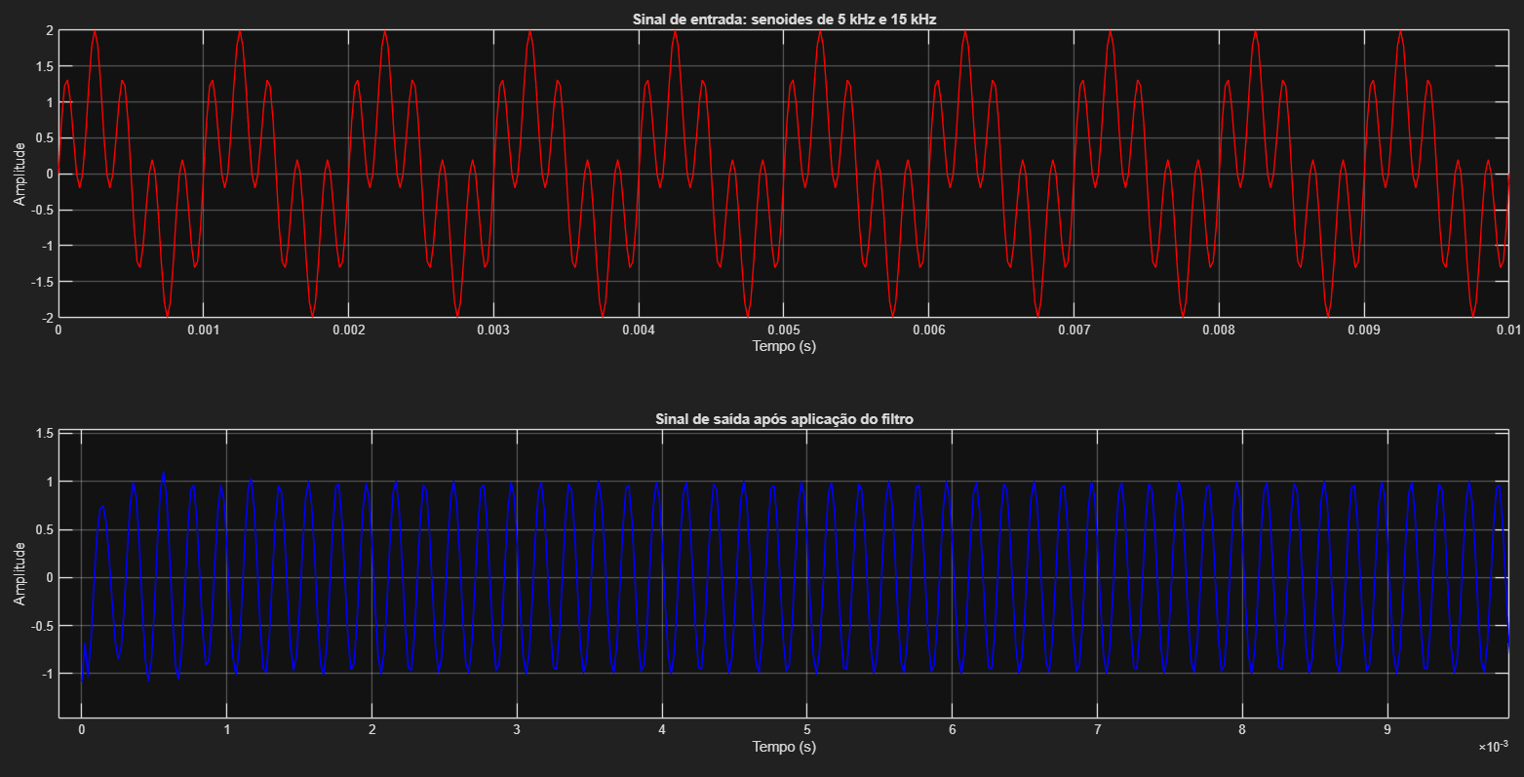
Source: the authors.

Thus, it is possible to verify that the input signal, shown in red, had its lower-frequency component correctly filtered out, resulting in the blue signal. This confirms that the filter generated in the doFilter() function works correctly, according to the specifications stated earlier.
Now, MATLAB C Coder will be used to translate this function into a native C library. To facilitate automatic code generation and subsequent testing, the library will be compiled for the Windows environment itself—but it could also be compiled for another processor or microcontroller supported by MATLAB.
First, the reader should go to the Apps tab and select MATLAB Coder. A pop-up window will open, allowing the user to choose a name and location for the project. Proceed with the default options and click OK.
After that, a panel will open on the right to guide the user through C code generation. At the same time, the top tab will show some configuration options for MATLAB Coder. First, go to Output Type in the upper-left corner and select Static Library (.lib). This will create a static library containing the implementation of the previously created doFilter() function.
Next, click Add Entry Point in the panel on the right. A new tab called Entry Points will be created, allowing the user to specify the function that will be converted into C code. Enter the doFilter function, as shown in the image below, and press Enter.
Figure 19 — Specifying the doFilter function in MATLAB Coder.

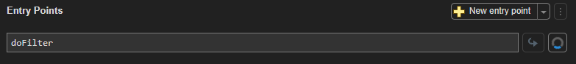
Source: the authors.

The previous step will initiate the code-generation workflow for the function. Next, you need to specify the data types of the function’s input variables. As shown below, configure it as a 1×1000 array of type double.

Figure 19 — Specifying the variable type for the doFilter function.
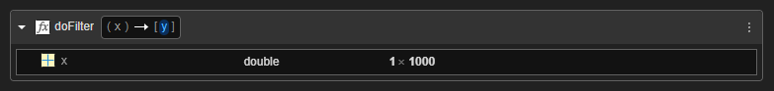
Source: the authors.

Now you can generate the code. Click the Generate Code button in the lower-right corner of the page. When you click it, MATLAB Coder will generate the C source code equivalent to the doFilter() function created earlier, according to the instructions provided to MATLAB. You can then view the generated files in the directory:
<MATLAB_root_folder>/codegen/lib/doFilter.
Despite the code generation, since no compilation directive was given to MATLAB, the .lib library for the function has not yet been compiled. For the compilation to be performed correctly, you must install the MATLAB Support for MinGW-w64 C/C++/Fortran Compiler package. After installing the package, restart MATLAB for it to work properly.
Next, return to MATLAB Coder through the Apps tab and, under the options in the GENERATE section, click Generate Code and Build. This will regenerate the code and compile it into a .lib library. After this step, you will be able to see the generated doFilter.lib library in the same directory mentioned earlier.
This library, together with the generated header files, can be used to create C programs that actively use the modeled filtering techniques. Specifically, the library is compiled for the Windows x86 environment. However, other compilers can be selected under Settings >> Hardware, covering different microcontrollers used in modern embedded systems.
The practical examples presented earlier showed how the C language, together with specialized MATLAB tools, can enable the creation of digital filtering elements typical of embedded systems—particularly for control systems, telecommunications, and even power electronics. It is important to emphasize that MATLAB’s auxiliary tools not only allow the translation of filters, but can also be used to convert many other kinds of code.
Although the C language is powerful and fulfills its purposes within its field of use, there are applications that impose explicit timing requirements that must be met—something that is not possible to guarantee with bare-metal C code. To address this important need, the next subsection will discuss what real-time operating systems are and their application in embedded systems.

RTOS and FreeRTOS Systems
As embedded systems development evolves, it becomes clear that simply running sequential C code based on a single infinite loop is not always sufficient to meet the functional and timing requirements of more complex applications. In real systems, it is common for multiple distinct activities to coexist, such as signal acquisition, digital processing, communication with peripherals, actuator control, and system supervision. When these functionalities begin to compete for processing time, the traditional bare-metal model tends to become difficult to maintain, scale, and analyze from a timing standpoint.
In this context, there arises the need for a software structure capable of organizing the execution of these functionalities in a predictable and deterministic manner. Real-Time Operating Systems, known as RTOS (Real-Time Operating Systems), were developed precisely for this purpose. Unlike general-purpose operating systems—whose main focus is average performance and user experience—an RTOS prioritizes response-time predictability, ensuring that certain tasks are executed within known time limits.
Using an RTOS allows the application to be structured as a set of independent tasks, each responsible for a specific system function. These tasks share the same processor, but their execution is coordinated by a scheduler, which decides which task should run at each moment based on criteria such as priority and execution state. A general scheduling example can be seen below, in which the scheduler organizes system usage time across three different tasks. In preemptive systems, higher-priority tasks can immediately interrupt the execution of lower-priority tasks—a fundamental feature for applications that are sensitive to external events or asynchronous interrupts.
Figure 23 — Example of task scheduling in a generic RTOS system.
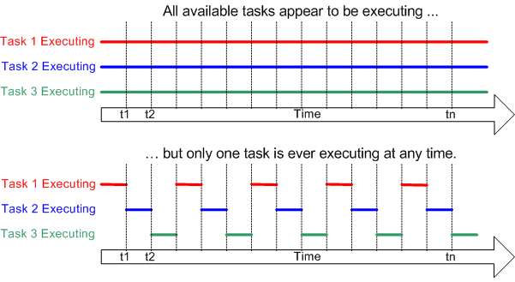
Source: FreeRTOS.

In addition to scheduling, an RTOS provides mechanisms that enable safe cooperation among concurrent tasks. Resources such as semaphores, mutexes, queues, and timers allow synchronization and communication between different parts of the software, preventing race conditions and nondeterministic behavior. These mechanisms become especially relevant when distinct tasks access shared resources or when data must be transferred in a controlled manner between different stages of the system.
Within the context presented in this manuscript, introducing an RTOS represents a natural evolution of the development flow previously discussed. Digital signal processing algorithms, such as FIR and IIR filters, can first be modeled and validated at a high level in MATLAB, translated into C code through automatic code-generation tools, and later encapsulated as independent tasks within a real-time operating system. This approach makes it possible to isolate functionalities, improve software readability, and facilitate validation and maintenance.
Among the RTOS options available today, FreeRTOS stands out as one of the most widely adopted in both industry and academia. FreeRTOS is characterized by its lightweight design, portability, and ease of integration, making it suitable for embedded systems with limited resources. Its modular architecture allows only the necessary components to be included in the final application, reducing memory usage and processing overhead.
From an embedded systems architecture perspective, FreeRTOS acts as an intermediate layer between the hardware and the C application. It does not replace the need for good hardware design, nor does it eliminate the importance of sound architectural decisions, but it provides a structured way to coordinate software execution. When combined with modules implemented in dedicated hardware—described in HDL languages and executed on an FPGA—the use of an RTOS reinforces the concept of hardware–software co-design, in which each part of the system is implemented in the most appropriate domain. The figure below illustrates how an RTOS such as FreeRTOS fits within the hardware and software components of an embedded system.

Figure 24 — Structuring the RTOS in an embedded system.
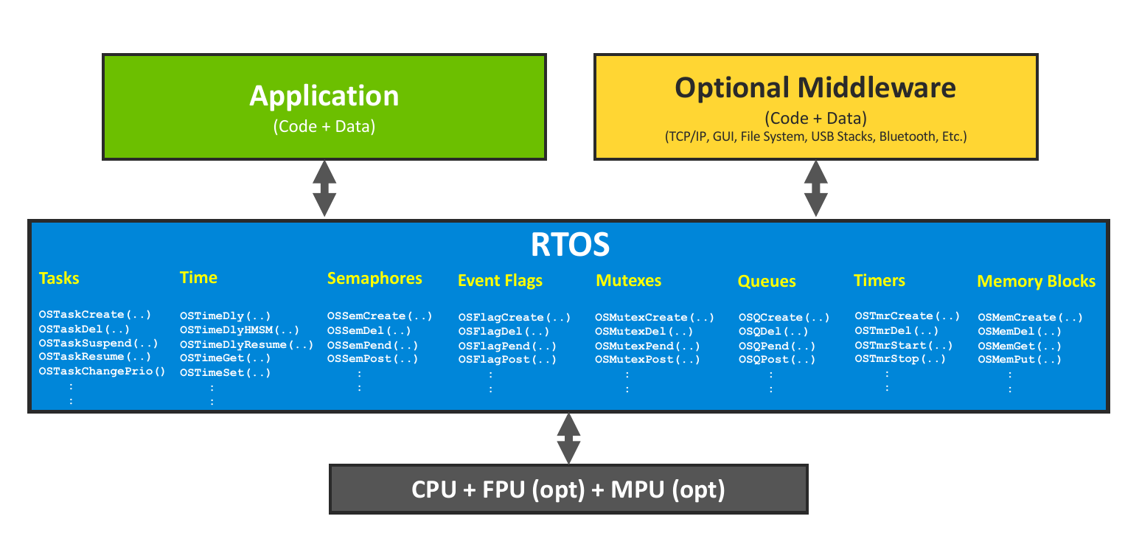
Source: this link.

Thus, adopting an RTOS—and FreeRTOS in particular—should not be seen as a mandatory requirement in every project, but rather as an additional tool for developing complex embedded systems. Its use is especially advantageous when there are multiple concurrent tasks, well-defined timing requirements, and a need to integrate processing, control, and communication algorithms in an organized and deterministic way.
Next, a theoretical example of using FreeRTOS will be discussed in a simple hypothetical application for managing an autonomous garden system. The goal of this example is to introduce the user to the general structure and syntax of FreeRTOS, making it easier to use in introductory applications.

THEORETICAL EXAMPLE 3 – APPLYING FREERTOS IN AN AUTONOMOUS GARDEN SYSTEM

Consider a simple embedded system intended to control an autonomous garden. This system is responsible for monitoring soil moisture and activating an irrigation system whenever environmental conditions require it. For didactic purposes, assume that the system has a moisture sensor connected to some analog input and an irrigation valve controlled by a digital output.
In a real-time operating system–based approach, such as FreeRTOS, the system’s behavior can be organized into independent tasks, each representing a logical functionality of the system. In this example, two main tasks are considered: a sensor data acquisition task—vSensorTask—and an irrigation control task—vIrrigationTask.
The vSensorTask task is responsible for performing periodic readings from the soil moisture sensor. This task runs at regular intervals, ensuring that measurements occur deterministically over time. The measured value is then made available to other parts of the system through a native FreeRTOS queue mechanism: Queues. Through the xQueueSend() and xQueueReceive() functions, one task can send information asynchronously to another, as in the illustrated example.
The vIrrigationTask task, in turn, evaluates the moisture data and decides whether the irrigation system should be activated. If the moisture level is below a previously defined threshold, the irrigation valve is turned on; otherwise, it remains off.

Next, each component of the FreeRTOS code will be discussed qualitatively, according to its main parts.
#include "FreeRTOS.h"
#include "task.h"
#include "queue.h"

QueueHandle_t xHumidityQueue;
First, it is necessary to include FreeRTOS functions and constants using the #include directives. Here, it is important to note that the FreeRTOS operating system and its supporting source code must be accessible to the compiler used in the project. In addition, the variable xHumidityQueue is defined and will be used to transmit data between the vSensorTask and vIrrigationTask tasks. Next, the code sections related to the mentioned tasks are highlighted.
void vSensorTask(void *pvParameters)
{
int humidity;

for (;;)
{
/* Simplified sensor reading */
humidity = readHumiditySensor();

/* Send the humidity value to the queue. */
xQueueSend(xHumidityQueue, &humidity, portMAX_DELAY);

/* Wait 1 second before the next reading. */
vTaskDelay(pdMS_TO_TICKS(1000));
}
}

void vIrrigationTask(void *pvParameters)
{
int humidity;
const int threshold = 40; /* Moisture threshold */

for (;;)
{
/* Awaiting a new humidity value. */
xQueueReceive(xHumidityQueue, &humidity, portMAX_DELAY);

if (humidity < threshold)
{
turnIrrigationOn();
}
else
{
turnIrrigationOff();
}
}
}

The vSensorTask task operates periodically, reading the system’s humidity sensor and sending its value to the xHumidityQueue queue. In addition, the vIrrigationTask task operates asynchronously relative to the previous task, waiting for a new item from the xHumidityQueue queue and then deciding whether or not to activate the garden’s irrigation system using the turnIrrigationOn() or turnIrrigationOff() functions.
It is important to note that the tasks in this example—as well as all FreeRTOS applications and other RTOS-based systems—must comply with specific and limited timing constraints. If the vSensorTask task does not follow the appropriate acquisition timing of the humidity sensor, the plants may be overwatered or underwatered, potentially causing damage to the garden. This characteristic is fundamental to RTOS-based systems and is what defines their real-time nature.
Finally, it is necessary to implement the main() function code, performing the initialization of the queues and tasks discussed earlier. As shown below, after initializing the system components, the main() function calls vTaskStartScheduler(), which is responsible for starting task execution and scheduling.
int main(void)
{
/* Basic hardware initialization */
initHardware();

/* Creating a queue for communication between tasks
Capacity: 5 elements of the type int */
xHumidityQueue = xQueueCreate(5, sizeof(int));

/* Simple verification of queue creation. */
if (xHumidityQueue == NULL)
{
/* Initialization error – system enters a loop. */
for (;;);
}

/* Creating the sensor reading task */
xTaskCreate(vSensorTask,
"SensorTask",
256,
NULL,
2,
NULL);

/* Creating the irrigation control task */
xTaskCreate(vIrrigationTask,
"IrrigationTask",
256,
NULL,
1,
NULL);

/* Start of the FreeRTOS scheduler */
vTaskStartScheduler();

/* The code shouldn't reach here. */
for (;;);
}

Based on the principles and foundations of the example shown, it is then possible to add new tasks, queues, and other FreeRTOS components in order to build more complex systems, addressing different applications and use cases.

The example demonstrated the direct application of FreeRTOS in a simple theoretical application. In the next subsection, it will be discussed how MATLAB’s automatic code generation tools can contribute to building FreeRTOS-based systems.
3.3 Generating FreeRTOS-Based Code with MATLAB
After describing how RTOS systems work and discussing FreeRTOS, this subsection presents MATLAB’s capabilities for automatically generating code for such applications.
Since FreeRTOS is particularly applicable to embedded systems, MATLAB provides support—through the inclusion of certain toolchains—for some microcontrollers. Among the supported devices, the STM32 microcontrollers produced by STMicroelectronics stand out. In the example discussed next, it will be shown how it is possible to generate, compile, and flash FreeRTOS-based code to an STM32F411RET6U microcontroller on an STM32 Nucleo development board. The code will be relatively simple, serving as a baseline to demonstrate the procedure for generating and running code from MATLAB.

PRACTICAL EXAMPLE 7 – GENERATING, COMPILING, AND FLASHING FreeRTOS CODE FOR STM32 IN MATLAB

First, the user must install the Embedded Coder Support Package for STMicroelectronics STM32 Processors. This package provides all the features and capabilities needed for automatic code generation and flashing for microcontrollers in the STM32 family. During the installation process, follow the instructions provided by the STMicroelectronics application to download and install the required auxiliary tools and compilers.
Next, the user should open a new Simulink window, create a Blank Model, and save it with any name, such as STM32_FreeRTOS_example.slx.
After that, the user should go to Modeling >> Model Settings, then navigate to the Hardware Implementation section and select the corresponding Hardware Board used (in this case, an STM32F4xx Based) and set the Operating system to FreeRTOS, as shown below.

Figure 25 — Hardware Implementation settings for the example.
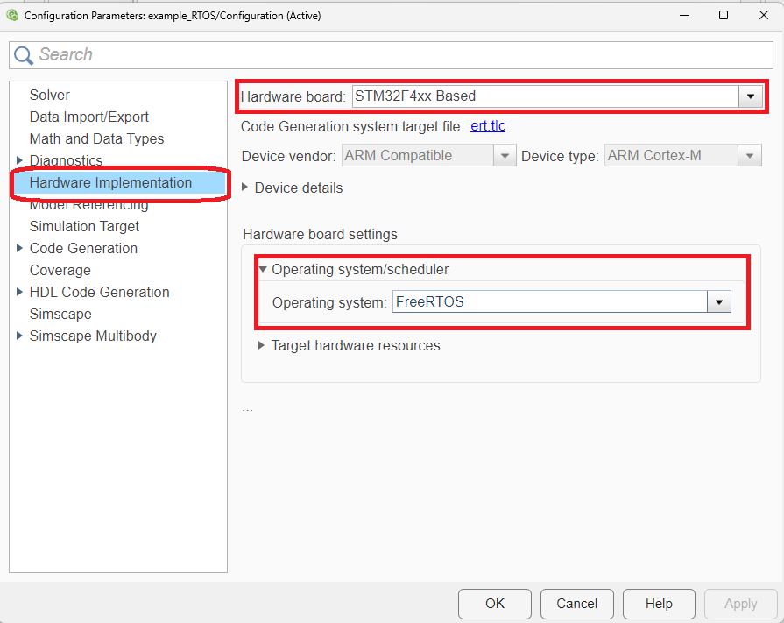
Source: the authors.

Next, a simple system will be implemented and modeled in Simulink to generate two square digital signals at different frequencies. This model aims to illustrate the use of FreeRTOS in a simple application, running two separate functions in parallel. To do so, follow the step-by-step instructions below:

- First, go to SIMULATION >> Library Browser and search for the Discrete Pulse Generator block, placing two of them in the workspace.
- Next, go to the Library Browser and, under Embedded Coder Support Package for STMicroelectronics STM32 Processor, select the STM32F4xx Based Boards family and look for the Digital Port Write block, inserting two of these blocks in the workspace.
- After that, connect the inserted blocks as shown below.

Figure 26 — Modeling of the example FreeRTOS system.

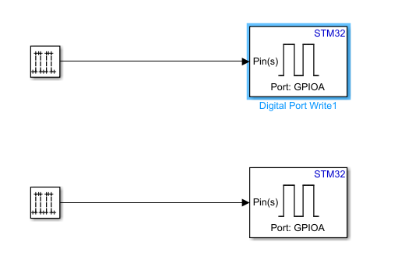
Source: the authors

- To enable the generation of digital signals with different frequencies for each GPIO (General Purpose I/O), configure the first Discrete Pulse Generator block according to the settings shown below. This will produce a square wave with a 1 s period.

Figure 26 — Configuration of the first Discrete Pulse Generator.

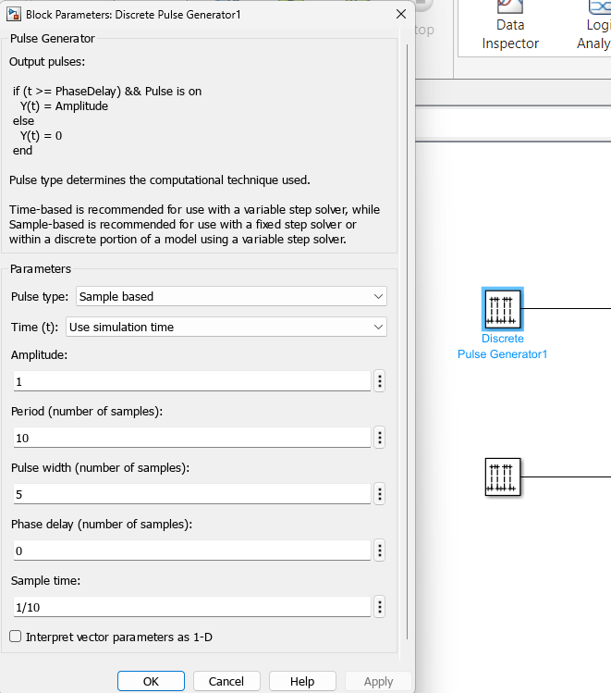
Source: the authors.

- Similarly, configure the second Discrete Pulse Generator block according to the settings shown below. This will produce a square wave with a 0.5 s period.

Figure 26 — Configuration of the second Discrete Pulse Generator.
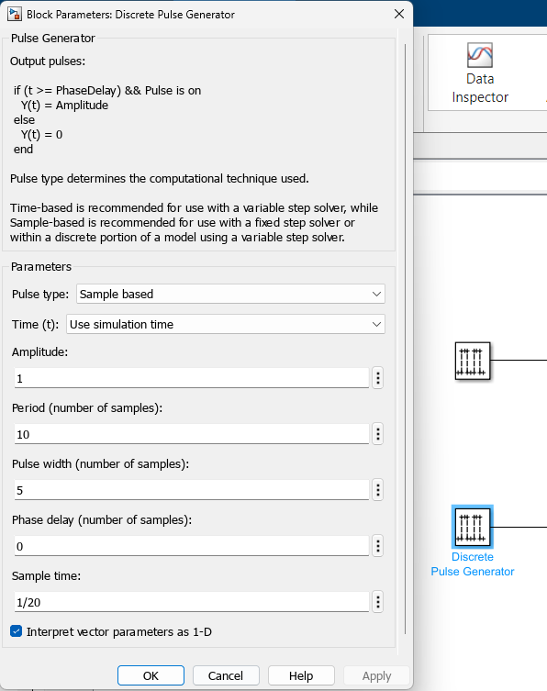
Source: the authors.

- Finally, configure the Pin number and Port name variables of the Digital Port Write blocks according to the desired digital output pins on your board. In the case of the board used here (a NUCLEO-F411RE), set the first block to Port name = DIGITAL1 and Pin number = [9]. For the second block, set Port name = DIGITAL2 and Pin number = [6]. According to the board datasheet, this remaps the digital signals to pins D8 and D7, respectively.
- To configure the I/O pins used by the project, open the STM32CubeMX software and open the generated .ioc file.
- A microcontroller pin-configuration window will open. For the board used in this example, configure pins PA9 and PA8 as GPIO_Output, as shown below. Then click Save and close the software.

Figure 29 — Pin configuration of the STM32F411 microcontroller used.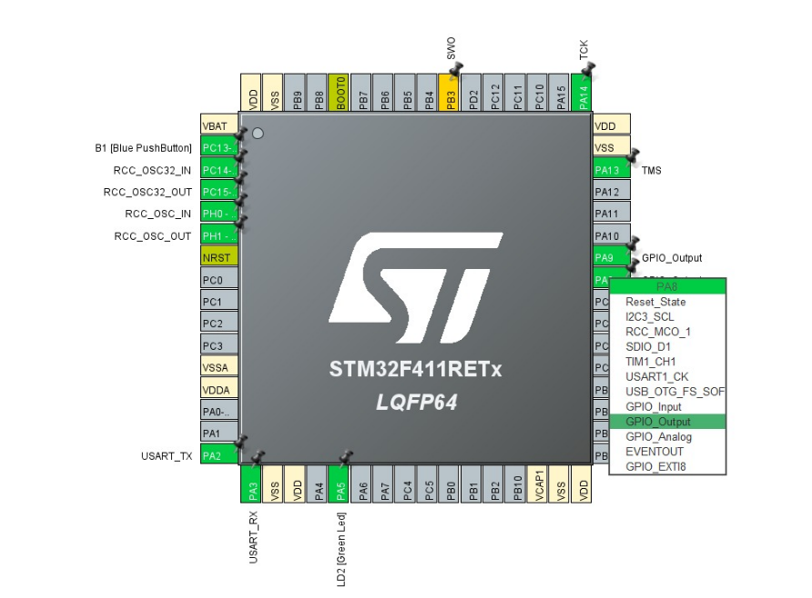
Source: the authors

- Finally, in MATLAB, save the project and click Hardware >> Build to compile it.
- To test the compiled code, connect your board to the PC and click Hardware >> Build, Deploy & Start, which will flash the code to the microcontroller and start its execution.
- By placing oscilloscope probes on the configured pins, it will be possible to observe the modeled digital signals as shown below—each one governed by a different task in the FreeRTOS system deployed on the target.

Figure 29 — Digital signals generated by the microcontroller and its FreeRTOS-based code.
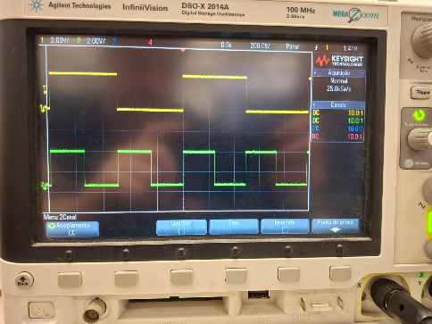
Source: the authors.

Although the practical example demonstrated the standard procedure for generating, compiling, and flashing FreeRTOS-based code with relatively simple behavior, the same method can be applied to more complex systems. This only requires using other Simulink blocks supported by the tool, enabling many different applications and possibilities.
Practical Example 7 successfully demonstrated the use of MATLAB automatic code-generation tools to create, compile, and deploy embedded FreeRTOS-based applications. All modeling, validation, and testing performed up to this point were based on running the code in its final environment—either on a general-purpose operating system, such as Microsoft Windows, or directly on a physical microcontroller, such as the STM32F411. However, especially in more sophisticated embedded systems, access to the target hardware is not always straightforward and may be limited by availability, cost, logistics, or even project constraints—often resulting in delays in software development and validation.
Given this challenge, various academic institutions, open-source communities, and corporations have invested in developing tools capable of reproducing—in a controlled manner—the behavior of complete embedded systems without requiring the corresponding physical hardware. These tools, known as emulators, allow software to run in a virtual environment that simulates the processor architecture, peripherals, and, in some cases, even external devices, enabling earlier testing, detailed debugging, and functional validation of the code. The next subsection will address, in greater depth, what these emulators are and will emphasize a standout open-source tool in this area: QEMU.

3.3 Embedded Systems Emulators and QEMU
The use of emulation in embedded-systems development represents a natural extension of the approaches already discussed in this manuscript. Just as MATLAB models are used to validate algorithms before implementing them in C or VHDL, emulators allow the behavior of embedded software to be validated before it runs on real hardware. This approach reduces coupling between software development and hardware availability, making the process more flexible and iterative.
Among the emulation tools available today, QEMU (Quick Emulator) stands out as a widely used open-source emulator in both academia and industry. QEMU can emulate multiple processor architectures, including ARM, RISC-V, and x86, enabling the execution of complete operating systems such as Linux, or embedded applications based on an RTOS such as FreeRTOS. In addition, QEMU provides advanced debugging mechanisms, integration with tools such as GDB, and support for peripheral modeling, making it a powerful platform for developing and testing embedded software.
In the context of this work, using emulation with QEMU makes it possible to create an intermediate environment between high-level simulation and execution on physical hardware. This additional abstraction layer helps test the integration between automatically generated C code, the real-time operating system, and the target processor architecture, enabling earlier identification of functional and integration issues. As a result, emulation becomes a fundamental part of the modern embedded-systems development flow, especially when combined with hardware–software co-design techniques and automatic code generation.
Due to the complexity of the QEMU software, the software development and research teams of the Núcleo de Sistemas Eletrônicos Embarcados (NSEE) at the Instituto Mauá de Tecnologia (IMT) developed a new tool: QEMULA. The figure below shows the QEMULA logo, which alludes to the word “mula” in its design.

Figure 31 — Logo of the QEMULA emulation tool.

Source: the authors.

QEMULA is initially positioned as a framework for the development and testing of software, especially for the LEON3 space processor, widely used in several large, well-known aerospace applications and missions. The LEON3 processor and its SPARC architecture are already emulated by the original QEMU code. However, the base code of the microcontroller that uses this processor in the emulation software is very limited and includes only a small set of integrated peripherals. In addition, the process of compiling and running QEMU is not straightforward, which can be challenging for new users of the tool. Because of this, QEMULA emerges:

- Promoting customization of the LEON3 microcontroller code within QEMU, adding several important peripherals such as **GRSPW (SpaceWire codec), AHBSTAT (AHB bus status register), and others.
- Creating debugging, control, and direct communication interfaces with the simulated code’s internal interfaces, making the simulation system easier for an external user to operate and even allowing direct integration into automated testing environments such as GitHub Actions or Jenkins.

The figure below shows the overall structure of QEMULA, highlighting its different layers and, in particular, its external TCP/IP interfaces.

Figure 32 — QEMULA structure for a generic use case.
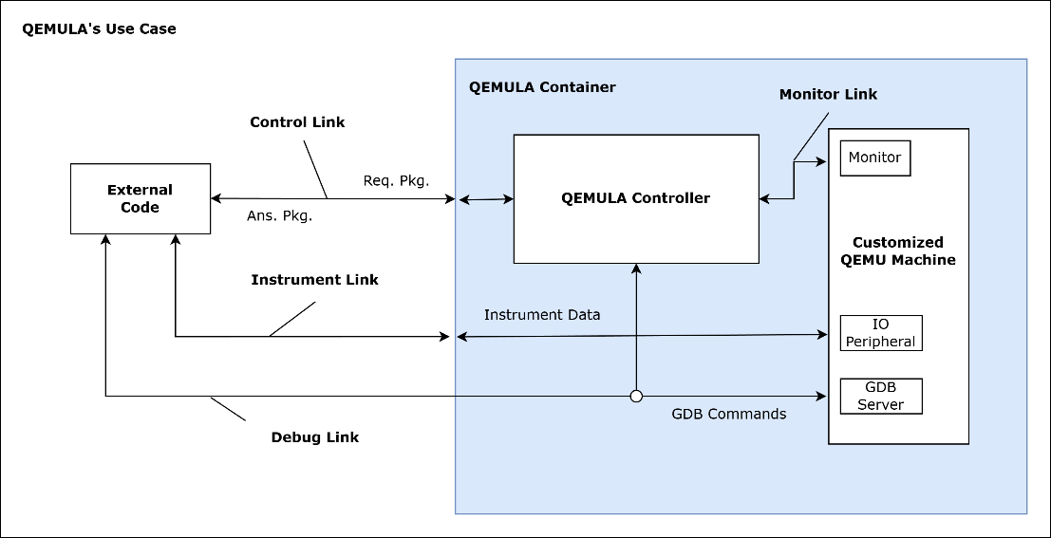
Source: the authors.

From the figure, it is possible to see that three main TCP/IP interfaces are exposed to the system user: the control interface—responsible for sending commands to the QEMULA Controller; the instrument interface—responsible for communicating with the input and output peripherals simulated in QEMU; and the debug interface—which enables a possible direct connection between the user and the system’s GDB (GNU Debugger) server. These connections allow a non-expert user, as long as they know the system-manipulation commands, to load and test code written for the LEON3 processor in a fully emulated environment.
Due to its complexity, the internal aspects of QEMULA and how it works will not be fully detailed in this manuscript. However, in order to present it as a unique tool for testing and validating embedded code—especially for the LEON3 processor—a practical example of using the tool to test a simple filtering software is proposed next.

PRACTICAL EXAMPLE 8 – EXECUTING AND VALIDATING FILTERING SOFTWARE USING QEMULA

As stated earlier, the goal of this practical example is to show the user, from a generalized perspective, how emulation tools can contribute to the testing and validation of algorithms intended for embedded systems. In particular, the QEMULA tool will be used as the basis for testing moving-average filtering software intended for the LEON3 space processor.
First, the user must have the Docker containerization tool installed on their PC, which is essential for running QEMULA. To install the tool, follow the step-by-step instructions provided at this link. In addition, you must have the Python interpreter installed on your PC, following the instructions at this link.
By accessing the GitHub repository related to this manuscript, you can navigate to the directory
<repository_root_folder>/1_LINGUAGEM_C_E_RTOS/7_QEMULA_EXAMPLE. Inside it, some code files can be found, including:
- start_qemula_container.bat: responsible for loading the QEMULA image in the computer’s Docker environment, running it, and initializing the tool’s interface script, accessing its user interface.
- start_process_audio.bat: responsible for starting the connection scripts to QEMULA’s instrument interfaces, loading the audio data to be processed, and collecting the processed data.
- qemula_interface.py: a script for connecting and communicating with QEMULA’s user interface. It allows manually sending commands to the system and receiving the corresponding acknowledgements.
- process_qemula_audio.py: a script responsible for connecting to QEMULA’s instrument interfaces, sending the audio to be processed, receiving the processed audio, and playing it back.
These files will be used in this example to execute and test the moving-average filtering code. For this example, the function created for the moving-average filter in Practical Example 5 was reused, since it can be applied generically to any use case. In addition, auxiliary libraries for the LEON3 processor were used to handle its UART peripherals, enabling the reception and transmission of data within the system. In this way, the following main code was created for the embedded processor, represented as C pseudocode:

It is easy to see that this code, using the LEON3 libraries, receives a set of data through its emulated UART, processes it using the moving-average filter, and then sends it back through the same UART. This code was compiled using the LEON3-specific compilation toolchain, resulting in the binary main.elf, located in the example folder.
#define MAX_BUFF_SIZE 1024

int main(){

// Creating a buffer for receiving and outputting data
double buff_in[MAX_BUFF_SIZE];
double buff_out[MAX_BUFF_SIZE];

// UART variable initialization
uart_dev* uart = init_uart()

// Function that receives data over UART and stores it in the buffer
uart_recv_data(uart, &buff_in);

// Applies the moving-average filter to the buffer
for(int i = 0; i < MAX_BUFF_SIZE; i++) buff_out[i] = moving_average(buff_in[i]);

// Function that sends the processed data back over UART
uart_send_data(uart, &buff_out);

return 0;

}
To run the container and connect to it, start Docker Desktop and, in a PowerShell window pointed to the example directory, run the command below:
>> ./ start_qemula_container.bat
When the emulation starts, QEMULA will open its instrument interfaces as TCP/IP ports in server mode. To connect to these ports and start sending the audio data to be processed, run the command below:
>> ./start_process_audio.bat
After running the command, the script that connects to the user interface will start, allowing the user to send commands directly to QEMULA. To run the example correctly, send the following commands:
- Choose command 3 – Send Inject .ELF Command, and select the main.elf file. This command loads the moving-average filter binary created earlier into the emulator environment, to be used by QEMU.
- Next, choose command 5 – Send Config RAM Command, and enter the value 128. This configures the emulator to allocate 128 MB of RAM to the emulated machine.
- Now, choose command 6 – Send Config Debug Command, and then select option 0 – no debug mode. This tells the emulator to run without debugging features enabled.
- Finally, choose command 8 – Send Start Emulation Command, starting QEMULA emulation.

This command will start the Python script that connects to QEMULA’s instrument interfaces, including the UART interface. In this way, audio data will be sent to the system, which will process it and then return it to the script. The audio data used comes from MATLAB’s chirp model and is stored in the file dados_chirp.xlsx.
The script then plays the original chirp audio, processes the audio through QEMULA, and finally plays the processed audio. To allow a better comparison between the two, run the previously shown command again, adding the --only-show-audio argument, as shown below:
>> ./start_process_audio.bat --only-show-audio

This will allow the user to listen to the original chirp audio—which is clearly higher-pitched—and compare it to the processed, lower-pitched audio. This happens due to the low-pass characteristic of the moving-average filter compiled into the main.elf code injected into the emulator, demonstrating its correct operation.
Thus, the use of the emulator is demonstrated, enabling the execution of filtering code intended for the LEON3 processor (SPARC architecture) together with auxiliary interface tools. Although QEMULA’s internal complexity and functionalities are not covered in depth, it is possible to recognize the power and importance of this tool, especially for embedded systems where access to physical hardware is more restricted.
The practical and theoretical examples in this section showed how important the C language is for embedded-systems development and, more specifically, how it can be integrated with other facilitating tools—such as MATLAB Coder and QEMU (or QEMULA). In addition, some applications for these types of programs were discussed, with a special focus on digital signal filtering algorithms. The language was also presented together with important real-time operating system concepts, illustrating how an RTOS contributes to building complex embedded systems with critical timing requirements.
The next section, building on the concepts discussed so far, introduces new tools for data processing and physical models in a constrained embedded system: neural networks.

Neural Networks and PINNs
In this chapter, we will briefly discuss what neural networks are and their fundamental role in embedded systems—especially from the perspective of computational optimization.
We will also discuss a few examples of how they work and how they are trained, using important tools such as Python’s TensorFlow library and combining them with tools previously covered, such as MATLAB HDL Coder. The goal is to bring together the concepts learned so far and apply them to a complex and highly relevant topic in modern data processing, both in the cloud and on-site.

The Neural Networks and MLPs
As embedded and cyber-physical systems become more complex, the need grows for models capable of representing nonlinear dynamic behaviors, coupled phenomena, and systems governed by multiple physical variables. In previous chapters, approaches based on analytical models, hardware descriptions, deterministic algorithms in C, and automatic code generation techniques were explored—always with the goal of ensuring predictability, performance, and reliability. However, there are problems in which obtaining purely analytical and deterministic systems is impractical, especially when they involve computationally intensive behavior.
In this context, machine learning techniques—and artificial neural networks in particular—have taken on an important role in the modeling, identification, and control of complex systems. Neural networks offer the ability to approximate nonlinear functions from data, capturing implicit relationships between variables without the need to explicitly state all governing equations of the system. This characteristic has made such models especially attractive in applications involving complex physical systems, measurement noise, parametric uncertainties, or strongly nonlinear behavior.
For embedded systems in particular, neural networks bring an important advantage: computational cost. Although in some cases they may have a large number of calibration parameters, neural networks can enable faster processing of data and information than other conventional approaches.
In short, a neural network is a computational component that performs successive linear and nonlinear operations on an arbitrary input, producing a specific output. The core of these computational entities lies in the calibration parameters of these operations, which define their behavior. Knowing the operations performed by a given network, together with a set of input data and a set of expected output data—called the training set—it is possible to optimize the parameters that configure the entity’s operations, allowing it to “learn” from the training data. This enables some important advantages:
- Learning patterns that are not easily handled by other classical computational methods, such as image recognition, data clustering, and related tasks.
- Computationally simplifying a calculation or operation into fewer steps, trading exactness for accuracy within an acceptable range.
The following theoretical example aims to introduce a classic neural-network topology—an MLP (Multi-Layer Perceptron)—with the goal of performing function interpolation. The main idea of the example is to illustrate to the reader how the network works in general and how it is effectively trained. Since there are countless network topologies, this example is intended to introduce the topic and enable the reader to later seek other references to explore it in greater depth.

THEORETICAL EXAMPLE 4 – PERCEPTRONS, OPTIMIZATION ALGORITHMS, AND MLPs

The goal of this example is to introduce the reader to the concept of a Perceptron and to a network that combines multiple Perceptrons so that—“imitating” the human brain—it can predict specific information or data. These types of networks are called MLPs.
Essentially, a Perceptron is the atomic unit of an MLP network, often referred to simply as a “neuron.” The Perceptron in question has the general structure shown in the block diagram below.

Figure 33 — Perceptron
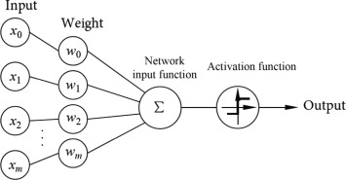
Source: Science Direct.

Analogous to a biological neuron, a Perceptron combines information from its inputs (the dendrites) into a single output (the axon). In essence, it performs simple mathematical operations, combining linear elements—additions and multiplications—with nonlinear ones. From the illustrated Perceptron, the output value can be computed according to Equation 4 below:

 | $$y=f_{a}\left(\sum_{i=0}^{n}{x_{n}}⋅w_{n}\right)$$ | (3)

In this equation, y is the Perceptron’s output, xₙ is its n-th input, wₙ is its n-th input weight, and fₐ(t) is the chosen activation function. Put simply, the parameters wₙ are real numbers, while the activation function fₐ(t) can take different forms, but it always introduces some kind of nonlinearity. The purpose of introducing a nonlinearity is to avoid limiting the Perceptron—and a network of Perceptrons—to purely linear mathematical operations, which are trivial in mathematics and computation and do not provide any new insight or learning. One of the most well-known and widely used activation functions is the sigmoid function σ(t), shown below:

Figure 33 — Graphical representation of the sigmoid activation function.
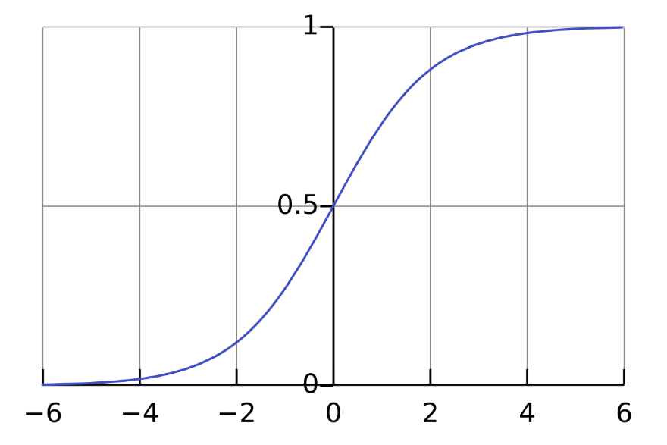
Source: Wikipedia.

In short, the number of inputs n and the activation function fₐ(t) are defined as intrinsic parameters of the Perceptron—that is, they do not store any active information. The parameters responsible for the computational tool’s “learning” are its weights wₙ. Essentially, given predetermined and known inputs and outputs—called training data—it is possible to optimize the Perceptron’s weights wₙ so that it learns some simple information.
For a single Perceptron, optimizing it for a specific training dataset is relatively straightforward. You simply choose an associated loss function, which characterizes the difference between the expected output and the obtained output, and then optimize the parameters wₙ so that the accumulated loss tends toward a minimum value. There are many possible loss functions, with the mean squared error (MSE) being one of the most common, as shown in Equation 5 below.

 | $$P=\frac{1}{n}⋅\sum_{i=0}^{n}{{\left(y_{n}-{\hat{y}}_{n}\right)}^{2}}$$ | (4)

Let P be the accumulated loss value, n the number of individual training data points evaluated, yₙ the n-th output produced by the Perceptron, and ŷₙ the n-th output expected from the Perceptron. Thus, by substituting yₙ with the Perceptron’s characteristic equation shown in Equation 4, it is possible to obtain a function that relates P directly to the Perceptron’s weights wₙ. By optimizing the function P, one can then obtain the weights wₙ that best fit the training dataset, thereby “training” the Perceptron.
Although it is a powerful tool, a single Perceptron does not have a high learning capacity, especially when dealing with large training datasets with multiple inputs and outputs. For this reason, MLP neural networks emerged, aggregating multiple Perceptrons in series and in parallel, enabling deeper learning. The figure below shows the general structure of a simple MLP, where each object represents a Perceptron.
.

Figura 35 — General representation of an MLP.
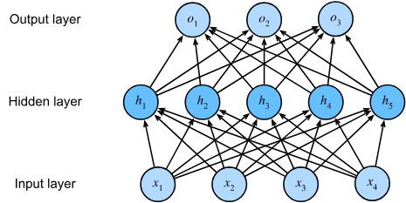
Source: Dive into Deep Learning.

From the figure shown, it is possible to see that an MLP can have a varying number of layers, each composed of a different number of Perceptrons. In essence, the network’s first layer is called the input layer, the intermediate layers are called hidden layers, and the final layer is called the output layer. As in the Perceptron, input data is provided to the input layer, then propagated forward according to the mathematical operations performed by the Perceptrons in the network—layer by layer—ultimately producing outputs at the output layer. The characteristics that define the MLP topology—such as the number of layers and the number of Perceptrons per layer—are called hyperparameters. There is no general rule for choosing hyperparameters; they are usually tuned on a case-by-case basis, often in a largely empirical manner.
It is important to note that each Perceptron in an MLP has its own individual weights wₙ, which collectively represent the learned knowledge of the network. Because of this, it is not so simple to optimize the weights of all neurons in the network directly from a loss function and the training data. More complex algorithms—among which the simplest is gradient descent—were developed to enable the optimization of the weights wₙ with respect to the training data. In all of them, parameter training happens gradually, iterating over the training data in epochs. It is expected that, with each epoch, the neural network will tend to exhibit a smaller loss value P, indicating its “learning.”
Training algorithms for MLPs—and neural networks in general—are not simple and involve important nuances. For example, if a network has too many neurons and is trained excessively on its dataset, it may tend to “memorize” the training data instead of learning its patterns. This leads to a loss of generality, preventing the network from predicting or interpreting new incoming data.
To prevent the network from memorizing its training data, the dataset is typically split into training data and validation data. The training data is used to optimize the network parameters wₙ, while the validation data is used to check, at the end of training, whether the network has overfit (i.e., memorized) the provided inputs. If it has, the validation loss will be excessively high. In that case, the network hyperparameters must be adjusted—reducing its topology and complexity—or the number of training epochs must be reduced.
At the end of this process, the network designer will have a computationally simple resource capable of making predictions based on some correlated pattern in specific input data. At larger scales, this enables image or character recognition, face recognition, and even the prediction of textual elements—something commonly associated with large generative AI tools such as ChatGPT and Gemini.

Traditionally, the use of neural networks is associated with purely data-driven approaches, in which the model learns exclusively from examples provided during training. Although this strategy has proven effective in many domains, it presents important limitations when applied to physical systems. In particular, purely data-based models can violate conservation laws, exhibit non-physical behavior outside the training domain, or require large volumes of data to reach acceptable accuracy levels. The next subsection will illustrate how PINNs emerge to address this limitation of traditional neural networks by introducing new training techniques for the same network topologies discussed so far.

4.2 Physics-Informed Neural Networks (PINNs) and Their Characteristics
In response to these limitations, hybrid approaches emerged that combine machine learning with prior physical knowledge. Among these approaches, Physics-Informed Neural Networks (PINNs) stand out, as they integrate the differential equations governing the physical system directly into the neural network training process. Instead of learning only from observed data, a PINN is trained to simultaneously satisfy the available data and the known physical laws, which are incorporated as constraints in the optimization problem.
This characteristic positions PINNs as a natural extension of the modeling techniques presented throughout this manuscript. Just as digital filters, control systems, and dynamic models can be described by differential equations and later implemented in software or hardware, PINNs make it possible to approximate solutions to these equations using neural structures, maintaining physical consistency even in regions where data is scarce or nonexistent. In this way, learning is no longer purely empirical and becomes guided by fundamental principles of the system under study.
In the context of embedded and cyber-physical systems, using physics-informed neural networks opens new possibilities for modeling, state estimation, parameter identification, and even control. Although directly deploying neural networks on resource-constrained devices still poses challenges, advances in code-generation tools, quantization techniques, and hardware acceleration have made such integration increasingly feasible. Thus, introducing PINNs in this work complements the set of tools discussed so far, expanding the range of techniques available for developing intelligent, robust, and physically consistent systems.
Next, a practical example will be presented with the goal of creating and training a simple PINN based on a known physical law with a determined analytical solution: Newton’s Law of Cooling. It is important to note that PINNs are not restricted to laws with known analytical solutions; using such a law here is simply a choice for the example, in order to demonstrate the accuracy of the trained network.

PRACTICAL EXAMPLE 9 – TRAINING A PINN FOR NEWTON’S LAW OF COOLING

This practical example aims to illustrate the use of Physics-Informed Neural Networks (PINNs) to solve a simple yet representative physical problem: Newton’s law of cooling. The problem was chosen because it has a known analytical solution, allowing direct validation of the results obtained by the neural network. In addition, it involves a first-order ordinary differential equation, making it suitable for didactic purposes.
Newton’s law of cooling describes the time evolution of the temperature of a body in contact with an environment of constant temperature, and it is expressed by the differential equation shown in Equation 6 below.

 | $$\frac{dT\left(t\right)}{dt}=-k⋅\left(T\left(t\right)-T_{amb}\right)$$ | (4)

Where T(t) represents the body’s temperature over time, Tₐₘ_{b} is the ambient temperature, and k is the thermal constant of the phenomenon. For the initial condition T(0) = T₀, the analytical solution to the problem is known, which makes it possible to directly compare the solution provided by the PINN with the expected physical behavior.
In this example, the neural network is implemented in Python using the TensorFlow library. The chosen architecture consists of a fully connected network with multiple hidden layers and a hyperbolic tangent activation function, a configuration commonly used in PINN applications due to its smoothness and good capability for approximating continuous functions. The network takes time t as input and outputs the estimated temperature T(t). The code related to training, structuring, and analyzing the PINN is in the project’s GitHub repository, located in the folder <repository_root>/1_EXAMPLE_PINN_TEMPERATURE_PYTHON/.
Unlike traditional supervised learning approaches, training a PINN is not based solely on labeled data. Instead, the differential equation governing the physical system is incorporated directly into the network’s loss function. To do this, samples from the time domain are generated and, through automatic differentiation, the derivative of the network output with respect to time is computed numerically. This derivative is then used to form the residual of the differential equation, which is adopted as the loss function for the network being trained. In this way, minimizing the residual forces the network to comply with the physical dynamics of the problem.
In addition to the term associated with the differential equation, the loss function includes an additional term that enforces the system’s initial condition. Thus, the training simultaneously aims to satisfy the physical law and the initial condition, which characterizes the physics-informed approach. In particular, this additional term is very important to prevent the neural network from converging to the trivial solution of the differential equation, which is not desired.
Finally, the optimization process is carried out using the Adam algorithm, which is widely used in deep neural networks. The code below illustrates the definition of the network’s training functions, including the definition of its loss function associated with the differential equation discussed above.
def analytical_solution(t):
return T_amb + (T0 - T_amb) * np.exp(-k * t)

def build_model():
inputs = tf.keras.Input(shape=(1,))
x = inputs
for _ in range(3):
x = tf.keras.layers.Dense(32, activation=tf.nn.tanh)(x)
outputs = tf.keras.layers.Dense(1)(x)
return tf.keras.Model(inputs, outputs)

model = build_model()
optimizer = tf.keras.optimizers.Adam(LR)

@tf.function
def train_step():
t_f = tf.random.uniform((N_F, 1), 0.0, T_MAX, dtype=tf.float32)
t0 = tf.zeros((1, 1), dtype=tf.float32)
T0_target = tf.constant([[T0]], dtype=tf.float32)

with tf.GradientTape(persistent=True) as tape:
tape.watch(t_f)
T_pred = model(t_f)
dTdt = tape.gradient(T_pred, t_f)
residual = dTdt + k * (T_pred - T_amb)

T0_pred = model(t0)
loss_pde = tf.reduce_mean(tf.square(residual))
loss_ic = tf.reduce_mean(tf.square(T0_pred - T0_target))
loss = loss_pde + loss_ic

grads = tape.gradient(loss, model.trainable_variables)
optimizer.apply_gradients(zip(grads, model.trainable_variables))
return loss

for epoch in range(1, EPOCHS + 1):
loss = train_step()
if epoch % PRINT_EVERY == 0:
print(f"Epoch {epoch:5d} | Loss {loss.numpy():.6e}")

In essence, the analytical_function() function is used as a reference to represent the analytical solution of the model. The build_model() function defines the MLP network structure and its hyperparameters, with three hidden layers of 32 neurons each. The constructed network is designed to take a single input value t and predict the temperature T(t) at any instant. Therefore, it has only one input and one output. Finally, the optimizer is defined as Adam via tf.keras.optimizers.Adam(LR), and the training function train_step() is defined, specifying the loss function and its corresponding modeling error terms mentioned earlier. The specific syntax of TensorFlow is not covered in this manuscript, but based on the theoretical foundations presented, it is possible to understand what each part of the Python code does.
After training, the network is evaluated over a set of points along the time domain, and its results are compared with the analytical solution of the problem. This comparison makes it possible to quantitatively verify the quality of the approximation obtained by the PINN—typically through metrics such as MSE—along with a visual analysis of the temporal response. The figure below shows a comparison of the cooling phenomenon computed by the analytical solution versus what was predicted by the neural network.
Figure 36 — Comparison between the analytical model and the values predicted by the PINN.
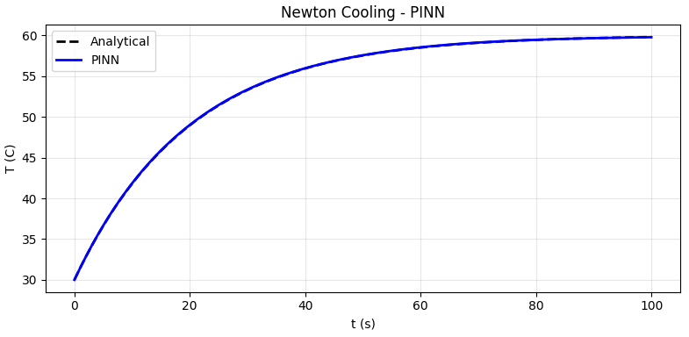
Source: the authors.

It is clear, from a superficial analysis of the image, that the PINN was trained correctly and closely matched the original model. An important point to note is that, since the PINN does not take as inputs the parameters of the law mentioned—such as T(0), Tₐₘ_{b}, and k—it cannot be generalized to other parameter choices. Adding these values as inputs would be straightforward, but it would require a more complex training function covering multiple instances of the studied physical phenomenon so that the network can “learn” its behavior. In addition, the process would be more computationally demanding, making it impractical for a didactic approach like the one presented here.
To run the code and perform the construction, training, and evaluation of the PINN, simply download and install Python by following the instructions at that link. After installing the tool, open a Windows PowerShell session in the previously mentioned repository folder and run the command below:
./ run_pinn_venv.bat

This will create a virtual environment to install all the libraries required to run the code, then execute it and generate the output plot. By watching the same terminal window, you can also see the resulting accumulated RMSE loss, which demonstrates the model’s accuracy.
From the last practical example, it was possible to create, train, and evaluate a simple PINN for a physical phenomenon that is commonly encountered in everyday life and across many applications—such as steelmaking, the automotive industry, and even the food industry. The example showed that, with the right techniques, tools, and theory, training and evaluating a PINN is straightforward, making it ready to be used in complex operating environments such as Windows.
In order to combine the PINN concepts learned with embedded systems, the final practical example in this manuscript aims to translate the trained PINN into VHDL using MATLAB’s native tools. This allows the network to be implemented in edge-computing embedded environments with a high degree of computational efficiency, removing the need for intensive connections to centralized cloud environments and related infrastructure. To make the example easier to design and illustrate, the training model and the parameters obtained in Practical Example 9 will be reused, placing greater focus on translating the network into its VHDL counterpart.

PRACTICAL EXAMPLE 10 – TRANSLATING A PINN TO VHDL

As mentioned earlier, this practical example aims to present a step-by-step procedure for translating a trained PINN—or any neural network—into VHDL using MATLAB HDL Coder. The process is similar to what was done in Practical Example 6, with some important nuances and differences.
First, you should verify that after running the PINN training code in Practical Example 9, some parameter storage files were generated—namely pinn_weights.npz and pinn_weights.mat. These files are essential for recreating the network inside a MATLAB function, which will then allow that function to be translated into VHDL using HDL Coder.
First, open MATLAB (preferably version R2025b) and set the project repository to the directory:
<github_repository_root>/3_NNs&PINNS/3_EXAMPLE_PINN_IN_HDL.
Next, copy the parameter files pinn_weights.npz and pinn_weights.mat into the configured directory, allowing them to be reused by the MATLAB scripts that generate the HDL code.
In the repository, you can find some scripts that are important for generating the PINN’s HDL code:

- pinn_forward_scalar.m: a function that performs the PINN computations based on the provided parameters. This is the main computational element that will be translated into VHDL.
- pinn_predict_hdl.m: the function that will actually be translated into VHDL. It loads the parameters from the pinn_weights.mat file and calls the previously shown function to predict the neural network output.
- tb_pinn_predict_hdl.m: a reference function for building the testbench that complements the generated HDL code. It will be essential for generating the testbench and later simulating it in Modelsim.

To start generating the code, go to the Apps tab and look for HDL Coder, then left-click it. Create a project with any name. A new window will open, intended for configuring the HDL code to be generated. In this window, choose the pinn_predict_hdl.m script under Add MATLAB Function to specify the function to be converted, and also add the file tb_pinn_predict_hdl.m under Add Files as the testbench configuration.
In the MATLAB Function tab of the same window, set the input variable x to type Single 1 × 1, as shown below.

Figure 37 — Input configuration for the function to be translated.
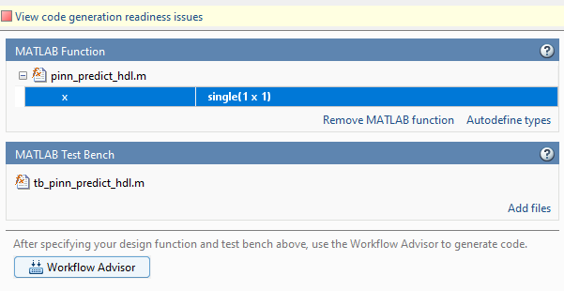
Source: the authors.

Next, in the same window, click Workflow Advisor to continue the HDL code generation process. In the new window that opens, go to the HDL Workflow Advisor sub-tab and click Run. After that, all steps for converting the variables and computations in the code to fixed-point floating-point (i.e., floating-point–to–fixed-point conversion) and generating the network’s HDL code will be performed.
At the end of the process, go to the Verify with HDL Testbench sub-tab, check the Generate testbench box, and click Run. This will generate the testbench according to the previously configured test script.
Now, check the Simulate generated testbench box and set the simulator option to Modelsim. Then click Run to execute the testbench. Using this MATLAB feature, log files will be generated showing the compilation and execution results of the testbench—the main one being pinn_predict_hdl_fixpt_vsim_log_sim.txt. By analyzing the generated data, you can see that the testbench and the module ran correctly, as shown in the log below.

In essence, MATLAB generates .dat data files that are compared at runtime against the module’s output values during the testbench execution. If everything runs correctly and the module is proven functional, the message TEST COMPLETED (PASSED) can be seen. It is also possible to simulate the testbench natively using Modelsim, as in Practical Example 4, allowing the visualization of the module’s timing diagram. Since this procedure was shown previously, it will not be revisited here.
# ** Warning: NUMERIC_STD."<": metavalue detected, returning FALSE
# Time: 2 ns Iteration: 2 Instance: /pinn_predict_hdl_fixpt_tb/u_pinn_predict_hdl_fixpt
# ** Warning: NUMERIC_STD."<": metavalue detected, returning FALSE
# Time: 2 ns Iteration: 2 Instance: /pinn_predict_hdl_fixpt_tb/u_pinn_predict_hdl_fixpt
# ** Warning: NUMERIC_STD."=": metavalue detected, returning FALSE
# Time: 2 ns Iteration: 2 Instance: /pinn_predict_hdl_fixpt_tb/u_pinn_predict_hdl_fixpt
# ** Warning: NUMERIC_STD."<": metavalue detected, returning FALSE
# Time: 2 ns Iteration: 2 Instance: /pinn_predict_hdl_fixpt_tb/u_pinn_predict_hdl_fixpt
# ** Warning: NUMERIC_STD.">": metavalue detected, returning FALSE
# Time: 2 ns Iteration: 2 Instance: /pinn_predict_hdl_fixpt_tb/u_pinn_predict_hdl_fixpt
# ** Warning: NUMERIC_STD.">": metavalue detected, returning FALSE
# Time: 2 ns Iteration: 2 Instance: /pinn_predict_hdl_fixpt_tb/u_pinn_predict_hdl_fixpt
# ** Warning: NUMERIC_STD.TO_INTEGER: metavalue detected, returning 0
# Time: 2 ns Iteration: 2 Instance: /pinn_predict_hdl_fixpt_tb/u_pinn_predict_hdl_fixpt
# ** Note: **************TEST COMPLETED (PASSED)**************
# Time: 1040 ns Iteration: 1 Instance: /pinn_predict_hdl_fixpt_tb
# End time: 17:08:49 on Feb 01,2026, Elapsed time: 0:00:03
# Errors: 0, Warnings: 1859

The examples in this section highlighted the importance of neural networks and, more specifically, PINNs—especially for embedded systems. In addition, the essential techniques and tools for building and training a neural network were demonstrated, as well as translating it into hardware description languages.
It is important to note that the methods shown are not unique and can be adapted to different applications. For example, it would be possible to translate the neural network to C using MATLAB C Coder, which was not covered here. The purpose of this section was to introduce the reader to these techniques, enabling them to reuse and expand them for new use cases, as in the example presented.

Conclusion
Throughout this manuscript, an integrated workflow for the development of advanced digital systems was presented, covering everything from dedicated hardware descriptions to modern machine learning techniques. Starting from HDL languages, aspects of parallelism and determinism in hardware were explored, followed by the use of the C language and automatic code generation tools for implementing algorithms in embedded systems.
The introduction of real-time operating systems, such as FreeRTOS, made it possible to structure applications with multiple concurrent functionalities, meeting more stringent timing requirements. In addition, the use of emulation environments—especially QEMU—proved fundamental for validating and debugging software independently of the immediate availability of the target hardware, reducing risks and accelerating the development process.
Finally, the incorporation of artificial neural networks, and in particular Physics-Informed Neural Networks, expanded the scope of the approaches discussed, offering ways to model complex systems in a manner consistent with known physical laws. By integrating classical engineering methods with learning-based techniques, this work highlighted the importance of a multidisciplinary perspective in the development of modern digital systems.
It is hoped that the concepts and examples presented will contribute not only to an understanding of the tools used, but also of the methodological workflow required to design robust, scalable systems aligned with current engineering demands.
Thank you for your time and dedication to reading, understanding, and carrying out the examples provided in this booklet. We (the authors) wish the reader good luck and a fruitful learning experience on this “journey” toward creating complex embedded systems.

References
Ashenden, P. J. . (2002). The designer’s guide to VHDL. Morgan Kaufmann.
Barry, Richard. (2010). Using the freeRTOS real time kernel : a practical guide. Real Time Engineers Ltd.
D’Amore, Roberto. (2005). VHDL : descrição e síntese de circuitos digitais. Livros Técnicos e Científicos.
Farea, A., Yli-Harja, O., & Emmert-Streib, F. (2024). Understanding Physics-Informed Neural Networks: Techniques, Applications, Trends, and Challenges. AI, 5(3), 1534–1557. https://doi.org/10.3390/ai5030074
HARROW, Z. M. M. . (2025). RTOS BEGINNER GUIDE : a practical introduction to real-time embedded systems. ADMIT HUB REF SERVICE PR.
Hertz, John., Palmer, R. G. ., & Krogh, Anders. (2018). Introduction To The Theory Of Neural Computation. CRC Press.
Merrick, Russell. (2024). Getting started with FPGAs : digital circuit design, Verilog, and VHDL for beginners. No Starch Press.
Pont, M. J. . (2005). Embedded C. Addison-Wesley.
Software Freedom Conservancy. (2025). QEMU - Quick EMUlator. https://www.qemu.org
Zurada, J. M. . (1992). Introduction to artificial neural systems. West.
Zurell, Kirk. (2000). C Programming for embedded systems. CMP Media.

