QEMULA User Manual




Table of Signatures

11/10/2024

Summary

1. Introduction 1
2. System Requirements 2
3. Installation 2
3.1. For Linux Ubuntu/Debian 22 and older versions: 3
3.2. For other Linux distributions (Red Hat Enterprise and others) 4
3.3. For Windows (x86 and ARM) 5
4. Configuration and Initialization 5
5. QEMULA’s Control Interface Usage 6
6. QEMULA’s Debug Interface Usage 12
7. QEMULA’s Instrument Interface Usage 12
8. QEMULA’s Basic Tutorial with Provided Testing Code 13

Introduction

QEMULA is an integrated environment and framework designed to emulate the logical processing of the VenSpec-M processing unit. This unit is a core component of the Venus Emissivity Mapper (VEM) spectrometer instrument, which will support the VERITAS and EnVision missions. One of the primary objectives of QEMULA is to provide a virtual testing environment that replicates the behavior of the satellite's embedded hardware responsible for processing spectrometer data.
To achieve accurate emulation of VenSpec-M hardware configurations, the NSEE team conducted an in-depth analysis of QEMU, an open-source software developed by Fabrice Bellard. QEMU enables processor emulation and full system virtualization, making it an ideal foundation for this project. Following extensive comparisons and testing, the team selected QEMU as the core of QEMULA due to its compatibility with the LEON3 processor from Frontgrade Gaisler, its seamless integration with most relevant peripherals, and its adaptability for creating custom components.
This manual provides guidance on the emulation and simulation of the VenSpec-M processing unit, emphasizing the SpaceWire communication protocol. It outlines the software components and digital infrastructure required to meet the testing specifications, as detailed in the QEMULA Official Requirements document.
To meet the requirements of the first delivery, the user can interact with QEMULA through the following system TCP/IP interfaces:
- Control Interface: A layer and set of frameworks responsible for managing and supervising the general operation of the simulations carried out by the QEMU emulator running inside of QEMULA. Also, this interface enables debugging capabilities when the emulation is running, through a GDB Server provided directly by QEMU. This interface has only 1 TCP/IP link and its own control protocol, which will be better described later in this document.
- Instrument Interface: Responsible for enabling communication between QEMULA’s user and the emulated instrument itself. Because the main emulated system interfaces are, essentially, SpaceWire (SpW) links, this interface aims to emulate their behaviour, providing several TCP/IP links that replicate the instruments real SpW interfaces.
- Debug Interface: A module designed to monitor and address errors or failures during the execution and testing of software within QEMULA. This interface enables users to track performance issues, bugs, and unexpected behaviors, allowing for the analysis of both hardware and software operations to pinpoint the source and nature of errors. The connection is primarily managed by a GDB server within QEMULA, which can be externalized or kept internal during emulation.
The following items in this document will detail the use and preparation of the environment to meet the requirements of the first release of the project, with detailed instructions on how to operate the delivered system.

System Requirements

Below are defined the general system specifications for running QEMULA:
- Processor:

  - 64-bit processor (x86_64 or ARM) with at least two nuclei available.
  - Hardware virtualization support (Intel VT-x or AMD-V) is recommended for optimized performance but not strictly necessary.

- RAM:

  - At least 4 GB of RAM.

- Storage:

  - At least 500 MB of free disk space.

Installation

To run the application, the user only needs to have the main Docker components (Engine, Compose, and Build) or Docker Desktop installed. The following sections will comprehend instructive links and pages on how to install Docker in different operational systems.

3.1. For Linux Ubuntu/Debian 22 and older versions:

Set up Docker’s repository, executing the following commands on a terminal:
# Add Docker's official GPG key:
> sudo apt-get update
> sudo apt-get install ca-certificates curl
> sudo install -m 0755 -d /etc/apt/keyrings
> sudo curl -fsSL https://download.docker.com/linux/ubuntu/gpg -o /etc/apt/keyrings/docker.asc
> sudo chmod a+r /etc/apt/keyrings/docker.asc
# Add the repository to Apt sources:
> echo \
"deb [arch=$(dpkg --print-architecture) signed-by=/etc/apt/keyrings/docker.asc] https://download.docker.com/linux/ubuntu \
$(. /etc/os-release && echo "$VERSION_CODENAME") stable" | \
sudo tee /etc/apt/sources.list.d/docker.list > /dev/null
> sudo apt-get update

Install Docker packages:
# List the available versions:
> apt-cache madison docker-ce | awk '{ print $3 }'

Select the version:
> VERSION_STRING=5:27.1.1-1~ubuntu.22.04~noble
> sudo apt-get install docker-ce=$VERSION_STRING docker-ce-cli=$VERSION_STRING containerd.io docker-buildx-plugin docker-compose-plugin

Verify the installation:
> sudo docker run hello-world

Download the DEB for installation using this link. Gnome-terminal must be installed:
> sudo apt install gnome-terminal

Install packages necessary for docker:
> sudo apt-get update
> sudo apt-get install ./docker-desktop-amd64.deb

The user can start the docker use open with another application, or run this line:
> systemctl --user start docker-desktop

To finish, the user must only enable Docker:
> systemctl --user enable docker-desktop

When successfully installed, the user could see the Docker Desktop icon available (if the system has a graphical interface), as seen in Figure 1.
Figure 1 – Docker desktop initialization icon.
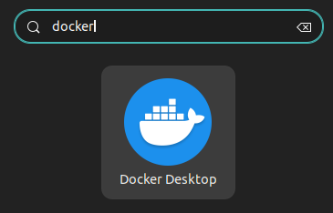
Source: the authors.

For more questions on how to install Docker Desktop on Ubuntu/Debian, please visit the Docker Manuals on this link.

3.2. For other Linux distributions (Red Hat Enterprise and others)

In a Linux environment, the user needs to follow the instructions on how to install Docker Desktop, following the instructions available on this link.
It is recommended to install Docker Desktop due to its compatibility and stability. However, if preferred, users can opt to install Docker Engine, Docker Compose, and Docker Build separately by following the instructions provided at this link.

3.3. For Windows (x86 and ARM)

In a Windows environment, the user needs to follow the instructions on how to install Docker Desktop, following the instructions available on this link.

Configuration and Initialization

To set up QEMULA, the user must first download the latest release available in the NSEE repository via the provided link.
Initialization involves running two scripts available in the downloaded release directory. First, execute the configure_qemula script to load QEMULA's image and prepare the environment. Then, execute the start_qemula script to launch QEMULA Docker container. Finally, execute the stop_qemula script to stop QEMULA, when convenient. Note that all scripts require Docker Desktop (or Docker Engine) to be running beforehand. Also, no additional configuration is necessary for running QEMULA when the system’s image is already loaded, so configure_qemula script can only be executed one time, while start_qemula and stop_qemula can be executed multiple times.
For Windows users, the .bat scripts should be executed, which are located on the /Windows/ directory. Linux users should run the corresponding .sh scripts, which are located on the /Linux_Unix/ directory. Both versions perform the same functions, tailored to their respective operating systems.
PS: For Linux environments, if the scripts couldn’t be executed, it may be necessary to execute the following commands:
> chmod +x configure_qemula.sh
> chmod +x start_qemula.sh

After that, the system should be initialized correctly. Then, the user needs to connect to QEMULA’s control link to send requisitions and receive answers, connecting to port 4322 of localhost.
When needed, the user should have the capability to connect to QEMULA’s instrument link and debug link:
ports:
- "5050:5050" # QEMULA’s instrument link
- "1234:1234" # QEMULA’s debug link

PS: For debugging purposes, it is important that the code to be tested in QEMULA’s environment be compiled with a -g flag, preferably without any optimizations enabled.

QEMULA’s Control Interface Usage

In this topic, some steps will be outlined so that the user or system can arbitrarily command the behavior of QEMULA through its defined control interface, as well as manage the codes to be tested and the emulation itself.
Initially, the user must connect to the QEMULA system through the control interface, which is open via a TCP/IP server at IP localhost:4322.
Once the connection is successfully established, the user or system can then send requisitions for QEMULA to execute predetermined actions. These requisitions involve answers from QEMULA, both defined through a standardized protocol (see QEMULA’s Official Requirements for more information).
It is important to note that the QEMULA system operates in two different states: configuration (CONFIG) and execution (RUN). Therefore, it is the user's responsibility to configure the emulation parameters and related settings during the CONFIG state of the machine, to begin the emulation itself and transition it to RUN mode.
Essentially, every requisition will take the form described in Figure 2 below.

Figure 2 – General structure of a QEMULA’s requisition package.
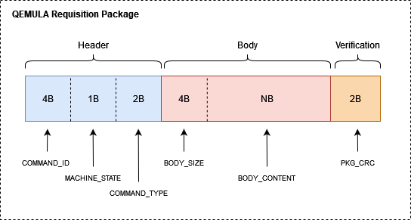
Source: the authors.

Thus, it is up to the user to determine the COMMAND_ID to be used, which is an arbitrary and unique value specific to each requisition sent. The other fields will be elaborated on in the future. The general format of an answer, the response packet from QEMULA, can be seen below in Figure 3.

Figure 3 – General structure of a QEMULA’s answer package.
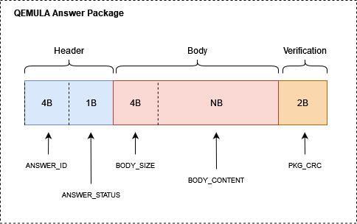
Source: the authors.

Each answer packet received by the user contains the same ANSWER_ID that matches the COMMAND_ID of the request that generated the answer. This allows the user to associate the received answer with a previously sent request. The other package fields will also be elaborated on in the future.
In this way, the fields particular to each type of requisition supported by the system can be viewed in the Table 1 below.

Table 1 – Requisitions packages supported and their respective fields.
MACHINE_STATE | COMMAND_TYPE | BODY_CONTENT
0xX | 0x00 (Verify State) | -
0x0 (CONFIG) | 0x01 (Inject .ELF) | .ELF Binaries
0x0 (CONFIG) | 0x02 (Inject AHBROM Mem File) | AHBROM Binaries
0x0 (CONFIG) | 0x03 (Config RAM) | RAM in MB
0x0 (CONFIG) | 0x04 (Config Debug) | 0x0 - Without Debug / 0x1 - With Debug and Interface / 0x2 – With Debug and without Interface
0x0 (CONFIG) | 0x05 (Set OS ABI For Debug) | GDB OS ABI (in utf-8)
0x0 (CONFIG) | 0x06 (Start Emulation) | -
0x1 (RUN) | 0x07 (Pause Machine) | -
0x1 (RUN) | 0x08 (Unpause Machine) | -
0x1 (RUN) | 0x09 (Dump Memory) | 0xXXXXXXXX - Mem ADDR + Mem Length (in bytes, 8192 MAX)
0x1 (RUN) | 0x0A (Load Memory) | 0xXXXXXXXX - Mem ADDR + Mem DATA
0x1 (RUN) | 0x0B (Read I/O) | 0xXXXXXXXX - Mem ADDR
0x1 (RUN) | 0x0C (Write I/O) | 0xXXXXXXXX - Mem ADDR + 0xX IO Value
0x1 (RUN) | 0x0D (Quit Emulation) | -
0x1 (RUN) | 0x0E (Configure Breakpoint) | Breakpoint Line Number
0x1 (RUN) | 0x0F (Delete Breakpoint) | Breakpoint Line Number
0x1 (RUN) | 0x10 (Continue Execution) | -
0x1 (RUN) | 0x11 (Finish Execution) | -
0x1 (RUN) | 0x12 (Next Line) | -
0x1 (RUN) | 0x13 (Step Into) | -
0x1 (RUN) | 0x14 (Verify Variable) | Variable Name (in utf-8)
0x1 (RUN) | 0x15 (Send GDB Command) | GDB Command (in utf-8)
Source: the authors.
PS: the commands marked in red are not implemented in this first version, being reserved for future improvements.
In this way, the user will be able to send commands that configure the emulation and start the emulation in the CONFIG state using the “Start Emulation” requisition, as well as commands that manage and terminate the emulation, using the “Quit Emulation” in the RUN state, generalizing the behavior of the machine.
PS: It is imperative to mention that the system can automatically transition from the RUN state to the CONFIG state if the injected .ELF code completes its execution. Similarly, as previously mentioned, this transition can also occur artificially if the user submits a 'Quit Emulation' request.
Complementing the table above, it is also necessary to display the fields of the answer packets according to their originating requisition. The BODY_CONTENT field of each generated answer is shown in Table 2 below.

Table 2 – Answer packages supported and their respective fields.
Prev. | Prev. | BODY_CONTENT
MACHINE_STATE | COMMMAND_TYPE | BODY_CONTENT
0xX | 0x00 (Verify State) | 0x0 - CONFIG / 0x1 - RUN
0x0 (CONFIG) | 0x01 (Inject .ELF) | -
0x0 (CONFIG) | 0x02 (Inject AHBROM Mem File) | -
0x0 (CONFIG) | 0x03 (Config RAM) | -
0x0 (CONFIG) | 0x04 (Config Debug) | -
0x0 (CONFIG) | 0x05 (Set OS ABI For Debug) | -
0x0 (CONFIG) | 0x06 (Start Emulation) | -
0x1 (RUN) | 0x07 (Pause Machine) | -
0x1 (RUN) | 0x08 (Unpause Machine) | -
0x1 (RUN) | 0x09 (Dump Memory) | Mem DATA
0x1 (RUN) | 0x0A (Load Memory) | -
0x1 (RUN) | 0x0B (Read I/O) | I/O Value
0x1 (RUN) | 0x0C (Write I/O) | -
0x1 (RUN) | 0x0D (Quit Emulation) | -
0x1 (RUN) | 0x0E (Configure Breakpoint) | GDB Answer (in utf-8)
0x1 (RUN) | 0x0F (Delete Breakpoint) | GDB Answer (in utf-8)
0x1 (RUN) | 0x10 (Continue Execution) | GDB Answer (in utf-8)
0x1 (RUN) | 0x11 (Finish Execution) | GDB Answer (in utf-8)
0x1 (RUN) | 0x12 (Next Line) | GDB Answer (in utf-8)
0x1 (RUN) | 0x13 (Step Into) | GDB Answer (in utf-8)
0x1 (RUN) | 0x14 (Verify Variable) | GDB Answer (in utf-8)
0x1 (RUN) | 0x15 (Send GDB Command) | GDB Answer (in utf-8)
Source: the authors.

With respect to the ANSWER_STATUS field in each answer, its values are detailed in Table 3, reflecting whether any errors were encountered by the system during the processing of the originating request.

Table 3 – Relation between the ANSWER_STATUS values and its execution status.
ANSWER_STATUS | Execution Status
0x00 | QEMU Error
0x01 | Executed Succesfully
0x02 | CRC Error
0x03 | Invalid COMMAND_TYPE
0x04 | Invalid BODY_CONTENT
0x05 | Timeout
0x06 | Invalid MACHINE_STATE
0x07 | Invalid COMMAND_ID
0x08 | Invalid Requisition Length
Source: the authors.

In this way, the user will be able to send commands that configure the emulation and start it in the CONFIG state, as well as commands that manage and terminate it in the RUN state, generalizing the behavior of the machine.
For the RUN state, it is possible to visualize that the user can send also send GDB debug commands to QEMULA’s GDB interface. For that, the user must configure debugging mode in the CONFIG state without enabling the debug interface, transition to the RUN state and, finally, send the Control Interface GDB related requisitions.
It is worth noting that, for both the request and response packets, the 2-byte CRC is determined using the CRC16-CITT algorithm, with an initial hexadecimal value of 0xFFFF.

QEMULA’s Debug Interface Usage

The QEMULA debug interface becomes accessible only after the user enables the debug mode and configures the debug interface in the system's CONFIG state, subsequently transitioning to the RUN mode.
Therefore, the user must connect to the system's TCP/IP debug port, assuming it operates as a standard GDB Server. Once connected, the user can debug the code under test through its completion using the interfaces provided by GDB. It is imperative that the user specifies, via the GDB Server, the code symbols to be debugged. To do so, the user must previously download the BCC binaries provided by Frontgrade Gaisler (available on this link), which include the GDB related ones, and insert them into the system’s PATH, subsequently executing the following commands:
> sparc-gaisler-elf-gdb # Start GAISLER’s GDB
> (gdb) set osabi <OS> # Set OS for debugging (none
for baremetal)
> (gdb) file <INSERT_FILE_PATH> # Insert code PATH
> (gdb) target remote localhost:1234 # Connects to GDB Server

Then, GDB should be able to connect with QEMU’s debugging server, enabling the user to debug the previously injected .ELF code. When the user chooses to artificially stop the emulation through the “Quit Emulation” command, the Debug Link closes automatically.

QEMULA’s Instrument Interface Usage

The QEMULA instrument interface, composed of multiple TCP/IP links, provides direct communication between the user and the emulated SpaceWire communication interfaces of the emulated instrument. The instrument interface not only provides SpaceWire link emulation, but also any communication channel that belongs to the instrument (UART links, for example). The data can be multiplexed or not (TBD) and was formatted to be similar to the real SpaceWire format, allowing artifacts such as EEPs to be injected at any time, or disconnections errors and such. The instrument link is still being developed, due to its need to properly integrate to the low-level simulation and data controller.
Particularly when utilizing the SpaceWire interfaces of the emulated system, communication is established as illustrated in Figure 4 below. Ideally, each atomic unit of communication—comprising N-Chars, Timecodes, Tokens, among others—is encapsulated within a 16-bit TCP/IP packet. Of these 16 bits, 8 are allocated for defining the packet's identifier, while the remaining 8 bits carry the data payload. Within the identifier field, 4 bits are reserved to indicate the source or destination of the TCP/IP packet, and the remaining 4 bits specify its category (e.g., N-Char, Timecode, Token, Error, etc.).

Figure 4 – General structure of a QEMULA’ s SpaceWire over TCP/IP atomic package.
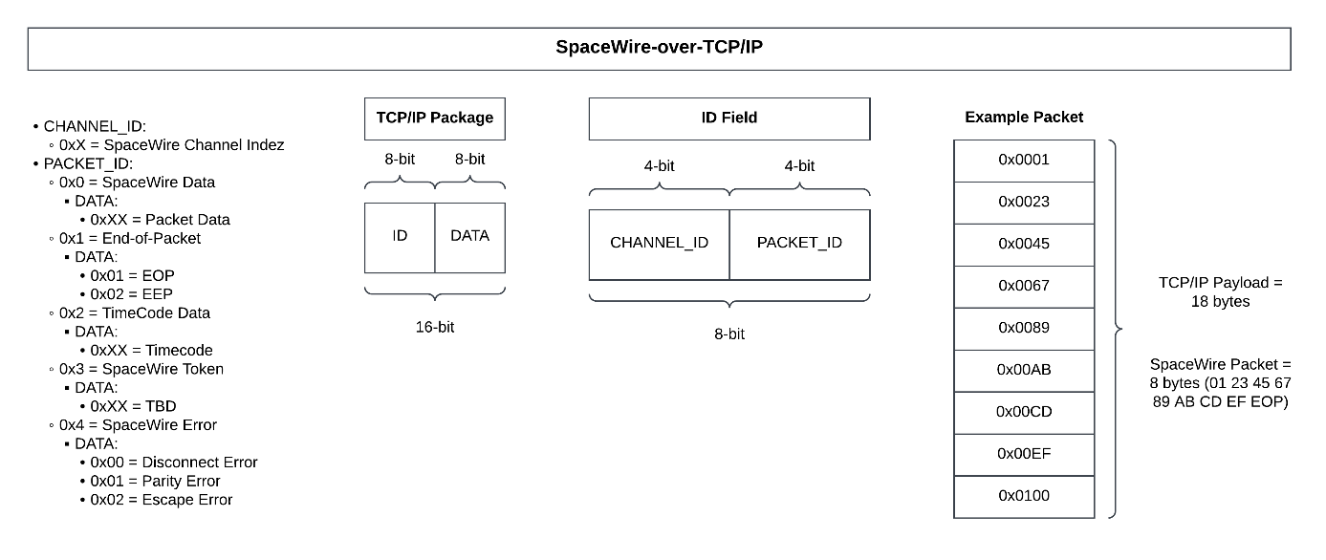
Source: the authors.

Like the debug interface, the user can connect to the instrument ports at any point while the system is in its RUN state. Also, the instrument interface is automatically closed if the user artificially terminates the emulation via the 'Quit Emulation' command or if the inserted code reaches the end of its execution.

QEMULA’s Basic Tutorial with Provided Testing Code

To provide an initial testing platform for the delivered system, a Python script named QEMULAs_Testing_Code.py was developed, which is available on QEMULA’s release. This script establishes a connection with the QEMULA system's control link, enabling the exchange of requests and responses.
This section, therefore, presents a straightforward tutorial for initializing QEMULA, using the developed testing code as a foundation for system control.
Initially, the user must configure the QEMULA runtime environment using the configure_qemula script while running Docker Desktop or Docker Engine. Subsequently, the start_qemula script should be executed to launch the system. As mentioned previously, Both scripts must be used with attention to the operational system: .bat scripts for Windows and .sh scripts for Linux/Unix.
Once the system is running, the user must execute the QEMULAs_Testing_Code.py script using the Python3 interpreter available on the system. If done successfully, the user must visualize the screen as seen in Figure 4 below, representing the code’s main menu:

Figure 4 – QEMULAs Testing Code main menu.
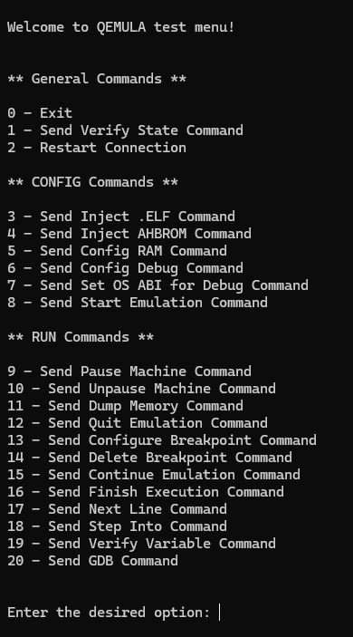
Source: the authors.

Thus, upon initialization, the script connects to the QEMULA control link, enabling the transmission of the commands listed in its menu. Each command sent elicits a response from the system, which is displayed to the user in a manner similar to that shown in Figure 5, as exemplified by the execution of a “Verify State” command.

Figure 5 – Testing code print when receiving na answer from a “Verify State” command.
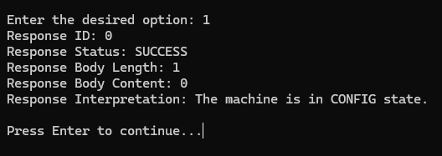
Source: the authors.

As previously described in this manual, only specific commands can be accepted by QEMULA in certain operational states. Therefore, users must pay attention to the command groupings detailed in the menu:
- General Commands: These can be sent in any QEMULA state.
- CONFIG Commands: These must be sent only while QEMULA is in the CONFIG state. To verify the system's state, the 'Verify State' command can be used.
- RUN Commands: These must be sent only while QEMULA is in the RUN state. To verify the system's state, the 'Verify State' command can be used.
Finally, in a typical system execution, the following commands are recommended to be executed in this order: Inject .ELF, Inject AHBROM, Config RAM, Config Debug, Set OS ABI for Debug, and Start Emulation. Afterward, the QEMU emulated system will be initialized, enabling the execution of commands related to the RUN state of QEMULA, according to the user's needs. When necessary, the user may send the Quit Emulation command to end the QEMU emulation and return to the CONFIG state of the system.

