Coffee Importation by Portugal
The main goal of this work will be to forecast the quantity of coffee imported by Portugal for a specific time series, having as base the chosen dataset which was sourced from Eurostat.
More concretely, this dataset compiles the quantity, measured in kilograms (Kg), of imported coffee by Portugal in the period that goes from January 2002 to December 2024. More precisely, the quantity is measured in a monthly basis and after a first look reveals significant trends and fluctuations, which can provide some insights not only on Portugal’s coffee import patterns but also on its coffee consumption patterns since, in a way, they’re both intrinsically correlated.
The main reason behind this topic consists in the country being well known for its high consumption and how highly this good is regarded by most of Portugal’s population.
The analysis of the data was intentionally limited (which can be seen in the Excel file with the data) to December 2019 in order to avoid any disruptions caused by COVID-19 pandemic, since this event impacted global trade and supply chains in the early 2020. Furthermore, to complete a 15-year period and avoid an excessively extensive dataset, the considered starting point will be January 2005. This leads to a total of 180 months of data and ensures structural integrity for the time series analysis and forecasting by removing any possible noise introduced by the pandemic.
All this allows for a good foundation to identify trends, seasonal effects, and cyclical patterns in coffee importation. In terms of seasonality, for example, it can be easy to recognise by observing that certain months exhibit consistently higher import volumes, but this will be furtherly addressed in the future.
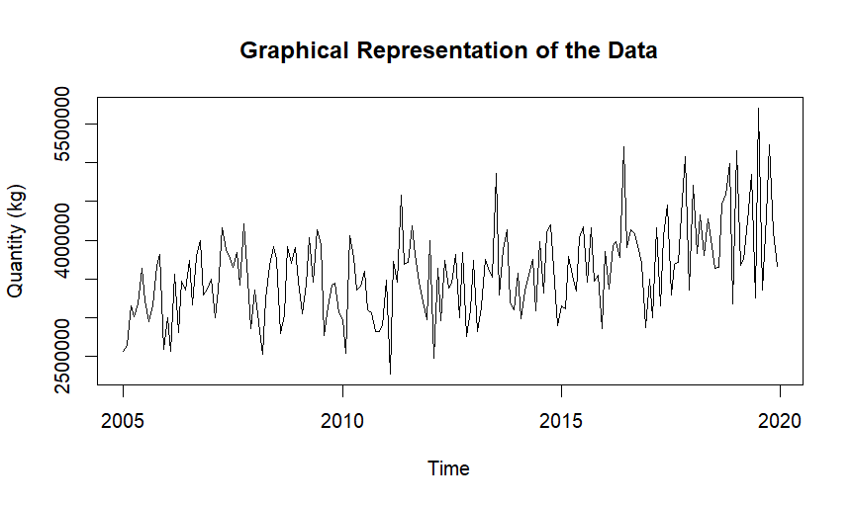
Figure 1: Monthly Coffee Importation in Portugal (2005–2019)

Eurostat. (2025). International trade of EU and non-EU countries since 2002 by HS2-4-6 [Dataset]. European Commission. Retrieved February 20, 2025, from https://ec.europa.eu/eurostat/databrowser/view/ds-059341__custom_15553171/default/table?lang=en

