Forecasting the quantity of imported coffee by Portugal
Luís Ferreira [202107032]

MADSAD, 2024/2025
Forecasting Methods and Time Series
Abstract. This report has as its objective to forecast the volume of coffee imported by Portugal using time series analysis techniques. Regarding the dataset, it spans from January 2005 to December 2019, intentionally excluding some pandemic related distortions. More specifically, this analysis includes smoothing methods (Simple Exponential Smoothing, Holt’s Linear trend and Holt-Winters Seasonal), decomposition methods (Classical Additive, Classical multiplicative and STL) and SARIMA models. To evaluate their performance, there were used some error metrics (ME, RMSE, MAE, MASE, MPE, MAPE) and some information criterions (AIC, BIC). Among all the models, the Holt-Winters additive model performed best and achieved the most accurate forecast. However, the results suggest some limitations in the predictive accuracy, due essentially to the volatility and susceptibility of the data to market fluctuations.
Keywords: Smoothing, Decomposition, SARIMA
- Introduction
The main goal of this work will be to forecast the quantity of coffee imported by Portugal for a specific time series, having as base the chosen dataset which was sourced from Eurostat.
Portugal has a strong cultural connection to coffee, which combined with its status of one of the highest consumers per capita in Europe, makes this product a significant part of the daily lives of the Portuguese as well as an important factor in the economic activity. As so, understanding the behaviour of the volume of imported coffee can offer some valuable insights into the country’s consumption patterns and into some economical trading dynamics. Analysing the imports through time series forecasting can help anticipate future demand, allowing for a support to the decision-makers, like importers, policymakers and even retailers.
This report seeks to identify which statistical methods provide the better forecasts, using methods of smoothing, decompositions and SARIMA modelling.
- Time Series Description
The chosen dataset compiles the quantity, measured in kilograms (Kg), of imported coffee by Portugal in the period that goes from January 2002 to December 2024. More precisely, the quantity is measured in a monthly basis and after a first look reveals significant trends and fluctuations, which can provide some insights not only on Portugal’s coffee import patterns but also on its coffee consumption patterns since, in a way, they’re both intrinsically correlated.
The analysis of the data was intentionally limited (which can be seen in the Excel file with the data) to December 2019 to avoid any disruptions caused by the COVID-19 pandemic, since this event impacted global trade and supply chains in the early 2020. Furthermore, to complete a 15-year period and avoid an excessively extensive dataset, the considered starting point will be January 2005, leading to a total of 180 months of data and ensuring structural integrity for the time series analysis and forecasting by removing any possible noise introduced by the pandemic. As so, the considered series can be seen in Figure 1 after the mentioned modifications.
All of this allows for a good foundation to identify trends, seasonal effects, and cyclical patterns in coffee importation. In terms of seasonality, for example, it can be easy to recognise by observing that certain months exhibit consistently higher import volumes, but this will be further addressed in the future.
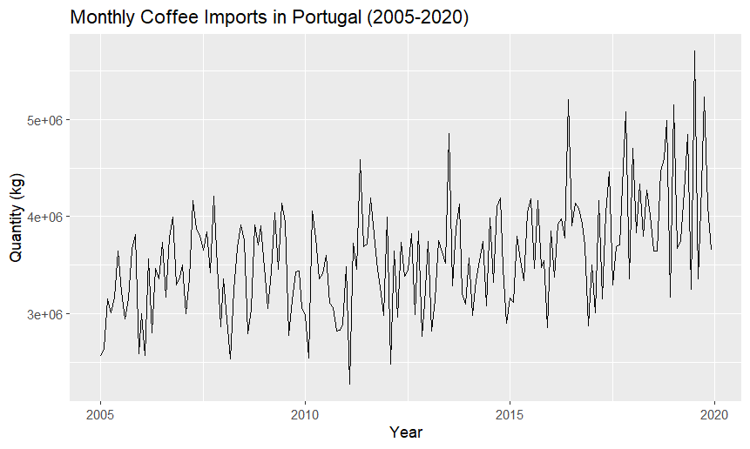
Figure 1. Monthly Coffee Imports in Portugal (2005-2020)
- Smoothing Methods
In a time series analysis such as this, smoothing methods play an important part, reducing noise and random fluctuations, which provides a clearer view and analysis. This report includes four smoothing techniques, applied to the training set to forecast the monthly coffee import quantities of 2019. To evaluate the performance of the methods I used standard metrics (AIC for information regarding the fit and RMSE, MAPE and MAE for measuring the accuracy) and visual forecasting graphics. More precisely, the graphics will contribute to make interpretations, and the metrics will allow a comparison between the methods.
  - Single Moving Average (MA)
I opted to use a single MA of period of 12 months to serve as a baseline term of comparison while minimizing the seasonal fluctuations and subsequently revealing the underlying trend.
Analysing Figure 2, we can clearly see an upward trend in the data which is accompanied by consistent seasonal variations. This leads to infer the need for more advanced smoothing techniques.
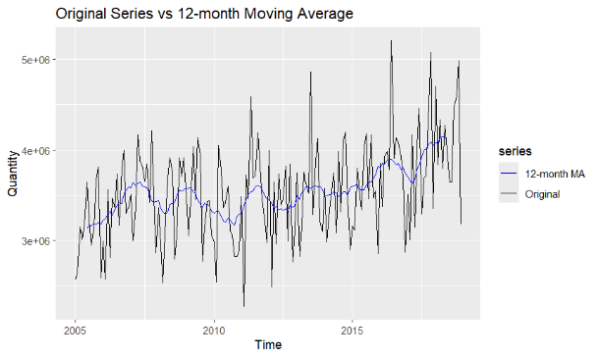
Figure 2. Visualization of a 12-month MA
  - Simple Exponential Smoothing (SES)
Following the MA, I decided to apply the Simple Exponential Smoothing (SES) since it assigns a higher relative weight to recent observations, allowing the model to provide an output that is more sensitive to short-term changes while still smoothing the irregular fluctuations. However, it still only constitutes a benchmark to understand the behaviour of the time series without any trend or seasonal adjustments.
Observing Figures 3 & 4 (the figures are the same but the second enables a better visualization by focusing on the period 2018-2020), it is only identifiable a straight flat line that corresponds to the fact of this model not assuming no trend nor seasonality. Looking at its individual error metrics in Table 5, we can also perceive that it does not capture temporal dynamics (changes or shifts in the trend or seasonality) but performs reasonably.
Furthermore, this method had an alpha of 0.0854 (α = 0.0854), suggesting some slowness from the model in adapting to the recent changes, giving more credit to past observations. This coincides with the fact that the model assumes no trend or seasonality (it prefers stability over the reactivity).
The forecast produced by this model is present in Table 1.
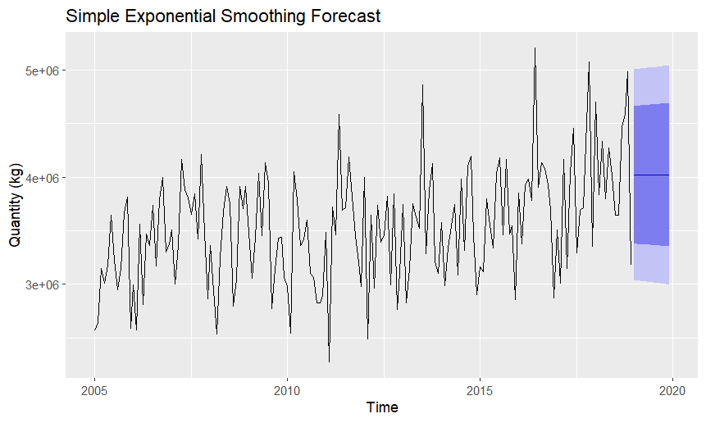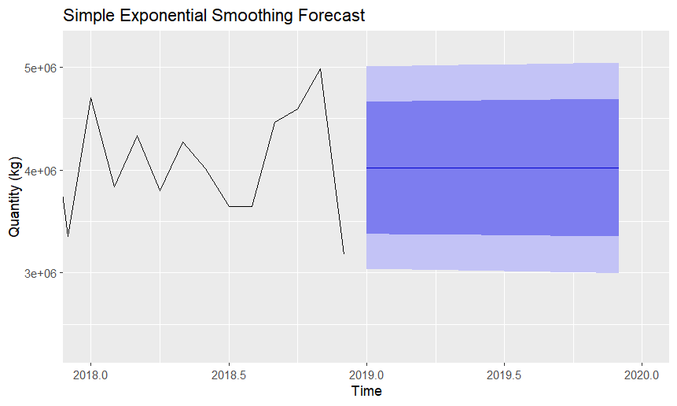
Figure 3. SES (2005-2020) Figure 4. SES (2018-2020)

Table 1. SES Method Forecast (2019)
Month | Point Forecast | Lo 80 | Hi 80 | Lo 95 | Hi 95
Jan 2019 | 4,020,395 | 3,377,533 | 4,663,256 | 3,037,223 | 5,003,566
Feb 2019 | 4,020,395 | 3,375,195 | 4,665,594 | 3,033,648 | 5,007,142
Mar 2019 | 4,020,395 | 3,372,866 | 4,667,924 | 3,030,085 | 5,010,705
Apr 2019 | 4,020,395 | 3,370,545 | 4,670,245 | 3,026,535 | 5,014,255
May 2019 | 4,020,395 | 3,368,232 | 4,672,558 | 3,022,998 | 5,017,792
Jun 2019 | 4,020,395 | 3,365,927 | 4,674,862 | 3,019,473 | 5,021,317
Jul 2019 | 4,020,395 | 3,363,630 | 4,677,159 | 3,015,960 | 5,024,829
Aug 2019 | 4,020,395 | 3,361,342 | 4,679,448 | 3,012,460 | 5,028,329
Sep 2019 | 4,020,395 | 3,359,061 | 4,681,728 | 3,008,972 | 5,031,817
Oct 2019 | 4,020,395 | 3,356,788 | 4,684,001 | 3,005,496 | 5,035,293
Nov 2019 | 4,020,395 | 3,354,523 | 4,686,267 | 3,002,032 | 5,038,758
Dec 2019 | 4,020,395 | 3,352,266 | 4,688,524 | 2,998,579 | 5,042,210
  - Holt’s Linear Trend Method
To capture the upward trend in the series, I employed Holt’s linear trend method. The reasoning behind this stands in the fact that this method extends SES by introducing a second equation that models the trend over time, i.e., focuses explicitly on the trend component. With this, the model adapts itself to the consistent upward trend, further improving the suitability for forecasting.
Focusing on Figures 5 & 6, it is evident the projection of an increasing trend in 2019, revealing clearly the consideration of the trend by this methos. However, it still lacks an adjustment associated to the seasonal component. Adding this to the fact that this model performed slightly worse than the SES (assumption made based on the results from Table 5) can lead to conclude that the seasonal component probably plays an important role in the data.
Focusing on this model’s smoothing parameters, it got an alpha of 0.033 (α = 0.033) and a beta of 0.0127 (β = 0.0127). Both values are low and indicate that the average value and the trend are updated slowly.
The forecast from this method can be seen in Table 2.
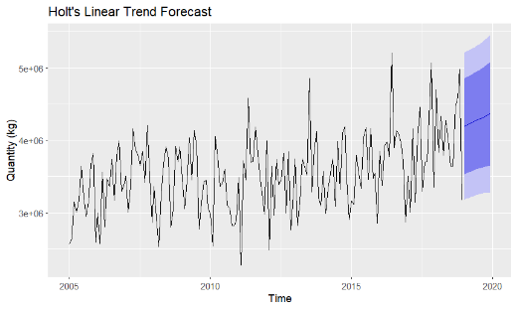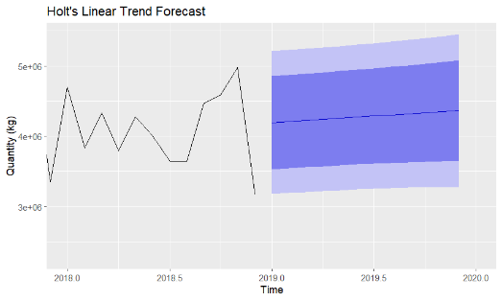
Figure 6. Holt’s Linear Method (2018-2020)
Figure 5. Holt’s Linear Method (2005-2020)

Table 2. Holt’s Method Forecast (2019)
Month | Point Forecast | Lo 80 | Hi 80 | Lo 95 | Hi 95
Jan 2019 | 4,195,988 | 3,531,759 | 4,860,217 | 3,180,137 | 5,211,839
Feb 2019 | 4,211,402 | 3,546,479 | 4,876,324 | 3,194,490 | 5,228,313
Mar 2019 | 4,226,816 | 3,560,763 | 4,892,868 | 3,208,177 | 5,245,455
Apr 2019 | 4,242,229 | 3,574,507 | 4,909,952 | 3,221,036 | 5,263,422
May 2019 | 4,257,643 | 3,587,609 | 4,927,677 | 3,232,914 | 5,282,372
Jun 2019 | 4,273,057 | 3,599,970 | 4,946,144 | 3,243,659 | 5,302,455
Jul 2019 | 4,288,471 | 3,611,495 | 4,965,446 | 3,253,126 | 5,323,815
Aug 2019 | 4,303,884 | 3,622,095 | 4,985,673 | 3,261,178 | 5,346,591
Sep 2019 | 4,319,298 | 3,631,687 | 5,006,910 | 3,267,687 | 5,370,909
Oct 2019 | 4,334,712 | 3,640,192 | 5,029,232 | 3,272,536 | 5,396,888
Nov 2019 | 4,350,126 | 3,647,544 | 5,054,708 | 3,275,619 | 5,424,632
Dec 2019 | 4,365,540 | 3,653,680 | 5,077,399 | 3,276,844 | 5,454,235
  - Holt-Winters Seasonal Method (Additive)
Now that the presence of trend and seasonality in the data, is more than clear, I decided to apply Holt-Winters’ seasonal method. Considering that this method adds some complexity to Holt’s linear method by adding the seasonal component then it might be the perfect fit. Firstly, I will try the additive method and then the multiplicative, in order to understand which might perform better. Knowing that the additive works better with time series that have more stable seasonal variations in terms of size, then it might be a good option for this specific case (as it reveals some variations of the seasonal component with a similar size).
Reviewing Figures 7 & 8, it is possible to visualize the inclusion of trend and seasonality in the forecast of this model. All the assumptions made until now end up being confirmed by the error statistics, present in Table 5, revealing that between this model and the previous ones, this one has a good advantage in performance. More specifically, has lower values in the error measures, namely RMSE, MAE and MAPE, as well as a slightly lower Akaike Information Criterion (AIC), but this will be better explored in section 3.6, “Comparing The Methods”.
Additionally, this model presented an alpha of 0.0641 (α = 0.0641), a beta of 0.0052 (β = 0.0052) and a gamma of 0.0001 (γ = 0.0001). It is noticeable that these values are relatively small, indicating that the level and the trend are updated very slowly (alpha and beta), and that the seasonal pattern is very stable (the low gamma reveals that the seasonal pattern is approximately constant from year to year)
The values of the forecast present in the mentioned figures can be analysed and observed in Table 3.
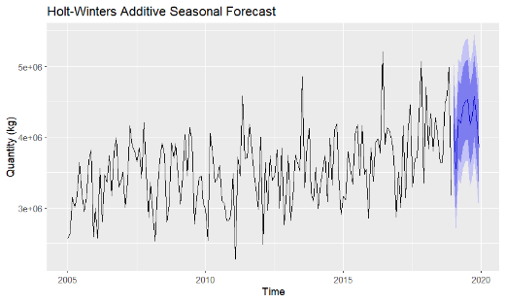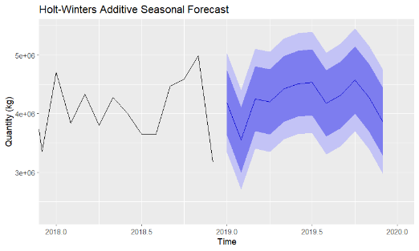
Figure 8. Holt-Winters Seasonal Method - Additive (2018-2020)
Figure 7. Holt-Winters Seasonal Method - Additive (2005-2020)

Table 3. Holt-Winters’ Additive Method Forecast (2019)
Month | Point Forecast | Lo 80 | Hi 80 | Lo 95 | Hi 95
Jan 2019 | 4,183,232 | 3,630,447 | 4,736,016 | 3,337,821 | 5,028,643
Feb 2019 | 3,553,946 | 2,999,836 | 4,108,056 | 2,706,508 | 4,401,384
Mar 2019 | 4,254,198 | 3,698,560 | 4,809,836 | 3,404,423 | 5,103,973
Apr 2019 | 4,200,863 | 3,643,481 | 4,758,246 | 3,348,421 | 5,053,306
May 2019 | 4,420,872 | 3,861,516 | 4,980,228 | 3,565,411 | 5,276,333
Jun 2019 | 4,510,495 | 3,948,924 | 5,072,067 | 3,651,646 | 5,369,345
Jul 2019 | 4,535,017 | 3,970,976 | 5,099,057 | 3,672,391 | 5,397,642
Aug 2019 | 4,174,468 | 3,607,694 | 4,741,242 | 3,307,661 | 5,041,274
Sep 2019 | 4,320,494 | 3,750,711 | 4,890,278 | 3,449,086 | 5,191,903
Oct 2019 | 4,576,724 | 4,003,645 | 5,149,802 | 3,700,275 | 5,453,172
Nov 2019 | 4,274,643 | 3,697,974 | 4,851,313 | 3,392,704 | 5,156,583
Dec 2019 | 3,849,660 | 3,269,096 | 4,430,224 | 2,961,764 | 4,737,556
  - Holt-Winters Seasonal Method (Multiplicative)
The Multiplicative method might also be a good fit since it assumes that the seasonal variations occur in proportion to the trend over time, meaning that with an upward trend the variations should be higher in size, which can in fact be slightly verified in this time series, although it is not too easy to observe and can be somewhat open to discussion (I believe that in this specific case, it is not possible to distinguish between the additive and multiplicative method by mere observation).
Analysing Figures 9 & 10, we can clearly distinguish the upward trend and the seasonal effects (growing and shrinking) that scale with it. Additionally, the values given by the forecast adapt very well to the fluctuating size seasonal component.
The multiplicative method performs very similarly to the additive one, which is confirmed by Table 5, revealing very close values regarding the different metrics. It is uncertain which one of these two performed better but it is evident that the Holt-Winters seasonal method provides more realistic and dynamic forecast. This will be further discussed in section 3.6, “Comparing The Methods”.
Lastly, going over the smoothing parameters, this model had an alpha of 0.1011 (α = 0.1011), a beta of 0.0057 (β = 0.0057) and a gamma of 0.0004 (γ = 0.0004). These values are very similar to the ones seen previously in the additive approach except for the alpha, which is slightly higher, pointing to a more responsive behaviour towards recent changes in the level. Besides this exception, the conclusions remain the same, where the trend is updated slowly and the seasonal pattern is somewhat fixed.
Additionally, it is possible to observe the forecasted values by this model in Table 4.
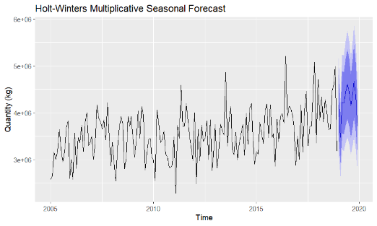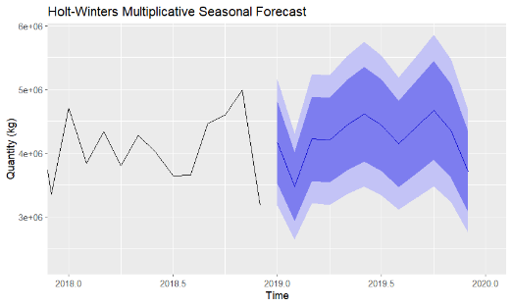
Figure 10. Holt-Winters Seasonal Method - Multiplicative (2018-2020)
Figure 9. Holt-Winters Seasonal Method - Multiplicative (2005-2020)

Table 4. Holt-Winters’ Multiplicative Method Forecast (2019)
Month | Point Forecast | Lo 80 | Hi 80 | Lo 95 | Hi 95
Jan 2019 | 4,166,350 | 3,518,900 | 4,813,799 | 3,176,161 | 5,156,538
Feb 2019 | 3,471,916 | 2,929,283 | 4,014,549 | 2,642,030 | 4,301,802
Mar 2019 | 4,222,098 | 3,558,084 | 4,886,112 | 3,206,577 | 5,237,619
Apr 2019 | 4,202,132 | 3,536,772 | 4,867,491 | 3,184,552 | 5,219,712
May 2019 | 4,436,750 | 3,729,102 | 5,144,399 | 3,354,496 | 5,519,005
Jun 2019 | 4,609,146 | 3,868,236 | 5,350,056 | 3,476,021 | 5,742,270
Jul 2019 | 4,433,253 | 3,714,656 | 5,151,850 | 3,334,253 | 5,532,253
Aug 2019 | 4,143,904 | 3,466,241 | 4,821,566 | 3,107,508 | 5,180,299
Sep 2019 | 4,409,208 | 3,681,388 | 5,137,028 | 3,296,103 | 5,522,313
Oct 2019 | 4,666,663 | 3,888,727 | 5,444,599 | 3,476,913 | 5,856,413
Nov 2019 | 4,349,859 | 3,617,212 | 5,082,507 | 3,229,372 | 5,470,347
Dec 2019 | 3,704,872 | 3,074,092 | 4,335,651 | 2,740,178 | 4,669,566
  - Comparing The Methods
I will start this comparison from the point that the Holt-Winters Seasonal Method produced the best forecasts, since both the additive and multiplicative options, of this method, had significantly lower error statistics than the other ones, meaning a higher accuracy, as well as a marginally lower AIC, revealing a better fit of the data.
So, the question now is to determine which is the better suited approach, if the additive or the multiplicative. Considering the results from Table 5, the additive option outperforms the multiplicative one in terms of accuracy but ends up falling a little bit short in terms of the information criterion. As so, despite being very similar (observed on their metrics and on Figure 11), the one that I believe ends up achieving the best performance is the additive approach, due essentially to the error metrics seeing as it performs better both in the train and test sets (with special attention that in the test set we start to see some significant difference, where the additive seems to be more accurate).

Table 5. Metrics of the models relative to the train and test sets
(taken from appendixes 8.1.1, 8.1.2 and 8.1.3)
 | Information |  | Error
Model | AIC | Dataset | RMSE | MAE | MAPE | MASE
Simple Exp. Smoothing | 5275.02 | Train set | 498,632 | 404,402 | 11.58% | 0.986
 |  | Test set | 803,986 | 656,009 | 14.66% | 1.599
Holt’s Linear Trend | 5287.97 | Train set | 512,094 | 416,273 | 12.20% | 1.015
 |  | Test set | 767,555 | 649,290 | 15.40% | 1.583
Holt-Winters Additive | 5237.50 | Train set | 410,286 | 320,536 | 9.16% | 0.781
 |  | Test set | 676,076 | 526,285 | 12.54% | 1.283
Holt-Winters Multiplicative | 5235.27 | Train set | 410,972 | 321,530 | 9.19% | 0.784
 |  | Test set | 698,305 | 538,678 | 12.83% | 1.313

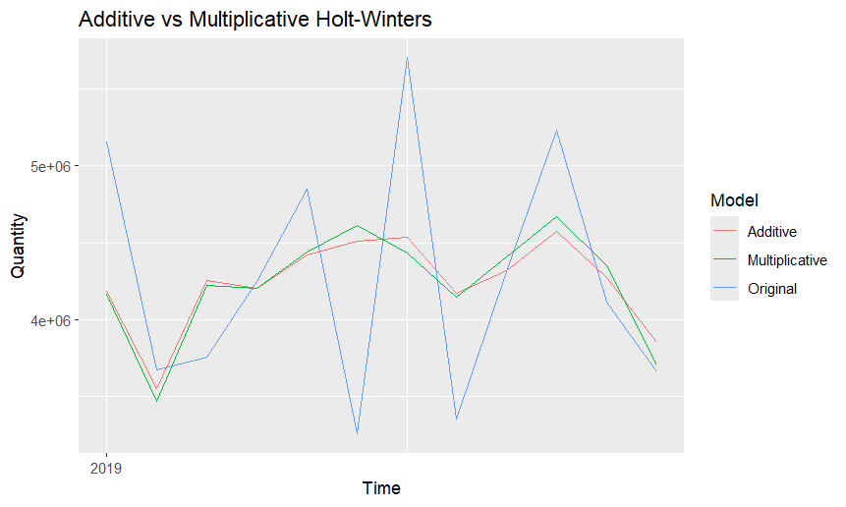
Figure 11. Visual Comparison of Additive and Multiplicative approaches’ forecasts (2019-2020)

- Decomposition Methods
In order to have a better understanding of the structure of the time series, I decided to apply both classical decomposition methods, additive and multiplicative, and the Seasonal-Trend Decomposition using Loess (STL Decomposition). To be more concrete, these techniques break the series into three main components, trend, seasonal and residual (corresponds to the error).
Furthermore, I derived a seasonally adjusted series from each of these decompositions. The purpose was to isolate the trend by removing the seasonal effects, i.e. to visualize the trend’s movement without seasonal noise. This allows a clearer and finer analysis of the long-term behaviour of the data.
  - Classical Additive Decomposition
The classical additive decomposition is known for combining the previously discussed components, trend, seasonal and residual, linearly, i.e., the data is equal to the sum of these components (Data = Trend + Seasonality + Residual).
The decomposition plot produced through this method can be seen in Figure 12 and it separates the original time series into its components, allowing an individual interpretation and analysis of each. Additionally, to complete the analysis I added a summary of each of the components, which can be seen in Table 6.
Starting with the trend, it reveals a consistent upward trajectory (as seen before) of the imported quantity over time. Considering the summary of this component, it is possible to infer a long-term growth in coffee demand, based on the values that range from 3.15 to 4.14 million kilograms and on the values of the quartiles 1 and 3.
Regarding the seasonal component, its values oscillate between -618 and +290 thousand which confirms the presence of strong monthly seasonality. Some specific months regularly have higher or lower import volumes, reaffirming and pointing to the necessity of seasonal adjustment.
Lastly, addressing the remainder (residual), its values fluctuate widely from -875 thousand to +1 million and most values are close to 0 (around the mean). So, the presence of outliers probably reflects some irregular shocks that might come from disruptions in the market or changes to the policy.
On a separate note, I also forecasted the imported quantity of coffee for the year of 2019 as well as the values of each component identified in the decomposition. This can be seen in Table 7.
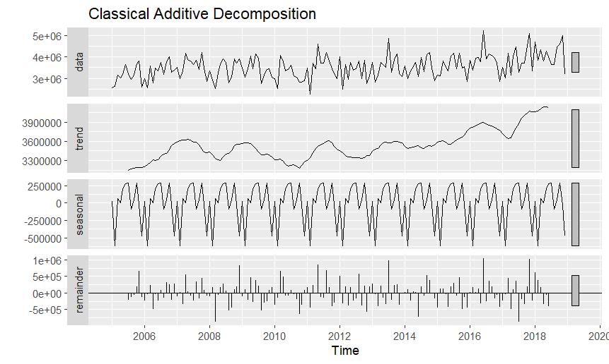
Figure 12. Classical Additive Decomposition (2005-2019)

Table 6. Summary of the Components from the classical additive decomposition
Component | Min | 1st Quartile | Median | Mean | 3rd Quartile | Max
Trend | 3,150,175 | 3,374,216 | 3,527,048 | 3,536,617 | 3,613,064 | 4,140,669
Seasonal | -618,311 | -43,058 | 35,864 | 0 | 223,631 | 289,912
Random | -875,435 | -231,808 | -34,849 | 609.5 | 196,958 | 1,030,868

Table 7. Additive Decomposition Forecast Components (2019)
Month | Decomp Forecast | Trend Forecast | Seasonal Forecast | Random Forecast
Jan 2019 | 4,154,721 | 4,129,087 | 25,634.43 | 1.8554 × 10⁻¹⁰
Feb 2019 | 3,510,775 | 4,129,087 | -618,311.41 | 1.1642 × 10⁻¹⁰
Mar 2019 | 4,196,459 | 4,129,087 | 67,372.56 | 4.6566 × 10⁻¹⁰
Apr 2019 | 4,128,544 | 4,129,087 | -542.60 | 1.8576 × 10⁻¹⁰
May 2019 | 4,333,969 | 4,129,087 | 204,881.82 | -2.3283 × 10⁻¹⁰
Jun 2019 | 4,408,965 | 4,129,087 | 279,878.65 | 4.6566 × 10⁻¹⁰
Jul 2019 | 4,418,999 | 4,129,087 | 289,911.74 | -2.3283 × 10⁻¹⁰
Aug 2019 | 4,043,813 | 4,129,087 | -85,273.38 | 1.1642 × 10⁻¹⁰
Sep 2019 | 4,175,181 | 4,129,087 | 46,093.94 | -1.3824 × 10⁻¹⁰
Oct 2019 | 4,416,837 | 4,129,087 | 287,750.25 | 2.3283 × 10⁻¹⁰
Nov 2019 | 4,100,101 | 4,129,087 | -28,985.97 | -2.9104 × 10⁻¹¹
Dec 2019 | 3,660,677 | 4,129,087 | -468,410.02 | -1.1642 × 10⁻¹⁰

The seasonally adjusted series, which can be visualized in Figure 13, consists, as the name suggests, in the removal of the seasonal component from the original series. This produces, as it can be seen below, a plot with solely the trend and the residuals. It is important to note that, for this method, to remove the seasonality it was necessary to simply subtract it (the same does not verify for the multiplicative method)

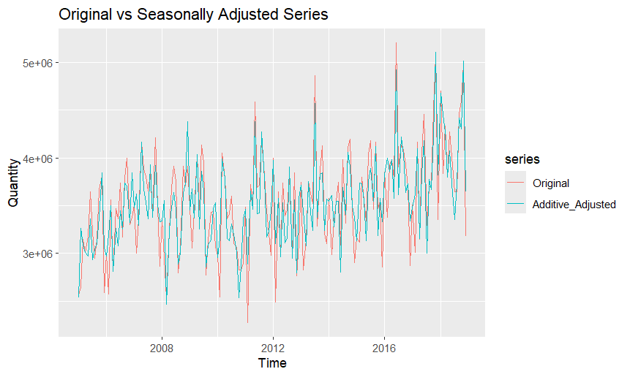
Figure 13. Comparison of the original series to the
seasonally adjusted series (additive, 2005-2019)
  - Classical Multiplicative Decomposition
In contrast to the previous method, the classical multiplicative decomposition is known for combining the components, trend, seasonal and residual, proportionally, i.e., the data is equal to the product of these components (Data = Trend*Seasonality*Residual).
Similarly to the additive method, a decomposition plot was produced based on the multiplicative method which can be seen in Figure 14, as well as the summary table of each of the components, in Table 8.
Despite the methods (additive and multiplicative) being different, in terms of trend the results are identical and the same «, so the conclusion drawn through this method (multiplicative) will be the same as the ones already stated in the previous section that regards the other method (additive),
However, in the seasonal component, there are significant differences since it now reflects proportions and not the raw values. In this case the seasonal indices range from 0.82 to 1.08, pointing to the fact that in some months the volume of imports is reduced by approximately 18% (0.82 - 1 = - 0.18), while in others it raises by around 8% (1.08 – 1 = + 0.08), respectively and all of this when regarding the baseline of 1.
Lastly, the random component is also different but leads to the same conclusions. More precisely, in this case it is expressed as a ratio and its values range from 0.75 to 1.27, revealing once again significant variations (the only difference is that now they are presented in relative terms).
Similarly to the approach on the additive decomposition, I compiled the values of the forecast and of the components in a table, Table 9.
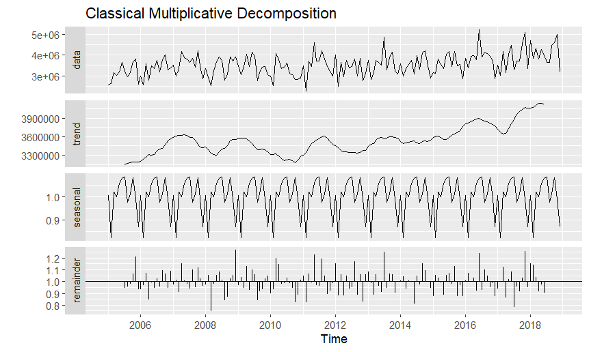
Figure 14. Classical Multiplicative Decomposition (2005-2019)

Table 8. Summary of the Components from
the classical multiplicative decomposition
Component | Min | 1st Quartile | Median | Mean | 3rd Quartile | Max
Trend | 3,150,175 | 3,374,216 | 3,527,048 | 3,536,617 | 3,613,064 | 4,140,669
Seasonal | 0.8229 | 0.9861 | 1.0093 | 1.0000 | 1.0639 | 1.0853
Random | 0.7459 | 0.9363 | 0.9908 | 0.9997 | 1.0581 | 1.2660

Table 9. Multiplicative Decomposition Forecast Components (2019)
Month | Decomp Forecast | Trend Forecast | Seasonal Forecast | Random Forecast
Jan 2019 | 4,154,085 | 4,129,087 | 1.006054 | 1
Feb 2019 | 3,398,012 | 4,129,087 | 0.822945 | 1
Mar 2019 | 4,209,054 | 4,129,087 | 1.019367 | 1
Apr 2019 | 4,132,065 | 4,129,087 | 1.000721 | 1
May 2019 | 4,374,193 | 4,129,087 | 1.059361 | 1
Jun 2019 | 4,449,875 | 4,129,087 | 1.077690 | 1
Jul 2019 | 4,481,280 | 4,129,087 | 1.085296 | 1
Aug 2019 | 4,025,351 | 4,129,087 | 0.974877 | 1
Sep 2019 | 4,180,544 | 4,129,087 | 1.012462 | 1
Oct 2019 | 4,467,278 | 4,129,087 | 1.081905 | 1
Nov 2019 | 4,087,412 | 4,129,087 | 0.989907 | 1
Dec 2019 | 3,589,893 | 4,129,087 | 0.869416 | 1

Regarding Table 9, it is important to highlight that the random component forecast has a constant value of 1. This behaviour is expected since the random component represents irregular and unpredictable shocks and as so it cannot be forecasted with accuracy, leading to assume a neutral value of 1 (reflecting this way the idea that no unusual deviations are expected to happen in the forecasted period)

As mentioned before, a different process was required to generate the seasonally adjusted series seen in Figure 15. In this case it was necessary to divide the original series by the seasonal component. Analysing the graphic, the seasonally adjusted series does seem slightly smoother and more efficient when capturing the movement of the data, since the peaks and dips appear consistently spaced in time, well separated and more uniform in magnitude. It is important to highlight that this allows for an easier analysis and interpretation of the overall trend.
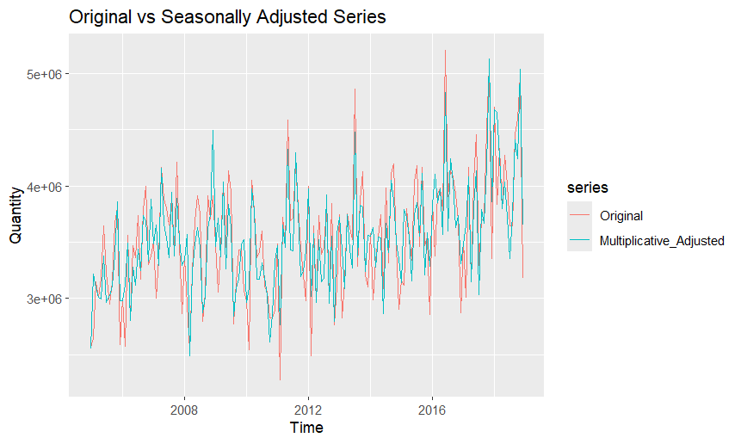
Figure 15. Comparison of the original series to the
seasonally adjusted series (multiplicative, 2005-2019)
  - Seasonal-Trend Decomposition using Loess (STL Decomposition)
Lastly, I applied the Seasonal-Trend Decomposition using Loess (STL Decomposition) due to it being more flexible than the classic methods, adapting to the different changes in seasonality over time.
Following the structure used in the two previous methods, a decomposition plot was also created but this time based on the STL method which can be seen in Figure 16. Regarding the summary table of each of the components, it was also created with the purpose of aiding and complementing the analysis and corresponds to the Table 10.
Here we see a little change in the values of the trend, with a minimum of 2.9 million and a maximum of 4.1 million imported kilograms. However, its behaviour remains similar to the one registered before in the previous methods.
The seasonal component also points to the same conclusions drawn before, presenting only different values, which in this case range from -602 to +308 thousand, but still reflect a strong and variable seasonal range.
As for the remainder, it shows some moderate fluctuations which appear very similar to the ones viewed before. Its values range from -870 thousand and 1 million, also indicating some unpredictable noise in the data.
Furthermore, the values of the forecast produced by the STL decomposition, and the values of its components can be observed in Table 11.
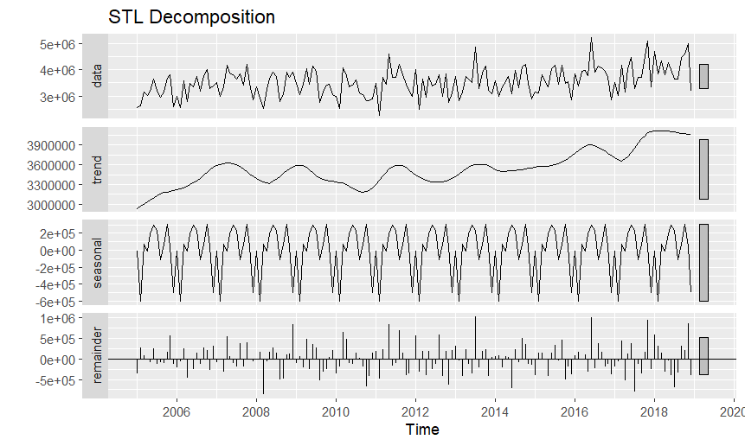
Figure 16. STL Decomposition (2005-2019)

Table 10. Summary of the Components
from the STL decomposition
Component | Min | 1st Quartile | Median | Mean | 3rd Quartile | Max
Trend | 2,935,790 | 3,355,269 | 3,527,494 | 3,537,398 | 3,621,387 | 4,117,593
Seasonal | -602,741 | -31,899 | 55,117 | 0 | 204,582 | 308,050
Random | -869,924 | -234,523 | -20,324 | 1,295 | 206,191 | 1,020,826

Table 11. Additive Decomposition Forecast Components (2019)
Month | Decomp Forecast | Trend Forecast | Seasonal Forecast | Random Forecast
Jan 2019 | 4,065,451 | 4,071,156 | -5,704.87 | 2.13e-10
Feb 2019 | 3,468,415 | 4,071,156 | -602,741.34 | -2.33e-10
Mar 2019 | 4,139,086 | 4,071,156 | 67,929.64 | -5.82e-11
Apr 2019 | 4,064,502 | 4,071,156 | -6,653.76 | 1.42e-10
May 2019 | 4,265,257 | 4,071,156 | 194,101.47 | -5.82e-11
Jun 2019 | 4,366,943 | 4,071,156 | 295,787.38 | 5.82e-11
Jul 2019 | 4,307,178 | 4,071,156 | 236,022.12 | -3.49e-10
Aug 2019 | 3,963,520 | 4,071,156 | -107,636.45 | 4.37e-11
Sep 2019 | 4,145,196 | 4,071,156 | 74,039.58 | -2.04e-10
Oct 2019 | 4,379,206 | 4,071,156 | 308,049.53 | 2.91e-10
Nov 2019 | 4,113,461 | 4,071,156 | 42,304.49 | -1.89e-10
Dec 2019 | 3,575,658 | 4,071,156 | -495,497.86 | 1.16e-10

Focusing on the seasonally adjusted STL series, portrayed in Figure 17, it is possible to confirm the findings from the classical decomposition but also to notice the improved flexibility of this method, since there are fewer edge effects as well as a smooth view of the trend.
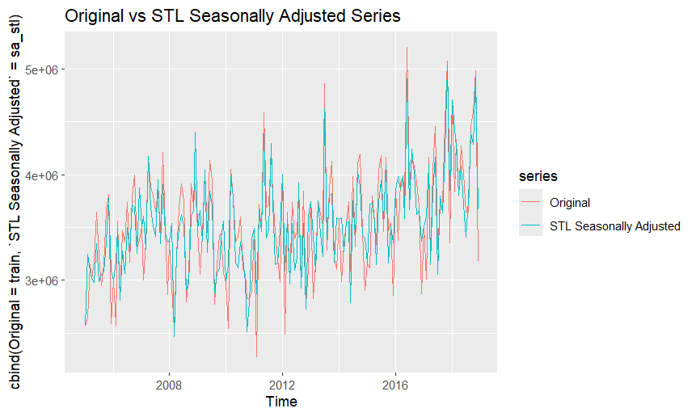
Figure 17. Comparison of the original series to the
seasonally adjusted series (STL, 2005-2019)
  - Comparing the Methods
Having in mind what was previously seen as well as the values of the metrics in Table 12, it is possible to identify the model that performed better (relative to the test set).
Comparing all the values of the metrics, it is relatively easy to see that the STL decomposition is the worst of these models in terms of accuracy. Despite being a model that is flexible and robust to seasonal changes, it falls behind the other two models in all values, possibly due to not being the best fit for this data.
Looking at the other two models, it is visible that the classical additive decomposition achieves better results apart from the ME (Mean Error) which is the same and the RMSE (Root Mean Squared Error) which ends up being worse than the one registered by the classical multiplicative decomposition. Since it performs better in terms of all the other metrics, MAE (Mean Absolute Error), MPE (Mean Percentage Error) and MAPE (Mean Absolute Percentage Error), then it provides more consistent and less biased forecasts.
In summary, the classical additive model emerges as the most suitable decomposition approach for forecasting the volume of coffee imports (for this dataset).

Table 12. Metrics of the Decomposition models relative to the test set
Decomposition Models | ME | RMSE | MAE | MPE | MAPE
Classical Additive | 146,413 | 684,752 | 527,117 | 0.920% | 12.21%
Classical  Multiplicative | 146,413 | 676,179 | 532,627 | 1.019% | 12.47%
STL | 204,344 | 710,336 | 554,898 | 2.286% | 12.70%
- ARIMA modelling and forecasting
  - Data Preparation and Stationarity
Before fitting any ARIMA model and doing any stationarity test, I began by verifying whether the time series needed to be differenced. To do this I used the functions “nsdiffs()” and “ndiffs()”. Starting with the former which indicated that there was no necessity of a seasonal differencing (D = 0, output from “ndiffs()”), and next, the latter which confirmed the necessity of a single regular difference (d = 1, output from “nsdiffs()”) to remove the trend. The result of this procedure can be observed in Figure 18, and consists of the plot of the differenced series.
Based on these results I applied the first difference (present in Figure 18) and was now in conditions to perform the statistical stationary tests, namely, the Augmented Dickey-Fuller (ADF) and the Kwiatkowski-Phillips-Schmidt-Shin (KPSS) tests (that end up being complementary). In terms of results, the ADF presented a very small p-value (lower than 0.01) and the KPSS returned a p-value above 0.05 (around 0.1), suggesting the non-rejection of the null hypothesis that states that the series is stationary (the full output from the application of the mentioned tests is present in appendix 8.1.1). It is important to note that verifying that the performed tests agree in terms of the outcome, constitutes a solid foundation to proceed, considering that the stationarity is a requirement for ARIMA models.
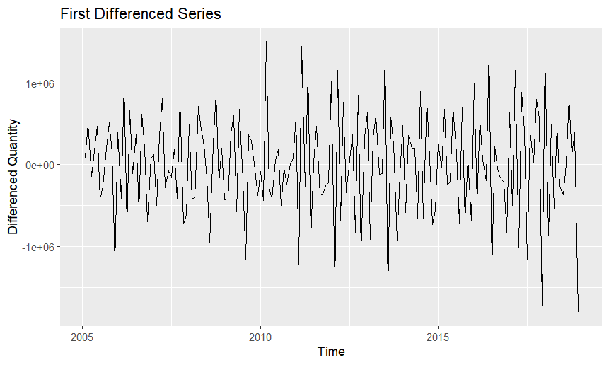
Figure 18. Differenced time series (2005-2020)
  - ACF/PACF and Model Selection Strategy
To ensure that the parameters of the model are correctly defined I examined the Autocorrelation Function (ACF) and the Partial Autocorrelation Function (PACF) plots of the differenced series, portrayed in Figure 19 and Figure 20, respectively. More precisely, the negative spike in ACF at lag 1 indicates the presence of MA(1) components, and the spikes in PACF at the lag points 1 and 2 to existence of AR(2) terms (or possibly AR (1) since the spike in lag 2 is not as significative as the one in lag 1). Additionally, the spike at lag 12 in ACF reflects some seasonal correlation, which I believe supports the inclusion of seasonal AR or MA components (still it does not seem enough to justify seasonal differencing, as verified before). Complementing this with the negative spike verified at lag 12 in the PACF leads to concluding that a seasonal AR term might be in fact necessary.
This analysis of the ACF and PACF will be used in the next section to guide the selection of the most appropriate values for each parameter in the SARIMA modelling.

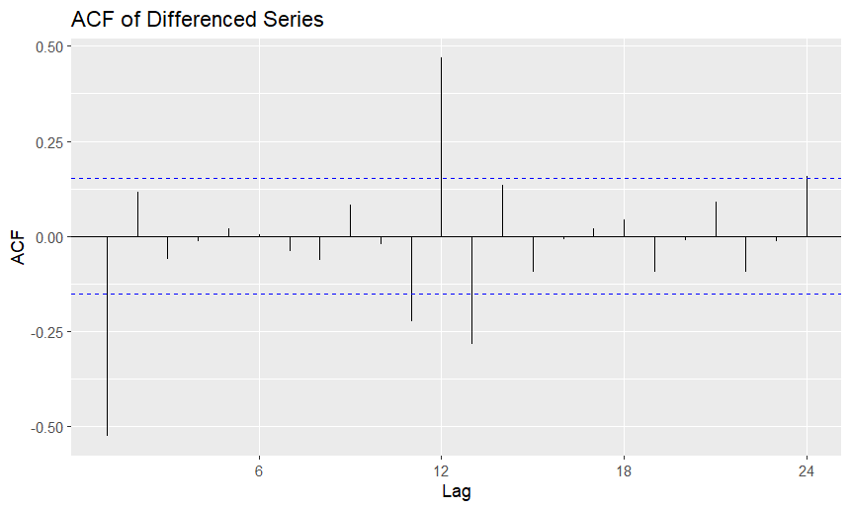
Figure 19. ACF of the Differenced Series

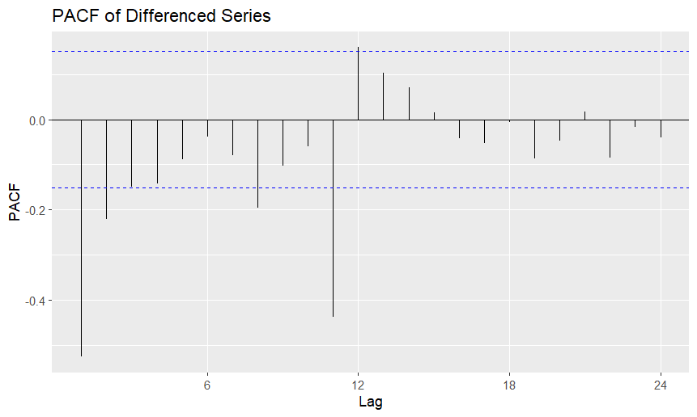
Figure 20. PACF of the Differenced Series

  - Model Estimation
To perform the SARIMA modelling it is necessary to define the parameters, namely the non-seasonal ones, p, d and q, and the seasonal ones, P, D, Q and s. It was already seen that d = 1 and D = 0, relative to the requiring a regular differencing and not requiring seasonal differencing, respectively.
The conclusions drawn from the previous section are essential in determining the remaining parameters. More specifically and using a simplistic language, p is the number of AR terms and q is the number of MA terms. Considering this, p should be 1 or 2 and q should be 1. As for the remaining seasonal parameters, knowing that P corresponds to the number of seasonal AR terms and Q the number of seasonal MA terms, then P can assume the value of 1 and Q the value of 0.
The last parameter, s, concerns the seasonal period, which in this case I assumed to be 12, since the data is in a monthly basis and the seasonality repeats around every 12 months. The model that uses these parameters will be classified as “Model 1”.
In the following tables I identify the tested models, created using different values for the parameters (Table 13) and specify the equation of each one (Table 14). This was done with the intention of making the report more complete by including more than one SARIMA model (revealing also the performed tests until reaching a satisfactory result). It is important to note that this was done using the package “astsa” from R which immediately produces metrics and diagnostics that allow one to identify the best models (however, this will be developed in a further section).

Table 13. Parameters of the Tested Models
Model | p | d | q | P | D | Q | s
Model 1 | 2 | 1 | 1 | 1 | 0 | 0 | 12
Model 2 | 1 | 1 | 1 | 1 | 0 | 0 | 12
Model 3 | 2 | 1 | 1 | 0 | 0 | 1 | 12
Model 4 | 2 | 1 | 1 | 0 | 0 | 2 | 12

These four models were based on the different possibilities that were closer and aligned with what was found in the ACF and PACF plots.

Model | Equation
Model 1 | (1−0.1253B−0.2204B²)(1−0.5006B¹²)(1−B)Y_{t}​ = (1+1.0000B)ε_{t}
Model 2 | (1−0.1572B)(1−0.4849B¹²)(1−B)Y_{t} ​= (1+1.0000B)ε_{t}
Model 3 | (1−0.1392B−0.2385B²)(1−B)Y_{t}​ = (1+1.0000B)(1+0.4323B¹²)ε_{t​}
Model 4 | (1−0.1338B−0.2071B²)(1−B)Y_{t} ​= (1+1.0000B)(1+0.4995B¹²+0.2420B²⁴)ε_{t}
Table 14. Equations of the Tested Models
(Created using the values from appendix 8.1.2)
  - Model Comparison and Selection
With the objective of identifying the most appropriate model to forecast the coffee imports I will base myself in the p-values of the coefficients (to see if the components are statistically significant) and on the values of the metrics, presented in Table 15 and Table 16, respectively. More concretely, a component is significant to the model when its p-value is lower than 0.05 and in terms of metrics I opted for the AIC (Akaike Information Criterion) and BIC (Bayesian Information criteria), which reveal whether the model fits well the data, and for the degrees of freedom which reflect the complexity of the models.
Analysing both tables, there are two models that stand out, namely “Model 1” for presenting the best values of AIC and BIC and “Model 2”, which despite being more simplistic (only one AR, one MA and one seasonal AR) still has a good performance in terms of AIC and BIC. It is important to note that in “Model 2” all the components are significant while in “Model 1” the same does not happen as AR(1) presents a p-value higher than 0.05, meaning that this component is not significant to the model. As for the other two models, they present worse fitting of the data and are also more complex than “Model 2” and “model 4” is even more complex than “Model 1” (“Model 3” is similar to “Model 1” in terms of complexity)
So, from this first contact with the models we can clearly highlight “Model 1” and “Model 2” as the possible best, however there is still an essential step to verify this, which is to check their residuals behaviour.

Table 15. p-values of the components of the Tested Models
Model | AR(1) | AR(2) | MA(1) | SAR(1) | SMA(1) | SMA(2) | Constant
Model 1 | 0.1029 | 0.0045 | <0.0001 | <0.0001 | – | – | 0.0029
Model 2 | 0.0442 | – | <0.0001 | <0.0001 | – | – | 0.0002
Model 3 | 0.0722 | 0.0025 | <0.0001 | – | <0.0001 | – | 0.0016
Model 4 | 0.0866 | 0.0098 | <0.0001 | – | <0.0001 | 0.0048 | 0.0019

Table 16. Metrics of the Tested Models
Model | AIC | BIC | Residual Degrees of Freedom | Degrees of Freedom
Model 1 | 28.847 | 28.959 | 162 | 5
Model 2 | 28.884 | 28.977 | 163 | 4
Model 3 | 28.899 | 29.011 | 162 | 5
Model 4 | 28.863 | 28.994 | 161 | 6
  - Analysis of the Behaviour of the Residuals
To ensure the adequacy of the used SARIMA models, I conducted a residuals diagnostic on both “Model 1” and “Model 2”. This essentially allows me to verify if the model assumptions are respected, namely that the residuals adopt a behaviour similar to that of white noise, which is characterized for being uncorrelated, normally distributed and centred around zero.
Analysing Figure 21, which regards “Model 1” residuals, we identify that the standardized residuals appear randomly scattered around zero (without any evident pattern) and that the residuals’ autocorrelations place within the 95% confidence interval in the ACF plot. Additionally, the Q-Q plot presents a reasonably straight line, indicating that the residuals are approximately normally distributed (to confirm this I also applied the Shapiro-Wilk normality test which is present in appendix 8.1.3; for “Model 1” the p-value was of 0.015 which leads us to reject the normality of the residuals, however this can happen due to some outliers or to the fact that since it is a larger sample the test is detecting some trivial non-normalities and as so I opted to disregard it). Finally, the Ljung-Box p-values are consistently above the 0.05 threshold throughout all the given lags, suggesting no significant lack of fit, meaning that the model adequately captures the structure of the data.
As for the “Model 2”, whose residual analysis is present in Figure 22, possesses a very similar behaviour in all aspects seen for “Model 1” regarding the residual’s behaviour, respecting the assumptions of being approximately normally distributed, centred around zero and with autocorrelations that lie within the 95% confidence interval. However, when we look at the Ljung-Box p-values these are consistently below the 0.05 threshold for almost all lags, reflecting that the model is not ideal since it fails to explain some autocorrelation and as so, needs to suffer some adjustments concerning the parameters.
Considering this analysis, “Model 1” will be the chosen SARIMA model since it stands out for having a good performance as well as for its residuals behaviour the aligns with the assumptions of SARIMA modelling.
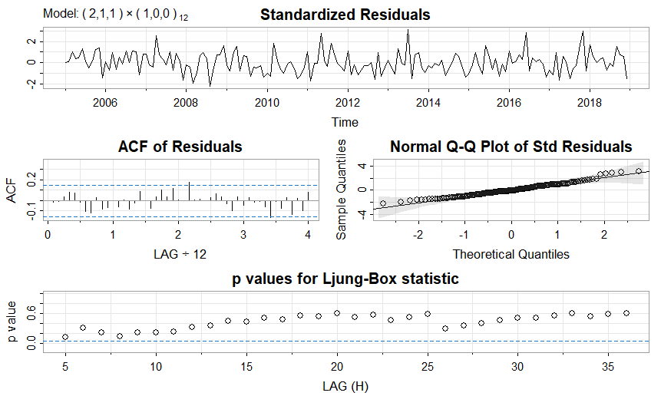
Figure 21. Residual Analysis of “Model 1” (SARIMA (2,1,1) (1,0,0) [12])

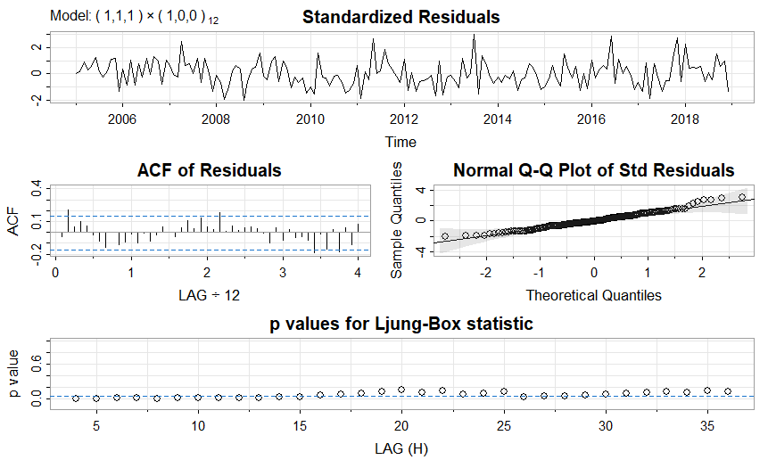
Figure 22. Residuals Analysis of “Model 2” (SARIMA (1,1,1) (1,0,0) [12])
  - Evaluation of the Forecast
So, having now decided which model I will use, it is time to see how it performs relative to the test set. For that I will use the error metrics relative to the test set, represented in Table 17, the values of the forecast (Table 18) as well as a graphic image that compares these values to the real ones (test set), present in Figure 23.
Taking a quick look at the results on the training set, in Table 17, it is possible to assert that it performed relatively well with a MAPE (Mean Absolute Percentage Error) of 9.3%, revealing a fairly accurate fit to the data. However, when comparing to the results on the test set, it presents a visible increase in the error metrics, revealing a slight drop in the forecasting precision (still these increased values lie within an acceptable range considering an economic time series very susceptible to changes in the market).
Analysing these increases, the RMSE (Root Mean Squared Error) rose from 427 thousand to 755 thousand kg and the MASE (Mean Absolute Scaled Error) crossed above 1. Naturally, this reveals that the forecast is less accurate, but what stands out is the fact that it performed worse than a naïve (simple) seasonal benchmark (since its MASE > 1). In another words, this means that if it was assumed that each month in 2019 had the same values as the ones registered in each month of 2018, the results would have been better. Faced with this, I can only conclude that the model did not hold up too well when faced with unseen data that is very susceptible to variations in the market (as stated before).
This can be observed through Figure 23 where it is clear that the forecast completely fails in some months and in others gets values close to the real ones. Essentially, the model did not account for such high volatility in the peaks and dips, since those moments are where it lacks the most in terms of accuracy.

Table 17. Metrics of the performance of “Model 1”
relative to the training and test sets
Set | ME | RMSE | MAE | MPE | MAPE | MASE
Train set | 58,745.99 | 427,065.1 | 329,658.0 | 0.33608% | 9.3115% | 0.8037179
Test set | 237,346.2 | 755,179.3 | 582,514.1 | 3.03811% | 12.8322% | 1.4201898

Table 18. Forecasted values of “Model 1” for 2019
Month | Point  Forecast | Lo 80 | Hi 80 | Lo 95 | Hi 95
Jan 2019 | 4,382,061 | 3,826,424 | 4,937,697 | 3,532,287 | 5,231,834
Feb 2019 | 3,796,384 | 3,233,244 | 4,359,523 | 2,935,136 | 4,657,632
Mar 2019 | 4,149,147 | 3,564,676 | 4,733,617 | 3,255,277 | 5,043,017
Apr 2019 | 3,858,417 | 3,270,917 | 4,445,917 | 2,959,914 | 4,756,921
May 2019 | 4,121,131 | 3,530,421 | 4,711,841 | 3,217,718 | 5,024,544
Jun 2019 | 3,984,749 | 3,392,704 | 4,576,794 | 3,079,295 | 4,890,204
Jul 2019 | 3,801,407 | 3,208,190 | 4,394,625 | 2,894,159 | 4,708,656
Aug 2019 | 3,805,020 | 3,210,939 | 4,399,102 | 2,896,451 | 4,713,589
Sep 2019 | 4,221,194 | 3,626,317 | 4,816,072 | 3,311,408 | 5,130,981
Oct 2019 | 4,286,064 | 3,690,461 | 4,881,668 | 3,375,167 | 5,196,961
Nov 2019 | 4,486,250 | 3,889,944 | 5,082,556 | 3,574,279 | 5,398,222
Dec 2019 | 3,566,021 | 2,969,032 | 4,163,011 | 2,653,004 | 4,479,038

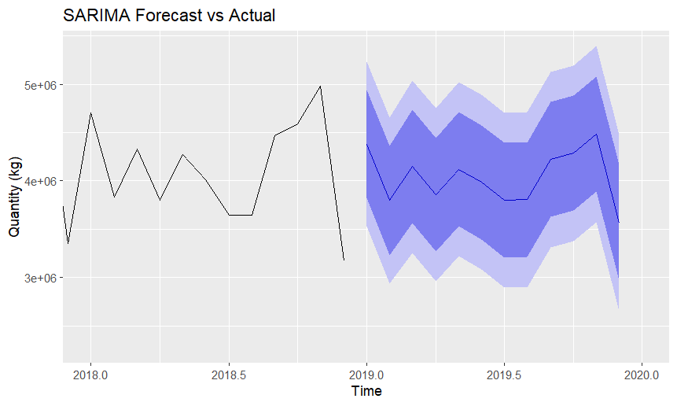
Figure 23. SARIMA Forecast for the year of 2019

- Forecast comparison and final comments
This section will serve as the conclusion of the report, comparing the selected models from each method present in this work (smoothing, Decomposition and SARIMA) using the metrics provided by Table 19. It is important to note that these metrics are relative to the test set, which concerns the data from 2019, and the forecasts from each model for this same year, can be seen in their respective section.
Looking at the error metrics, it is clear that SARIMA is the model that performs worst out of all the selected models, having the highest values which naturally indicates that this model is less accurate than the other two. Despite being known by how sophisticated it is, it revealed to be an inappropriate match for this data. Besides its higher values in terms of error measures, the one that is most worth mentioning is the MPE, suggesting this model tended to overestimate.
Focusing on the other two models, the Holt-Winters demonstrated the lowest Mean Error (ME) and Root Mean Square Error (RMSE), leading to believe that it was more accurate in minimizing the average forecast error, and the spread of the errors. Its Mean Absolute Error (MAE) and Mean Absolute Percentage Error (MAPE) were also very competitive, coming close to the values of the classical additive decomposition.
Essentially, besides ME and RMSE which favour the smoothing method (in terms of accuracy), the other metric that differentiates these two models is the Mean Percentage Error. Since it shows if the model underestimates or overestimates the actual values and that the ideal value is 0, then it is possible to conclude that the Holt-Winters additive method ends up besting the decomposition method by a slight margin in this metric too.
Considering this analysis, I believe the best model for this specific case is the smoothing model, Holt-Winters additive method, due to its lower errors and the fact that it only performs worst than the decomposition model by small margins that end up compensating the gains in the other error metrics. Although it is something very relative, this can be somewhat confirmed by the results presented in Figure 24, since despite being still far from the actual values it does seem to be the closest model to reaching them.
Ultimately, none of the models was capable of delivering an exceptionally accurate forecast for 2019. This limitation is likely due to the dataset’s sensitivity to the market shocks and fluctuations. This susceptibility to external economic, political, geographical or logistical factors hinders the from the models’ results and performance.

Table 19. Metrics of the Selected Models relative to the test set
Model | ME | RMSE | MAE | MPE | MAPE
Holt-Winters  Additive | 37,615.75 | 676,075.8 | 526,285.0 | -1.72% | 12.54%
Classical Additive Decomposition | 146,413.29 | 684,752.4 | 527,116.9 | 0.92% | 12.21%
SARIMA | 237,346.20 | 755,179.3 | 582,514.1 | 3.04% | 12.83%

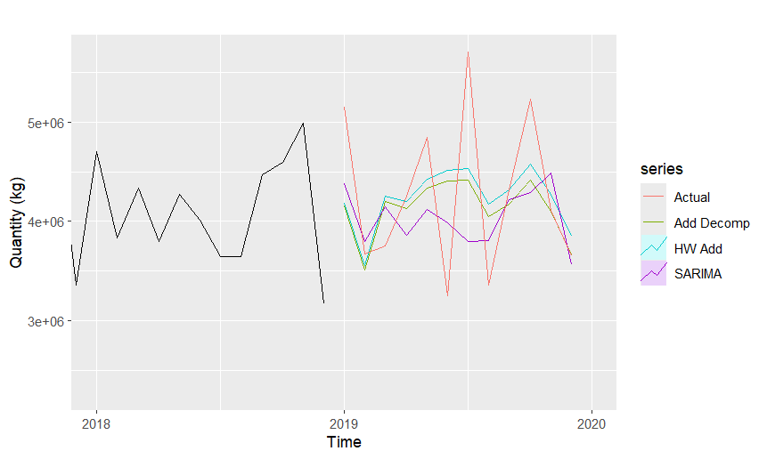
Figure 24. Comparison of the selected models’ forecasts (2018-2020)

- References
Eurostat. (2025). International trade of EU and non-EU countries since 2002 by HS2-4-6 [Dataset]. European Commission. Retrieved February 20, 2025, from https://ec.europa.eu/eurostat/databrowser/view/ds-059341__custom_15553171/default/table?lang=en

- Appendices
  - Appendices from the SARIMA modelling
    - Outputs from the application of the statistical tests ADF and KPSS
Augmented Dickey-Fuller Test

data: diff_train
Dickey-Fuller = -7.2353, Lag order = 5, p-value = 0.01
alternative hypothesis: stationary

KPSS Test for Level Stationarity

data: diff_train
KPSS Level = 0.039629, Truncation lag parameter = 4, p-value = 0.1

    - Outputs relative to the tested SARIMA models

“Model 1”:
Coefficients:
Parameter | Estimate | SE | t-value | p-value
ar1 | 0.1253 | 0.0764 | 1.6404 | 0.1029
ar2 | 0.2204 | 0.0765 | 2.8796 | 0.0045
ma1 | -1.0000 | 0.0161 | -62.0275 | 0.0000
sar1 | 0.5006 | 0.0689 | 7.2606 | 0.0000
constant | 5035.1125 | 1662.9361 | 3.0278 | 0.0029

sigma^2 estimated as 176723609718 on 162 degrees of freedom
AIC = 28.8472 AICc = 28.84943 BIC = 28.95922

“Model 2”:
Coefficients:
Parameter | Estimate | SE | t-value | p-value
ar1 | 0.1572 | 0.0775 | 2.0275 | 0.0442
ma1 | -1.0000 | 0.0198 | -50.5819 | 0.0000
sar1 | 0.4849 | 0.0699 | 6.9392 | 0.0000
constant | 4942.1418 | 1312.7518 | 3.7647 | 0.0002

sigma^2 estimated as 185266088172 on 163 degrees of freedom
AIC = 28.88369 AICc = 28.88517 BIC = 28.97704

“Model 3”:
Coefficients:
Parameter | Estimate | SE | t-value | p-value
ar1 | 0.1392 | 0.0769 | 1.8096 | 0.0722
ar2 | 0.2385 | 0.0778 | 3.0664 | 0.0025
ma1 | -1.0000 | 0.0178 | -56.0829 | 0.0000
sma1 | 0.4323 | 0.0669 | 6.4600 | 0.0000
constant | 4686.1832 | 1460.5819 | 3.2084 | 0.0016

sigma^2 estimated as 1.86554e+11 on 162 degrees of freedom
AIC = 28.89851 AICc = 28.90074 BIC = 29.01053

“Model 4”:
Coefficients:
Parameter | Estimate | SE | t-value | p-value
ar1 | 0.1338 | 0.0776 | 1.7243 | 0.0866
ar2 | 0.2071 | 0.0793 | 2.6128 | 0.0098
ma1 | -1.0000 | 0.0168 | -59.6244 | 0.0000
sma1 | 0.4995 | 0.0784 | 6.3676 | 0.0000
sma2 | 0.2420 | 0.0847 | 2.8573 | 0.0048
constant | 4910.5705 | 1555.9619 | 3.1560 | 0.0019

sigma^2 estimated as 177133781082 on 161 degrees of freedom
AIC = 28.86349 AICc = 28.86664 BIC = 28.99419

    - Outputs from the application of the Shapiro-Wilk normality test
Shapiro-Wilk normality test for “Model 1”

data: residuals(model_train)
W = 0.97981, p-value = 0.01501

Shapiro-Wilk normality test for “Model 2”

data: residuals(model_train)
W = 0.97955, p-value = 0.01395

