# Classical decomposition
> decomp_add <- decompose(train, type="additive")
> autoplot(decomp_add) + ggtitle("Classical Additive Decomposition")
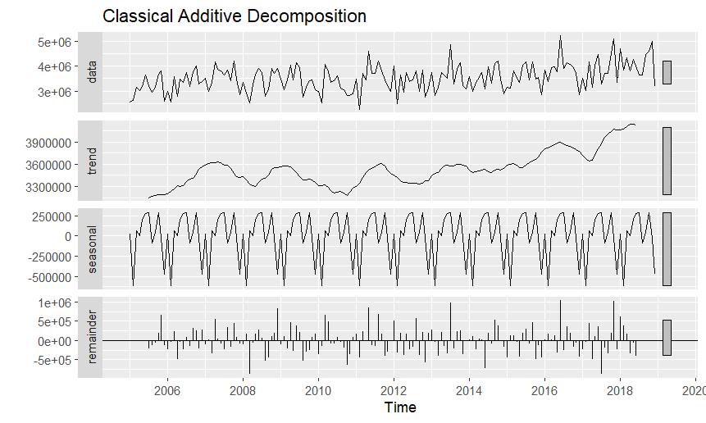
> head(decomp_add$trend)
Jan Feb Mar Apr May Jun
2005 NA NA NA NA NA NA
> head(decomp_add$seasonal)
Jan Feb Mar Apr May Jun
2005 25634.4348 -618311.4081 67372.5566 -542.5972 204881.8194 279878.6496
> head(decomp_add$random)
Jan Feb Mar Apr May Jun
2005 NA NA NA NA NA NA
> summary(decomp_add$trend)
Min. 1st Qu. Median Mean 3rd Qu. Max. NA's
3150175 3374216 3527048 3536617 3613064 4140669 12
> summary(decomp_add$seasonal)
Min. 1st Qu. Median Mean 3rd Qu. Max.
-618311 -43058 35864 0 223631 289912
> summary(decomp_add$random)
Min. 1st Qu. Median Mean 3rd Qu. Max. NA's
-875434.9 -231807.6 -34849.4 609.5 196957.9 1030867.9 12
> decomp_mult <- decompose(train, type="multiplicative")
> autoplot(decomp_mult) + ggtitle("Classical Multiplicative Decomposition")
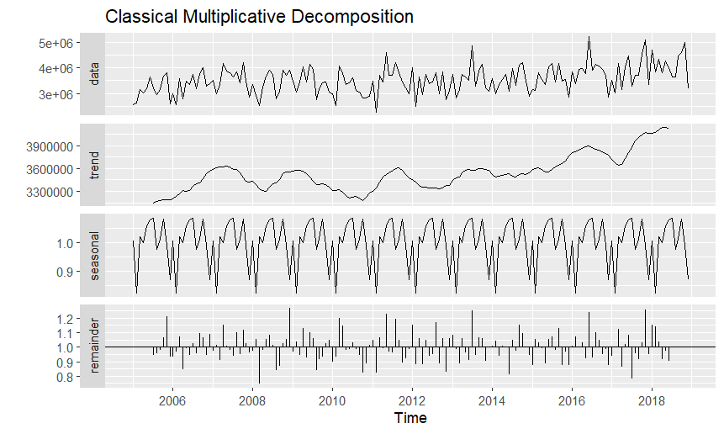
> head(decomp_mult$trend)
Jan Feb Mar Apr May Jun
2005 NA NA NA NA NA NA
> head(decomp_mult$seasonal)
Jan Feb Mar Apr May Jun
2005 1.0060542 0.8229452 1.0193667 1.0007214 1.0593609 1.0776898
> head(decomp_mult$random)
Jan Feb Mar Apr May Jun
2005 NA NA NA NA NA NA
> summary(decomp_mult$trend)
Min. 1st Qu. Median Mean 3rd Qu. Max. NA's
3150175 3374216 3527048 3536617 3613064 4140669 12
> summary(decomp_mult$seasonal)
Min. 1st Qu. Median Mean 3rd Qu. Max.
0.8229 0.9861 1.0093 1.0000 1.0639 1.0853
> summary(decomp_mult$random)
Min. 1st Qu. Median Mean 3rd Qu. Max. NA's
0.7459 0.9363 0.9908 0.9997 1.0581 1.2660 12
> # Seasonally adjusted data
> sa_add <- train - decomp_add$seasonal
> sa_mult <- train / decomp_mult$seasonal
> autoplot(cbind(Original=train,
+ `Additive Seasonally Adjusted`=sa_add,
+ `Multiplicative Seasonally Adjusted`=sa_mult)) +
+ ggtitle("Original vs Seasonally Adjusted Series")
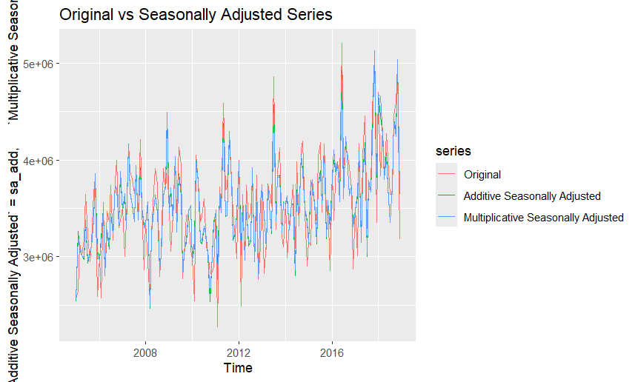
> autoplot(ts(cbind(Original = train,
+ Additive_Adjusted = sa_add),
+ start = start(train), frequency = 12)) +
+ ggtitle("Original vs Seasonally Adjusted Series") +
+ ylab("Quantity")
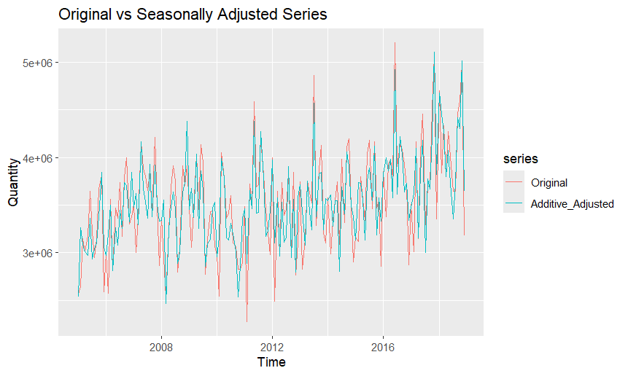
> autoplot(ts(cbind(Original = train,
+ Multiplicative_Adjusted = sa_mult),
+ start = start(train), frequency = 12)) +
+ ggtitle("Original vs Seasonally Adjusted Series") +
+ ylab("Quantity")
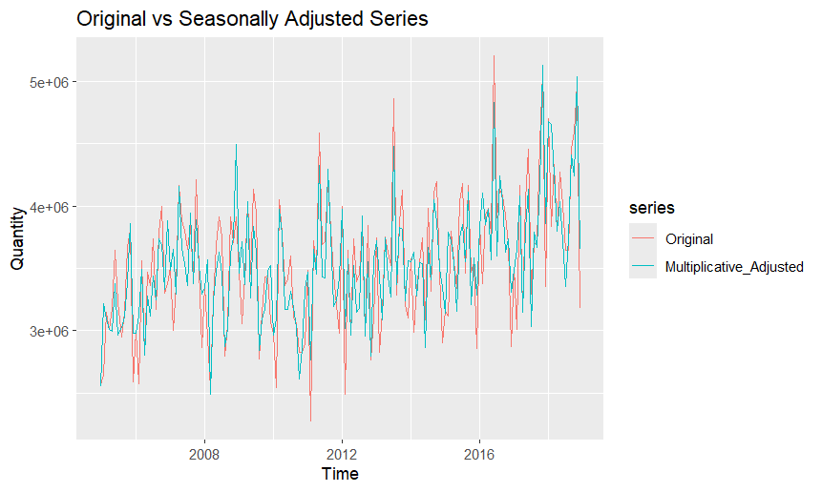
> # STL decomposition
> stl_coffee <- stl(train, s.window="periodic")
> autoplot(stl_coffee) + ggtitle("STL Decomposition")
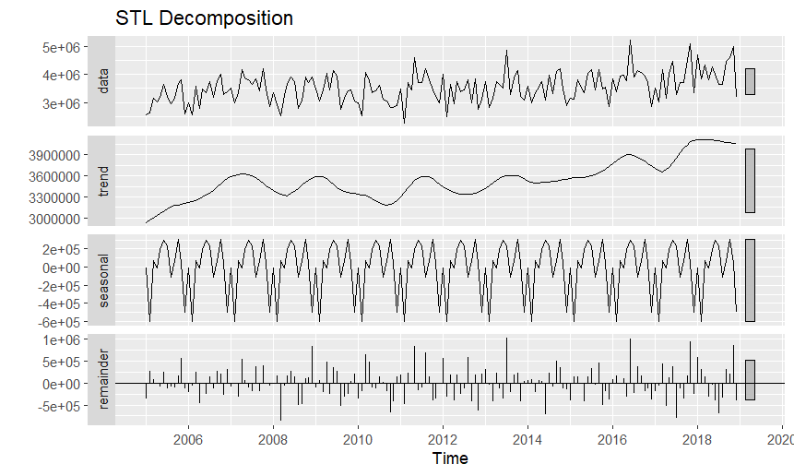
> head(stl_coffee$time.series)
seasonal trend remainder
Jan 2005 -5704.866 2935790 -366085.53
Feb 2005 -602741.335 2968596 278945.23
Mar 2005 67929.635 3001402 81768.55
Apr 2005 -6653.759 3032937 -16983.16
May 2005 194101.469 3064472 -83673.50
Jun 2005 295787.383 3094257 251655.93
> summary(stl_coffee$time.series)
seasonal trend remainder
Min. :-602741 Min. :2935790 Min. :-869924
1st Qu.: -31899 1st Qu.:3355269 1st Qu.:-234523
Median : 55117 Median :3527494 Median : -20324
Mean : 0 Mean :3537398 Mean : 1295
3rd Qu.: 204582 3rd Qu.:3621387 3rd Qu.: 206191
Max. : 308050 Max. :4117593 Max. :1020826
> # Seasonally adjusted from STL
> sa_stl <- seasadj(stl_coffee)
> autoplot(cbind(Original=train, `STL Seasonally Adjusted`=sa_stl)) +
+ ggtitle("Original vs STL Seasonally Adjusted Series")
